Report on an experiment looking at tests

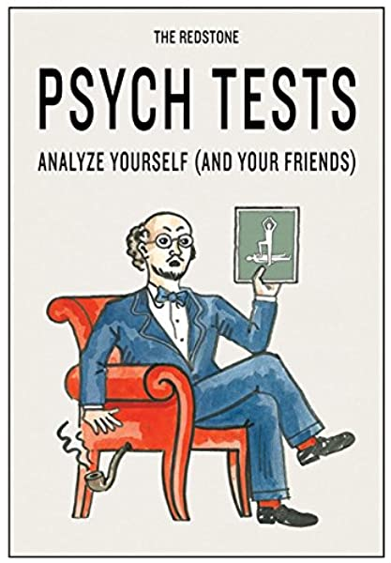

We gleaned 50 people from our lab class to give their consent to do an experiment where they sat down at a computer and learnt words and then we thanked them for their help and reminded them they had the right to withdraw. They obtained 14% right guessing but 13% correct reading and the Bayes was 0.3 which means nothing materialized which iisn’t what Potts got and we had another conditions where things were easier but we still didn’t find anything. It is argued that probably Potts is wrong because she didn’t test memory right.

In this report I am going to write about some results that explain as to how we are good at memory. And what makes it good. Atkinson and Shiffren explained that there are three types of memory iconic memory short term long term. Iconic memory is memory for a few seconds, short-term memory is for small amounts of information for a short time and long term memory is for lots of information for a long time. Although more recently psychologists have explained thast the Atkinson theory is wrong and our memory has working memory.

In this lab class we executed the Potts experiment “The benefit of generating errors during learning” which is a memory experience who showed guessing was better than reading but they were probably wrong because they didn’t have to learn any thing. And So we gave them a test where they could’t do that. they had to write out the answers so they couldn’t get lucky. The reason as to why tests are an important thing to do research on in psychology and in this day and age teachers like to give us lots of tests (Guardian, “ Testing of under-fives goes ahead despite teaching union objections”). Some peoplesay testing is good. Which is call the testing affect. “The **testing effect** is the finding that [long-term memory](https://en.wikipedia.org/wiki/Long-term_memory) is often increased when some of the learning period is devoted to retrieving the to-be-remembered information. The effect is also sometimes referred to as **retrieval practice**, **practice testing**, or **test-enhanced learning**.The testing effect on memory should be distinguished from more general **practice effects**, defined in the APA Dictionary of Psychology (2007) as "any change or improvement that results from practice or repetition of task items or activities."” - Wikipedia

So the testing affect explains that tests are good. Students do bad on tests sometimes though so maybe tests are bad after all. But maybe there not because of Potts. In the Potts in three expeirments people will learn English words no one knows sometimes they had to guess and sometimes they were told the answer was tube. It was a multi-choice test. They always guessed wrong but it was better than reading so testing is good, Potts thinks, even when the tests are really difficult and stressy. We thnk Potts is wrong and heres the experiment we did to prove it.

**Method**

Everyone in class was working in groups and so each froup tested each other. We did this over and over.The gap between trails was seconds.

We test people in our class time. Except Jenny, who was ill, so she didn’t. I emailed the data to myself but it didn’t work properly and so we couldn’t use that persons data and so we didn’t. Our experiment had lots of power and was run on OpenSesame over the interenet There were 17 pairs of word like fish. You saw them for 13 seconds or 19 seconds. And then you will see them for 10 seconds if you were guessing. Guessing was for 10 seconds and you had to guess even if you didn’t really want to. The computer told you to keep ni guessing anyway by saying “What does this word mean?” all the time. They had to type in words and it was for 11 seconds. Some people got a hard test and other people got an esay test.

*Apparatus and materials:* Laptops,

* OpenSesame script
* Consent and information forms
* tidyverse
* The DLE (a.ka. Moodle)
* Psyc:EL

Also, look at our appendix.

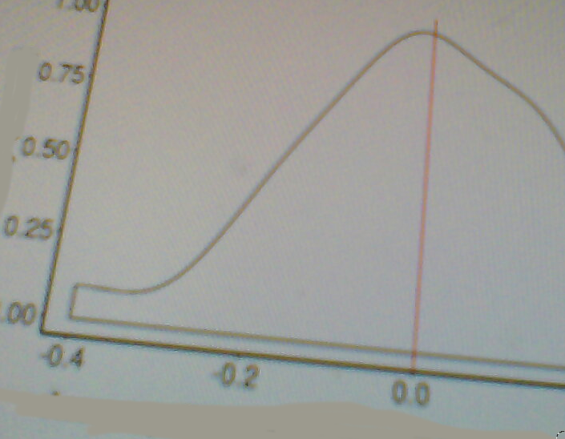**Figure 1: Graph to show the density of our experoiment.**

These are our result’s. We used RSTudiO. The bayes was 3.0 which means that research displays that nothing happened. You can also see this is true in the Table.

**Conclusion’s**

Guessing didn’t help, which is different to Potts, but she tested people in London Also we had more girls than boys which is bias and we only tested 50 people which isnt very many and if we tested more people we might have found something different, which would have effected our results.But also there were some problems with Potts becsause she didn’t use a proper test. If I ran this experiment again I would test more people and Id also enhance the ecological validity of the underlying protocol to increase the mundane realism which was low and means you can’t say much about the real world form what we found becorse experiments have low validity. We should have used a questionnaire instead about how teachers think children learn best in school which would have been more realistic. I would also look at learning styles because some people like me are visual learners and learning by words is not good for people like us. Maybe also depressed people would be bad at these tests and introverted people would be good. Future research could extricate this.

Another theory as to why it was that maybe it was all a flour affect because no one was very good at the test. But 14 is bigger than 13 and so there was a difference its just it wasn’t significant and if it was signifcant guessing would be better which is what should have happened. We are going to fix the flour affect in our next experiment except we can’t because of the pandemic and social distancing and you can’t test people if you can’t get close to them.

Grimaldi and Karpicke (2012) proposed that generating errors canonly benefit memory to a greater extent than passive reading when the correct answer is 47already known and is activated during the initial generation attempt. Others (Huelser &Metcalfe, 2012; Hays et al., 2013) have also argued that an existing cue-target relationship isnecessary for this benefit to be observed. Our findings are inconsistent with these proposals.

Another thing it could be is that 7 seconds is less than 17 seconds, so they get more time in one condition than the other. That isn’t fair. But it’s not that many seconds. So it isn’t that important really. Probably. In conclusion some would say that guessing helps but others would say that guessing doesn’t help and our result is more like the second but it could also be the other one because there were some problems and we can’t really conclude any thing. Further research into this crucial phenomenon of scholastic aperture would be highly approvable and would shine a torch into the dark cornets of psychological science, neuroscience, and pedagogy.

Rosalind Potts & Shanks, D. R. “The benefit of generating errors during learning”. Journal of Experimental Psychology: General, 644. 2014.