________OUR MISSION HOUSE PUBLICATIONS________
Sisters of Mary Immaculate
Books for Religious Education
by Bishop Louis L.R. Morrow, SDB
Excellent in quality, Low in price.

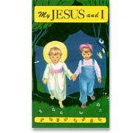
My JESUS AND I—BOOK — of 40 pictures in full color. a beautiful picture book to inspire young children how to love Jesus as their best friend and to teach prayers with the help of simple text and pictures on each page. The pictures and explanations offer many opportunities for discussion with your little child on so much more than just the prayers introduced. Soft cover 5 x 8 inches - 48 pages. $5.00

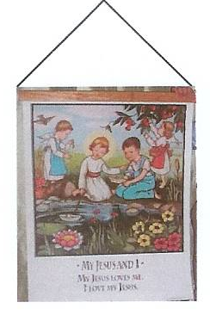
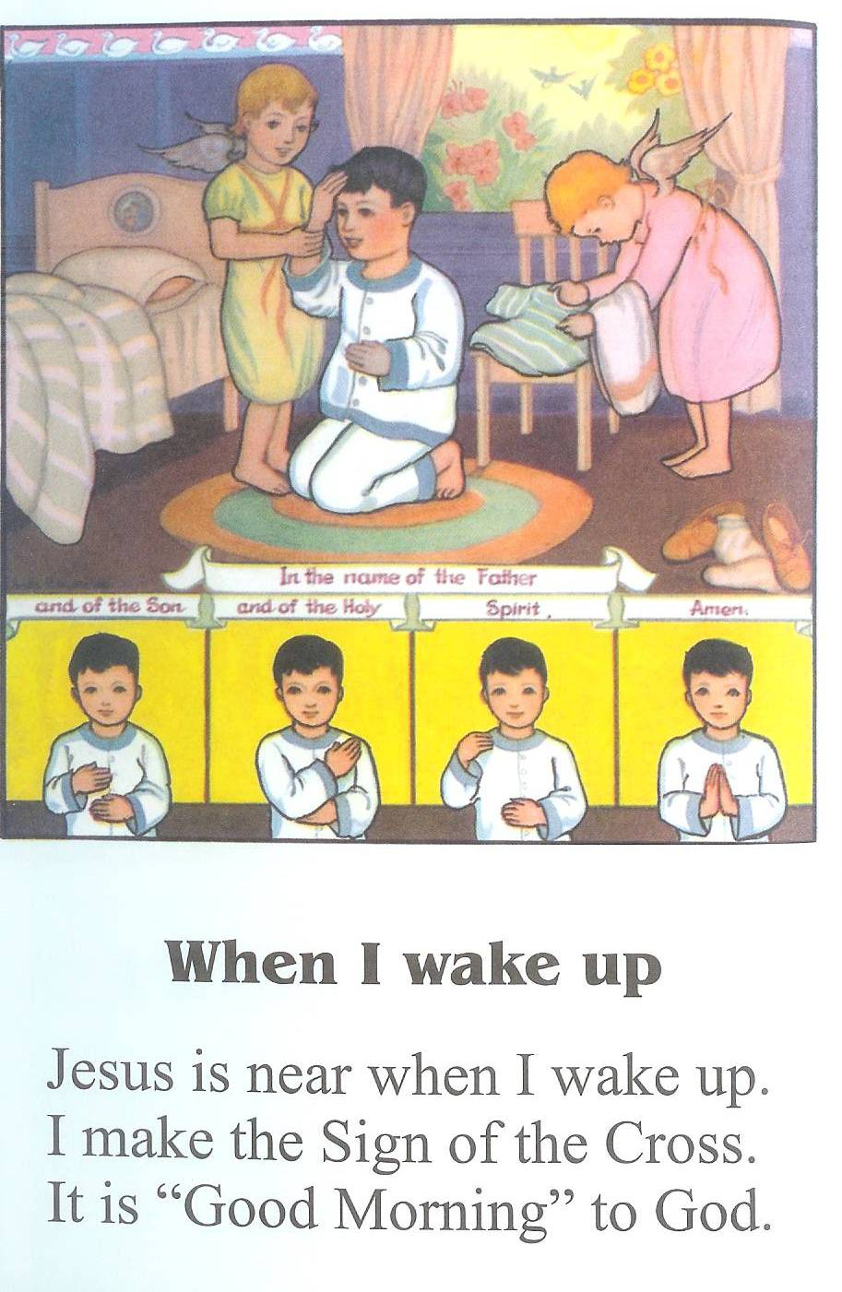
MY JESUS AND I—FLIP CHART— The same 40 pictures in full colors – a great classroom visual aid. The heavy sheets are printed on both sides in full color and are bound very sturdy. 22 x 28 inches. $22.95

MY JESUS AND I—TEACHER’S GUIDE - To use with My Jesus and I flip chart and book. Most helpful for busy catechists, parents and teachers. An outline of work to be taken up each week. $2.75

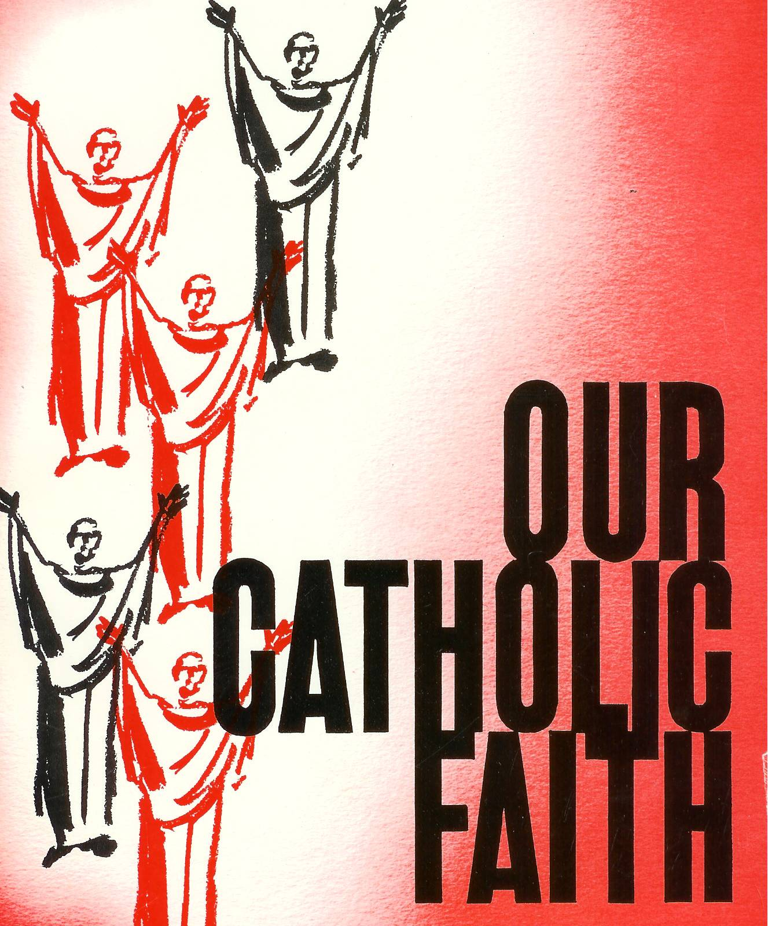
OUR CATHOLIC FAITH
A complete Manual of Religion with instructive illustrations for those who desire a concise knowledge of the teachings and practice of Catholic Faith. Written in an easy-to-read question and answer format about God’s Saving Action, God’s Commandments and Precepts of the Church, The Sacraments, and Practical Guide lines for Christian Way of Living. Excellent guide for adult Catechesis, RCIA program, religious educators, and all those who like to deepen their life of faith. 7^{1/4} x 10^{1/2} inches - 524 pages text and illustrations in two colors—hardbound. $28.95

ORDER FROM:
OUR MISSION HOUSE
118 Park Road
Leechburg, PA 15656
Phone: 724-845-2828 – E-mail: omhsmi@gmail.com – www.omhsmi.org
Make check payable to: Sisters of Mary Immaculate

Shipping Charges for U.S. - by Media Mail :
$0.01 - $15.00 add $3.50
$15.01 - $25.00 add $4.50
$25.01 - $40.00 add $5.50
$40.01 - $55.00 add $6.50
$55.01 - $75.00 add $7.50
Above $75.00 add $.1.00 for each additional $10.00
** Please include $7.00 for each Flip Chart **
The proceeds from your purchase benefit our missions in India and Africa.
Thank you and God bless you.

