**Novel TMS Coil Design for the Stimulation of Several Regions in the Mesolimbic Pathway as Treatment for Psychiatric Disorders**

By Prithvi Nathan ([swamiprithvi@gmail.com](mailto:swamiprithvi@gmail.com)) and Pawan Jayamukar ([pawan.jayakumar@gmail.com](mailto:pawan.jayakumar@gmail.com))

**Abstract**

Transcranial magnetic stimulation (TMS) is a recent form of non-invasive brain stimulation that uses the principle of induction to induce currents in the brain. This has been proven to help treat many psychiatric illnesses including major depression and post traumatic stress disorder. One of the limitations of TMS is that currently approved coils that are used for treatment do not penetrate deep in the brain and are unable to stimulation more than one region simultaneously, inhibiting the ability to target key areas involved in mental illnesses such as the reward pathway. We present a novel coil design that is specifically made to target the mesolimbic pathway in order to help better treat major depression. We designed the coils using computer aided design software and simulated the magnetic and current density fields generated from running a variable current through the coil using MATLAB and a brain model. Our results showed that the coil is able to induce proper levels of current in the mesolimbic pathway and minimizes any induced currents in other areas. This research will prove to be valuable in developing advanced neuromodulation techniques to alleviate the symptoms of many psychiatric disorders.

**Statement of Purpose**

Typical TMS coils are generally incapable of deep brain stimulation. Coil geometries such as the Fo8 and Halo designs are generally only capable of stimulating a few centimeters of cortex. A more advanced coil, the H coil, is capable of reaching deep brain regions but are incapable of targeting multiple regions in a brain pathway with a single geometry.  
The objective of this project is to construct a coil for a TMS device that is capable of stimulating multiple areas of the mesolimbic pathway. Using computational resources such as MATLAB and head anatomical models, a basic environment for testing and producing a unique coil configuration has been constructed  
We proposed the construction of two coils placed on two sides lateral to the head for a TMS simulation. These coils comprise of two solenoidal shapes, with a smaller one on the inside. The purpose of this configuration was to create a magnetic field that was strong enough to stimulate the central regions of the brain but avoid severely targeting other areas such as the cerebral cortex. By running currents in a direction different from the other in the solenoid pairs, two magnetic fields are produced and they can construct or deconstruct each other in magnitude depending on where they are positioned and how much current is being run through them.

**General Background**

Transcranial magnetic stimulation (TMS) is an advanced medical treatment based on directly stimulating the brain via properties of electromagnetic induction. Over the past four decades, the technology has been widely used for researching, diagnosing, and treating various neurodegenerative and psychiatric disorders including Parkinson’s disease, bipolar disorder, and major depressive disorder (MDD).

TMS devices use electromagnetic induction developed from a time varying magnetic field to develop an electric current within the head within very short time periods. Naturally, neurons fire when an electric charge develops across an axon. By inducing a current, the TMS device can cause a neuron to depolarize, causing a signal to propagate. TMS devices use fundamental laws of electricity and magnetism such as the Biot Savart Law which determines the magnetic field produced from the coil and Faraday’s law of induction which characterizes how strong the electric field produced by said magnetic field is inside the brain. For a TMS device to work, it must first generate a magnetic field that rapidly changes over a short period of time which requires a time varying current to flow through the coil. This time varying magnetic field will produce a

The mesolimbic pathway, also known as the “reward” pathway is a collection of neurons that illicit pleasure when stimulated. In many animals with complex nervous systems such as humans, these neurons release chemical signals called neurotransmitters such as dopamine during instances of food consumption or sexual activity to promote such behavior. Typically, in disorders such as MDD, levels of brain activity in regions and pathways such as the mesolimbic pathway are lower than normal. While the exact relationship between activity in the mesolimbic pathway and psychiatric disorders isn’t fully understood, there is no doubt behind that a relationship between the them exist.

**Theory**

Two important laws in electrostatics and magnetostatics are used to advance this project: the Biot-Savart Law and Faraday’s Law of Induction  
  
The Biot Savart law represents the magnetic field produced generated from a constant electric current. Because the current is time varying however, one may assume that Jefimenko’s equations would be more appropriate for the task as they can more accurately estimate magnetic fields using retarded potentials. However, temporal integrals are more complex and difficult to calculate so rather than using up too much computational power and time, we decided to instead recalculate the magnetic field at each time interval. This approximation has been previously used by Sousa et. al., (2018) and has returned a very accurate estimate of the magnetic field at a given time.

The relative complexity and the need for more computational resources can secure a firm estimate regarding the electric field. Using advanced methods for calculating the vector potential (E) from Faraday’s Law is difficult to implement in MATLAB computationally because of the requirement of a symbolic expression of the vector field. However, the relationship between dB/dt and the E field is sufficient to contextualize the strength of the electric field throughout the brain.

**Hypothesis**

By employing constructive interference of magnetic fields on coils placed laterally from the brain for a transcranial magnetic stimulation device, it is likely that only segments of the mesolimbic pathway in the brain will be stimulated with an induced electric field.

**Materials**

* MATLAB
* MIDA Model: Ultra-High Resolution Head & Neck Model
* Computer with Strong GPU for processing

**Procedure**  
  
For coil designs, the x, y, and z coordinates of each point along the coil were mapped using a function that took in a desired position on the field to start constructing the coil and a set distance between each loop in the solenoid. This was repeated for all 6 solenoids in a MATLAB function.   
A 3-D plotting function was then added into the program to associate colors with a scale representative of the range of magnetic fields produced by this coil. To better make sense of the data, 3D CAD models of various brain regions were purchased from Zurich Medtech AG. These 3D CAD models were converted to .stl files and the vertices of each line in the file were mapped onto the plot. The ability to rotate the plot, zoom in on certain points, and automatically read just the scales were also built.  
To represent an approximation for the Biot Savart law, two matrices of points were defined. One was the source matrix (S) , a list of points separated by a minute difference representing the shape of the coil. The other matrix was the field matrix (F), representing each point in the brain. Because the Biot Savart law involves a constant current in its calculation, we had to calculate it at not only every spatial step but also every temporal step. We predicted a desired current to run through the coil at a certain time so we multiplied that desired current with the electric permittivity constant divided by 4pi. This new value will have to be multiplied over the path integral of the coil. We defined a dl to be the difference of two points in the source field and created an r-vector designed to represent the difference between a certain point in the source field and the field point where the magnetic field would be measured. To approximate the integral, we looped over every source point for every field point, calculated (dl x r_hat)/r^2 for every since source point, and added up all the results in the end and multiplied by the value calculated beforehand.  
To calculate dB/dt, we chose to recalculate the Biot Savart law over two instantaneous currents calculated over a time interval of 10 milliseconds. We used accurate current assessments that follow international guidelines to insure that the massive change in electric current and magnetic field over the time interval is indeed safe. This calculation of dB/dt will then need to be contextualized in terms of surrounding points. If dB/dt at certain point is larger than its surroundings (regardless of sign because that indicates direction), then the electric field should be the strongest at that point. Adjust the coil positioning and size if necessary to tweak the relative electric field strength so that the regions of the mesolimbic pathway receive more stimulation than other areas.

**Data and Figures**

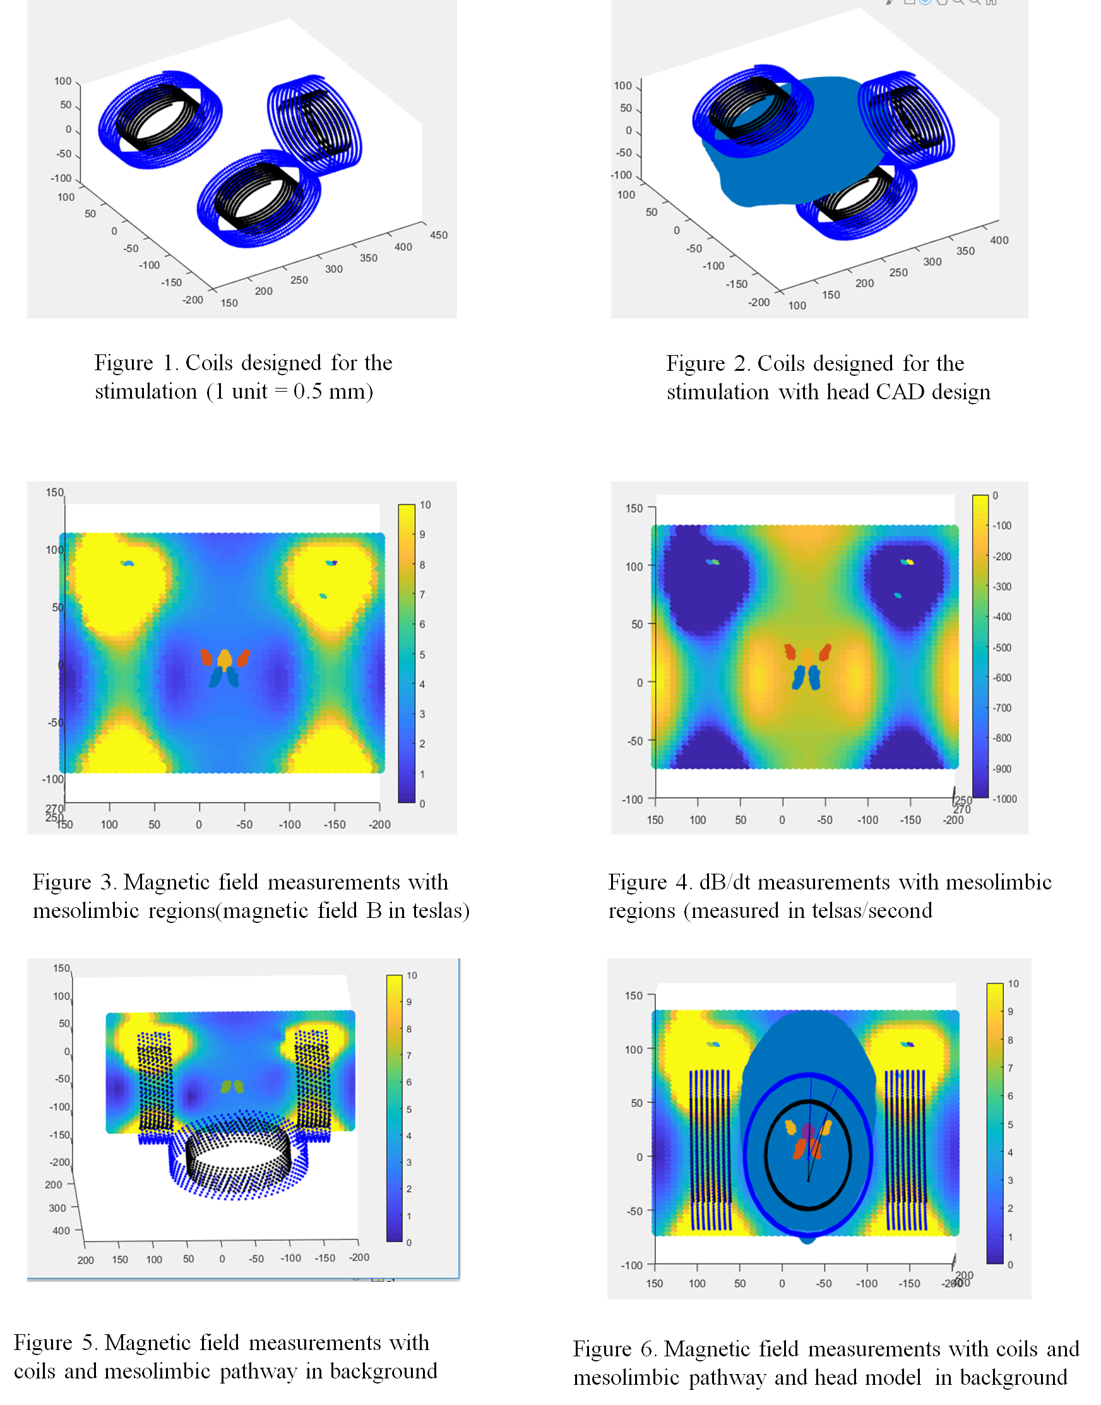

**Data Analysis**  
  
The diagrams and values support our hypothesis that the coil configuration could build up an electric field towards the center of the brain and deconstruct on the side. At the point holding parts of the anterior side of the nucleus accumbens, a region connected to the mesolimbic pathway and the basal ganglia where dopamine from surrounding dopaminergic neurons is released, we have approximately 4.0155 teslas released over a 10 millisecond interval. This pattern can be found throughout the mesolimbic pathway from the prefrontal cortex to the basal ganglia. Meanwhile, in the center left and right lateral sections of the cerebral cortex, we have only around 0.8370 teslas also released over the same 10 millisecond interval. This meets general standards for the amount of teslas produced by TMS devices over short intervals (~3-4 teslas) indicating the safety of the procedure.  
By contextualizing Faraday’s law of induction, we know that a quick change in magnetic field will directly correlate with a strong electric field produced regardless of the direction of the vector field. As shown by the diagrams, the electric field produced by the time derivative of the magnetic field should indeed be stronger in the central parts of the brain and weaker on surrounding regions. This highly supports our hypothesis that this coil configuration was able to build up in the mesolimbic pathway and deconstruct in other regions.  
A notable part of the data is the very intense magnetic (and likewise, electric field) produced in the locations directly surrounding the coils. This is to be expected, magnetic and electric fields will be stronger closer to the source. Fortunately, the coil was positioned in such a manner to insure that these electric fields do not electrocute the patient and are just outside his head. TMS devices also generally have insulation to prevent electric fields from disturbing the patient or the coil.

**Conclusion**  
  
By employing constructive interference of magnetic fields on coils placed laterally from the brain for a transcranial magnetic stimulation device, only segments of the mesolimbic pathway in the brain will be stimulated with an induced electric field. The technology discussed in this project could potentially revolutionize non-invasive deep brain stimulation. With this novel coil design, easy stimulation of gray matter pockets deep within the brain is viable. This will certainly prove to beneficial for treatment and research regarding cures for psychiatric and neurodegenerative disorders.

**References**

Rotenberg, A. (2016). Transcranial magnetic stimulation. Place of publication not identified: Humana.  
Lu, M., & Ueno, S. (2017). Comparison of the induced fields using different coil configurations during deep transcranial magnetic stimulation. Plos One, 12(6). doi:10.1371/journal.pone.0178422  
  
Sachdev, P. S., Mcbride, R., Loo, C., Mitchell, P. M., Malhi, G. S., & Croker, V. (2002). Effects of different frequencies of transcranial magnetic stimulation (TMS) on the forced swim test model of depression in rats. Biological Psychiatry, 51(6), 474-479. doi:10.1016/s0006-3223(01)01298-7  
  
Sousa, I. P., Barbosa, C. R., & Monteiro, E. C. (2018). Safe exposure distances for transcranial magnetic stimulation based on computer simulations. PeerJ, 6. doi:10.7717/peerj.5034  
  
Helm, K., Viol, K., Weiger, T. M., Tass, P. A., Grefkes, C., Monte, D. D., & Schiepek, G. (2018). Neuronal connectivity in major depressive disorder: A systematic review. Neuropsychiatric Disease and Treatment, Volume 14, 2715-2737. doi:10.2147/ndt.s170989