ERICA INGRAM

evoingram@aquoco.onmicrosoft.com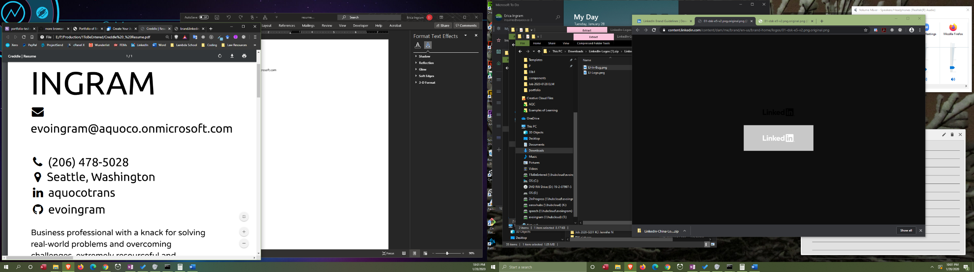

(206) 478-5028

Seattle, Washington

aquocotrans

evoingram

Business professional with a knack for solving real-world problems and overcoming challenges, extremely resourceful and adaptable with excellent communication skills from a decade-long writing career and another decade in court transcription, thorough, self-disciplined, and well equipped to work independently under regular strict deadlines.

Skills

**TECH SKILLS**

HTML

CSS

JavaScript

Visual Basic

Git

MySQL

React

Redux

GSAP  
Microsoft Access

Adobe XD

LESS

Bootstrap

Emmet

Yarn

Jest

Formik

SASS

jQuery

Python

PHP

API

UI

REST

JSON

**LEGAL SERVICES SKILLS**

Legal Research

Editing

Writing

Transcription  
Litigation Support

Proofreading

Project Management

**Employment**

|  |  |
| --- | --- |
| **Lambda School** | **Online** |

|  |  |
| --- | --- |
| **Team Lead** | **Jan. 2020​ to Current** |

* Code review for every student in my team twice per week
* Hosted stand-up meetings with seven students two to three times per week
* Presentations on various resources to facilitate students' growth during stand-ups
* Mentored and provided feedback to students on areas of improvement
* Tracked attendance and other student metrics
* Use of Slackbot and Slack Workflow Builder to manage tasks, information, and reminders

|  |  |
| --- | --- |
| **A Quo Co.** | **Seattle, Washington** |

|  |  |
| --- | --- |
| **Owner/Operator** | **May 2009​ to Current** |

* Standard business operations such as accounting and project management
* Streamlined consistent business communications & marketing
* General & legal transcription services of digital audio/video
* Completely unique features such as authority hyperlinking via CourtListener, .gov sites, and the like as well as tables of authority for free with every transcript via VBA automation
* Consistently produced twice the number of transcript pages as most of my colleagues due to VBA automation
* Used text-analyzing software on over 10,000 transcript pages to produce autocorrect entries in Word to improve typing speed and accuracy, then used VBA to automate creation of those entries regarding proper names and nouns

**Projects**

|  |  |
| --- | --- |
| [**Portfolio: ericaingram.com**](https://www.ericaingram.com/) | **Nov. 2019​ to Feb. 2020**​ |

* Made with JavaScript, HTML, CSS,  SVG, different media queries for desktop and phone.

|  |  |
| --- | --- |
| [**NASA Random APOD Generator: nasa-random-apod.herokuapp.com**](https://nasa-random-apod.herokuapp.com/) | **Jan. 2020​ to Jan. 2020**​ |

* React and Redux app integrating the NASA Astronomy Photo of the Day API
* Generates a random date's NASA Astronomy Photo of the Day
* Displays a new corresponding picture, date, and description at the click of a button
* The loader animation is a rocket shooting around Earth, which is also rotating

|  |  |
| --- | --- |
| [**Transcription Management:** **github.com/evoingram/VBProjects/tree/master/database**](https://github.com/evoingram/VBProjects/tree/master/database) | **June 2017​ to Jan. 2020​** |

* Developed using Visual Basic for Applications, Microsoft Access, and MySQL
* Company database for used for transcript production and management
* Saved an average of 15 to 20 hours per week
* Generates 25 to 30 different documents automatically such as price quotes, invoices, cover pages, indexes, and others
* Manages schedule and production workflow
* Auto-imports e-mails from Outlook

ERICA INGRAM

evoingram@aquoco.onmicrosoft.com

(206) 478-5028

Seattle, Washington

aquocotrans

evoingram

Business professional with a knack for solving real-world problems and overcoming challenges, extremely resourceful and adaptable with excellent communication skills from a decade-long writing career and another decade in court transcription, thorough, self-disciplined, and well equipped to work independently under regular strict deadlines.

Skills

**TECH SKILLS**

HTML

CSS

JavaScript

Visual Basic

Git

MySQL

React

Redux

GSAP  
Microsoft Access

Adobe XD

LESS

Bootstrap

Emmet

Yarn

Jest

Formik

SASS

jQuery

Python

PHP

API

UI

REST

JSON

**LEGAL SERVICES SKILLS**

Legal Research

Editing

Writing

Transcription  
Litigation Support

Proofreading

Project Management

* Automatically hyperlinks authority within transcripts via CourtListener API
* Manipulates PDFs to auto-generate bookmarks and create different transcript versions
* Tracks communication and document history of each transcript order
* Manages and plays audio and reporter notes
* Integrated with Office, Acrobat, and WinSCP libraries and several APIs such as CourtListener, Wunderlist, PayPal, OneNote, and others

|  |  |
| --- | --- |
| [**Company Website: aquoco.co**](https://www.aquoco.co/) | **Oct. 2019​ to Dec. 2019**​ |

* Made with LESS, JavaScript, HTML, and CSS
* Fourth iteration, utilizing what I've learned at Lambda
* Ranks in the 90th percentile in Google PageSpeed Insights
* Ranks on first page results for "seattle transcription" in Google, page two for Bing/Duckduckgo

|  |  |
| --- | --- |
| [**Multi-Page Marketing Website: partyplannersite.herokuapp.com**](https://partyplannersite.herokuapp.com/) | **Nov. 2019​ to Nov. 2019**​ |

* Developed using HTML, CSS, JavaScript, SVG, and LESS with animations, several parametric mixins and nested styles, different media queries for phone, tablet, and desktop, responsive units for font sizing, and media queries escaped

**Education**

|  |  |
| --- | --- |
| **Lambda School Academy of Computer Science and Web Development** | **Oct. 2019​ to Curren**t |

*endorsement full-stack web development 2020​*

*https://lambdaschool.com/courses/full-stack-web-development*

Six+ month computer science and software engineering academy providing intense immersive curriculum in web development and computer science-focused topics such as JavaScript, HTML, CSS, Node, React, Redux, Python, Express, Git, SQL, Bootstrap, NPM/Yarn, GSAP, and Jest

|  |  |
| --- | --- |
| **freeCodeCamp** | **May 2019​ to Current** |

*certificate JavaScript Algorithms and Data Structures 2019​*

*certificate Front End Libraries 2019​*

*certificate Responsive Web Design 2019​*

*certificate Data Visualization 2019​*

*certificate APIs and Microservices Certification 2020​*

*certificate Information Security and Quality Assurance Certification 2020​*

*https://www.freecodecamp.org/evoingram*

Working towards full-stack web development certificate (2 certificates remaining)

|  |  |
| --- | --- |
| **FrontEnd Masters** | **Nov. 2019​ to Current** |

*learning paths React, Beginner, Professional, CSS, JavaScript 2020​*

*https://frontendmasters.com/learn/*

|  |  |
| --- | --- |
| **Wes Bos's JavaScript 30** | **Nov. 2019​ to Dec. 2019**​ |

30-day JavaScript coding challenge