**AED Assignment-3**

|  |  |
| --- | --- |
| Mohith Lalita Kumar Parvataneni | 001565574 |
| Eswara Sainath Adusumalli | 001565578 |
| Sai Saketh Kosuri | 002199401 |

**Introduction:**

The best way for an educational institution to track its progress is to take continuous feedback from the students who have already graduated from the institution. Alumni are the people who represent the institution in the real world. To achieve this, we should develop a web-based application that allows former students to provide the feedback about the institution over a period of 5 years. The alumni network is becoming important in the development of the institution because of their vast potential that benefits both the institution and the students.

**Task:**

* To study ways to create a performance measurement solution to enable universities to measure the quality of the education they deliver to their students.
* Track the connection of courses and their relevance to graduates' growth.

**Approach:**

1. Track the jobs and promotions of graduates over next 5 years by taking feedback from alumni using a portal which can be accessed by alumni, admin and current students by assigning respective privileges.
2. Track the connection of courses and their relevance to graduates' growth.

**Abstract:**

The system is designed to take the feedback as input from alumni which can be accessed by university admins and creates a dashboard as the output which is used by current students and the university/college admins to measure the quality of education provided by the university to its students. The dashboard help the current students and college administrators to check the alumni feedback about the courses that helped them the most to become successful in their career (tracking the career growth of the alumni). Thus, help the university admins to enhance the coursework, faculties teaching process in the university. The presented information system includes all the above points and focuses on usability and comfortable user interface.

**University portal – Alumni window:**

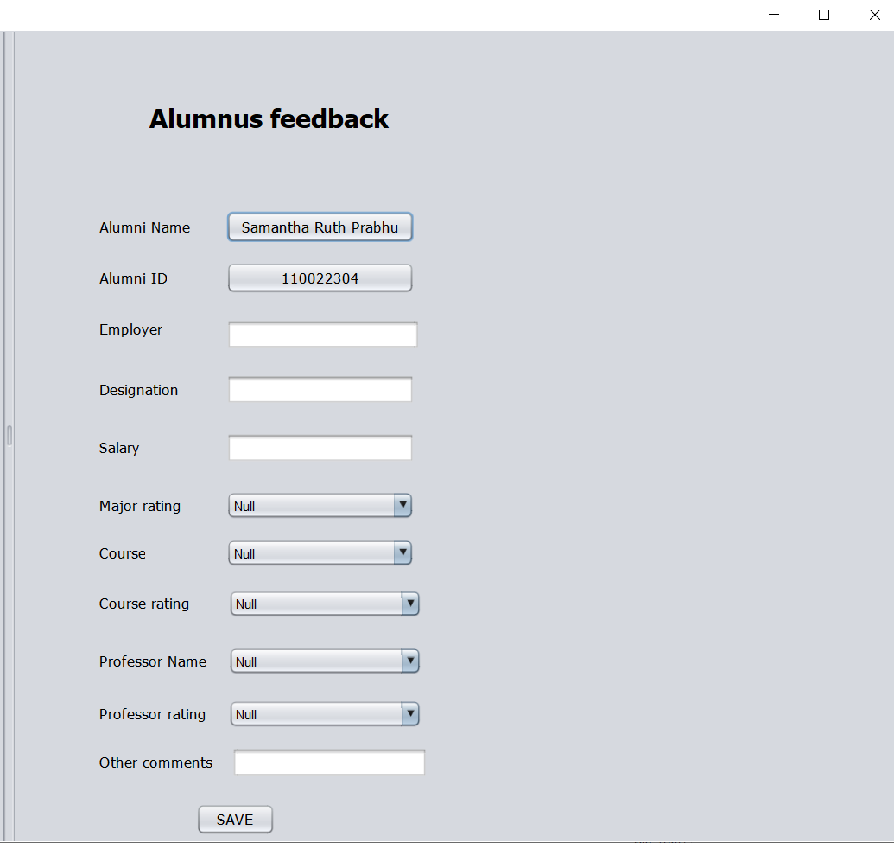

**Dashboard that enables university administrators and Students to compare the performance of their alumnus:**

The search here is universal. We can search the alumnus feedbacks with respect to majors, course work in a particular major and by the name of the professor that particular course work has taught.

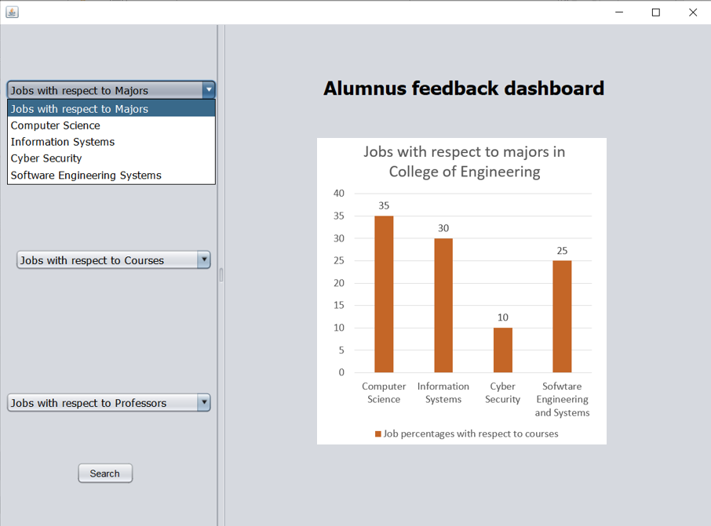

**Fig 1: Majors of alumnus who are in senior positions within 5 years after their graduate studies.**

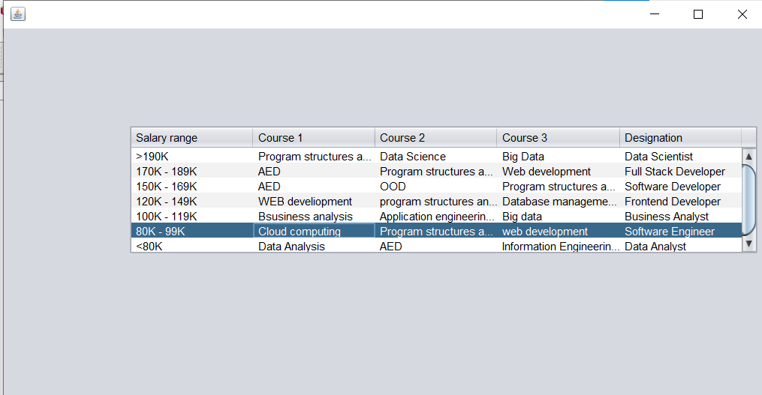

**Fig2: Alumni Salaries with respect to the courses they have completed**

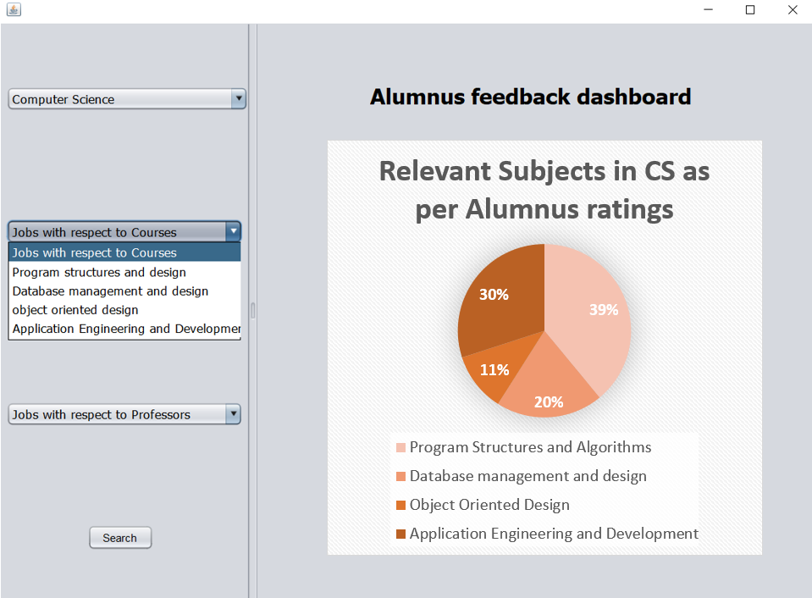

**Fig 3: Alumnus who are from computer science that rated the above subjects as most helpful.**

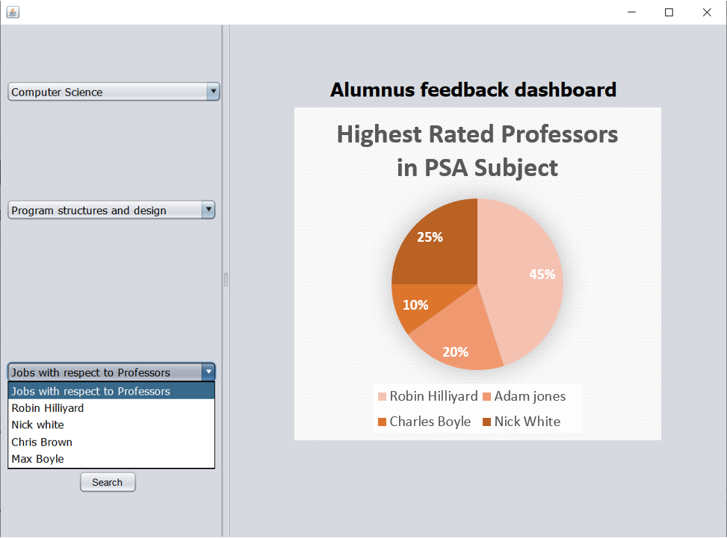

**Fig 4: Alumnus who are from computer science & Selected PSA course work rated the above professors as most helpful in that specific subject PSA.**

**SEQUENCEE DIAGRAM**

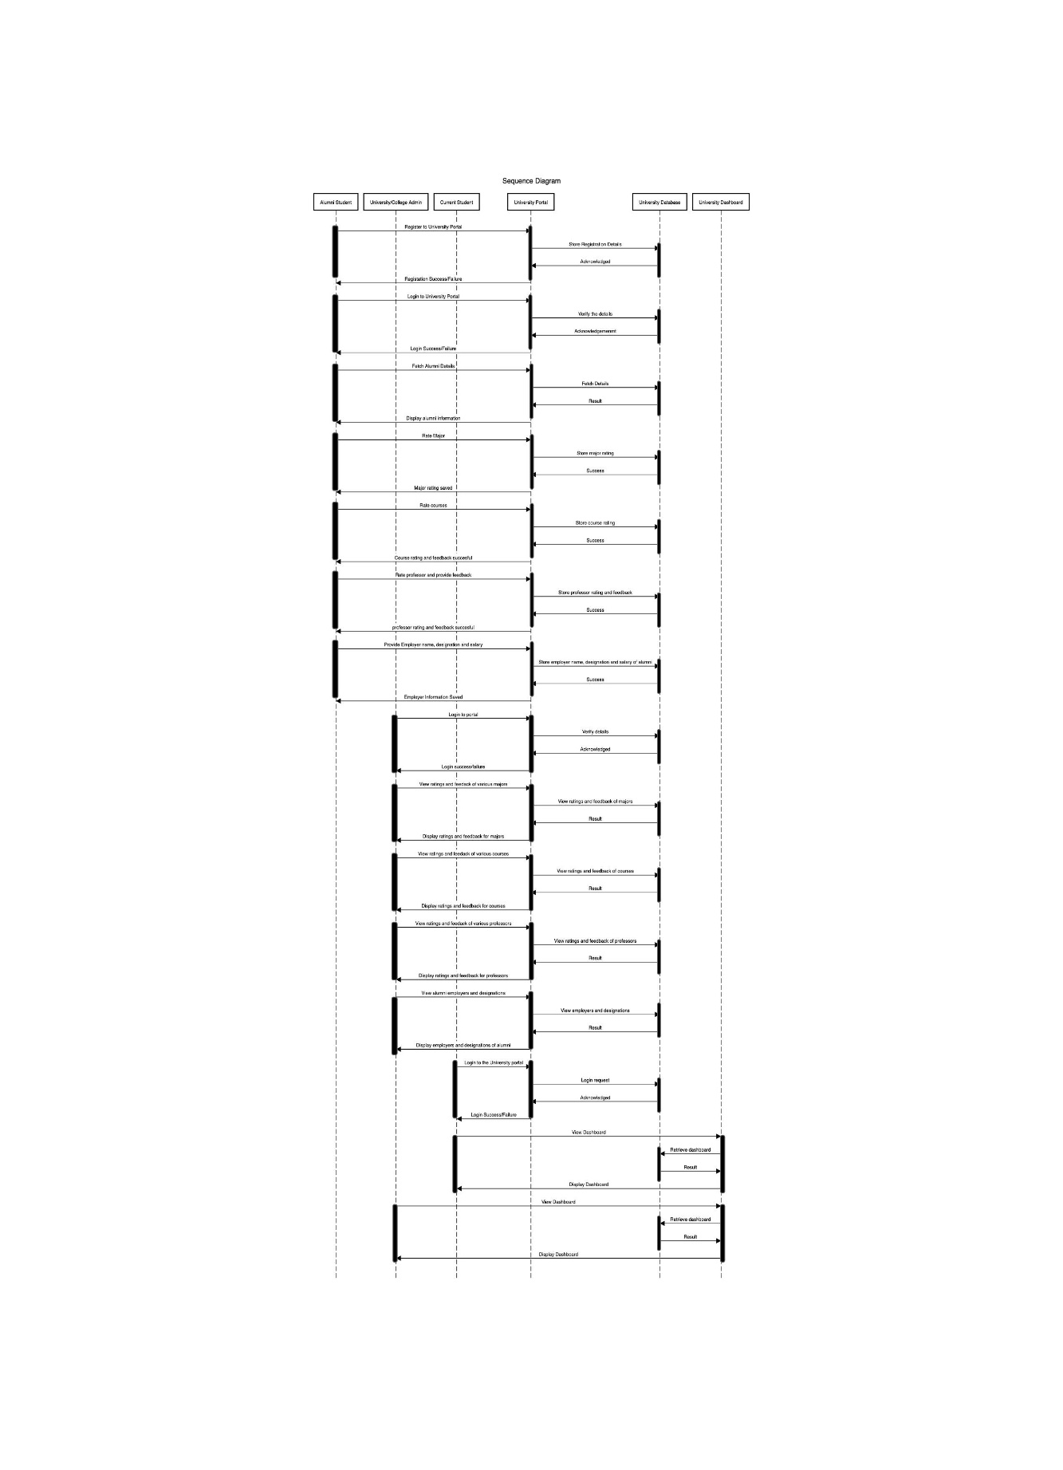

**Fig 5: Sequence diagram**

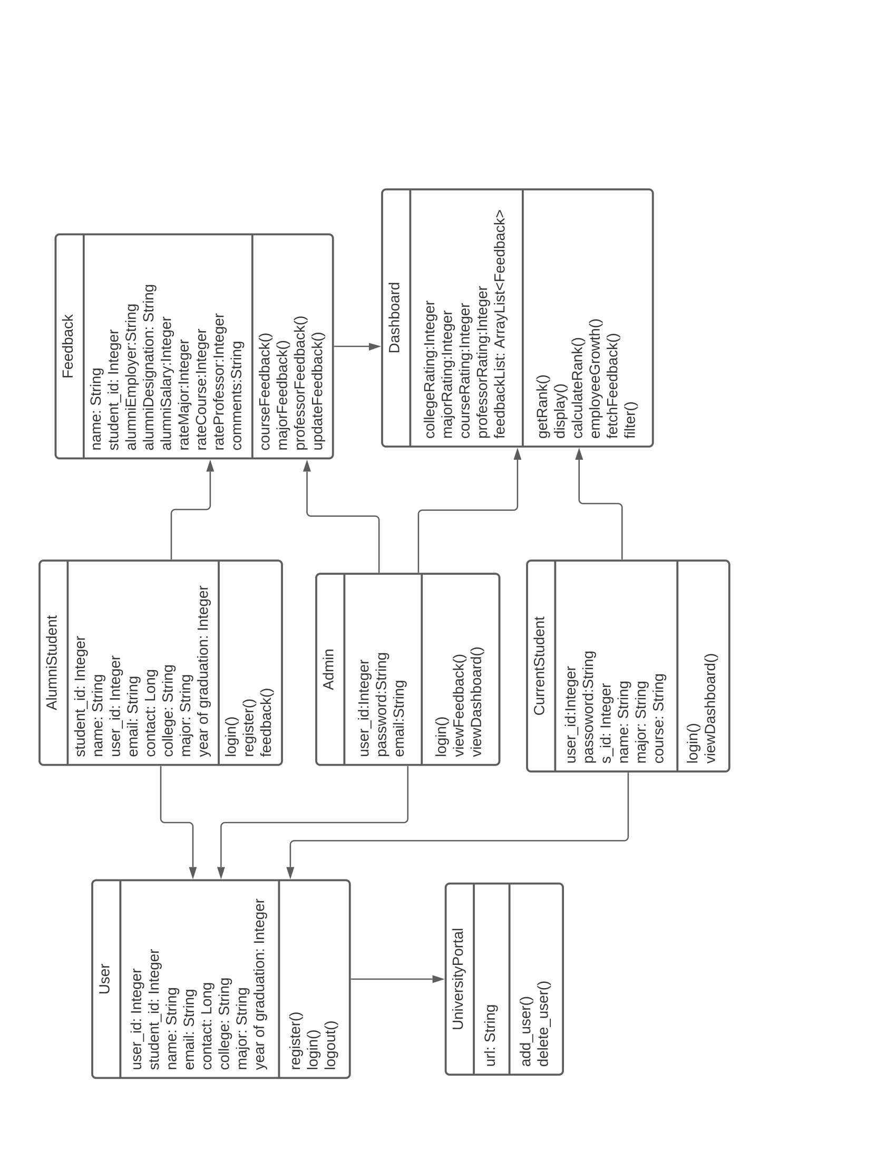**CLASS DIAGRAM**

**Fig 6: System class diagram**

**Table 1: Class diagram member functions**

|  |  |
| --- | --- |
| Title : | College Alumni feedback dashboard |
| Description: | Created a dashboard functionality in the university portal for the current students and college administrators to check the alumni feedback about the courses that helped them the most. Thus, helped the university admins to enhance the faculties teaching process in the university. |
| Actors: | Alumni, Admin, Student |
| UniversityPortal | It is where alumni, students, admin register, login and perform all the operations based on their permissions. |
| User | User is a type of user it can be Alumni Student, Admin and Current student. The user class has the following attributes and functionalities.   1. register() helps to register a new user 2. login() and logout() helps in signing in and signoff in the portal |
| AlumniStudent | Alumni student are a type of user who can register as a new user, can login and can give feedback. |
| Admin | Admin are the type of user and after the registration they can able to manage the whole portal in terms of maintaining all the modules and can add or delete the records of the students, can view the feedback given by alumni and can view the dashboard. |
| CurrentStudent | Students are also another type of user who all are going to use the portal after the registration and with that they can be able to login, viewDashboard. |
| Feedback | The feedback module is used by Alumni student and he can give courseFeedback, majorFeedback, professorFeedback and can updateFeedback that was given prior. |
| Dashboard | The dashboard has the following methods:   1. calculateRank functionality helps in segregating alumnus based on their designation and salary 2. Display functionality displays the search results 3. employeeGrowth functionality helps in setting rank based on the employer they working for and their designation. 4. fetchFeedback method is useful in getting the result. 5. Filter is the main search functionality. |

**Summary:**

This project is aimed at developing a website which is used by alumni to provide feedback, admin to track and compare the performance of their academic units which is of importance to a college, students to decide where they want to go for their studies.

This system can be used as an application for the Alumni Information and used to track the progress of a university with respect to its majors, courses and their professors and measure the quality of education provided by the university by providing rankings accordingly.

-