https://dummy.restapiexample.com/

Get Employee Details: (Get method)

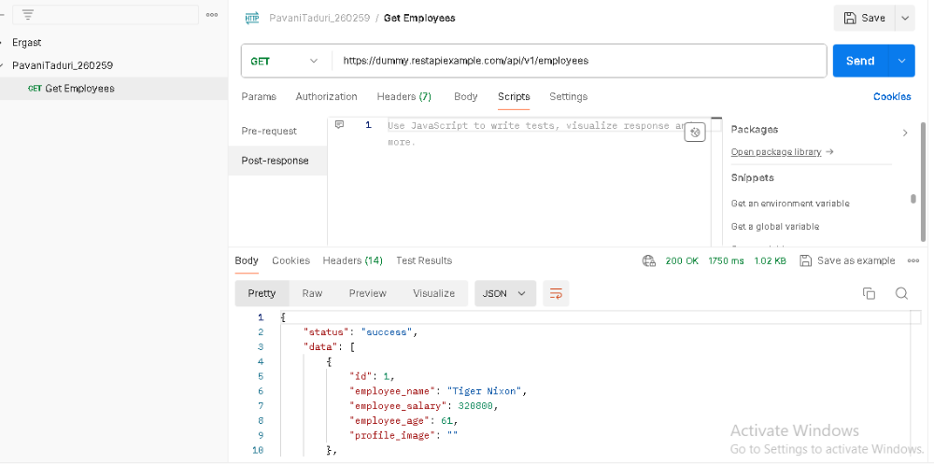

Case 1: pass
a. Test for response 200
b. Test for response if employee_name = Tiger Nixon contains id = 1

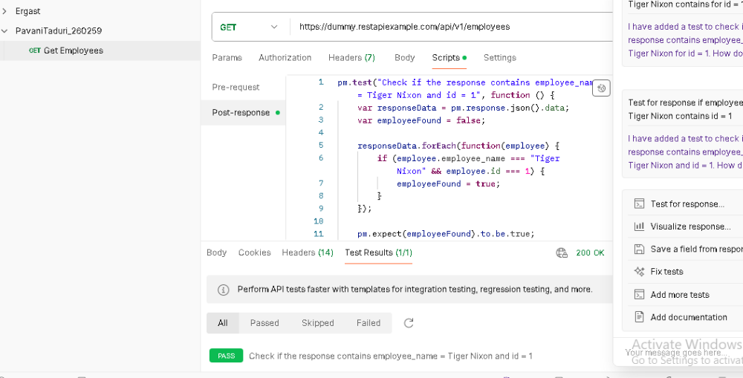

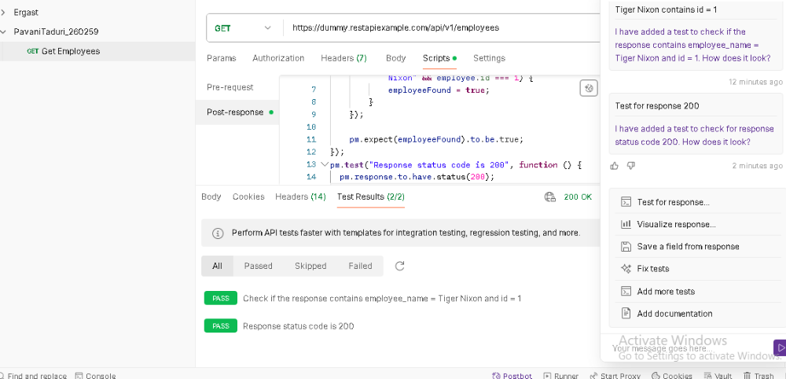

Case 2: Fail
Changed the employee name
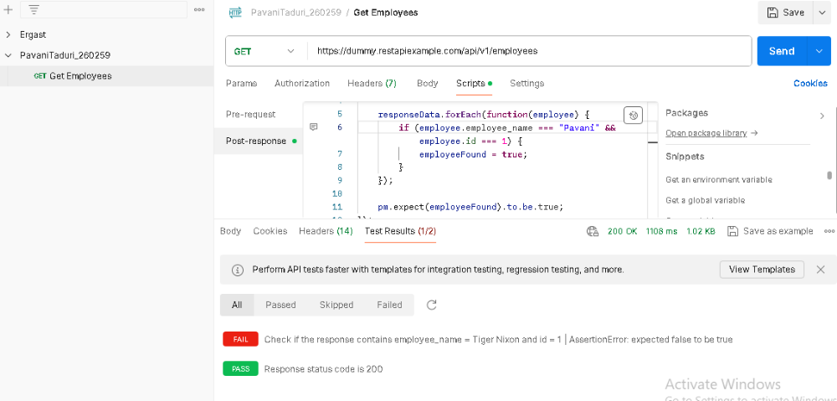

Create New Record: (POST method)
Case 1:
Selecting raw and giving {"name":"Pavani Taduri","salary":"30000","age":"25"}
Authorization is No Auth

Record has been added & status is 200 OK
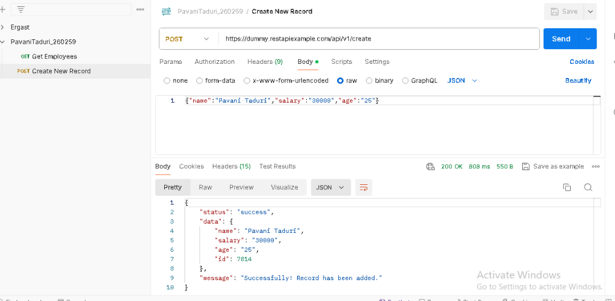
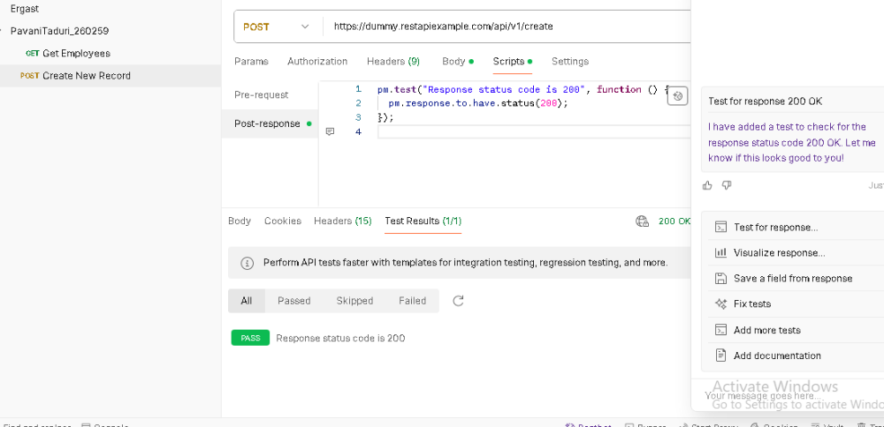

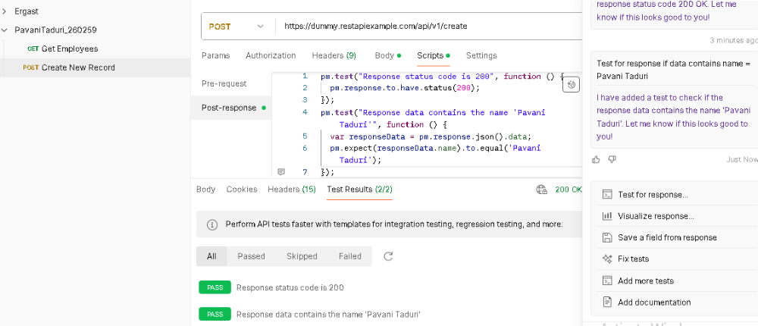

Case 2: Fail
Test for response if data contains name = Pavani Taduri
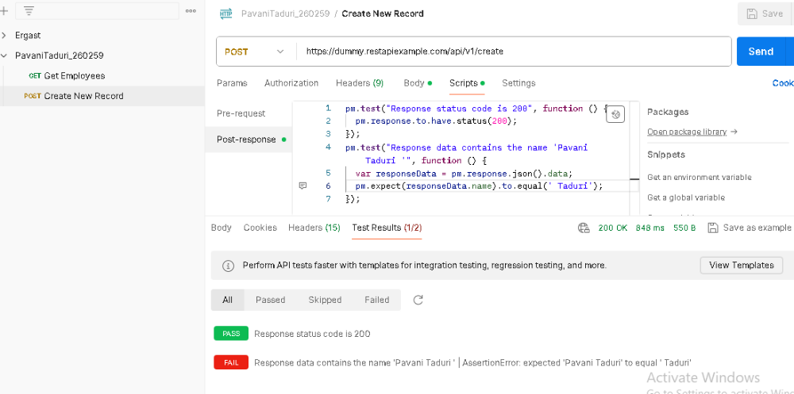

Update Record (PUT method):

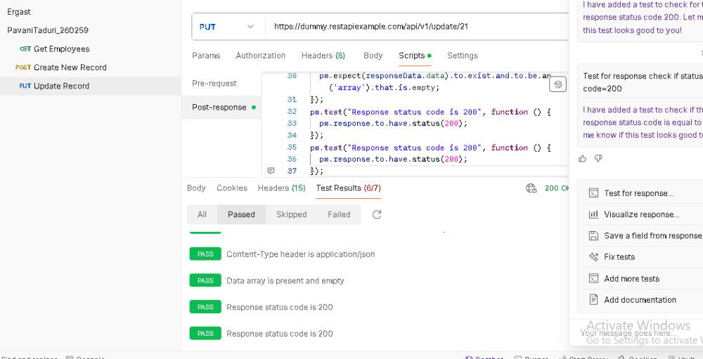

Record has been updated
{"name":"Pavani Taduri","salary":"123234","age":"23"}
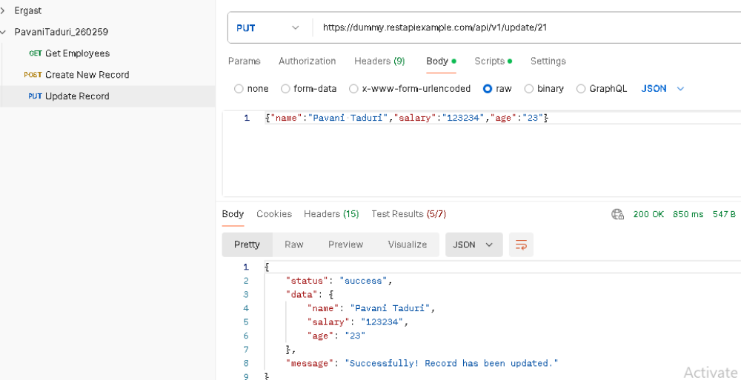

Case1: Pass
test if salary="123234"
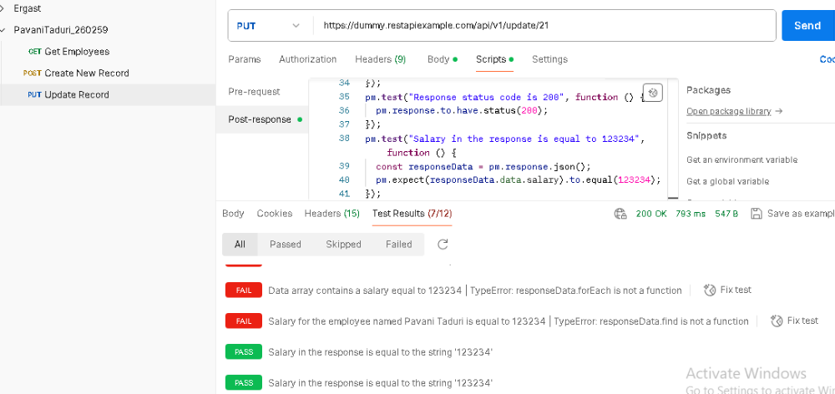

Case 2: Fail
test if age="25"
