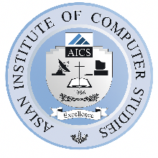
ASIAN INSTITUTE OF COMPUTER STUDIES
COMPUTER SCIENCE DEPARTMENT
1571 Triangle Bldg., Doña Soledad Ave., Better Living Subd., Bicutan, Parañaque City
BUSINESS PLAN
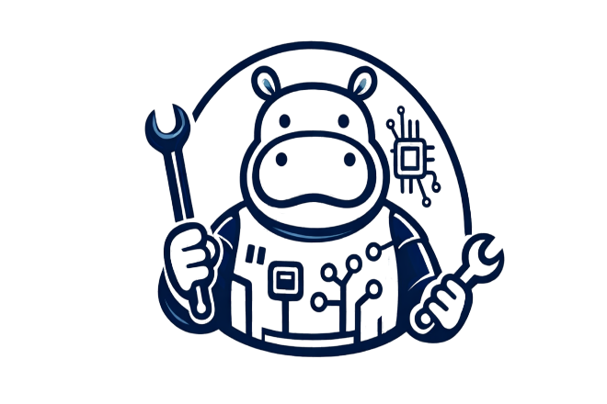
MOODENG TECH
Andam, Edrian
Barba, Christian Dave
De Castro, Dona Belle
Domingo, Rengiee
Gumba, Jeff Christian
Martizano, Ramil
Quiray, Noriel A.
To:

MR. DONN GARRI C. FLORENDO, MBA INSTRUCTOR
INSTRUCTOR
JANUARY 2026

Confidentiality Agreement
This agreement acknowledges that the information given by MOODENG TECH in this business plan is proprietary to this company and therefore confidential. Anyone who reads this plan agrees not to divulge any information included within it without the researchers' prior written authorization.
Upon request, this document is to be immediately returned to

Mr. Donn Garri C. Florendo, MBA

_________________________

Signature

_________________________

Name (typed or printed)

_________________________

Date

MOODENG TECH generated this material, which is only for informational reasons and cannot be replicated without their permission.
TABLE OF CONTENTS
Preliminary TITLE Page Chap
Confidential Agreement II
1 Executive Summary
1.1 Objectives
1.2 Mission And Vision
1.3 Keys To Success
1.4 Start Up Cost and Funding
Organization Chart
1.5 Company Ownership
1.6 Products And Services
1.7 Market
1.8 Strategy
1.9 Management
1.10 Financials
1.11 Investor Considerations
1.12 Disclaimer
2.0 Company Summary
2.1 Start-Up Summary
2.2 Start-Up Funding
2.3 Company Ownership
3 Product And Services
3.1 Business Model
3.1.1 Competitive Landscapes
4 Market Analysis Summary
4.1 Market Segmentation
4.2 Target Market Segmentation
5.0 Strategy Implementation Summary
5.1 Swot Analysis
5.1.1 Strengths
5.1.2 Weaknesses
5.1.3 Opportunities
5.1.4 Threats
5.2 Competitive Edge
5.3 Sales Strategy
5.3.1 Sales Forecast
5.4 Milestones
5.5 Marketing Strategy
5.6 Pricing Strategy
5.7 Sourcing Strategy
5.8 Location And Facilities
6 Management Summary
6.1 Personnel Plan
7 Financial Plan
7.1 Projected Profit and Loss
7.2 Projected Cash Flow
7.3 Projected Balance Sheet
7.4 Business Ratios
7.5 Long-Term Plan
Appendix

EXECUTIVE SUMMARY
Moodeng Tech is a specialized laptop repair service operating under Ramil & Friends Incorporated (R&F Inc.), established in 2025. By focusing exclusively on laptops, Moodeng Tech delivers fast, honest, and high-quality repair, upgrade, and maintenance services to individuals, students, and small businesses. Our competitive advantage lies in specialization, transparent pricing, and strong customer trust.
1.1 Objectives
- Establish Moodeng Tech as a trusted local laptop repair brand
- Achieve profitability within the first year of operations
- Maintain high customer satisfaction through honest diagnostics and fair pricing
- Build long‑term client relationships and repeat business
1.2 Mission and Vision

MISSION

To provide reliable, transparent, and high‑quality laptop repair services that remove stress and downtime for our customers.

VISION

To become the leading laptop repair specialist in the community, known for integrity, expertise, and genuine service.

Values:
Integrity
We operate with honesty and transparency in every diagnosis, recommendation, and transaction. Customers can trust that we only suggest what is truly needed.

Customer First
Behind every laptop is a person. We prioritize understanding our customers’ needs and delivering solutions that minimize stress and downtime.
Specialized Excellence
By focusing exclusively on laptops, we commit to deep technical expertise, precision repairs, and continuous learning as technology evolves.

Transparency
No hidden fees, no confusing technical jargon. We believe in clear communication and upfront pricing at all times.

Reliability
We value our customers’ time. Fast turnaround and dependable service are core to how we operate.

Quality Workmanship
Every repair is done with care, tested thoroughly, and completed to professional standards—because shortcuts compromise trust.

Community Commitment
We aim to build long-term relationships, not one-time transactions. We support and grow with the community we serve.

Continuous Improvement
We constantly refine our skills, processes, and services to deliver better results and adapt to new technologies.

1.3 Keys to Success
Keys to Success
- Specialized focus on laptops only
- Skilled and continuously trained technicians
- Transparent pricing and honest recommendations
- Fast turnaround time
- Strong community reputation and referrals

1.4 Start-Up Cost and Founding
Moodeng Tech was established with a lean but sufficient capital structure to support professional laptop repair operations. Start-up funding was primarily provided through owner equity and partner contributions under Ramil & Friends Incorporated.

The initial capital was allocated to essential repair tools, spare parts inventory, facility costs, and operational readiness to ensure quality service from day one.

Estimated Start-Up Costs (PHP)
Category Estimated Cost (PHP)
Repair Tools & Equipment 120,000
Initial Spare Parts Inventory 80,000
Rent & Security Deposit 100,000
Utilities & Internet 20,000
Marketing & Branding 30,000
Licenses & Registration 15,000
Contingency Fund 35,000
Total Estimated Start-Up Cost 400,000 PHP

Funding Source
Owner & Partner Equity: 100%
No external loans during the start-up phase, reducing financial risk and interest burden.
Start-Up Cost Graph

The bar graph above visually represents how start-up funds are distributed, highlighting major investments in tools, equipment, and facility requirements—critical for delivering reliable and professional laptop repair services.
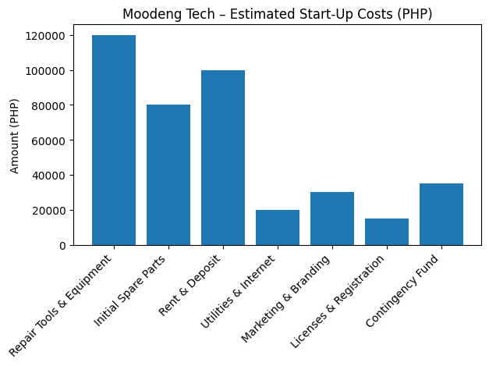

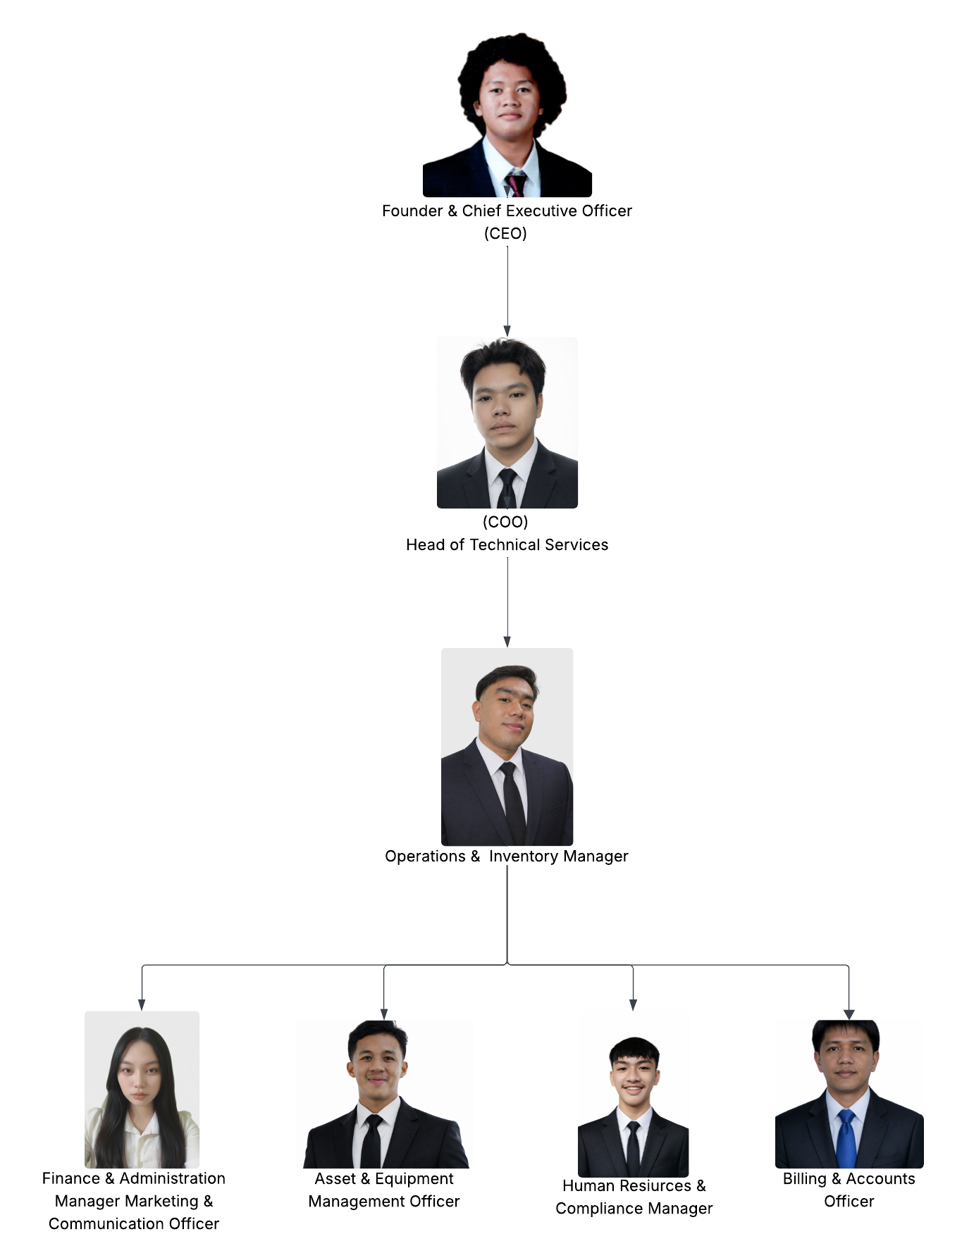
Figure 1
Organization Chart
MOODENG TECH

1.5 Company Ownership

Moodeng Tech operates under Ramil & Friends, founded by Ramil with partners Noriel, Rengiee, Belle, Dave, and Jeff.

1.6 Product And Services

Products and Services

Moodeng Tech offers specialized laptop repair and technical support services designed to restore functionality, improve performance, and extend the lifespan of customer devices. By focusing exclusively on laptops, the company delivers accurate diagnostics and high-quality service.

Hardware Repair Services

- Laptop screen replacement
- Keyboard and touchpad repair
- Battery replacement
- Charging port and connector repair
- Motherboard and component-level repair
- Cooling system and fan repair

Upgrade and Performance Services

- RAM upgrades
- SSD and storage upgrades
- Performance tuning and optimization

Software and System Services

- Operating system installation and repair
- Software troubleshooting and system error resolution
- Virus and malware removal
- System cleanup and optimization

Data Services

- Data recovery from damaged or non-booting laptops
- Data backup and transfer services

Preventive Maintenance Services

- Internal cleaning and dust removal
- Thermal repasting and cooling optimization
- Routine diagnostics and preventive checkups

Customer Support Services

- Honest diagnostics and clear repair explanations
- Transparent pricing with no hidden charges
- Post-repair testing and quality assurance
All products and services are delivered using professional tools and industry-standard procedures to ensure reliability, data security, and customer satisfaction.

1.7 Market
Moodeng Tech serves students, professionals, freelancers, and small businesses who rely on laptops for work, study, and daily activities. The market continues to grow as users prefer repairing and upgrading laptops rather than replacing them, driven by cost efficiency and increasing device dependence.

1.8 Strategy
Moodeng Tech adopts a focused and customer-oriented strategy designed to establish a strong market presence, ensure operational efficiency, and support sustainable business growth.

Service Specialization
Moodeng Tech concentrates exclusively on laptop repair and maintenance services. This strategic specialization enables the company to develop advanced technical expertise, provide accurate diagnostics, and deliver consistent, high-quality repair solutions across various laptop brands and models. By limiting its scope to laptops, the company enhances efficiency and minimizes service errors.

Customer Trust and Transparency
The company prioritizes customer trust as a core strategic objective. Moodeng Tech implements transparent business practices, including clear diagnostic explanations, upfront pricing, and honest service recommendations. This approach fosters credibility, strengthens customer relationships, and encourages repeat business and positive referrals.

Competitive Pricing Strategy
Moodeng Tech employs a competitive and value-based pricing model. Service fees are determined based on repair complexity, labor requirements, and parts costs while remaining affordable to the target market. This strategy ensures accessibility for customers while maintaining sustainable profit margins.

Operational Efficiency and Turnaround Time
Operational processes are structured to deliver timely and reliable services. Skilled technicians, standardized repair procedures, and efficient workflow management allow Moodeng Tech to achieve fast turnaround times without compromising service quality. Reducing customer downtime remains a key strategic advantage.

Marketing and Market Penetration
The company utilizes cost-effective marketing strategies to build brand awareness and attract customers. These include maintaining an active social media presence, leveraging customer testimonials, implementing referral programs, and conducting localized promotional activities. This targeted approach maximizes market reach while controlling marketing expenditures.

Growth and Long-Term Development
Moodeng Tech’s strategy supports long-term growth through service diversification, strategic partnerships with educational institutions and small businesses, and gradual geographic expansion. As operational capacity and financial stability improve, the company plans to explore additional service locations and mobile or on-site repair services.

1.9 Management
Moodeng Tech is managed by a structured leadership team responsible for strategic planning, daily operations, service quality, and financial oversight. The management framework emphasizes accountability, efficiency, and customer-focused service delivery to ensure consistent operational performance and long-term business sustainability.
Management Structure and Roles

General Manager
The General Manager oversees the overall operations of Moodeng Tech and provides strategic direction for the business. Key responsibilities include business planning, policy development, performance monitoring, supplier coordination, and ensuring alignment with the company’s mission and vision.

Operations Manager
The Operations Manager is responsible for managing daily shop operations, workflow scheduling, inventory control, and service turnaround time. This role ensures that repair processes are efficient, standardized, and compliant with quality and safety standards.

Lead Technician
The Lead Technician supervises all technical repair activities and ensures service accuracy and quality. Responsibilities include advanced diagnostics, complex repairs, technician guidance, quality control testing, and continuous technical improvement.

Technicians
Technicians perform laptop diagnostics, repairs, upgrades, preventive maintenance, and post-repair testing. They are responsible for following standardized procedures, maintaining data security, and delivering reliable repair services.

Administrative and Customer Service Officer
The Administrative and Customer Service Officer handles customer inquiries, service documentation, appointment scheduling, billing, and after-sales support. This role ensures clear communication, transparent pricing, and positive customer experience.

Finance and Records Officer
The Finance and Records Officer manages financial documentation, expense monitoring, cash flow tracking, and basic accounting records. This role supports sound financial management and compliance with reporting requirements.

Management Practices
Management at Moodeng Tech operates under clearly defined policies, ethical standards, and performance guidelines. Regular team meetings, service evaluations, and financial reviews are conducted to ensure operational efficiency and continuous improvement.

Through defined leadership roles, professional management practices, and a commitment to transparency and service excellence, Moodeng Tech ensures effective coordination, accountability, and sustainable growth.
1.10 Financials
Moodeng Tech’s financial projections indicate steady growth and profitability within the first year of operations. Revenue is generated primarily from laptop repair services, upgrades, preventive maintenance, and software-related services. Cost control, transparent pricing, and consistent customer demand support positive financialperformance
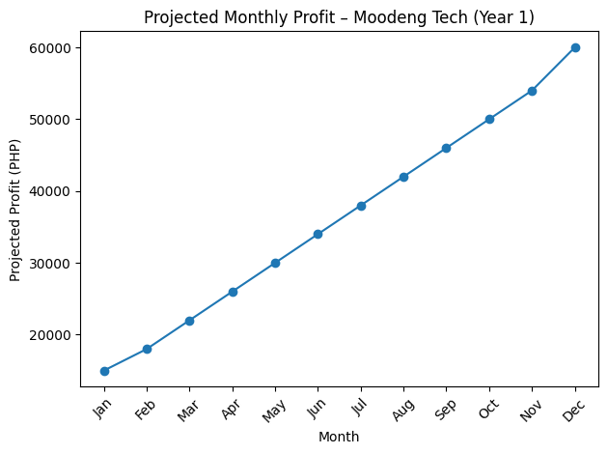
.

1.11.Investor Considerations

Moodeng Tech presents a viable investment opportunity characterized by steady market demand, controlled operational risk, and scalable growth potential. The business operates within the essential technology services sector, where laptop repair and maintenance remain necessary for students, professionals, and small businesses.

Stable and Growing Market Demand
The increasing reliance on laptops for education, remote work, and digital commerce ensures consistent demand for repair and maintenance services. Customers often prefer repairing and upgrading devices rather than purchasing new ones, creating a reliable and recurring revenue stream.

Low Capital Intensity and Risk Exposure
Moodeng Tech operates with relatively low capital requirements compared to other technology ventures. Start-up funding is primarily equity-based, minimizing debt exposure and interest obligations. Operating costs are predictable and manageable, reducing financial risk for investors.

Strong Profitability Potential
Projected financial performance indicates profitability within the first year of operations. Revenue is generated from diversified service offerings, including hardware repairs, software services, upgrades, and preventive maintenance. Controlled expenses and value-based pricing support healthy profit margins.

Clear Competitive Advantage
The company’s exclusive focus on laptop repair, skilled technical team, transparent pricing, and fast turnaround times differentiate Moodeng Tech from general electronics repair shops and informal technicians. These strengths enhance customer retention and brand credibility.

Scalability and Expansion Opportunities
Moodeng Tech offers strong scalability potential through service diversification, partnership agreements with schools and businesses, and the establishment of additional branches or mobile repair services. These growth strategies provide opportunities for increased returns on investment.

Experienced and Accountable Management
The business is managed by a dedicated leadership team with hands-on involvement in operations and decision-making. Strong governance, ethical practices, and performance monitoring ensure responsible use of invested capital.

Exit and Return Opportunities
Investors may benefit from long-term returns through profit-sharing, equity appreciation, or future business expansion. Potential exit opportunities include branch franchising, acquisition by a larger service provider, or strategic partnerships.
1.12 Disclaimer

This business plan contains forward‑looking statements based on current assumptions and market conditions.

2.0. Company Summary

Moodeng Tech is a customer‑centric laptop repair service designed to deliver dependable technical solutions with a human touch.
(Business Location and Market)
( Survey/table )
( Survey ques. )
( Frenqeuncy and Percentage Distribution of Respondens )
( Table2 )

Vision
To become the leading laptop repair specialist in the community, known for integrity, expertise, and genuine service.

Commitment
Moodeng Tech is committed to delivering high-quality, efficient, and cost-effective laptop repair services founded on integrity, technical expertise, and customer-focused care. We uphold strict quality standards, transparent communication, and timely service to ensure every client receives dependable solutions. Through continuous improvement, professional development, and the adoption of modern repair practices, we aim to build lasting partnerships and maintain our reputation as a dependable technology service provider.

2.1 Start‑Up Summary

The business launched with essential repair tools, skilled technicians, and a modest physical location.
(Business Structure and founders)
(Table 3 Financial Statement)

2.2 Start‑Up Costs & Funding

Funded primarily through owner equity and partner contributions.
(table 4 start-up costs and funding)

2.3 Company Ownership
Moodeng Tech operates as a specialized laptop repair service under Ramil & Friends Incorporated (R&F Inc.), a company established in 2025. The corporation was founded by Ramil, together with partners Noriel, Rengiee, Belle, Dave, and Jeff.

Ramil & Friends Incorporated is privately owned and managed by its founders, who collectively provide strategic direction, operational oversight, and capital support for Moodeng Tech. The ownership structure allows for agile decision-making, strong accountability, and direct involvement in daily operations.

Moodeng Tech functions as a business unit of R&F Inc., benefiting from shared resources, unified management principles, and a common commitment to integrity, transparency, and long-term customer relationships.

3.0 Products and Services
Moodeng Tech provides specialized laptop repair and maintenance services designed to extend device lifespan, improve performance, and reduce downtime for customers. By focusing exclusively on laptops, the company delivers precise, reliable, and high-quality technical solutions.

Hardware Repair Services
- Laptop screen replacement
- Keyboard and touchpad repair
- Battery replacement
- Charging port and connector repair
- Motherboard and component-level repair
- Cooling system repair and thermal maintenance

Upgrade and Performance Services
- RAM upgrades
- SSD and storage upgrades
- System optimization for speed and stability

Software and System Services
- Operating system installation and repair
- Software troubleshooting and error resolution
- Virus and malware removal
- System cleanup and performance optimization
Data Services
- Data recovery from damaged or non-booting laptops
- Backup setup and data transfer services

Preventive Maintenance
- Internal cleaning and dust removal
- Thermal repasting and cooling optimization
- Routine diagnostics and health checks
Customer Support Services
- Honest diagnostics and repair recommendations
- Transparent pricing and service explanations
- Post-repair testing and quality assurance
All services are performed using professional tools and industry-standard practices to ensure reliability, data safety, and customer satisfaction.

3.1 Business Model

Revenue is generated per service transaction, with additional income from upgrades and preventive maintenance packages.
( picture of our service or product )

3.1.1 Competitive Landscape

Competitors include general repair shops and informal technicians. Moodeng Tech differentiates through specialization and transparency.
( Table Competitive Landscape )

4.0 Market Analysis Summary

Moodeng Tech operates in the growing technology services sector, with a primary focus on laptop repair and maintenance. The increasing dependence on laptops for education, remote work, online businesses, and digital communication has created a sustained demand for reliable and affordable repair services. In the local market, many consumers prefer repairing devices rather than purchasing new ones due to rising hardware costs, making laptop repair a practical and cost-effective solution.

The target market of Moodeng Tech includes students, professionals, small business owners, and home users who rely heavily on laptops for daily activities. This customer base values fast turnaround time, transparent pricing, and trustworthy technical expertise. Small and medium-sized enterprises (SMEs) and educational institutions also represent a potential long-term market segment for contract-based maintenance and support services.

The competitive landscape consists of independent repair shops, authorized service centers, and freelance technicians. While competition is moderate to high, many providers lack consistent service quality, transparent pricing, or reliable after-sales support. Moodeng Tech differentiates itself through skilled technicians, honest diagnostics, customer-focused service, and the use of high-quality replacement parts.

Market trends indicate increasing demand for services such as data recovery, software troubleshooting, system upgrades, and preventive maintenance. Customers are also showing greater preference for businesses that offer online booking, digital payments, and real-time service updates. These trends create opportunities for Moodeng Tech to expand service offerings and strengthen its digital presence.

Overall, the market conditions are favorable for Moodeng Tech. With a clear value proposition centered on quality, reliability, and customer trust, the company is well-positioned to capture market share, build long-term customer relationships, and achieve sustainable growth.

4.1 Market Segmentation

- Students
- Office workers
- Freelancers
- Small businesses

4.2 Target Market Segmentation

Primary targets are students and professionals aged 18–45 who depend on laptops daily.

( table market segment )

5.0 Strategy Implementation Summary

Execution focuses on service quality, fast turnaround, and customer trust.

5.1 SWOT Analysis
- Strengths: Specialized expertise, honest service, fast turnaround
- Weaknesses: Limited initial capital, small team
- Opportunities: Growing laptop usage, demand for affordable repairs
- Threats: Price competition, rapid technology changes

5.1.1 Strengths
Specialized Laptop Expertise
- Exclusive focus on laptop repair allows deeper technical knowledge, higher repair accuracy, and faster problem resolution.
Honest and Transparent Service
- Clear diagnostics, upfront pricing, and no unnecessary repairs build strong customer trust and long-term loyalty.
Fast Turnaround Time
- Efficient repair processes minimize downtime, which is critical for students, professionals, and small businesses.
- Skilled and Dedicated Team
- Technicians are experienced, detail-oriented, and committed to continuous learning as laptop technology evolves.
Customer-Centric Approach
- Personalized service ensures each customer’s needs are fully understood and properly addressed.
Competitive and Fair Pricing
- High-quality service offered at reasonable rates makes repairs accessible and attractive versus device replacement.
Strong Community Reputation
- Local presence and word-of-mouth referrals strengthen brand credibility and repeat business.
Low Operational Complexity
- A focused service scope reduces overhead costs and improves operational efficiency.

5.1.2 Weaknesses
Limited Initial Capital
- As a growing business, financial resources are limited, which may restrict rapid expansion and large inventory purchases.
Small Team Size
- A lean workforce may experience workload pressure during peak demand periods, potentially affecting turnaround time.
Dependence on Skilled Technicians
- Service quality relies heavily on the expertise of key technicians, making operations vulnerable to staff absence or turnover.
- Limited Brand Awareness
- As a relatively new business, Moodeng Tech is still building recognition and market presence.
Physical Location Dependency
- Walk-in traffic and local visibility play a significant role in sales, limiting reach beyond the immediate area.
Parts Availability Constraints
- Some laptop components may have limited availability, leading to delays in certain repairs.

5.1.3 Opportunities
Growing Demand for Laptop Repairs
The increasing reliance on laptops for work, education, and business creates continuous demand for reliable repair and maintenance services.

Expansion of Services
Moodeng Tech can broaden its offerings to include data recovery, software support, preventive maintenance, upgrades, and on-site or remote technical assistance.

Partnerships with Schools and Businesses
Establishing service contracts with educational institutions, offices, and small businesses can provide stable, long-term revenue streams.

Online Presence and Digital Marketing
Strengthening visibility through a professional website, social media, and online booking systems can attract a wider customer base and improve customer convenience.

E-commerce and Spare Parts Sales
Selling accessories and genuine replacement parts online and in-store presents an additional revenue channel.

Emerging Technologies and Certifications
Investing in technician training and certifications can position Moodeng Tech as a specialist in modern devices, including ultrabooks, gaming laptops, and hybrid systems.

5.1.4 Threats
Intense Market Competition
The presence of numerous independent repair shops and authorized service centers can lead to pricing pressure and customer attrition.

Rapid Technological Changes
Frequent updates in laptop designs and hardware architectures may require constant investment in tools, training, and parts inventory.

Supply Chain Disruptions
Delays or shortages in replacement parts can impact service turnaround time and customer satisfaction.

Customer Price Sensitivity
Some customers may opt for lower-cost or unofficial repair services, affecting profit margins.

Data Security and Privacy Risks
Handling customer devices exposes the company to potential data protection and confidentiality concerns.

Economic Instability
Economic downturns can reduce discretionary spending on device repairs, impacting overall business performance.

5.2 Competitive Edge

Skilled and Certified Technicians
Moodeng Tech is staffed with well-trained professionals who possess up-to-date technical knowledge and hands-on expertise in repairing a wide range of laptop brands and models.

High-Quality and Genuine Parts
The company prioritizes the use of high-quality and genuine replacement components, ensuring long-term reliability and optimal device performance.

Transparent Pricing and Honest Diagnostics
Moodeng Tech maintains clear and fair pricing, providing accurate diagnostics and upfront cost estimates with no hidden charges.

Fast Turnaround Time
Efficient repair processes and proper inventory management enable quicker service completion without compromising quality.

Customer-Centered Service Approach
Every client receives personalized support, professional communication, and consistent updates throughout the repair process.

Comprehensive Service Offerings
Beyond standard laptop repairs, Moodeng Tech offers software troubleshooting, upgrades, preventive maintenance, and data recovery services, providing a one-stop technology solution.

Commitment to Continuous Improvement
The company invests in ongoing training, modern tools, and updated repair methodologies to stay competitive in an evolving technology landscape.

5.3 Sales Strategy

Customer-Centered Service Model
Moodeng Tech will focus on delivering excellent customer service through accurate diagnostics, timely repairs, and transparent pricing. Satisfied customers will be encouraged to provide referrals and online reviews to strengthen brand credibility.

Service Diversification and Bundling
The company will offer bundled services such as laptop cleaning and maintenance packages, software optimization, and upgrade services at competitive rates to increase average transaction value and customer retention.

Strategic Partnerships
Moodeng Tech will establish partnerships with schools, small businesses, and corporate offices to provide contract-based repair and maintenance services, ensuring consistent revenue streams.

Digital Marketing and Online Booking
The company will invest in a professional website, social media presence, and online appointment scheduling to improve customer accessibility and expand market reach.

Promotions and Loyalty Programs
Seasonal discounts, referral incentives, and customer loyalty programs will be implemented to encourage repeat business and long-term customer relationships.

Upselling and Cross-Selling
Technicians and front-desk staff will be trained to recommend relevant upgrades, accessories, and preventive services that add value to customer needs.

Local Market Penetration
Moodeng Tech will strengthen its presence in the local market through community engagement, flyers, and partnerships with nearby computer shops and retailers.

After-Sales Support and Warranty Services
Offering limited service warranties and post-repair support will enhance customer confidence and differentiate Moodeng Tech from competitors.

5.3.1 Sales Fore cast
( table of sales forecast )
Steady monthly growth driven by repeat customers and referrals.

5.4 Milestones
* First 100 satisfied customers
* Break‑even point
* Service expansion

5.5 Marketing Strategy
Flyer and Poster
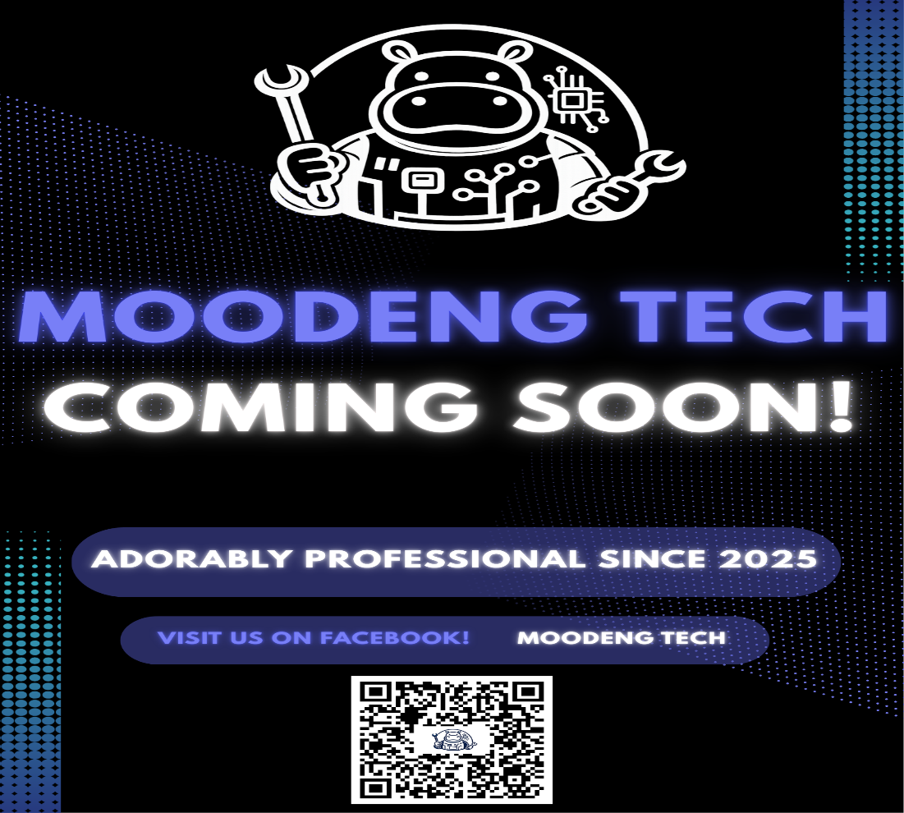
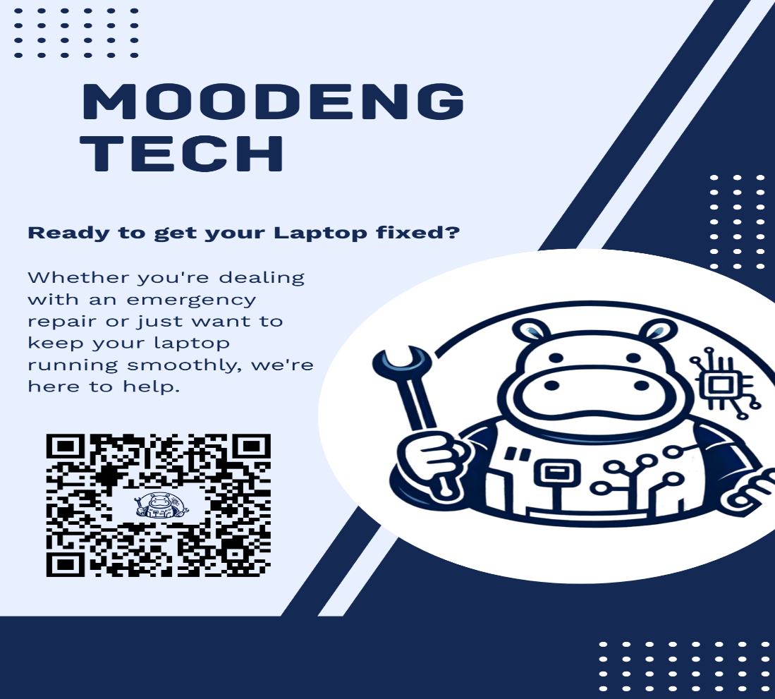
5.6 Pricing Strategy

Transparent, competitive, and value‑based pricing.
( Table of pricing )

5.7 Sourcing Strategy

Parts sourced from reliable local and online suppliers.

5.8 Location and Facilities

Operates from a convenient, accessible location with essential repair facilities.
( Location map )
( Store sketch plan and 3D plan )
( 1st Floor/ 3D store and Work place )
( 2nd Floor/ 3D store and Admin office )

6.0 Management Summary

Moodeng Tech is a specialized laptop repair shop dedicated to delivering high-quality, reliable, and customer-focused technical services. The company is managed by a competent leadership team with a strong foundation in information technology, electronics repair, and business operations. Management emphasizes integrity, professionalism, and continuous improvement as core principles guiding all business decisions.

The management team is responsible for overseeing daily operations, ensuring service quality, maintaining efficient workflows, and implementing strategic initiatives that support long-term growth. Through structured processes, staff training, and performance monitoring, Moodeng Tech ensures consistent service standards and operational excellence.

Management places a strong focus on customer satisfaction, transparent communication, and ethical business practices. By investing in modern tools, technician development, and updated repair methodologies, the leadership team positions Moodeng Tech to remain competitive in an evolving technology market.

With a commitment to innovation, accountability, and sustainable growth, Moodeng Tech’s management is dedicated to building a trusted brand and establishing long-term relationships with customers, partners, and the local community.

6.1 Personnel Plan
Moodeng Tech (Operating Hours: 7:00 AM – 10:00 PM)
To ensure efficient operations, consistent service quality, and proper workload management, Moodeng Tech will implement a structured daily work schedule for management and staff.
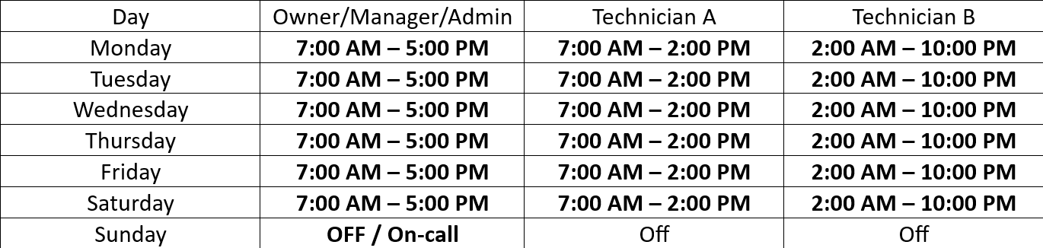
Notes for Your Team
Breaks can be taken between 12:00 PM – 1:00 PM (morning shift) and 6:00 PM – 7:00 PM (evening shift).
On high-demand days, all staff may work 10:00 AM – 8:00 PM temporarily.
Sunday service can be offered by appointment only.
Schedules can be adjusted monthly based on customer volume.
7.0 Financial Plan

Moodeng Tech’s financial plan is designed to ensure sustainable growth, operational efficiency, and long-term profitability. The company will maintain disciplined financial management practices, supported by accurate forecasting, cost control, and revenue diversification.

Startup and Capital Structure
Initial funding will be allocated to shop setup, repair tools and equipment, spare parts inventory, software licenses, marketing activities, and working capital. The business will be financed through a combination of owner’s equity and, if necessary, external financing such as small business loans or investor contributions.

Revenue Streams
Moodeng Tech will generate income primarily from laptop repair services, including hardware repairs, software troubleshooting, data recovery, upgrades, and preventive maintenance. Additional revenue will be derived from the sale of accessories and replacement parts, as well as contract-based services with schools, offices, and small businesses.

Pricing Strategy
Service pricing will be competitive and based on repair complexity, labor time, and parts costs. Transparent pricing and standardized service rates will be implemented to ensure customer trust while maintaining healthy profit margins.

Cost Structure and Expense Management
Operating expenses will include rent, utilities, staff salaries, spare parts procurement, marketing, equipment maintenance, and administrative costs. The company will implement strict inventory control, supplier negotiation, and expense monitoring to minimize operational costs and improve cash flow management.

Profitability and Break-Even Analysis
Moodeng Tech aims to achieve profitability within the first year of operation. Break-even analysis will be conducted to determine the required service volume needed to cover fixed and variable costs. Continuous monitoring of financial performance will guide pricing adjustments and cost optimization.

Cash Flow Management
Strong cash flow management will be prioritized to ensure the availability of funds for daily operations, parts procurement, and business expansion. The company will maintain a cash reserve to manage unexpected expenses and seasonal fluctuations in demand.

Financial Controls and Reporting
Moodeng Tech will implement proper accounting systems, regular financial reporting, and internal controls to ensure transparency and compliance. Monthly financial statements, budget reviews, and performance evaluations will support informed decision-making.

Growth and Reinvestment Strategy
A portion of profits will be reinvested into expanding service offerings, upgrading equipment, technician training, and marketing initiatives. This reinvestment strategy will support continuous improvement and long-term business sustainability.

7.1 Projected Profit and Loss

Expected profitability within the first year.
( Table )

7.2 Projected Cash Flow

Positive cash flow supported by consistent service demand.
( Table of start-up capital )

7.3 Projected Balance Sheet

Assets include tools and inventory; liabilities remain minimal.
( Table of projected balance sheet )

7.4 Business Ratios

Business ratios are used to evaluate the financial performance, efficiency, and stability of Moodeng Tech. These indicators support informed decision-making and provide insights into the company’s operational effectiveness and financial health.

Liquidity Ratios

Current Ratio – Measures the company’s ability to meet short-term obligations using current assets. A ratio above 1.5 indicates strong liquidity and operational stability.

Quick Ratio – Excludes inventory from current assets to assess immediate liquidity. This ratio reflects the company’s capacity to cover short-term liabilities without relying on inventory sales.

Profitability Ratios

Gross Profit Margin – Indicates the percentage of revenue remaining after deducting the cost of parts and direct labor. A higher margin reflects efficient service delivery and effective pricing strategies.

Net Profit Margin – Measures overall profitability after all expenses. This ratio evaluates the company’s ability to convert revenue into net income.

Return on Assets (ROA) – Assesses how effectively company assets are used to generate profits.

Return on Equity (ROE) – Evaluates the return generated on owners’ investments.

Efficiency Ratios

Inventory Turnover Ratio – Measures how frequently spare parts inventory is sold and replaced within a period. A higher turnover rate indicates efficient inventory management.

Accounts Receivable Turnover Ratio – Evaluates how quickly customer receivables are collected, supporting healthy cash flow.

Asset Turnover Ratio – Measures the company’s efficiency in using assets to generate revenue.

Solvency Ratios

Debt-to-Equity Ratio – Indicates the proportion of debt used to finance the business relative to owner’s equity. A lower ratio reflects financial stability and reduced financial risk.

Interest Coverage Ratio – Measures the company’s ability to meet interest obligations on borrowed funds.

Break-Even Ratio

Break-Even Point (Sales Volume) – Determines the level of sales required to cover total fixed and variable costs. This ratio supports pricing and sales volume planning.

7.5 Long‑Term Plan

Moodeng Tech’s long-term plan is focused on sustainable growth, service excellence, and brand leadership in the laptop repair and technology services industry. The company aims to expand its market presence, enhance service capabilities, and strengthen operational efficiency over the next five to ten years.

Service Expansion and Diversification
Moodeng Tech will broaden its service portfolio to include advanced data recovery, device refurbishment, corporate IT support, preventive maintenance contracts, and repairs for emerging technologies such as ultrabooks, gaming laptops, and hybrid devices.

Branch and Market Expansion
The company plans to establish additional service locations in high-demand areas and explore mobile or on-site repair services for business clients, schools, and government offices to increase accessibility and revenue opportunities.

Technology and Equipment Investment
Continuous investment in modern diagnostic tools, repair equipment, and software systems will be prioritized to ensure high-quality service delivery and efficient operations.

Talent Development and Workforce Growth
Moodeng Tech will invest in technician training, certifications, and leadership development programs to build a highly skilled and motivated workforce.

Digital Transformation
The company will implement advanced customer relationship management (CRM) systems, online booking platforms, and digital payment solutions to improve customer experience and operational efficiency.

Strategic Partnerships and Alliances
Long-term partnerships with suppliers, educational institutions, and corporate clients will be developed to ensure stable revenue streams and access to high-quality parts and resources.

Brand Development and Marketing Leadership
Moodeng Tech will strengthen its brand identity through consistent marketing, community engagement, and customer advocacy programs.

Financial Growth and Sustainability
The company aims to achieve steady revenue growth, strong cash flow, and increasing profitability, while maintaining prudent financial management and reinvesting profits to support expansion and innovation.

Corporate Social Responsibility (CSR)
Moodeng Tech will implement responsible e-waste disposal practices, device recycling programs, and community technology education initiatives to support environmental sustainability and social impact.

APPENDICES A
CURRICULUM VITAE

