-putting an item on top of the stack is called "push" and removing an item is called "pop".

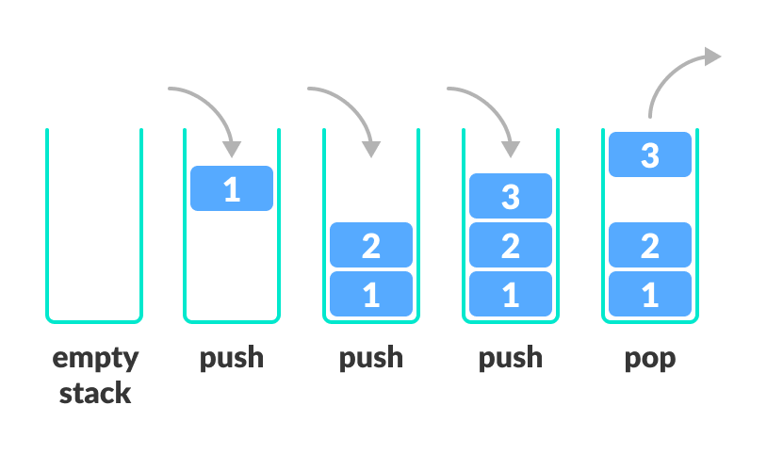

-It follows **the Last In First Out(LIFO)** principle.

A stack is an object or more specifically an abstract data structure(ADT) that allows the following operations:

* Push: Add an element to the top of a stack
* Pop: Remove an element from the top of a stack
* IsEmpty: Check if the stack is empty
* IsFull: Check if the stack is full
* Peek: Get the value of the top element without removing it

**Working of stack**

The operations work as follows:

1. A pointer called TOP is used to keep track of the top element in the stack.
2. When initializing the stack, we set its value to -1 so that we can check if the stack is empty by comparing TOP == -1.
3. On pushing an element, we increase the value of TOP and place the new element in the position pointed to by TOP.
4. On popping an element, we return the element pointed to by TOP and reduce its value.
5. Before pushing, we check if the stack is already full
6. Before popping, we check if the stack is already empty

