

Coursework Versus Dissertation



Submitted By: Puja Neupane

Submitted To: Manoj Shrestha

Date: 2021/02/20

Contents

Abstract 2

Academic Writing 2

Coursework 3

Dissertation 4

Writing Process 5

Coursework 5

Dissertation 7

Similarities 9

Differences 9

Benefits 10

Challenges 11

Conclusion 13

References 14

Table of Figures

Figure 1 Coursework Writing Process 5

Figure 2 Dissertation Writing Process 7

Figure 3 Challenges of Coursework and Dissertation 11

# Abstract

This paper includes a

# Keywords

Academic Writing Coursework Dissertation Plagiarism Research Critical Thinking Proposal Assignment Skills Knowledge Report

# Academic Writing

Academic Writing is the formal style of writing that down what you know in clear, focused, structured and concise way for the purpose of discussing it with other knowledgeable people with evidenced opinions and arguments in college or university. However, the main purpose of academic writing is for the communication and expressing oneself to other additionally with information in appropriate language and tenses. It helps to evaluate the student’s knowledge based on the particular course or subject matter. According to the academic writing, the four characteristics of academic writing are planned and focused document which easily demonstrates the understanding of the subject, structured and written in coherent order, supports opinions and determines the knowledge with evidence and lastly written in appropriate tone and style (*Academic Writing* 2021).

# Coursework

Coursework is a study work or academic assignment done by a student according to the module of study to analyze and evaluate the understanding and knowledge of students and additionally identifying the final grades of the student. It is a part of course to find out how effectively and efficiently the student can use the knowledge and skill gained through the course. According to definitions.net, Coursework is certain task performed by student for the purpose of learning. It includes a wide range of practice, research, activities, experiment and writing. Coursework is often evaluated as part of student grade during the course (*What Does Coursework Mean?* 2021). According to oxford dictionary, written or practical work done by a student during a course of study, usually assessed in order to count towards a final mark or grade (*Coursework | Definition Of Coursework By Oxford Dictionary On Lexico.Com Also Meaning Of Coursework* 2021).

# Dissertation

Dissertation is usually the last stage of studies that demonstrates and analyzes the skills and knowledge collected throughout the period of studies forming a conclusion about the research. However, it is also known as thesis and is a writing prepared at the last of the course study. According to UKDiss Dissertation may be partially taught and partially researched or completely researched. In case of completely researched, student should find the topic by themselves and the topic should be capable of sustaining an extended argument (*What Is A Dissertation?* 2021). The dissertation that are partially taught and partially researched follows three subsequent structure like introduction, main body and conclusion, whereas the dissertation that is completely research-based needs more time and research should be done from scratch. First, a proposal stating the concept of dissertation should be submitted and research should be done on particular topic. After the proposal is accepted, research should be done on that particular title and well-structured assignment should be written with strong and fact-based arguments.

# Writing Process

Writing process of coursework and dissertation both includes research as both are part of academic writing but coursework is easier and has fixed guidelines when compared with dissertation whereas dissertation does not have any guidelines and is complicated to write as it is based on research.

## Coursework

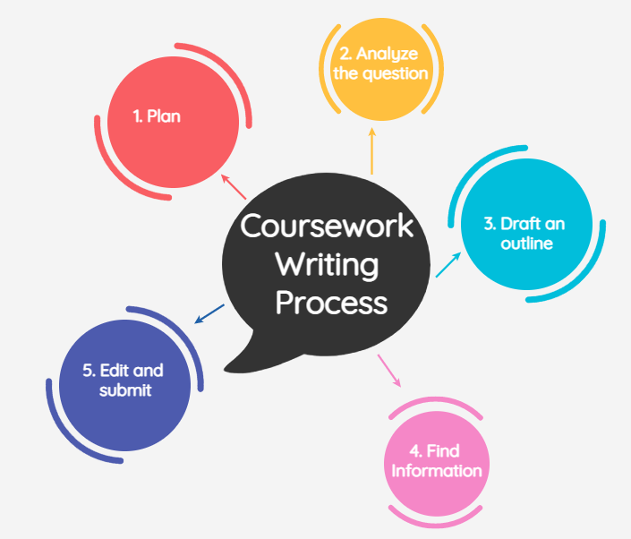

Figure 1Coursework Writing Process

1. **Plan**

Before writing a coursework, student should check about the lecture they need to attend in order to be eligible for submitting the coursework. They should plan time according to the marking schedule of the question and do proper research, write drafts and check reference. It helps students to be on track and keep focused.

1. **Analyze the question**

The student should have a clear idea on what they are trying to do. However, they need to compare analyze and check the meaning of the topic and words to get further idea about the question. They should find out what should be done and prohibited while writing assignment.

1. **Draft an outline**

Outline of the draft assignment should be done to follow the writing process of the assignment. Drafting an outline provides idea on which part requires more research or carries more marks. The structure of writing process includes Introduction, Discussion and Conclusion. Introduction covers 10%, Discussion covers 80% and Conclusion covers 10% of the assignment.

1. **Find Information**

Research on the topic should be done before starting to write final assignment. Relevant and reliable information should be researched and evaluate it if it is right for the assignment or not.

1. **Write**

After the completion of drafting outline and finding relevant information, first draft should be written. Student should make sure they have referenced from the relevant book or website. Proper reference list and bibliography should be kept in the assignment. Use of correct tense and appropriate language should be done.

1. **Edit and Submit**

Written assignment needs to be edited as per the feedback given by tutor. Proper use of Infographics, punctuation mark, language, writing style and font should be considered.

Dissertation 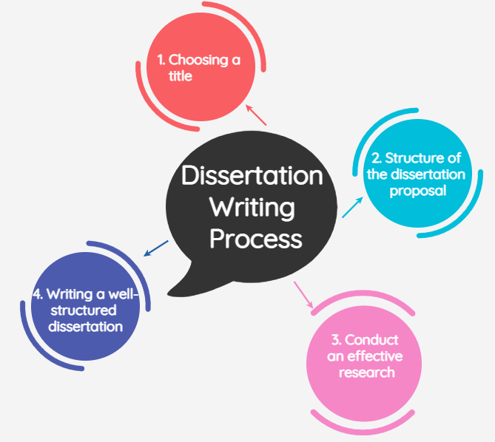

Figure 2 Dissertation Writing Process

1. **Choosing a title**

While writing dissertation, theme and question is important as title. Unique and brainstorming title needs to be chosen so that strong argument can be presented. The topic chosen should allow to collect the essential primary and secondary data in short period of time.

1. **Structure of the dissertation proposal**

Well structured dissertation includes objectives, aim, literature review, research, methodology, risk analysis, time management, list of references should be written.

1. **Conduct an effective research**

As the research stage while writing dissertation determines overall development of the project, it has to be effective and methodical. Irreverent resource ought to be discarded. Resources needs to be well organized.

1. **Writing a well-structured dissertation**

Final process while writing dissertation is well structured report. Introduction includes problem background and statement of issue. Expose and assumption of final result needs to be done. Literature review includes review of research process and acknowledgements. Methodology consists of methods of implementation of resources. Moreover, collection of data and analysis needs to be done. Findings includes what problem did the research resolved and all the research questions needs to be answered in this part. However, it is the most important part in whole research process.

# Similarities

As both coursework and dissertation are the part of academic writing, they have a lot of similarities. Both coursework and dissertation have certain time period. If dissertation or coursework is not submitted before deadline, student is disqualified. Both coursework and dissertation require research and knowledge of the topic and proper referencing in most. Both are done to graduate either from college or from high school. Both needs guidance of tutor for completing the research. Both have similar writing style like language, grammar, and similar format like font size, font style, margins, spacing, paper size, bibliography, infographics, etc.

# Differences

Dissertation does not require attending class as it is research based but to be eligible for coursework, student need to attend class. Coursework is done to pass the exam or to get the second cycle education whereas dissertation is written to continue with masters or PhD moreover, it is written to get highest qualification possible. Coursework mostly focuses on secondary data collection from books, articles, survey reports, course books and official statistics whereas Dissertation mostly uses data from primary sources such as questionnaires or surveys, interviews and focus group. Coursework does not necessarily need to have original research, but the student must take a view and back it up with arguments collected from existing research in the form of literature review. Whereas, Dissertation is a original research that a student does over a long period of time and moreover it contains references and relations to existing research that has been done by other people.

# Benefits

Coursework and Dissertation both are beneficial for students as the research done helps to improve the knowledge about the topic and helps in getting good grades. Both helps in developing researching skills. Both helps to be better in academic writing. Analytical and cognitive ability can be improved, planning skills and organizing skills will be developed. Both helps in improving time management skills and learn to prioritize work. It helps to keep balance between personal work and academic works. Critical thinking will be developed. Academic writing will be developed as both dissertation and coursework needs to be written in proper grammatical order following the proper structure.

# Challenges

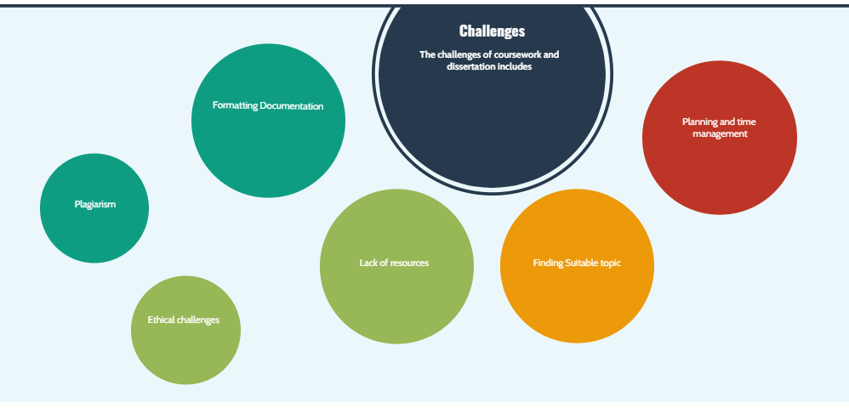

Figure 3 Challenges of Coursework and Dissertation

The challenges of coursework and dissertation includes

1. **Plagiarism**

As the documentation of both coursework and dissertation includes the data and references from the other secondary sources like book, research paper, journals, websites, there is high chance of getting plagiarism in the content.

1. **Communication**

Content written in both coursework and dissertation can cause misunderstanding of some words and can lead to miscommunication between the content writer and reader.

1. **Poor support from tutor**

Coursework is given to student after finishing the course, so tutor may not provide support to the students and as dissertation is mostly research based tutor may not be available to students for help.

1. **Formatting Documentation**

As different university and school asks different format of documentation like font size, border size and font style as per the rule, student can face problem in formatting the documentation.

1. **Lack of resources**

While writing dissertation, research is done based on the research papers, journals, vouchers, books and websites, it does not have a specific book like coursework does. Therefore, student may face problem of resources for the research.

1. **Finding Suitable topic**

As dissertation topic should be selected by the student themselves, they find difficult to choose the suitable topic.

1. **Ethical challenges**

Ethical and legal aspects of the country should be kept in consideration while doing the research as the research done and product developed in one country may not be legal in other country.

1. **Planning and time management**

As dissertation takes a lot of time to complete, student easily get unfocused on research and are unable to manage time. Student also find difficult to manage personal work and academic work.

# Conclusion

This report includes the academic writing process with basic concept of coursework and dissertation. It includes similarities and differences of both coursework and dissertation. From this report we can conclude that both dissertation and coursework have certain challenges and benefits. However, the academic writing process helps student to develop writing skills, problem solving and gain knowledge through the writing process.

# References

*Academic Writing* (2021) available from <https://library.leeds.ac.uk/info/14011/writing/106/academic_writing> [17 February 2021]

*What Does Coursework Mean?* (2021) available from <https://www.definitions.net/definition/Coursework> [16 February 2021]

*Coursework | Definition Of Coursework By Oxford Dictionary On Lexico.Com Also Meaning Of Coursework* (2021) available from <https://www.lexico.com/definition/coursework> [16 February 2021]

*What Is A Dissertation?* (2021) available from <https://ukdiss.com/guides/what-is-a-dissertation.php> [16 February 2021]

*What Are The Benefits Of Writing A Dissertation?* (2021) available from <http://www.careercamel.com/benefits-writing-dissertation/#:~:text=Writing%20a%20dissertation%20is%20a,knowledge%20in%20your%20study%20area.> [14 February 2021]

*Dissertation Writing Help? Allassignmenthelp.Com Is Here To Help You.* (2021) available from <https://www.allassignmenthelp.com/blog/advantages-of-dissertation-writing-in-the-academics/> [15 February 2021]

AcademicWriting

Coursework

Dissertation

Plagiarism

Research

CriticalThinking

Proposal

Assignment

Skills

Knowledge

Report