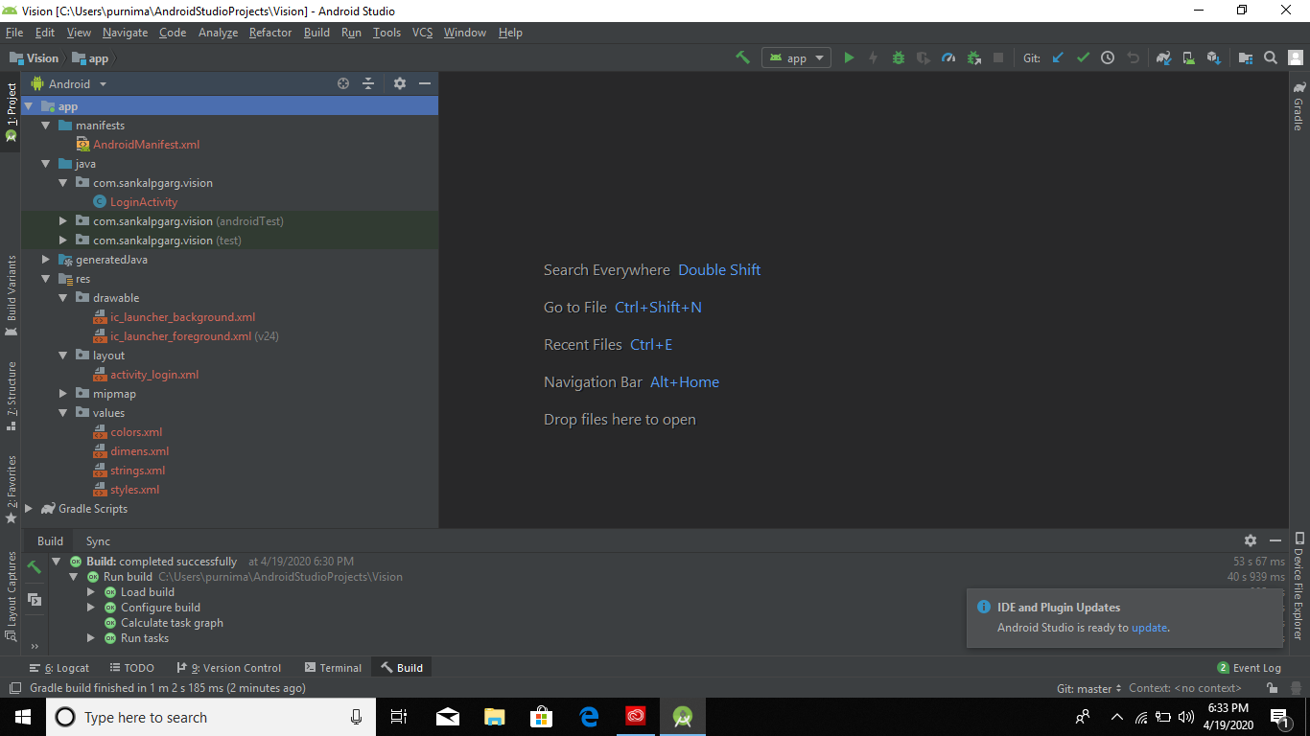

These are files to fix changes that are common for whole activity.

All design related work are done here.

We have to import any static image we are using in our application.

Java file where backend code executes.

The file that gets executed in out mobile phone. But nothing do witt th this on initial stages.