PROJECT PROPOSAL


Temporary Rental Space Management System of MFU

PANITI KONNGOEN
PRATHANAKORN PITI
PHLOIPHAILIN KHAMPUK
PHONGSAPHAK DUANGNET

BACHELOR OF ENGINEERING
IN COMPUTER ENGINEERING

MAE FAH LUANG UNIVERSITY
2026
© COPYRIGHT BY MAE FAH LUANG UNIVERSITY

Temporary Rental Space Management System of MFU

PANITI KONNGOEN
PRATHANAKORN PITI
PHLOIPHAILIN KHAMPUK
PHONGSAPHAK DUANGNET

A COMPUTER ENGINEERING PROJECT SUBMITTED TO
MAE FAH LUANG UNIVERSITY IN PARTIAL FULFILLMENT OF THE REQUIREMENTS FOR THE DEGREE OF
BACHELOR OF ENGINEERING
IN COMPUTER ENGINEERING

MAE FAH LUANG UNIVERSITY
2026
© COPYRIGHT BY MAE FAH LUANG UNIVERSITY

Temporary Rental Space Management System of MFU

PANITI KONNGOEN
PRATHANAKORN PITI
PHLOIPHAILIN KHAMPUK
PHONGSAPHAK DUANGNET

THIS COMPUTER ENGINEERING PROJECT HAS BEEN APPROVED
TO BE PARTIAL FULFILLMENT OF REQUIREMENTS FOR
THE DEGREE OF BACHELOR OF ENGINEERING IN
COMPUTER ENGINEERING
2026

EXAMINING COMMITTEE

……………………………………………………… ADVISOR
(Dr. Surapong Uttama)

……………………………………………………… COMMITTEE
(Dr. Paweena Suebsombut)

……………………………………………………… COMMITTEE
(Dr. Khwunta Kirimasthong)

© COPYRIGHT BY MAE FAH LUANG UNIVERSITY
ACKNOWLEDGEMENT

This project was completed with the valuable support and guidance of many individuals. The authors would like to express their sincere gratitude to the advisor and supervisory committee members for their professional guidance, constructive suggestions, and continuous support throughout the project.
The authors also wish to thank Mae Fah Luang University for providing the facilities and resources necessary for this study. Finally, heartfelt appreciation is extended to the authors’ parents and friends for their encouragement and support during the completion of this project.

Paniti Konngoen
Prathanakorn Piti
Phloiphailin Khampuk
Phongsaphak Duangnet
Title Temporary Rental Space Management System of MFU
Author Mr. Paniti Konngoen
Mr. Prathanakorn Piti
Mrs. Phloiphailin Khampuk
Mr. Phongsaphak Duangnet
Degree Bachelor of Engineering
(Computer Engineering)
Supervisory Committee Dr. Surapong Uttama Advisor
Dr. Paweena Suebsombut Committee
Dr. Khwunta Kirimasthong Committee

Abstract

This senior project proposes the development of a web-based Temporary Rental Space Management System for Mae Fah Luang University. Designed to serve both internal university members and external organizations, the system addresses the inefficiencies of traditional, paper-based reservation methods. By fully digitizing the workflow, the platform aims to eliminate manual processing errors, reduce communication delays, and prevent scheduling conflicts.
The system provides a comprehensive online solution where users can check real-time availability, select customized add-ons, and process secure payments seamlessly. Simultaneously, administrators are equipped with a centralized dashboard for dynamic facility management, digital approval workflows, and data visualization. Ultimately, this system enhances the transparency, convenience, and overall operational efficiency of managing the university's commercial and non-commercial rental spaces.
Keyword: Space Management System, Web Application, Online Booking, Payment Integration, Mae Fah Luang University
CONTENT
ACKNOWLEDGEMENT iii
Abstract iv
LIST OF TABLES vi
LIST OF FIGURES vii
CHAPTER 1 INTRODUCTION 1
  - Background and Rationale 1
  - Objectives 1
  - Scope 1
  - Methodology 3
  - Plan 3
  - Expected Result 4
  - Place and Equipment 4
CHAPTER 2 LITERATURE REVIEW 5
2.1 Review of Existing MFU Room Booking System 5
2.2 Related Technologies and Integrations 6
2.3 Comparison with Commercial Booking Platforms 6
CHAPTER 3 ANALYSIS AND DESIGN 7
3.1 Use case diagram 7
3.2 Swim Lane diagram 8
3.3 Site map 11
3.4 User Interface (UI) 11
3.5 ER diagram 21
3.6 Data Dictionary 22
3.7 Third-Party Service Integrations 24
CHAPTER 4 CONCLUSION 25
4.1 Complete Work 25
4.2 Future Work Plan 25

LIST OF TABLES
Table pages
Table 1.1 Working plan 3
Table 2.1 Comparison between the Existing MFU Booking System 5
Table 2.2 Comparison between the Proposed System and Commercial Platforms 6

LIST OF FIGURES
Figure pages
Figure 3.1 Use case diagram for existing website 7
Figure 3.2 Swim lane diagram for login 8
Figure 3.3 Swim lane diagram for booking 9
Figure 3.4 Swim lane diagram for payment 10
Figure 3.5 Site map for webpages 11
Figure 3.6 User interface for login page 11
Figure 3.7 User interface for user home page 12
Figure 3.8 User interface for user home page 12
Figure 3.9 User interface for user home page 12
Figure 3.10 User interface for user home page 13
Figure 3.11 User interface for all-room page 13
Figure 3.12 User interface for all-room page 13
Figure 3.13 User interface for all-room page 14
Figure 3.14 User interface for room details page 14
Figure 3.15 User interface for room details page 14
Figure 3.16 User interface for booking room page 15
Figure 3.17 User interface for booking room page 15
Figure 3.18 User interface for user dashboard page 16
Figure 3.19 User interface for user dashboard page 16
Figure 3.20 User interface for privacy information page 17
Figure 3.21 User interface for admin dashboard page 17
Figure 3.22 User interface for admin dashboard page 18
Figure 3.23 User interface for admin request page 18
Figure 3.24 User interface for admin request page 18
Figure 3.25 User interface for admin edit room page 19
Figure 3.26 User interface for admin history activity page 19
Figure 3.27 User interface for admin broadcast and promotions page 20
Figure 3.28 User interface for admin broadcast and promotions page 20
Figure 3.29 ER diagram for database 21
Figure 3.30 Data Dictionary for feedback table 22
Figure 3.31 Data Dictionary for booking addons table 22
Figure 3.32 Data Dictionary for payments table 22
Figure 3.33 Data Dictionary for addons table 22
Figure 3.34 Data Dictionary for rooms table 22
Figure 3.35 Data Dictionary for room pricing table 23
Figure 3.36 Data Dictionary for bookings table 23
Figure 3.37 Data Dictionary for admin activity log table 23
Figure 3.38 Data Dictionary for user table 23

CHAPTER 1
INTRODUCTION

1.1 Background and Rationale
The Property Management Division of Mae Fah Luang University is primarily responsible for managing and monetizing a variety of temporary rental spaces. These facilities serve as a crucial source of revenue for the university, being utilized not only for internal academic activities but also for commercial rentals by external individuals, companies, and organizations.
However, the current space reservation process relies heavily on manual, paper-based procedures. This traditional approach is highly susceptible to human error, frequently resulting in scheduling conflicts, delayed communications, and significant complexities in managing financial transactions and official documentation with external clients.
To resolve these operational bottlenecks and enhance user convenience, this project proposes the development of a comprehensive web-based Temporary Rental Space Management System. By providing a fully digital platform that allows external users to easily book spaces and process payments online, the system will significantly reduce human errors and redundant manual tasks. Ultimately, this solution will empower the Property Management Division to maximize resource utilization and manage revenue generation with high accuracy and efficiency.
1.2 Objectives
1.2.1 To develop a fully functional web-based temporary rental space management system for Mae Fah Luang University.
1.2.2 To implement a full-stack system architecture, demonstrating the seamless integration between frontend development and backend management.
1.2.3 To enable users to process secure online bookings and provide administrators with a centralized dashboard for efficient facility management.
1.3 Scope
1.3.1 System Users
Users are categorized into distinct authorization levels based on their relationship with Mae Fah Luang University (MFU). The system will automatically apply different rental pricing tiers based on these roles:
- 1.3.1.1 Internal Users: Individuals or entities operating within the MFU organization. They will be charged the "Internal Rate".
- 1.3.1.2 Collaborative Users (Co-op): Users involved in cross-organizational partnerships or activities co-hosted with the university. They will be charged the "Collaborative Rate".
- 1.3.1.3 External Users: Individuals or private companies outside the MFU organization. They will be charged the standard "External Rate".
- 1.3.1.4 System Administrator: Personnel responsible for overseeing facility data, managing reservation requests, and handling administrative workflows.
1.3.2 User Functional Scope:
- Availability Search & Advanced Booking: Check real-time room availability and submit advance reservation requests within specified timeframes.
- Service Customization (Add-ons): Select supplementary services or additional equipment (e.g., specific quantities of tables and chairs) during the booking process, with automated calculation of additional costs.
- Secure Payment Integration: Process transactions securely and seamlessly via an integrated payment gateway.
- Promotions and Incentives: Apply promotional discounts or special offers provided by the system during the reservation process.
- Reservation Management & History: Access personal booking logs, specify reservation purposes, track current statuses, and cancel existing bookings according to system policies.
- Status and Event Notifications: Receive automated alerts regarding booking confirmations, workflow status updates, and announcements for new promotional campaigns.
- Post-Service Feedback: Submit reviews and satisfaction ratings after completing the reservation lifecycle to provide service evaluations.
- Secure Authentication: Users can securely log in via Google OAuth. The system automatically assigns user roles (e.g., internal or external) based on their registered email domains, such as @mfu.ac.th or @lamduan.mfu.ac.th.
- Secure Payment Integration: Users can process secure and instant online payments via a third-party gateway, specifically utilizing dynamic PromptPay QR Codes.
1.3.3 Administrator Functional Scope:
- Facility & Rate Management: Maintain room records (Add/Edit/Disable) and manage pricing structures. This includes the ability to bulk import room details and room rates directly from spreadsheet datasets (Excel files).
- Administrative Dashboard & Data Visualization: Access a centralized analytics dashboard featuring comprehensive data visualization through interactive graphs and charts. This tool allows for monitoring real-time booking statistics, revenue tracking, and facility utilization, with the ability to drill down into specific data entries for detailed analysis.
- Approval Workflow and Documentation: Process reservation requests by updating statuses (Approve/Disapprove). This includes the ability to import executive authorization files and export official approval documents to serve as verified digital evidence.
- Promotion Management: Create, configure, and manage promotional campaigns to encourage system utilization.
- System Notifications & Broadcasts: Manage automated system alerts and broadcast new promotional information or critical updates to designated user groups.

1.4 Methodology
This project follows an iterative Software Development Life Cycle (SDLC) to ensure the system meets the requirements of Mae Fah Luang University.
- 1.4.1 Requirement Gathering and Analysis: Collect and analyze user requirements by reviewing existing manual reservation processes and examining documents from the Intellectual Property and Innovation Management Division.
- 1.4.2 System Design: Design the system architecture, user interface (UI), and database. This includes designing the relational database schema and mapping data relationships using PostgreSQL and pgAdmin4.
  - 1.4.2.1 Third-Party Integrations (Overview): The system uses Google OAuth for secure Single Sign-On (SSO) and integrates a commercial Payment Gateway (e.g., Opn Payments or 2C2P) to process dynamic PromptPay QR Codes. Utilizing this payment service incurs a standard transaction fee of approximately 1.65%.
- 1.4.4 System Testing and Evaluation: Conduct rigorous testing to identify and resolve bugs. This includes testing role-based access for internal and external users, validating the approval workflows, and ensuring the system prevents scheduling conflicts.
- 1.4.5 Documentation and Presentation: Prepare the formal Senior Project 1 and 2 documentation and defend the project before the examination committee.
  - Plan
- Table 1.1 Working plan
 | Senior project 1 |  |  |  |  | Senior project 2
Plan/Month | Jan | Feb | Mar | Apr | May | Aug | Sep | Oct | Nov | Dec
Proposal preparation and defense
Literature review and requirement gathering
System analysis
System design
Senior project 1 document preparation
Senior Project 1 examination
System development
System testing and evaluation
Senior project 2 document preparation
Senior Project 2 examination

1.6 Expected Result
1.6.1 A fully functional and secure web-based room reservation system for Mae Fah Luang University.
1.6.2 A streamlined booking experience with integrated online payment, enhancing convenience for external commercial users.
1.6.3 Significantly reduced human errors and redundant paperwork in the reservation and financial tracking processes.
1.6.4 Improved operational efficiency and enhanced revenue generation capabilities for the Property Management Division.
1.7 Place and Equipment
1.7.1 Equipment
1.7.1.1 Hardware
- Personal computer or laptop
- Internet connection
1.7.1.2 Software
- Frontend: Vue.js, Tailwind CSS
- Backend: Node.js
- Database: PostgreSQL, pgAdmin4
1.7.1.3 Data set
- University room details and specifications

CHAPTER 2
LITERATURE REVIEW
This chapter reviews the existing literature, systems, and technologies relevant to the development of the Temporary Rental Space Management System. It evaluates the current booking methods at Mae Fah Luang University (MFU) and explores the core technologies and third-party integrations utilized in this project.
2.1 Review of the Existing MFU Room Booking System
Currently, the room booking process at Mae Fah Luang University relies significantly on manual workflows and basic internal platforms. These existing systems are primarily designed for internal academic use, lacking the flexibility to accommodate external commercial clients. Furthermore, the absence of an integrated online payment gateway forces users to complete transactions manually, leading to administrative delays.
To highlight the improvements proposed by this project, a comparison between the existing MFU system and the proposed system is presented in Table 2.1.
Table 2.1 Comparison between the Existing MFU Booking System
Features | Existing MFU Booking System | Proposed System
External User Booking | Manual paper-based application and in-person coordination | Direct online booking via web platform
Overall Workflow | Paper-based routing with manual administrative approval | Fully automated web-based approval workflow
Authentication | Local university database login (Staff/Students only) | Google OAuth (SSO) for all users
Payment Method | Manual transactions / Cash at the counter | Integrated Payment Gateway (PromptPay QR)
Service Add-ons | Manual request required during paperwork submission | Automated add-on selection during booking

2.2 Related Technologies and Integrations
To achieve the proposed features, several modern technologies and third-party services were reviewed and implemented:
- 2.2.1 Web Application Frameworks: Vue.js and Tailwind CSS were selected for the frontend to provide a responsive and dynamic user interface. Node.js and PostgreSQL were chosen for the backend to ensure robust data management and high-performance server processing.
- 2.2.2 Single Sign-On (SSO) and Authentication: Google OAuth is utilized to handle user authentication securely. This eliminates the need for localized password storage, leveraging Google’s robust security infrastructure while providing a seamless login experience for users with existing university or personal Google accounts.
- 2.2.3 Payment Gateway Providers: For the financial transaction module, Opn Payments (formerly Omise) was selected over other regional providers like 2C2P. Opn Payments offers a highly developer-friendly API, seamless integration with Node.js, and a highly competitive transaction fee for dynamic PromptPay QR Codes (1.65%). This makes it the most cost-effective and efficient solution for the university's Property Management Division.

2.3 Comparison with Commercial Booking Platforms
To ensure the proposed system meets standard practices while addressing the university's specific operational needs, commercial platforms such as Peerspace and Skedda were reviewed. While these platforms offer robust general features, they lack customized workflows for internal university approvals and role-based pricing structures.
Table 2.2 Comparison between the Proposed System and Commercial Platforms
Feature | Proposed MFU System | Peerspace | Skedda
Primary Focus | University properties and facilities | General event spaces and studios | Academic & office workspaces
Approval Workflow | Custom Admin Approval (Management Office) | Host Approval | Instant Booking / Admin override
Pricing Tier | Dynamic (Internal / External / Co-op) | Standard Public Rate | Standard Public Rate
Payment Gateway | PromptPay QR (Opn Payments) | Credit Card (Stripe) | Online Card Payments
Service Add-ons | Tailored to MFU (e.g., specific tables, mics) | General host offerings | Limited custom add-ons

CHAPTER 3
ANALYSIS AND DESIGN
3.1 Use case diagram
The use case could be demonstrated by a use case diagram in Figure 3.1
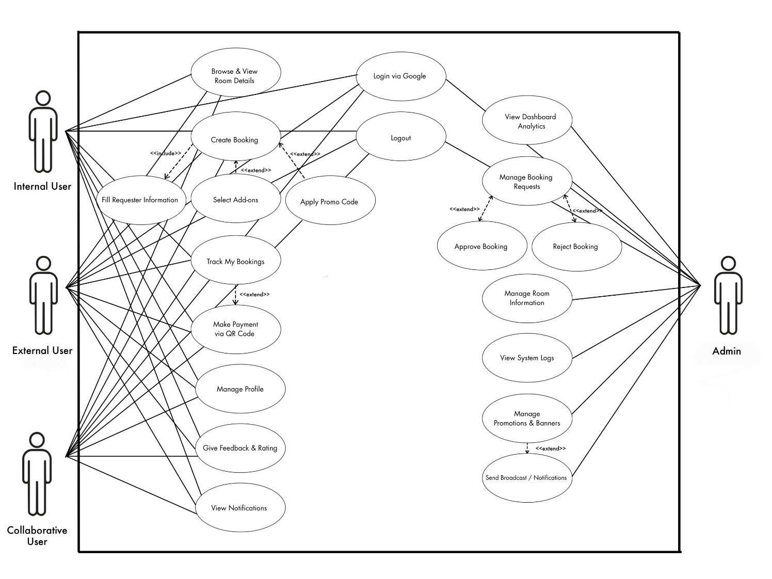
Figure 3.1 Use case diagram for existing website

3.2 Swim lane diagram
The login could be demonstrated by a swim lane diagram in Figure 3.2
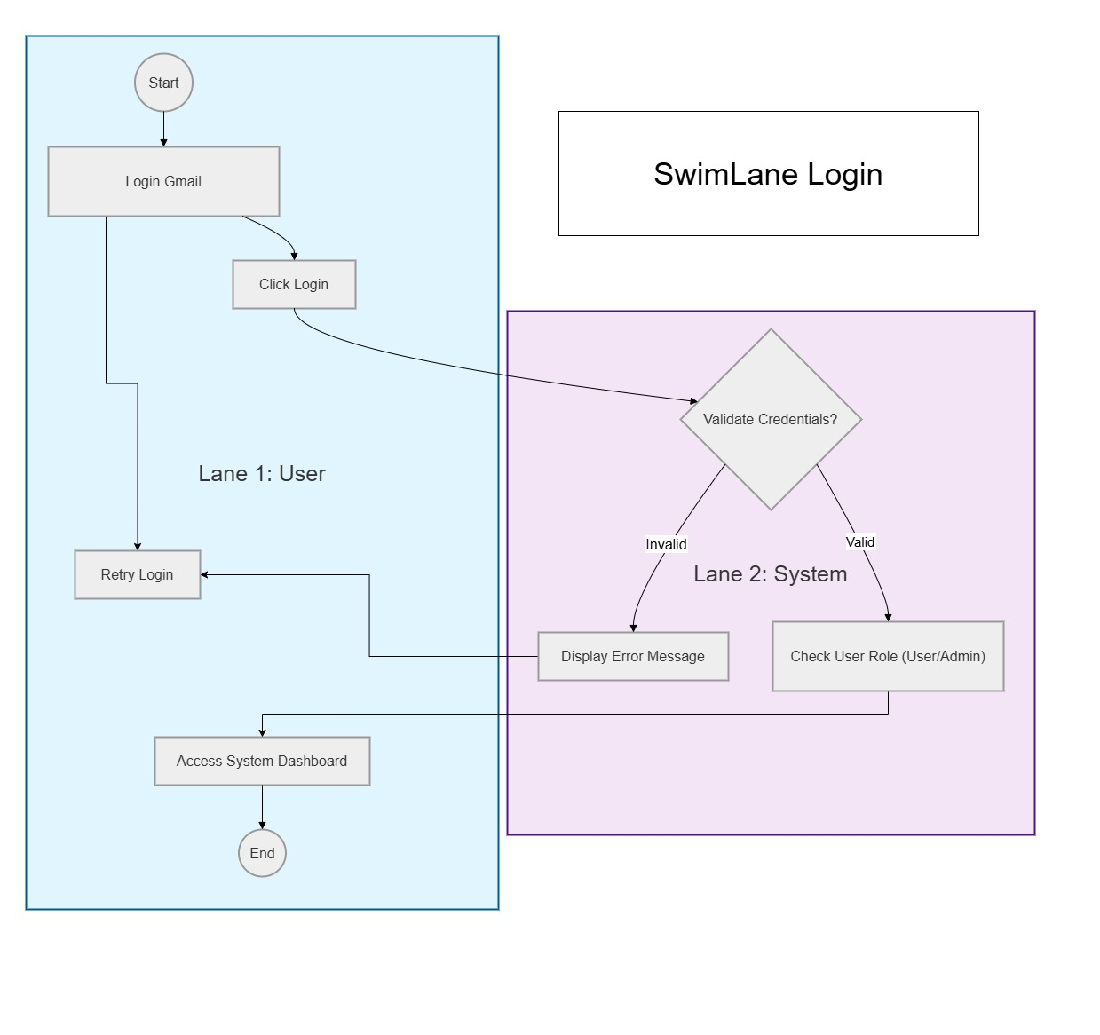
Figure 3.2 Swim lane diagram for login

The booking could be demonstrated by a swim lane diagram in Figure 3.3
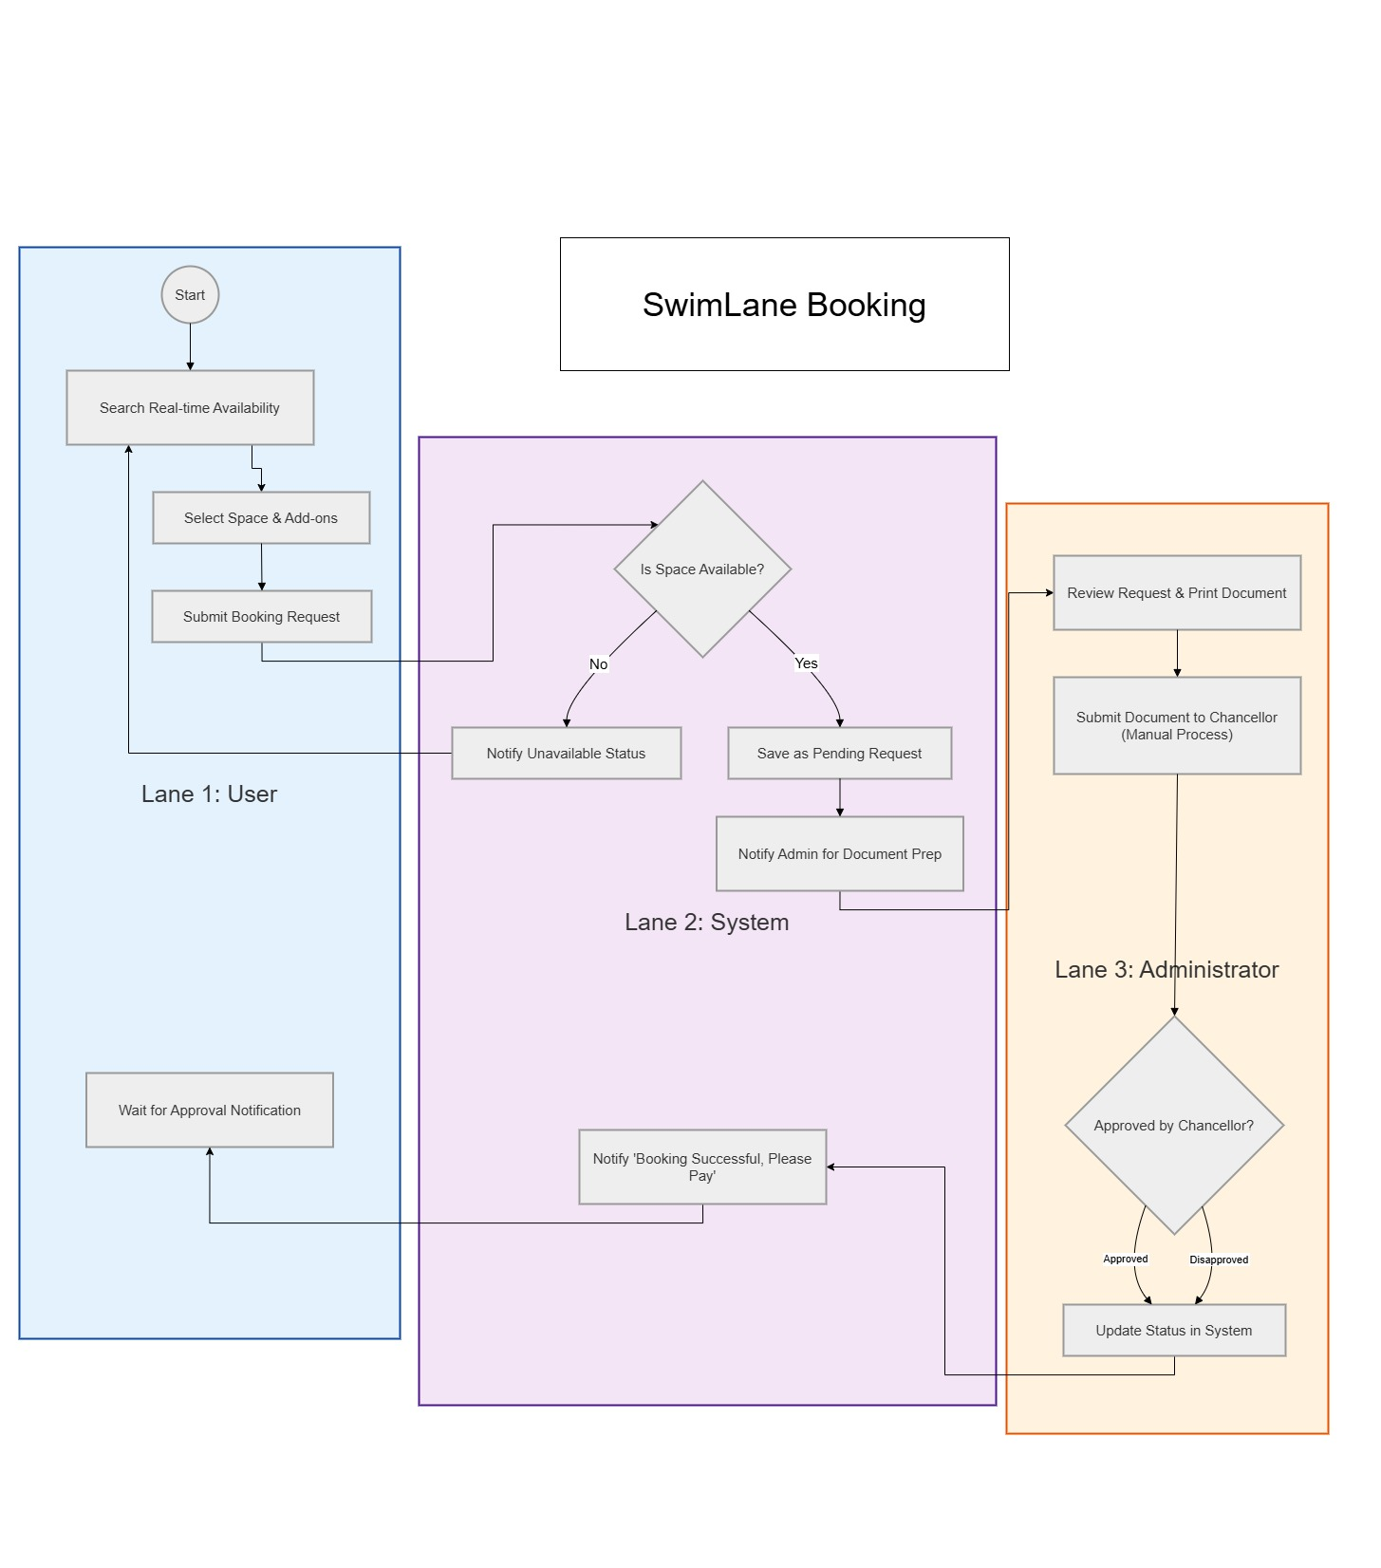
Figure 3.3 Swim lane diagram for booking

The payment could be demonstrated by a swim lane diagram in Figure 3.4
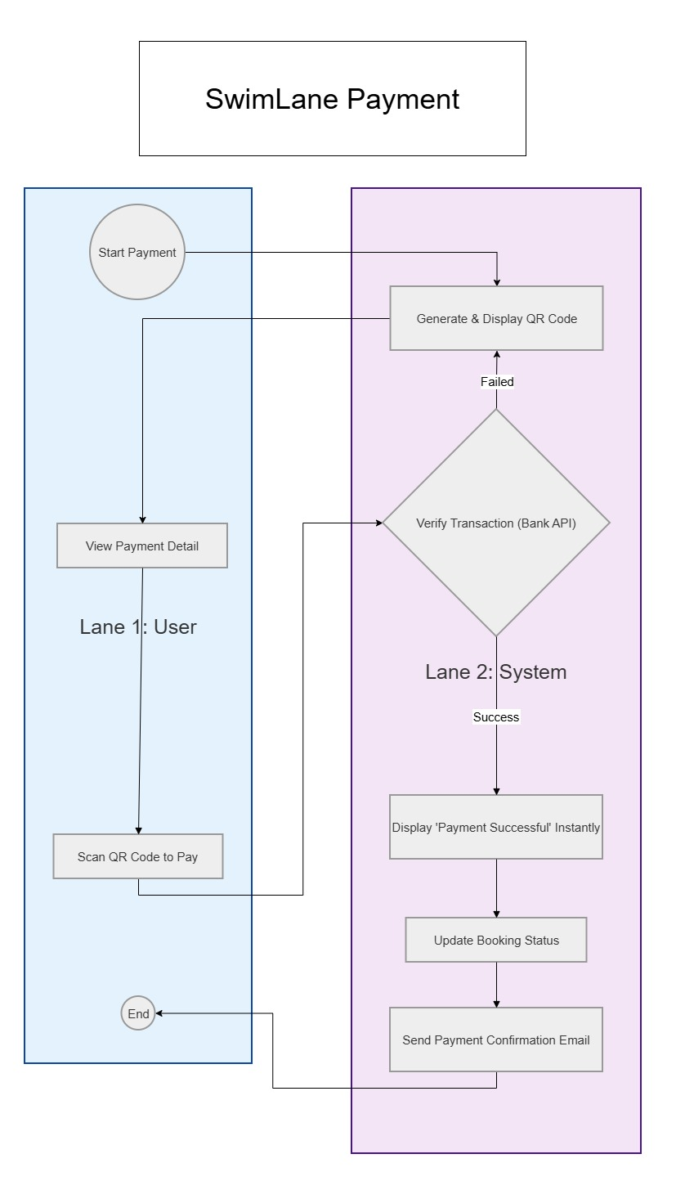
Figure 3.4 Swim lane diagram for payment

3.3 Site map
The webpage could be demonstrated by a site map in Figure 3.5
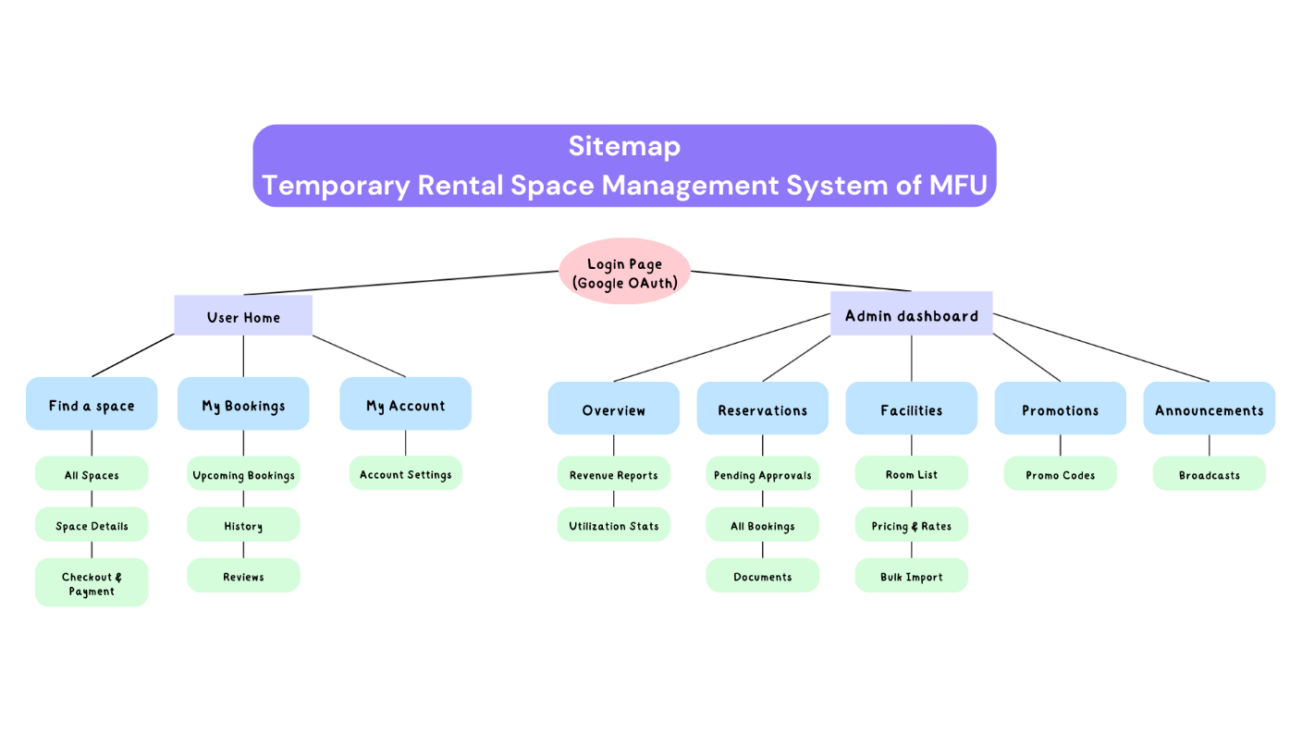
Figure 3.5 Site map for webpages
3.4 User Interface (UI)
The login page could be demonstrated by a user interface in Figure 3.6
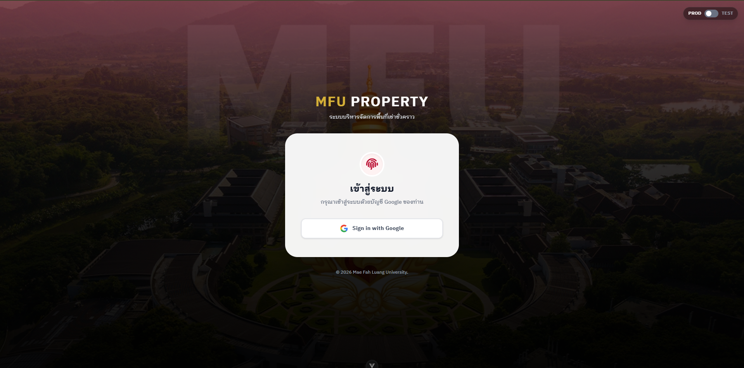
Figure 3.6 User interface for login page

The home page could be demonstrated by a user interface in Figure 3.7 - Figure 3.10
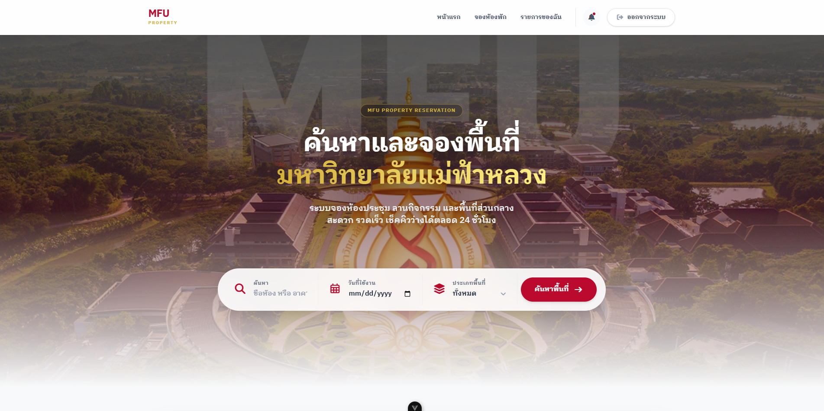
Figure 3.7 User interface for user home page
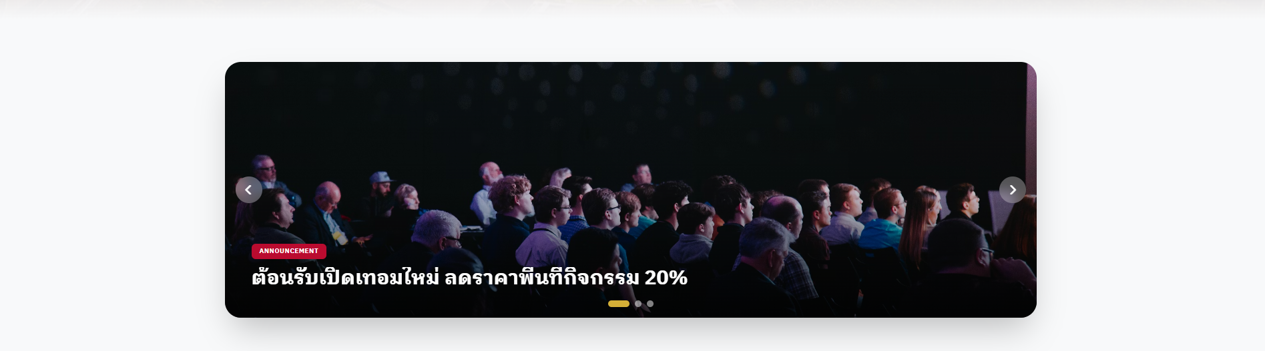
Figure 3.8 User interface for user home page
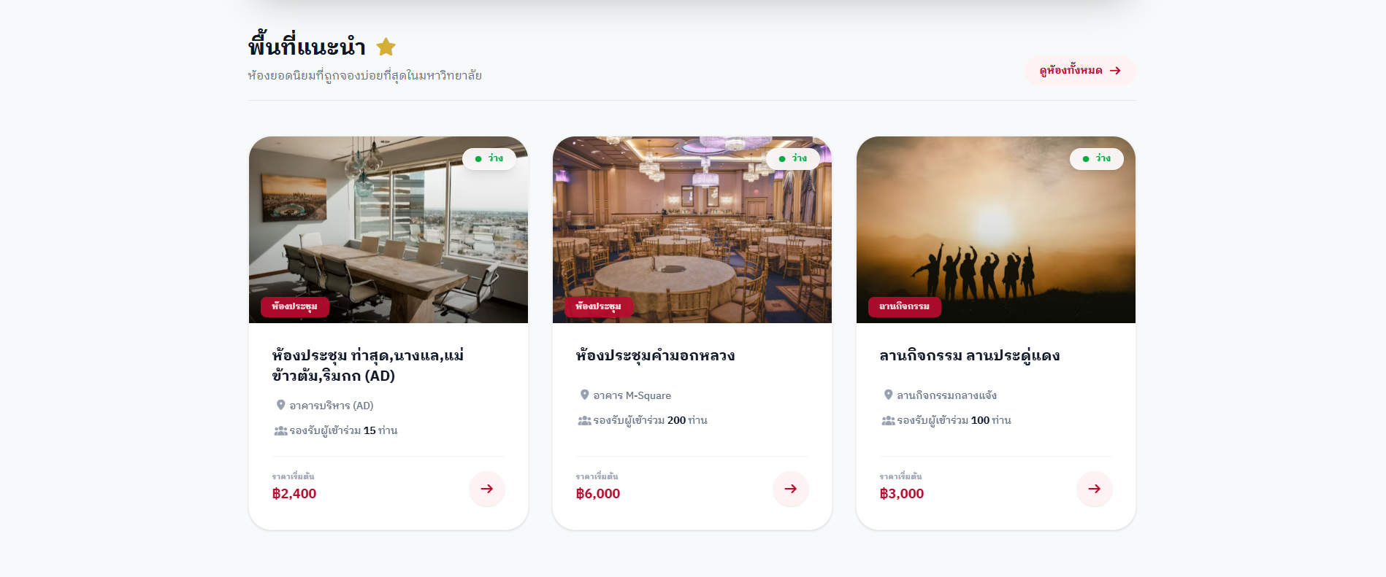
Figure 3.9 User interface for user home page
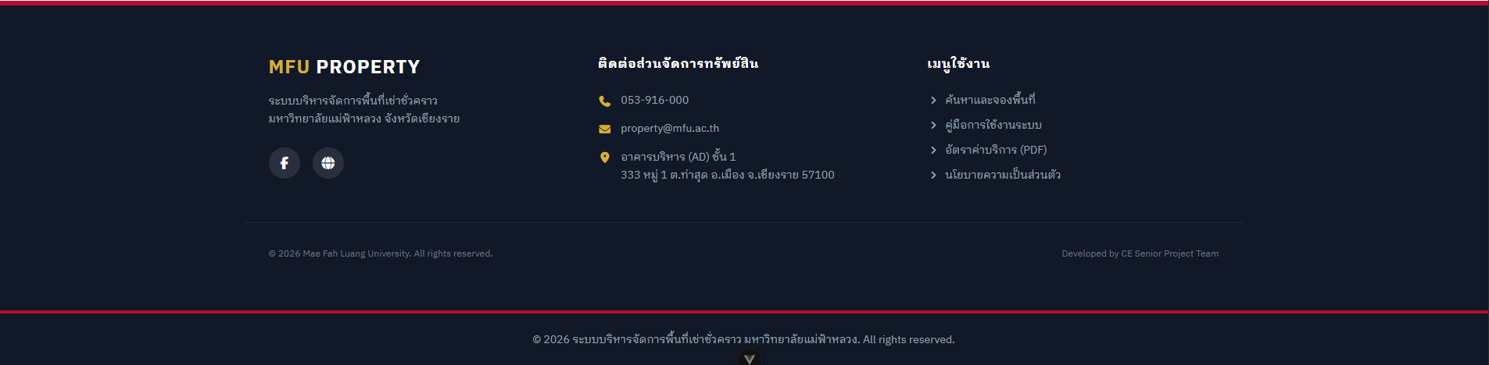
Figure 3.10 User interface for user home page

The all-room page could be demonstrated by a user interface in Figure 3.11 - Figure 3.13
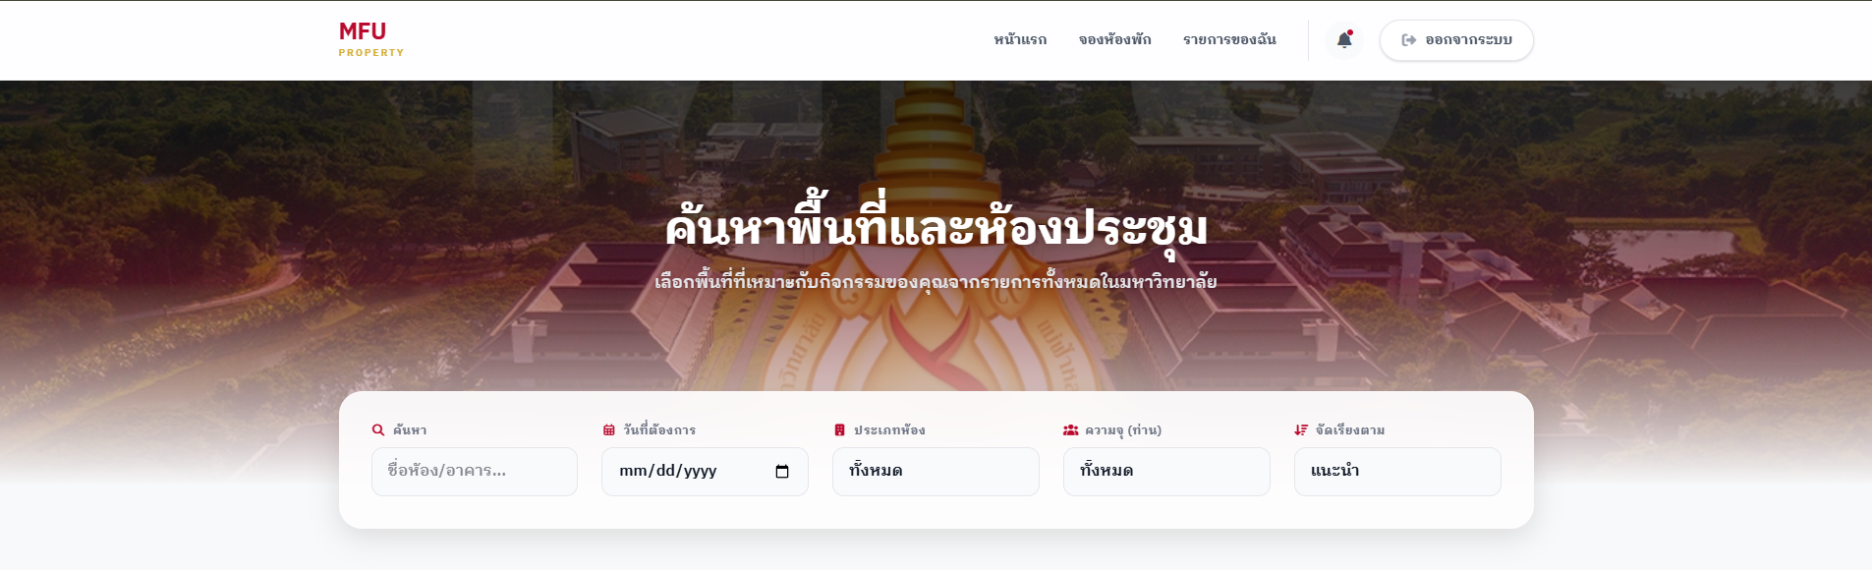
Figure 3.11 User interface for all-room page
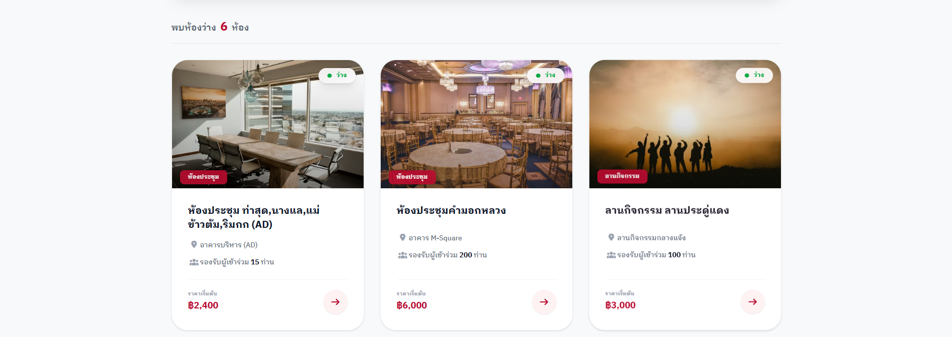
Figure 3.12 User interface for all-room page
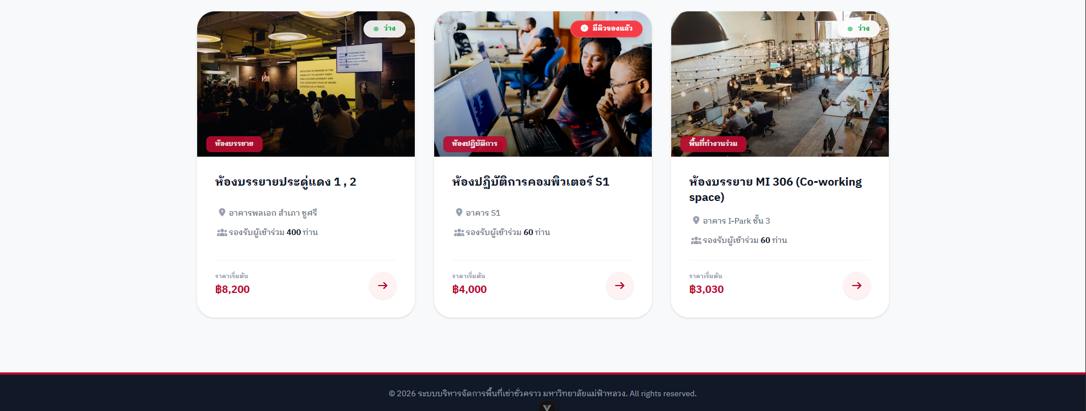
Figure 3.13 User interface for all-room page

The room details page could be demonstrated by a user interface in Figure 3.14 - Figure 3.15
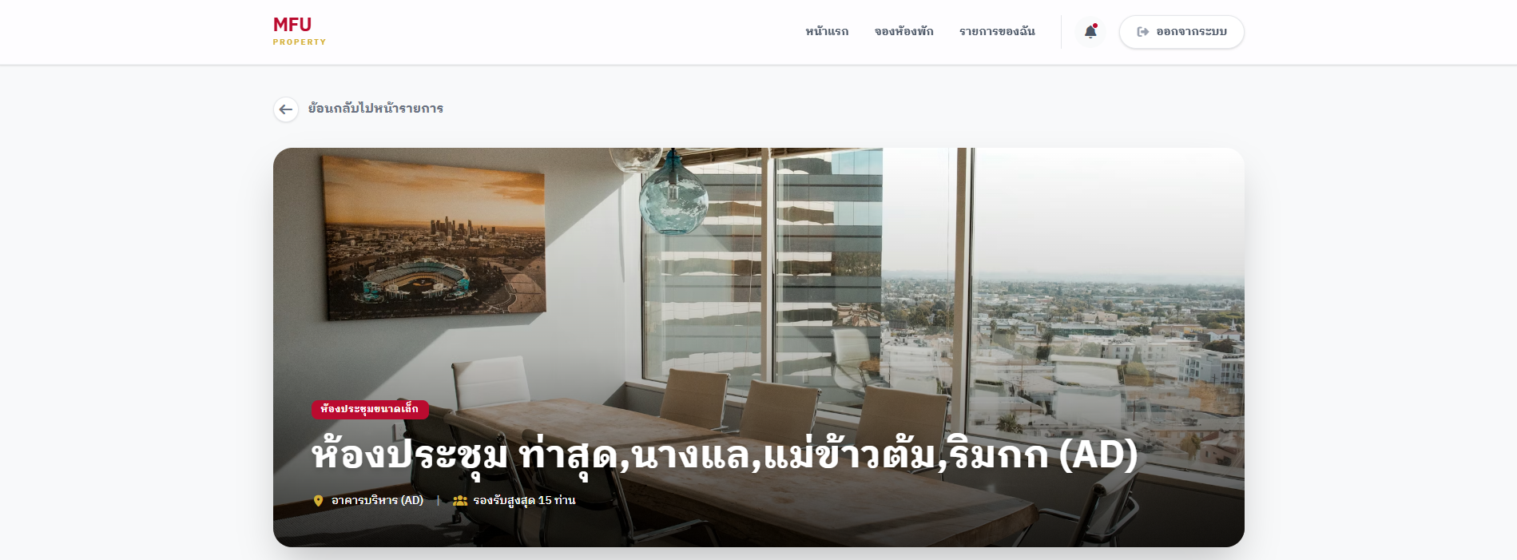
Figure 3.14 User interface for room details page
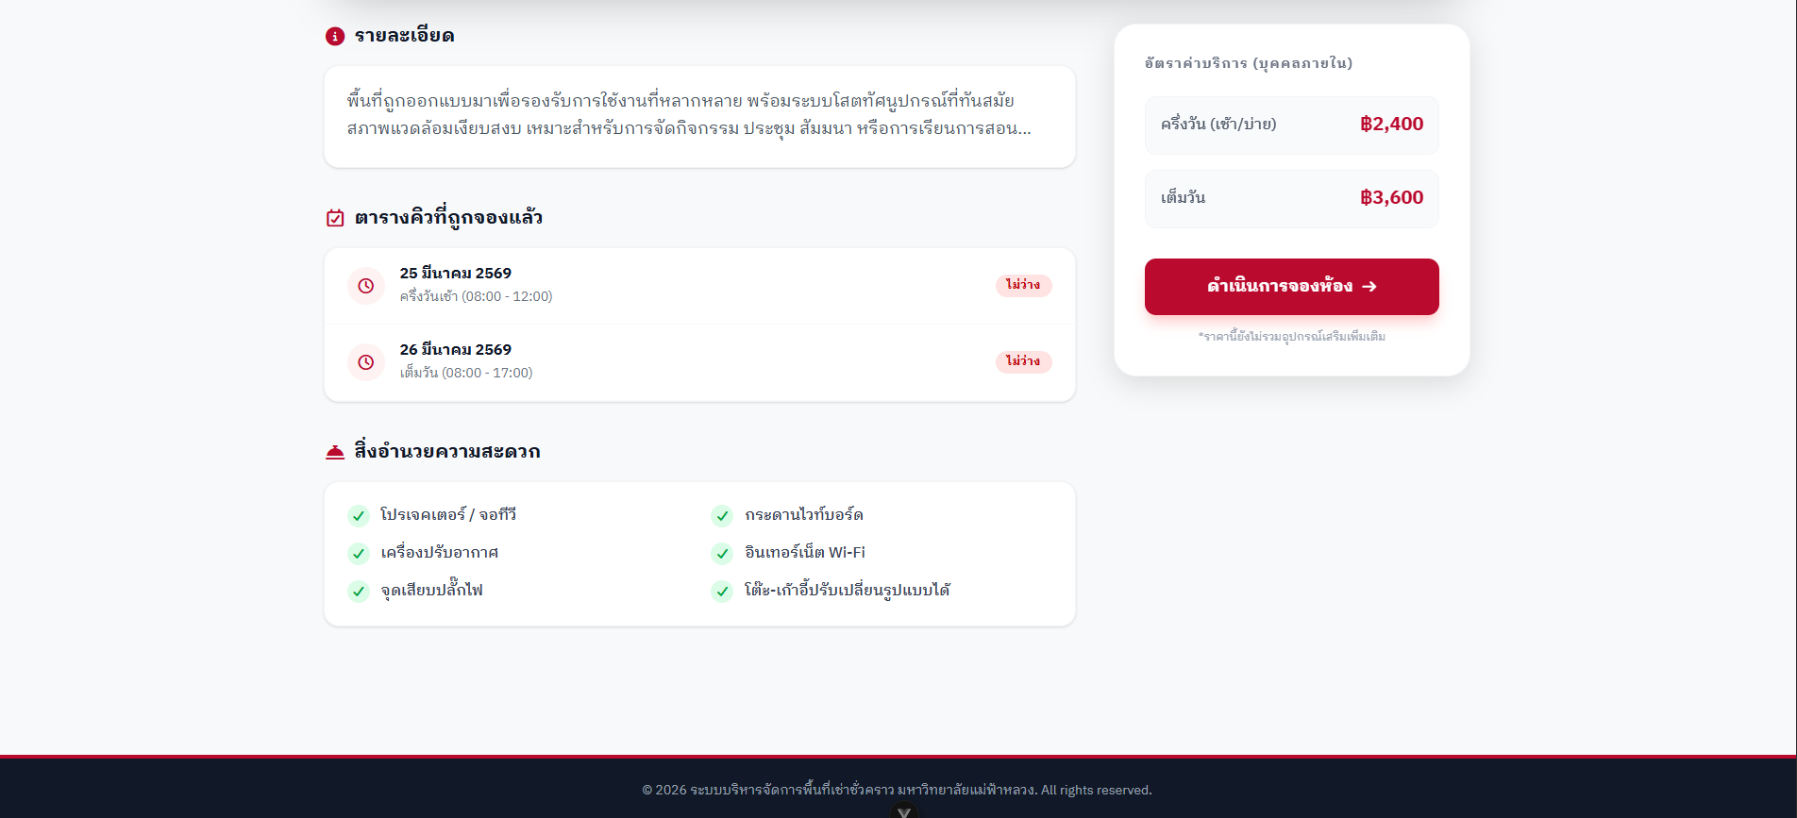
Figure 3.15 User interface for room details page

The booking room page could be demonstrated by a user interface in Figure 3.16 - Figure 3.17
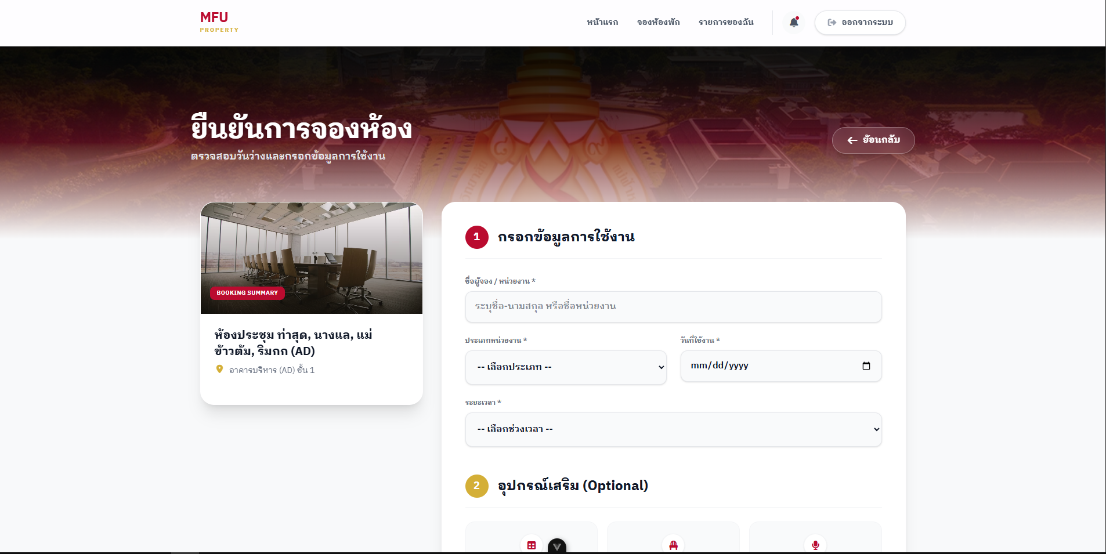
Figure 3.16 User interface for booking room page
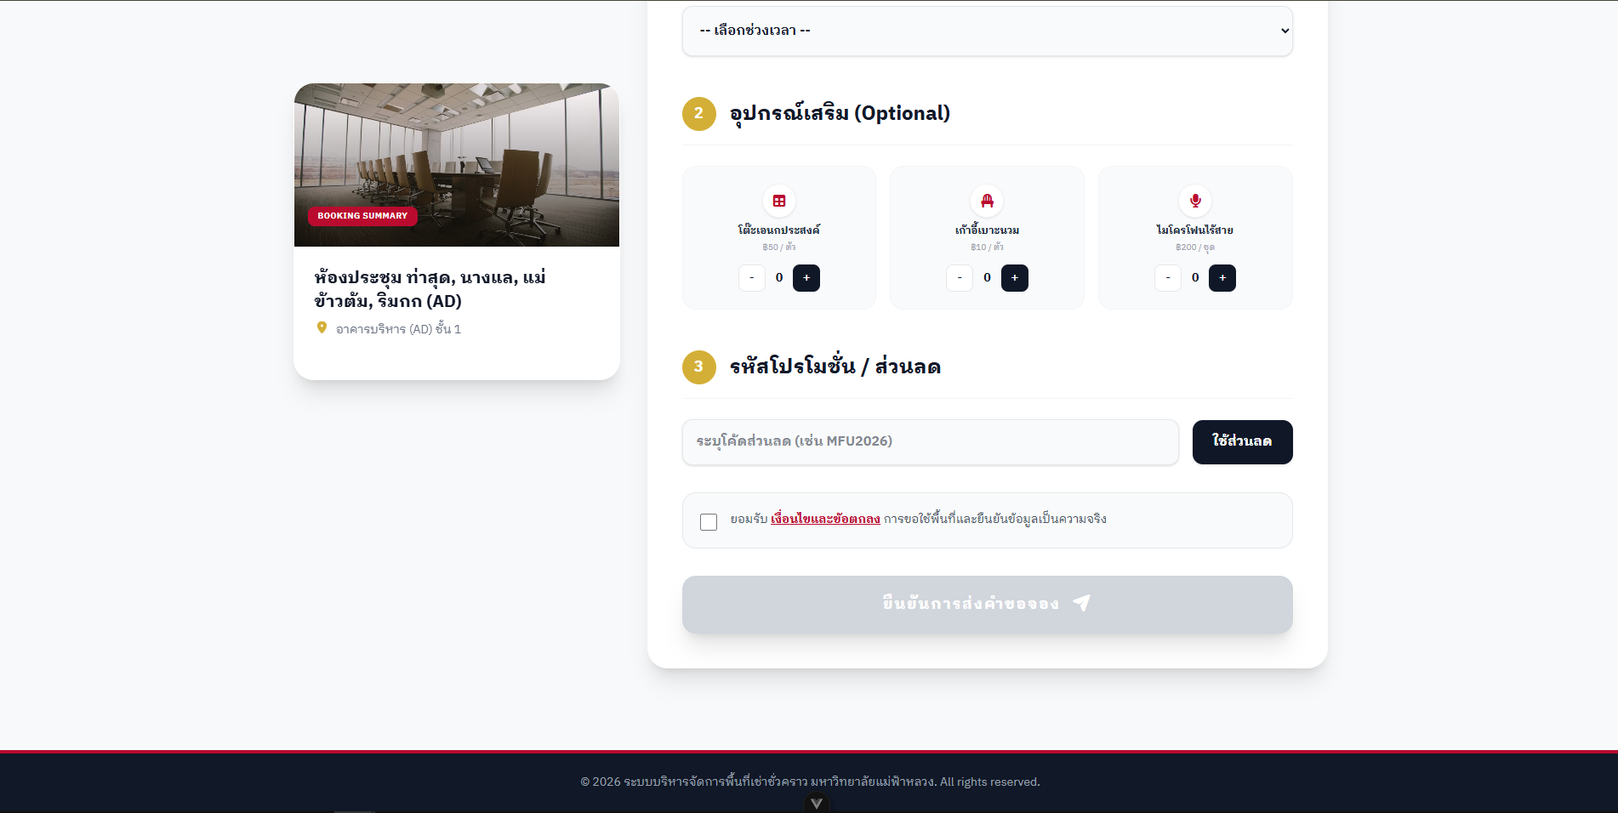
Figure 3.17 User interface for booking room page

The user dashboard page could be demonstrated by a user interface in Figure 3.18 - Figure 3.19
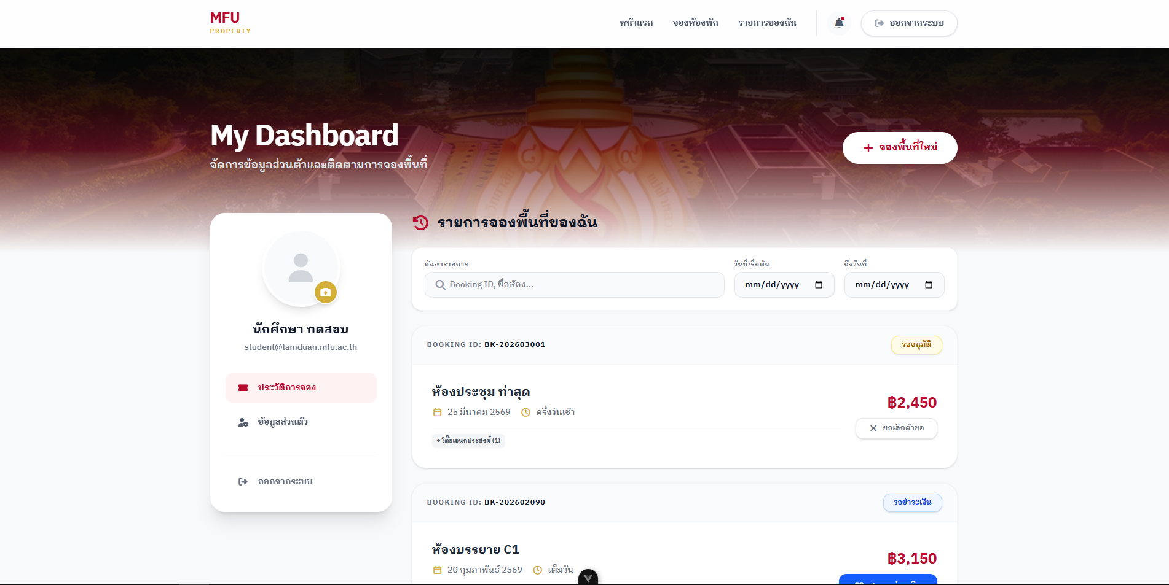
Figure 3.18 User interface for user dashboard page
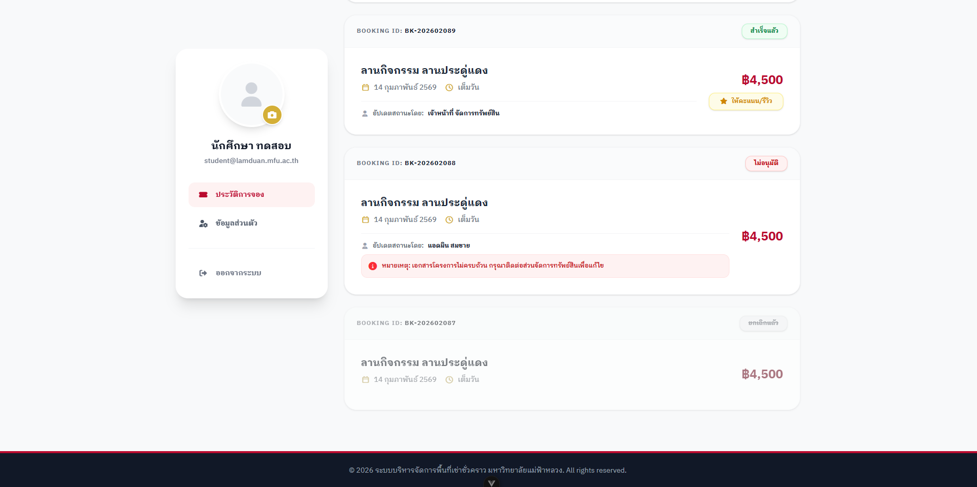
Figure 3.19 User interface for user dashboard page

The privacy information page could be demonstrated by a user interface in Figure 3.20
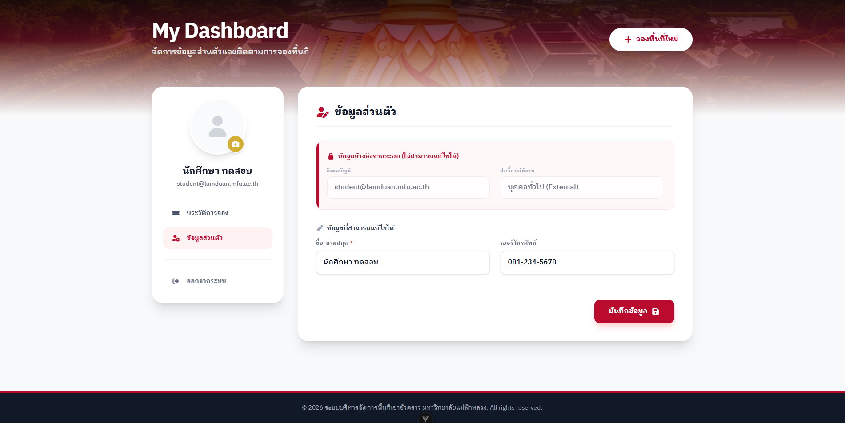
Figure 3.20 User interface for privacy information page

The admin dashboard page could be demonstrated by a user interface in Figure 3.21 - Figure 3.22
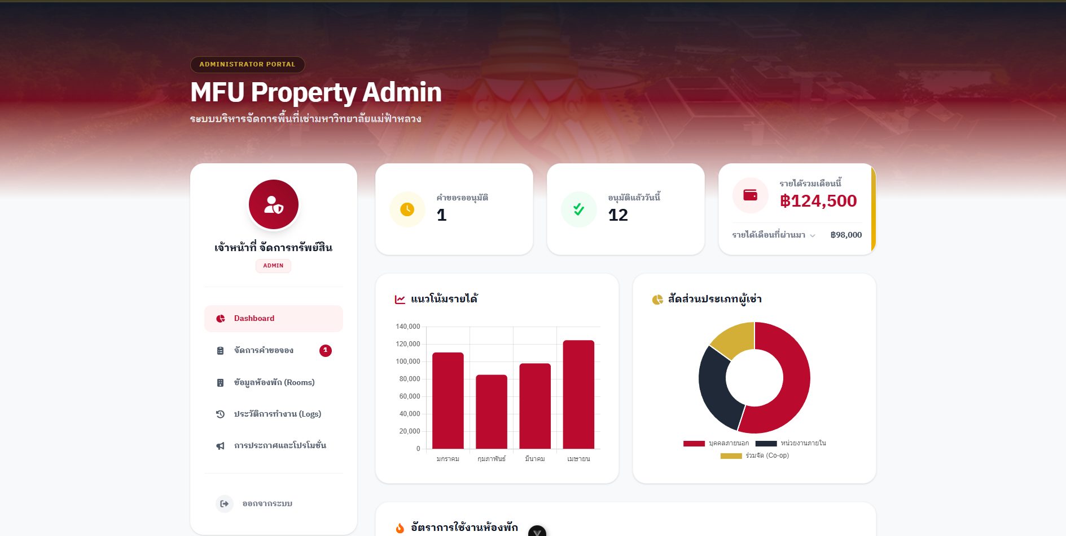
Figure 3.21 User interface for admin dashboard page


Figure 3.22 User interface for admin dashboard page

The admin request page could be demonstrated by a user interface in Figure 3.23 - Figure 3.24
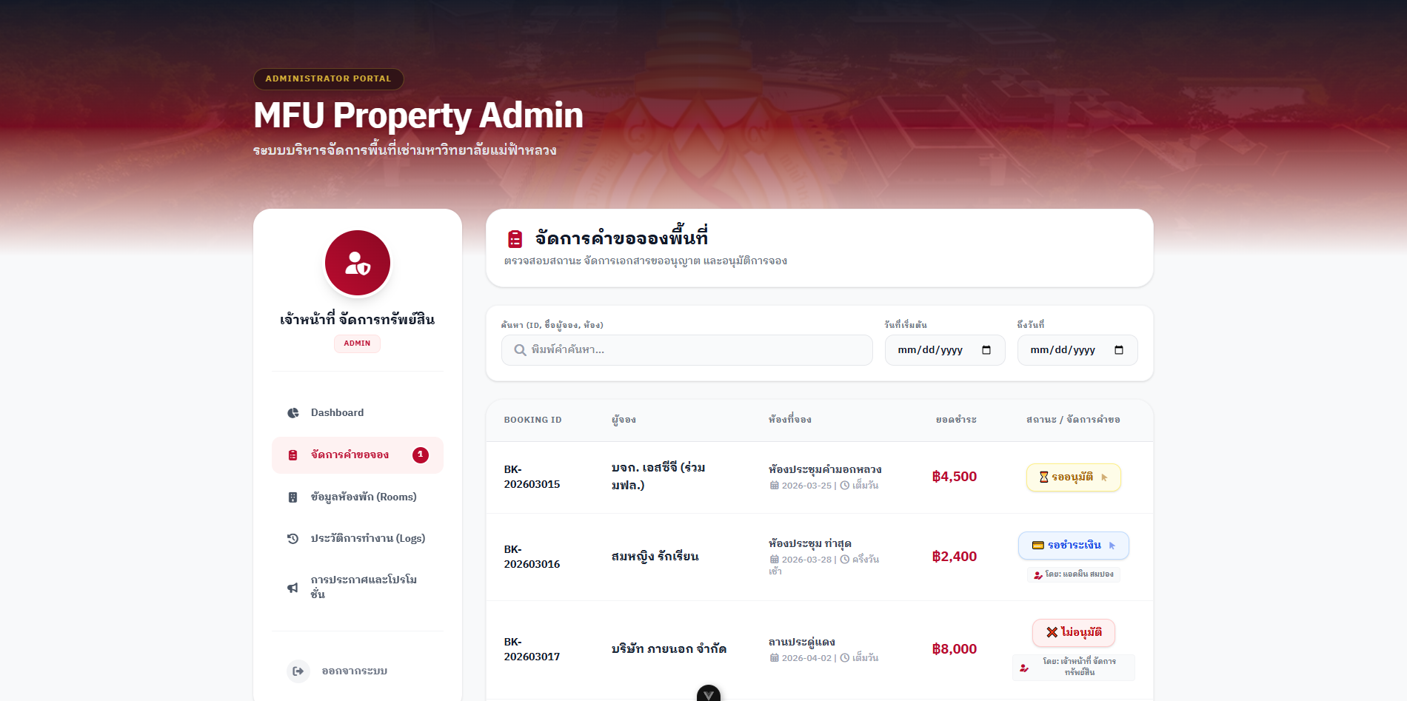
Figure 3.23 User interface for admin request page
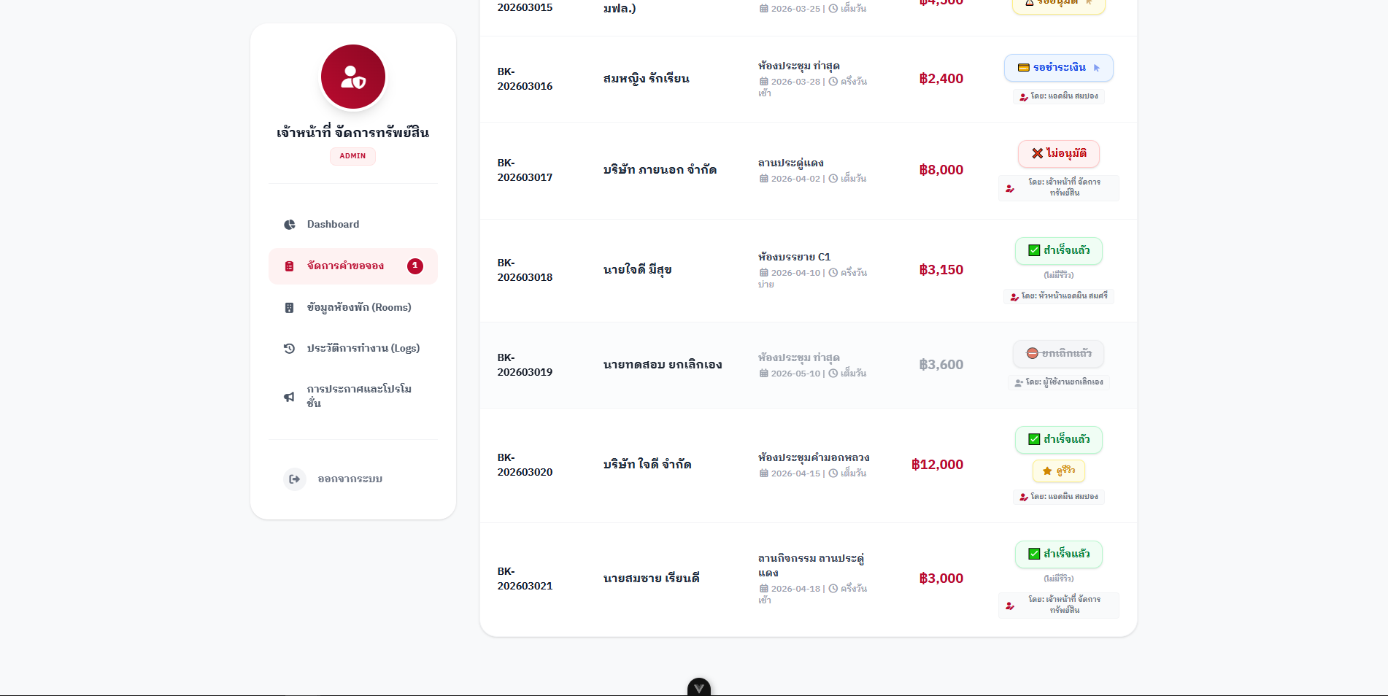
Figure 3.24 User interface for admin request page
The admin edit room page could be demonstrated by a user interface in Figure 3.25
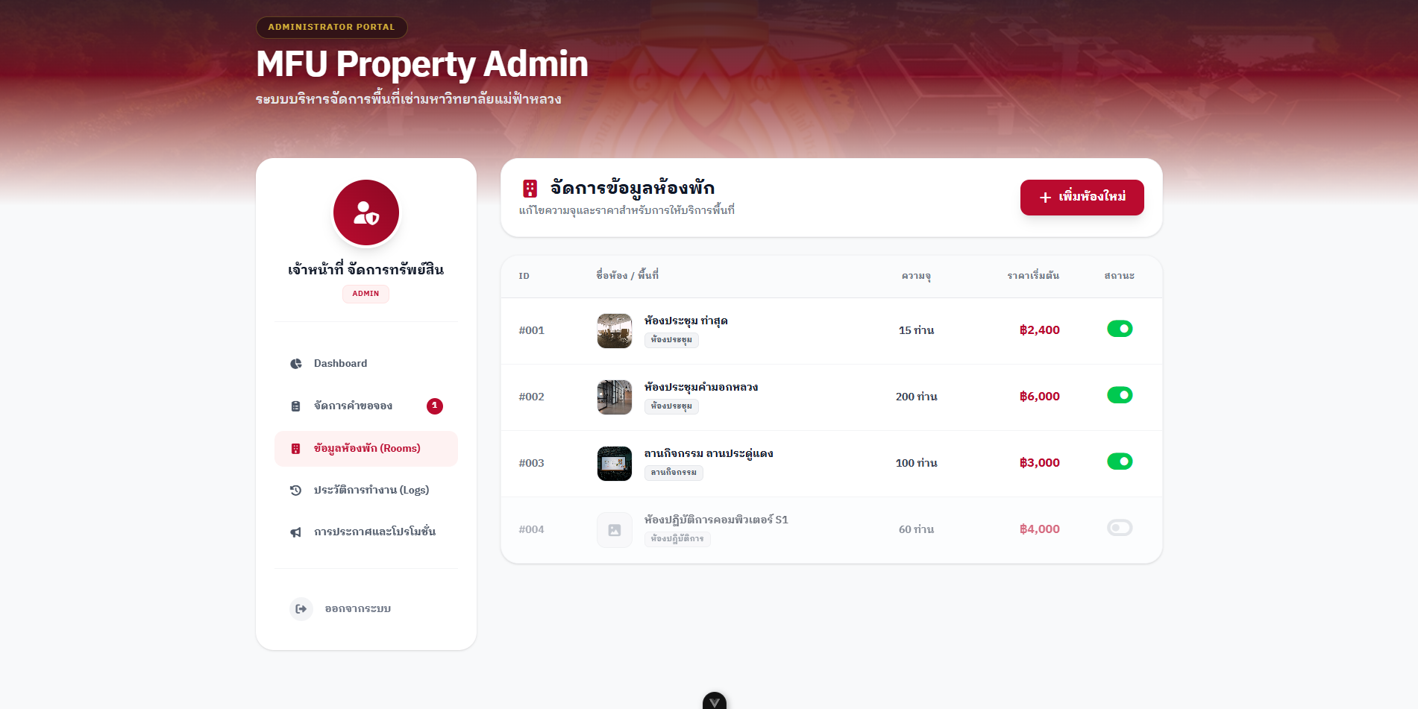
Figure 3.25 User interface for admin edit room page

The admin history activity could be demonstrated by a user interface in Figure 3.26
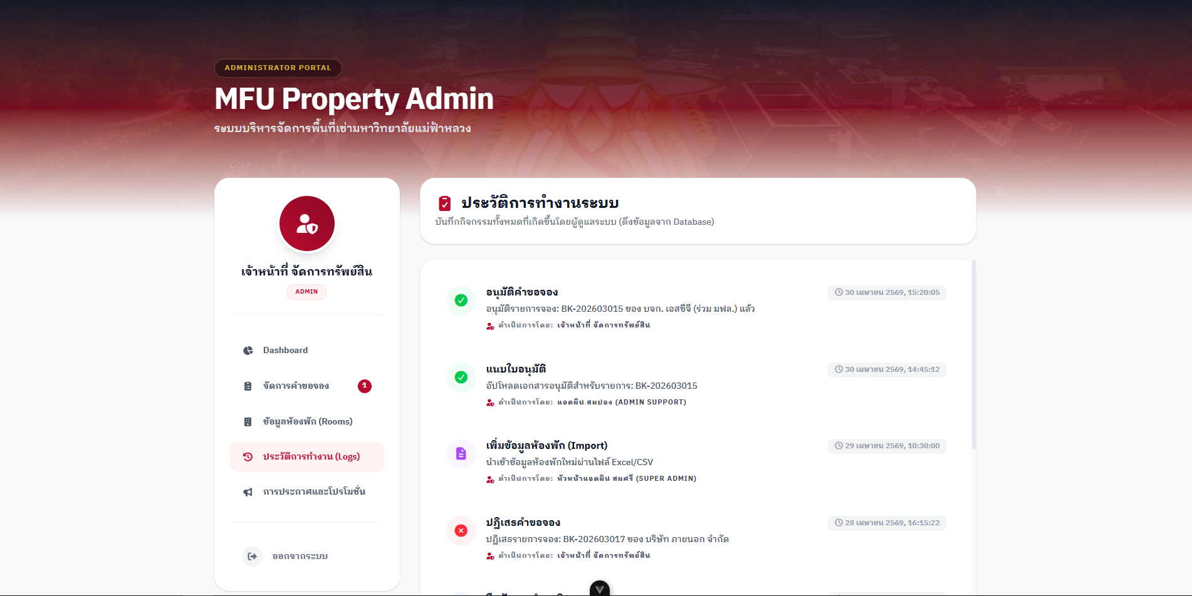
Figure 3.26 User interface for admin history activity page

The admin broadcast and promotions page could be demonstrated by a user interface in Figure 3.27 - Figure 3.28
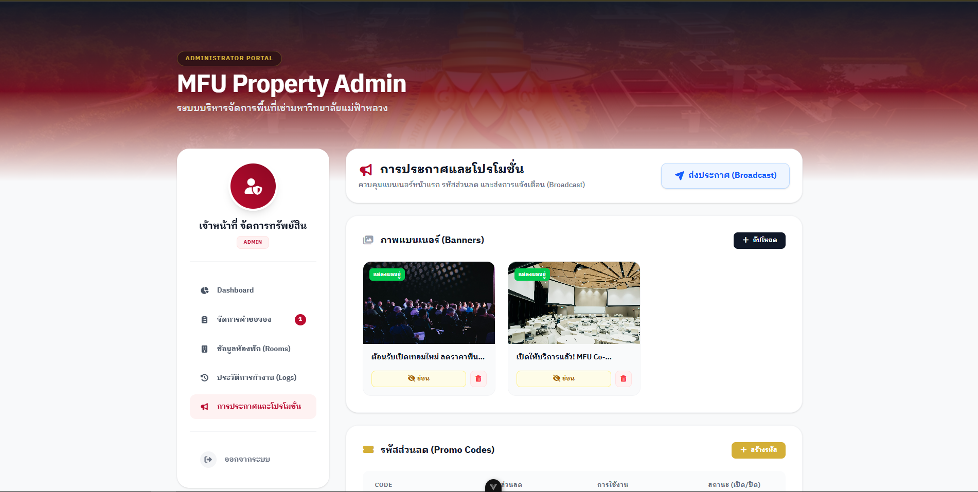
Figure 3.27 User interface for admin broadcast and promotions page
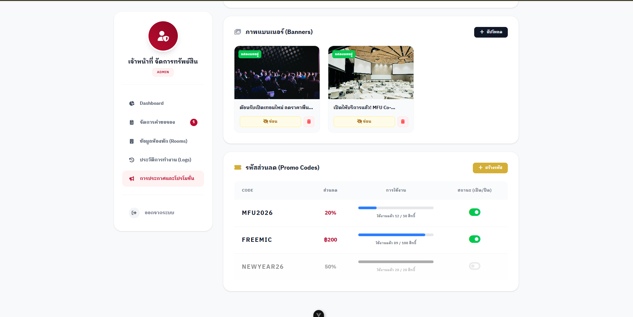
Figure 3.28 User interface for admin broadcast and promotions page

3.5 ER diagram
The database could be demonstrated by an er diagram in Figure 3.29
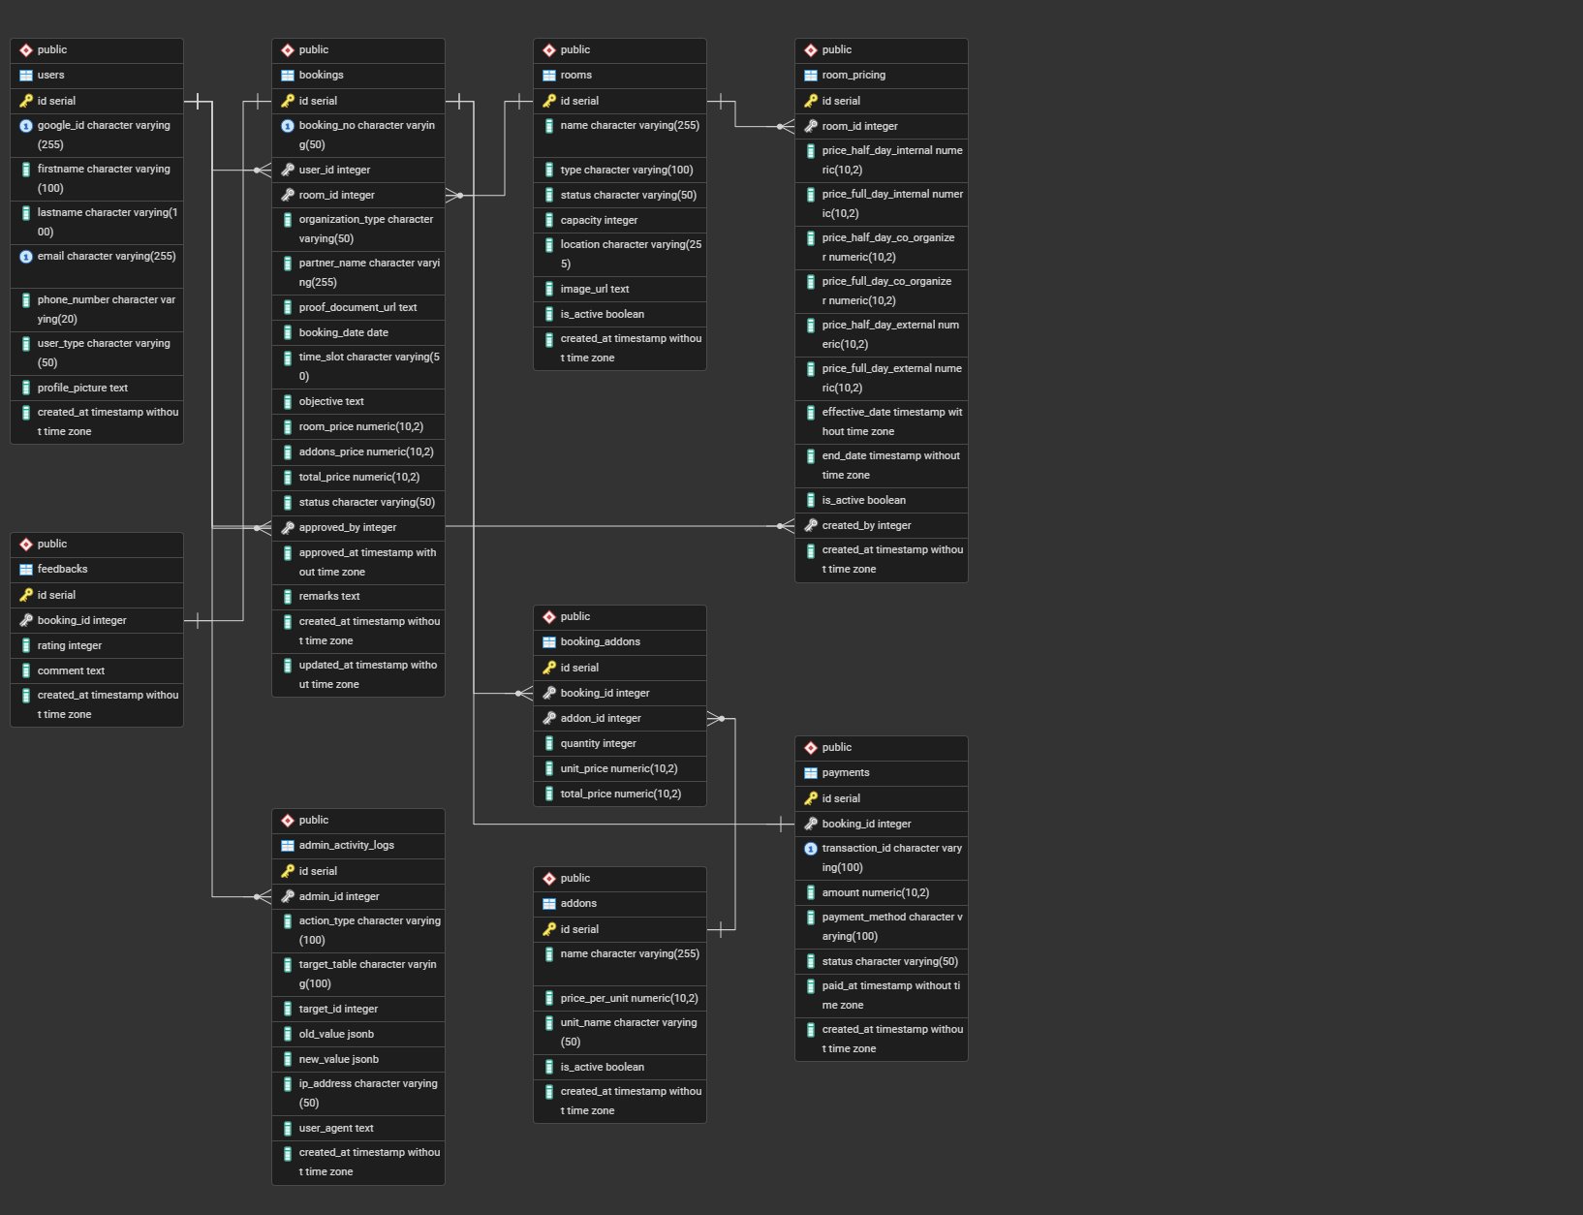
Figure 3.29 ER diagram for database

3.6 Data Dictionary
The database could be demonstrated by a data dictionary in Figure 3.30 – Figure 3.38
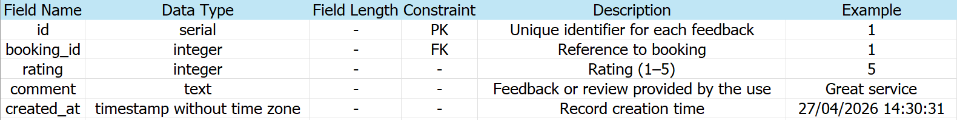
Figure 3.30 Data Dictionary for feedback table
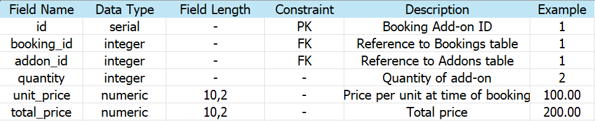
Figure 3.31 Data Dictionary for booking addons table
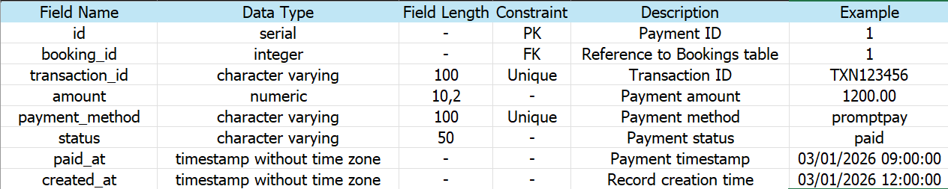
Figure 3.32 Data Dictionary for payments table
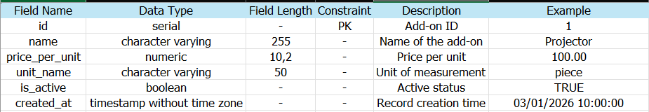
Figure 3.33 Data Dictionary for addons table
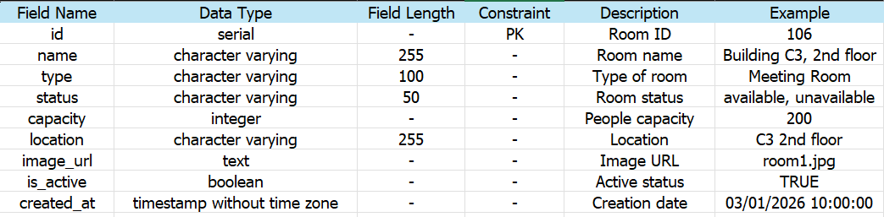
Figure 3.34 Data Dictionary for rooms table
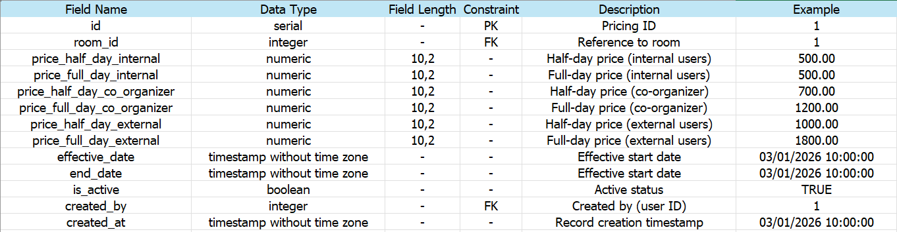
Figure 3.35 Data Dictionary for room pricing table
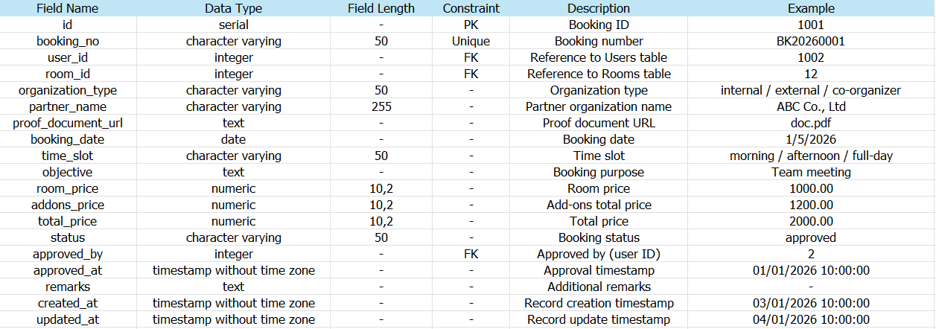
Figure 3.36 Data Dictionary for bookings table
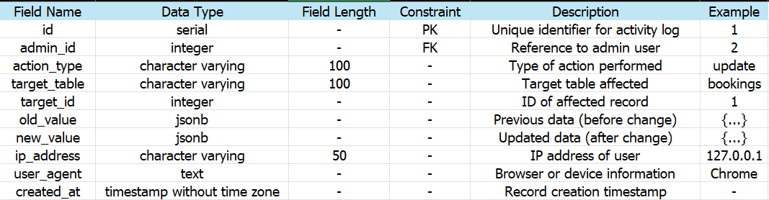
Figure 3.37 Data Dictionary for admin activity log table
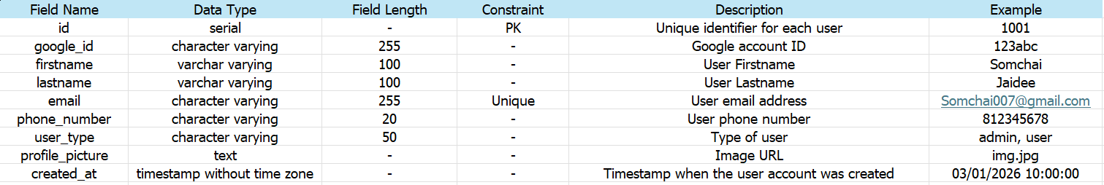
Figure 3.38 Data Dictionary for user table

3.7 Third-Party Service Integrations
The system integrates two major third-party services to enhance security and streamline administrative workflows:
- 3.7.1 Google OAuth 2.0 Authentication The system utilizes Google OAuth 2.0 for Single Sign-On (SSO).
  - Integration: The Node.js backend securely retrieves user profiles via Google's authorization server.
  - Automated Role Assignment: The system assigns roles based on email domains. Emails ending in @mfu.ac.th or @lamduan.mfu.ac.th are registered as "Internal Users," while public domains (e.g., @gmail.com) are "External Users."
- 3.7.2 Payment Gateway Integration To automate payment verification, the system integrates a payment gateway to generate dynamic PromptPay QR codes.
  - Gateway Selection: Opn Payments was selected over 2C2P due to its developer-friendly API, comprehensive Node.js libraries, and an accessible Sandbox environment.
  - Transaction Fee: Opn Payments charges a 1.65% fee (exclusive of VAT) per successful transaction, which must be accounted for in the system's revenue management.
  - Payment Workflow:
    - The Node.js backend requests a dynamic PromptPay QR Code from the Opn Payments API for the total price.
    - The Vue.js frontend displays the generated QR code.
    - After the user pays via mobile banking, Opn Payments sends a secure Webhook to the server.
    - The system validates the Webhook and automatically updates the booking status to "Paid."

CHAPTER 4
CONCLUSION
4.1 Completed Work (January - May 2026)
During the first phase of the project (Senior Project 1), the team successfully established the foundational structure of the Temporary Rental Space Management System. The completed tasks include:
- Requirement Analysis: Gathered and analyzed user requirements based on the existing workflows of the Property Management Division at Mae Fah Luang University.
- System Design: Designed the overall system architecture, relational database schema (PostgreSQL), and user interfaces (UI).
- Prototyping: Developed the initial functional prototype of the web application to demonstrate the core user flows and centralized dashboard concepts.
- Documentation: Prepared the formal Project Proposal and completed the Senior Project 1 examination.
4.2 Future Work Plan (August - December 2026)
For the next phase in Senior Project 2, the team will focus on the full implementation and deployment of the system. The planned tasks include:
- System Development: Fully implement the full-stack web application, seamlessly integrating the Vue.js frontend with the Node.js backend logic.
- Third-Party Integrations: Implement Google OAuth for secure single sign-on (SSO) and integrate the Opn Payments gateway to enable PromptPay QR transactions.
- System Testing and Evaluation: Conduct rigorous software testing to resolve bugs, validate role-based access controls, and ensure the system accurately prevents scheduling conflicts.
- Final Defense: Prepare the official Senior Project 2 documentation and present the finalized system to the examination committee.

