
(PROJECT PROPSAL)

Temporary Rental Space Management System of MFU

PANITI KONNGOEN
PRATHANAKORN PITI

BACHELOR OF ENGINEERING
IN COMPUTER ENGINEERING

MAE FAH LUANG UNIVERSITY
2026
© COPYRIGHT BY MAE FAH LUANG UNIVERSITY
Temporary Rental Space Management System of MFU

PANITI KONNGOEN
PRATHANAKORN PITI

A COMPUTER ENGINEERING PROJECT SUBMITTED TO
MAE FAH LUANG UNIVERSITY IN PARTIAL FULFILLMENT OF
THE REQUIREMENTS FOR THE DEGREE OF
BACHELOR OF ENGINEERING
IN COMPUTER ENGINEERING

MAE FAH LUANG UNIVERSITY
2026
© COPYRIGHT BY MAE FAH LUANG UNIVERSITY

Temporary Rental Space Management System of MFU

PANITI KONNGOEN
PRATHANAKORN PITI

THIS COMPUTER ENGINEERING PROJECT HAS BEE APPROVED
TO BE A PARTIAL FULFILLMENT OF THE REQUIREMENTS
FOR THE DEGREE OF BACHELOR OF ENGINEERING
IN COMPUTER ENGINEERING
2026

EXAMINING COMMITTEE

....................................................................................................... ADVISOR
(Dr. Surapong Uttama)

....................................................................................................... COMMITTEE
(Dr. Paweena Suebsombut)

....................................................................................................... COMMITTEE
(Dr. Khwunta Kirimasthong)

© COPYRIGHT BY MAE FAH LUANG UNIVERSITY

ACKNOWLEDGEMENT

This project was completed with the valuable support and guidance of many individuals. The authors would like to express their sincere gratitude to the advisor and supervisory committee members for their professional guidance, constructive suggestions, and continuous support throughout the project.
The authors also wish to thank Mae Fah Luang University for providing the facilities and resources necessary for this study. Finally, heartfelt appreciation is extended to the authors’ parents and friends for their encouragement and support during the completion of this project.

Paniti Konngoen
Prathanakorn Piti
Title Temporary Rental Space Management System of MFU

Author Mr. Paniti Konngoen
Mr. Prathanakorn Piti

Degree Bachelor of Engineering
(Computer Engineering)

Supervisory Committee Dr. Surapong Uttama Advisor
Dr. Paweena Suebsombut Committee
Dr. Khwunta Kirimasthong Committee

Abstract

This senior project proposes the development of a web-based room reservation system for Mae Fah Luang University. The purpose of this system is to improve the efficiency and convenience of reserving university rooms by providing an online platform for students, lecturers, and staff members.
The system allows users to view room availability, make reservation requests, manage booking schedules, and check reservation status through a user-friendly website. Administrators can manage rooms, approve or reject reservation requests, and monitor system usage.
The developed system aims to reduce manual processes, prevent scheduling conflicts, and enhance overall room management efficiency. System testing results indicate that the website operates according to the defined requirements and can effectively support room reservation activities within the university.

Keyword: Room Reservation System, Web Application, University Management, Online Booking, Mae Fah Luang University
CONTENTS

ACKNOWLEDGEMENT iii
Abstract iv
LIST OF TABLES vi
LIST OF FIGURES vii
CHAPTER 1 INTRODUCTION 1
1.1 Background and Rational 1
1.2 Objective 1
1.3 Scope 1
1.4 Methodology 2
1.5 Plan 2
1.6 Expected Result 3
1.7 Place and Equipment 3
CHAPTER 2 LITERATURE REVIEW 4
2.1 Related Theory 4
2.2 Related Research 4
2.3 Related Work 4
2.4 Related Technology 4
CHAPTER 3 ANALYSIS AND DESIGN 7
3.1 Existing System 7
3.2 New System 7
3.3 Use case diagram 8
3.4 Activity diagram 8
CHAPTER 4 CONCLUSION 10
4.1 Conclusion 10
4.2 Discussion 10
REFERENCES 11

LIST OF TABLES

Table Page
Table 1.1 Working plan 2

LIST OF FIGURES

Figure Page
Figure 2.1 Kinect camera and its sensor [4] 5
Figure 2.2 Example of Processing [6] 5
Figure 3.1 Use case diagram of the existing system 7
Figure 3.2 Use case diagram of the new system 8
Figure 3.3 Activity diagram of the new system 9

INTRODUCTION

Background and Rational
Room reservation management is an essential service in educational institutions, especially in universities where classrooms, meeting rooms, and activity spaces are shared among many users. Traditional reservation methods, such as manual booking or paper-based systems, often lead to scheduling conflicts, inefficient communication, and difficulty in tracking room usage.
With the advancement of web technologies, online reservation systems have become an effective solution for managing shared resources. A web-based room reservation system can provide real-time availability information, reduce administrative workload, and improve accessibility for users.
Therefore, this project focuses on developing a room reservation website for Mae Fah Luang University to enhance the efficiency, accuracy, and transparency of room booking processes.

Objective

To develop a web-based room reservation system for Mae Fah Luang University

To enable users to view room availability and submit reservation requests online
1.2.3 To provide administrators with tools to manage rooms and reservation requests efficiently

Scope

General user
- Check available dates and times and make reservations in advance within the specified time.
- Reservation history.
- Reservation purpose.
- Status notification.
- Cancellation reservation.

1.3.1.1) Inside role (In MFU Organization)

1.3.1.2) Outside role (Out MFU Organization)

Administrator
- Manage rooms (Add/Disable/Edit)
- Update status (Approve/Disapprove)
- Proof Command
  - Attach file from President’s approve.
- Check availability date and time
- Check expenses months/years

Methodology

Proposal preparation and defense

Literature review and requirement gathering

System analysis

System design

Senior project 1 document preparation

Senior Project 1 examiantion

System development

System testing and evaluation

Senior Project 2 document preparation

Senior Project 2 examination

Plan
Table 1.1 Working plan
 | Senior project 1 |  |  |  |  | Senior project 2
Plan/Month | Jan | Feb | Mar | Apr | May | Aug | Sep | Oct | Nov | Dec
Proposal preparation and defense
Literature review and requirement gathering
System analysis
System design
Senior project 1 document preparation
Senior Project 1 examination
System development
System testing and evaluation
Senior project 2 document preparation
Senior Project 2 examination

Expected Result

A web-based room reservation system for Mae Fah Luang University 1.6.2 Users will be able to reserve rooms conveniently through an online platform
1.6.3 Improved efficiency and accuracy in room reservation management

Place and Equipment

Place (Locate the working place such as MFU and/or other places for getting requirements, testing and installing the system)

Hardware (Identify also the minimum specification)

Software (List all target software and version)

LITERATURE REVIEW

Related Theory
Indicate related theories and references (if any). See the next paragraph for an example.
A system design is frequently based on Unified Modeling Language (UML) which includes several diagrams such as Use case diagram [1] and Activity diagram [2].

Related Research
List all related researches and references (if any). Try to group research works than explain each of them. Also mention the differences between your work and the existing research papers.

Related Work
List all related works and references (if any). Also compare the existing works with your work.

Related Technology
Identify both hardware and software required for the project as well as their references. The details should include the target version and you could explain each item separately as a new subtopic.

Kinect [3]
Kinect is a motion-detection camera developed by Microsoft Company. It is designed to let users interact with a videogame player or a computer through body gesture or voice. The camera is equipped with different sensors as shown in Figure 2.1.
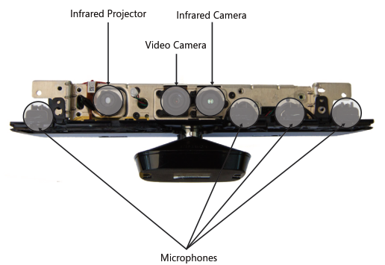
Figure 2.1 Kinect camera and its sensor [4]

Processing [5]
Processing is a programming language and environment used for multimedia and computer graphics. It is an open source designed to support graphics with user interaction. The background and coding format of Processing is based on Java.
An example of Processing is shown in Figure 2.2.

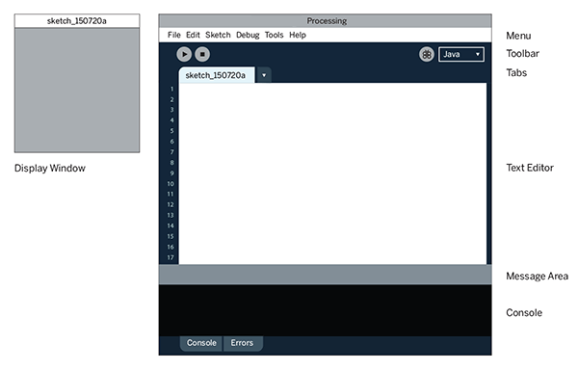
Figure 2.2 Example of Processing [6]
It is not necessary to give too many details of the technology. You must not copy and paste from any source. Read and conclude by your own words.

ANALYSIS AND DESIGN

Existing System
The existing could be demonstrated by a use case diagram in Figure 3.1.

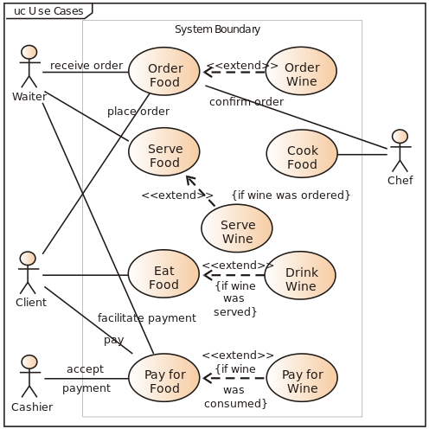

Figure 3.1 Use case diagram of the existing system
Always explain the Figure and give its reference (if the figure is not created by yourself).

New System
Analyze and design the new system. Generally for a system, the analysis and design would include of many diagrams such as Use case diagram, Activity Diagram, Flow chart, ER diagram, Data dictionary and User Interface design. Each of this topic could be a new subtopic (Heading 2).

Use case diagram
After gathering user requirements, the new system could be represented by a use case diagram as shown in Figure 3.2.



Figure 3.2 Use case diagram of the new system
Always explain the Figure and give its reference (if the figure is not created by yourself).

Activity diagram
Analysis of a new system derives an activity diagram as shown in Figure 3.3.
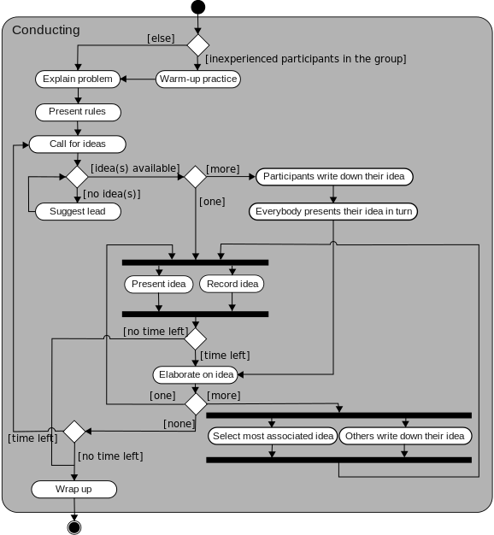
Figure 3.3 Activity diagram of the new system
Always explain the Figure and give its reference (if the figure is not created by yourself).

CONCLUSION

Conclusion
Summarize what you have done in the senior project.

Discussion
Discuss the results. For example, explain your experimental results whether they are accordance with the assumptions and give the reasons. In case of system development, you can discuss the problems and obstacles found during the entire processes including your solutions. Finally mention the suggestion for the further works.

REFERENCES

[1] “Use case diagram - Wikipedia.” [Online]. Available: https://en.wikipedia.org/wiki/Use_case_diagram. [Accessed: 25-Apr-2017].
[2] “Activity diagram - Wikipedia.” [Online]. Available: https://en.wikipedia.org/wiki/Activity_diagram. [Accessed: 25-Apr-2017].
[3] “Kinect - Windows app development.” [Online]. Available: https://developer.microsoft.com/en-us/windows/kinect. [Accessed: 25-Apr-2017].
[4] R. Miles, Start Here! Learn the Kinect API, 1 edition. Sebastopol, California: Microsoft Press, 2012.
[5] “Processing.org.” [Online]. Available: https://processing.org/. [Accessed: 25-Apr-2017].
[6] C. Reas and B. Fry, Processing: A Programming Handbook for Visual Designers and Artists, Second edition edition. Cambridge, Massachusetts: The MIT Press, 2014.

(Please use IEEE reference style)

