11.2

Contiguous Sequential - works very well as the file is stored contiguously

Contiguous Random – works well

Linked Sequential - Works okay since you are following the links from one block to the next

Linked Random - This would be poor as you may need to traverse around the links

Indexed sequential - Works well as sequential access simply involves sequentially accessing each index

Indexed Random - Works well as it is easy to determine the index from the index blocks

11.8

**Disk size**: 8KB

**Pointer size**: 4B

As mentioned in the question, there is 1 single indirect block and 1 doubly indirect block..

**No. of pointers in a block would be** = 84 KB / 4B = 21000

**Total file size:**

12 direct disk block size: 10 * 8KB                         +

1 single indirect size: 1 * 21000 * 8KB                      +

1 doubly indirect size: 1 * 21000* 21000 * 8KB +

1 tripple indirect size 1*21000*21000*8KB=

約663PB

12.3

The following table shows the access order of tracks and the total number of cylinders crossed.

|  |  |  |  |  |  |  |  |  |  |  |  |  |  |  |
| --- | --- | --- | --- | --- | --- | --- | --- | --- | --- | --- | --- | --- | --- | --- |
| Method | 1 | 2 | 3 | 4 | 5 | 6 | 7 | 8 | 9 | 10 | 11 | 12 | 13 | total |
| FCFS | 2150 | 2069 | 1212 | 2296 | 2800 | 544 | 1618 | 356 | 1523 | 4965 | 3681 |  |  | 13011 |
| SSTF | 2150 | 2069 | 2296 | 2800 | 3681 | 4965 | 1618 | 1523 | 1212 | 544 | 356 |  |  | 7586 |
| SCAN | 2150 | 2296 | 2800 | 3681 | 4965 | 4999 | 2069 | 1618 | 1523 | 1212 | 544 | 356 |  | 7492 |
| C-SCAN | 2150 | 2296 | 2800 | 3681 | 4965 | 4999 | 0 | 356 | 544 | 1212 | 1523 | 1618 | 2069 | 9917 |

In SCAN and C-SCAN the 4999 indicates that the disk head has to moved to the last track 4999. In the C-SCAN, the disk head only scan in one direction. As a result, after the desk heads visited the last track 4999 it has to be moved back to the first track 0 and scan in the same direction.

12.10

1. The amount of throughput depends on the number of

disks in the RAID system. A RAID Level 5 comprising of a parity block

for every set of four blocks spread over five disks can support four

to five operations simultaneously. A RAID Level 1 comprising of two

disks can support two simultaneous operations. Of course, there is

greater flexibility in RAID Level 1 as to which copy of a block could be

accessed and that could provide performance benefits by taking into

account position of disk head.

2. RAID Level 5 organization achieves

greater bandwidth for accesses to multiple contiguous blocks since the

adjacent blocks could be simultaneously accessed. Such bandwidth

improvements are not possible in RAID Level 1.

12.12

Frequently updated data need to be stored on RAID Level

1 disks while data which is more frequently read as opposed to being

written should be stored in RAID Level 5 disks.

程式題

11.13

先創file1.txt 跟file3.txt裡面要有內容

檢視file1.txt的內容

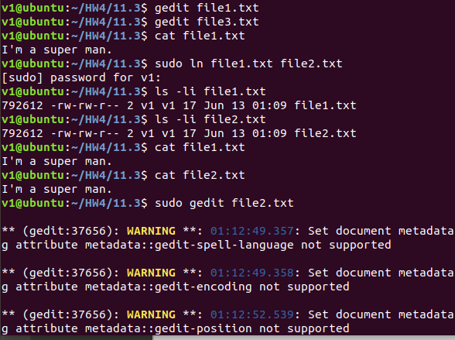

再來檢視file1.txt的inode碼:792612

輸入sudo ln file1.txt file2.txt

檢視file1.txt跟file2.txt的內容是否相同? 相同

檢視file1.txt跟file2.txt的inode碼是否相同?相同

修改file2.txt的內容

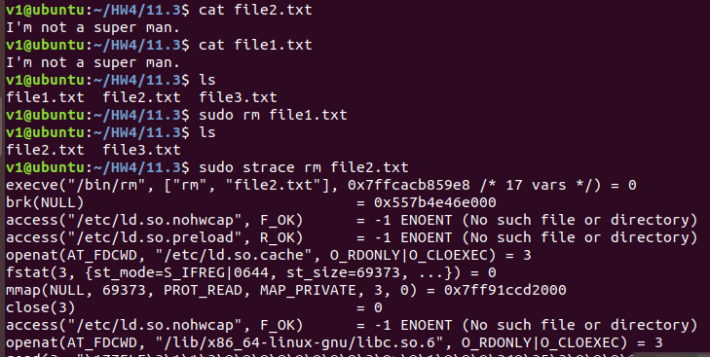

檢查file1.txt的內容

file1跟file2的內容相同

再來移除file1.txt

結果file2.txt沒有被移除

再來追述移除file2.txt

結果剩file3.txt

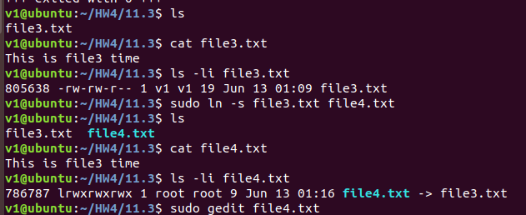

檢視file3.txt的inode碼

再來建立跟file4.txt 的soft link

檢查file4.txt的inode碼是否與file3相同?不同

編輯file4.txt

檢視file4跟file3的內容

結果內容都一樣

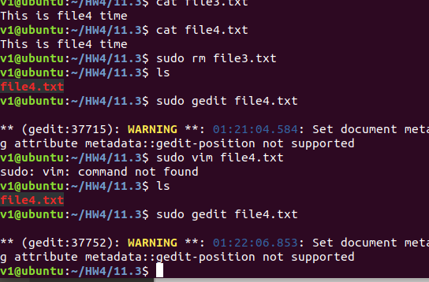

再來嘗試刪除file3.txt看file4能不能編輯

結果file4變成read-only不能編輯

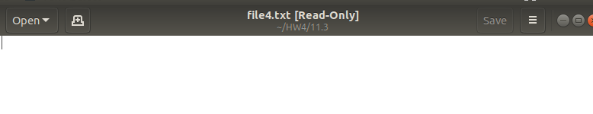

12.16

