**1. Introduction**

In today's fast-paced world, maintaining a healthy lifestyle is crucial. Regular physical activity is essential for overall well-being. However, many individuals struggle to keep track of their fitness activities. The "Fitness Activity Log with Weekly Summary" project aims to provide a simple yet effective solution for users to log their daily fitness activities and view a summary of their weekly performance.

**2. Problem Statement**

Many people find it challenging to monitor their fitness activities consistently. Without a structured way to log activities, individuals may lose motivation or fail to recognize their progress. The primary problems addressed by this project include:

* Lack of a systematic approach to log daily fitness activities.
* Difficulty in tracking progress over time.
* Inability to view a summary of activities to motivate continued engagement in fitness.

**3. Methodologies Used**

The project employs the following methodologies:

* **Data Structures:** A **struct** is used to define an **Activity** that holds the name and duration of each fitness activity.
* **Maps:** A **map** is utilized to store the total duration of each activity logged throughout the week.
* **User Interaction:** The program provides a simple command-line interface for users to log activities and view summaries.
* **Control Flow:** A **do-while** loop is implemented to allow users to continuously log activities or view summaries until they choose to exit.

**4. Code Implementation**

The following C++ code implements the Fitness Activity Log with Weekly Summary:

#include <iostream>

#include <string>

using namespace std;

const int MAX_ACTIVITIES = 10;

struct Activity {

string name;

int duration;

};

void logDailyActivities(Activity weeklyLog[], int& activityCount) {

int numActivities;

cout << "\nEnter the number of activities you want to log today (max " << (MAX_ACTIVITIES - activityCount) << "): ";

cin >> numActivities;

if (activityCount + numActivities > MAX_ACTIVITIES) {

cout << "Cannot log more than " << MAX_ACTIVITIES << " activities.\n";

return;

}

for (int i = 0; i < numActivities; ++i) {

Activity activity;

cout << "Enter activity name: ";

cin >> activity.name;

cout << "Enter duration in minutes: ";

cin >> activity.duration;

weeklyLog[activityCount] = activity;

activityCount++;

}

cout << "\nActivities logged successfully!\n";

}

void displayWeeklySummary(const Activity weeklyLog[], int activityCount) {

cout << "\n===== Weekly Fitness Summary =====\n";

for (int i = 0; i < activityCount; ++i) {

cout << "Activity: " << weeklyLog[i].name << " | Total Time: " << weeklyLog[i].duration << " minutes\n";

}

cout << "=================================\n";

}

int main() {

Activity weeklyLog[MAX_ACTIVITIES];

int activityCount = 0;

int choice;

do {

cout << "\n====== Fitness Activity Log ======\n";

cout << "1. Log Daily Activities\n";

cout << "2. View Weekly Summary\n";

cout << "3. Exit\n";

cout << "Choose an option: ";

cin >> choice;

switch (choice) {

case 1:

logDailyActivities(weeklyLog, activityCount);

break;

case 2:

displayWeeklySummary(weeklyLog, activityCount);

break;

case 3:

cout << "Exiting the program. Stay fit and healthy!\n";

break;

default:

cout << "Invalid choice. Please try again.\n";

}

} while (choice != 3);

return 0;

}

**5. Results**

The program successfully allows users to log their daily fitness activities and view a summary of their weekly performance. Users can input multiple activities, and the program aggregates the total duration for each activity. The summary provides a clear overview of the time spent on various activities, which can help users stay motivated and track their progress.

**Output:**

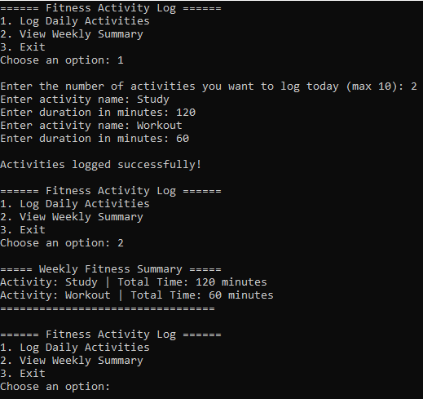

**6. References**

* C++ Programming Language, Bjarne Stroustrup.