# CS 255 Business Requirements Document Template

Pomai Ahlo

## System Components and Design

### Purpose

* DriverPass wants to help people pass driving tests by providing online classes, practice tests, and on the road training.
* They plan to do this with an online system that provides customers with the ability to access materials and book driving appointments. This system is also going to be responsible for managing users and data.

### System Background

* Access data from anywhere with internet access, be it a computer or mobile device.
* There shall be different types of accounts with different privileges:
  + Admin account, which can access everything
  + IT account, which can maintain and modify the system, but without full data access
  + Secretary account, which can access basic user information and create appointments for users.
  + Users, which can access certain materials if they paid for it, and make, modify, or cancel appointments
* In order to troubleshoot potential problems, the system shall also have a log of reservations being made, cancelled, and modified.
* The system shall track the driver, car, and time slot assigned to a user.

### Objectives and Goals

* The system shall be able to print an activity report.
* The system shall be able to register at least one of each account type.
* A secretary and a user shall be able to create, modify, and delete reservations.
* All of the aforementioned tasks shall be possible so long that the user has an internet connection.

## Requirements

### Nonfunctional Requirements

#### Performance Requirements

* This is a web based application. As such, it needs to be able to connect to the internet and update every time a user logs in.
* The processing for each request shall be done within 10 seconds.
* The system shall be available for use at all times.

#### Platform Constraints

* The system shall be able to run on Linux, Mac, and Windows machines as well as mobile devices.
* The system shall use a database to store user information as well as appointment information.

#### Accuracy and Precision

* When logging in, input shall be case-sensitive.
* The system shall notify the admin when there is an outage and when a user has unsuccessfully attempted to log in ten times.

#### Adaptability

* User and appointment data shall be stored in a database.
* The IT officers shall have access to all logs, and all functions related to the creation, deletion, or modification of user data.
* Nothing shall be hard coded into this application.

#### Security

* The system shall validate users using a username and password.
* The system shall encrypt stored user data.
* The system shall use TLS to ensure secure communication between client and server.
* The system shall require a password reset after ten failed login attempts.
* The system shall use a user’s email to authenticate them in order to verify their identity and allow a password reset.

### Functional Requirements

* The system shall validate user credentials upon login.
* The system shall provide customers with a dashboard with their information, driver and test notes, and upcoming appointments.
* The system shall allow the secretary and admin roles to create customer and driver profiles.
* The system shall allow the secretary, customer, and administrator view, modify, cancel, and create appointments.
* The system shall allow the driver to upload notes and update their information.
* The system shall provide the administrator and IT officers with a log of edits to the reservation and user databases.

### User Interface

* A draft of the user interface for the customer is shown below:

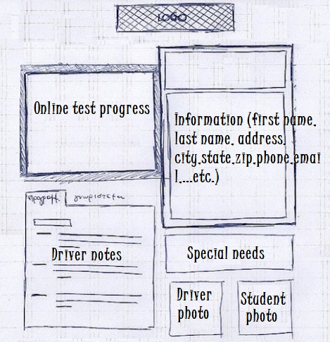

* The secretary’s interface will have the availability to register drivers and customers along with manage reservations.
* The IT officer’s interface will show the status of the system and a button for printing the system logs.
* The administrator’s interface will have a dashboard with a summary of the system, and access to most functions. The administrator will also be able to create and assign Administrator, IT officer and Secretary Users.
* The interface shall be accessed through a web browser either on a phone or a PC.

### Assumptions

* The team assigned to this project have all the required skills.
* Users will have access to their own internet and have stable connections.
* Users will have access to their own devices capable of running the application.

### Limitations

* The system needs to be finished by May.
* The budget is set and cannot be changed.
* The team assigned to this project is the only group of people available to work on the project.
* The system is reliant on a stable internet connection. It will not run without it.

### Gantt Chart

