# CS 255 System Design Document Template

## UML Diagrams

### UML Use Case Diagram

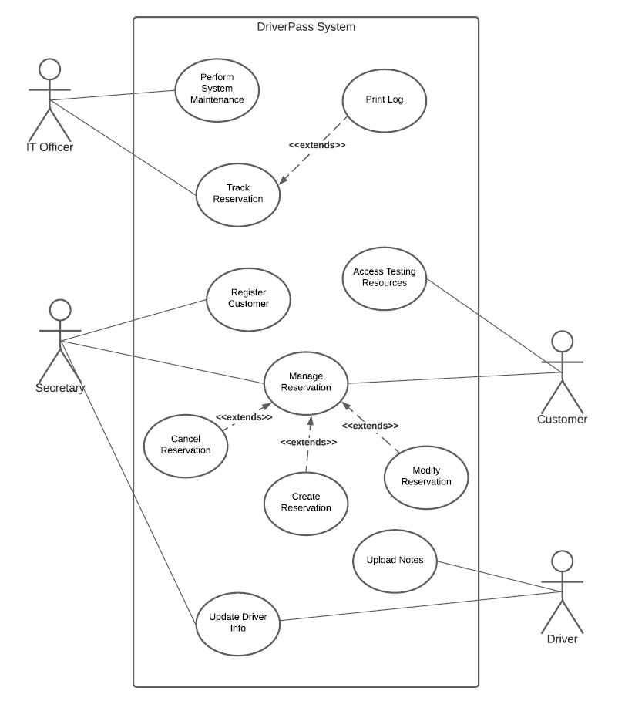

### UML Activity Diagrams

Use Case: Print Log

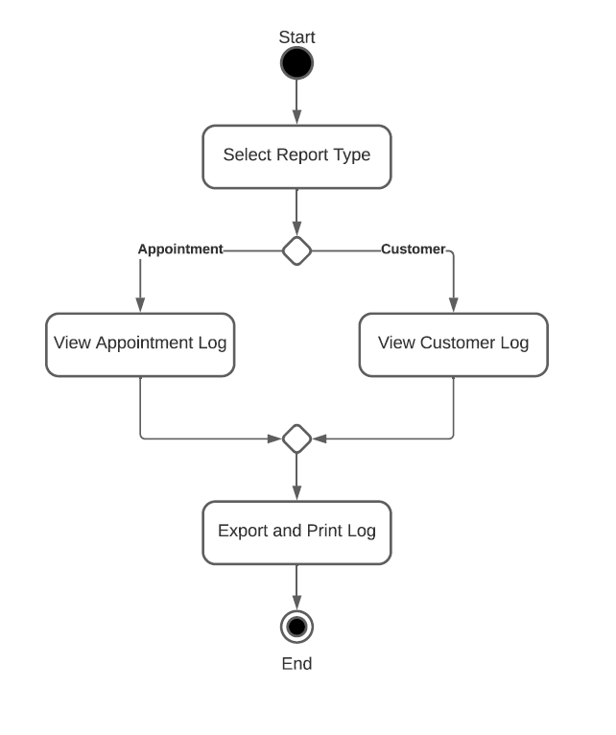

Use Case: Register Customer

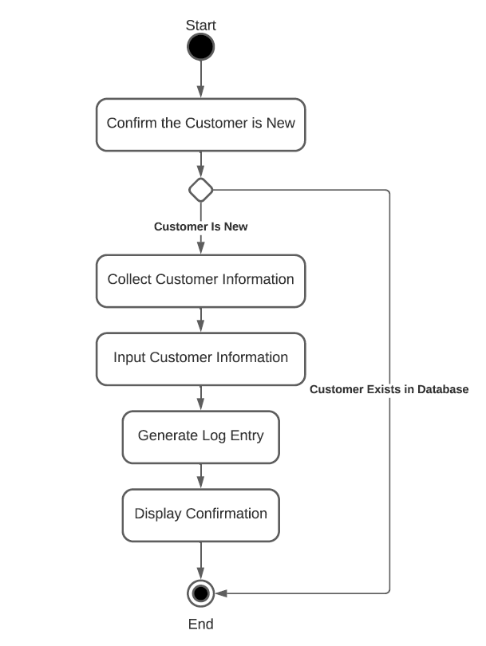

### UML Sequence Diagram

Use Case: Register Customer

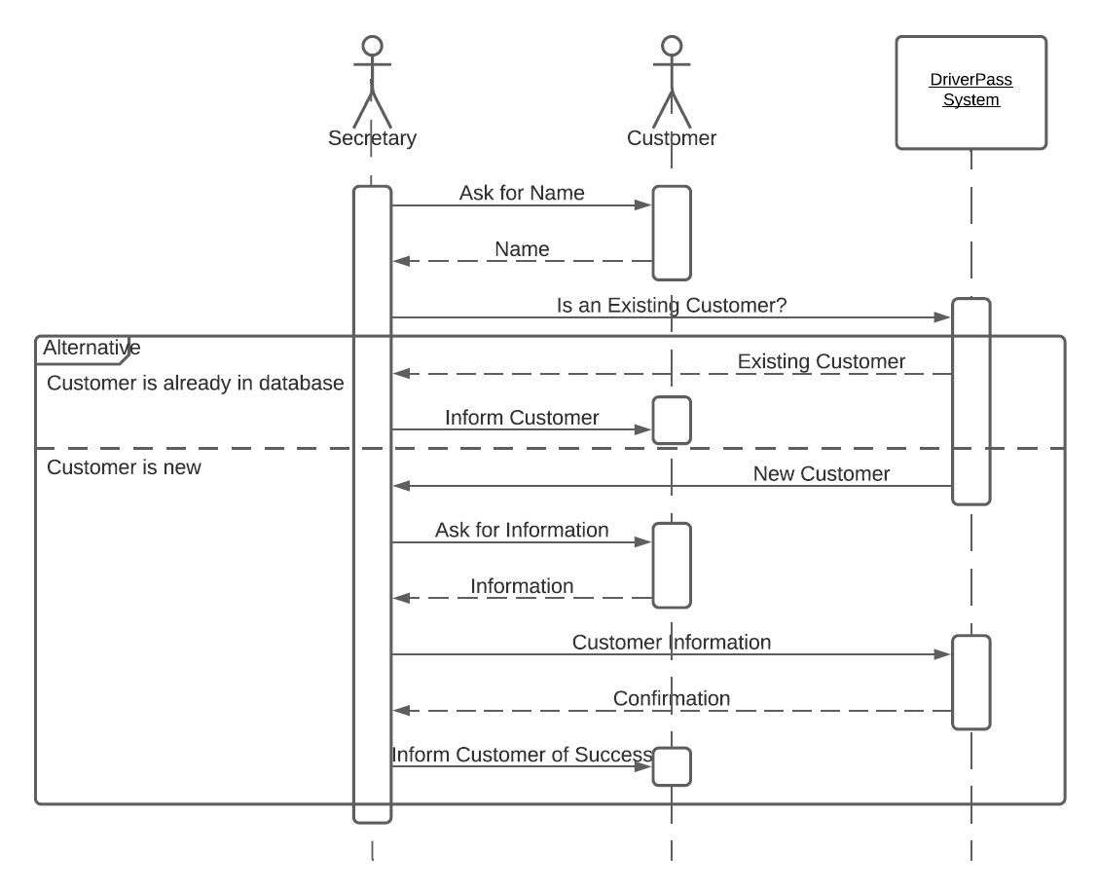

### UML Class Diagram

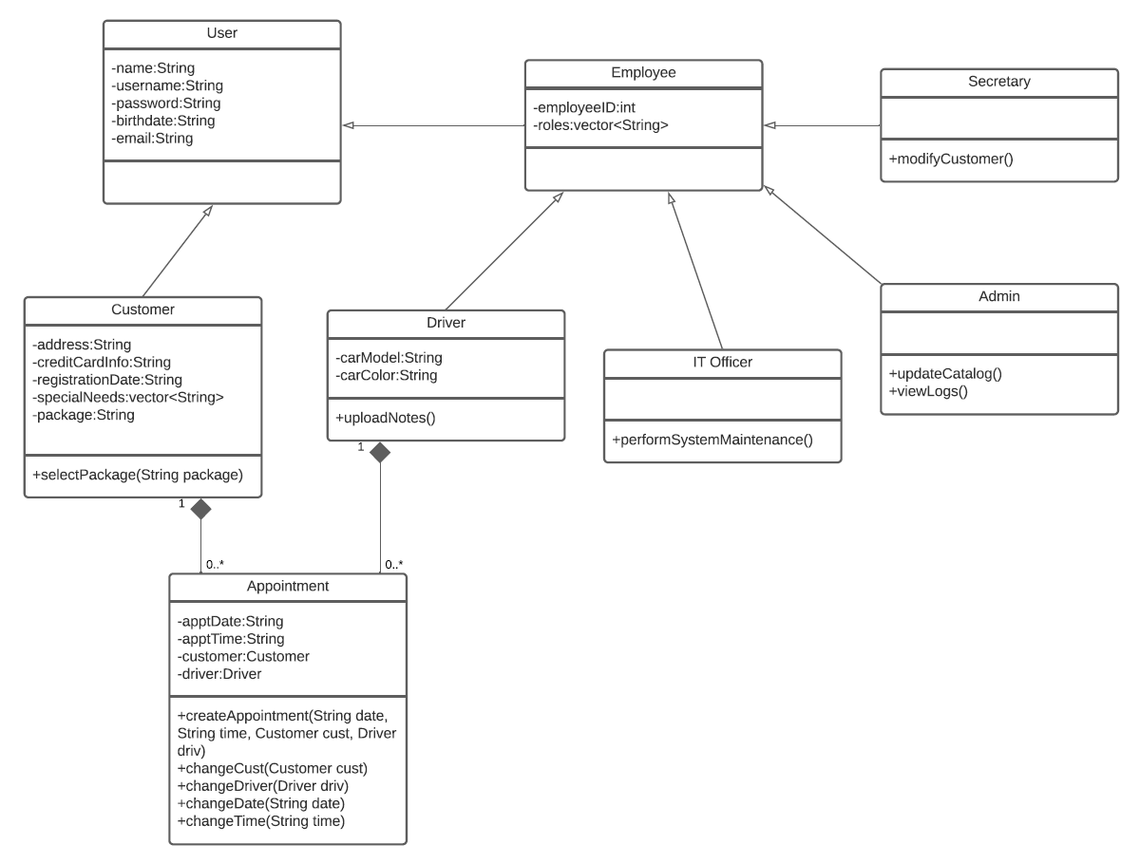

## Technical Requirements

The internet is required for this system. The system will work on many types of machines: mobile devices, Windows, Linux, and Mac computers, and more. In short, as the system needs a functioning web browser to work, and as long as the machine supports that, the software is compatible.