**Arctic Ocean Puzzle and Sea Ice Overlays Script**

**Supplies:** Arctic puzzle, sea ice overlays (x3), polar bear toy (optional)

**Set up:** Start with the puzzle mostly set up, with only a handful of pieces missing.

**Interaction:**

Facilitator (F) : Can you help me finish this puzzle?

*Visitor (V): Stops to finish it*

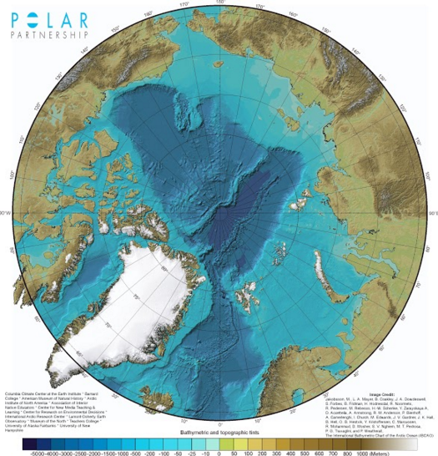

(F): Do you know what ocean this is?

(V): *Thinks*…Arctic?

(F): Right. Can you find the North Pole? *(Starred in image on right)*

(V): *Locates North Pole*…There?

(F) Can you see how deep it is at the North Pole?

(V) *Consulting depth chart*…Wow, 4500 to 5000 meters (or 3 miles or 16,000 feet) deep!

(F): Right. So, it’s a deep area in the middle of the ocean. Is this what you think of when you think of the North Pole?

(V): *Thinks*…No, I think of ice.

(F): Yes, you’re right, it is generally covered by sea ice.Sea ice forms when the water on the surface of the ocean freezes. Every year, sea ice freezes in the winter and melts in the summer. Why do you think sea ice is important?

(V): *Names a reason*… It’s a habitat for animals like polar bears, seals, and walrus…people living in the Arctic use sea ice as a platform for hunting and transportation…sea ice reflects sunlight and heat, helping to keep the temperature of the Earth balanced…etc.

(F): Yes, that’s right! *Takes the ice piece for 1984 –* Can you fit this piece on the puzzle so that it only covers the ocean?

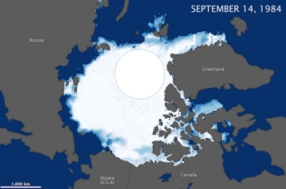(V) *Tries to place piece*…Like that?

(F) *Make sure piece is correctly placed (see image on right for reference)* – Great! Scientists call the area of the ocean covered by at least some sea ice the “sea ice extent”. Usually, the maximum extent happens in March, and the minimum extent happens in September. This is the minimum extent from September of 1984. But, because the Arctic is warming up quickly, it’s been shrinking since then.

(F) *Remove the 1984 piece and take out the ice piece for 2012 –* This is what the sea ice looked like just a couple of years ago in September of 2012. That is the lowest sea ice minimum extent on record. We’ve been measuring sea ice extent using satellites since the 1970’s. Where to you think it fits?

(V) *Tries to place piece*…There?

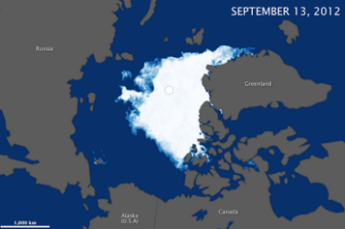

(F) *Make sure piece is correctly placed (see image on left for reference)* - Right. *Remove the 2012 piece and* *take out the ice piece for 2050 –* Based on scientific research, this is the projected sea ice extent for summertime 2050. Can you show me where you think it fits?

(V) *Tries to place piece*…Maybe here?

(F) *Make sure piece is correctly placed (see image below for reference)* – Yes, that’s right. The wind and ocean currents in current in the Arctic move the sea ice around, and it piles up over here against Canada and Greenland. Scientists call this the “Last Ice Area”. If we know that this might be the last place, at least for a while, that we’ll have Arctic sea ice in the summertime, what do you think we might want to do with this area?

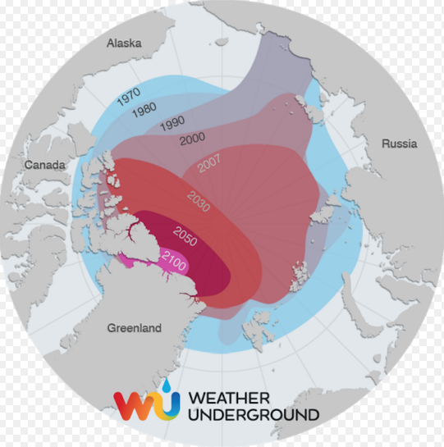(V) Gives an idea…Protect it…Reduce warming…etc.

(F) That’s right. If we protect this area (from things like shipping and oil/gas exploration), the people and animals that depend on it can continue to use it. And, if we reduce warming (by doing things like switching to renewable energy and reducing carbon pollution), we might even be able to help increase the amount of Arctic sea ice in the future.