
DOC-SLA-2026-000482

Software Licensing Agreement

Title Software Licensing Agreement  Counterparty Name TechSolutions Inc.  Category Technology / Licensing  Risk Baseline Medium  Effective Date August 1, 2026  Expiration Date July 31, 2027  Owner User ID U12345  Tags software, licensing, annual, renewal  Counterparties TechSolutions Inc., GlobalSoft Ltd.  Document ID DOC-SLA-2026-000482 | 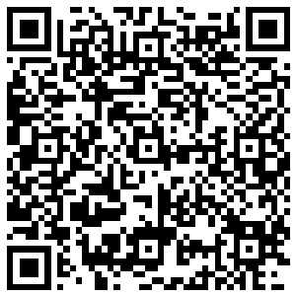  Scan for record lookup

Agreement Overview
This Software Licensing Agreement ("Agreement") is entered into between TechSolutions Inc. ("Licensor") and GlobalSoft Ltd. ("Licensee") effective as of August 1, 2026. The purpose of this Agreement is to grant Licensee the rights to use Licensor’s proprietary software under the terms and conditions outlined herein.

Key Terms
- License Grant: Licensor hereby grants Licensee a non-exclusive, non-transferable license to use the software for internal business purposes.
- Term: The Agreement shall remain in effect until July 31, 2027, unless terminated earlier in accordance with the provisions herein.
- Fees: Licensee agrees to pay an annual licensing fee of $50,000, payable within 30 days of the Effective Date.
- Confidentiality: Both parties agree to maintain the confidentiality of proprietary information exchanged under this Agreement.
- Termination: Either party may terminate this Agreement with 30 days’ written notice in the event of a material breach.

Risk Baseline
This Agreement has been assessed as Medium Risk, primarily due to dependency on proprietary technology and annual renewal obligations.

Signatures
Licensor: TechSolutions Inc.
Authorized Representative: _____________________
Date: _____________________
Licensee: GlobalSoft Ltd.
Authorized Representative: _____________________
Date: _____________________

