延畢檢測站 - ntou cse畢業檢測

# 系統功能介紹

畢業將至，但我們需要透過繁雜的判斷才能確定自己是否達到畢業門檻，有些人甚至到大四，才發現有課沒修，未達畢業門檻，因此我們製作了一個系統讓資工系學生能夠填寫自己的修課資料，幫助資工系的學生判斷自己是否達到畢業門檻。為簡化起見，本系統僅適用於111年入學的資工系學生，且游泳與英文畢業門檻、服務學習不在檢測範圍內。

# SQL DDL 和範例資料

**student表格**

1. CREATE TABLE `student` (
2. `student_ID` VARCHAR(255) NOT NULL,
3. `name` VARCHAR(255) NOT NULL,
4. PRIMARY KEY (`student_ID`)
5. ) ENGINE=InnoDB DEFAULT CHARSET=utf8;

|  |  |
| --- | --- |
| student_ID | name |
| 01257011 | 邱函函 |
| 01357018 | 郭函函 |
| 01057016 | 陳函函 |

[student_ID] 記錄各學生學號，為Primary Key。

[name] 記錄各學生姓名。

**course 表格**

1. CREATE TABLE 'course' (
2. 'course_ID' VARCHAR(255) NOT NULL,
3. 'course_name' VARCHAR(255) NOT NULL,
4. 'dept_name' VARCHAR(255) NOT NULL,
5. 'credit' INT NOT NULL,
6. 'required' BOOLEAN,
7. 'core' BOOLEAN,
8. 'field' ENUM('Personality', 'Democracy', 'Global', 'History', 'Aesthetics', 'Technology', 'Nature', 'Classics') DEFAULT NULL,
9. PRIMARY KEY ('course_ID')
10. ) ENGINE=InnoDB DEFAULT CHARSET=utf8;

|  |  |  |  |  |  |  |
| --- | --- | --- | --- | --- | --- | --- |
| course_ID | course_name | credit | dept_name | required | core | field |
| B5703N54 | 資料庫系統 | 3 | CSE | 0 | 1 | null |
| B57030OI | 圖論演算法 | 3 | CSE | 0 | 0 | null |
| B5703660 | 作業系統 | 3 | CSE | 1 | 0 | null |
| B5101M9J | 微積分(一) | 3 | CSE | null | null | null |
| B5303S05 | 數值方法 | 3 | EE | null | null | null |
| B9K014DF | 國文（上）（國文領域） | 2 | LL | null | null | null |
| B9D01968 | 英文(大一英文) | 2 | LL | null | null | null |
| B9K020AX | 法文(一) | 2 | LL | null | null | null |
| B9M01ZGM | 混沌學入門 | 2 | LI | null | null | 科技 |
| B9M01ZKT | 海洋事務概論 | 2 | LI | null | null | 全球 |
| B9M01ZGL | 海洋社會科學概論 | 2 | LI | null | null | 科技 |
| B92F2G10 | 桌球(初) | 0 | PE | null | null | null |
| B92G2G10 | 桌球(初) | 0 | PE | null | null | null |

[course_ID] 記錄各課程課號，為Primary Key。

[course_name] 記錄各課程名稱。

[credit] 記錄各課程學分數。

[dept_name] 記錄開課系所

[required] 記錄是否為必修課，`是’為1，`否’為0。

[core] 記錄是否為核心選修，`是’為1，`否’為0。

[field] 此課程所在的領域，共有8個領域，分別為人格培育與多元文化(人格)、民主法治與公民意識(民主)、全球化與社經結構(全球)、中外經典(經典)、美學與美感表達(美學)、科技與社會(科技)、自然科學(自然)、歷史分析與詮釋(歷史)

**my_course**

1. CREATE TABLE `my_course` (
2. `student_ID` VARCHAR(255) NOT NULL,
3. `course_ID` VARCHAR(255) NOT NULL,
4. PRIMARY KEY (`student_ID`, `course_ID`),
5. FOREIGN KEY (`student_ID`) REFERENCES `student`(`student_ID`),
6. FOREIGN KEY (`course_ID`) REFERENCES `course`(`course_ID`)
7. ) ENGINE=InnoDB DEFAULT CHARSET=utf8;

|  |  |
| --- | --- |
| student_ID | course_ID |
| 01257011 | B9M01ZGL |
| 01257011 | B92F2G10 |
| 01357018 | B92F2G10 |

[student_ID] 記錄各學生學號。

[course_ID] 記錄各課程課號。

# SQL DML

* **插入student資料**

1. INSERT INTO student (student_ID, name) VALUES
2. ('01257011', '陳函函'),
3. ('01357018', '邱函函'),
4. ('01057016', '郭函函');

* **插入course資料**

1. INSERT INTO course (course_ID, course_name, credit, dept_name, required, core, field) VALUES
2. ('B5703N54', '資料庫系統', 3, 'CSE', 0, 1, NULL),
3. ('B57030OI', '圖論演算法', 3, 'CSE', 0, 0, NULL),
4. ('B5703660', '作業系統', 3, 'CSE', 1, 0, NULL),
5. ('B5101M9J', '微積分(一)', 3, 'CSE', 1, 0, NULL), -- 系內微積分
6. ('B8888888', '微積分(一)', 3, 'CNCE', NULL, NULL, NULL), -- 外系微積分(在電資、工學院)
7. ('B7777777', '微積分(二)', 3, 'TS', NULL, NULL, NULL), -- 外系微積分(非電資、工學院)
8. ('B92G2G10', '桌球(初)', 0, 'PE', NULL, NULL, NULL),
9. ('B9M01ZKT', '海洋事務概論', 2, 'LI', NULL, NULL, '科技');

* **插入學生修課資料**

1. INSERT INTO my_course (student_ID, course_ID) VALUES
2. ('01257011', 'B5703N54'), -- 陳函函修資料庫系統
3. ('01257011', 'B5703660'), -- 陳函函修作業系統
4. ('01357018', 'B5703N54'), -- 邱函函修資料庫系統
5. ('01357018', 'B57030OI'), -- 邱函函修圖論演算法
6. ('01357018', 'B5703660'), -- 邱函函修作業系統
7. ('01357018', 'B9M01ZKT'), -- 邱函函修海洋事務概論
8. ('01357018', 'B8888888'), -- 邱函函修微積分(一)(外系)
9. ('01357018', 'B7777777'), -- 邱函函修微積分(二)(外系)(不是指定系開的)
10. ('01057016', 'B57030OI'), -- 郭函函修圖論演算法
11. ('01057016', 'B92G2G10'), -- 郭函函修桌球(初)
12. ('01057016', 'B9M01ZKT'); -- 郭函函修海洋事務概論

* **顯示邱函函(學號01357018)已修過的所有課程**

1. SELECT s.student_ID, s.name, c.course_ID, c.course_name, c.credit, c.dept_name, c.required, c.core, c.field
2. FROM my_course AS mc
3. JOIN student AS s ON mc.student_ID = s.student_ID
4. JOIN course AS c ON mc.course_ID = c.course_ID
5. WHERE s.student_ID = '01357018';

* **顯示邱函函修過的必修課**

1. SELECT c.course_ID, c.course_name, c.credit, c.dept_name
2. FROM my_course AS mc
3. JOIN course AS c ON mc.course_ID = c.course_ID
4. WHERE mc.student_ID = '01357018'
5. AND (
6. c.required = 1 OR
7. (c.course_name IN ('微積分(一)', '微積分(二)') AND c.dept_name IN ('CSE', 'CNCE', 'EE'))
8. );

* **顯示邱函函修過的選修課**

1. SELECT c.course_ID, c.course_name, c.credit, c.dept_name
2. FROM my_course AS mc
3. JOIN course AS c ON mc.course_ID = c.course_ID
4. WHERE mc.student_ID = '01357018'
5. AND (
6. c.required = 0 OR c.required IS NULL
7. AND NOT (c.course_name IN ('微積分(一)', '微積分(二)') -- 把可以算是必修微積分扣掉
8. AND c.dept_name IN ('CSE', 'CNCE', 'EE'))
9. );

* **顯示邱函函已修的系內選修**

1. SELECT c.course_ID, c.course_name, c.credit, c.dept_name
2. FROM my_course AS mc
3. JOIN course AS c ON mc.course_ID = c.course_ID
4. WHERE mc.student_ID = '01357018' AND c.required = 0;

* **顯示邱函函已修的系外選修**

1. SELECT c.course_ID, c.course_name, c.credit, c.dept_name
2. FROM my_course AS mc
3. JOIN course AS c ON mc.course_ID = c.course_ID
4. WHERE mc.student_ID = '01357018'
5. AND c.required IS NULL
6. AND NOT (c.course_name IN ('微積分(一)', '微積分(二)')
7. AND c.dept_name IN ('CSE', 'CNCE', 'EE'));

* **顯示邱函函修過的體育課**

1. SELECT c.course_ID, c.course_name, c.credit, c.dept_name
2. FROM my_course AS mc
3. JOIN course AS c ON mc.course_ID = c.course_ID
4. WHERE mc.student_ID = '01357018'
5. AND c.dept_name = 'PE';

* **顯示邱函函修過的通識課**

1. SELECT c.course_ID, c.course_name, c.credit, c.dept_name, c.field
2. FROM my_course AS mc
3. JOIN course AS c ON mc.course_ID = c.course_ID
4. WHERE mc.student_ID = '01357018'
5. AND c.dept_name = 'LI';

* **顯示邱函函修過的語言課**

1. SELECT c.course_ID, c.course_name, c.credit, c.dept_name, c.field
2. FROM my_course AS mc
3. JOIN course AS c ON mc.course_ID = c.course_ID
4. WHERE mc.student_ID = '01357018'
5. AND c.dept_name = 'LL'

* **顯示邱函函修過的核心選修**

1. SELECT c.course_ID, c.course_name, c.credit, c.dept_name
2. FROM my_course AS mc
3. JOIN course AS c ON mc.course_ID = c.course_ID
4. WHERE mc.student_ID = '01357018' AND c.core = 1;

* **修改課號為B5703N54的課程名稱**

1. UPDATE course
2. SET course_name = '資料庫系統(改)'
3. WHERE course_ID = 'B5703N54';

* **刪除陳函函課號為B9M01ZKT的課程**

1. DELETE FROM my_course
2. WHERE student_ID = '01257011' AND course_ID = 'B5703660';

* **顯示邱函函各種類學分數/課程數的統計**

1. SELECT
2. mc.student_ID,
3. SUM(CASE
4. WHEN c.required = 1 OR
5. (c.course_name IN ('微積分(一)', '微積分(二)') AND c.dept_name IN ('CSE', 'CNCE', 'EE'))
6. THEN c.credit
7. ELSE 0
8. END) AS 必修_學分,
9. SUM(CASE WHEN c.dept_name = 'CSE' AND c.required = 0 THEN c.credit ELSE 0 END) AS 系內選修_學分,
10. SUM(CASE WHEN c.core = 1 THEN c.credit ELSE 0 END) AS 核心選修_學分_包含在系內選修,
11. SUM(CASE
12. WHEN c.required IS NULL AND
13. NOT (c.course_name IN ('微積分(一)', '微積分(二)') AND
14. c.dept_name IN ('CSE', 'CNCE', 'EE')) AND
15. c.dept_name <> 'PE' AND
16. c.dept_name <> 'LI'
17. THEN c.credit
18. ELSE 0
19. END) AS 系外選修_學分,
20. SUM(CASE WHEN c.dept_name = 'LL' THEN c.credit ELSE 0 END) AS 語文_學分_包含在系外選修,
21. SUM(CASE WHEN c.dept_name = 'LI' THEN c.credit ELSE 0 END) AS 通識_學分,
22. SUM(CASE WHEN c.dept_name = 'PE' THEN 1 ELSE 0 END) AS 體育_門,
23. -- 加總
24. SUM(CASE
25. WHEN c.required = 1 OR
26. (c.course_name IN ('微積分(一)', '微積分(二)') AND c.dept_name IN ('CSE', 'CNCE', 'EE'))
27. THEN c.credit
28. ELSE 0
29. END) +
30. SUM(CASE WHEN c.dept_name = 'CSE' AND c.required = 0 THEN c.credit ELSE 0 END) +
31. SUM(CASE
32. WHEN c.required IS NULL AND
33. NOT (c.course_name IN ('微積分(一)', '微積分(二)') AND
34. c.dept_name IN ('CSE', 'CNCE', 'EE')) AND
35. c.dept_name <> 'PE' AND
36. c.dept_name <> 'LI'
37. THEN c.credit
38. ELSE 0
39. END) +
40. SUM(CASE WHEN c.dept_name = 'LI' THEN c.credit ELSE 0 END) AS 總學分
41. FROM my_course AS mc
42. JOIN course AS c ON mc.course_ID = c.course_ID
43. WHERE mc.student_ID = '01357018'
44. GROUP BY mc.student_ID;

# 網站結構

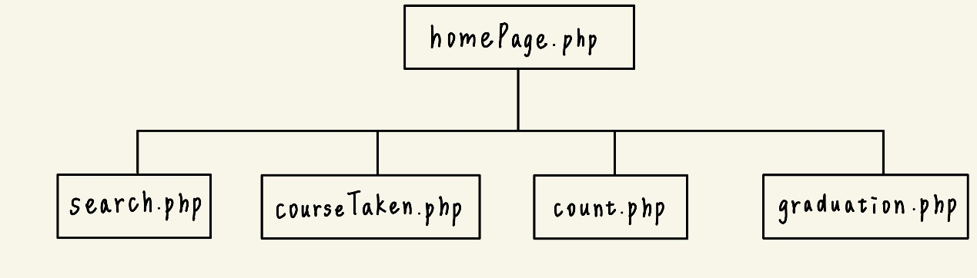

1. homePage.php為首頁。
2. search.php用來方便學生查詢課程。
3. courseTaken.php讓學生能夠新增、刪除、修改課程。
4. count.php計算總學分以及檢測學生是否達到畢業門檻。
5. graduation.php 顯示畢業門檻資料，幫助學生更了解畢業門檻。

# 畫面設計

首頁(homePage.php)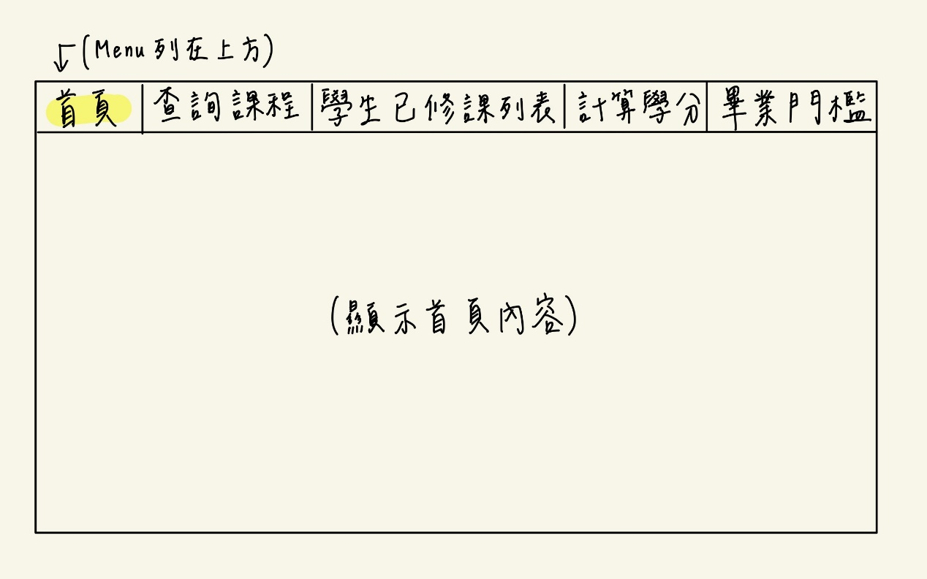

讓使用者可以查詢課程(search.php)

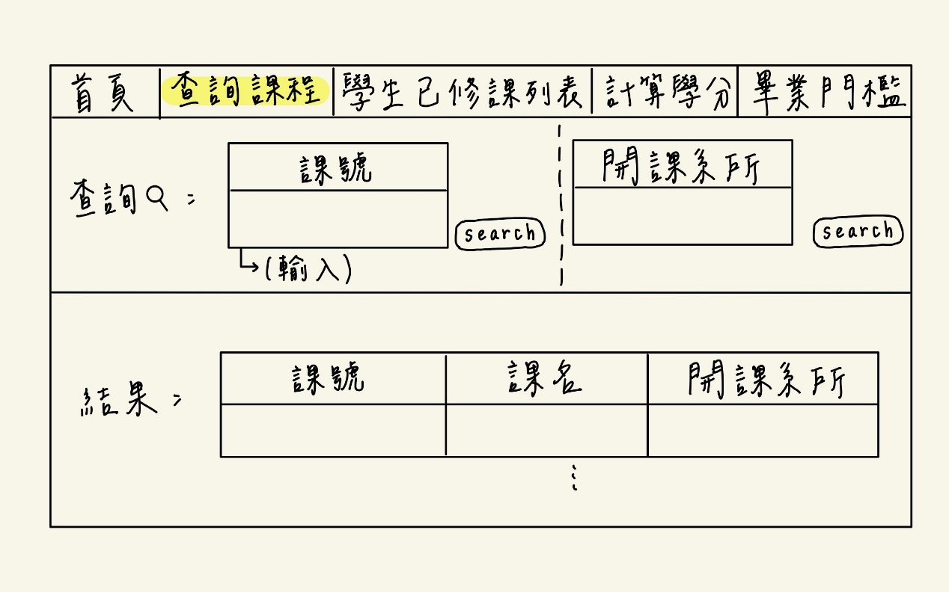

讓學生能新增、刪除、修改課程，並顯示該學生已修課列表。(courseTaken.php)

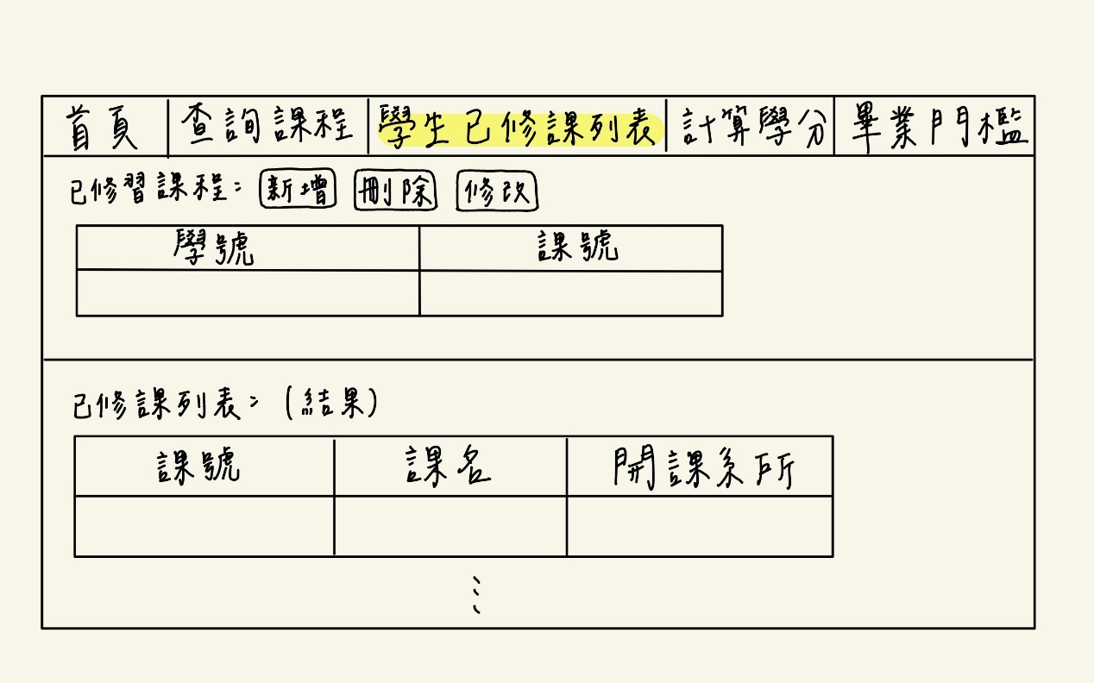

用課程種類(必修、系內選修、核心選修、系外選修、語文、通識、體育)分類並顯示出來，計算該學生不同種類課程的總學分數/課程數(count.php)

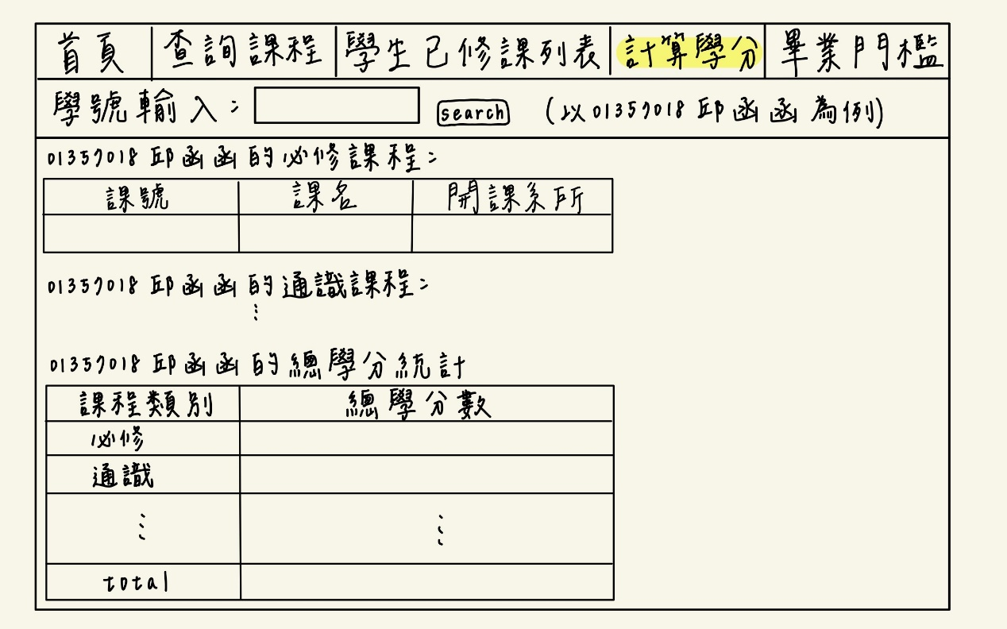

顯示資工系畢業門檻資料(graduation.php)

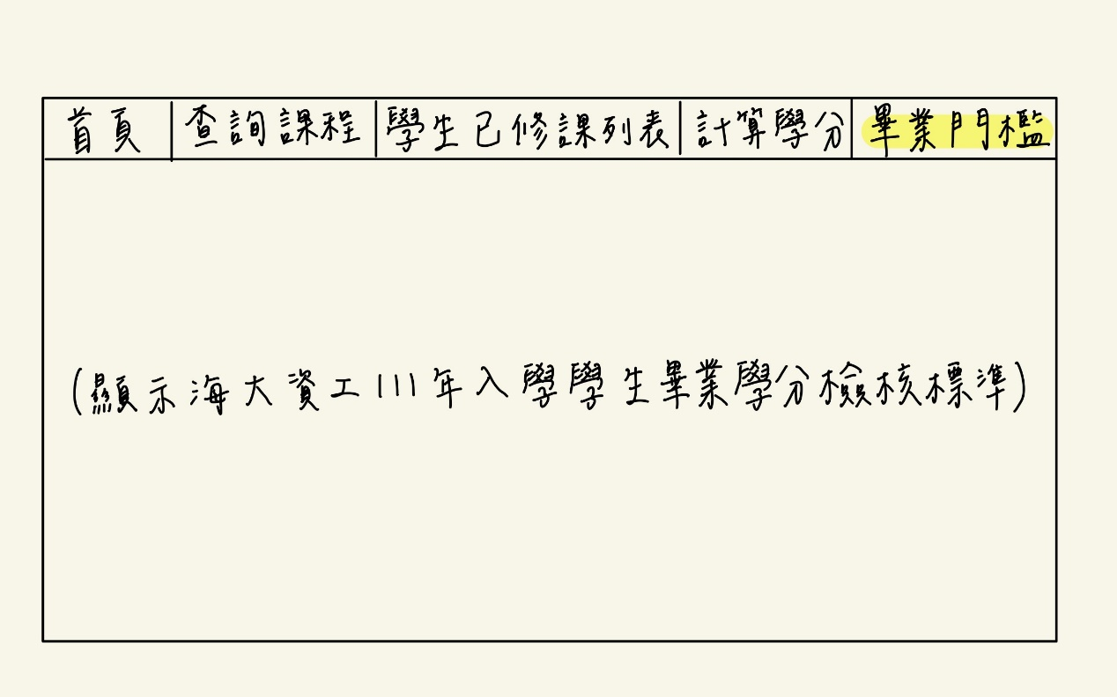

# 工作分配

|  |  |
| --- | --- |
| 組員 | 工作分配 |
| 陳柏秀 | 資料庫建置[外系]、homePage.php、courseTaken.php |
| 邱子玲 | 資料庫建置[體育、資工]、count.php |
| 郭泳函 | 資料庫建置[語文、通識]、search.php、graduation.php |

# 參考資料

[CSE課程地圖](https://cse.ntou.edu.tw/var/file/63/1063/attach/53/pta_60830_4761975_08093.pdf)、[111學年度CSE修課規定](https://cse.ntou.edu.tw/var/file/63/1063/attach/60/pta_44720_3805145_46451.pdf)、[資工承認電資課程為系內選修課程表](https://cse.ntou.edu.tw/var/file/63/1063/attach/60/pta_28712_6597656_87470.pdf)、[111年度入學畢業學分檢核表](https://cse.ntou.edu.tw/p/405-1063-83635,c7910.php?Lang=zh-tw)