report

ZJH

2022/3/29

tea <- readRDS('nonglin_tea.RDS')  
library(tidyverse)

ggplot(data=tea,aes(observe_ys,tea_kind,color=cultivar))+  
 geom_point()+  
 facet_wrap(~cultivar)

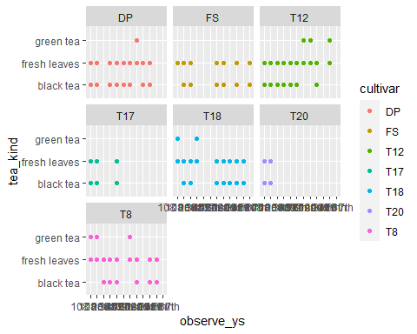

ggplot(data=tea,aes(observe_ys,cutting_height,color=cultivar))+  
 geom_point()+  
 facet_wrap(~cultivar)

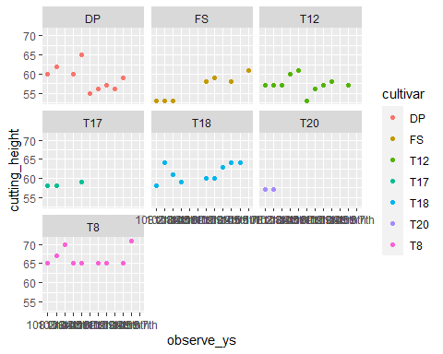

ggplot(data=tea,aes(observe_ys,cutting_height,size=duration_oc))+  
 geom_point()+  
 facet_wrap(~cultivar)

