report

ZJH

2022/3/29

analyze_data <- readRDS('analyze.RDS')   
numeric_dat <- analyze_data %>% select(.,-c(key,observe_ys,observe_date:sample_label,G1L:O9L,year,temp_differ))  
train_idx <- sample(1:138,100)  
test_idx <- !(1:138 %in%train_idx)  
train <- numeric_dat[train_idx,]  
test <- numeric_dat[test_idx,]  
  
 importanceplot <- function(pp=and_rf) {  
 i_scores <- varImp(pp, conditional=TRUE)  
 #Gathering rownames in 'var' and converting it to the factor  
 #to provide 'fill' parameter for the bar chart.   
 i_scores <- i_scores %>% tibble::rownames_to_column("var")   
 i_scores$var<- i_scores$var %>% as.factor()  
   
 #Plotting the bar and polar charts for comparing variables  
 i_bar <- ggplot(data = i_scores) +   
 geom_bar(  
 stat = "identity",#it leaves the data without count and bin  
 mapping = aes(x = var, y=Overall, fill = var),   
 show.legend = FALSE,  
 width = 1  
 ) +   
 labs(x = NULL, y = NULL)  
 i_bar + coord_flip() + theme_minimal()  
 }

xtrain <- model.matrix(polyphenol~.+acu_mean_temp*RH*Solar_rad_H*Solar_rad_MJM2, train)[,-1]  
ytrain <- train$polyphenol  
ytest <- test$polyphenol  
xtest <- model.matrix(polyphenol~.+acu_mean_temp*RH*Solar_rad_H*Solar_rad_MJM2, test)[,-1] %>% as_tibble() %>% select(.,season2nd:season6th,season7th,everything()) %>% as.matrix()  
data_polyphenol <- analyze_data %>% select(., c(cultivar,rain,polyphenol,acu_mean_temp,RH,Solar_rad_H,Solar_rad_MJM2))  
and_rf <- randomForest(polyphenol~.+acu_mean_temp*RH*Solar_rad_H*Solar_rad_MJM2, data = data_polyphenol[train_idx,])  
and_pred <- predict(and_rf,data_polyphenol[test_idx,])  
(mean((and_pred-ytest)^2)/var(ytest))^0.5

## [1] 0.356668

importanceplot()

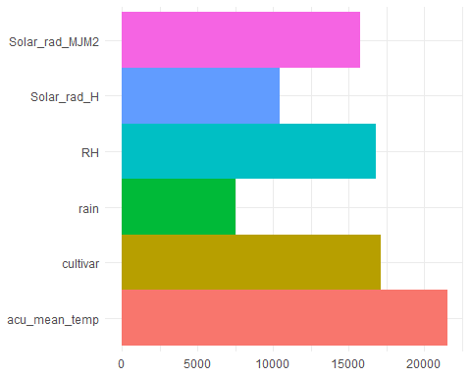

xtrain <- model.matrix(FAA~., train)[,-1]  
ytrain <- train$FAA  
ytest <- test$FAA  
xtest <- model.matrix(FAA~., test)[,-1] %>% as_tibble() %>% select(.,season2nd:season6th,season7th,everything()) %>% as.matrix()  
data_FAA <- analyze_data %>% select(., c(cultivar,FAA,rain,acu_mean_temp,RH,Solar_rad_H,Solar_rad_MJM2))  
and_rf <- randomForest(FAA~., data = data_FAA[train_idx,])  
and_pred <- predict(and_rf,data_FAA[test_idx,])  
(mean((and_pred-ytest)^2)/var(ytest))^0.5

## [1] 0.4748558

importanceplot()

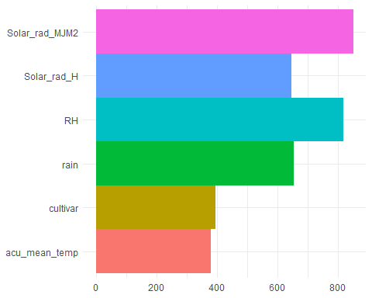

xtrain <- model.matrix(Gallic_Acid~., train)[,-1]  
ytrain <- train$Gallic_Acid  
ytest <- test$Gallic_Acid  
xtest <- model.matrix(Gallic_Acid~., test)[,-1] %>% as_tibble() %>% select(.,season2nd:season6th,season7th,everything()) %>% as.matrix()  
data_Gallic_Acid <- analyze_data %>% select(., c(cultivar,rain,Gallic_Acid,acu_mean_temp,RH,Solar_rad_H,Solar_rad_MJM2))  
and_rf <- randomForest(Gallic_Acid~., data = data_Gallic_Acid[train_idx,])  
and_pred <- predict(and_rf,data_Gallic_Acid[test_idx,])  
(mean((and_pred-ytest)^2)/var(ytest))^0.5

## [1] 0.4251999

importanceplot()

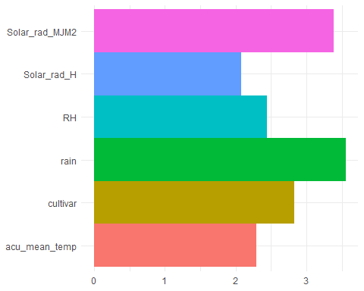

xtrain <- model.matrix(GC~., train)[,-1]  
ytrain <- train$GC  
ytest <- test$GC  
xtest <- model.matrix(GC~., test)[,-1] %>% as_tibble() %>% select(.,season2nd:season6th,season7th,everything()) %>% as.matrix()  
data_GC <- analyze_data %>% select(., c(cultivar,rain,GC,acu_mean_temp,RH,Solar_rad_H,Solar_rad_MJM2))  
and_rf <- randomForest(GC~., data = data_GC[train_idx,])  
and_pred <- predict(and_rf,data_GC[test_idx,])  
(mean((and_pred-ytest)^2)/var(ytest))^0.5

## [1] 0.3226176

importanceplot()

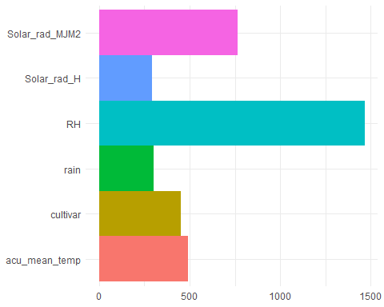

xtrain <- model.matrix(GCG~., train)[,-1]  
ytrain <- train$GCG  
ytest <- test$GCG  
xtest <- model.matrix(GCG~., test)[,-1] %>% as_tibble() %>% select(.,season2nd:season6th,season7th,everything()) %>% as.matrix()  
data_GCG <- analyze_data %>% select(., c(cultivar,GCG,rain,acu_mean_temp,RH,Solar_rad_H,Solar_rad_MJM2))  
and_rf <- randomForest(GCG~., data = data_GCG[train_idx,])  
and_pred <- predict(and_rf,data_GCG[test_idx,])  
(mean((and_pred-ytest)^2)/var(ytest))^0.5

## [1] 0.2057175

importanceplot()

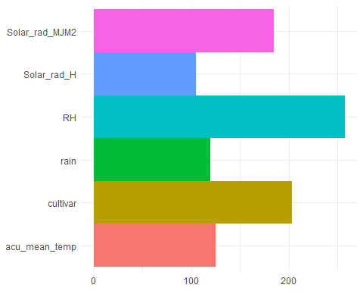

xtrain <- model.matrix(Catechin~., train)[,-1]  
ytrain <- train$Catechin  
ytest <- test$Catechin  
xtest <- model.matrix(Catechin~., test)[,-1] %>% as_tibble() %>% select(.,season2nd:season6th,season7th,everything()) %>% as.matrix()  
data_caffeine <- analyze_data %>% select(., c(cultivar,Catechin,rain,acu_mean_temp,RH,Solar_rad_H,Solar_rad_MJM2))  
and_rf <- randomForest(Catechin~., data = data_caffeine[train_idx,])  
and_pred <- predict(and_rf,data_caffeine[test_idx,])  
(mean((and_pred-ytest)^2)/var(ytest))^0.5

## [1] 0.5386441

importanceplot()

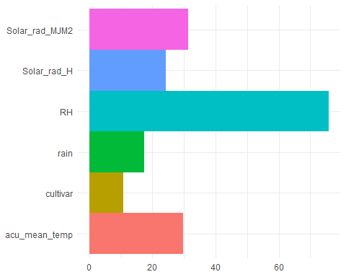

chem <- analyze_data %>% select(,polyphenol:total_catechins)  
pr_chem <- prcomp(scale(chem) )  
biplot(pr_chem)

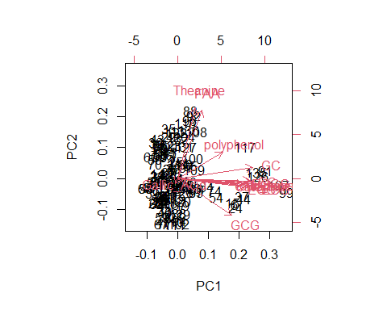

importanceplot()



xtrain <- model.matrix(level~., train)[,-1]  
ytrain <- train$level  
ytest <- test$level  
xtest <- model.matrix(level~., test)[,-1] %>% as_tibble() %>% select(.,season2nd:season6th,season7th,everything()) %>% as.matrix()  
data_level <- analyze_data %>% select(., c(cultivar,level,polyphenol:total_catechins))  
data_level$level <- factor(data_level$level)  
and_rf <- randomForest(level~., data = data_level[train_idx,])  
and_pred <- predict(and_rf,data_level[test_idx,])  
table(data_level[test_idx,]$level,and_pred)

## and_pred  
## B C  
## B 8 3  
## C 4 23

importanceplot()

