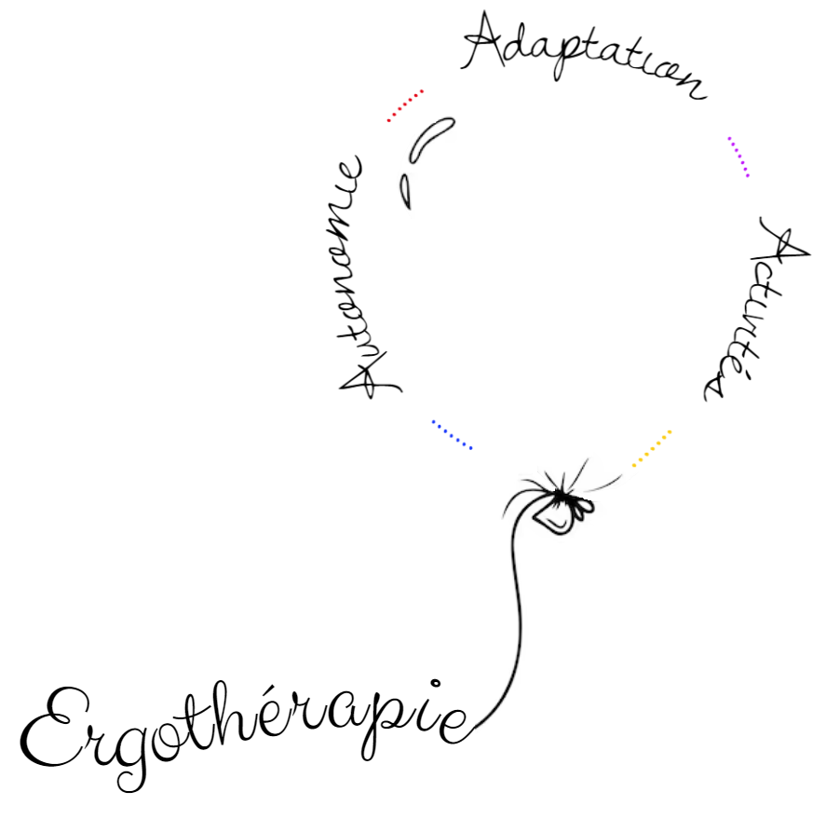

|  |
| --- |
| *Edwina*  *Decherf* |