(T19)討論Transaction和ErrorHandling。討論TryCatch  
CourseGUID: e48417fc-9db5-4e99-822c-706c5ccef6cc  
=======================================================================  
(T19)討論Transaction和ErrorHandling。討論TryCatch  
=======================================================================  
0. Summary

1. CreateSampleData

-----------

2. Transaction

2.1. Reason to use Transaction

2.2. BEGIN TRAN ... COMMIT TRAN

2.3. ROLLBACK TRAN

-----------

3. Transaction Naming and Syntax

-----------

4. Transaction Naming and Syntax

4.1. Nested transactions basics

4.2. ROLLBACK any inner Transaction

4.3. Savepoint

4.4. ROLLBACK Outter Transaction

4.5. Prohibit to ROLLBACK any inner Transaction

-----------

5. ErrorHandling, Transaction, TryCatch

5.1. ErrorHandling, Transaction, TryCatch

5.2. ErrorHandling, Transaction, TryCatch, Raiserror

-----------

6. Store Procedure, ErrorHandling, Transaction, TryCatch, Raiserror

7. Clean up  
=======================================================================

0. Summary

1.

We have to ensure a group of sql statement

can perform successfully together or unsuccessfully together.

Thus, we need SQL Transaction.

--BEGIN TRANSACTION;

BEGIN TRAN

...

--ROLLBACK TRANSACTION;

COMMIT TRAN;

2.

Prohibit to ROLLBACK any inner Transaction

No matter inner Transaction has name or not.

If you really want to roll back inner Transaction,

don't use inner Transaction, Use Savepoint with SavepointName

--BEGIN TRAN Tranl;

--PRINT @@TRANCOUNT;    --1st TRANCOUNT, 1

--SAVE TRAN SavePoint;

--PRINT @@TRANCOUNT;    --2nd TRANCOUNT, 1

--...

--ROLLBACK TRAN SavePoint;

--PRINT @@TRANCOUNT;    --3rd TRANCOUNT, 1

----ROLLBACK TRAN Tranl

--COMMIT TRAN Tranl;

3.

When ROLLBACK Outter Transaction

No matter you have commit inner Transaction or not,

the inner Transaction will be forced to rollback too.

4.

--SELECT  ERROR_NUMBER() AS [ERROR_NUMBER()] ,    --245

--    ERROR_MESSAGE() AS [ERROR_MESSAGE()] ,        --Conversion failed when converting the varchar value 'Account1' to data type int.

--    ERROR_PROCEDURE() AS [ERROR_PROCEDURE()] ,    --NULL

--    ERROR_STATE() AS [ERROR_STATE()] ,            --1

--    ERROR_SEVERITY() AS [ERROR_SEVERITY()] ,    --16

--    ERROR_LINE() AS [ERROR_LINE()]                --9

Reference:

<https://docs.microsoft.com/en-us/sql/t-sql/functions/error-procedure-transact-sql>

<https://docs.microsoft.com/en-us/sql/t-sql/functions/error-state-transact-sql>

4.1.

Each kind of Error has ONE Error number just like and id, and ONE ERROR_MESSAGE

In this case, ERROR_NUMBER is 245.

ERROR_MESSAGE is 'Conversion failed when converting the varchar value 'Account1' to data type int.'

4.2.

ERROR_PROCEDURE() returns the name of the stored procedure or trigger

where an error occurred that caused the CATCH block of a TRY…CATCH.

In this case, ERROR_PROCEDURE is NULL, because this is not stored procedure or trigger.

4.3.

ERROR_STATE is kind of flat for debugging.

Each specific condition that raises the error assigns a unique state code.

A SQL Server support engineer can also use the state code from an error to find the location

in the source code where that error is being raised,

which may provide additional ideas on how to diagnose the problem.

4.4.

ERROR_SEVERITY 16 means a general error.

This is kind of the category of error message.

4.5.

ERROR_LINE returns the lind number where an error occurred.

5.

We have to ensure a group of sql statement

can perform successfully together or unsuccessfully together.

Thus, we need SQL Transaction and try catch

--BEGIN TRY

--    --BEGIN TRANSACTION;

--      BEGIN TRAN

--      ...

--      --ROLLBACK TRANSACTION;

--      COMMIT TRAN;

--END TRY

--BEGIN CATCH

--     ...

--END CATCH

5.1.

--INSERT  INTO BankTransaction

--    (    FromBankAccountID ,

--        ToBankAccountID ,

--        Amount

--    )

--VALUES  ('Account1' ,    -- datatype Error

--        'Account2' ,    --datatype Error

--        @TransferAmount

--    );

FromBankAccountID and ToBankAccountID need int type parameter,

but the input is character string.

This will raise an error and automaticly "ROLLBACK" to beginning of transaction.

and then jump to   BEGIN CATCH clause.

==================================================

1. CreateSampleData

--============================================================

--T019_01_CreateSampleData

--============================================================

IF ( EXISTS ( SELECT    *

              FROM      INFORMATION_SCHEMA.TABLES

              WHERE     TABLE_NAME = 'BankTransaction' ) )

    BEGIN

        TRUNCATE TABLE BankTransaction;

        DROP TABLE BankTransaction;

    END;

GO -- Run the previous command and begins new batch

IF ( EXISTS ( SELECT    *

              FROM      INFORMATION_SCHEMA.TABLES

              WHERE     TABLE_NAME = 'BankAccount' ) )

    BEGIN

        TRUNCATE TABLE BankAccount;

        DROP TABLE BankAccount;

    END;

GO -- Run the previous command and begins new batch

CREATE TABLE BankAccount

(

  BankAccountID INT PRIMARY KEY

                    IDENTITY(1, 1)

                    NOT NULL ,

  BankAccountName NVARCHAR(100) NULL ,

  BankAvailableBalance MONEY NULL,

 );

GO -- Run the previous command and begins new batch

INSERT  INTO BankAccount

VALUES  ( N'Account1', 41000 );

INSERT  INTO BankAccount

VALUES  ( N'Account2', 42000 );

GO -- Run the previous command and begins new batch

--Ch55toCh56_00_02

--Create [BankTransaction] table

CREATE TABLE BankTransaction

(

  BankTransactionID INT PRIMARY KEY

                        IDENTITY(1, 1)

                        NOT NULL ,

  FromBankAccountID INT FOREIGN KEY REFERENCES BankAccount ( BankAccountID )

                        NOT NULL ,

  ToBankAccountID INT FOREIGN KEY REFERENCES BankAccount ( BankAccountID )

                      NOT NULL ,

  Amount MONEY DEFAULT ( (0) )

               NULL,

 );

GO -- Run the previous command and begins new batch

SELECT  *

FROM    BankTransaction;

SELECT  *

FROM    BankAccount;

GO -- Run the previous command and begins new batch

==================================================

2. Transaction

--============================================================

--T019_02_Transaction

--============================================================

2.1. Reason to use Transaction

--============================================================

--T019_02_01

--Reason to use Transaction :

--We want a group of SQL statements perform successfully together or unsuccessfully together.

--E.g. Transfer $1000 From BankAccountID=1 to BankAccountID=2

DECLARE @TransferAmount INT = 1000;

--Adding new records to [BankTransaction] table

INSERT  INTO BankTransaction

        ( FromBankAccountID ,

          ToBankAccountID ,

          Amount

        )

VALUES  ( 1 ,

          2 ,

          @TransferAmount

        );

--Updating existing records

UPDATE  BankAccount

SET     [BankAvailableBalance] -= @TransferAmount

WHERE   [BankAccountID] = 1;

UPDATE  BankAccount

SET     [BankAvailableBalance] += @TransferAmount

WHERE   [BankAccountID] = 2;

GO -- Run the previous command and begins new batch

SELECT  *

FROM    [BankTransaction];

SELECT  *

FROM    dbo.BankAccount

WHERE   [BankAccountID] BETWEEN 1 AND 2;

GO -- Run the previous command and begins new batch

/*

1.

Transfer $1000 From BankAccountID=1 to BankAccountID=2

Before:

Account1 [BankAvailableBalance] = $41000

Account2 [BankAvailableBalance] = $42000

After:

Account1 [BankAvailableBalance] = $40000

Account2 [BankAvailableBalance] = $43000

2.

We have to ensure

--INSERT  INTO BankTransaction

and

--2 of the  UPDATE  BankAccount

have to peformed successfully together or unsuccessfully together.

Thus, we need SQL Transaction.

*/

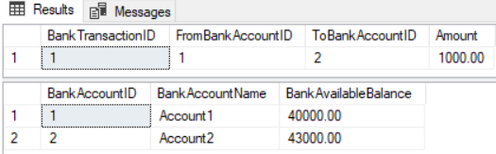

2.2. BEGIN TRAN ... COMMIT TRAN

--============================================================

--T019_02_02

--BEGIN TRAN ... COMMIT TRAN

--Reason to use Transaction :

--We want a group of SQL statements perform successfully together or unsuccessfully together.

--E.g. Transfer $1000 From BankAccountID=1 to BankAccountID=2

--Begin a Transaction, and then commit the Transaction

--BEGIN TRANSACTION;

BEGIN TRAN

DECLARE @TransferAmount int = 1000;

--Adding new records to [BankTransaction] table

INSERT  INTO BankTransaction

        ( FromBankAccountID ,

          ToBankAccountID ,

          Amount

        )

VALUES  ( 1 ,

          2 ,

          @TransferAmount

        );

--Updating existing records

UPDATE  BankAccount

SET     [BankAvailableBalance] -= @TransferAmount

WHERE   [BankAccountID] = 1;

UPDATE  BankAccount

SET     [BankAvailableBalance] += @TransferAmount

WHERE   [BankAccountID] = 2;

GO -- Run the previous command and begins new batch

--COMMIT TRAN;

COMMIT TRAN;

SELECT  *

FROM    [BankTransaction]

SELECT  *

FROM    dbo.BankAccount

WHERE   [BankAccountID] between 1 AND 2

GO -- Run the previous command and begins new batch

/*

1.

Transfer $1000 From BankAccountID=1 to BankAccountID=2

Before:

Account1 [BankAvailableBalance] = $40000

Account2 [BankAvailableBalance] = $43000

After:

Account1 [BankAvailableBalance] = $39000

Account2 [BankAvailableBalance] = $44000

2.

We have to ensure

--INSERT  INTO BankTransaction

and

--2 of the  UPDATE  BankAccount

have to peformed successfully together or unsuccessfully together.

Thus, we need SQL Transaction.

--BEGIN TRANSACTION;

BEGIN TRAN

...

--COMMIT TRAN;

COMMIT TRAN;

*/

2.3. ROLLBACK TRAN

--============================================================

--T019_02_03

--ROLLBACK TRAN

--Reason to use Transaction :

--We want a group of SQL statements perform successfully together or unsuccessfully together.

--E.g. Transfer $1000 From BankAccountID=1 to BankAccountID=2

--Begin a Transaction, and then Rollback the Transaction

--BEGIN TRANSACTION;

BEGIN TRAN

DECLARE @TransferAmount int = 1000;

--Adding new records to [BankTransaction] table

INSERT  INTO BankTransaction

        ( FromBankAccountID ,

          ToBankAccountID ,

          Amount

        )

VALUES  ( 1 ,

          2 ,

          @TransferAmount

        );

--Updating existing records

UPDATE  BankAccount

SET     [BankAvailableBalance] -= @TransferAmount

WHERE   [BankAccountID] = 1;

UPDATE  BankAccount

SET     [BankAvailableBalance] += @TransferAmount

WHERE   [BankAccountID] = 2;

GO -- Run the previous command and begins new batch

--ROLLBACK TRANSACTION;

ROLLBACK TRAN;

SELECT  *

FROM    [BankTransaction]

SELECT  *

FROM    dbo.BankAccount

WHERE   [BankAccountID] between 1 AND 2

GO -- Run the previous command and begins new batch

/*

1.

Transfer $1000 From BankAccountID=1 to BankAccountID=2

Begin a Transaction, and then Rollback the Transaction

Before:

Account1 [BankAvailableBalance] = $39000

Account2 [BankAvailableBalance] = $44000

After:

Account1 [BankAvailableBalance] = $39000

Account2 [BankAvailableBalance] = $44000

2.

We have to ensure

--INSERT  INTO BankTransaction

and

--2 of the  UPDATE  BankAccount

have to peformed successfully together or unsuccessfully together.

Thus, we need SQL Transaction.

--BEGIN TRANSACTION;

BEGIN TRAN

...

--ROLLBACK TRANSACTION;

ROLLBACK TRAN;

In this case, a group of SQL statements perform unsuccessfully together.

*/

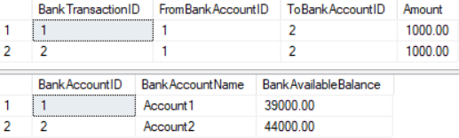

=====================================================================

3. Transaction Naming and Syntax

--BEGIN Transaction TransactionName

BEGIN TRAN TransactionName

--COMMIT Transaction TransactionName

COMMIT TRAN TransactionName

--BEGIN Transaction TransactionName

BEGIN TRAN TransactionName

--COMMIT Transaction

COMMIT TRAN

--BEGIN Transaction

BEGIN TRAN

--COMMIT Transaction

COMMIT TRAN

GO -- Run the previous command and begins new batch

-------------

--BEGIN Transaction TransactionName

BEGIN TRAN TransactionName

--ROLLBACK Transaction TransactionName

ROLLBACK TRAN TransactionName

--BEGIN Transaction TransactionName

BEGIN TRAN TransactionName

--ROLLBACK Transaction

ROLLBACK TRAN

--BEGIN Transaction

BEGIN TRAN

--ROLLBACK Transaction

ROLLBACK TRAN

GO -- Run the previous command and begins new batch

=====================================================================

4. Transaction Naming and Syntax

/*

1.

Prohibit to ROLLBACK any inner Transaction

No matter inner Transaction has name or not.

If you really want to roll back inner Transaction,

don't use inner Transaction, Use Savepoint with SavepointName

2.

When ROLLBACK Outter Transaction

No matter you have commit inner Transaction or not,

the inner Transaction will be forced to rollback too.

*/

4.1. Nested transactions basics

--===========================================================================

--T019_04_01

--Nested transactions basics

BEGIN TRAN Tranl;

PRINT @@TRANCOUNT;

       --1st TRANCOUNT, 1

BEGIN TRAN Tran2;

PRINT @@TRANCOUNT;

       --2nd TRANCOUNT, 2

COMMIT TRAN Tran2;

PRINT @@TRANCOUNT;

       --3rd TRANCOUNT, 1

COMMIT TRAN Tranl;

GO -- Run the previous command and begins new batch

/*

1.

@@TRANCOUNT

Reference:

<https://docs.microsoft.com/en-us/sql/t-sql/functions/trancount-transact-sql>

Returns the number of BEGIN TRANSACTION statements that have occurred on the current connection.

That means how many transaction has begun.

2.

This will return

--1

--2

--1

The 1st @@TRANCOUNT ==1, that means means 1 transaction has begun at that time.

The 2nd @@TRANCOUNT ==2, that means means 2 transaction has begun at that time.

The 1rd @@TRANCOUNT ==1, that means means 1 transaction has begun at that time.

Because at that time, the 2nd traction has been committed.

*/

4.2. ROLLBACK any inner Transaction

--===========================================================================

--T019_04_02

/*

1.

Prohibit to ROLLBACK any inner Transaction

No matter inner Transaction has name or not.

If you really want to roll back inner Transaction,

don't use inner Transaction, Use Savepoint with SavepointName

*/

BEGIN TRAN Tranl;

PRINT @@TRANCOUNT;

       --1st TRANCOUNT, 1

BEGIN TRAN Tran2;

PRINT @@TRANCOUNT;

       --2nd TRANCOUNT, 2

ROLLBACK TRAN Tran2;

       -- * ROLLBACK Tran2 here, Error Message

PRINT @@TRANCOUNT;

       --3rd TRANCOUNT, 2

COMMIT TRAN Tranl;

GO -- Run the previous command and begins new batch

/*

1.

@@TRANCOUNT

Reference:

<https://docs.microsoft.com/en-us/sql/t-sql/functions/trancount-transact-sql>

Returns the number of BEGIN TRANSACTION statements that have occurred on the current connection.

That means how many transaction has begun.

2.

This will return

--1

--2

--Msg 6401, Level 16, State 1, Line 11

--Cannot roll back Tran2. No transaction or savepoint of that name was found.

--2

That means prohibit to ROLLBACK any inner Transaction.

*/

4.3. Savepoint

--===========================================================================

--T019_04_03

/*

1.

Prohibit to ROLLBACK any inner Transaction

No matter inner Transaction has name or not.

If you really want to roll back inner Transaction,

don't use inner Transaction, Use Savepoint with SavepointName

*/

BEGIN TRAN Tranl;

PRINT @@TRANCOUNT;

       --1st TRANCOUNT, 1

BEGIN TRAN;

PRINT @@TRANCOUNT;

       --2nd TRANCOUNT, 2

ROLLBACK TRAN;

       -- * ROLLBACK here,  Error Message

PRINT @@TRANCOUNT;

       --3rd TRANCOUNT, 0

COMMIT TRAN Tranl;

GO -- Run the previous command and begins new batch

/*

1.

@@TRANCOUNT

Reference:

<https://docs.microsoft.com/en-us/sql/t-sql/functions/trancount-transact-sql>

Returns the number of BEGIN TRANSACTION statements that have occurred on the current connection.

That means how many transaction has begun.

2.

It will return

--1

--2

--0

--Msg 3902, Level 16, State 1, Line 14

--The COMMIT TRANSACTION request has no corresponding BEGIN TRANSACTION.

ROLLBACK TRAN will rollback both inner TRAN and outter TRAN.

Thus, no TRAN can be commit in the last line and output error message.

*/

4.4. ROLLBACK Outter Transaction

--===========================================================================

--T019_04_04

/*

2.

When ROLLBACK Outter Transaction

No matter you have commit inner Transaction or not,

the inner Transaction will be forced to rollback too.

*/

SELECT  *

FROM    dbo.BankAccount

WHERE   BankAccountID = 1

--Nested transactions basics

BEGIN TRAN Tranl;

PRINT @@TRANCOUNT;

       --1st TRANCOUNT, 1

BEGIN TRAN;

UPDATE  dbo.BankAccount

SET     BankAccountName = 'NewName'

WHERE   BankAccountID = 1

PRINT @@TRANCOUNT;

       --2nd TRANCOUNT, 2

COMMIT TRAN;

             -- * commit Inner Transaction

PRINT @@TRANCOUNT;

       --3rd TRANCOUNT, 1

--COMMIT TRAN Tranl;

ROLLBACK TRAN Tranl

       -- * ROLLBACK outter Transaction

SELECT  *

FROM    dbo.BankAccount

WHERE   BankAccountID = 1

GO -- Run the previous command and begins new batch

/*

1.

@@TRANCOUNT

Reference:

<https://docs.microsoft.com/en-us/sql/t-sql/functions/trancount-transact-sql>

Returns the number of BEGIN TRANSACTION statements that have occurred on the current connection.

That means how many transaction has begun.

2.

It will return

--1

--2

--1

The last line will ROLLBACK every thing, so should return zero by logic.

Thus, ROLLBACK is hard to debug.

*/

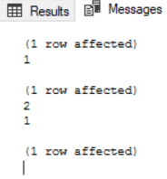

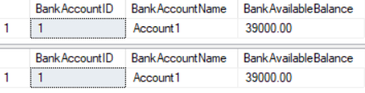

4.5. Prohibit to ROLLBACK any inner Transaction

--===========================================================================

--T019_04_05

/*

1.

Prohibit to ROLLBACK any inner Transaction

No matter inner Transaction has name or not.

If you really want to roll back inner Transaction,

don't use inner Transaction, Use Savepoint with SavepointName

2.

When ROLLBACK Outter Transaction

No matter you have commit inner Transaction or not,

the inner Transaction will be forced to rollback too.

*/

SELECT  *

FROM    dbo.BankAccount

WHERE   BankAccountID = 1

BEGIN TRAN Tranl;

PRINT @@TRANCOUNT;

       --1st TRANCOUNT, 1

SAVE TRAN SavePoint;

PRINT @@TRANCOUNT;

       --2nd TRANCOUNT, 1

UPDATE  dbo.BankAccount

SET     BankAccountName = 'NewName'

WHERE   BankAccountID = 1

ROLLBACK TRAN SavePoint;

PRINT @@TRANCOUNT;

       --3rd TRANCOUNT, 1

--ROLLBACK TRAN Tranl

COMMIT TRAN Tranl;

SELECT  *

FROM    dbo.BankAccount

WHERE   BankAccountID = 1

GO -- Run the previous command and begins new batch

/*

1.

@@TRANCOUNT

Reference:

<https://docs.microsoft.com/en-us/sql/t-sql/functions/trancount-transact-sql>

Returns the number of BEGIN TRANSACTION statements that have occurred on the current connection.

That means how many transaction has begun.

2.

It will return

--1

--1

--1

1st @@TRANCOUNT == 1 because Tranl

2nd @@TRANCOUNT == 1 because still in Train 1

Then

--     ROLLBACK TRAN SavePoint;

This will only ROLLBACK to   SAVE TRAN SavePoint;

That means ROLLBACK

--     SAVE TRAN SavePoint;

--     PRINT @@TRANCOUNT;  --2nd @@TRANCOUNT

3rd @@TRANCOUNT == 1 because still in Train 1

*/

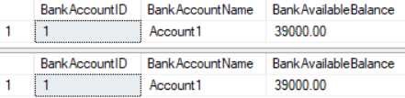

5. ErrorHandling, Transaction, TryCatch

--===========================================================================

--T019_05 : ErrorHandling, Transaction, TryCatch

--===========================================================================

5.1. ErrorHandling, Transaction, TryCatch

--===========================================================================

--T019_05_01

--ErrorHandling, Transaction, TryCatch

BEGIN TRY

    BEGIN TRAN;

    DECLARE @TransferAmount INT = 1000;

       --Adding new records to [BankTransaction] table

    INSERT  INTO BankTransaction

            ( FromBankAccountID ,

              ToBankAccountID ,

              Amount

                 )

    VALUES  ( 'Account1' , -- datatype Error

              'Account2' , --datatype Error

              @TransferAmount

                 );

       --Updating existing records

    UPDATE  BankAccount

    SET     [BankAvailableBalance] -= @TransferAmount

    WHERE   [BankAccountID] = 1;

    UPDATE  BankAccount

    SET     [BankAvailableBalance] += @TransferAmount

    WHERE   [BankAccountID] = 2;

       --COMMIT TRANSACTION;

    COMMIT TRAN;

END TRY

BEGIN CATCH

    SELECT  ERROR_NUMBER() AS [ERROR_NUMBER()] ,

            ERROR_MESSAGE() AS [ERROR_MESSAGE()] ,

            ERROR_PROCEDURE() AS [ERROR_PROCEDURE()] ,

            ERROR_STATE() AS [ERROR_STATE()] ,

            ERROR_SEVERITY() AS [ERROR_SEVERITY()] ,

            ERROR_LINE() AS [ERROR_LINE()];

END CATCH;

SELECT  *

FROM    [BankTransaction];

SELECT  *

FROM    dbo.BankAccount

WHERE   [BankAccountID] BETWEEN 1 AND 2;

GO -- Run the previous command and begins new batch

/*

1.

--SELECT  ERROR_NUMBER() AS [ERROR_NUMBER()] , --245

--    ERROR_MESSAGE() AS [ERROR_MESSAGE()] ,         --Conversion failed when converting the varchar value 'Account1' to data type int.

--    ERROR_PROCEDURE() AS [ERROR_PROCEDURE()] ,     --NULL

--    ERROR_STATE() AS [ERROR_STATE()] ,                    --1

--    ERROR_SEVERITY() AS [ERROR_SEVERITY()] , --16

--    ERROR_LINE() AS [ERROR_LINE()]                        --9

Reference:

<https://docs.microsoft.com/en-us/sql/t-sql/functions/error-procedure-transact-sql>

<https://docs.microsoft.com/en-us/sql/t-sql/functions/error-state-transact-sql>

1.1.

Each kind of Error has ONE Error number just like and id, and ONE ERROR_MESSAGE

In this case, ERROR_NUMBER is 245.

ERROR_MESSAGE is 'Conversion failed when converting the varchar value 'Account1' to data type int.'

1.2.

ERROR_PROCEDURE() returns the name of the stored procedure or trigger

where an error occurred that caused the CATCH block of a TRY…CATCH.

In this case, ERROR_PROCEDURE is NULL, because this is not stored procedure or trigger.

1.3.

ERROR_STATE is kind of flat for debugging.

Each specific condition that raises the error assigns a unique state code.

A SQL Server support engineer can also use the state code from an error to find the location

in the source code where that error is being raised,

which may provide additional ideas on how to diagnose the problem.

1.4.

ERROR_SEVERITY 16 means a general error.

This is kind of the category of error message.

1.5.

ERROR_LINE returns the lind number where an error occurred.

2.

We have to ensure a group of sql statement

can perform successfully together or unsuccessfully together.

Thus, we need SQL Transaction and try catch

--BEGIN TRY

--    --BEGIN TRANSACTION;

--       BEGIN TRAN

--       ...

--       --ROLLBACK TRANSACTION;

--       COMMIT TRAN;

--END TRY

--BEGIN CATCH

--     ...

--END CATCH

2.1.

--INSERT  INTO BankTransaction

--     (      FromBankAccountID ,

--           ToBankAccountID ,

--           Amount

--     )

--VALUES  ('Account1' ,    -- datatype Error

--           'Account2' , --datatype Error

--           @TransferAmount

--     );

FromBankAccountID and ToBankAccountID need int type parameter,

but the input is character string.

This will raise an error and automaticly "ROLLBACK" to beginning of transaction.

and then jump to   BEGIN CATCH clause.

3.

Transfer $1000 From BankAccountID=1 to BankAccountID=2

Begin a Transaction, and then Rollback the Transaction

Before:

Account1 [BankAvailableBalance] = $39000

Account2 [BankAvailableBalance] = $44000

After:

Account1 [BankAvailableBalance] = $39000

Account2 [BankAvailableBalance] = $44000

*/

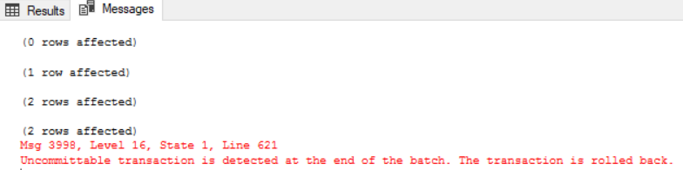

5.2. ErrorHandling, Transaction, TryCatch, Raiserror

--===========================================================================

--T019_05_02

--ErrorHandling, Transaction, TryCatch, Raiserror

BEGIN TRY

    BEGIN TRAN

    DECLARE @TransferAmount INT ,

        @FromBankAccountID INT ,

        @ToBankAccountID INT ,

        @FromBankAvailableBalance INT;

    SET @TransferAmount = 500000;

    SET @FromBankAccountID = 1;

    SET @ToBankAccountID = 2;

       --Declare @FromBankAvailableBalance int

    Select  @FromBankAvailableBalance = [BankAvailableBalance]

    from    BankAccount

    where   [BankAccountID] = 1;

       -- Throw an error if Not enough money available.

    if ( @FromBankAvailableBalance < @TransferAmount )

        Begin

            Raiserror('Not enough money available.',16,1)

        END

       --Adding new records to [BankTransaction] table

    INSERT  INTO BankTransaction

            ( FromBankAccountID ,

              ToBankAccountID ,

              Amount

                 )

    VALUES  ( @FromBankAccountID ,

              @ToBankAccountID ,

              @TransferAmount

                 );

       --Updating existing records

    UPDATE  BankAccount

    SET     [BankAvailableBalance] -= @TransferAmount

    WHERE   [BankAccountID] = @FromBankAccountID;

    UPDATE  BankAccount

    SET     [BankAvailableBalance] += @TransferAmount

    WHERE   [BankAccountID] = @ToBankAccountID;

       --COMMIT TRANSACTION;

    COMMIT TRAN;

END TRY

BEGIN CATCH

    SELECT  ERROR_NUMBER() AS [ERROR_NUMBER()] ,

            ERROR_MESSAGE() AS [ERROR_MESSAGE()] ,

            ERROR_PROCEDURE() AS [ERROR_PROCEDURE()] ,

            ERROR_STATE() AS [ERROR_STATE()] ,

            ERROR_SEVERITY() AS [ERROR_SEVERITY()] ,

            ERROR_LINE() AS [ERROR_LINE()]

END CATCH

SELECT  *

FROM    [BankTransaction]

SELECT  *

FROM    dbo.BankAccount

WHERE   [BankAccountID] between 1 AND 2

GO -- Run the previous command and begins new batch

/*

1.

--SELECT  ERROR_NUMBER() AS [ERROR_NUMBER()] , --50000

--    ERROR_MESSAGE() AS [ERROR_MESSAGE()] ,         --Not enough money available..

--    ERROR_PROCEDURE() AS [ERROR_PROCEDURE()] ,     --NULL

--    ERROR_STATE() AS [ERROR_STATE()] ,                    --1

--    ERROR_SEVERITY() AS [ERROR_SEVERITY()] , --16

--    ERROR_LINE() AS [ERROR_LINE()]                        --18

Reference:

<https://docs.microsoft.com/en-us/sql/t-sql/functions/error-procedure-transact-sql>

<https://docs.microsoft.com/en-us/sql/t-sql/functions/error-state-transact-sql>

1.1.

Each kind of Error has ONE Error number just like and id, and ONE ERROR_MESSAGE

1.2.

ERROR_PROCEDURE() returns the name of the stored procedure or trigger

where an error occurred that caused the CATCH block of a TRY…CATCH.

In this case, ERROR_PROCEDURE is NULL, because this is not stored procedure or trigger.

1.3.

ERROR_STATE is kind of flat for debugging.

Normally set to 1.

Each specific condition that raises the error assigns a unique state code.

A SQL Server support engineer can also use the state code from an error to find the location

in the source code where that error is being raised,

which may provide additional ideas on how to diagnose the problem.

1.4.

ERROR_SEVERITY 16 means a general error.

This is kind of the category of error message.

1.5.

ERROR_LINE returns the lind number where an error occurred.

2.

--if ( @FromBankAvailableBalance < @TransferAmount )

--    Begin

--        Raiserror('Not enough money available.',16,1)

--    END

2.1.

Throw an error if Not enough money available.

2.2.

--RAISERROR ( { msg_str | @local_variable }

--    { ,severity ,state }

--    [ ,argument [ ,...n ] ] )

--    [ WITH option [ ,...n ] ]

Reference:

<https://docs.microsoft.com/en-us/sql/t-sql/language-elements/raiserror-transact-sql>

2.2.1.

The first parameter, msg_str, is the error message.

2.2.2.

the second parameter, severity, is the severity level.

Severity level 16 means general errors and can be corrected by the user.

2.2.3.

The third parameter is state, and we should set default to 1.

RAISERROR only generates errors with state from 1 through 18.

Because the PDW engine may raise errors with state 0,

using a unique state number for different location

can help find which section of code is raising the errors.

3.

Transfer From BankAccountID=1 to BankAccountID=2

Begin a Transaction, and then Rollback the Transaction

Before:

Account1 [BankAvailableBalance] = $39000

Account2 [BankAvailableBalance] = $44000

After:

Account1 [BankAvailableBalance] = $39000

Account2 [BankAvailableBalance] = $44000

*/

==================================================

6. Store Procedure, ErrorHandling, Transaction, TryCatch, Raiserror

--=================================================================

--T019_06 : Store Procedure, ErrorHandling, Transaction, TryCatch, Raiserror

--=================================================================

/*

/// <summary>

/// Transfer amount of money from one account to another.

/// Rollback transaction if any error or

/// if the available amount in FromAccount is not enough.

/// </summary>

/// <param name="@FromBankAccountID">From bank account.</param>

/// <param name="@ToBankAccountID">To bank account.</param>

/// <param name="@TransferAmount">The amount of money you want to transfer.</param>

/// <returns>This is void method.</returns>

*/

IF ( EXISTS ( SELECT    *

              FROM      INFORMATION_SCHEMA.ROUTINES

              WHERE     ROUTINE_TYPE = 'PROCEDURE'

                        AND LEFT(ROUTINE_NAME, 3) NOT IN ( 'sp_', 'xp_', 'ms_' )

                        AND SPECIFIC_NAME = 'spTransferMoneyFromTo' ) )

    BEGIN

        DROP PROCEDURE spTransferMoneyFromTo;

    END;

GO -- Run the previous command and begins new batch

CREATE PROC spTransferMoneyFromTo

    (

      @FromBankAccountID INT ,

      @ToBankAccountID INT ,

      @TransferAmount MONEY

    )

AS

    BEGIN

        BEGIN TRY

            BEGIN TRAN

                    DECLARE @FromBankAvailableBalance INT;

                    --Declare @FromBankAvailableBalance int

            Select  @FromBankAvailableBalance = [BankAvailableBalance]

            from    BankAccount

            where   [BankAccountID] = 1;

                    -- Throw an error if Not enough money available.

            if ( @FromBankAvailableBalance < @TransferAmount )

                Begin

                    Raiserror('Not enough money available.',16,1)

                END

                    --Adding new records to [BankTransaction] table

            INSERT  INTO BankTransaction

                    ( FromBankAccountID ,

                      ToBankAccountID ,

                      Amount

                         )

            VALUES  ( @FromBankAccountID ,

                      @ToBankAccountID ,

                      @TransferAmount

                         );

                    --Updating existing records

            UPDATE  BankAccount

            SET     [BankAvailableBalance] -= @TransferAmount

            WHERE   [BankAccountID] = @FromBankAccountID;

            UPDATE  BankAccount

            SET     [BankAvailableBalance] += @TransferAmount

            WHERE   [BankAccountID] = @ToBankAccountID;

                    --COMMIT TRANSACTION;

            COMMIT TRAN;

                    -- Get out from stored procedure.

                    RETURN;

        END TRY

        BEGIN CATCH

            SELECT  ERROR_NUMBER() AS [ERROR_NUMBER()] ,

                    ERROR_MESSAGE() AS [ERROR_MESSAGE()] ,

                    ERROR_PROCEDURE() AS [ERROR_PROCEDURE()] ,

                    ERROR_STATE() AS [ERROR_STATE()] ,

                    ERROR_SEVERITY() AS [ERROR_SEVERITY()] ,

                    ERROR_LINE() AS [ERROR_LINE()]

        END CATCH

    END;

GO -- Run the previous command and begins new batch

SELECT  *

FROM    [BankTransaction]

SELECT  *

FROM    dbo.BankAccount

WHERE   [BankAccountID] between 1 AND 2

EXEC spTransferMoneyFromTo 1, 2, 50000

SELECT  *

FROM    [BankTransaction]

SELECT  *

FROM    dbo.BankAccount

WHERE   [BankAccountID] between 1 AND 2

EXEC spTransferMoneyFromTo 1, 2, 1000

SELECT  *

FROM    [BankTransaction]

SELECT  *

FROM    dbo.BankAccount

WHERE   [BankAccountID] between 1 AND 2

GO -- Run the previous command and begins new batch

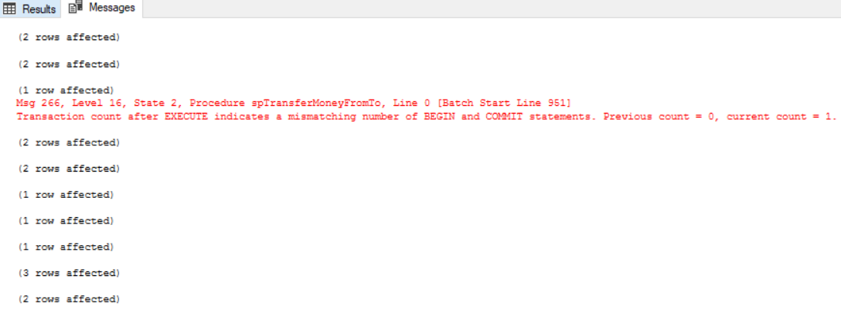

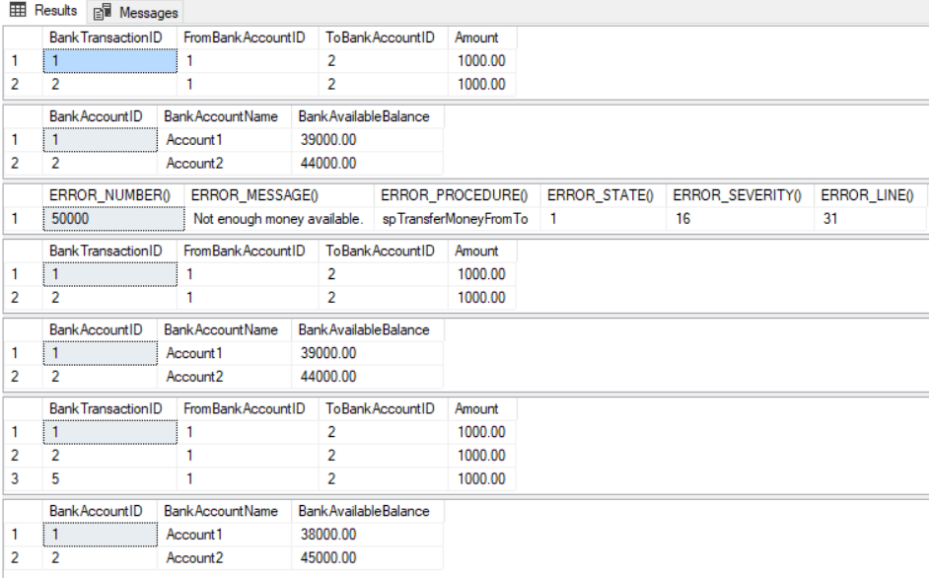

/*

1.

--SELECT  ERROR_NUMBER() AS [ERROR_NUMBER()] , --50000

--    ERROR_MESSAGE() AS [ERROR_MESSAGE()] ,         --Not enough money available..

--    ERROR_PROCEDURE() AS [ERROR_PROCEDURE()] ,     --NULL

--    ERROR_STATE() AS [ERROR_STATE()] ,                    --1

--    ERROR_SEVERITY() AS [ERROR_SEVERITY()] , --16

--    ERROR_LINE() AS [ERROR_LINE()]                        --18

Reference:

<https://docs.microsoft.com/en-us/sql/t-sql/functions/error-procedure-transact-sql>

<https://docs.microsoft.com/en-us/sql/t-sql/functions/error-state-transact-sql>

1.1.

Each kind of Error has ONE Error number just like and id, and ONE ERROR_MESSAGE

1.2.

ERROR_PROCEDURE() returns the name of the stored procedure or trigger

where an error occurred that caused the CATCH block of a TRY…CATCH.

In this case, ERROR_PROCEDURE is NULL, because this is not stored procedure or trigger.

1.3.

ERROR_STATE is kind of flat for debugging.

Normally set to 1.

Each specific condition that raises the error assigns a unique state code.

A SQL Server support engineer can also use the state code from an error to find the location

in the source code where that error is being raised,

which may provide additional ideas on how to diagnose the problem.

1.4.

ERROR_SEVERITY 16 means a general error.

This is kind of the category of error message.

1.5.

ERROR_LINE returns the lind number where an error occurred.

2.

2.1.

--EXEC spTransferMoneyFromTo 1, 2, 50000

Transfer From BankAccountID=1 to BankAccountID=2

Begin a Transaction, and then Rollback the Transaction

Before:

Account1 [BankAvailableBalance] = $39000

Account2 [BankAvailableBalance] = $44000

After:

Account1 [BankAvailableBalance] = $39000

Account2 [BankAvailableBalance] = $44000

2.2.

EXEC spTransferMoneyFromTo 1, 2, 1000

Transfer From BankAccountID=1 to BankAccountID=2

Begin a Transaction, and then commit the Transaction

Before:

Account1 [BankAvailableBalance] = $39000

Account2 [BankAvailableBalance] = $44000

After:

Account1 [BankAvailableBalance] = $38000

Account2 [BankAvailableBalance] = $45000

*/

==================================================

7. Clean up

--=================================================================

--T019_07 : Clean up

--=================================================================

IF ( EXISTS ( SELECT    *

              FROM      INFORMATION_SCHEMA.ROUTINES

              WHERE     ROUTINE_TYPE = 'PROCEDURE'

                        AND LEFT(ROUTINE_NAME, 3) NOT IN ( 'sp_', 'xp_', 'ms_' )

                        AND SPECIFIC_NAME = 'spTransferMoneyFromTo' ) )

    BEGIN

        DROP PROCEDURE spTransferMoneyFromTo;

    END;

GO -- Run the previous command and begins new batch

-------------------------------------------------

IF ( EXISTS ( SELECT    *

              FROM      INFORMATION_SCHEMA.TABLES

              WHERE     TABLE_NAME = 'BankTransaction' ) )

    BEGIN

        TRUNCATE TABLE BankTransaction;

        DROP TABLE BankTransaction;

    END;

GO -- Run the previous command and begins new batch

IF ( EXISTS ( SELECT    *

              FROM      INFORMATION_SCHEMA.TABLES

              WHERE     TABLE_NAME = 'BankAccount' ) )

    BEGIN

        TRUNCATE TABLE BankAccount;

        DROP TABLE BankAccount;

    END;

GO -- Run the previous command and begins new batch