(T2)入門DataTyp、DDL、DML  
CourseGUID: e48417fc-9db5-4e99-822c-706c5ccef6cc  
=======================================================================  
(T2)入門DataTyp、DDL、DML  
=======================================================================  
1. Data Type

1.2. Exact numerics : decimal and numeric

1.3. Exact numerics : money and smallmoney

1.4. Approximate numerics : float and real

1.5. Date and Time

1.6. Char, varchar, varchar(Max), nchar, nvarchar, nvarChar(Max)

1.7. uniqueidentifier

-----------

2. DDL V.S. DML / Fragmentation and Defragmentation  
=======================================================================

1. Data Type

Reference:

<https://docs.microsoft.com/en-us/sql/t-sql/data-types/data-types-transact-sql>

[https://technet.microsoft.com/en-us/library/ms187752(v=sql.105).aspx](https://technet.microsoft.com/en-us/library/ms187752%28v=sql.105%29.aspx)

1.1. Exact numerics : int, bigint, smallint, and tinyint

Reference:

<https://docs.microsoft.com/en-us/sql/t-sql/data-types/int-bigint-smallint-and-tinyint-transact-sql>

**bigint**

-2^63 (-9,223,372,036,854,775,808) to 2^63-1 (9,223,372,036,854,775,807)

8 Bytes

**int**

-2^31 (-2,147,483,648) to 2^31-1 (2,147,483,647)

4 Bytes

**smallint**

-2^15 (-32,768) to 2^15-1 (32,767)

2 Bytes

**tinyint**

0 to 255

1 Byte

1.2. Exact numerics : decimal and numeric

Reference:

<https://docs.microsoft.com/en-us/sql/t-sql/data-types/decimal-and-numeric-transact-sql>

**decimal[ (p[ ,s] )]** and **numeric[ (p[ ,s] )]**

The numeric and decimal types vary

because you can specify how large of a decimal portion you want to be able to store,

and so the more accuracy or the more numbers you keep, the larger the data takes on disk.

**Precision      Storage bytes**

1 - 9            5

10-19           9

20-28          13

29-38          17

CREATE TABLE dbo.MyTable (

    MyDecimalColumn **decimal(5,2) ,**

    MyNumericColumn **numeric(10,5)**

);

--12.345 is converted into a **numeric**value with a **precision** of **5** and a scale **of 3**.

1.3. Exact numerics : money and smallmoney

Reference:

<https://docs.microsoft.com/en-us/sql/t-sql/data-types/money-and-smallmoney-transact-sql>

Data types that represent monetary or currency values.

**money**

-922,337,203,685,477.5808 to 922,337,203,685,477.5807 (-922,337,203,685,477.58

to 922,337,203,685,477.58 for Informatica. Informatica only supports two decimals, not four.)

8 bytes

**smallmoney**

- 214,748.3648 to 214,748.3647

4 bytes

1.4. Approximate numerics : float and real

Reference:

<https://docs.microsoft.com/en-us/sql/t-sql/data-types/float-and-real-transact-sql>

**float [ (n) ]** Where n is the number of bits that are used to store the mantissa of the float number in scientific notation and, therefore, dictates the precision and storage size. If n is specified, it must be a value between **1 and 53**. The default value of n is **53**.

The ISO synonym for **real**is **float(24)**.

n value       Precision    Storage size

1-24           7 digits      4 bytes

25-53         15 digits     8 bytes

float

- 1.79E+308 to -2.23E-308, 0 and 2.23E-308 to 1.79E+308

Depends on the value of n

real

- 3.40E + 38 to -1.18E - 38, 0 and 1.18E - 38 to 3.40E + 38

4 Bytes

1.5. Date and Time

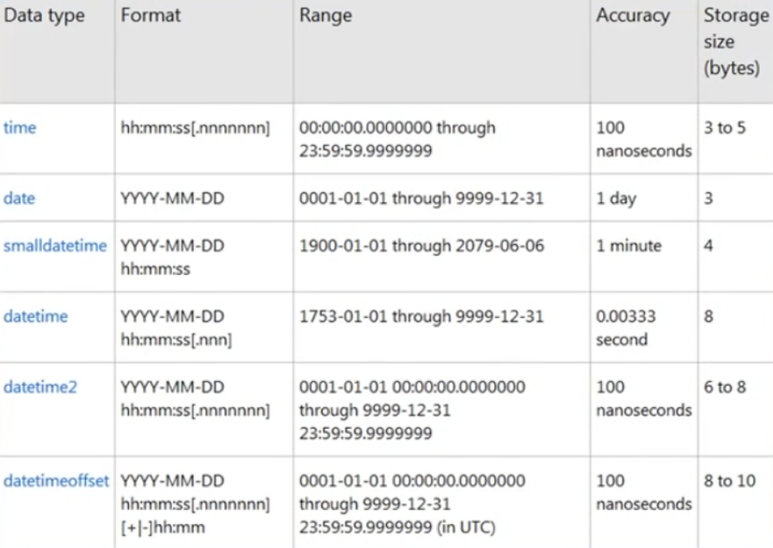

Reference:

<https://docs.microsoft.com/en-us/sql/t-sql/functions/date-and-time-data-types-and-functions-transact-sql>

1.6. Char, varchar, varchar(Max), nchar, nvarchar, nvarChar(Max)

**Char(N)**,

is a fixed length characters.

Each **character** take **1 Byte**.

It is like C# string with the length of N.

If the value is "KL", and if the data type is Char(5).

Then it will fill 3 blank into the string, _ _ _ K L

**varchar(N)**is not a fixed length characters.

Each **character** take **1 Byte**.

If the value is "KL", and if the data type is Char(5).

Then it will not fill blanks into the string, "KL"

**varchar(Max)**

It is similar to **varchar(N)**

Just replace N to max value.

Each **character** take **1 Byte**.

**NChar(N)**,

It is similar to **Char(N)**

But each **character** take 2**Byte** in order to save**non-English language character**

such as **Chinese character**

**Nvarchar(N)**

It is similar to **varchar(N)**

But each **character** take 2**Byte** in order to save**non-English language character**

such as **Chinese character**

**Nvarchar(Max)**

It is similar to **varchar(Max)**

But each **character** take 2**Byte** in order to save**non-English language character**

such as **Chinese character**

1.7. uniqueidentifier

Reference:

<https://docs.microsoft.com/en-us/sql/t-sql/data-types/uniqueidentifier-transact-sql>

**uniqueidentifier**

16 bytes.

E.g.

6F9619FF-8B86-D011-B42D-00C04FC964FF

2. DDL V.S. DML / Fragmentation and Defragmentation

<https://stackoverflow.com/questions/2578194/what-is-ddl-and-dml>

[https://technet.microsoft.com/en-us/library/ff848799(v=sql.110).aspx](https://technet.microsoft.com/en-us/library/ff848799%28v=sql.110%29.aspx)

**Data Definition Language (DDL)**

* It is used to define data **structures**.
* Data Definition Language (DDL) statements are used to define the database structure or **schema**. Some examples:
* SQL Server uses **Transact-SQL**, or **T-SQL**

1. CREATE - to create objects in the database

2. ALTER - alters the structure of the database

3. DROP - delete objects from the database

4. **TRUNCATE**截短 - removes rows from a table and reclaims free space. The data is **less likely** to become **fragmented** and more likely to stay in the correct order.

5. COMMENT - add comments to the data dictionary

6. RENAME - rename an object

**Data Manipulation Language (DML)**

* It is used to manipulate **data** **itself**.
* Data Manipulation Language (DML) statements are used for managing data within schema objects. Some examples:

1. SELECT - retrieve data from the a database

2. INSERT - insert data into a table UPDATE - updates existing data within a table

3. **DELETE** - removes rows from a table but does not reclaim space.  It does so piecemeal零碎地, which can result in something called **fragmentation**.

4. MERGE - UPSERT operation (insert or update)

5. CALL - call a PL/SQL or Java subprogram

6. EXPLAIN PLAN - explain access path to data

7. LOCK TABLE - control concurrency

**Fragmentation** and **Defragmentation**

     Over time, fragmentation can reduce SQL Server's performance,

     and you have to do something called defragmentation to put the pages back in the order that they're meant to be in.