(T27)深入理解Join中的Except和NotIn和Insert和Union和UnionAll。比較InnerJoin和DistinctInnerJoin  
CourseGUID: e48417fc-9db5-4e99-822c-706c5ccef6cc  
=======================================================================  
(T27)深入理解Join中的Except和NotIn和Insert和Union和UnionAll。比較InnerJoin和DistinctInnerJoin  
=======================================================================  
0. Summary

-----------

1. Except V.S. NOT IN

1.1. Create Sample Data

1.2. Except V.S. NOT IN ; Except for 2 tables

1.3. Except for 1 table

1.4. EXCEPT limit

1.5. NOT IN limit

1.6. Clean up

-----------

2. Intersect

2.1. Create sample data

2.2. INTERSECT V.S. INNER JOIN V.S. DISTINCT INNER JOIN

2.2.1. INTERSECT

2.2.2. INNER JOIN

2.2.3. DISTINCT INNER JOIN

2.3. Clean up

-----------

3. Intersect V.S. Except

3.1. Create sample data

3.2. UNION

3.3. UNION ALL

3.4. INTERSECT

3.5. EXCEPT

3.6. EXCEPT

3.7. Clean up  
=======================================================================  
  
0. Summary

1.

1.1.

--Except, INTERSECT, UNION, UNION ALL

Except, INTERSECT, UNION, UNION ALL operators deal with rows, not columns.

In order to use Except, INTERSECT, UNION, UNION ALL,

the order and the the number of the columns from the select cluase

must be the same as all queries.

The data types must be same or at least compatible as all queries.

1.1.1

--UNION

UNION operator returns "DISTINCT rows" from both QueryA and QueryB.

1.1.2.

--UNION ALL

UNION ALL operator returns all rows from both QueryA and QueryB,

and it may "contains duplicates rows"

1.1.3.

--INTERSECT

INTERSECT operator retrieves the "DISTINCT rows"

which exists in both QueryA and QueryB,

1.1.4.

--EXCEPT

1.1.4.1.

--QueryA EXCEPT QueryB

EXCEPT operator retrieves the "DISTINCT rows" from PersonA

that does not exist in PersonB

1.1.4.2.

--QueryB EXCEPT QueryA

EXCEPT operator retrieves the "DISTINCT rows" from PersonB

that does not exist in PersonA

-------------

1.2.

--INNER JOIN, DISTINCT INNER JOIN

INNER JOIN, DISTINCT INNER JOIN operators deal with columns

by using JoinColumns.

1.2.1.

--INTERSECT  V.S. INNER JOIN  V.S.  DISTINCT INNER JOIN

1.2.1.1.

INTERSECT and DISTINCT INNER JOIN both return "DISTINCT rows".

but INNER JOIN may return duplicated rows.

1.2.1.2.

If columnA INNER JOIN columnB,

and If value of columnARow5 is NULL,

and If value of columnBRow5 is NULL,

1.2.1.2.1.

Then INTERSECT treats two NULLs as a same value

and it will think columnARow5 and columnBRow5 are matching row.

It will display this matching row.

1.2.1.2.2.

Then (DISTINCT) INNER JOIN treats two NULLs as a different value

and it will think columnARow5 and columnBRow5 are NOT matching row.

It will NOT display this row.

-------------

1.3.

--NOT IN

NOT IN compares ONE column from the Outer query

with a ONE column from the Inner query.

NOT IN get the rows from the outter query

that aren’t in the Inner query’s results.

NOT IN might "contain duplicated rows".

1.3.1.

--Except V.S. NOT IN

Except and NOT IN both get the rows from the left/outter query

that aren’t in the right/Inner query’s results.

Except returns "DISTINCT ROWS",

but NOT IN may return "duplicated rows".

1.3.2.

--Except

1.3.2.1.

Except, INTERSECT, UNION, UNION ALL operators deal with rows, not columns.

In order to use Except, INTERSECT, UNION, UNION ALL,

the order and the the number of the columns from the select cluase

must be the same as all queries.

The data types must be same or at least compatible as all queries.

1.3.2.2.

Except operator only get the rows from the left query

that aren’t in the right query’s results.

Except will return "DISTINCT ROWS".

1.3.3.

--NOT IN

NOT IN compares ONE column from the Outer query

with a ONE column from the Inner query.

NOT IN may return "duplicated rows".

==================================================

1. Except V.S. NOT IN

--====================================================================

--T027_01_Except V.S. NOT IN

--====================================================================

/*

1.

Except V.S. NOT IN

1.1.

Except

1.1.1.

In order to use Except,

the order and the the number of the columns from the select cluase

must be the same as all queries.

1.1.2.

Except operator only get the "DISTINCT ROWS" from the left query

that aren’t in the right query’s results.

1.2.

NOT IN

1.2.1.

NOT IN compares ONE column from the outer query with a ONE column from the subquery.

1.2.2.

NOT IN does "NOT FILTER OUT DUPLICATED" rows in the result.

*/

1.1. Create Sample Data

--====================================================================

--T027_01_01

--Create Sample Data

IF ( EXISTS ( SELECT    *

              FROM      INFORMATION_SCHEMA.TABLES

              WHERE     TABLE_NAME = 'PersonA' ) )

    BEGIN

        TRUNCATE TABLE dbo.PersonA;

        DROP TABLE PersonA;

    END;

GO -- Run the previous command and begins new batch

IF ( EXISTS ( SELECT    *

              FROM      INFORMATION_SCHEMA.TABLES

              WHERE     TABLE_NAME = 'PersonB' ) )

    BEGIN

        TRUNCATE TABLE dbo.PersonB;

        DROP TABLE PersonB;

    END;

GO -- Run the previous command and begins new batch

CREATE TABLE PersonA

    (

      ID INT IDENTITY(1, 1)

             PRIMARY KEY ,

      [Name] NVARCHAR(100) ,

      Gender NVARCHAR(10) ,

      Salary INT

    );

GO -- Run the previous command and begins new batch

INSERT  INTO PersonA

VALUES  ( 'Name01', 'Male', 42000 );

INSERT  INTO PersonA

VALUES  ( 'PersonAName02', 'Female', 43000 );

INSERT  INTO PersonA

VALUES  ( 'PersonAName03', 'Male', 45000 );

INSERT  INTO PersonA

VALUES  ( 'PersonAName04', 'Male', 55000 );

INSERT  INTO PersonA

VALUES  ( 'Name05', 'Female', 42000 );

INSERT  INTO PersonA

VALUES  ( 'PersonAName06', 'Female', 53000 );

INSERT  INTO PersonA

VALUES  ( 'PersonAName07', 'Male', 60000 );

INSERT  INTO PersonA

VALUES  ( 'PersonAName08', 'Male', 54000 );

INSERT  INTO PersonA

VALUES  ( 'PersonAName09', 'Female', 42000 );

INSERT  INTO PersonA

VALUES  ( 'Name10', 'Male', 60000 );

--The duplicated Rows

INSERT  INTO PersonA

VALUES  ( 'Name01', 'Male', 42000 );

INSERT  INTO PersonA

VALUES  ( 'PersonAName02', 'Female', 43000 );

GO -- Run the previous command and begins new batch

CREATE TABLE PersonB

    (

      ID INT IDENTITY(1, 1)

             PRIMARY KEY ,

      [Name] NVARCHAR(100) ,

      Gender NVARCHAR(10) ,

      Salary INT

    );

GO -- Run the previous command and begins new batch

INSERT  INTO PersonB

VALUES  ( 'Name01', 'Male', 42000 );

INSERT  INTO PersonB

VALUES  ( 'PersonBName02', 'Female', 43000 );

INSERT  INTO PersonB

VALUES  ( 'PersonBName03', 'Male', 45000 );

INSERT  INTO PersonB

VALUES  ( 'PersonBName04', 'Male', 45000 );

INSERT  INTO PersonB

VALUES  ( 'Name5', 'Female', 42000 );

INSERT  INTO PersonB

VALUES  ( 'PersonBName06', 'Female', 60000 );

INSERT  INTO PersonB

VALUES  ( 'PersonBName07', 'Male', 43000 );

INSERT  INTO PersonB

VALUES  ( 'PersonBName08', 'Male', 42000 );

INSERT  INTO PersonB

VALUES  ( 'PersonBName09', 'Female', 42000 );

INSERT  INTO PersonB

VALUES  ( 'Name10', 'Male', 60000 );

GO -- Run the previous command and begins new batch

SELECT  *

FROM    PersonA;

SELECT  *

FROM    PersonB;

GO -- Run the previous command and begins new batch

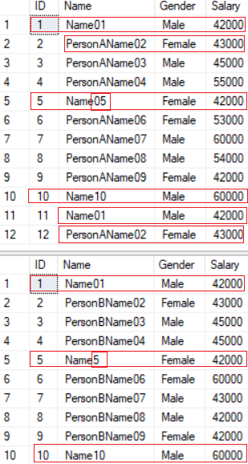

1.2. Except V.S. NOT IN ; Except for 2 tables

--====================================================================

--T027_01_02

--Except V.S. NOT IN ; Except for 2 tables

------------------------------------------------------------------

--T027_01_02_01

--select all rows from TableB that does not exist in TableA.

SELECT  [Name] ,

        Gender ,

        Salary

FROM    dbo.PersonB

EXCEPT

SELECT  [Name] ,

        Gender ,

        Salary

FROM    dbo.PersonA;

GO -- Run the previous command and begins new batch

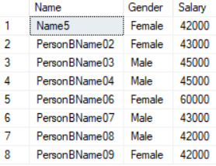

------------------------------------------------------------------

--T027_01_02_02

--select all rows from TableA that does not exist in TableB.

SELECT  [Name] ,

        Gender ,

        Salary

FROM    dbo.PersonA

EXCEPT

SELECT  [Name] ,

        Gender ,

        Salary

FROM    dbo.PersonB;

GO -- Run the previous command and begins new batch

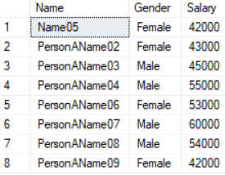

------------------------------------------------------------------

--T027_01_02_03

--select all rows from TableA that does not exist in TableB.

SELECT  [Name] ,

        Gender ,

        Salary

FROM    dbo.PersonA

WHERE   [Name] NOT IN ( SELECT  [Name]

                        FROM    dbo.PersonB );

GO -- Run the previous command and begins new batch

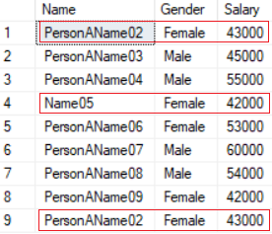

/*

1.

Except V.S. NOT IN

1.1.

Except

1.1.1.

In order to use Except,

the order and the the number of the columns from the select cluase

must be the same as all queries.

1.1.2.

Except operator only get the "DISTINCT ROWS" from the left query

that aren’t in the right query’s results.

1.2.

NOT IN

1.2.1.

NOT IN compares ONE column from the outer query with a ONE column from the subquery.

1.2.2.

NOT IN does "NOT FILTER OUT DUPLICATED" rows in the result.

*/

1.3. Except for 1 table

--====================================================================

--T027_01_03

--Except for 1 table

------------------------------------------------------------------

--T027_01_03_01

--Salary >= 45000 AND Salary <= 58000

SELECT  [Name] ,

        Gender ,

        Salary

FROM    dbo.PersonA

WHERE   Salary >= 45000

EXCEPT

SELECT  [Name] ,

        Gender ,

        Salary

FROM    dbo.PersonA

WHERE   Salary >= 58000

ORDER BY [Name];

GO -- Run the previous command and begins new batch

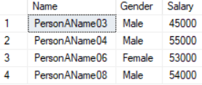

/*

The result is same as

--WHERE   Salary >= 45000 AND Salary <= 58000

*/

------------------------------------------------------------------

--T027_01_03_02

--Salary >= 45000 AND Salary <= 58000

SELECT  [Name] ,

        Gender ,

        Salary

FROM    dbo.PersonA

WHERE   Salary >= 45000

        AND Salary <= 58000;

GO -- Run the previous command and begins new batch

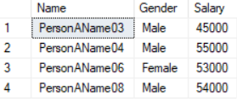

1.4. EXCEPT limit

--====================================================================

--T027_01_04

--EXCEPT limit

SELECT  [Name] ,

        Gender ,

        Salary

FROM    dbo.PersonA

EXCEPT

SELECT  [Name] ,

        Gender

FROM    dbo.PersonB;

/*

1.

Output

--Msg 205, Level 16, State 1, Line 250

--All queries combined using a UNION, INTERSECT or EXCEPT operator

--must have an equal number of expressions in their target lists.

In order to use Except,

the order and the the number of the columns from the select cluase

must be the same as all queries.

*/



1.5. NOT IN limit

--====================================================================

--T027_01_05

--NOT IN limit

SELECT  [Name] ,

        Gender ,

        Salary

FROM    PersonA

WHERE   ID NOT IN ( SELECT  [Name] ,

                            Gender

                    FROM    PersonB );

/*

Output

--Msg 116, Level 16, State 1, Line 274

--Only one expression can be specified in the select list

--when the subquery is not introduced with EXISTS.

NOT IN compares ONE column from the outer query

with a ONE column from the subquery.

*/



1.6. Clean up

--====================================================================

--T027_01_06

--Clean up

IF ( EXISTS ( SELECT    *

              FROM      INFORMATION_SCHEMA.TABLES

              WHERE     TABLE_NAME = 'PersonA' ) )

    BEGIN

        TRUNCATE TABLE dbo.PersonA;

        DROP TABLE PersonA;

    END;

GO -- Run the previous command and begins new batch

--If Table exists then DROP it

IF ( EXISTS ( SELECT    *

              FROM      INFORMATION_SCHEMA.TABLES

              WHERE     TABLE_NAME = 'PersonB' ) )

    BEGIN

        TRUNCATE TABLE dbo.PersonB;

        DROP TABLE PersonB;

    END;

GO -- Run the previous command and begins new batch

==================================================

2. Intersect

--====================================================================

--T027_02_Intersect

--====================================================================

/*

1.2.

--INNER JOIN, DISTINCT INNER JOIN

INNER JOIN, DISTINCT INNER JOIN operators deal with columns

by using JoinColumns.

1.2.1.

--INTERSECT  V.S. INNER JOIN  V.S.  DISTINCT INNER JOIN

1.2.1.1.

INTERSECT and DISTINCT INNER JOIN both return "DISTINCT rows".

but INNER JOIN may return duplicated rows.

1.2.1.2.

If columnA INNER JOIN columnB,

and If value of columnARow5 is NULL,

and If value of columnBRow5 is NULL,

1.2.1.2.1.

Then INTERSECT treats two NULLs as a same value

and it will think columnARow5 and columnBRow5 are matching row.

It will display this matching row.

1.2.1.2.2.

Then (DISTINCT) INNER JOIN treats two NULLs as a different value

and it will think columnARow5 and columnBRow5 are NOT matching row.

*/

2.1. Create sample data

--====================================================================

--T027_02_01

--Create sample data

IF ( EXISTS ( SELECT    *

              FROM      INFORMATION_SCHEMA.TABLES

              WHERE     TABLE_NAME = 'PersonA' ) )

    BEGIN

        TRUNCATE TABLE dbo.PersonA;

        DROP TABLE PersonA;

    END;

GO -- Run the previous command and begins new batch

IF ( EXISTS ( SELECT    *

              FROM      INFORMATION_SCHEMA.TABLES

              WHERE     TABLE_NAME = 'PersonB' ) )

    BEGIN

        TRUNCATE TABLE dbo.PersonB;

        DROP TABLE PersonB;

    END;

GO -- Run the previous command and begins new batch

CREATE TABLE PersonA

    (

      ID INT ,

      [Name] NVARCHAR(100) ,

      Gender NVARCHAR(10) ,

      Salary INT

    );

GO -- Run the previous command and begins new batch

INSERT  INTO PersonA

VALUES  ( 1, 'Name01', 'Male', 42000 );

INSERT  INTO PersonA

VALUES  ( 2, 'Name02', 'Female', 43000 );

INSERT  INTO PersonA

VALUES  ( 3, 'PersonAName03', 'Male', 45000 );

INSERT  INTO PersonA

VALUES  ( 4, 'PersonAName04', 'Male', 55000 );

INSERT  INTO PersonA

VALUES  ( 5, 'Name05', 'Female', 42000 );

INSERT  INTO PersonA

VALUES  ( 6, NULL, 'Female', 53000 );

INSERT  INTO PersonA

VALUES  ( 7, NULL, 'Male', 60000 );

INSERT  INTO PersonA

VALUES  ( 8, 'PersonAName08', 'Male', 54000 );

INSERT  INTO PersonA

VALUES  ( 9, 'PersonAName09', 'Female', 42000 );

INSERT  INTO PersonA

VALUES  ( 10, 'Name10', 'Male', 60000 );

--The duplicated Rows

INSERT  INTO PersonA

VALUES  ( 1, 'Name01', 'Male', 42000 );

INSERT  INTO PersonA

VALUES  ( 8, 'PersonAName08', 'Male', 54000 );

INSERT  INTO PersonA

VALUES  ( 9, 'PersonAName09', 'Female', 42000 );

GO -- Run the previous command and begins new batch

CREATE TABLE PersonB

    (

      ID INT ,

      [Name] NVARCHAR(100) ,

      Gender NVARCHAR(10) ,

      Salary INT

    );

GO -- Run the previous command and begins new batch

INSERT  INTO PersonB

VALUES  ( 1, 'Name01', 'Male', 42000 );

INSERT  INTO PersonB

VALUES  ( 2, 'Name02', 'Female', 43000 );

INSERT  INTO PersonB

VALUES  ( 3, 'PersonBName03', 'Male', 45000 );

INSERT  INTO PersonB

VALUES  ( 4, 'PersonBName04', 'Male', 45000 );

INSERT  INTO PersonB

VALUES  ( 5, 'Name05', 'Female', 42000 );

INSERT  INTO PersonB

VALUES  ( 6, NULL, 'Female', 53000 );

INSERT  INTO PersonB

VALUES  ( 7, NULL, 'Male', 60000 );

INSERT  INTO PersonB

VALUES  ( 8, 'PersonBName08', 'Male', 42000 );

INSERT  INTO PersonB

VALUES  ( 9, 'PersonBName09', 'Female', 42000 );

INSERT  INTO PersonB

VALUES  ( 10, 'Name10', 'Male', 60000 );

GO -- Run the previous command and begins new batch

SELECT  *

FROM    dbo.PersonA;

SELECT  *

FROM    dbo.PersonB;

GO -- Run the previous command and begins new batch

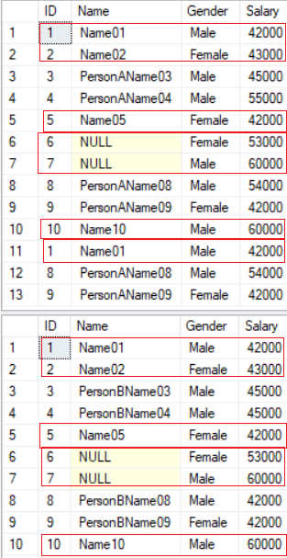

2.2. INTERSECT  V.S. INNER JOIN  V.S.  DISTINCT INNER JOIN

--====================================================================

--T027_02_02

--INTERSECT  V.S. INNER JOIN  V.S.  DISTINCT INNER JOIN

2.2.1. INTERSECT

---------------------------------------------------------------------

--T027_02_02_01

--INTERSECT

SELECT  ID ,

        [Name] ,

        Gender ,

        Salary

FROM    dbo.PersonA

INTERSECT

SELECT  ID ,

        [Name] ,

        Gender ,

        Salary

FROM    dbo.PersonB;

GO -- Run the previous command and begins new batch

/*

1.

1.1.

It will Show ID=1,2,5,6,7,10.

The [name] of row ID=6,7  is NULL.

1.2.

Then INTERSECT treats two NULLs as a same value

and it will think columnARow5 and columnBRow5 are matching row.

It will display this matching row.

*/

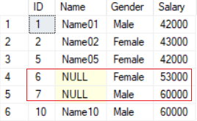

2.2.2. INNER JOIN

---------------------------------------------------------------------

--T027_02_02_02

--INNER JOIN

SELECT  dbo.PersonA.ID ,

        dbo.PersonA.[Name] ,

        dbo.PersonA.Gender ,

        dbo.PersonA.Salary

FROM    dbo.PersonA

        INNER JOIN dbo.PersonB ON dbo.PersonA.[Name] = dbo.PersonB.[Name];

GO -- Run the previous command and begins new batch

/*

1.

1.1.

It will Show ID=1,2,5,10,1.

The [name] of row ID=6,7  is NULL,

and these two rows does not display.

1.2.

(DISTINCT) INNER JOIN treats two NULLs as a different value

and it will think columnARow5 and columnBRow5 are NOT matching row.

It will NOT display this row.

1.3.

INTERSECT and DISTINCT INNER JOIN both return non-duplicated rows.

but INNER JOIN returns duplicated rows.

*/

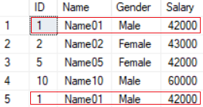

2.2.3. DISTINCT INNER JOIN

---------------------------------------------------------------------

--T027_02_02_03

--DISTINCT INNER JOIN

SELECT  DISTINCT

        dbo.PersonA.ID ,

        dbo.PersonA.[Name] ,

        dbo.PersonA.Gender ,

        dbo.PersonA.Salary

FROM    dbo.PersonA

        INNER JOIN dbo.PersonB ON dbo.PersonA.[Name] = dbo.PersonB.[Name];

GO -- Run the previous command and begins new batch

/*

1.

1.1.

It will Show ID=1,2,5,10.

The [name] of row ID=6,7  is NULL,

and these two rows does not display.

The ID=1 is a duplicated row,

and DISTINCT will only show one of them.

1.2.

(DISTINCT) INNER JOIN treats two NULLs as a different value

and it will think columnARow5 and columnBRow5 are NOT matching row.

It will NOT display this row.

1.3.

INTERSECT and DISTINCT INNER JOIN both return non-duplicated rows.

but INNER JOIN returns duplicated rows.

*/

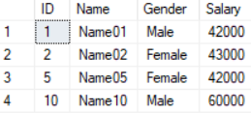

2.3. Clean up

--====================================================================

--T027_02_03

--Clean up

IF ( EXISTS ( SELECT    *

              FROM      INFORMATION_SCHEMA.TABLES

              WHERE     TABLE_NAME = 'PersonA' ) )

    BEGIN

        TRUNCATE TABLE dbo.PersonA;

        DROP TABLE PersonA;

    END;

GO -- Run the previous command and begins new batch

IF ( EXISTS ( SELECT    *

              FROM      INFORMATION_SCHEMA.TABLES

              WHERE     TABLE_NAME = 'PersonB' ) )

    BEGIN

        TRUNCATE TABLE dbo.PersonB;

        DROP TABLE PersonB;

    END;

GO -- Run the previous command and begins new batch

==================================================

3. Intersect V.S. Except

--====================================================================

--T027_03_Intersect V.S. Except

--====================================================================

3.1. Create sample data

--====================================================================

--T027_03_01

--Create sample data

IF ( EXISTS ( SELECT    *

              FROM      INFORMATION_SCHEMA.TABLES

              WHERE     TABLE_NAME = 'PersonA' ) )

    BEGIN

        TRUNCATE TABLE dbo.PersonA;

        DROP TABLE PersonA;

    END;

GO -- Run the previous command and begins new batch

IF ( EXISTS ( SELECT    *

              FROM      INFORMATION_SCHEMA.TABLES

              WHERE     TABLE_NAME = 'PersonB' ) )

    BEGIN

        TRUNCATE TABLE dbo.PersonB;

        DROP TABLE PersonB;

    END;

GO -- Run the previous command and begins new batch

CREATE TABLE PersonA

    (

      ID INT ,

      [Name] NVARCHAR(100) ,

      Gender NVARCHAR(10)

    );

GO -- Run the previous command and begins new batch

INSERT  INTO PersonA

VALUES  ( 1, 'Name01', 'Male' );

INSERT  INTO PersonA

VALUES  ( 2, 'Name02', 'Female' );

--Duplicated Rows

INSERT  INTO PersonA

VALUES  ( 3, 'Name03', 'Female' );

INSERT  INTO PersonA

VALUES  ( 3, 'Name03', 'Female' );

GO -- Run the previous command and begins new batch

CREATE TABLE PersonB

    (

      ID INT ,

      [Name] NVARCHAR(100) ,

      Gender NVARCHAR(10)

    );

GO -- Run the previous command and begins new batch

INSERT  INTO PersonB

VALUES  ( 2, 'Name02', 'Female' );

INSERT  INTO PersonB

VALUES  ( 3, 'Name03', 'Female' );

INSERT  INTO PersonB

VALUES  ( 4, 'Name04', 'Male' );

GO -- Run the previous command and begins new batch

SELECT  *

FROM    dbo.PersonA;

SELECT  *

FROM    dbo.PersonB;

GO -- Run the previous command and begins new batch

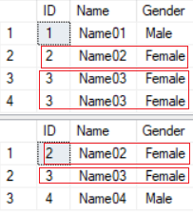

3.2. UNION

--====================================================================

--T027_03_02

--UNION

SELECT  ID ,

        [Name] ,

        Gender

FROM    PersonA

UNION

SELECT  ID ,

        [Name] ,

        Gender

FROM    PersonB;

/*

1.

--UNION

UNION operator removes duplicates rows and

only returns unique rows from both PersonA and PersonB.

2.

Output

ID=1,2,3,4

*/

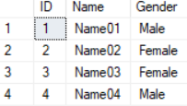

3.3. UNION ALL

--====================================================================

--T027_03_03

--UNION ALL

SELECT  ID ,

        [Name] ,

        Gender

FROM    dbo.PersonA

UNION ALL

SELECT  ID ,

        [Name] ,

        Gender

FROM    dbo.PersonB;

/*

1.

--UNION ALL

UNION ALL operator does NOT remove duplicates rows and

returns all rows from both PersonA and PersonB.

2.

Output

ID=1,2,3,3,2,3,4

*/

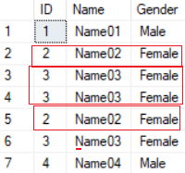

3.4. INTERSECT

--====================================================================

--T027_03_04

--INTERSECT

SELECT  ID ,

        Name ,

        Gender

FROM    dbo.PersonA

INTERSECT

SELECT  ID ,

        Name ,

        Gender

FROM    dbo.PersonB;

/*

--INTERSECT

1.

INTERSECT operator retrieves the rows

which exists in both PersonA and PersonB

and removes the duplicated rows.

2.

Output

ID=2,3

*/

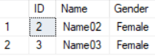

3.5. EXCEPT

--====================================================================

--T027_03_05

--EXCEPT

SELECT  ID ,

        [Name] ,

        Gender

FROM    dbo.PersonA

EXCEPT

SELECT  ID ,

        [Name] ,

        Gender

FROM    dbo.PersonB;

/*

1.

--EXCEPT

EXCEPT operator retrieves the unique rows from PersonA

that does not exist in PersonB

2.

Output

ID=1

*/



3.6. EXCEPT

--====================================================================

--T027_03_06

--EXCEPT

SELECT  ID ,

        [Name] ,

        Gender

FROM    dbo.PersonB

EXCEPT

SELECT  ID ,

        [Name] ,

        Gender

FROM    dbo.PersonA;

GO -- Run the previous command and begins new batch

/*

1.

--EXCEPT

EXCEPT operator retrieves the unique rows from PersonB

that does not exist in PersonA

2.

Output

ID=4

*/



3.7. Clean up

--====================================================================

--T027_03_07

--Clean up

--If Table exists then DROP it

IF ( EXISTS ( SELECT    *

              FROM      INFORMATION_SCHEMA.TABLES

              WHERE     TABLE_NAME = 'PersonA' ) )

    BEGIN

        TRUNCATE TABLE dbo.PersonA;

        DROP TABLE PersonA;

    END;

GO -- Run the previous command and begins new batch

--If Table exists then DROP it

IF ( EXISTS ( SELECT    *

              FROM      INFORMATION_SCHEMA.TABLES

              WHERE     TABLE_NAME = 'PersonB' ) )

    BEGIN

        TRUNCATE TABLE dbo.PersonB;

        DROP TABLE PersonB;

    END;

GO -- Run the previous command and begins new batch