(T45)討論DatabaseNormalization  
CourseGUID: e48417fc-9db5-4e99-822c-706c5ccef6cc  
=======================================================================  
(T45)討論DatabaseNormalization  
=======================================================================  
1. Normalization

1NF Eliminate Repeating Groups

2NF Eliminate Redundant Data

3NF Eliminate Non-Dependent Columns

4NF No Independent Multiple Relationships

5NF Isolate Semantically Related Relationships  
=======================================================================

1. Normalization

Normalization can educe data storage and data redundancy by making sure any given piece of data is stored only once.

There are normally 5 or 6 techniques (5NF or 6NF) to do the fully normalizing a database design.

The 5 normal forms are shortened as 1NF, 2NF, 3NF, 4NF, and 5NF, many people consider 3NF is sufficiently practical.

* 1NF: Eliminate Repeating Groups
* 2NF: Eliminate Redundant Data
* 3NF: Eliminate Non-Dependent Columns
* 4NF: No Independent Multiple Relationships
* 5NF: Isolate Semantically Related Relationships

1NF Eliminate Repeating Groups

Reference:

<http://www.gitta.info/LogicModelin/en/html/DataConsiten_Norm1NF.html>

1 NF must eliminate repeating groups which means no duplicate records in the table, no multi-valued column, and the same column always contain the same data type.

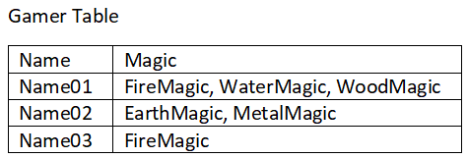

Magic column is currently a multi-valued column, thus, it need to be separated.

2NF Eliminate Redundant Data

2NF has to firstly meet all conditions of 1NF.

2NF also has to move Redundant Data to a **separate table**

,then create **relationship between** these **tables** using **foreign keys**.

In our example, moving Magic to its own table also achieved 2NF.

2NF also has to move Redundant Data, Magic, to a separate table

,then create relationship between these tables using **foreign keys**.

3NF Eliminate Non-Dependent Columns

Reference:

<https://www.tutorialcup.com/dbms/third-normal-form.htm>

3NF has to firstly meet all conditions of 2NF.

3NF also has to remove Non-Dependent Columns

that means table should not contain columns that are not fully dependent upon the primary key.

GamerID is Primary key, but TeamName column are not fully dependent upon the primary key.

Thus, 3NF has to move TeamName to other table.

The TeamName is actually depending on TeamID.

4NF No Independent Multiple Relationships

Reference:

<https://www.tutorialcup.com/dbms/fourth-normal-form.htm>

4NF has to firstly meet all conditions of 3NF.

4NF also has to remove multi-valued dependencies.

Magic Table

This satisfies 3NF,

but the MagicType and the MagicSpell are really 2 independent entities here.

There is no relationship between MagicType and MagicSpell.

 4NF also has to remove multi-valued dependencies which means we have to separate MagicType and MagicSpell.

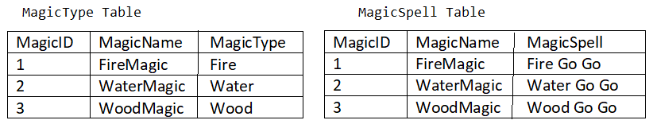

Too much normalization might reduce performance, as SQL must repeatedly join a lot of tables.

Many people think 3NF is good enough.

5NF Isolate Semantically Related Relationships

Reference:

<https://www.tutorialcup.com/dbms/fifth-normal-form.htm>

5NF has to firstly meet all conditions of 4NF.

5NF also has to isolate Semantically Related Relationships.

Magic Table

This satisfies 3NF,

but the MagicType and the MagicSpell are really 2 independent entities here.

There is no relationship between MagicType and MagicSpell.

 4NF also has to remove multi-valued dependencies which means we have to separate MagicType and MagicSpell.



This satisfies 4NF,

but we still can see the magic Id is appeared  in both tables.

5NF also has to isolate Semantically Related Relationships.

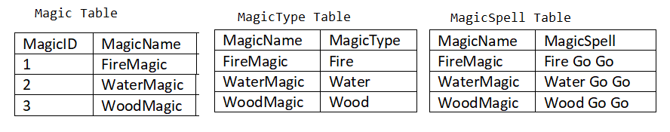

Too much normalization might reduce performance, as SQL must repeatedly join a lot of tables.

Many people think 3NF is good enough.