(T11)比較ConvertToString、ToString、OverrideToString  
CourseGUID: 29f1196a-1950-41a4-b9c1-dd13a9e92d92  
=======================================================================  
(T11)比較ConvertToString、ToString、OverrideToString  
=======================================================================  
0. Summary

-----------

1. New Project

1.1. Create New Project

-----------

2. Program.cs  
=======================================================================

0. Summary

Convert.ToString(variable) return string.Empty when variable==null;

variable.ToString throws a NULL Reference exception when variable==null;

1. New Project

1.1. Create New Project

File --> New --> Project... -->

Visual C# -->  **Console App** **(.Net Framework)** -->

Name: **Sample**

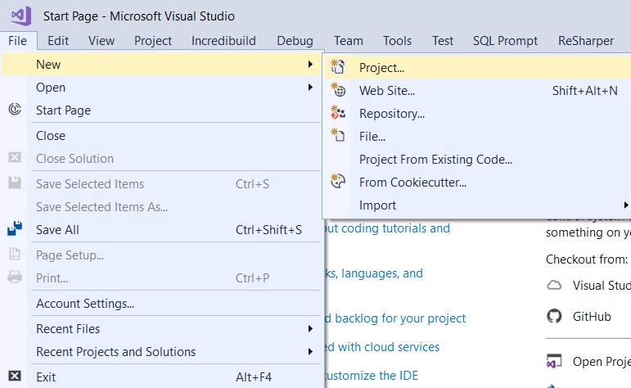

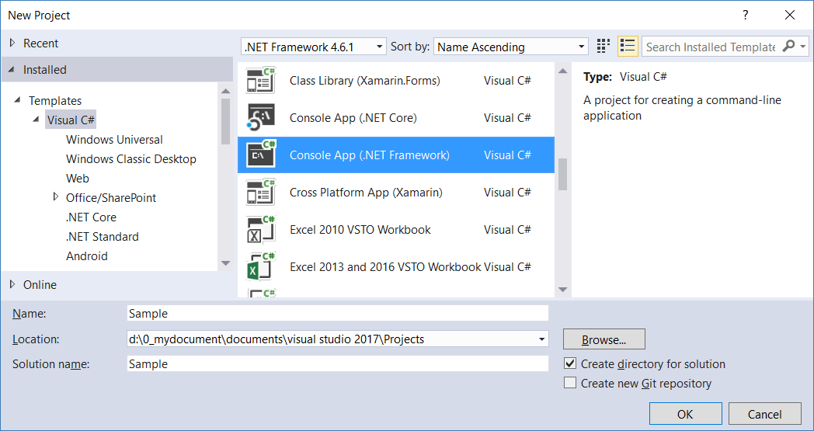

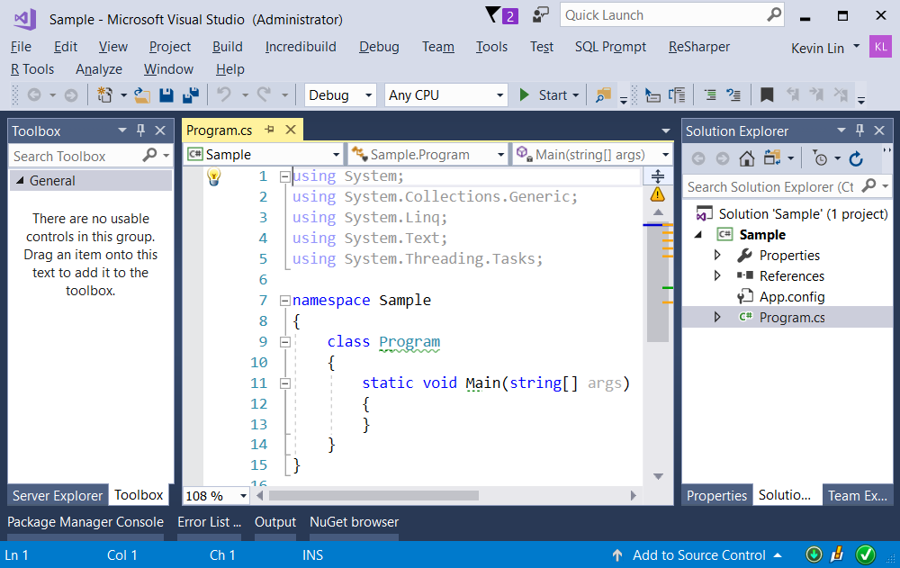

=============================================

2. Program.cs

using System;

using OnLineGame;

namespace Sample

{

    class Program

    {

        static void Main(string[] args)

        {

            // 1. -----------------------------

            int i1 = 1;

            Console.WriteLine(i1.ToString());

            //1

            // 2. -----------------------------

            // reason to override ToString()

            GamerA gA1 = new GamerA();

            gA1.FirstName = "F01";

            gA1.LastName = "L01";

            Console.WriteLine(gA1.ToString());

            // OnLineGame.GamerA

            // 3. -----------------------------

            Gamer g1 = new Gamer();

            g1.FirstName = "F01";

            g1.LastName = "L01";

            Console.WriteLine(g1.ToString());

            //F01 L02

            g1 = null;

            try

            {

                Console.WriteLine(g1.ToString());

            }

            catch (Exception ex)

            {

                Console.WriteLine("Exception : {0} \nMessage : {1} \nStackTrace : {2} \n", ex.GetType().Name, ex.Message, ex.StackTrace);

            }

            //Exception: NullReferenceException

            //Message : Object reference not set to an instance of an object.

            //StackTrace :    at Sample.Program.Main(String[] args) in d:\0_mydocument\documents\visual studio 2017\Projects\Sample\Sample\Program.cs:line 36

            // 4. -----------------------------

            //Convert.ToString(variable) return string.Empty when variable== null;

            //variable.ToString throws a NULL Reference exception when variable== null;

            Gamer g2 = new Gamer();

            g2.FirstName = "F02";

            g2.LastName = "L02";

            Console.WriteLine(Convert.ToString(g2));

            //F02 L02

            g2 = null;

            Console.WriteLine(Convert.ToString(g2) == string.Empty ?

                "NULL" :

                Convert.ToString(g2));

            //NULL

            Console.ReadLine();

        }

    }

}

namespace OnLineGame

{

    public class GamerA

    {

        public string FirstName { get; set; }

        public string LastName { get; set; }

    }

    public class Gamer

    {

        public string FirstName { get; set; }

        public string LastName { get; set; }

        public override string ToString()

        {

            return $"{FirstName} {LastName}";

        }

    }

}

/*

Convert.ToString(variable) return string.Empty when variable==null;

variable.ToString throws a NULL Reference exception when variable==null;

*/

