(T1)C#的Type(型別)、NullableType(可空型別)  
CourseGUID: 29f1196a-1950-41a4-b9c1-dd13a9e92d92  
=======================================================================  
(T1)C#的Type(型別)、NullableType(可空型別)  
=======================================================================  
0. Summary

1. Create New Project

2. Comment

3. C# basic  
=======================================================================

0. Summary

* 第1章: C#基礎介紹

    * Tutorial01: C#的各個型別包括介紹Nullable，各種loop，switch，if...else...。關於各種operator。

    * Tutorial02: C#的物件導向，關於Base Class，Sub Class，Interface

    * Tutorial03: 關於Namespace，Static method和Instance method比較，Ref，Out，params關鍵字比較，MethodOverride和MethodHide比較

    * Tutorial04: RAM的Stack和Heap比較，Struct和Class比較，Value Type和Reference Type比較

    * Tutorial05: public，protected，private的比較，Abstract Class和Interface的比較

    * Tutorial06: public，protected，private的比較，關於Delegate和Multicast Delegates

    * Tutorial07: TryCatch搭配常見的Exception，蝦毀?內建的不夠用，客製化的Exception

        * TryCatch ，Exception，FileNotFoundException，SqlException，FormatException，OverflowException，DivideByZeroException，客製化的Exception

    * Tutorial08: 關於Enum，Enum.GetValue和Enum.GetNames的比較

    * Tutorial09: Access modifiers大亂鬥。private V.S. public V.S. protected V.S. internal V.S. protected internal

    * Tutorial10: System.String和System.Text.StringBuilder比較。Ram的Stack和Heap比較。

    * Tutorial11: Convert.ToString和ToString的比較。納尼?不夠用?那就Override ToString。

    * Tutorial12: Contains()和Equals()和SequenceEqual()的bug的三種解決方法。Override Equals()和GetHashCode()。IEqualityComparer。使用匿名型別。

=============================================

1. Create New Project

File --> New --> Project... -->

Visual C# -->  **Console App** **(.Net Framework)** -->

Name: **Sample**

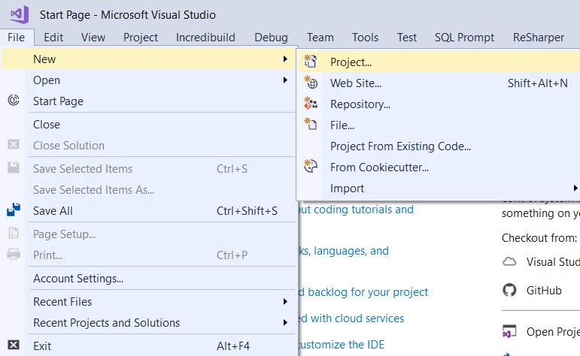

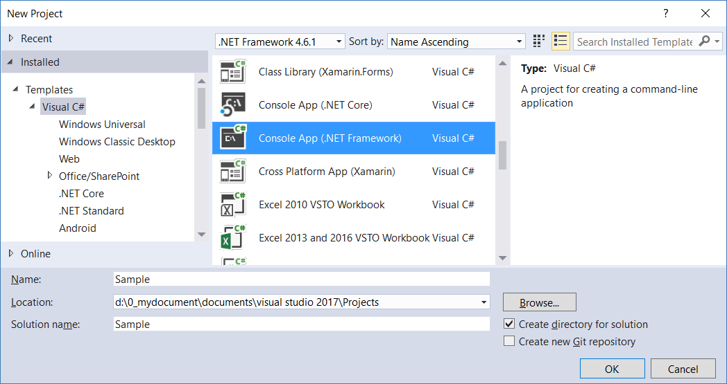

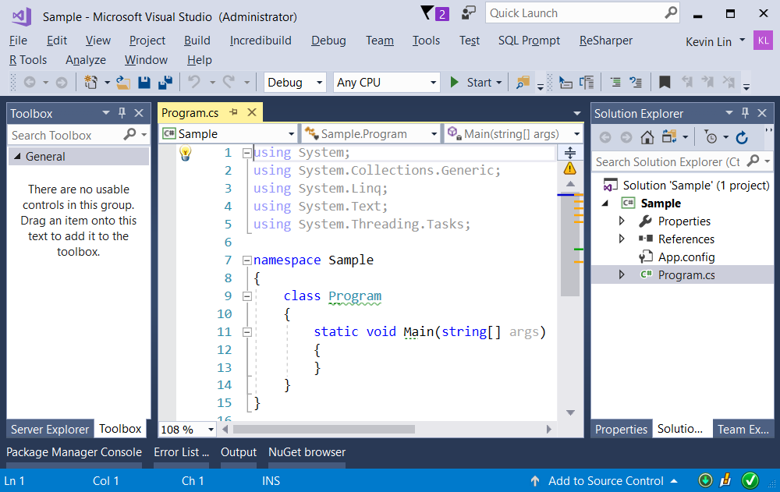

2. Comment

// Single line comment

/*

Multi line Comments

*/

/// means XML Documentation Comments

E.g.

/// <summary>

/// The magic start point of Console App (.Net Framework).

/// </summary>

/// <param name="args">the main arguments.</param>

static void Main(string[] args){}

You may highlight the code which you want to comments, then press

**Ctrl+K, Ctrl+C** to comment

OR

**Ctrl+K, Ctrl+U** to Un-Comment

You may also use tool bar to do comments.

 means comment.

 means Un-Comment.

3. C# basic

using System;

using System.Linq;

namespace Sample

{

    internal class Program

    {

        /// <summary>

        /// The magic start point of Console App (.Net Framework).

        /// </summary>

        /// <param name="args">the main arguments.</param>

        private static void Main(string[] args)

        {

            //1.

            Console.WriteLine("Hello, This is main method.");

            //-------------------------------------------------------------

            //2. Read the name

            Console.WriteLine("What is your name?");

            string name = Console.ReadLine();

            Console.WriteLine("Hello, " + name);

            Console.WriteLine("Have a good day. {0}", name);

            //-------------------------------------------------------------

            //3. Escape symbol, "\"

            //------------------------------------------------------

            //3.1.

            //Displaying double quotes

            string str = "\"AAA\""; //"AAA"

            Console.WriteLine(str);

            //------------------------------------------------------

            //3.2.

            //Displaying new line character

            str = "AAA\nBBB\nCCC";

            Console.WriteLine(str);

            //AAA

            //BBB

            //CCC

            //------------------------------------------------------

            //3.3.

            //Displaying the directory, Less Readable

            str = "c:\\AAA\\BBB\\CCC"; //c:\AAA\BBB\CCC

            Console.WriteLine(str);

            //------------------------------------------------------

            //3.4.

            //verbatim literal string displaying the directory, Better Readable

            str = @"c:\AAA\BBB\CCC\"; //c:\AAA\BBB\CCC\

            Console.WriteLine(str);

            //-------------------------------------------------------------

            //4. Operators

            //------------------------------------------------------

            //4.1. Assignment Operator : =

            char ch = 'A';

            string str2 = "AAAA";

            int i = 1;

            double d = 1.1;

            bool b = true;

            //------------------------------------------------------

            //4.2. Arithmetic Operators : +,-,*,/,%

            int i1 = 10;

            int i2 = 2;

            int i3 = 3;

            Console.WriteLine("i1 = {0}, i2 = {1}, i3 = {2}", i1, i2, i3); //i1 = 10, i2 = 2, i3 = 3

            Console.WriteLine("i2 + i3 = {0}", i2 + i3); //i2 + i3 = 5

            Console.WriteLine("i2 - i3 = {0}", i2 - i3); //i2 - i3 = -1

            Console.WriteLine("i2 * i3 = {0}", i2 * i3); //i2 * i3 = 6

            Console.WriteLine("i1 / i2 = {0}", i1 / i2); //i1 / i2 = 5, Find Quotient

            Console.WriteLine("i1 / i3 = {0}", i1 / i3); //i1 / i3 = 3, Find Quotient

            Console.WriteLine("i1 % i2 = {0}", i1 % i2); //i1 % i2 = 0, Find Remainder

            Console.WriteLine("i1 % i3 = {0}", i1 % i3); //i1 % i3 = 1, Find Remainder

            //------------------------------------------------------

            //4.3.

            //--------------------------------------------

            //4.3.1.

            //Comparison Operators : ==, !=,>, >=, <, <=

            //Conditional Operators : &&, ||

            //Ternary Operator :   Condition? True:False

            //Null Coalescing Operator: Condition ??

            //--------------------------------------------

            //4.3.2.

            // if(Condition){A}else{B} , if condition is true then A, else B.

            string str3 = "";

            if (i2 == 2)

            {

                str3 = "i2 == 2";

            }

            else

            {

                str3 = "i2 != 2";

            }

            Console.WriteLine(str3);

            //i2 == 2

            //--------------------------------------------

            //4.3.3.

            // variable = (condition) ? A : B , if condition is true then A, else B.

            str3 = i2 == 2 ? "i2 == 2" : "i2 != 2";

            Console.WriteLine(str3);

            //i2 == 2

            //--------------------------------------------

            //4.3.4.

            if (i2 != 5)

            {

                Console.WriteLine("i2 != 5");

            }

            //i2 != 5

            //--------------------------------------------

            //4.3.5.

            if (i2 == 2 && i3 == 3)

            {

                Console.WriteLine("i2 == 2 is true AND i3 == 3 is true");

            }

            //i2 == 2 is true AND i3 == 3 is true

            //--------------------------------------------

            //4.3.6.

            if (i2 == 2 || i3 == 5)

            {

                Console.WriteLine("i2 == 2 is true OR i3 == 5 is true");

            }

            //i2 == 2 is true OR i3 == 5 is true

            //-------------------------------------------------------------

            //5. Convert, Parse, TryParse

            //------------------------------------------------------

            //5.1. // Implicit convert int to float/double will not loss data.

            int i4 = 100;

            float f1 = i4; //Implicit convert int to float/double

            Console.WriteLine("f1 == {0}", f1); // f1 == 100

            //------------------------------------------------------

            //5.2. float/double to int

            float f2 = 100.25F;

            ////5.2.1.

            ////float/double can not be implicit converted to int.

            //int i5 = f2;

            //5.2.2.

            int i6 = (int) f2;

            Console.WriteLine("i6 == {0}", i6); //i6 == 100

            //Explicit conversion will loss fractional part.

            //There is also a possiblity of overflow exception.

            //5.2.3.

            //Convert class

            int i7 = Convert.ToInt32(f2);

            Console.WriteLine("i7 == {0}", i7); //i7 == 100

            //------------------------------------------------------

            //5.3. Parse and TryParse

            //5.3.1.

            string str4 = "100TG";

            //int i8 = int.Parse(str4);   // Error! throws an exception

            //5.3.2.

            int i9;

            int.TryParse(str4, out i9);

            Console.WriteLine("i9 == {0}", i9); //i9 == 0, this means false.

            //5.3.3.

            string str5 = "100";

            int i10 = int.Parse(str5);

            int i11;

            int.TryParse(str5, out i11);

            Console.WriteLine("i10 == {0}, i11 == {1}", i10, i11); //i10 == 100, i11 == 100

                   //-------------------------------------------------------------

            //6. Nullable

            //------------------------------------------------------

            //6.1.  string V.S. int?

            string str6 = null; //string can be a class type, thus can be null.

            //int i12 = null; //Error! int is value type, thus can not be null.

            int? i13 = null; //int? will make it become nullable.

            //------------------------------------------------------

            //6.2.  bool?

            bool? b2 = null; //bool is value type, thus can not be null. bool? will make it become nullable.

            if (b2 == true)

            {

                Console.WriteLine("b2 == true");

            }

            else if (b2 == false)

            {

                Console.WriteLine("b2 == false");

            }

            else

            {

                Console.WriteLine("bool? b2 == null");

            }

            //------------------------------------------------------

            //6.3.  bool?

            int i14;

            int? i15 = null;

            if (i15 == null)

            {

                i14 = 0;

            }

            else

            {

                i14 = (int) i15;

            }

            Console.WriteLine("i14 == {0}", i14);

            //------------------------------------------------------

            //6.4.  bool?

            int i16;

            int? i17 = null;

            //A = B??C , if B==null, then C, otherwise B

            i16 = i17 ?? 0;

            Console.WriteLine("i16 =={0}", i16);

                   //-------------------------------------------------------------

            //7. Array and loop

            //------------------------------------------------------

            //7.1.  Even Array

            //Array use index to store or retrieve items from the array.

            int[] intEvenArr1 = new int[3];

            intEvenArr1[0] = 0;

            intEvenArr1[1] = 2;

            intEvenArr1[2] = 4;

            Console.WriteLine("intEvenArr1[0] == {0}", intEvenArr1[0]);

            Console.WriteLine("intEvenArr1[1] == {0}", intEvenArr1[1]);

            Console.WriteLine("intEvenArr1[2] == {0}", intEvenArr1[2]);

            //intEvenArr1[0] == 0

            //intEvenArr1[1] == 2

            //intEvenArr1[2] == 4

            //------------------------------------------------------

            //7.2.  For loop for array

            // For loop check the condition first, if condition is ture then execute.

            // Then repeatly execute the process until the condition is false.

            // Initialize and assign values in the same line

            int[] intOddArr1 = {1, 3, 5};

            // i will start from 0, i++ means i=i+1 in each end of loop,

            // loop will stop until i >= intOddArr1.Length which is 3.

            // that means i will be 0,1,2

            for (int a = 0; a < intOddArr1.Length; a++)

            {

                Console.WriteLine("intOddArr1[{0}] == {1}", a, intOddArr1[a]);

            }

            //intOddArr1[0] == 1

            //intOddArr1[1] == 3

            //intOddArr1[2] == 5

            //------------------------------------------------------

            //7.3.  Foreach loop for array

            // For loop check the condition first, if condition is ture then execute.

            // Then repeatly execute the process until the condition is false.

            // if you use foreach, you cannot use index any more.

            // but you can use Arr.First() or Arr.Last().

            Console.Write(@"intOddArr1[] == { ");

            foreach (int item in intOddArr1)

            {

                Console.Write(item == intOddArr1.Last()

                    ? item + " "

                    : item + " , ");

            }

            Console.WriteLine("}");

            //intOddArr1[] == { 1 , 3 , 5 }

            Console.Write(@"intOddArr1[] == { ");

            foreach (int item in intOddArr1)

            {

                Console.Write(item == intOddArr1.First()

                    ? item.ToString()

                    : " , " + item);

            }

            Console.WriteLine(" }");

            //intOddArr1[] == { 1 , 3 , 5 }

            //------------------------------------------------------

            //7.4.  While loop

            // While loop check the condition first, if condition is ture then execute.

            // Then repeatly execute the process until the condition is false.

            int i18 = 0;

            Console.Write(@"intOddArr1[] == { ");

            while (i18 < intOddArr1.Length)

            {

                Console.Write(intOddArr1[i18] == intOddArr1.First()

                    ? intOddArr1[i18].ToString()

                    : " , " + intOddArr1[i18]);

                i18++; //i18 = i18+1;

            }

            Console.WriteLine(" }");

            //intOddArr1[] == { 1 , 3 , 5 }

            //------------------------------------------------------

            //7.5.  Do While loop

            //Do While loop check the condition at the end of loop,

            //it guaranteed to execute at least once.

            int i19 = 0;

            Console.Write(@"intOddArr1[] == { ");

            do

            {

                Console.Write(intOddArr1[i19] == intOddArr1.First()

                    ? intOddArr1[i19].ToString()

                    : " , " + intOddArr1[i19]);

                i19++; //i19 = i19+1;

            } while (i19 < intOddArr1.Length);

            //intOddArr1[] == { 1 , 3 , 5 }

            Console.WriteLine(" }");

            //intOddArr1[] == { 1 , 3 , 5 }

            //-------------------------------------------------------------

            //8. if V.S. switch

            //------------------------------------------------------

            //8.1.  if

            int i20 = 15;

            if (i20 == 5)

            {

                Console.WriteLine("i20 == 5");

            }

            else if (i20 == 10)

            {

                Console.WriteLine("i20 == 10");

            }

            else if (i20 == 15)

            {

                Console.WriteLine("i20 == 15");

            }

            else

            {

                Console.WriteLine("i20 != 5  &&  i20 != 10  &&  i20 != 15");

            }

            // i20 == 15

            //------------------------------------------------------

            //8.2.  switch

            int i21 = 15;

            switch (i21)

            {

                case 5:

                    Console.WriteLine("i21 == 5");

                    break; // leave the current {}

                case 10:

                    Console.WriteLine("i21 == 10");

                    break; // leave the current {}

                case 15:

                    Console.WriteLine("i21 == 15");

                    break; // leave the current {}

                default:

                    Console.WriteLine("i21 != 5  &&  i21 != 10  &&  i21 != 15");

                    break; // leave the current {}

            }

            // i21 == 15

            //------------------------------------------------------

            //8.3.  switch

            int i22 = 10;

            switch (i22)

            {

                case 5:

                case 10:

                case 15:

                    Console.WriteLine("i22 == 5  ||  i22 == 10  ||  i22 == 15");

                    break; // leave the current {}

                default:

                    Console.WriteLine("i22 != 5  &&  i22 != 10  &&  i22 != 15");

                    break; // leave the current {}

            }

            // i22 == 5  ||  i22 == 10  ||  i22 == 15

            //------------------------------------------------------

            //8.4.  switch

            int i23 = 10;

            switch (i23)

            {

                case 5:

                    Console.WriteLine("i23 == 5  ||  i23 == 10  ||  i23 == 15");

                    break; // leave the current {}

                case 10:

                    goto case 5; // goto can jump to other case.

                // Goto is hard to debug, you should try to avoid using goto.

                case 15:

                    goto case 5; // goto can jump to other case.

                // Goto is hard to debug, you should try to avoid using goto.

                default:

                    Console.WriteLine("i23 != 5  &&  i23 != 10  &&  i23 != 15");

                    break; // leave the current {}

            }

            // i23 == 5  ||  i23 == 10  ||  i23 == 15

            Console.ReadLine();

        }

    }

}

/*

1.

C# Built-in types

Reference:

<https://docs.microsoft.com/en-us/dotnet/csharp/language-reference/keywords/integral-types-table>

<https://docs.microsoft.com/en-us/dotnet/csharp/language-reference/keywords/built-in-types-table>

1.1. Boolean type : It returns true (1) or false (0)

1.2. Integer Types : sbyte < byte < char = short = ushort < int = uint < long < ulong,

1.3. Floating Types – float < double < Decimal

1.3.1.

float is 32 bits.

1.3.2.

double is 64 bits.

1.3.3.

Decimal is 128 bits, and has more precision and a smaller range.

1.4.

Char Type :

Char is a single Unicode character,

Char and int can be converted to each other.

1.5.

String Type :

string contains zero or more Unicode characters.

2.

Operators

2.1.

Assignment Operator : =

2.2.

Arithmetic Operators : +,-,*,/,%

2.3.

Comparison Operators : ==, !=,>, >=, <, <=

2.4.

Conditional Operators : &&, ||

2.5.

Ternary Operator :   Condition?True:False

2.6.

Null Coalescing Operator :   Condition??

3.

3.1.

if(Condition){A}else{B}

if condition is true then A, else B.

3.2.

if(A==1){A1}

else if(A==2) {A2}

else {A3}

if A==1 then A1, if A==2, then A2, else A3

3.3.

if(A||B){C}

if A is true OR B is true, then C

3.4.

if(A&&B){C}

if A is true AND B is true, then C

3.5.

variable = (condition) ? A : B

if condition is true then A, else B.

E.g.

str3 = i2 == 2 ? "i2 == 2" : "i2 != 2";

3.6.

A = B??C

if B==null, then C, otherwise B

E.g.

i16 = i17 ?? 0;

5.

Convert

5.1.

E.g.

//int i4 = 100;

//float f1 = i4;  //100

5.2.

//float f2 = 100.25F;

//int i6 = (int)f2;   //100

5.3.

//float f2 = 100.25F;

//int i7 = Convert.ToInt32(f2);   //100

6.

Parse V.S. TryParse

6.1.

Parse can only covert string to number.

If convertion is failed, then Parse() will throws an exception,

but TryParse() returns a bool 0 (0 means false, 1 means true.)

I suggest always use TryParse()

6.2.

E.g.

//string str4 = "100TG";

//int i8 = int.Parse(str4);   // Error! throws an exception

6.3.

E.g.

//int i9;

//int.TryParse(str4, out i9);

//Console.WriteLine("i9 == {0}",i9);  //i9 == 0, this means false.

6.4.

E.g.

//string str5 = "100";

//int i10 = int.Parse(str5);

//int i11;

//int.TryParse(str5, out i11);

//Console.WriteLine("i10 == {0}, i11 == {1}", i10, i11);  //i10 == 100, i11 == 100

7.

2 categories of data types, value type, reference type.

Value Types : int, float, double, structs, enums...etc

Reference Types : Interface, Class, delegates, arrays...etc

string can be a class type, thus can be null.

int is value type, thus can not be null.

int? will make int become nullable.

7.1.

E.g.

//string str6 = null; //string can be a class type, thus can be null.

////int i12 = null; //Error! int is value type, thus can not be null.

//int? i13 = null;    //int? will make it become nullable.

//bool? b2 = null;    //bool is value type, thus can not be null. bool? will make it become nullable.

8.

An array is strongly typed and a collection of objects.

Array use index to store or retrieve items from the array.

Arrays cannot grow in size once initialized.

9.

Loop

9.1.

For loop

For loop check the condition first,

if condition is ture then execute.

Then repeatly execute the process until the condition is false.

E.g.

//for (int a = 0; a < intOddArr1.Length; a++)

//{

//    Console.WriteLine("intOddArr1[{0}] == {1}", a, intOddArr1[a]);

//}

------------

9.2.

Foreach loop for array

For loop check the condition first, if condition is ture then execute.

Then repeatly execute the process until the condition is false.

if you use foreach, you cannot use index any more.

but you can use Arr.First() or Arr.Last().

E.g.1.

//foreach (int item in intOddArr1)

//{

//    Console.Write(item == intOddArr1.Last()

//        ? item + " "

//        : item + " , ");

//}

E.g.2.

//foreach (int item in intOddArr1)

//{

//    Console.Write(item == intOddArr1.First()

//        ? item.ToString()

//        : " , " + item);

//}

------------

9.3.

While loop

While loop check the condition first, if condition is ture then execute.

Then repeatly execute the process until the condition is false.

E.g.

//while (i18 < intOddArr1.Length)

//{

//    Console.Write(intOddArr1[i18] == intOddArr1.First()

//        ? intOddArr1[i18].ToString()

//        : " , " + intOddArr1[i18]);

//    i18++;  //i18 = i18+1;

//}

------------

9.4.

Do While loop

Do While loop check the condition at the end of loop,

it guaranteed to execute at least once.

E.g.

//do

//{

//    Console.Write(intOddArr1[i19] == intOddArr1.First()

//        ? intOddArr1[i19].ToString()

//        : " , " + intOddArr1[i19]);

//    i19++;  //i19 = i19+1;

//} while (i19 < intOddArr1.Length);

*/

