(T24)討論FuncDelegate(委派)、LamdaExpression(表達式)、AnonymousMethod(匿名方法)  
CourseGUID: 29f1196a-1950-41a4-b9c1-dd13a9e92d92  
=======================================================================  
(T24)討論FuncDelegate(委派)、LamdaExpression(表達式)、AnonymousMethod(匿名方法)  
=======================================================================  
0. Student Questions

-----------

1. New Project

1.1. Create New Project : Sample

-----------

2. Sample : Program.cs  
=======================================================================

0. Student Questions

=================================================================================

學生提問

<https://www.facebook.com/groups/934567793358849/posts/2040629736085977/>

老師及前輩們好

小弟有課程上關於Predicate、Fun、以及Enumerable的問題想請教，先前有發過文，這裡再依指定格式重新發文一次

分述如下:

Tutorial 024 完全理解FuncDelegate委派和LamdaExpression表達式和AnonymousMethods匿名方法之中

影片連結:

<https://hiskio.com/courses/182/lectures/7142>

講義連結:

<https://ithandyguytutorial.blogspot.com/2017/12/t024funcdelegatelambdaexpressionanonymo.html>

影片05:11處，講義1. Step 3之中

Gamer gamerId1 = listGamers.Find(g => predicateGetGamerId1(g));

此處g為什麼會代表Gamer?原理是什麼?

g => predicateGetGamerId1(g)所執行的邏輯是將每一個listGamers的元素Gamer作為參數，呼叫point method◊GetGamerId1，然後分別傳回bool值嗎?

同章節影片09:06處，講義1. Step 3之中

Gamer gamerId3V2 = listGamers.Find(g => g.Id == 3);

此處g為甚麼會代表Gamer?原理是什麼?

同章節影片11:38處，講義2.1.之中

Func<Gamer, string> funcDelegateSelector = employee => $"Name == {employee.Name}";

其中Gamer是input parameter的型別，string是ouput返回值的型別，這邊設計設計上我不懂，是藉由Func <Gamer,string>

來設定employee => $"Name == {employee.Name}"的傳入參數employee的型別，以及$"Name == {employee.Name}"的返回型別嗎?

另外，Func 和Predicate的主要差別是什麼?

--------------------------------------------------------------------------------

LINQ完全攻略(C#)中

Tutorial02 linQ總計中

影片連結:

<https://hiskio.com/courses/181/lectures/7012>

講義連結:

<https://ithandyguytutorial.blogspot.com/2017/12/t002linqaggregateminmaxsumcountaverage.html>

影片09:13，講義2.Using Lambda Expressions.之中

IEnumerable<GamerA> allFemaleV2 = listGamerA.Where(gamer => gamer.Gender == "Female");

其中Where裡面要放Func，請問本例中Func<Gamer,bool>是如何產生的?因為上述Where的參數只有gamer => gamer.Gender == "Female"，我不明白是什麼設定而導致Func<Gamer,bool>這個結果

--------------------------------------------------------------------------------

Tutorial03完整攻略Linq to Object的Where搜尋語法中

影片連結:

<https://hiskio.com/courses/181/lectures/7015>

講義連結:

<https://ithandyguytutorial.blogspot.com/2017/12/t003where.html>

影片04:45，講義1.中提到的

Enumerable.Where<TSource>(this

IEnumerable<TSource> source, Func<TSource, Boolean> filter)

其中Where有this IEnumerable<TSource> source這個參數，但案例IEnumerable<int> intOddV1 = intList.Where(num => IsOdd(num));

卻沒看到這個參數，似乎僅有Func<TSource, Boolean> filter

this IEnumerable<TSource> source這個參數是什麼?有什麼意義呢?使用上哪時候要填，哪時候不需要填?

影片05:15中提到的extend method，是什麼?

感謝!

------------------------------------------------------------------------------------------------------------------

接下來是強者Sam Chuang的回答

問：

Gamer gamerId1 = listGamers.Find(g => predicateGetGamerId1(g));

此處g為什麼會代表Gamer?原理是什麼?

g => predicateGetGamerId1(g)所執行的邏輯是將每一個listGamers的元素Gamer作為參數，

呼叫point method GetGamerId1，然後分別傳回bool值嗎?

答：

在回答 g 為什麼會代表 Gamer 之前，要先理解一下 Find() 方法是什麼內容

透過 ILSpy 反組譯後，可看到他是 List<T> 提供的方法，原型如下

從範例 listGamers 得知 T 就是 Gamer，帶入後就是

public Gamer Find(Predicate<Gamer> match)

參數 Predicate<Gamer> match 可看成如下方法

bool 方法名稱不重要 (Gamer 參數名稱不重要)

{

    // 委派填入的方法內容

}

傳入 match 的 g => predicateGetGamerId1(g) 是 lambda 表達式的簡化寫法

和Predicate<Gamer> 組合可得到如下的完整寫法

bool 方法名稱不重要 (Gamer g)

{

   return predicateGetGamerId1(g);

}

由此可知 g 就是 Gamer

不一定要叫 g，你想取任何名稱都可以

-----------------------------------------------------------------

Kevin補充

Gamer gamerId3V2 = listGamers.Find(g => g.Id == 3)

其中

g => g.Id == 3

這部分其實只是一個Anonymous method(匿名方法)

這method如果要完整地寫出來大約如下

bool AAAA(Gamer g) {

    return g.Id == 3

}

也就是說這裡的g其實只是一個參數名稱

也可以改稱lol(誰沒玩過，顆顆)

Gamer gamerId3V2 = listGamers.Find(lol => lol.Id == 3)

只是因為這個method的內容只有一行

所以我們沒有必要寫整個method出來

就變成Anonymous method(匿名方法)

------------------------------------------------------------------------------------------------------------------

接下來是強者Sam Chuang的回答

問：

Func<Gamer, string> funcDelegateSelector = employee => $"Name == {employee.Name}";

其中Gamer是input parameter的型別，string是ouput返回值的型別，這邊設計設計上我不懂，

是藉由Func <Gamer,string> 來設定employee => $"Name == {employee.Name}"的傳入參數employee的型別，

以及$"Name == {employee.Name}"的返回型別嗎?

另外，Func 和Predicate的主要差別是什麼?

答：

你可以用 delegate 去建立自訂方法的委派

微軟也包裝了幾種常用的委派 Func、Predicate、Action 說明如下

-----------------------------------------------

**Func<TResult> 用在會回傳指定型別的方法**

泛型最多可以傳入 9 個型別，前 8 個是傳入方法參數的型別，最後一個是方法回傳的型別

例如 Func<int, string, bool, 自訂類別, ..., 回傳的指定型別> delegateFunc = ...;

舉例傳入 2 個型別的原型如下

public delegate TResult Func<in T1, in T2, out TResult>(T1 arg1, T2 arg2);

-----------------------------------------------

**Predicate<T> 用在回傳 bool 的方法**

原型如下

public delegate bool Predicate<in T>(T obj);

-----------------------------------------------

**Action<T> 用在 void 不會有回傳的方法**

泛型最多可以傳入 8 個型別

例如 Action<int, string, bool, 自訂類別, ....> delegateAction = ....;

舉例傳入 2 個型別的原型如下

public delegate void Action<in T1, in T2>(T1 arg1, T2 arg2);

-----------------------------------------------

回到原本的問題 employee => $"Name == {employee.Name}" 是 lambda 表示式

如果寫成方法的話大概長這樣

string GetName(Gamer employee)

{

  return $"Name == {employee.Name}";

}

再把這個方法指派給 Func<Gamer, string> funcDelegateSelector 這個委派

等同以下寫法

void Main()

{

  myDelegate funcDelegateSelector = new myDelegate(GetName);

}

delegate string myDelegate(Gamer employee);

------------------------------------------------------------------------------------------------------------------

接下來是強者Sam Chuang的回答

問：

IEnumerable<GamerA> allFemaleV2 = listGamerA.Where(gamer => gamer.Gender == "Female");

其中Where裡面要放Func，請問本例中Func<Gamer,bool>是如何產生的?因為上述Where的參數只有gamer => gamer.Gender == "Female"，我不明白是什麼設定而導致Func<Gamer,bool>這個結果

答：

用 ILSpy 可看到 Where() 的原型如下

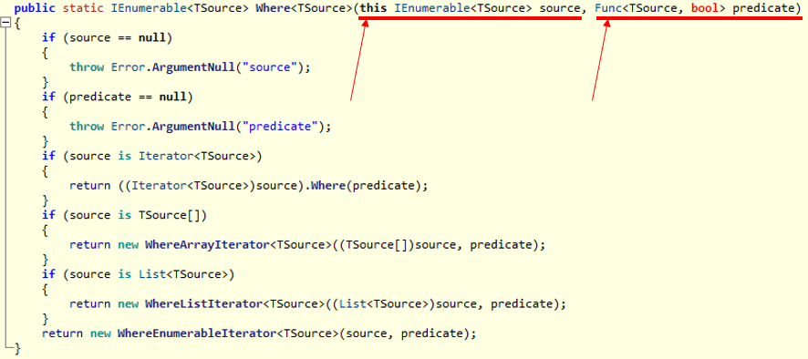

第一個參數表示 Where 是一個擴充方法

第二個參數表示需要傳入一個 Func<TSource, bool> 答案就在此

------------------------------------------------------------------------------------------------------------------

接下來是強者Sam Chuang的回答

問：

Enumerable.Where<TSource>(this IEnumerable<TSource> source, Func<TSource, Boolean> filter)

其中Where有this IEnumerable<TSource> source這個參數，但案例IEnumerable<int> intOddV1 = intList.Where(num => IsOdd(num));

卻沒看到這個參數，似乎僅有Func<TSource, Boolean> filter

this IEnumerable<TSource> source這個參數是什麼?有什麼意義呢?使用上哪時候要填，哪時候不需要填?

影片05:15中提到的extend method，是什麼?

答：

第一個參數 this 表示這是一個擴充方法，請 Google "C# Extension Methods"

-----------------------------------------------------------------

Kevin補充

請參考

Tutorial31講義: 完全攻略Extend Method擴充方法

=================================================================================

1. New Project

1.1. Create New Project : Sample

File --> New --> Project... -->

Visual C# -->  **Console App** **(.Net Framework)** -->

Name: **Sample**

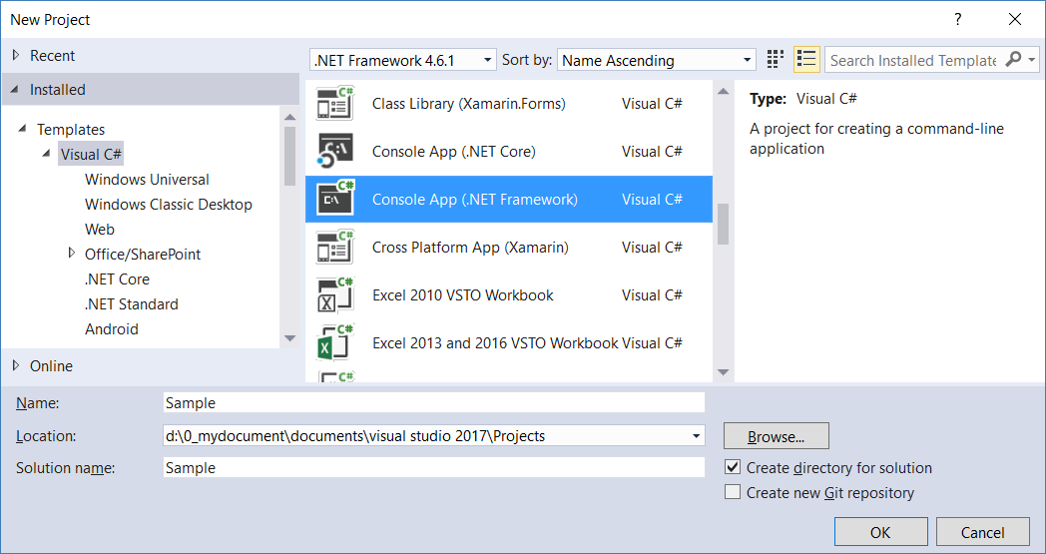

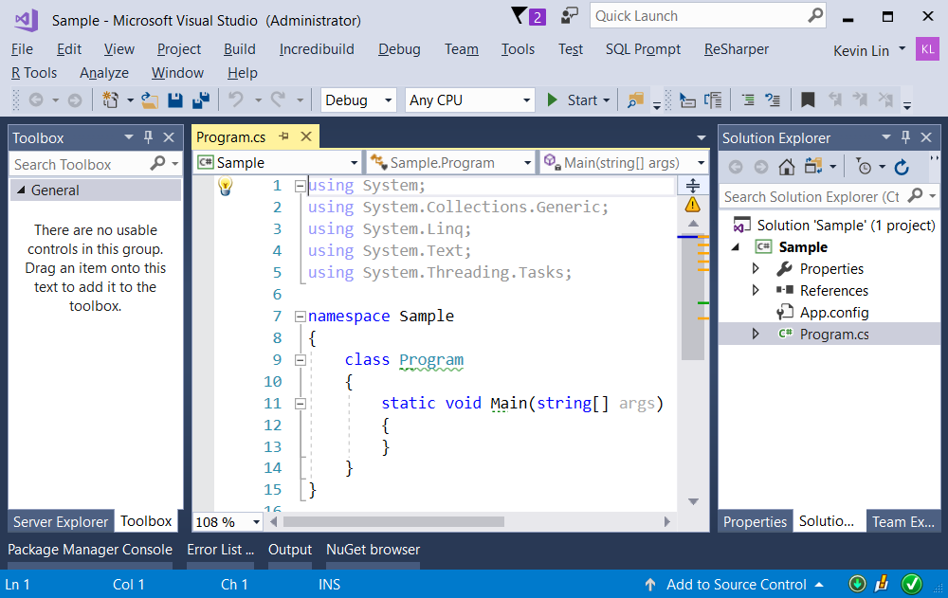

=============================================

2. Sample : Program.cs

using System;

using System.Collections.Generic;

using System.Linq;

using OnlineGame;

namespace Sample

{

    class Program

    {

        static void Main(string[] args)

        {

            // 1. =========================================================

            //Anonymous methods

            Console.WriteLine("1. AnonymousMethodsSample() ====================== ");

            AnonymousMethodsSample();

            // 2. =========================================================

            //Func<T, TResult> Delegate

            Console.WriteLine("2. FuncDelegateSample() ====================== ");

            FuncDelegateSample();

            Console.ReadLine();

        }

        //1. =========================================================

        //Anonymous methods

        static void AnonymousMethodsSample()

        {

            List<Gamer> listGamers = new List<Gamer>

            {

                new Gamer{ Id = 1, Name = "Name01"},

                new Gamer{ Id = 2, Name = "Name02"},

                new Gamer{ Id = 3, Name = "Name03"},

                new Gamer{ Id = 4, Name = "Name04"}

            };

            //Step 2: Create a Predicate<Gamer> delegate object

            //with GetGamerId1 method as parameter.

            Predicate<Gamer> predicateGetGamerId1 = new Predicate<Gamer>(GetGamerId1);

            //Step 3: pass the delegate instance as parameter of Find()

            Gamer gamerId1 = listGamers.Find(g => predicateGetGamerId1(g));

            Console.WriteLine($"predicateGetGamerId1 : gamerId1.Id=={gamerId1.Id}, gamerId1.Name=={gamerId1.Name}.");

            // "new Predicate<Gamer> " can be omitted.

            Predicate<Gamer> predicateGetGamerId2 = GetGamerId2;

            Gamer gamerId2 = listGamers.Find(g => predicateGetGamerId2(g));

            Console.WriteLine($"predicateGetGamerId2 : gamerId2.Id=={gamerId2.Id}, gamerId2.Name=={gamerId2.Name}.");

            // Anonymous method is being passed as an argument to

            // the Find() method. This anonymous method replaces

            // the need for Step 1, 2 and 3

            Gamer gamerId3 = listGamers.Find(delegate (Gamer g) { return g.Id == 3; });

            Console.WriteLine($"predicateGetGamerId3 : gamerId3.Id=={gamerId3.Id}, gamerId3.Name=={gamerId3.Name}.");

            //using lambda expression

            //=> is called lambda operator and read as GOES TO

            Gamer gamerId3V2 = listGamers.Find(g => g.Id == 3);

            Console.WriteLine($"predicateGetgamerId3V2 : gamerId3V2.Id=={gamerId3V2.Id}, gamerId3V2.Name=={gamerId3V2.Name}.");

            //using lambda expression

            Gamer gamerId3V3 = listGamers.Find((Gamer g) => g.Id == 3);

            Console.WriteLine($"predicateGetgamerId3V2 : gamerId3V3.Id=={gamerId3V3.Id}, gamerId3V3.Name=={gamerId3V3.Name}.");

        }

        // Step 1: Create a method whose signature matches Predicate<Gamer> delegate.

        private static bool GetGamerId1(Gamer g)

        {

            return g.Id == 1;

        }

        private static bool GetGamerId2(Gamer g)

        {

            return g.Id == 2;

        }

        //2. =========================================================

        //Func<T, TResult> Delegate

        static void FuncDelegateSample()

        {

            List<Gamer> listGamers = new List<Gamer>

            {

                new Gamer{ Id = 1, Name = "Name01"},

                new Gamer{ Id = 2, Name = "Name02"},

                new Gamer{ Id = 3, Name = "Name03"},

                new Gamer{ Id = 4, Name = "Name04"}

            };

            //2.1. -------------------------------------

            // Create Func<T, TResult> Delegate

            // and pass it to the Select() LINQ function,

            // ListObject.Select(funcDelegate)

            Console.WriteLine("2.1. Func<T, TResult> Delegate ---------------------");

            Func<Gamer, string> funcDelegateSelector =

            employee => $"Name == {employee.Name}";

            IEnumerable<string> names = listGamers.Select(funcDelegateSelector);

            foreach (string nameItem in names)

            {

                Console.WriteLine(nameItem);

            }

            // 2.2. -------------------------------------------

            // lambda expression

            Console.WriteLine("2.2. lambda expression ---------------------");

            IEnumerable<string> names2 =

            listGamers.Select(employee => "Name == " + employee.Name);

            foreach (string nameItem in names2)

            {

                Console.WriteLine(nameItem);

            }

            // 2.3. -------------------------------------------

            // Create Func<T, T, TResult> Delegate

            Console.WriteLine("2.3. Func<T, T, TResult> Delegate ---------------------");

            Func<int, int, string> funcDelegateSelector2 =

                (i1, i2) =>

                "Sum == " + (i1 + i2).ToString();

            string result = funcDelegateSelector2(10, 20);

            Console.WriteLine(result);

        }

    }

}

namespace OnlineGame

{

    public class Gamer

    {

        public int Id { get; set; }

        public string Name { get; set; }

        public override string ToString()

        {

            return $"Id=={Id} ; Name=={Name}";

        }

    }

}

