(T23)比較Stack、Queue  
CourseGUID: 29f1196a-1950-41a4-b9c1-dd13a9e92d92  
=======================================================================  
(T23)比較Stack、Queue  
=======================================================================  
0. Summary

-----------

1. New Project

1.1. Create New Project : Sample

-----------

2. Sample : Program.cs  
=======================================================================

0. Summary

1.

Stack is First In Last out

Reference:

[https://msdn.microsoft.com/en-us/library/3278tedw(v=vs.110).aspx](https://msdn.microsoft.com/en-us/library/3278tedw%28v=vs.110%29.aspx)

1.1.

//Stack.Push(Object obj)

Inserts an object at the top of the Stack.

1.2.

//Stack.Peek()

Returns the object at the top of the Stack without removing it.

1.3.

//Enumerable.FirstOrDefault<TSource>(IEnumerable<TSource> source)

//Enumerable.FirstOrDefault<TSource>(IEnumerable<TSource> source, Func<TSource, Boolean> predicate)

Returns the first element of the sequence that satisfies a condition or a default value if no such element is found.

1.4.

//Stack<T>.Pop()

Removes and returns the object at the top of the Stack<T>.

1.5.

//Stack<T>.Count

Gets the number of elements contained in the Stack<T>.

------------------------------------------------------

2.

Queue is First in First out.

Reference:

[https://msdn.microsoft.com/en-us/library/7977ey2c(v=vs.110).aspx](https://msdn.microsoft.com/en-us/library/7977ey2c%28v=vs.110%29.aspx)

2.1.

//Queue<T>.Enqueue(T item)

Adds an object to the end of the Queue<T>.

2.2.

//Queue<T>.Peek()

Returns the object at the beginning of the Queue<T> without removing it.

2.3.

//Enumerable.FirstOrDefault<TSource>(IEnumerable<TSource> source)

//Enumerable.FirstOrDefault<TSource>(IEnumerable<TSource> source, Func<TSource, Boolean> predicate)

Returns the first element of the sequence that satisfies a condition or a default value if no such element is found.

2.4.

//Queue<T>.Dequeue()

Removes and returns the object at the beginning of the Queue<T>.

2.5.

//Queue<T>.Count

Gets the number of elements contained in the Queue<T>.

=============================================

1. New Project

1.1. Create New Project : Sample

File --> New --> Project... -->

Visual C# -->  **Console App** **(.Net Framework)** -->

Name: **Sample**

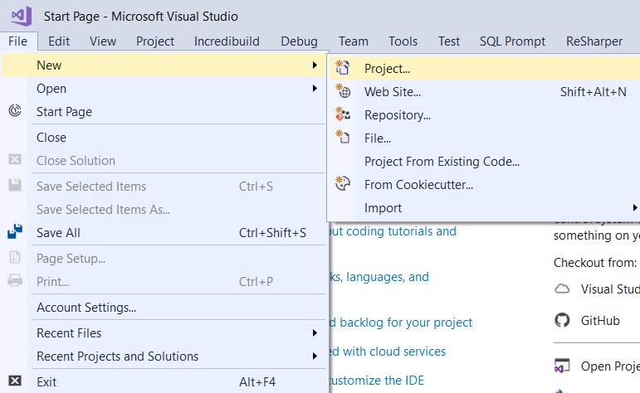

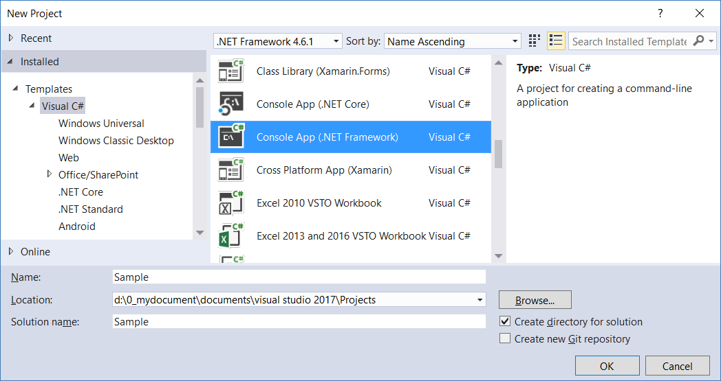

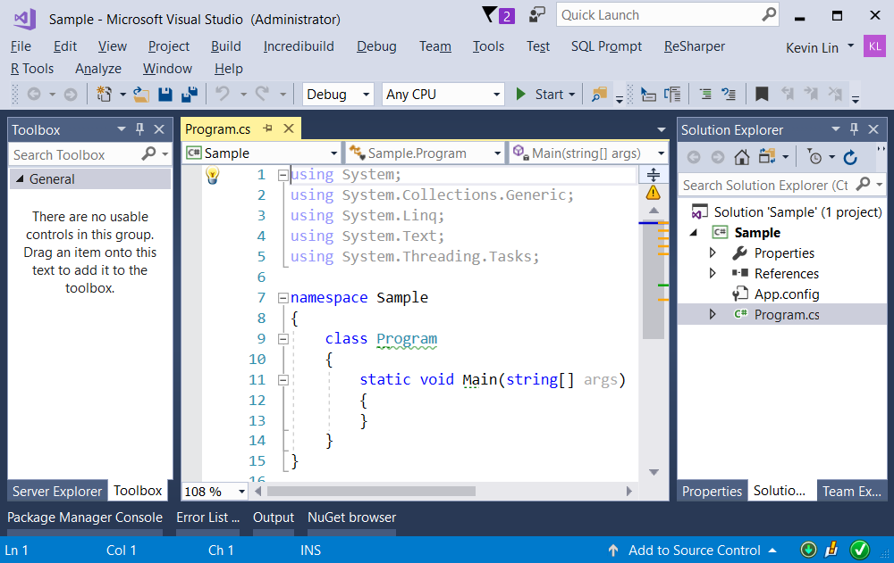

=============================================

2. Sample : Program.cs

using System;

using System.Collections.Generic;

using System.Linq;

using OnLineGame;

namespace Sample

{

    class Program

    {

        static void Main(string[] args)

        {

            // 1. ====================================================

            Console.WriteLine("1. StackSample() ================================");

            StackSample();

            // 2. ====================================================

            Console.WriteLine("2. QueueSample() ================================");

            QueueSample();

            Console.ReadLine();

        }

        // 1. ====================================================

        static void StackSample()

        {

            // 1.0. --------------------------------------------------

            // Create a Stack which is First In Last out.

            Stack<Gamer> gamersStack = new Stack<Gamer>();

            //Stack.Push(Object obj)

            //Inserts an object at the top of the Stack.

            gamersStack.Push(new Gamer { Id = 1, Name = "NameD" });

            gamersStack.Push(new Gamer { Id = 2, Name = "NameC" });

            gamersStack.Push(new Gamer { Id = 3, Name = "NameB" });

            gamersStack.Push(new Gamer { Id = 4, Name = "NameA" });

            // 1.1. ------------------------------------------------------------

            Console.WriteLine("1.1. Loop the Stack ------------------------------");

            Console.WriteLine($"gamersStack.Count=={gamersStack.Count}");

            foreach (Gamer gamerItem in gamersStack)

            {

                Console.WriteLine($"gamerItem.Id=={gamerItem.Id} ; gamerItem.Name=={gamerItem.Name} ; gamersStack.Count=={gamersStack.Count}");

            }

            //1.1.Loop the Stack ------------------------------

            //gamersStack.Count == 4

            //gamerItem.Id == 4; gamerItem.Name == NameA; gamersStack.Count == 4

            //gamerItem.Id == 3; gamerItem.Name == NameB; gamersStack.Count == 4

            //gamerItem.Id == 2; gamerItem.Name == NameC; gamersStack.Count == 4

            //gamerItem.Id == 1; gamerItem.Name == NameD; gamersStack.Count == 4

            // 1.2. ------------------------------------------------------------

            //Stack.Peek()

            //Returns the object at the top of the Stack without removing it.

            Console.WriteLine("1.2. Stack.Peek() ------------------------------");

            Gamer gPeek1 = gamersStack.Peek();

            Console.WriteLine($"Gamer gPeek1 = gamersStack.Peek();  :  gPeek1.Id=={gPeek1.Id} ; gPeek1.Name=={gPeek1.Name} ; gamersStack.Count=={gamersStack.Count}");

            Gamer gPeek2 = gamersStack.Peek();

            Console.WriteLine($"Gamer gPeek2 = gamersStack.Peek();  :  gPeek2.Id=={gPeek2.Id} ; gPeek2.Name=={gPeek2.Name} ; gamersStack.Count=={gamersStack.Count}");

            //1.2. Stack.Peek() ------------------------------

            //Gamer gPeek1 = gamersStack.Peek();  :  gPeek1.Id == 4; gPeek1.Name == NameA; gamersStack.Count == 4

            //Gamer gPeek2 = gamersStack.Peek();  :  gPeek2.Id == 4; gPeek2.Name == NameA; gamersStack.Count == 4

            // 1.3. ------------------------------------------------------------

            //Enumerable.FirstOrDefault<TSource>(IEnumerable<TSource> source)

            //Enumerable.FirstOrDefault<TSource>(IEnumerable<TSource> source, Func<TSource, Boolean> predicate)

            //Returns the first element of the sequence that satisfies a condition or a default value if no such element is found.

            Console.WriteLine("1.3. Enumerable.FirstOrDefault<TSource>(IEnumerable<TSource> source, Func<TSource, Boolean> predicate) ------------------------------");

            Gamer firstOrDefaultStackGamer = gamersStack.FirstOrDefault(g => g.Id == 3);

            //Console.WriteLine(firstOrDefaultStackGamer != null ?

            //    firstOrDefaultStackGamer.ToString() :

            //    "gamersStack.FirstOrDefault(g => g.Id==3) == NULL");

            Console.WriteLine(firstOrDefaultStackGamer?.ToString() ?? "gamersStack.FirstOrDefault(g => g.Id==3) == NULL");

            //1.3. Enumerable.FirstOrDefault<TSource>(IEnumerable<TSource> source,?Func<TSource,?Boolean> predicate) ------------------------------

            //Id: 3; Name; NameB

            // 1.4. ------------------------------------------------------------

            //Stack<T>.Pop()

            //Removes and returns the object at the top of the Stack<T>.

            //Stack<T>.Count

            //Gets the number of elements contained in the Stack<T>.

            Console.WriteLine("1.4. Stack<T>.Pop() ------------------------------");

            Console.WriteLine($"gamersStack.Count=={gamersStack.Count}");

            Gamer g1 = gamersStack.Pop();

            Console.WriteLine($"Gamer g1 = gamersStack.Pop();  :  g1.Id=={g1.Id} ; g1.Name=={g1.Name} ; gamersStack.Count=={gamersStack.Count}");

            Gamer g2 = gamersStack.Pop();

            Console.WriteLine($"Gamer g2 = gamersStack.Pop();  :  g2.Id=={g2.Id} ; g2.Name=={g2.Name} ; gamersStack.Count=={gamersStack.Count}");

            Gamer g3 = gamersStack.Pop();

            Console.WriteLine($"Gamer g3 = gamersStack.Pop();  :  g3.Id=={g3.Id} ; g3.Name=={g3.Name} ; gamersStack.Count=={gamersStack.Count}");

            Gamer g4 = gamersStack.Pop();

            Console.WriteLine($"Gamer g4 = gamersStack.Pop();  :  g4.Id=={g4.Id} ; g4.Name=={g4.Name} ; gamersStack.Count=={gamersStack.Count}");

            //1.4. Stack<T>.Pop() ------------------------------

            //gamersStack.Count == 4

            //Gamer g1 = gamersStack.Pop();  :  g1.Id == 4; g1.Name == NameA; gamersStack.Count == 3

            //Gamer g2 = gamersStack.Pop();  :  g2.Id == 3; g2.Name == NameB; gamersStack.Count == 2

            //Gamer g3 = gamersStack.Pop();  :  g3.Id == 2; g3.Name == NameC; gamersStack.Count == 1

            //Gamer g4 = gamersStack.Pop();  :  g4.Id == 1; g4.Name == NameD; gamersStack.Count == 0

        }

       // 2. ====================================================

        static void QueueSample()

        {

            // 1.0. --------------------------------------------------

            // Create a Queue which is First In First out.

            Queue<Gamer> gamersQueue = new Queue<Gamer>();

            //Queue<T>.Enqueue(T item)

            //Adds an object to the end of the Queue<T>.

            gamersQueue.Enqueue(new Gamer { Id = 1, Name = "NameD" });

            gamersQueue.Enqueue(new Gamer { Id = 2, Name = "NameC" });

            gamersQueue.Enqueue(new Gamer { Id = 3, Name = "NameB" });

            gamersQueue.Enqueue(new Gamer { Id = 4, Name = "NameA" });

            // 1.1. ------------------------------------------------------------

            Console.WriteLine("1.1. Loop the Queue ------------------------------");

            Console.WriteLine($"gamersQueue.Count=={gamersQueue.Count}");

            foreach (Gamer gamerItem in gamersQueue)

            {

                Console.WriteLine($"gamerItem.Id=={gamerItem.Id} ; gamerItem.Name=={gamerItem.Name} ; gamersQueue.Count=={gamersQueue.Count}");

            }

            //1.1.Loop the Queue ------------------------------

            //gamersQueue.Count == 4

            //gamerItem.Id == 1; gamerItem.Name == NameD; gamersQueue.Count == 4

            //gamerItem.Id == 2; gamerItem.Name == NameC; gamersQueue.Count == 4

            //gamerItem.Id == 3; gamerItem.Name == NameB; gamersQueue.Count == 4

            //gamerItem.Id == 4; gamerItem.Name == NameA; gamersQueue.Count == 4

            // 1.2. ------------------------------------------------------------

            //Queue<T>.Peek()

            //Returns the object at the beginning of the Queue<T> without removing it.

            Console.WriteLine("1.2. Queue.Peek() ------------------------------");

            Gamer gPeek1 = gamersQueue.Peek();

            Console.WriteLine($"Gamer gPeek1 = gamersQueue.Peek();  :  gPeek1.Id=={gPeek1.Id} ; gPeek1.Name=={gPeek1.Name} ; gamersQueue.Count=={gamersQueue.Count}");

            Gamer gPeek2 = gamersQueue.Peek();

            Console.WriteLine($"Gamer gPeek2 = gamersQueue.Peek();  :  gPeek2.Id=={gPeek2.Id} ; gPeek2.Name=={gPeek2.Name} ; gamersQueue.Count=={gamersQueue.Count}");

            //1.2. Queue.Peek() ------------------------------

            //Gamer gPeek1 = gamersQueue.Peek();  :  gPeek1.Id == 1; gPeek1.Name == NameD; gamersQueue.Count == 4

            //Gamer gPeek2 = gamersQueue.Peek();  :  gPeek2.Id == 1; gPeek2.Name == NameD; gamersQueue.Count == 4

            // 1.3. ------------------------------------------------------------

            //Enumerable.FirstOrDefault<TSource>(IEnumerable<TSource> source)

            //Enumerable.FirstOrDefault<TSource>(IEnumerable<TSource> source, Func<TSource, Boolean> predicate)

            //Returns the first element of the sequence that satisfies a condition or a default value if no such element is found.

            Console.WriteLine("1.3. Enumerable.FirstOrDefault<TSource>(IEnumerable<TSource> source, Func<TSource, Boolean> predicate) ------------------------------");

            Gamer firstOrDefaultQueueGamer = gamersQueue.FirstOrDefault(g => g.Id == 3);

            //Console.WriteLine(firstOrDefaultQueueGamer != null ?

            //    firstOrDefaultQueueGamer.ToString() :

            //    "gamersQueue.FirstOrDefault(g => g.Id==3) == NULL");

            Console.WriteLine(firstOrDefaultQueueGamer?.ToString() ?? "gamersQueue.FirstOrDefault(g => g.Id==3) == NULL");

            //1.3. Enumerable.FirstOrDefault<TSource>(IEnumerable<TSource> source,?Func<TSource,?Boolean> predicate) ------------------------------

            //Id: 3; Name; NameB

            // 1.4. ------------------------------------------------------------

            //Queue<T>.Dequeue()

            //Removes and returns the object at the beginning of the Queue<T>.

            //Queue<T>.Count

            //Gets the number of elements contained in the Queue<T>.

            Console.WriteLine("1.4. Queue<T>.Dequeue() ------------------------------");

            Console.WriteLine($"gamersQueue.Count=={gamersQueue.Count}");

            Gamer g1 = gamersQueue.Dequeue();

            Console.WriteLine($"Gamer g1 = gamersQueue.Dequeue();  :  g1.Id=={g1.Id} ; g1.Name=={g1.Name} ; gamersQueue.Count=={gamersQueue.Count}");

            Gamer g2 = gamersQueue.Dequeue();

            Console.WriteLine($"Gamer g2 = gamersQueue.Dequeue();  :  g2.Id=={g2.Id} ; g2.Name=={g2.Name} ; gamersQueue.Count=={gamersQueue.Count}");

            Gamer g3 = gamersQueue.Dequeue();

            Console.WriteLine($"Gamer g3 = gamersQueue.Dequeue();  :  g3.Id=={g3.Id} ; g3.Name=={g3.Name} ; gamersQueue.Count=={gamersQueue.Count}");

            Gamer g4 = gamersQueue.Dequeue();

            Console.WriteLine($"Gamer g4 = gamersQueue.Dequeue();  :  g4.Id=={g4.Id} ; g4.Name=={g4.Name} ; gamersQueue.Count=={gamersQueue.Count}");

            //1.4. Queue<T>.Dequeue() ------------------------------

            //gamersQueue.Count == 4

            //Gamer g1 = gamersQueue.Dequeue();  :  g1.Id == 1; g1.Name == NameD; gamersQueue.Count == 3

            //Gamer g2 = gamersQueue.Dequeue();  :  g2.Id == 2; g2.Name == NameC; gamersQueue.Count == 2

            //Gamer g3 = gamersQueue.Dequeue();  :  g3.Id == 3; g3.Name == NameB; gamersQueue.Count == 1

            //Gamer g4 = gamersQueue.Dequeue();  :  g4.Id == 4; g4.Name == NameA; gamersQueue.Count == 0s

        }

    }

}

namespace OnLineGame

{

    public class Gamer

    {

        public int Id { get; set; }

        public string Name { get; set; }

        public override string ToString()

        {

            return $"Id : {Id} ; Name ; {Name}";

        }

    }

}

/*

1.

Stack is First In Last out

Reference:

[https://msdn.microsoft.com/en-us/library/3278tedw(v=vs.110).aspx](https://msdn.microsoft.com/en-us/library/3278tedw%28v=vs.110%29.aspx)

1.1.

//Stack.Push(Object obj)

Inserts an object at the top of the Stack.

1.2.

//Stack.Peek()

Returns the object at the top of the Stack without removing it.

1.3.

//Enumerable.FirstOrDefault<TSource>(IEnumerable<TSource> source)

//Enumerable.FirstOrDefault<TSource>(IEnumerable<TSource> source, Func<TSource, Boolean> predicate)

Returns the first element of the sequence that satisfies a condition or a default value if no such element is found.

1.4.

//Stack<T>.Pop()

Removes and returns the object at the top of the Stack<T>.

1.5.

//Stack<T>.Count

Gets the number of elements contained in the Stack<T>.

------------------------------------------------------

2.

Queue is First in First out.

Reference:

[https://msdn.microsoft.com/en-us/library/7977ey2c(v=vs.110).aspx](https://msdn.microsoft.com/en-us/library/7977ey2c%28v=vs.110%29.aspx)

2.1.

//Queue<T>.Enqueue(T item)

Adds an object to the end of the Queue<T>.

2.2.

//Queue<T>.Peek()

Returns the object at the beginning of the Queue<T> without removing it.

2.3.

//Enumerable.FirstOrDefault<TSource>(IEnumerable<TSource> source)

//Enumerable.FirstOrDefault<TSource>(IEnumerable<TSource> source, Func<TSource, Boolean> predicate)

Returns the first element of the sequence that satisfies a condition or a default value if no such element is found.

2.4.

//Queue<T>.Dequeue()

Removes and returns the object at the beginning of the Queue<T>.

2.5.

//Queue<T>.Count

Gets the number of elements contained in the Queue<T>.

*/

