(T31)討論ExtendMethod(擴充方法)  
CourseGUID: 29f1196a-1950-41a4-b9c1-dd13a9e92d92  
=======================================================================  
(T31)討論ExtendMethod(擴充方法)  
=======================================================================  
0. Summary

-----------

1. New Project

1.1. Create New Project : Sample

-----------

2. Sample : Program.cs  
=======================================================================

0. Summary

extend method is a static method in a static class,

and the first parameter must use "this" keyword

to represent the object instance which invoke this extend method.

1. New Project

1.1. Create New Project : Sample

File --> New --> Project... -->

Visual C# -->  **Console App** **(.Net Framework)** -->

Name: **Sample**





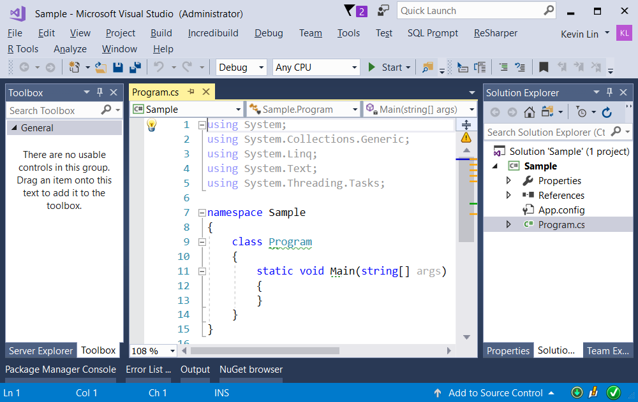

=============================================

2. Sample : Program.cs

using System;

using OnlineGame;

namespace Sample

{

    class Program

    {

        static void Main(string[] args)

        {

            string str = @"abcdef";

            Console.WriteLine($"StringHelper.ConverToUpper1(str) : {StringHelper.ConverToUpper1(str)}");

            Console.WriteLine($"str.ConverToUpper2() : {str.ConverToUpper2()}");

            Console.WriteLine($"str.ConverToUpper2(\"123\",\"a1b2c3\") : {str.ConverToUpper2("123", "a1b2c3")}");

            Console.ReadLine();

        }

    }

}

namespace OnlineGame

{

    public class StringHelper

    {

        public static string ConverToUpper1(string intStr)

        {

            return intStr.ToUpper();

        }

    }

    public static class StringHelper2

    {

        public static string ConverToUpper2(this string intStr)

        {

            return intStr.ToUpper();

        }

        public static string ConverToUpper2(this string intStr, string intStr1, string intStr2)

        {

            return intStr.ToUpper() + intStr1 + intStr2;

        }

    }

}

/*

Extend method is a static method in a static class,

and the first parameter must use "this" keyword

to represent the object instance which invoke this extend method.

*/

