(T28)討論MultiThread(多執行緒)、DeadLock(死鎖定)、Mutex(互斥鎖)  
CourseGUID: 29f1196a-1950-41a4-b9c1-dd13a9e92d92  
=======================================================================  
(T28)討論MultiThread(多執行緒)、DeadLock(死鎖定)、Mutex(互斥鎖)

(T28-1)討論DeadLock(死鎖定)

(T28-2)討論LockOrder，解決DeadLock(死鎖定)

(T28-3)討論Mutex(互斥鎖)，解決DeadLock(死鎖定)解法1

(T28-4)討論Mutex(互斥鎖)，解決DeadLock(死鎖定)解法2  
=======================================================================  
1. New Project

1.1. Create New Project : Sample

2. Sample : Program.cs  
=======================================================================



1. New Project

1.1. Create New Project : Sample

File --> New --> Project... -->

Visual C# -->  **Console App** **(.Net Framework)** -->

Name: **Sample**

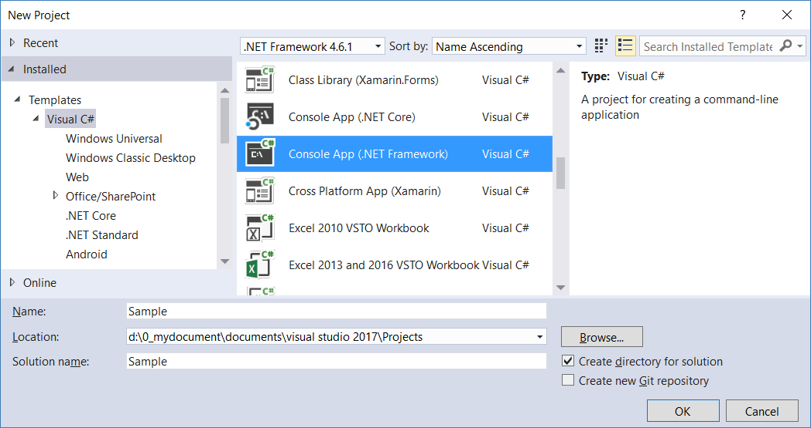

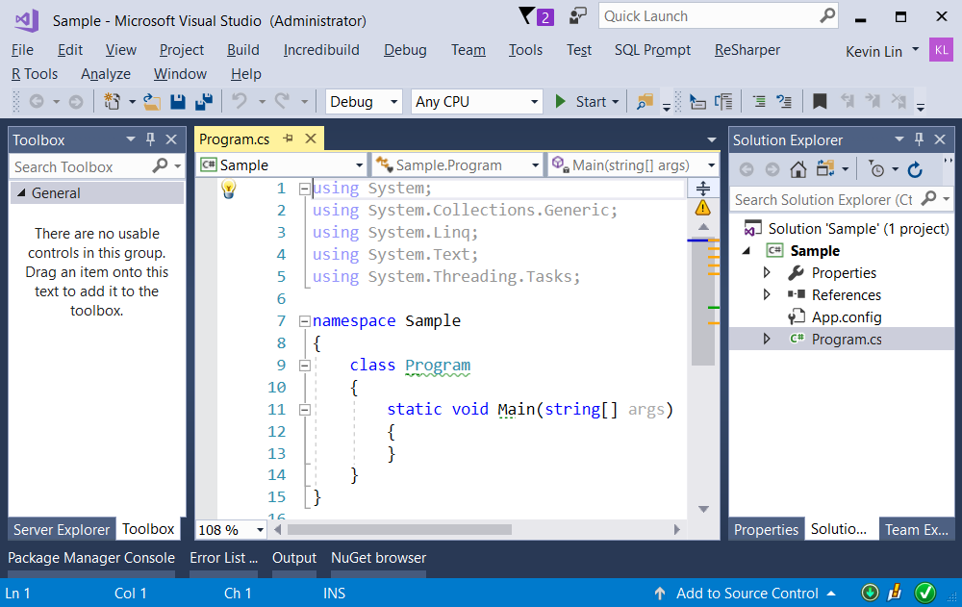

=============================================

2. Sample : Program.cs

using System;

using System.Threading;

using OnLineBanking;

namespace Sample

{

    class Program

    {

        static void Main(string[] args)

        {

            ////1 ==========================================

            ////DeadLock Sample

            //Console.WriteLine("1. DeadLockSample() ============================ ");

            //DeadLockSample();

            //2 ==========================================

            //We can fix the deadlock issue by the specific lock order.

            Console.WriteLine("2. specific defined lock accuire order can fix DeadLock ================ ");

            SpecificDefinedLockAccuireOrder();

            //3 ==========================================

            //MutexSample can fix DeadLock V1

            Console.WriteLine("3. Mutex can fix DeadLock V1 ================ ");

            MutexSample();

            //4 ==========================================

            //MutexSample can fix DeadLock V2

            Console.WriteLine("4. Mutex can fix DeadLock V2 ================ ");

            MutexSampleV2();

            Console.ReadLine();

        }

        //1 ==========================================

        //DeadLock Sample

        static void DeadLockSample()

        {

            Console.WriteLine("Beginning of DeadLockSample() ------------------ ");

            Account accA = new Account(1, 4000);

            Account accB = new Account(2, 2000);

            TransferHelper transferHelperA =

                new TransferHelper(accA, accB, 1000);

            Thread t1 = new Thread(transferHelperA.Transfer)

            {

                Name = "t1"

            };

            TransferHelper transferHelperB = new

                TransferHelper(accB, accA, 500);

            Thread t2 = new Thread(transferHelperB.Transfer)

            {

                Name = "t2"

            };

            t1.Start();

            t2.Start();

            t1.Join();

            t2.Join();

            Console.WriteLine("End of DeadLockSample() ------------------ ");

        }

        //2 ==========================================

        //specific defined lock accuire order can fix DeadLock,

        //but it might get some unexpect result without care.

        static void SpecificDefinedLockAccuireOrder()

        {

            Console.WriteLine("Beginning of SpecificDefinedLockAccuireOrder() ------------------ ");

            Account accA = new Account(1, 4000);

            Account accB = new Account(2, 2000);

            TransferHelper2 transferHelperA =

                new TransferHelper2(accA, accB, 1000);

            Thread t1 = new Thread(transferHelperA.Transfer)

            {

                Name = "t1"

            };

            TransferHelper2 transferHelperB = new

                TransferHelper2(accB, accA, 500);

            Thread t2 = new Thread(transferHelperB.Transfer)

            {

                Name = "t2"

            };

            t1.Start();

            t2.Start();

            t1.Join();

            t2.Join();

            Console.WriteLine($"accA.id=={accA.Id},accA.Balance=={accA.Balance} ; accB.id=={accB.Id},accB.Balance=={accB.Balance}");

            Console.WriteLine("End of SpecificDefinedLockAccuireOrder() ------------------ ");

        }

        //3 ==========================================

        //MutexSample can fix DeadLock V1

        static void MutexSample()

        {

            Console.WriteLine("Beginning of MutexSample() ------------------ ");

            AccountA accA = new AccountA(1, 4000);

            AccountA accB = new AccountA(2, 2000);

            Thread t1 = new Thread(() => accB.TransferFrom(accA, 1000))

            {

                Name = "t1"

            };

            Thread t2 = new Thread(() => accA.TransferFrom(accB, 500))

            {

                Name = "t2"

            };

            t1.Start();

            t2.Start();

            t1.Join();

            t2.Join();

            Console.WriteLine($"accA.id=={accA.Id},accA.Balance=={accA.Balance} ; accB.id=={accB.Id},accB.Balance=={accB.Balance}");

            Console.WriteLine("End of MutexSample() ------------------ ");

        }

        //4 ==========================================

        //MutexSample can fix DeadLock V2

        static void MutexSampleV2()

        {

            Console.WriteLine("Beginning of SpecificDefinedLockAccuireOrder() ------------------ ");

            AccountB accA = new AccountB(1, 4000);

            AccountB accB = new AccountB(2, 2000);

            TransferHelper4 transferHelperA =

                new TransferHelper4(accA, accB, 1000);

            Thread t1 = new Thread(transferHelperA.Transfer)

            {

                Name = "t1"

            };

            TransferHelper4 transferHelperB = new

                TransferHelper4(accB, accA, 500);

            Thread t2 = new Thread(transferHelperB.Transfer)

            {

                Name = "t2"

            };

            t1.Start();

            t2.Start();

            t1.Join();

            t2.Join();

            Console.WriteLine($"accA.id=={accA.Id},accA.Balance=={accA.Balance} ; accB.id=={accB.Id},accB.Balance=={accB.Balance}");

            Console.WriteLine("End of SpecificDefinedLockAccuireOrder() ------------------ ");

        }

    }

}

namespace OnLineBanking

{

    //1 ==========================================

    //DeadLock Sample

    public class Account

    {

        public double Balance { get; set; }

        public int Id { get; }

        public Account(int id, double balance)

        {

            Id = id;

            Balance = balance;

        }

        public void Withdraw(double amount)

        {

            Balance -= amount;

        }

        public void Deposit(double amount)

        {

            Balance += amount;

        }

    }

    //============================

    //1.

    //這部分我們將討論如何產生DeadLock

    public class TransferHelper

    {

        Account _fromAccount;

        Account _toAccount;

        double _amount;

        public TransferHelper(Account fromAccount,

            Account toAccount, double amount)

        {

            _fromAccount = fromAccount;

            _toAccount = toAccount;

            _amount = amount;

        }

        public void Transfer()

        {

            Console.WriteLine(

                $"Beginning of Transfer, Thread.CurrentThread.Name=={Thread.CurrentThread.Name}, _fromAccount.Id=={_fromAccount.Id} , _toAccount.Id=={_toAccount.Id}, _amount=={_amount}");

            Console.WriteLine($"Thread.CurrentThread.Name=={Thread.CurrentThread.Name}, is about to lock(_fromAccount), and _fromAccount.Id=={_fromAccount.Id}");

            lock (_fromAccount)

            {

                Console.WriteLine($"Thread.CurrentThread.Name=={Thread.CurrentThread.Name}, lock(_fromAccount) acquired lock on _fromAccount.Id=={_fromAccount.Id}");

                Thread.Sleep(1000); // wait for 1000 milliseconds

                Console.WriteLine($"Thread.CurrentThread.Name=={Thread.CurrentThread.Name}, is about to lock(_toAccount), and _toAccount.Id=={_toAccount.Id}");

                lock (_toAccount)

                {

                    Console.WriteLine($"Thread.CurrentThread.Name=={Thread.CurrentThread.Name}, lock(_toAccount) acquired lock on _toAccount.Id=={_toAccount.Id}");

                    _fromAccount.Withdraw(_amount);

                    _toAccount.Deposit(_amount);

                }

            }

            Console.WriteLine($"End of Transfer, Thread.CurrentThread.Name=={Thread.CurrentThread.Name}, _fromAccount.Id=={_fromAccount.Id} , _toAccount.Id=={_toAccount.Id}, _amount=={_amount}");

        }

    }

    /*

    1. DeadLockSample() ============================

    Beginning of DeadLockSample() ------------------

    Beginning of Transfer, Thread.CurrentThread.Name==t1, _fromAccount.Id==1 , _toAccount.Id==2, _amount==1000

    Thread.CurrentThread.Name==t1, is about to lock(_fromAccount), and _fromAccount.Id==1

    Thread.CurrentThread.Name==t1, lock(_fromAccount) acquired lock on _fromAccount.Id==1

    Beginning of Transfer, Thread.CurrentThread.Name==t2, _fromAccount.Id==2 , _toAccount.Id==1, _amount==500

    Thread.CurrentThread.Name==t2, is about to lock(_fromAccount), and _fromAccount.Id==2

    Thread.CurrentThread.Name==t2, lock(_fromAccount) acquired lock on _fromAccount.Id==2

    Thread.CurrentThread.Name==t1, is about to lock(_toAccount), and _toAccount.Id==2

    Thread.CurrentThread.Name==t2, is about to lock(_toAccount), and _toAccount.Id==1

    -------------------------

    A.

    這邊我們將討論, 如何產生DeadLock

    A.1.

    thread t1一開始會鎖住fromAccount, 也就是鎖住accA

    ---------

    A.2.

    同一時間, thread t2也開始跑了

    thread t2一開始會鎖住fromAccount, 也就是鎖住accB

    ---------

    A.3.

    然後, thread t1繼續跑

    thread t1 準備要鎖住toAccount, 也就是鎖住accB

    結果thread t1發現accB早已經被thread t2鎖住了

    ---------

    A.4.

    然後, thread t2繼續跑

    thread t2 準備要鎖住toAccount, 也就是鎖住accA

    結果thread t2發現accA早已經被thread t1鎖住了

    ---------

    A.5.

    這下尷尬了, 因為這形成了DeadLock

    那我們接下來討論怎麼解決DeadLock

    */

    //2 ==========================================

    //We can fix the deadlock issue by the specific lock order.

    public class TransferHelper2

    {

        Account _fromAccount;

        Account _toAccount;

        double _amount;

        public TransferHelper2(Account fromAccount,

            Account toAccount, double amount)

        {

            _fromAccount = fromAccount;

            _toAccount = toAccount;

            _amount = amount;

        }

        public void Transfer()

        {

            Console.WriteLine(

                $"Beginning of Transfer, Thread.CurrentThread.Name=={Thread.CurrentThread.Name}, _fromAccount.Id=={_fromAccount.Id} , _fromAccount.Balance=={_fromAccount.Balance}, _toAccount.Id=={_toAccount.Id}, _toAccount.Balance=={_toAccount.Balance}, _amount=={_amount}");

            //***check the comment

            object _lockA =

                _fromAccount.Id < _toAccount.Id ?

                _fromAccount :

                _toAccount;

            object _lockB =

                _fromAccount.Id > _toAccount.Id ?

                _fromAccount :

                _toAccount;

            Console.WriteLine($"Thread.CurrentThread.Name=={Thread.CurrentThread.Name}, is about to lock(_lockA), and ((Account)_lockA).Id=={((Account)_lockA).Id}");

            lock (_lockA)

            {

                Console.WriteLine($"Thread.CurrentThread.Name=={Thread.CurrentThread.Name}, lock(_lockA) acquired lock on ((Account)_lockA).Id=={((Account)_lockA).Id}");

                Thread.Sleep(1000); // wait for 1000 milliseconds

                Console.WriteLine($"Thread.CurrentThread.Name=={Thread.CurrentThread.Name}, is about to lock(_lockB), and ((Account)_lockB).Id=={((Account)_lockB).Id}");

                lock (_lockB)

                {

                    Console.WriteLine($"Thread.CurrentThread.Name=={Thread.CurrentThread.Name}, lock(_lockB) acquired lock on ((Account)_lockB).Id=={((Account)_lockB).Id}");

                    _fromAccount.Withdraw(_amount);

                    _toAccount.Deposit(_amount);

                }

            }

            Console.WriteLine(

                $"End of Transfer, Thread.CurrentThread.Name=={Thread.CurrentThread.Name}, _fromAccount.Id=={_fromAccount.Id} , _fromAccount.Balance=={_fromAccount.Balance}, _toAccount.Id=={_toAccount.Id}, _toAccount.Balance=={_toAccount.Balance}, _amount=={_amount}");

        }

    }

    /*

    2. specific defined lock accuire order can fix DeadLock ================

    Beginning of SpecificDefinedLockAccuireOrder() ------------------

    Beginning of Transfer, Thread.CurrentThread.Name==t2, _fromAccount.Id==2 , _fromAccount.Balance==2000, _toAccount.Id==1, _toAccount.Balance==4000, _amount==500

    Thread.CurrentThread.Name==t2, is about to lock(_lockA), and ((Account)_lockA).Id==1

    Thread.CurrentThread.Name==t2, lock(_lockA) acquired lock on ((Account)_lockA).Id==1

    Beginning of Transfer, Thread.CurrentThread.Name==t1, _fromAccount.Id==1 , _fromAccount.Balance==4000, _toAccount.Id==2, _toAccount.Balance==2000, _amount==1000

    Thread.CurrentThread.Name==t1, is about to lock(_lockA), and ((Account)_lockA).Id==1

    Thread.CurrentThread.Name==t2, is about to lock(_lockB), and ((Account)_lockB).Id==2

    Thread.CurrentThread.Name==t2, lock(_lockB) acquired lock on ((Account)_lockB).Id==2

    End of Transfer, Thread.CurrentThread.Name==t2, _fromAccount.Id==2 , _fromAccount.Balance==1500, _toAccount.Id==1, _toAccount.Balance==4500, _amount==500

    Thread.CurrentThread.Name==t1, lock(_lockA) acquired lock on ((Account)_lockA).Id==1

    Thread.CurrentThread.Name==t1, is about to lock(_lockB), and ((Account)_lockB).Id==2

    Thread.CurrentThread.Name==t1, lock(_lockB) acquired lock on ((Account)_lockB).Id==2

    End of Transfer, Thread.CurrentThread.Name==t1, _fromAccount.Id==1 , _fromAccount.Balance==3500, _toAccount.Id==2, _toAccount.Balance==2500, _amount==1000

    accA.id==1,accA.Balance==3500 ; accB.id==2,accB.Balance==2500

    End of SpecificDefinedLockAccuireOrder() ------------------

    -------------------------------

    A.

    4000-1000 = 3000

    3000 + 500 = 3500

    B.

    2000+1000=3000

    3000-500=2500

    -------------------------------

    A.

    A.1.

    我們可以透過

    設定特定的lock順序

    來解決deadlock問題

    ------------------

    A.2.

    我們知道, 我們需要lock兩個account

    之前會產生deadlock的例子

    的原因是因為

    我們先lock FromAccount才lock ToAccount

    可是

    不同的thread會有不同的FromAccount和ToAccount

    就會有可能產生deadlock問題

    所以之前的範例才會產生deadlock

    ------------------

    A.3.

    現在, 為了要解決deadlock問題

    我們打算

    不管什麼thread

    都是先lock Account Id比較小的account

    才lock Account Id比較大的account

    這樣deadlock問題就可以解決了

    ------------------

    A.4.

    我們舉個例子

    假設系統現在只有2個account

    分別為accountId==1和accountId==2 這2個account

    那麼, 我們打算

    不管什麼thread

    都是先lock Account Id比較小的account

    才lock Account Id比較大的account

    所以

    ---------

    Thread t1 "先" 把accountId==1 的 account鎖起來

    接著, Thread t2也開始跑了

    Thread t2 "先嘗試" 把accountId==1 的 account鎖起來

    結果Thread t2發現發現 accountId==1 的 account

    已經被其他thread鎖住了 (其實是被Thread t1鎖住)

    所以Thread t2只好等待

    ---------

    接著, Thread t1 "再" 把accountId==2 的 account鎖起來

    所以目前

    Thread t1 已經 "同時鎖住" accountId==1 和 accountId==2 這2個account

    等Thread t1 執行完Transfer的動作後

    這2個account被解鎖了

    ---------

    Thread t2發現accountId==1 被解鎖了

    所以Thread t2 "馬上先" 把accountId==1 的 account鎖起來

    接著, Thread t2 "再" 把accountId==2 的 account鎖起來

    所以目前

    Thread t2 已經 "同時鎖住" accountId==1 和 accountId==2 這2個account

    等Thread t2 執行完Transfer的動作後

    這2個account被解鎖了

    ------------------

    A.5.

    以上的例子, 每次跑都會不一樣

    有可能Thread t2先跑

    然後Thread t2 "先同時鎖住" accountId==1 和 accountId==2 這2個account

    或是

    有可能Thread t1先跑

    然後Thread t1 "先同時鎖住" accountId==1 和 accountId==2 這2個account

    -------------------------------

    We can fix the deadlock issue by the specific lock order.

    For example, in this case,

    we can always lock the account which id is smaller first,

    then lock the account which id is bigger.

    In this sample, we can fix the deadlock issue by the specific lock order easily.

    However, the real world sample is always more complex,

    the specific lock order still might get some un-expect result.

    */

    //3 ==========================================

    //MutexSample can fix DeadLock V1

    public class AccountA

    {

        public int Id { get; set; }

        public double Balance { get; set; }

        Mutex _mutexLock = new Mutex();

        public AccountA(int id, double balance)

        {

            Id = id;

            Balance = balance;

        }

        //check the comment

        public void Withdraw(double amount)

        {

            if (!_mutexLock.WaitOne()) return;

            try

            {

                Balance -= amount;

            }

            finally

            {

                _mutexLock.ReleaseMutex();

            }

        }

        public void Deposit(double amount)

        {

            if (!_mutexLock.WaitOne()) return;

            try

            {

                Balance += amount;

            }

            finally

            {

                _mutexLock.ReleaseMutex();

            }

        }

        //Transfer the "amount" from "fromAcc" into current object, which is "toAcc"

        public void TransferFrom(AccountA fromAcc, double amount)

        {

            Console.WriteLine(

                $"Beginning of TransferFrom, Thread.CurrentThread.Name=={Thread.CurrentThread.Name}, fromAcc.Id=={fromAcc.Id} , fromAcc.Balance=={fromAcc.Balance}, _toAccount.Id==this.Id=={Id}, _toAccount.Balance==this.Balance=={Balance}, amount=={amount}");

            //***check the comment

            Mutex[] mutexlocks = { _mutexLock, fromAcc._mutexLock };

            if (WaitHandle.WaitAll(mutexlocks))

            {

                //***check the comment

                try

                {

                    fromAcc.Withdraw(amount); //從fromAcc取出錢來

                    Deposit(amount); //把錢放進toAcc

                }

                finally

                {

                    foreach (Mutex mutexlockItem in mutexlocks)

                    {

                        //***check the comment

                        mutexlockItem.ReleaseMutex();

                    }

                }

            }

            Console.WriteLine(

                $"End of TransferFrom, Thread.CurrentThread.Name=={Thread.CurrentThread.Name}, fromAcc.Id=={fromAcc.Id} , fromAcc.Balance=={fromAcc.Balance}, _toAccount.Id==this.Id=={Id}, _toAccount.Balance==this.Balance=={Balance}, amount=={amount}");

        }

    }

    /*

    3. Mutex can fix DeadLock V1 ================

    Beginning of MutexSample() ------------------

    Beginning of TransferFrom, Thread.CurrentThread.Name==t2, fromAcc.Id==2 , fromAcc.Balance==2000, _toAccount.Id==this.Id==1, _toAccount.Balance==this.Balance==4000, amount==500

    Beginning of TransferFrom, Thread.CurrentThread.Name==t1, fromAcc.Id==1 , fromAcc.Balance==4000, _toAccount.Id==this.Id==2, _toAccount.Balance==this.Balance==2000, amount==1000

    End of TransferFrom, Thread.CurrentThread.Name==t2, fromAcc.Id==2 , fromAcc.Balance==1500, _toAccount.Id==this.Id==1, _toAccount.Balance==this.Balance==4500, amount==500

    End of TransferFrom, Thread.CurrentThread.Name==t1, fromAcc.Id==1 , fromAcc.Balance==3500, _toAccount.Id==this.Id==2, _toAccount.Balance==this.Balance==2500, amount==1000

    accA.id==1,accA.Balance==3500 ; accB.id==2,accB.Balance==2500

    End of MutexSample() ------------------

    -------------------------

    A.

    //public void Withdraw(double amount)

    //{

    //    if (!_mutexLock.WaitOne()) return;

    //    try

    //    {

    //        Balance -= amount;

    //    }

    //    finally

    //    {

    //        _mutexLock.ReleaseMutex();

    //    }

    //}

    -----------------

    A.1.

    --------------

    A.1.1.

    Threading.WaitHandle.WaitOne()

    Blocks the current thread until the current

    System.Threading.WaitHandle receives a signal.

    Returns true if the current instance receives a signal.

    Returns false if the current instance is never signaled,

    System.Threading.WaitHandle.WaitOne(System.Int32, System.Boolean) never returns.

    --------------

    A.1.2.

    Use mutex to lock the thread.

    //if (!_mutexLock.WaitOne()) return;

    _mutexLock.WaitOne() return false means

    the current thread fails to lock,

    so it has to go back to the previous thread.

    -----

    _mutexLock.WaitOne() return true means

    the current thread is successfully locked,

    so it may continue to work.

    -----------------

    A.2.

    --------------

    A.2.1.

    Threading.WaitHandle.WaitOne()

    這意思是把current thread暫時暫停

    然後看看可不可以得到一個signal

    這邊的signal有點像是接力賽跑的"接力棒"

    --------------

    A.2.2.

    //if (!_mutexLock.WaitOne()) return;

    _mutexLock.WaitOne()

    Returns false if the current thread does not receive a signal

    回傳false如果current thread沒有  收到/搶到  signal(接力棒)

    ------

    這邊的意思是

    如果 "沒有" 接收到/搶到  signal(接力棒)

    則代表current thread  "沒有" 成功的把 該資源鎖住

    所以就不能繼續跑下去

    這裡沒收到Signal你可以想像成,

    沒成功搶到"接力棒",

    代表沒有lock成功,

    就只能等待下回看看可不可以  收到/搶到 Signal (接力棒),

    --------------

    A.2.3.

    _mutexLock.WaitOne()

    Returns true if the current thread receive a signal

    回傳true如果current thread有  收到/搶到  signal(接力棒)

    ------

    如果有接收到signal(接力棒)

    代表有current thread有成功的把該資源鎖住

    則可以繼續往下做

    //    try

    //    {

    //        Balance -= amount;

    //    }

    然後做完後,

    就可以把  這個signal(接力棒)再重新傳出去

    就可以讓 其他的thread來搶 這個 signal(接力棒)

    //    finally

    //    {

    //        _mutexLock.ReleaseMutex();

    //    }

    --------------------------------------------------

    B.

    //public void TransferFrom(AccountA fromAcc, double amount)

    //{

    //    Mutex[] mutexlocks = { _mutexLock, fromAcc._mutexLock };

    //    if (WaitHandle.WaitAll(mutexlocks))

    //    {

    //        try

    //        {

    //            fromAcc.Withdraw(amount); //從fromAcc取出錢來

    //            Deposit(amount); //把錢放進toAcc

    //        }

    //        finally

    //        {

    //            foreach (Mutex mutexlockItem in mutexlocks)

    //            {

    //                mutexlockItem.ReleaseMutex();

    //            }

    //        }

    //    }

    //}

    --------------------------------------------

    B.1.

    _mutexLock

    ------------------------------------

    B.1.1.

    //public void TransferFrom(AccountA fromAcc, double amount)

    Transfer the "amount" from "fromAcc" into current object, which is "toAcc"

    ------------------------------------

    B.1.2.

    //if (WaitHandle.WaitAll(mutexlocks))

    Waits for all the elements

    in the specified array to receive a signal.

    --------------------------------------------

    B.2.

    ------------------------------------

    B.2.1.

    //public void TransferFrom(AccountA fromAcc, double amount)

    這個method的目的是 將amount從 fromAcc 轉進 toAccount

    amount是要轉帳的金額

    toAccount是目前的current object

    ------------------------------------

    B.2.2.

    //Mutex[] mutexlocks = { _mutexLock, fromAcc._mutexLock };

    fromAcc 和 toAcc 裡面都有 _mutexLock 也就是 Mutex物件

    我們需要把 fromAcc 和 toAcc 裡面的_mutexLock都先取出來

    ------------------------------------

    B.2.3.

    //if (WaitHandle.WaitAll(mutexlocks))

    如果把 toAcc的 _mutexLock 和  fromAcc的 _mutexLock 都拿到手的話

    有點像是

    如果 toAcc 和 fromAcc 都鎖起來的話

    就去做

    //fromAcc.Withdraw(amount); //從fromAcc取出錢來

    //Deposit(amount); //把錢放進toAcc

    然後最後

    釋放出 fromAcc的_mutexLock   和  toAcc的_mutexLock

    也就是解鎖 fromAcc和toAcc

    //foreach (Mutex mutexlockItem in mutexlocks)

    //{

    //    mutexlockItem.ReleaseMutex();

    //}

    --------------------------------------------

    B.3.

    結論:

    accA.

    4000-1000 = 3000

    3000 + 500 = 3500

    accB.

    2000+1000=3000

    3000-500=2500

    預期的結果, 和執行出來的結果相符合

    */

    //4 ==========================================

    //MutexSample can fix DeadLock V2

    public class AccountB

    {

        public int Id { get; set; }

        public double Balance { get; set; }

        public Mutex _mutexLock = new Mutex();

        public AccountB(int id, double balance)

        {

            Id = id;

            Balance = balance;

        }

        public void Withdraw(double amount)

        {

            if (!_mutexLock.WaitOne()) return;

            try

            {

                Balance -= amount;

            }

            finally

            {

                _mutexLock.ReleaseMutex();

            }

        }

        public void Deposit(double amount)

        {

            if (!_mutexLock.WaitOne()) return;

            try

            {

                Balance += amount;

            }

            finally

            {

                _mutexLock.ReleaseMutex();

            }

        }

    }

    public class TransferHelper4

    {

        AccountB _fromAccount;

        AccountB _toAccount;

        double _amount;

        public TransferHelper4(AccountB fromAccount,

            AccountB toAccount, double amount)

        {

            _fromAccount = fromAccount;

            _toAccount = toAccount;

            _amount = amount;

        }

        public void Transfer()

        {

            //***check the comment

            //Mutex[] mutexlocks = { _fromAccount._mutexLock, _toAccount._mutexLock };

            WaitHandle[] mutexlocks = { _fromAccount._mutexLock, _toAccount._mutexLock };

            if (WaitHandle.WaitAll(mutexlocks))

            {

                //***check the comment

                try

                {

                    _fromAccount.Withdraw(_amount); //從fromAcc取出錢來

                    _toAccount.Deposit(_amount); //把錢放進toAcc

                }

                finally

                {

                    foreach (var waitHandle in mutexlocks)

                    {

                        Mutex mutexlockItem = (Mutex)waitHandle;

                        mutexlockItem.ReleaseMutex();

                    }

                }

            }

        }

    }

    /*

    4. Mutex can fix DeadLock ================

    Beginning of SpecificDefinedLockAccuireOrder() ------------------

    accA.id==1,accA.Balance==3500 ; accB.id==2,accB.Balance==2500

    End of SpecificDefinedLockAccuireOrder() ------------------

    ---------------------------------

    A.

    //public void Transfer()

    //{

    //    //***check the comment

    //    WaitHandle[] mutexlocks = { _fromAccount._mutexLock, _toAccount._mutexLock };

    //    if (WaitHandle.WaitAll(mutexlocks))

    //    {

    //        //***check the comment

    //        try

    //        {

    //            _fromAccount.Withdraw(_amount); //從fromAcc取出錢來

    //            _toAccount.Deposit(_amount); //把錢放進toAcc

    //        }

    //        finally

    //        {

    //            foreach (var waitHandle in mutexlocks)

    //            {

    //                Mutex mutexlockItem = (Mutex) waitHandle;

    //                mutexlockItem.ReleaseMutex();

    //            }

    //        }

    //    }

    //}

    ----------------------------------------

    A.1.

    ------------------------------------

    A.1.1.

    //public void Transfer()

    Transfer the "amount" from "fromAcc" into current object, which is "toAcc"

    ------

    這個method的目的是 將amount從 fromAcc 轉進 toAccount

    ------------------------------------

    B.1.2.

    //Mutex[] mutexlocks = { _fromAccount._mutexLock, _toAccount._mutexLock };

    WaitHandle[] mutexlocks = { _fromAccount._mutexLock, _toAccount._mutexLock };

    You may use Mutex[] or WaitHandle[],

    it will not affect the result

    This array contain fromAcc Mutex and toAcc Mutex

    ------

    fromAcc 和 toAcc 裡面都有 _mutexLock 也就是 Mutex物件

    我們需要把 fromAcc 和 toAcc 裡面的_mutexLock都先取出來

    array型別上使用 Mutex[] 或是 WaitHandle[] 都不會影響結果

    ------------------------------------

    A.1.3.

    //if (WaitHandle.WaitAll(mutexlocks))

    Waits for all the elements

    in the specified array to receive a signal.

    ------

    如果把 toAcc的 _mutexLock 和  fromAcc的 _mutexLock 都拿到手的話

    有點像是

    如果 toAcc 和 fromAcc 都鎖起來的話

    就去做

    //fromAcc.Withdraw(amount); //從fromAcc取出錢來

    //Deposit(amount); //把錢放進toAcc

    然後最後

    釋放出 fromAcc的_mutexLock   和  toAcc的_mutexLock

    也就是解鎖 fromAcc和toAcc

    //foreach (var waitHandle in mutexlocks)

    //{

    //    Mutex mutexlockItem = (Mutex) waitHandle;

    //    mutexlockItem.ReleaseMutex();

    //}

    --------------------------------------------

    B.

    結論:

    ---------------------------------

    B.1.

    accA.

    4000-1000 = 3000

    3000 + 500 = 3500

    accB.

    2000+1000=3000

    3000-500=2500

    這個sample的結果也是accA==3500 , accB==2500

    沒有問題

    ---------------------------------

    B.2.

    這個sample跟上個sample的差別在於

    我們把Transfer method

    從Account class裡面刪除

    並且新增一個Helper class來處理transfer的事情

    所以Helper class的transfer method算是第三方

    這種寫法，比較符合邏輯一點

    有點像是

    "我是第三方, 我鎖住accA 同時也鎖住accB"

    可是, 上一個範例的寫法有點像是

    "我自己鎖自己, 同時 還要去 鎖別人"

    所以, 我個人是比較喜歡這個範例的

    */

}

