(T18)討論OptionalParameters的ParameterArrays、OverloadMethod、ParameterDefaultValue、OptionalAttribute  
CourseGUID: 29f1196a-1950-41a4-b9c1-dd13a9e92d92  
=======================================================================  
(T18)討論OptionalParameters的ParameterArrays、OverloadMethod、ParameterDefaultValue、OptionalAttribute  
=======================================================================  
0. Summary

-----------

1. New Project

1.1. Create New Project : Sample

-----------

2. Sample : Program.cs  
=======================================================================

0. Summary

討論OptionalParameters。ParameterArrays(參數陣列)、OverloadMethod(重載方法)、ParameterDefaultValue(參數預設值)、OptionalAttribute(可選屬性)

1.

4 popular ways to make method parameters optional.

1.1.

Use parameter arrays

1.2.

Overload Method

1.3.

Parameter default value

1.4.

OptionalAttribute from System.Runtime.InteropServices namespace

=============================================

1. New Project

1.1. Create New Project : Sample

File --> New --> Project... -->

Visual C# -->  **Console App** **(.Net Framework)** -->

Name: **Sample**

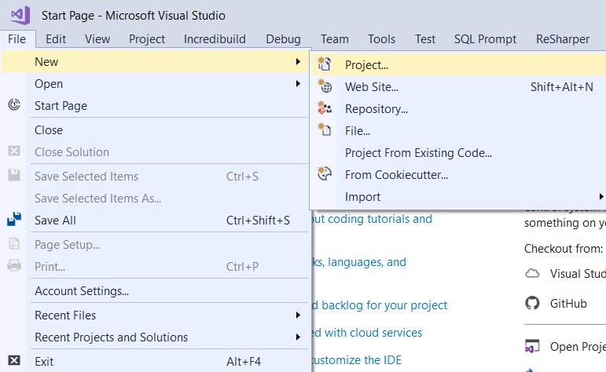

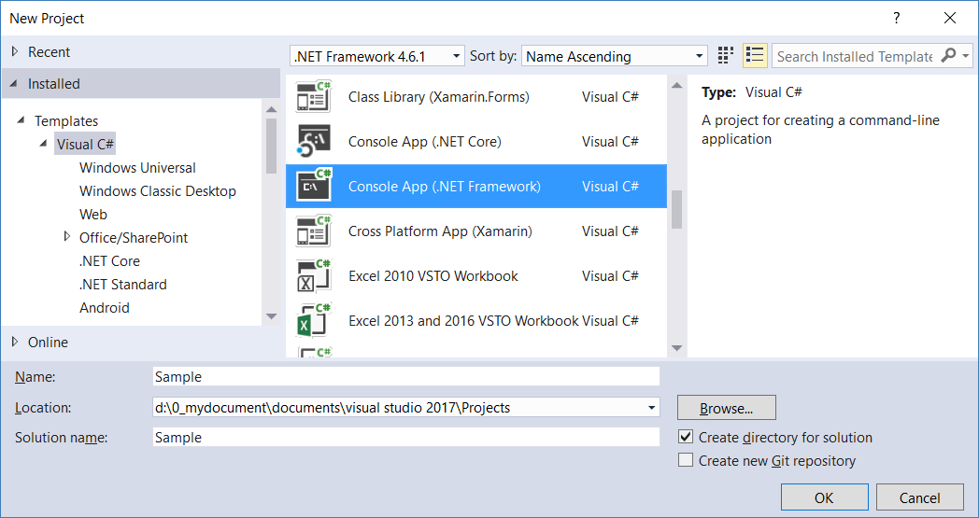

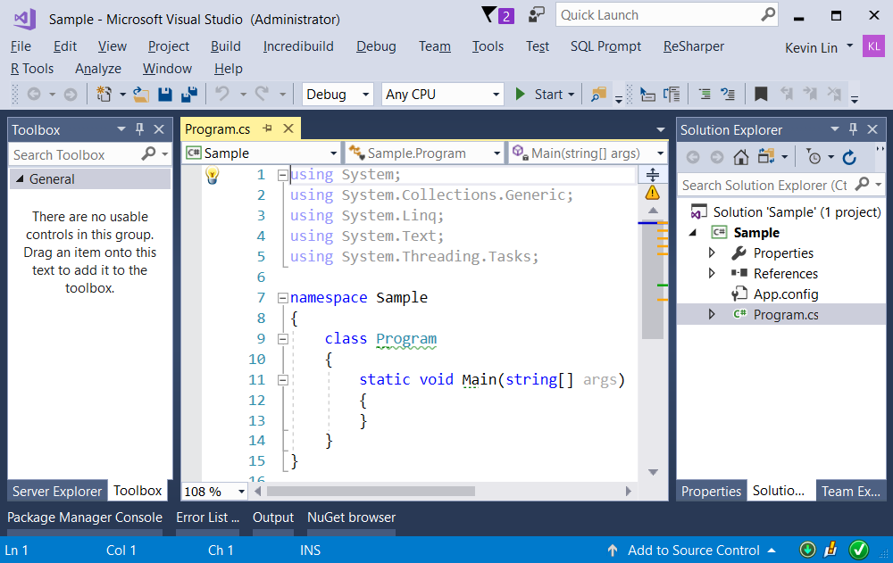

=============================================

2. Sample : Program.cs

using System;

using System.Runtime.InteropServices;

namespace Sample

{

    class Program

    {

        static void Main(string[] args)

        {

            // 1. ------------------------------------------------

            // Use parameter arrays

            Console.WriteLine("1. Use parameter arrays ===================== ");

            ParamsArrSample(1, 2);

            ParamsArrSample(1, 2, 3);

            ParamsArrSample(1, 2, 3, 4, 5);

            ParamsArrSample(1, 2, new int[] { 3, 4, 5 });

            //1. Use parameter arrays =====================

            //ParamsArrSample() == { 1 , 2  }

            //ParamsArrSample() == { 1 , 2 , 3  }

            //ParamsArrSample() == { 1 , 2 , 3 , 4 , 5  }

            //ParamsArrSample() == { 1 , 2 , 3 , 4 , 5  }

            // 2. ------------------------------------------------

            // Method Overload

            Console.WriteLine("2. Method Overload ===================== ");

            OverloadSample(1, 2);

            OverloadSample(1, 2, new int[] { 3 });

            OverloadSample(1, 2, new int[] { 3, 4, 5 });

            OverloadSample(1, 2, new[] { 3, 4, 5 });

            //2. Method Overload =====================

            //OverloadSample() == { 1 , 2 }

            //OverloadSample() == { 1 , 2 , 3  }

            //OverloadSample() == { 1 , 2 , 3 , 4 , 5  }

            //OverloadSample() == { 1 , 2 , 3 , 4 , 5  }

            // 3. ------------------------------------------------

            // Parameter default value

            Console.WriteLine("3. Parameter default value ===================== ");

            ParameterDefaultValueSample(1, 2);

            ParameterDefaultValueSample(1, 2, new int[] { 3 });

            ParameterDefaultValueSample(1, 2, new int[] { 3, 4, 5 });

            ParameterDefaultValueSample(1, 2, new[] { 3, 4, 5 });

            ParameterDefaultValueSample(1);   //{ 1 , 100  }

            ParameterDefaultValueSample(1, intArr: new[] { 101, 102, 103 });  //{ 1 , 100 , 101 , 102 , 103  }

            //3.Parameter default value =====================

            //ParameterDefaultValueSample() == { 1 , 2  }

            //ParameterDefaultValueSample() == { 1 , 2 , 3  }

            //ParameterDefaultValueSample() == { 1 , 2 , 3 , 4 , 5  }

            //ParameterDefaultValueSample() == { 1 , 2 , 3 , 4 , 5  }

            //ParameterDefaultValueSample() == { 1 , 100  }

            //ParameterDefaultValueSample() == { 1 , 100 , 101 , 102 , 103  }

            // 4. ------------------------------------------------

            // OptionalAttribute Sample

            Console.WriteLine("4. OptionalAttributeSample ===================== ");

            OptionalAttributeSample(1, 2);

            OptionalAttributeSample(1, 2, new int[] { 3 });

            OptionalAttributeSample(1, 2, new int[] { 3, 4, 5 });

            OptionalAttributeSample(1, 2, new[] { 3, 4, 5 });

            //4. OptionalAttributeSample =====================

            //OptionalAttributeSample() == { 1 , 2  }

            //OptionalAttributeSample() == { 1 , 2 , 3  }

            //OptionalAttributeSample() == { 1 , 2 , 3 , 4 , 5  }

            //OptionalAttributeSample() == { 1 , 2 , 3 , 4 , 5  }

            Console.ReadLine();

        }

        // 1. ------------------------------------------------

        // Use parameter arrays

        // static void PrintAll2(int i1, params int[] intArr, int i2)   //Error

        static void ParamsArrSample(int i1, int i2, params int[] intArr)

        {

            Console.Write("ParamsArrSample() == {{ {0} , {1} ", i1, i2);

            if (intArr != null)

            {

                foreach (int i in intArr)

                {

                    Console.Write($", {i} ");

                }

            }

            Console.WriteLine(" }");

        }

        //params int[] intArr, parameter array must be the last parameter.

        // 2. ------------------------------------------------

        // Method Overload

        static void OverloadSample(int i1, int i2)

        {

            Console.WriteLine("OverloadSample() == {{ {0} , {1} }}", i1, i2);

        }

        static void OverloadSample(int i1, int i2, int[] intArr)

        {

            Console.Write("OverloadSample() == {{ {0} , {1} ", i1, i2);

            if (intArr != null)

            {

                foreach (int i in intArr)

                {

                    Console.Write($", {i} ");

                }

            }

            Console.WriteLine(" }");

        }

        // 3. ------------------------------------------------

        // Parameter default value

        static void ParameterDefaultValueSample(int i1, int i2 = 100, int[] intArr = null)

        {

            Console.Write("ParameterDefaultValueSample() == {{ {0} , {1} ", i1, i2);

            if (intArr != null)

            {

                foreach (int i in intArr)

                {

                    Console.Write($", {i} ");

                }

            }

            Console.WriteLine(" }");

        }

        // 4. ------------------------------------------------

        // OptionalAttribute Sample

        static void OptionalAttributeSample(int i1, int i2, [Optional] int[] intArr)

        {

            Console.Write("OptionalAttributeSample() == {{ {0} , {1} ", i1, i2);

            if (intArr != null)

            {

                foreach (int i in intArr)

                {

                    Console.Write($", {i} ");

                }

            }

            Console.WriteLine(" }");

        }

    }

}

/*

1.

4 popular ways to make method parameters optional.

1.1.

Use parameter arrays

1.2.

Overload Method

1.3.

Parameter default value

1.4.

OptionalAttribute from System.Runtime.InteropServices namespace

*/

