(T3)討論Namespace。比較StaticMethod、InstanceMethod。比較Ref、Out、params。比較MethodOverride，MethodHide  
CourseGUID: 29f1196a-1950-41a4-b9c1-dd13a9e92d92  
=======================================================================  
(T3)討論Namespace。比較StaticMethod、InstanceMethod。比較Ref、Out、params。比較MethodOverride，MethodHide  
=======================================================================  
1. Create New Project

2. Program.cs  
=======================================================================

0. What to learn

Static method V.S. Instance method

Ref keyword

Out keyword

params keyword

Method override V.S. Method Hide

1. Create New Project

File --> New --> Project... -->

Visual C# -->  **Console App** **(.Net Framework)** -->

Name: **Sample**

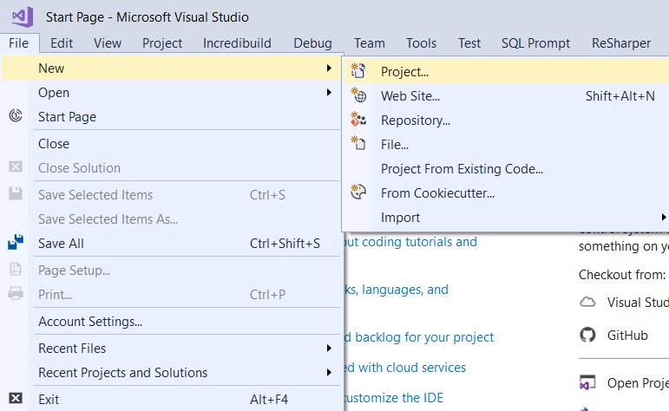

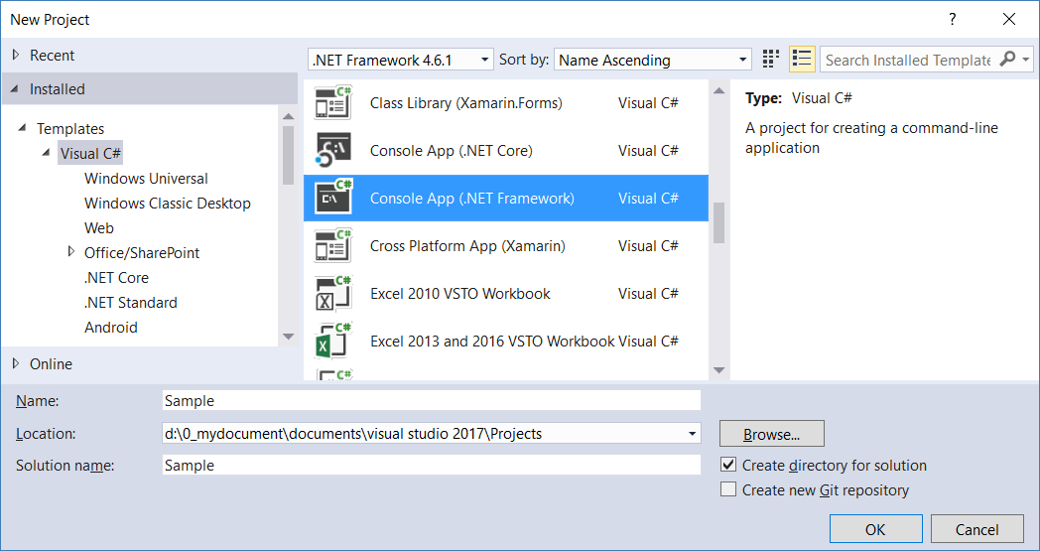

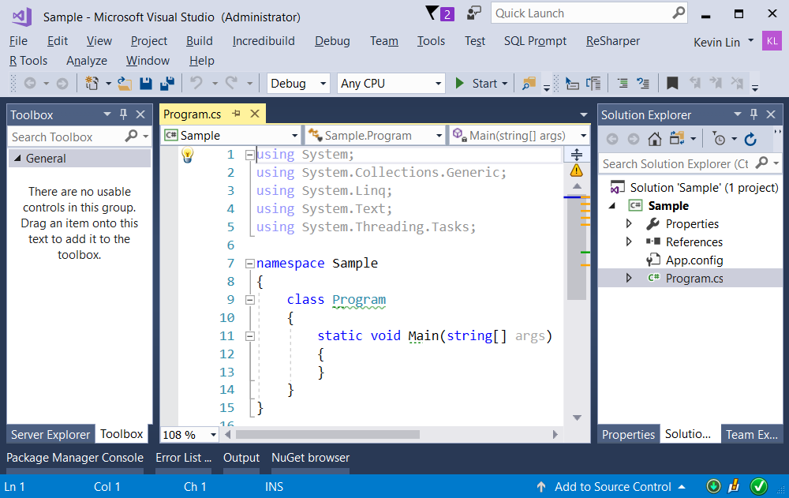

=============================================

2. Program.cs

// Namespace is like a folder which contains

// another namespace, class, interface, struct, enum delegate.

using System;

using AA11 = FolderA.FolderA1.FolderA1_1;

using AA2 = FolderA.FolderA2;

namespace Sample

{

    class Program

    {

        static void Main(string[] args)

        {

            // 1. Method

            Console.WriteLine("Method -------------------------------");

            // Static Method

            Program.StaticMethod(15);

            // Instance Method

            Program p = new Program();

            int sum = p.Sum(2,3);

            Console.WriteLine("sum = {0}", sum);

            // valued types parameter, pass by value

            int i = 0;

            Program.ValuedTypesParameter(i);

            Console.WriteLine(i);   // Still 0

            // Ref keyword, pass by reference

            int i2 = 0;

            Program.Refkeyword(ref i2);

            Console.WriteLine(i2);   // 100

            // Out keyword

            int outSum = 0;

            double outAvg = 0;

            Program.Outkeyword(2, 3, out outSum, out outAvg);

            Console.WriteLine("int outSum = {0}; double outAvg = {1}", outSum, outAvg);

            //int outSum = 5; double outAvg = 2

            // params keyword

            int[] paramsKeywordArr = {1, 2, 3};

            ParamsKeyword();

            ParamsKeyword(paramsKeywordArr);

            ParamsKeyword(10, 9, 8);

            // 2. namespace

            Console.WriteLine("namespace -------------------------------");

            FolderA.FolderA1.FolderA1_1.ClassA.WriteLine();

            FolderA.FolderA2.ClassA.WriteLine();

            FolderB.ClassA.WriteLine();

            // namespace alias.

            AA11.ClassA.WriteLine();

            AA2.ClassA.WriteLine();

            FolderB.ClassA.WriteLine();

            // 3. Static

            Console.WriteLine("Static -------------------------------");

            Console.WriteLine(OnlineGame.NumberOfMonstersInAreaA);  //5

            OnlineGame onlineGameSession1 = new OnlineGame();

            Console.WriteLine(OnlineGame.NumberOfMonstersInAreaA);  //6

            OnlineGame.KillOneMonsterInAreaA();

            Console.WriteLine(OnlineGame.NumberOfMonstersInAreaA);  //5

            OnlineGame onlineGameSession2 = new OnlineGame();

            Console.WriteLine(OnlineGame.NumberOfMonstersInAreaA);  //6

            // 4. Method override V.S. Method Hide

            Console.WriteLine("Method override V.S. Method Hide -------------------------------");

            Base1 b1 = new Sub1();

            b1.Print();

            //display "Sub Class"

            //Method override means

            //when baseClass has Print() with virtual

            //and subClass has Print() with override.

            //RHS is "new" Sub1() object.

            //LHS is the "Base1" typed variable b1.

            //b1.Print() will invoke the sub class Print() method.

            Base2 b2 = new Sub2();

            b2.Print();

            // display "Base Class"

            //Method hide means

            //when baseClass has Print()

            //and subClass has Print() without override.

            //RHS is "new" Sub2() object.

            //LHS is the "Base2" typed variable b2.

            //b2.Print() will invoke the base class Print() method.

            Console.ReadLine();

        }

       // 1. Method -------------------------------------------------------

       // Instance Method

        public int Sum(int i1, int i2)

        {

            return i1 + i2;

        }

        // Static Method

        public static void StaticMethod(int parameter1)

        {

            Console.WriteLine("Static Method {0}", parameter1);

        }

        //valued types parameter, pass by value

        public static void ValuedTypesParameter(int parameter1)

        {

            parameter1 = 100;

        }

        //Ref keyword, pass by reference

        public static void Refkeyword(ref int parameter1)

        {

            parameter1 = 100;

        }

        //Out keyword

        public static void Outkeyword(int i1, int i2, out int sum, out double avg)

        {

            sum = i1 + i2;

            avg = sum / 2;

        }

        // params keyword

        public static void ParamsKeyword(params int[] numbers)

        {

            Console.WriteLine("ParamsKeyword--------------------------");

            foreach (int item in numbers)

            {

                Console.WriteLine(item);

            }

        }

        //5. Method Overloading --------------------------------------------

        //allows methods have the same name but different method signature head.

        public static void Add(int a, int b)

        {

            Console.WriteLine("a + b = {0}", a+b);

        }

        ////public static string Add(int a, int b)

        ////{

        ////    return a + b;

        ////}

        //public static string Add(int a, int b)

        //and

        //public static void Add(int a, int b)

        //are actually having the same method signature.

        public static void Add(int a, int b, int c)

        {

            Console.WriteLine("a + b = {0}", a + b+c);

        }

        public static void Add(int a, int b, out int c)

        {

            Console.WriteLine("a + b = {0}", a + b);

            c = a + b;

        }

        public static void Add(int a, double b)

        {

            Console.WriteLine("a + b = {0}", (double)a + b);

        }

        public static void Add(int a, int b, int[] c)

        {

        }

        ////public static void Add(int a, int b, params int[] c)

        ////{

        ////}

        //public static void Add(int a, int b, params int[] c)

        //and

        //public static void Add(int a, int b, int[] c)

        //are actually having the same method signature.

    }

}

// 2. namespace -------------------------------------------------------

namespace FolderA

{

    namespace FolderA1

    {

        namespace FolderA1_1

        {

            public class ClassA

            {

                public static void WriteLine()

                {

                    Console.WriteLine("FolderA FolderA1 FolderA1_1 ClassA WriteLine");

                }

            }

        }

    }

    namespace FolderA2

    {

        public class ClassA

        {

            public static void WriteLine()

            {

                Console.WriteLine("FolderA FolderA2 ClassA WriteLine");

            }

        }

    }

}

namespace FolderB

{

    public class ClassA

    {

        public static void WriteLine()

        {

            Console.WriteLine("FolderB ClassA WriteLine");

        }

    }

}

// 3. Static -------------------------------------------------------

public class OnlineGame

{

    public static int NumberOfMonstersInAreaA;

    static OnlineGame()

    {

        NumberOfMonstersInAreaA = 5;

    }

    public OnlineGame()

    {

        NumberOfMonstersInAreaA = 6;

    }

    public static void KillOneMonsterInAreaA()

    {

        NumberOfMonstersInAreaA-=1;

    }

}

// 4. Method override V.S. Method Hide --------------------------------

public class Base1

{

    public virtual void Print()

    {

        Console.WriteLine("Base Class");

    }

}

public class Sub1 : Base1

{

    public override void Print()

    {

        Console.WriteLine("Sub Class");

    }

}

public class Base2

{

    public void Print()

    {

        Console.WriteLine("Base Class");

    }

}

public class Sub2 : Base2

{

    public void Print()

    {

        Console.WriteLine("Sub Class");

    }

}

/*

1.

Method (or called Function)

[attributes]

//AccessLevel (virtual) ReturnType methodName(Parameters)

//{

//    MethodBody

//}

1.1.

Method is a set of logic process

that you may repeatly perform in many place

by calling it.

1.2.

Only virtual method can be overrided in the sub-class.

1.3.

attributes can add some extra information to the method.

We will discuss later.

1.4.

//AccessLevel

//public / protected / private

Reference:

<https://docs.microsoft.com/en-us/dotnet/csharp/language-reference/keywords/accessibility-levels>

Accessibility Levels includes several levels.

Here, we only discuss, public, protected, and private.

public means access is not restricted.

protected means access is limited to the containing class or types derived from the containing class.

private means access is limited to the containing type.

1.5.

//ReturnType

Return type is the valid data type this method return.

//E.g. public string Name() { return "AAA"};

if the ReturnType is string,

then the method have to return string in the end of method.

//E.g. public void Name(){}

If the ReturnType is void,

then the method does not need to return anything.

1.6.

Parameters are optional

---------------------------------------------------------

2.

Static method V.S. Instance method

2.1.

// ClassName.StaticMethod()

You may call StaticMethod without creating the instance of the class.

2.2.

// ClassA classA = new ClassA();  classA.InstanceMethod();

You have to create an object of the class before you use InstanceMethod.

2.3.

class is like a blueprint or template.

object is a single instance of the class.

// ClassA classA = new ClassA();

Left hand side:  ClassA classA   means declare classA variable(like container)

which type is ClassA (like the container can only contain ClassA type object.)

Right hand side: new ClassA();

new is verb means create.

Use ClassA as template to create an object instance of ClassA

2.4.

InstanceMethod can only be used for that specific instance object.

All the instance object share the same StaticMethod();

E.g.

In the online game, there are 5 monster in areaA.

Now, I kill one, so only 4 left.

Thus, the game should use some kind of static method

to record the number of monsters in areaA.

---------------------------------------------------------

3.

Method parameter types

3.1

By default, valued types parameter

creates a copy of the parameter and pass into method.

E.g.

Pass by value:

//int i = 0;

//Program.ValuedTypesParameter(i);

//Console.WriteLine(i);   // Still 0

...

//public static void ValuedTypesParameter(int parameter1)

//{

//    parameter1 = 100;

//}

i --> 0

parameter1 --> 100

i and parameter1 are pointing to different memory location.

-----------------------------

3.2.

Ref keyword

Pass the memory address of the variable into the method.

Any changes made to the parameter in the method

will be reﬂected back to the method caller,

because the Reference Parameters memory location

and the original caller memory location

are actully pointing to the same location.

E.g.

//int i2 = 0;

//Program.Refkeyword(ref i2);

//Console.WriteLine(i2);   // retuns 100

...

//public static void Refkeyword(ref int parameter1)

//{

//    parameter1 = 100;

//}

i2 __________

             |----> 100

parameter1 __|

i2 and parameter1 are pointing to the same memory location.

Any changes made to the parameter1 in the method

will be reﬂected back to the i2.

-----------------------------

3.3.

Out keyword

Out keyword allow you to return more than one value.

-----------------------------

3.4.

params keyword

allows you to optionally pass an array[].

The method can take no parameter or an array

or a comma-separated list of arguments.

You may only has one params parameter

and must be the last one in a method declaration.

E.g.

//int[] paramsKeywordArr = {1, 2, 3};

//ParamsKeyword();

//ParamsKeyword(paramsKeywordArr);

//ParamsKeyword(10, 9, 8);

---------------------------------------------------------

4.

Namespace is like a folder which contains

another namespace, class, interface, struct, enum delegate.

E.g.

//using AA11 = FolderA.FolderA1.FolderA1_1;

//using AA2 = FolderA.FolderA2;

//using B = FolderB;

...

//FolderA.FolderA1.FolderA1_1.ClassA.WriteLine();

//FolderA.FolderA2.ClassA.WriteLine();

//FolderB.ClassA.WriteLine();

//// namespace alias.

//AA11.ClassA.WriteLine();

//AA2.ClassA.WriteLine();

//B.ClassA.WriteLine();

---------------------------------------------------------

5.

Static field V.S. Instance field

Static Constructor V.S. Instance Constructor

5.1.

InstanceField/InstanceMethod/InstanceConstructor

can only be used for that specific instance object.

All the instance object share the same copy of

StaticField/StaticMethod/StaticConstructor

No matter how many instances you create,

StaticConstructor is called only once before you "new" the first instance.

Thus, StaticConstructor is called before InstanceConstructor

E.g.

In the online game, there are 5 monster in areaA.

Now, I kill one, so only 4 left.

Thus, the game should use some kind of static method

to record the number of monsters in areaA.

---------------------------------------------------------

6.

Method override V.S. Method Hide

6.1.

Method override means

when baseClass has Print() with virtual

and subClass has Print() with override.

RHS is "new" Sub1() object.

LHS is the "Base1" typed variable b1.

b1.Print() will invoke the sub class Print() method.

6.2.

Method hide means

when baseClass has Print()

and subClass has Print() without override.

RHS is "new" Sub2() object.

LHS is the "Base2" typed variable b2.

b2.Print() will invoke the base class Print() method.

*/

