(T25)討論LamdaExpression(表達式)、AnonymousMethod(匿名方法)、RegisterEvent(註冊事件)  
CourseGUID: 29f1196a-1950-41a4-b9c1-dd13a9e92d92  
=======================================================================  
(T25)討論LamdaExpression(表達式)、AnonymousMethod(匿名方法)、RegisterEvent(註冊事件)  
=======================================================================  
1. New Project

1.1. Create New Project : Sample

-----------

2. Form1.cs

2.1. Form1.cs [Design]

2.2. Form1.cs  
=======================================================================

1. New Project

1.1. Create New Project : Sample

File --> New --> Project... -->

Visual C# -->  **Windows Forms App** **(.Net Framework)** -->

Name: **WindowsFormsApp1**

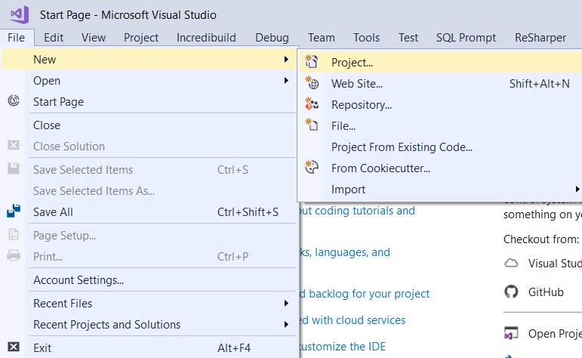

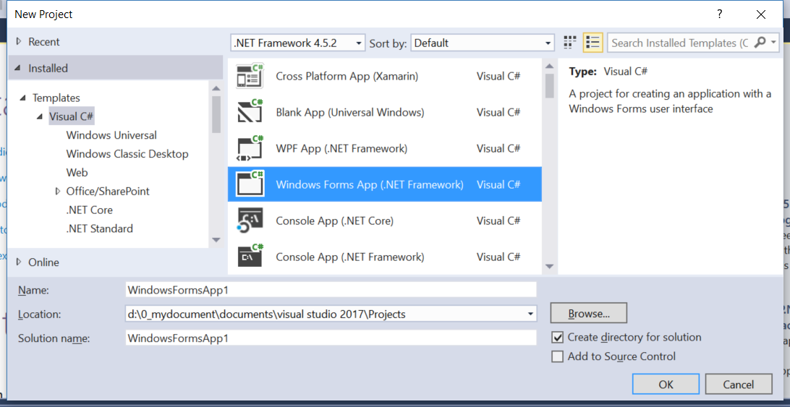

=============================================

2. Form1.cs

2.1. Form1.cs [Design]

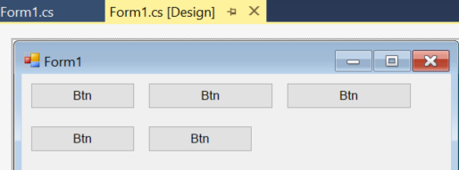

Drag and Drop 6 "Button"s on the Form and set the following properties

Name = btnClickMe

Name = btnClickMe2

Name = btnClickMe3

Name = btnClickMe4

Name = btnClickMe5

Name = btnClickMe6

2.2. Form1.cs

using System;

using System.Windows.Forms;

namespace WindowsFormsApp1

{

    public partial class Form1 : Form

    {

        public Form1()

        {

            InitializeComponent();

            btnClickMe.Text = "btnClickMe";

            btnClickMe.Click += new EventHandler(btnClickMe_Click);

            btnClickMe2.Text = "btnClickMe2";

            btnClickMe2.Click += btnClickMe2_Click;

            btnClickMe3.Text = "btnClickMe3";

            btnClickMe3.Click += delegate (object obj, EventArgs eventArgs)

            {

                MessageBox.Show("btnClickMe3 Clicked");

            };

            //This sample of anonymous method omit parameters

            //because the body does not use these parameters.

            btnClickMe4.Text = "btnClickMe4";

            btnClickMe4.Click += delegate {

                MessageBox.Show("btnClickMe4 Clicked");

            };

            //Lambda expression can never omit parameters

            //no matter the body use these parameters or not.

            btnClickMe5.Text = "btnClickMe5";

            btnClickMe5.Click += (sender, args) => MessageBox.Show("btnClickMe5 Clicked");

        }

        void btnClickMe_Click(object sender, EventArgs e)

        {

            MessageBox.Show("btnClickMe Clicked");

        }

        void btnClickMe2_Click(object sender, EventArgs e)

        {

            MessageBox.Show("btnClickMe2 Clicked");

        }

    }

}

