(T9)討論AccessModifiers。比較Public、Protected、Private、Internal、ProtectedInternal  
CourseGUID: 29f1196a-1950-41a4-b9c1-dd13a9e92d92  
=======================================================================  
(T9)討論AccessModifiers。比較Public、Protected、Private、Internal、ProtectedInternal  
=======================================================================  
0. Summary

-----------

1. New Project

1.1. Create New Project

1.2. Add New Project

1.3. Add Reference

-----------

2. Access modifiers

2.1. ClassLibrary1/GamerA.cs

2.2. Sample/Program.cs  
=======================================================================

0. Summary

1.

Access modifiers

Reference:

<https://docs.microsoft.com/en-us/dotnet/csharp/language-reference/keywords/accessibility-levels>

1.1.

Access modifiers are keywords used to specify the declared accessibility of a member or a type.

In this tutorial, we only discuss the following Accessibility Levels.

* **private** : Access is limited to the containing type. **(Default to Type Members)**
* **public** : Access is not restricted.
* **protected** : Access is limited to the containing class or types derived from the containing class.
* **internal** : Access is limited to the current assembly. **(Default to Types)**
* **protected internal** : Access is limited to the current assembly or types derived from the containing class.

1.2.

In general,

**Types** can use **public** and **internal** ,

and Types includes Class, Struct, Enums, Interface, Dlegate are belonged.

1.3.

**Type Members** can use **private**, **public**, **protected**, **internal**,**protected internal**

and Type Members includes **fields**, **properties**, **constructors**, and **methods**.

=============================================

1. New Project

1.1. Create New Project

File --> New --> Project... -->

Visual C# -->  **Console App** **(.Net Framework)** -->

Name: **Sample**

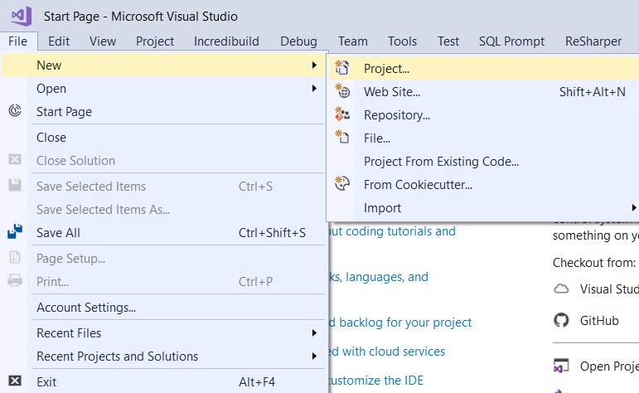

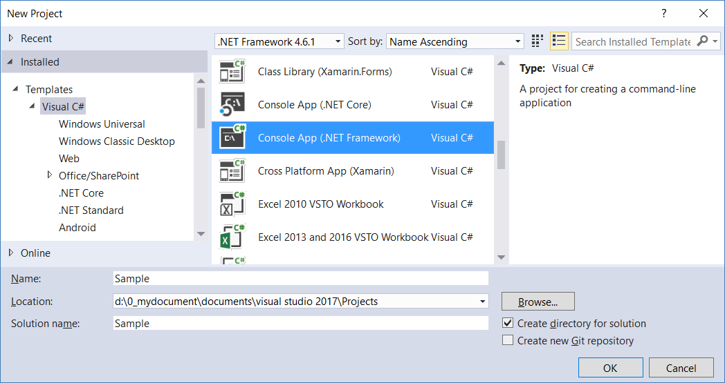

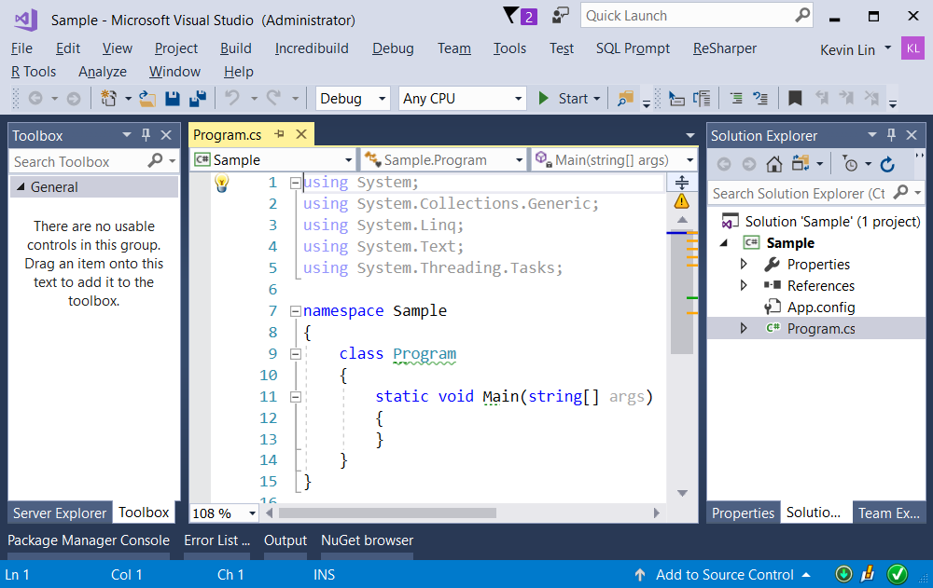

1.2. Add New Project

Solution Name --> Right Click --> Add --> New Project --> Class Library (.Net Framework)

-->

Project Name :

ClassLibrary1

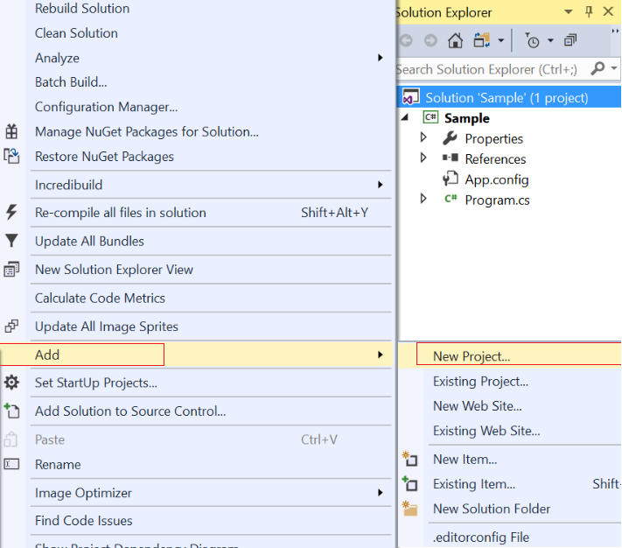

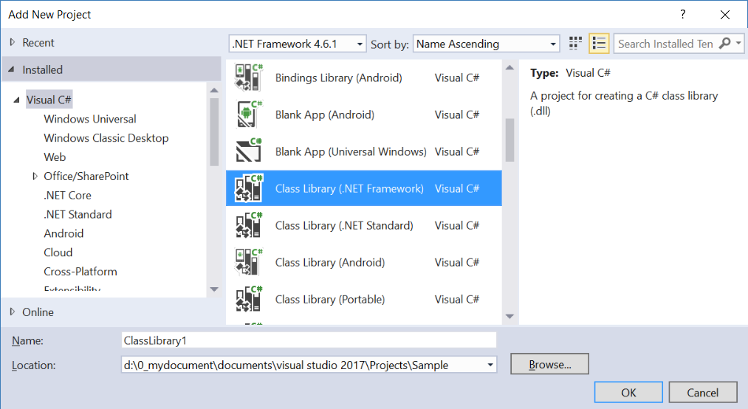

1.3. Add Reference

Project Name --> References  --> Add Reference

--> Select the reference you want to add.

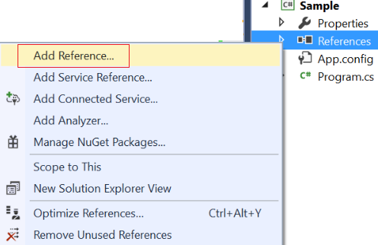

=============================================

2. Access modifiers

1.

Access modifiers

Reference:

<https://docs.microsoft.com/en-us/dotnet/csharp/language-reference/keywords/accessibility-levels>

1.1.

Access modifiers are keywords used to specify the declared accessibility of a member or a type.

In this tutorial, we only discuss the following Accessibility Levels.

* **private** : Access is limited to the containing type. **(Default to Type Members)**
* **public** : Access is not restricted.
* **protected** : Access is limited to the containing class or types derived from the containing class.
* **internal** : Access is limited to the current assembly. **(Default to Types)**
* **protected internal** : Access is limited to the current assembly or types derived from the containing class.

1.2.

In general,

**Types** can use **public** and **internal** ,

and **Types**includes **Class**, **Struct**, **Enums**, **Interface**, **Dlegate**.

1.3.

**Type Members** can use **private**, **public**, **protected**, **internal**,**protected internal**

and **Type Members** includes **fields**, **properties**, **constructors**, and **methods**.

2.1. ClassLibrary1/GamerA.cs

namespace OnLineGameA

{

    public class GamerA

    {

        // private field means only available in current class.

        private int _gameScore = 500;

        // protected field means available in current class and its sub class.

        protected internal int _level = 2;

        // public property means available every where.

        public int GameScore

        {

            get

            {

                return _gameScore;

            }

            set

            {

                _gameScore = value;

            }

        }

    }

    //Internal means only available in current assembly.

    public class GamerASub : GamerA

    {

        // public property means available every where.

        public int Level

        {

            get

            {

                return _level;

                // Sub Class can access the protected field from base class.

            }

            set

            {

                _level = value;

            }

        }

        // Protected internal method means only available in current assembly, and its sub class.

        protected internal int GetGameScore()

        {

            ////return base._gameScore;

            //  base._gameScore is private, thus, not available in its sub class.

            return GameScore;

        }

    }

}

2.2. Sample/Program.cs

using System;

using OnlineGame;

using OnLineGameA;

namespace Sample

{

    class Program

    {

        static void Main(string[] args)

        {

            Gamer gamer = new Gamer();

            //int gamer_gameScore = gamer._gameScore; // Error, Not available.

            //int gamer_Level = gamer._level; // Error, Not available.

            Console.WriteLine("gamer.GameScore == {0}", gamer.GameScore);

            GamerSub gamerSub = new GamerSub();

            gamerSub.GetGameScore();

            Console.WriteLine("gamerSub.GameScore == {0} , gamerSub.Level = {1}.", gamerSub.GameScore, gamerSub.Level);

            GamerA gamerA = new GamerA();

            //int gamerA_gameScore = gamerA._gameScore; // Error, Not available.

            //int gamerA_Level = gamerA._level; // Error, Not available.

            Console.WriteLine("gamerA.GameScore == {0}", gamerA.GameScore);

            GamerASub gamerASub = new GamerASub();

            Console.WriteLine("gamerASub.Level == {0} , gamerASub.GameScore = {1}", gamerASub.GameScore, gamerASub.Level);

            // gamerASub.GetGameScore();   // Error, Not available.

            Console.ReadLine();

        }

    }

}

namespace OnlineGame

{

    public class Gamer

    {

        // private field means only available in current class.

        private int _gameScore = 0;

        // protected field means available in current class and its sub class.

        protected int _level = 1;

        // public property means available every where.

        public int GameScore

        {

            get

            {

                return _gameScore;

            }

            set

            {

                _gameScore = value;

            }

        }

    }

    //Internal means only available in current assembly.

    internal class GamerSub : Gamer

    {

        // public property means available every where.

        public int Level

        {

            get

            {

                return _level;

                // Sub Class can access the protected field from base class.

            }

            set

            {

                _level = value;

            }

        }

        public int GetGameScore()

        {

            ////return base._gameScore; //Error, Not available.

            //  base._gameScore is private, thus, not available in its sub class.

            return GameScore;

        }

    }

}

/*

1.

Access modifiers

Reference:

<https://docs.microsoft.com/en-us/dotnet/csharp/language-reference/keywords/accessibility-levels>

1.1.

Access modifiers are keywords used to specify the declared accessibility of a member or a type.

In this tutorial, we only discuss the following Accessibility Levels.

* private : Access is limited to the containing type. (Default to Type Members)

* public : Access is not restricted.

* protected : Access is limited to the containing class or types derived from the containing class.

* internal : Access is limited to the current assembly. (Default to Types)

* protected internal : Access is limited to the current assembly or types derived from the containing class.

1.2.

In general,

Types can use public and internal ,

and Types includes Class, Struct, Enums, Interface, Dlegate.

1.3.

Type Members can use private, public, protected, internal, protected internal

and Type Members includes fields, properties, constructors, and methods.

*/

