(T2)討論LinqToObject的Aggregate，包括Min、Max、Sum、Count、Average  
CourseGUID: 5ba9a6fe-7475-4b0c-8b99-bbcf7f5e2e1c  
=======================================================================  
(T2)討論LinqToObject的Aggregate，包括Min、Max、Sum、Count、Average  
=======================================================================  
0. Summary

-----------

1. New Project

1.1. Create New Project : Sample

-----------

2. Sample : Program.cs  
=======================================================================

0. Summary

1.

There are 2 ways to write LINQ queries.

int[] intArr = { 10, 9, 8, 7, 6, 5, 4, 3, 2, 1 };

1.1.

Using SQL like query expressions

// IEnumerable<int> greaterThanFiveV1 =

//     from intItem in intArr

//     where intItem >= 5

//     select intItem;

1.2.

Using Lambda Expressions.

// IEnumerable<int> greaterThanFiveV2 = intArr.Where(intItem => intItem >= 5);

=============================================

1. New Project

1.1. Create New Project : Sample

File --> New --> Project... -->

Visual C# -->  **Console App** **(.Net Framework)** -->

Name: **Sample**

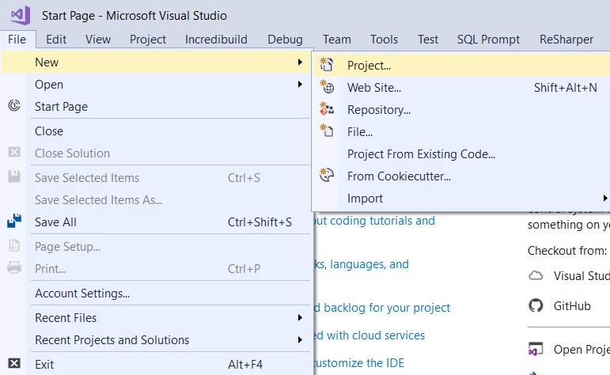

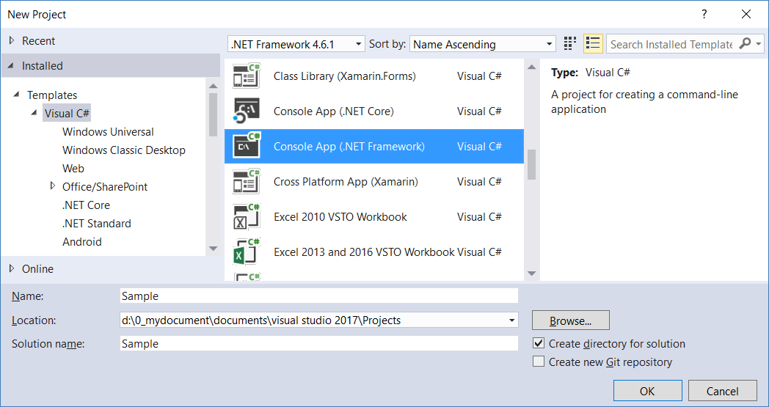

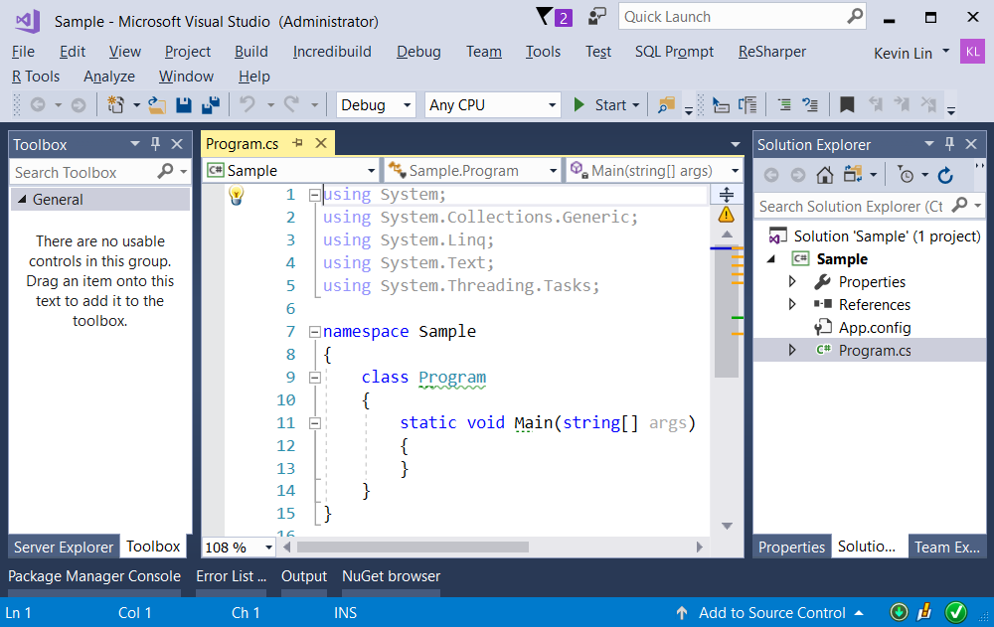

=============================================

2. Sample : Program.cs

using System;

using System.Collections.Generic;

using System.Linq;

using OnLineGame;

namespace Sample

{

    class LinqSimpleTypeSample1

    {

        static void Main(string[] args)

        {

            // 1. ==========================================

            Console.WriteLine("1. LinqSimpleTypeSample() ===============");

            LinqSimpleTypeSample();

            // 2. ==========================================

            Console.WriteLine("2. LinqComplexTypeSample() ===============");

            LinqComplexTypeSample();

            // 3. ==========================================

            Console.WriteLine("3. Min_Max_Sum_Count_AverageSample() ===============");

            Min_Max_Sum_Count_AverageSample();

            // 4. ==========================================

            Console.WriteLine("4. stringMinMaxSample() ===============");

            StringMinMaxSample();

            // 5. ==========================================

            Console.WriteLine("5. AggregateSample() ===============");

            AggregateSample();

            Console.ReadLine();

        }

       // 1. ==========================================

        static void LinqSimpleTypeSample()

        {

            //There are 2 ways to write LINQ queries.

            int[] intArr = { 10, 9, 8, 7, 6, 5, 4, 3, 2, 1 };

            //1.Using SQL like query expressions

            Console.WriteLine("1.1. Using SQL like query expressions ---------------");

            IEnumerable<int> greaterThanFiveV1 = from intItem in intArr

                                                 where intItem >= 5

                                                 select intItem;

            foreach (int greaterThanFiveV1Item in greaterThanFiveV1)

            {

                Console.WriteLine($"greaterThanFiveV1Item : {greaterThanFiveV1Item}");

            }

            //2.Using Lambda Expressions.

            Console.WriteLine("1.2. Using Lambda Expressions ---------------");

            IEnumerable<int> greaterThanFiveV2 = intArr.Where(intItem => intItem >= 5);

            foreach (int greaterThanFiveV2Item in greaterThanFiveV2)

            {

                Console.WriteLine($"greaterThanFiveV2 : {greaterThanFiveV2Item}");

            }

        }

        // 2. ==========================================

        static void LinqComplexTypeSample()

        {

            //There are 2 ways to write LINQ queries.

            List<GamerA> listGamerA = new List<GamerA>

            {

                new GamerA{Id = 1,Name="Name01",Gender = "Male"},

                new GamerA{Id = 2,Name="Name02",Gender = "Female"},

                new GamerA{Id = 3,Name="Name03",Gender = "Male"},

                new GamerA{Id = 4,Name="Name04",Gender = "Female"},

                new GamerA{Id = 5,Name="Name05",Gender = "Female"}

            };

            //1.Using SQL like query expressions

            Console.WriteLine("2.1. Using SQL like query expressions ---------------");

            IEnumerable<GamerA> allFemaleV1 = from gamer in listGamerA

                                              where gamer.Gender == "Female"

                                              select gamer;

            foreach (GamerA allFemaleV1Item in allFemaleV1)

            {

                Console.WriteLine($"allFemaleV1Item : {allFemaleV1Item}");

            }

            //2.Using Lambda Expressions.

           Console.WriteLine("2.2. Using Lambda Expressions ---------------");

            IEnumerable<GamerA> allFemaleV2 = listGamerA.Where(gamer => gamer.Gender == "Female");

            foreach (GamerA allFemaleV2Item in allFemaleV2)

            {

                Console.WriteLine($"allFemaleV2Item : {allFemaleV2Item}");

            }

        }

       // 3. ==========================================

        static void Min_Max_Sum_Count_AverageSample()

        {

            int[] intArr = { 10, 9, 8, 5, 4, 3, 7, 6, 2, 1 };

            Console.WriteLine("3.1. intArr ---------- ");

            foreach (int intArrItem in intArr)

            {

                Console.WriteLine($"intArrItem:{intArrItem}");

            }

            Console.WriteLine("3.2. intArr.Where(n => n % 2 == 0) ---------- ");

            foreach (int intArrItem in intArr.Where(n => n % 2 == 0))

            {

                Console.WriteLine($"intArr.Where(n => n % 2 == 0) Item :{intArrItem}");

            }

            Console.WriteLine("3.3. NoAggregateSample ---------- ");

            int? smallestItem = null;

            foreach (int intArrItem in intArr)

            {

                if (!smallestItem.HasValue || intArrItem < smallestItem)

                {

                    smallestItem = intArrItem;

                }

            }

            Console.WriteLine($"smallestItem:{smallestItem}");

            int? largestItem = null;

            foreach (int intArrItem in intArr)

            {

                if (!largestItem.HasValue || intArrItem > largestItem)

                {

                    largestItem = intArrItem;

                }

            }

            Console.WriteLine($"largestItem:{largestItem}");

            Console.WriteLine("3.4. Min_Max_Sum_Count_Average ---------- ");

            int smallestNumber = intArr.Min();

            int smallestEvenNumber = intArr.Where(n => n % 2 == 0).Min();

            Console.WriteLine($"intArr.Min()=={intArr.Min()}");

            Console.WriteLine($"intArr.Where(n => n % 2 == 0).Min()=={intArr.Where(n => n % 2 == 0).Min()}");

            int largestNumber = intArr.Max();

            int largestEvenNumber = intArr.Where(n => n % 2 == 0).Max();

            Console.WriteLine($"intArr.Max()=={intArr.Max()}");

            Console.WriteLine($"intArr.Where(n => n % 2 == 0).Max()=={intArr.Where(n => n % 2 == 0).Max()}");

            int sumOfAllNumbers = intArr.Sum();

            int sumOfAllEvenNumbers = intArr.Where(n => n % 2 == 0).Sum();

            Console.WriteLine($"intArr.Sum()=={intArr.Sum()}");

            Console.WriteLine($"intArr.Where(n => n % 2 == 0).Sum()=={intArr.Where(n => n % 2 == 0).Sum()}");

            int countOfAllNumbers = intArr.Length;

            int countOfAllEvenNumbers = intArr.Where(n => n % 2 == 0).Count();

            Console.WriteLine($"intArr.Length=={intArr.Length}");

            Console.WriteLine($"intArr.Where(n => n % 2 == 0).Count()=={intArr.Where(n => n % 2 == 0).Count()}");

            double averageOfAllNumbers = intArr.Average();

            double averageOfAllEvenNumbers = intArr.Where(n => n % 2 == 0).Average();

            Console.WriteLine($"intArr.Average()=={intArr.Average()}");

            Console.WriteLine($"intArr.Where(n => n % 2 == 0).Average()=={intArr.Where(n => n % 2 == 0).Average()}");

        }

        // 4. ==========================================

        static void StringMinMaxSample()

        {

            string[] gamerName = { "Name00001", "Name02", "Name123456789" };

            Console.WriteLine($"GamerName.Min(x => x.Length):{gamerName.Min(x => x.Length)}");

            Console.WriteLine($"GamerName.Max(x => x.Length):{gamerName.Max(x => x.Length)}");

        }

      // 5. ==========================================

        static void AggregateSample()

        {

            //5.1. -------------------------------------------------

            Console.WriteLine("5.1. NoAggregateSample ---------- ");

            string[] gamerNames = { "Name01", "Name02", "Name03", "Name04", "Name05" };

            string gamerNamesStr1 = string.Empty;

            foreach (string gamerNamesItem in gamerNames)

            {

                if (gamerNamesItem.Equals(gamerNames.Last()))

                {

                    gamerNamesStr1 += gamerNamesItem;

                }

                else

                {

                    gamerNamesStr1 += $"{gamerNamesItem} , ";

                }

            }

            Console.WriteLine(gamerNamesStr1);

            // Return "Name01 , Name02 , Name03 , Name04, Name05"

            //5.2. -------------------------------------------------

            Console.WriteLine("5.2. AggregateSample ---------- ");

            string gamerNamesStr2 = gamerNames.Aggregate((a, b) => $"{a} , {b}");

            Console.WriteLine(gamerNamesStr2);

            // Return "Name01 , Name02 , Name03 , Name04, Name05"

            //Step1: a=="Name01", b=="Name02",

            //so return "Name01 , Name02";

            //Step2: a=="Name01 , Name02" , b=="Name03",

            //so return "Name01 , Name02 , Name03";

            //Step3: a=="Name01 , Name02 , Name03" , b=="Name04",

            //so return "Name01 , Name02 , Name03 , Name04";

            //Step4: a=="Name01 , Name02 , Name03 , Name04" , b=="Name05",

            //so return "Name01 , Name02 , Name03 , Name04, Name05";

            //5.3. -------------------------------------------------

            //product of all numbers

            Console.WriteLine("5.3. NoAggregateSample : product of all numbers ---------- ");

            int[] intArr = { 10, 9, 8, 7, 6 };

            int intArrProduct1 = 1;

            foreach (int i in intArr)

            {

                intArrProduct1 = intArrProduct1 * i;

            }

            Console.WriteLine(intArrProduct1);

            // Return 30240 , because 10*9*8*7*6

            //5.4. -------------------------------------------------

            //product of all numbers

            Console.WriteLine("5.4. AggregateSample : product of all numbers ---------- ");

            int intArrProduct2 = intArr.Aggregate((a, b) => a * b);

            Console.WriteLine(intArrProduct2);

            // Return 30240 , because 10*9*8*7*6

            //Step1: a==10, b==9,

            //so return 10*9;

            //Step2: a==10*9" , b==8,

            //so return 10*9*8;

            //Step3: a==10*9*8 , b==7,

            //so return 10*9*8*7;

            //Step4: a==10*9*8*7 , b==6,

            //so return 10*9*8*7*6

            //5.5. -------------------------------------------------

            //product of all numbers

            Console.WriteLine("5.5. AggregateSample : product of all numbers ---------- ");

            int intArrProduct3 = intArr.Aggregate(5, (a, b) => a * b);

            Console.WriteLine(intArrProduct3);

            //Return 151200, because 5*10*9*8*7*6

            //1.

            //Enumerable.Aggregate<TSource, TAccumulate>

            //(IEnumerable<TSource> source, TAccumulate seed,

            //Func<TAccumulate, TSource, TAccumulate> func)

            //Reference:

            //[https://msdn.microsoft.com/en-us/library/bb549218(v=vs.110).aspx](https://msdn.microsoft.com/en-us/library/bb549218%28v=vs.110%29.aspx)

            //Applies an accumulator function over a sequence.

            //The specified seed value is used as the initial accumulator value.

            //---------------

            //2.

            //Step1: a==5, b==10,

            //so return 5*10;

            //Step2: a==5*10" , b==9,

            //so return 5*10*9;

            //Step3: a==5*10*9 , b==8,

            //so return 5*10*9*8;

            //Step4: a==5*10*9*8 , b==7,

            //so return 5*10*9*8*7

            //Step4: a==5*10*9*8*7 , b==6,

            //so return 5*10*9*8*7*6

        }

    }

}

namespace OnLineGame

{

    public class GamerA

    {

        public int Id { get; set; }

        public string Name { get; set; }

        public string Gender { get; set; }

        public override string ToString()

        {

            return $"Id=={Id}, Name=={Name}, Gender=={Gender}";

        }

    }

}

