(T21)討論LinqToSql的CompiledQueryCompile、IdentityCache。比較ExecuteQuery、ExecuteCommand  
CourseGUID: 5ba9a6fe-7475-4b0c-8b99-bbcf7f5e2e1c  
=======================================================================  
(T21)討論LinqToSql的CompiledQueryCompile、IdentityCache。比較ExecuteQuery、ExecuteCommand  
=======================================================================  
0. Summary

-----------

1. Web Form Application - Linq Query

1.1. TSQL

1.2. Set up SQL Authentication

-----------

2. Console App

2.1. Linq to SQL

2.1.1. Add Connection

2.1.2. Sample.dbml

2.2. Program.cs  
=======================================================================

0. Summary

1.

CompiledQuery.Compile(...)

Reference:

<https://docs.microsoft.com/en-us/dotnet/framework/data/adonet/ef/language-reference/compiled-queries-linq-to-entities>

[https://msdn.microsoft.com/en-us/library/system.data.linq.compiledquery.compile(v=vs.110).aspx](https://msdn.microsoft.com/en-us/library/system.data.linq.compiledquery.compile%28v=vs.110%29.aspx)

1.1.

Linq query expression dynamically generates the TSQL statements

every time when a LINQ query is issued.

1.2.

CompiledQuery.Compile() can create a new delegate

to represent the compiled query,

so the application will use that delegate

instead of dynamically generate the TSQL statements again,

when a LINQ query is issued.

--------------------------------

2.

ExecuteQuery V.S. ExecuteCommand

2.1.

ExecuteQuery is for Select.

ExecuteCommand is for Insert, Update, Delete or stored procedure.

2.2.

Try not to use ExecuteQuery and ExecuteCommand.

When using ExecuteQuery and ExecuteCommand,

we lose the advantage of strongly-typed variables in Linq queries.

--------------------------------

3.

IdentityCache

SampleDataContext.Refresh

Reference:

[https://msdn.microsoft.com/en-us/library/dd627203(v=vs.100).aspx](https://msdn.microsoft.com/en-us/library/dd627203%28v=vs.100%29.aspx)

----------

3.1.

E.g.

//dbContext2.Refresh(System.Data.Linq.RefreshMode.OverwriteCurrentValues, g2);

Refresh dbContext and then overwrite g2 variable

----------

3.2.

IdentityCache

E.g.

//using (SampleDataContext dbContext = new SampleDataContext())

//{

//    Gamer g1 = dbContext.Gamers.FirstOrDefault(g => g.Id == 1);

//    Gamer g2 = dbContext.Gamers.FirstOrDefault(g => g.Id == 1);

//    Console.WriteLine("g1==g2 : {0}", object.ReferenceEquals(g1, g2));

//}

3.2.1.

We are using the same dataContext object

and the same identity search condition in Linq query

to retrieve 2 gamers.

When g1 Linq query is executed, the Linq query is converted to Tsql.

Then the Tsql is executed in the database, and return the result back to the application.

The application creates the Gamer g1 object and stores its data into g1 object properties.

The **object identity** is stored in the **Identity Cache**.

3.2.2.

When g2 Linq query is executed, the Linq query checks the **Identity Cache**

and returns a reference to the student object that already exists.

The application only request data from database once.

g1 and g2 are pointing to the same student object in memory.

----------

3.3.

//using (SampleDataContext dbContext1 = new SampleDataContext())

//using (SampleDataContext dbContext2 = new SampleDataContext())

//{

//    //Write the generated sql query to the Console window

//    dbContext1.Log = Console.Out;

//    dbContext2.Log = Console.Out;

//    Console.WriteLine("4.2.1. -------------------------- ");

//    Gamer g1 = dbContext1.Gamers.FirstOrDefault(g => g.Id == 1);

//    Gamer g2 = dbContext2.Gamers.FirstOrDefault(g => g.Id == 1);

//    Console.WriteLine($"g1==g2 : {object.ReferenceEquals(g1, g2)}");

We are using 2 different dataContext object

and the same search condition in Linq query

to retrieve 2 gamers.

The application will request data from database twice.

The first call to the database and then application create Gamer g1 object.

The second call to the database and then application create Gamer g2 object.

g1 and g2 are pointing to the different student object in memory.

//    Console.WriteLine($"g1==g2 : {object.ReferenceEquals(g1, g2)}");

will return false.

=============================================

1. Web Form Application - Linq Query

1.1. TSQL

Database --> Right Click --> New Database -->

Database Name : Sample

Options --> Recovery Model : Simple

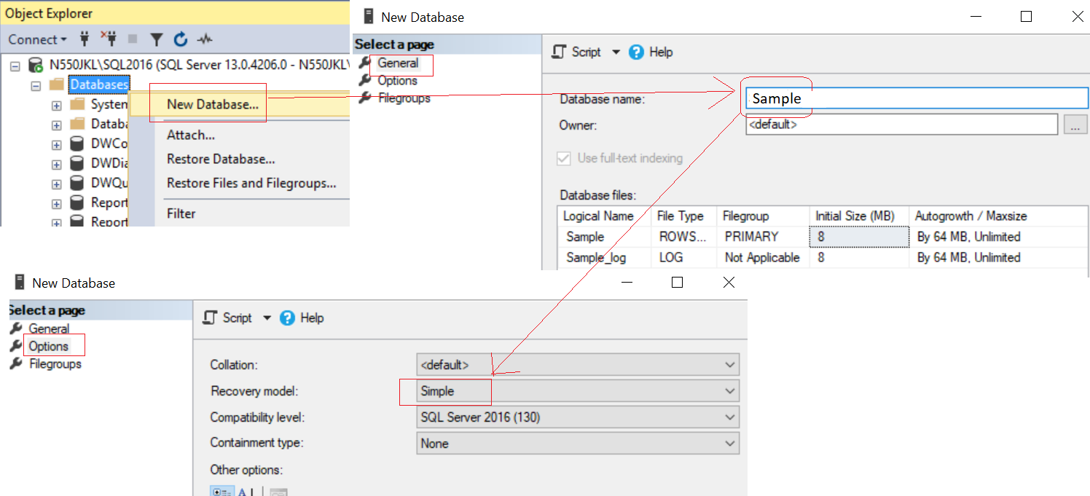

--Create a Sample DataBase and Run the following TSQL

--1 ----------------------------------------------------------

--Drop Table if it exists.

--IF OBJECT_ID('Gamer') IS NOT NULL

IF ( EXISTS ( SELECT    *

              FROM      INFORMATION_SCHEMA.TABLES

              WHERE     TABLE_NAME = 'Gamer' ) )

    BEGIN

        TRUNCATE TABLE Gamer;

        DROP TABLE Gamer;

    END;

GO -- Run the previous command and begins new batch

CREATE TABLE Gamer

    (

      Id INT PRIMARY KEY

             IDENTITY ,

      Name NVARCHAR(50) ,

      Gender NVARCHAR(50) ,

      Score INT ,

         Type NVARCHAR(50) ,

         CombatPower INT,

         MagicPower INT

    );

GO -- Run the previous command and begins new batch

--2 ----------------------------------------------------------

INSERT  INTO Gamer

VALUES  ( 'Name1 ABC', 'Male', 5000, 'Warrior', 500, NULL );

INSERT  INTO Gamer

VALUES  ( 'Name2 ABCDE', 'Female', 4500, 'Warrior', 350, NULL );

INSERT  INTO Gamer

VALUES  ( 'Name3 EFGH', 'Male', 6500, 'Magician', NULL, 600 );

INSERT  INTO Gamer

VALUES  ( 'Name4 HIJKLMN', 'Female', 45000, 'Magician', NULL, 650 );

INSERT  INTO Gamer

VALUES  ( 'Name5 NOP', 'Male', 3000, 'Magician', NULL, 700 );

INSERT  INTO Gamer

VALUES  ( 'Name6 PQRSTUVW', 'Male', 4000, 'Warrior', 450, NULL );

INSERT  INTO Gamer

VALUES  ( 'Name7 XYZ', 'Male', 4500, 'Warrior', 550, NULL );

GO -- Run the previous command and begins new batch

1.2. Set up SQL Authentication

In SQL server

Object Explorer --> Security --> Logins --> New Logins

-->

General Tab

Login Name :

Tester

Password:

1234

Default Database:

Sample

-->

Server Roles Tab

Select

sysadmin

-->

User Mapping Tab

Select Sample

Select every Roles.

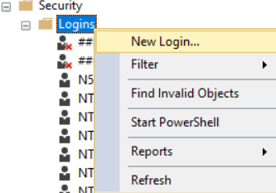

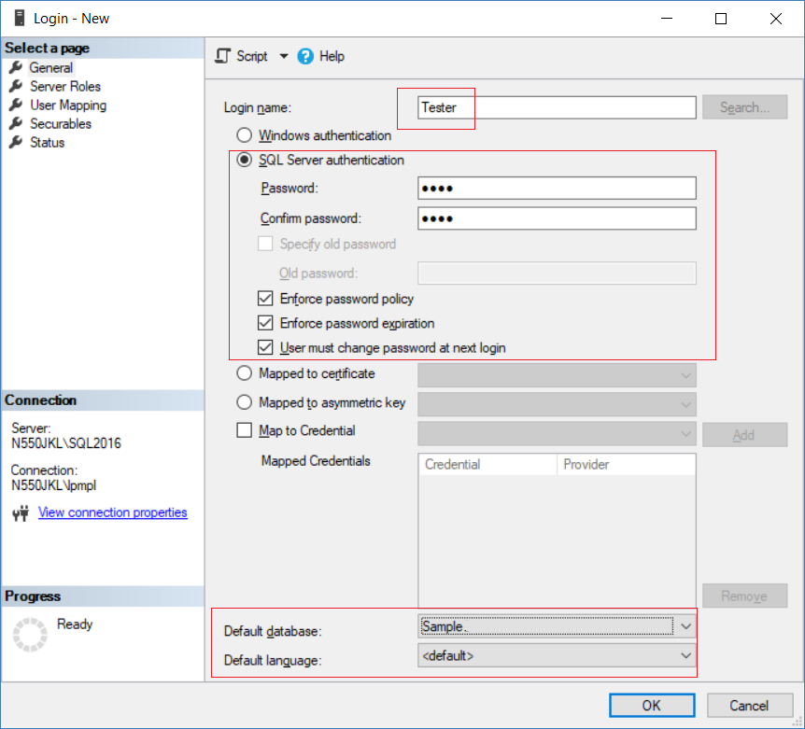

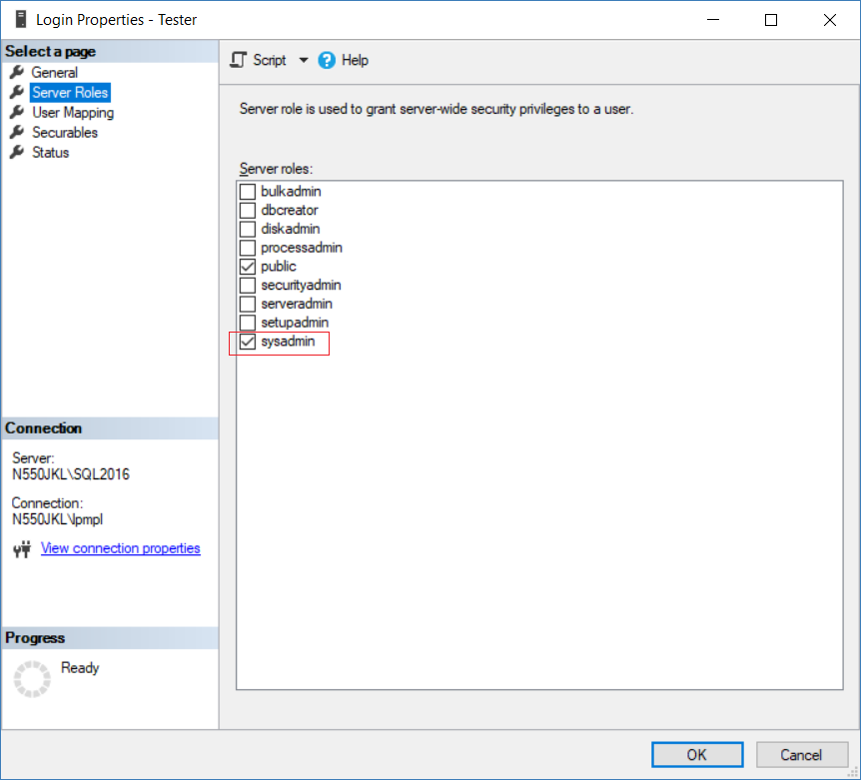

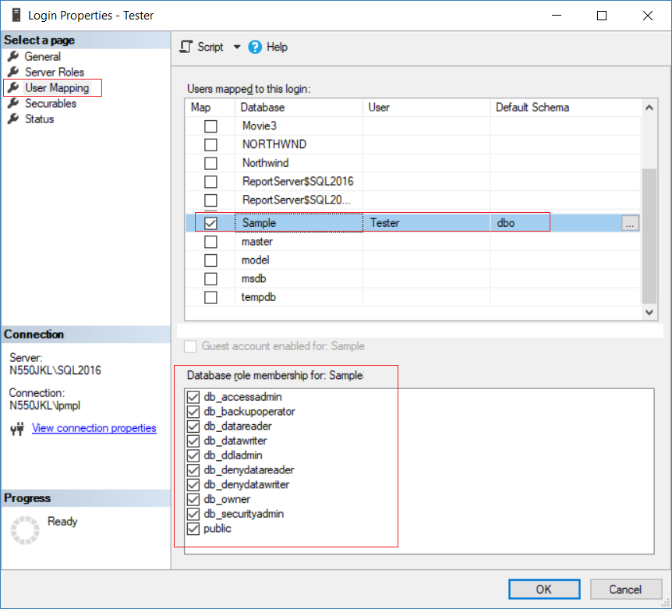

2. Console App

File --> New --> Project... -->

Visual C# -->  **Console App** **(.Net Framework)** -->

Name: **Sample**

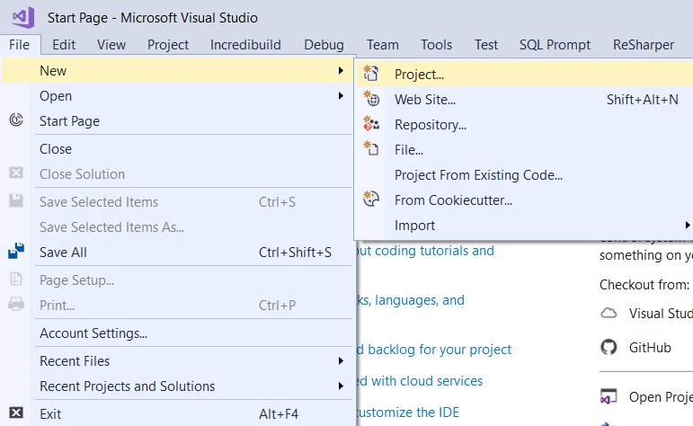

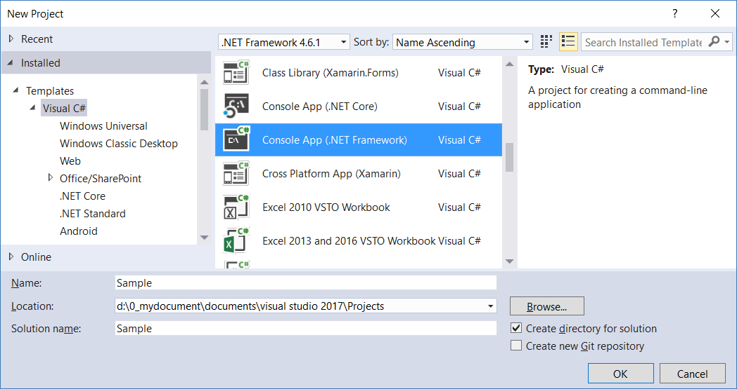

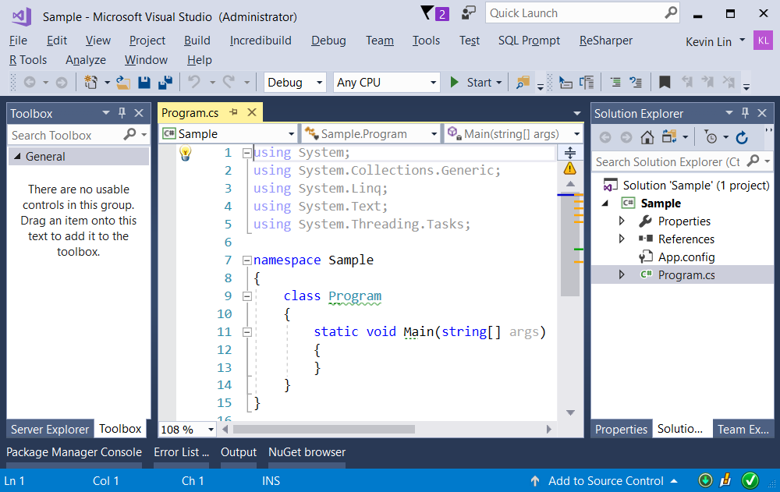

2.1. Linq to SQL

2.1.1. Add Connection

Server Explorer --> Data Connections --> Right click --> Add Connection...

--> Microsoft SQL server -->

Enter your server and database details ....

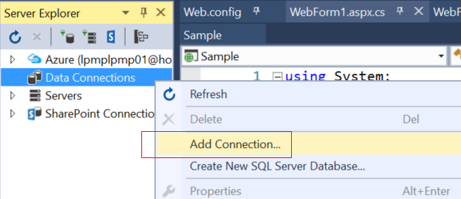

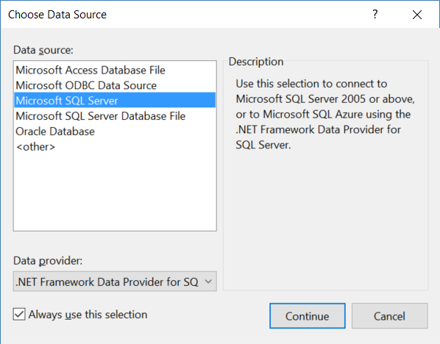

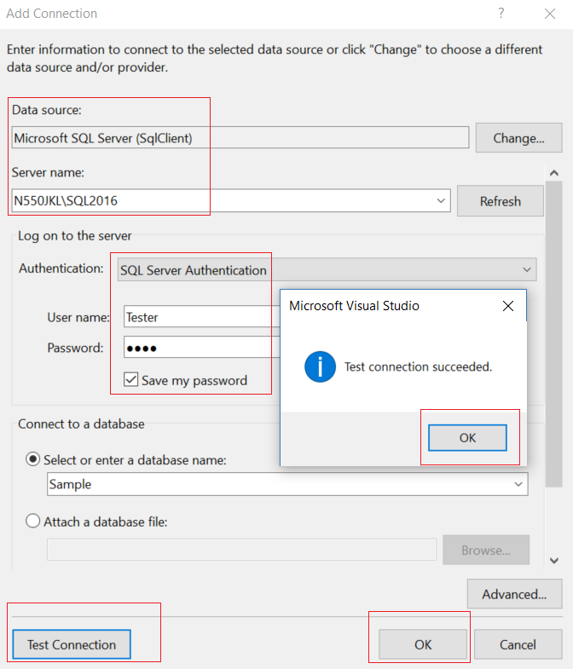

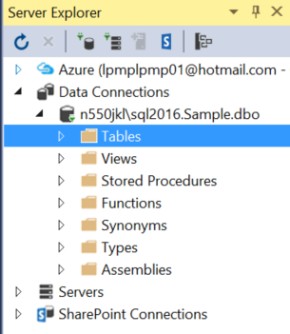

2.1.2. Sample.dbml

ProjectName --> Right Click --> Add --> New Item...

--> Linq to SQL classes -->

Name : **Sample.dbml**

I name it as "Sample.dbml",

because I know this is for connection to "Sample" Database.

-->

Drag Table from Server Explorer into DBML

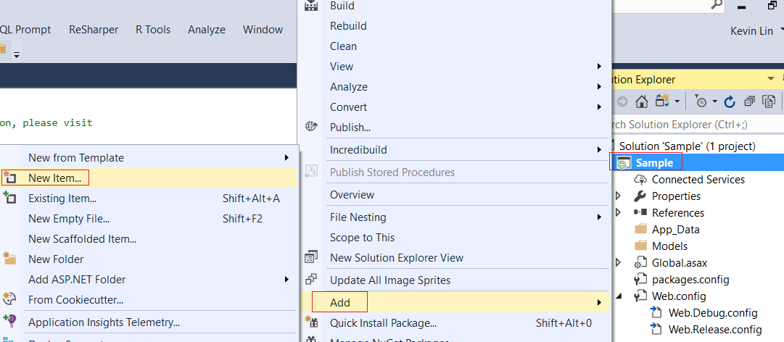

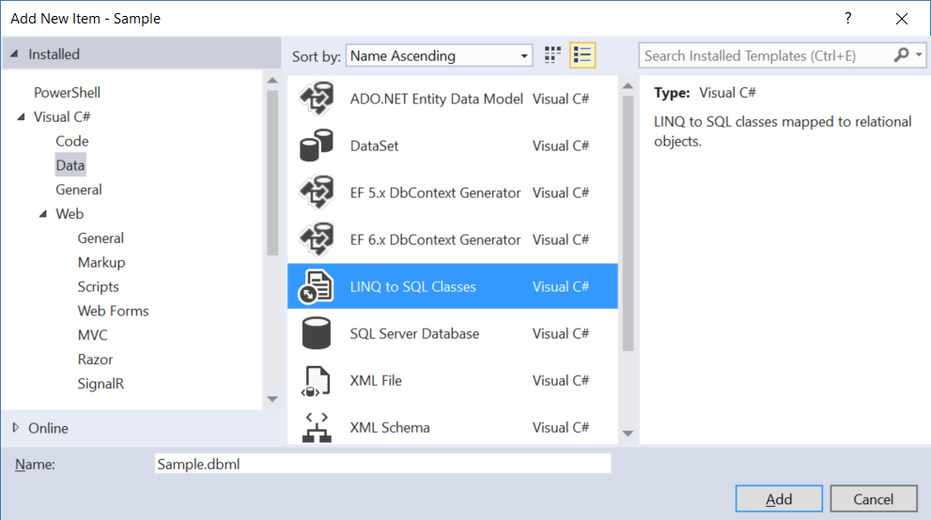

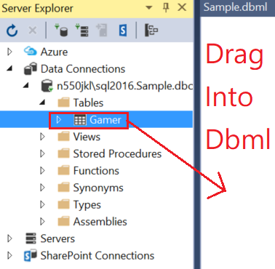

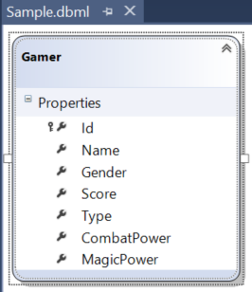

Save the dbml, it will generate the following files.

The DataContext context is the entry point to the database.

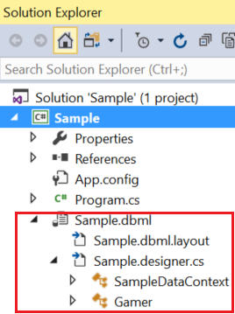

2.2. Program.cs

using System;

using System.Collections.Generic;

using System.Data.Linq;

using System.Linq;

namespace Sample

{

    class Program

    {

        static void Main(string[] args)

        {

            // 1. =====================================

            //CompiledQuerySample();

            Console.WriteLine("1. CompiledQuerySample() ============== ");

            CompiledQuerySample();

            // 2. =====================================

            //ExecuteQuerySample();

            Console.WriteLine("2. ExecuteQuerySample() ============== ");

            ExecuteQuerySample();

            // 3. =====================================

            //ExecuteCommandSample();

            Console.WriteLine("3. ExecuteCommandSample() ============== ");

            ExecuteCommandSample();

            // 4. =====================================

            //IdentityCacheRefreshSample();

            Console.WriteLine("4. IdentityCacheRefreshSample() =========== ");

            IdentityCacheRefreshSample();

            Console.ReadLine();

        }

        // 1. =====================================

        //CompiledQuerySample();

        static void CompiledQuerySample()

        {

            //1.

            //[CompiledQuery.Compile](http://compiledquery.compile/)(...)

            //Reference:

            //<https://docs.microsoft.com/en-us/dotnet/framework/data/adonet/ef/language-reference/compiled-queries-linq-to-entities>

            //[https://msdn.microsoft.com/en-us/library/system.data.linq.compiledquery.compile(v=vs.110).aspx](https://msdn.microsoft.com/en-us/library/system.data.linq.compiledquery.compile%28v=vs.110%29.aspx)

            //1.1.

            //Linq query expression dynamically generate the TSQL statements

            //every time when a LINQ query is issued.

            //1.2.

            //[CompiledQuery.Compile](http://compiledquery.compile/)() can create a new delegate

            //to represent the compiled query,

            //so the application will use that delegate

            //instead of dynamically generate the TSQL statements again,

            //when a LINQ query is issued.

            //1.1. ----------------------------------------------

            //Dynamically generate the required T-SQL statements

            Console.WriteLine("1.1. Dynamically generate the required T-SQL statements ------------ ");

            using (SampleDataContext dbContext = new SampleDataContext())

            {

                Gamer gamerId1 = (from g in dbContext.Gamers

                                   where g.Id == 1

                                   select g).Single();

                Console.WriteLine(gamerId1);

            }

            //1.2. ----------------------------------------------

            //[CompiledQuery.Compile](http://compiledquery.compile/)(...)

            Console.WriteLine("1.2. [CompiledQuery.Compile](http://compiledquery.compile/)(...) ------------ ");

            Func<SampleDataContext, int, Gamer> compiledQuery = CompiledQuery.Compile(

                            (SampleDataContext dataContext, int gamerId) =>

                                (from g in dataContext.Gamers

                                 where g.Id == gamerId

                                 select g).Single());

            using (SampleDataContext dbContext = new SampleDataContext())

            {

                if (compiledQuery != null)

                {

                    Gamer gamer = compiledQuery(dbContext, 1);

                    Console.WriteLine(gamer);

                }

            }

        }

        // 1.1. Dynamically generate the required T-SQL statements ------------

        // Id==1,Name==Name1 ABC,Gender==Male,Score==5000,Type==Warrior,CombatPower==500,MagicPower==

        // 1.2. [CompiledQuery.Compile](http://compiledquery.compile/)(...) ------------

        // Id==1,Name==Name1 ABC,Gender==Male,Score==5000,Type==Warrior,CombatPower==500,MagicPower==

       // 2. =====================================

        //ExecuteQuerySample();

        static void ExecuteQuerySample()

        {

            //ExecuteQuery is for Select.

            //ExecuteCommand is for Insert, Update, Delete or stored procedure.

            using (SampleDataContext dbContext = new SampleDataContext())

            {

                //2.1. ExecuteQuery ------------------------------------

                Console.WriteLine("2.1. ExecuteQuery ------------ ");

                IEnumerable<Gamer> gamers = dbContext.ExecuteQuery<Gamer>(

                    "Select * from Gamer where Gender='Male'");

                foreach (Gamer gamer in gamers)

                {

                    Console.WriteLine(gamer);

                }

                //2.2. ParameterizeQuery ------------------------------------

                Console.WriteLine("2.2. ParameterizeQuery ------------ ");

                IEnumerable<Gamer> gamers2 = dbContext.ExecuteQuery<Gamer>(

                    "Select * from Gamer where Gender={0} AND Type={1}","Male", "Warrior");

                foreach (Gamer gamer2 in gamers2)

                {

                    Console.WriteLine(gamer2);

                }

            }

        }

        // 2.1. ExecuteQuery ------------

        // Id==1,Name==Name1 ABC,Gender==Male,Score==5000,Type==Warrior,CombatPower==500,MagicPower==

        // Id==3,Name==Name3 EFGH,Gender==Male,Score==6500,Type==Magician,CombatPower==,MagicPower==600

        // Id==5,Name==Name5 NOP,Gender==Male,Score==3000,Type==Magician,CombatPower==,MagicPower==700

        // Id==6,Name==Name6 PQRSTUVW,Gender==Male,Score==4000,Type==Warrior,CombatPower==450,MagicPower==

        // Id==7,Name==Name7 XYZ,Gender==Male,Score==4500,Type==Warrior,CombatPower==550,MagicPower==

        // 2.2. ParameterizeQuery ------------

        // Id==1,Name==Name1 ABC,Gender==Male,Score==5000,Type==Warrior,CombatPower==500,MagicPower==

        // Id==6,Name==Name6 PQRSTUVW,Gender==Male,Score==4000,Type==Warrior,CombatPower==450,MagicPower==

        // Id==7,Name==Name7 XYZ,Gender==Male,Score==4500,Type==Warrior,CombatPower==550,MagicPower==

        // 3. =====================================

        //ExecuteCommandSample();

        static void ExecuteCommandSample()

        {

            using (SampleDataContext dbContext = new SampleDataContext())

            {

                //ExecuteQuery is for Select.

                //ExecuteCommand is for Insert, Update, Delete or stored procedure.

                int count = dbContext.ExecuteCommand(

                    "Update Gamer set Score=5555 where Id=1");

                Console.WriteLine("Rows Updated = {0}", count);

                Gamer gamerId1 = dbContext.ExecuteQuery<Gamer>(

                    "Select * from Gamer where Id=1").FirstOrDefault();

                Console.WriteLine(gamerId1);

            }

        }

        // Rows Updated = 1

        // Id==1,Name==Name1 ABC,Gender==Male,Score==5555,Type==Warrior,CombatPower==500,MagicPower==

        // 4. =====================================

        //IdentityCacheRefreshSample();

        static void IdentityCacheRefreshSample()

        {

            // 4.1. -----------------------------------------------------

            //3.2.

            //IdentityCache

            //3.2.1.

            //We are using the same dataContext object

            //and the same identity search condition in Linq query

            //to retrieve 2 gamers.

            //When g1 Linq query is executed, the Linq query is converted to Tsql.

            //Then the Tsql is executed in the database, and return the result back to the application.

            //The application creates the Gamer g1 object and stores its data into g1 object properties.

            //The object identity is stored in the Identity Cache.

            //3.2.2.

            //When g2 Linq query is executed, the Linq query checks the Identity Cache

            //and returns a reference to the student object that already exists.

            //The application only request data from the database once.

            //g1 and g2 are pointing to the same student object in memory.

            Console.WriteLine("4.1. -------------------------- ");

            using (SampleDataContext dbContext = new SampleDataContext())

            {

                //Write the generated sql query to the Console window

                dbContext.Log = Console.Out;

                Gamer g1 = dbContext.Gamers.FirstOrDefault(g => g.Id == 1);

                Gamer g2 = dbContext.Gamers.FirstOrDefault(g => g.Id == 1);

                Console.WriteLine("g1==g2 : {0}", object.ReferenceEquals(g1, g2));

            }

            // SELECT TOP (1) [t0].[Id], [t0].[Name], [t0].[Gender], [t0].[Score], [t0].[Type], [t0].[CombatPower], [t0].[MagicPower]

            // FROM [dbo].[Gamer] AS [t0]

            // WHERE [t0].[Id] = @p0

            // -- @p0: Input Int (Size = -1; Prec = 0; Scale = 0) [1]

            // -- Context: SqlProvider(Sql2008) Model: AttributedMetaModel Build: 4.7.2556.0

            // g1==g2 : True

           // 4.2.1. -----------------------------------------------------

            //3.3.

            // We are using 2 different dataContext object

            // and the same search condition in Linq query

            // to retrieve 2 gamers.

            // The application will request data from database twise.

            // First call to database and then application create Gamer g1 object.

            // Second call to database and then application create Gamer g2 object.

            // g1 and g2 are pointing to the different student object in memory.

            // //    Console.WriteLine($"g1==g2 : {object.ReferenceEquals(g1, g2)}");

            // will return false.

            Console.WriteLine("4.2. -------------------------- ");

            using (SampleDataContext dbContext1 = new SampleDataContext())

            using (SampleDataContext dbContext2 = new SampleDataContext())

            {

                //Write the generated sql query to the Console window

                dbContext1.Log = Console.Out;

                dbContext2.Log = Console.Out;

                Console.WriteLine("4.2.1. -------------------------- ");

                Gamer g1 = dbContext1.Gamers.FirstOrDefault(g => g.Id == 1);

                Gamer g2 = dbContext2.Gamers.FirstOrDefault(g => g.Id == 1);

                Console.WriteLine($"g1==g2 : {object.ReferenceEquals(g1, g2)}");

                Console.WriteLine($"g1: {g1}");

                Console.WriteLine($"g2: {g2}");

                // SELECT TOP (1) [t0].[Id], [t0].[Name], [t0].[Gender], [t0].[Score], [t0].[Type], [t0].[CombatPower], [t0].[MagicPower]

                // FROM [dbo].[Gamer] AS [t0]

                // WHERE [t0].[Id] = @p0

                // -- @p0: Input Int (Size = -1; Prec = 0; Scale = 0) [1]

                // -- Context: SqlProvider(Sql2008) Model: AttributedMetaModel Build: 4.7.2556.0

                // SELECT TOP (1) [t0].[Id], [t0].[Name], [t0].[Gender], [t0].[Score], [t0].[Type], [t0].[CombatPower], [t0].[MagicPower]

                // FROM [dbo].[Gamer] AS [t0]

                // WHERE [t0].[Id] = @p0

                // -- @p0: Input Int (Size = -1; Prec = 0; Scale = 0) [1]

                // -- Context: SqlProvider(Sql2008) Model: AttributedMetaModel Build: 4.7.2556.0

                // g1==g2 : False

                // g1: Id==1,Name==Name1 ABC,Gender==Male,Score==5555,Type==Warrior,CombatPower==500,MagicPower==

                // g2: Id==1,Name==Name1 ABC,Gender==Male,Score==5555,Type==Warrior,CombatPower==500,MagicPower==

               // 4.2.2. -----------------------------------------------------

                //g1 is created by dbContext1.

                //We update g1 Name and then submit the change to the database.

                //g2 are created by dbContext2 and still use the old Name.

                Console.WriteLine("4.2.2. -------------------------- ");

                if (g1 != null) g1.Name += "_New";

                dbContext1.SubmitChanges();

                Console.WriteLine("g1.Name += \"_New\"; dbContext1.SubmitChanges();");

                g2 = dbContext2.Gamers.FirstOrDefault(g => g.Id == 1);

                Console.WriteLine($"g1: {g1}");

                Console.WriteLine($"g2: {g2}");

                // UPDATE [dbo].[Gamer]

                // SET [Name] = @p6

                // WHERE ([Id] = @p0) AND ([Name] = @p1) AND ([Gender] = @p2) AND ([Score] = @p3) AND ([Type] = @p4) AND ([CombatPower] = @p5) AND ([MagicPower] IS NULL)

                // -- @p0: Input Int (Size = -1; Prec = 0; Scale = 0) [1]

                // -- @p1: Input NVarChar (Size = 4000; Prec = 0; Scale = 0) [Name1 ABC]

                // -- @p2: Input NVarChar (Size = 4000; Prec = 0; Scale = 0) [Male]

                // -- @p3: Input Int (Size = -1; Prec = 0; Scale = 0) [5555]

                // -- @p4: Input NVarChar (Size = 4000; Prec = 0; Scale = 0) [Warrior]

                // -- @p5: Input Int (Size = -1; Prec = 0; Scale = 0) [500]

                // -- @p6: Input NVarChar (Size = 4000; Prec = 0; Scale = 0) [Name1 ABC_New]

                // -- Context: SqlProvider(Sql2008) Model: AttributedMetaModel Build: 4.7.2556.0

                // g1.Name += "_New"; dbContext1.SubmitChanges();

                // g1: Id==1,Name==Name1 ABC_New,Gender==Male,Score==5555,Type==Warrior,CombatPower==500,MagicPower==

                // g2: Id==1,Name==Name1 ABC,Gender==Male,Score==5555,Type==Warrior,CombatPower==500,MagicPower==

                // 4.2.3. -----------------------------------------------------

                //g1 is created by dbContext1.

                //We update g1 Name and then submit change to database.

                //g2 are created by dbContext2 and still use the old Name.

                //So we have to refresh the data of g2.

                ////dbContext2.Refresh(System.Data.Linq.RefreshMode.OverwriteCurrentValues, g2);

                //Refresh dbContext and then overwrite g2 variable

                Console.WriteLine("4.2.3. -------------------------- ");

                if (g2 != null) dbContext2.Refresh(System.Data.Linq.RefreshMode.OverwriteCurrentValues, g2);

                //Refresh dbContext and then overwrite g2 variable

                Console.WriteLine("dbContext2.Refresh(RefreshMode.OverwriteCurrentValues, g2)");

                Console.WriteLine($"g1: {g1}");

                Console.WriteLine($"g2: {g2}");

                // SELECT [t0].[Id], [t0].[Name], [t0].[Gender], [t0].[Score], [t0].[Type], [t0].[CombatPower], [t0].[MagicPower]

                // FROM [dbo].[Gamer] AS [t0]

                // WHERE [t0].[Id] = @p0

                // -- @p0: Input Int (Size = -1; Prec = 0; Scale = 0) [1]

                // -- Context: SqlProvider(Sql2008) Model: AttributedMetaModel Build: 4.7.2556.0

                // dbContext2.Refresh(RefreshMode.OverwriteCurrentValues, g2)

                // g1: Id==1,Name==Name1 ABC_New,Gender==Male,Score==5555,Type==Warrior,CombatPower==500,MagicPower==

                // g2: Id==1,Name==Name1 ABC_New,Gender==Male,Score==5555,Type==Warrior,CombatPower==500,MagicPower==

            }

        }

    }

    public partial class Gamer

    {

        public override string ToString()

        {

            return $"Id=={Id},Name=={Name},Gender=={Gender},Score=={Score},Type=={Type},CombatPower=={CombatPower},MagicPower=={MagicPower}";

        }

    }

}