(T6)討論LinqToObject的OrderBy、ThenBy、Reverse  
CourseGUID: 5ba9a6fe-7475-4b0c-8b99-bbcf7f5e2e1c  
=======================================================================  
(T6)討論LinqToObject的OrderBy、ThenBy、Reverse  
=======================================================================  
0. Summary

-----------

1. New Project

1.1. Create New Project : Sample

-----------

2. Sample : Program.cs  
=======================================================================

0. Summary

What to learn :

OrderBy

OrderByDescending

ThenBy

ThenByDescending

Reverse

1. New Project

1.1. Create New Project : Sample

File --> New --> Project... -->

Visual C# -->  **Console App** **(.Net Framework)** -->

Name: **Sample**

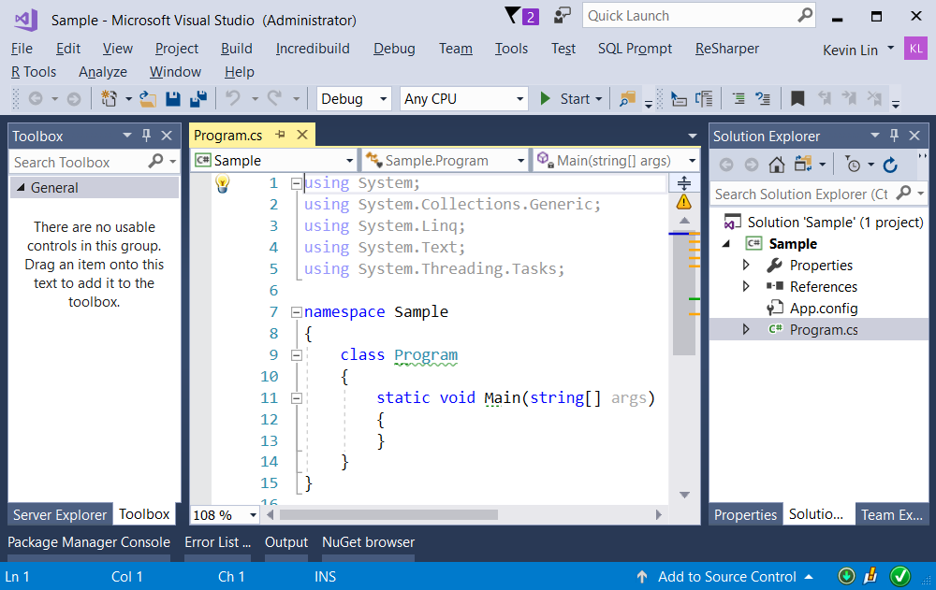

=============================================

2. Sample : Program.cs

using System;

using System.Collections.Generic;

using System.Linq;

using OnlineGame;

namespace Sample

{

    class Program

    {

        static void Main(string[] args)

        {

            // 1. =======================================

            //GamerOrderByName

            Console.WriteLine("1. GamerOrderByName() ============ ");

            GamerOrderByName();

            // 2. =======================================

            //GamerOrderByNameSqlLikeQuery

            Console.WriteLine("2. GamerOrderByNameSqlLikeQuery() ============ ");

            GamerOrderByNameSqlLikeQuery();

            // 3. =======================================

            //GamerOrderByNameDescending

            Console.WriteLine("3. GamerOrderByNameDescending() ============ ");

            GamerOrderByNameDescending();

            // 4. =======================================

            //GamerOrderByNameDescendingSqlLikeQuery

            Console.WriteLine("4. GamerOrderByNameDescendingSqlLikeQuery() ============ ");

            GamerOrderByNameDescendingSqlLikeQuery();

            // 5. =======================================

            //OrderByScoreByNameById

            Console.WriteLine("5. OrderByScoreByNameById() ============ ");

            OrderByScoreByNameById();

            // 6. =======================================

            //OrderByScoreByNameByIdSqlLikeQuery

            Console.WriteLine("6. OrderByScoreByNameByIdSqlLikeQuery() ============ ");

            OrderByScoreByNameByIdSqlLikeQuery();

            // 7. =======================================

            //OrderByScoreByNameByIdDescending

            Console.WriteLine("7. OrderByScoreByNameByIdDescending() ============ ");

            OrderByScoreByNameByIdDescending();

            // 8. =======================================

            //OrderByScoreByNameByIdDescendingSqlLikeQuery

            Console.WriteLine("8. OrderByScoreByNameByIdDescendingSqlLikeQuery() ============ ");

            OrderByScoreByNameByIdDescendingSqlLikeQuery();

            // 9. =======================================

            //ReverseSample

            Console.WriteLine("9. ReverseSample() ============ ");

            ReverseSample();

            Console.ReadLine();

        }

       // 1. =======================================

        static void GamerOrderByName()

        {

            IEnumerable<Gamer> gamers =

                GamerHelper.GetSampleGamers()

                .OrderBy(g => g.Name);

            foreach (Gamer gamersItem in gamers)

            {

                Console.WriteLine(gamersItem);

            }

        }

        //Order by Name

        //Id==1,Name==NameA,Score==2000

        //Id==2,Name==NameA,Score==2000

        //Id==3,Name==NameB,Score==2000

        //Id==5,Name==NameC,Score==2500

        //Id==4,Name==NameD,Score==2000

        // 2. =======================================

        private static void GamerOrderByNameSqlLikeQuery()

        {

            IOrderedEnumerable<Gamer> gamers =

                from gamer in GamerHelper.GetSampleGamers()

                orderby gamer.Name

                select gamer;

            foreach (Gamer gamersItem in gamers)

            {

                Console.WriteLine(gamersItem);

            }

        }

        //Order by Name

        //Id==1,Name==NameA,Score==2000

        //Id==2,Name==NameA,Score==2000

        //Id==3,Name==NameB,Score==2000

        //Id==5,Name==NameC,Score==2500

        //Id==4,Name==NameD,Score==2000

        // 3. =======================================

        private static void GamerOrderByNameDescending()

        {

            IOrderedEnumerable<Gamer> gamers =

                GamerHelper.GetSampleGamers()

                .OrderByDescending(g => g.Name);

            foreach (Gamer gamersItem in gamers)

            {

                Console.WriteLine(gamersItem);

            }

        }

        //Descending Order by Name

        //Id==4,Name==NameD,Score==2000

        //Id==5,Name==NameC,Score==2500

        //Id==3,Name==NameB,Score==2000

        //Id==1,Name==NameA,Score==2000

        //Id==2,Name==NameA,Score==2000

        // 4. =======================================

        static void GamerOrderByNameDescendingSqlLikeQuery()

        {

            IOrderedEnumerable<Gamer> gamers =

                from gamer in GamerHelper.GetSampleGamers()

                orderby gamer.Name descending

                select gamer;

            foreach (Gamer gamersItem in gamers)

            {

                Console.WriteLine(gamersItem);

            }

        }

        //Descending Order by Name

        //Id==4,Name==NameD,Score==2000

        //Id==5,Name==NameC,Score==2500

        //Id==3,Name==NameB,Score==2000

        //Id==1,Name==NameA,Score==2000

        //Id==2,Name==NameA,Score==2000

        // 5. =======================================

        static void OrderByScoreByNameById()

        {

            IOrderedEnumerable<Gamer> gamers =

                GamerHelper.GetSampleGamers()

                .OrderBy(g => g.Score)

                .ThenBy(g => g.Name)

                .ThenBy(g => g.Id);

            foreach (Gamer gamersItem in gamers)

            {

                Console.WriteLine(gamersItem);

            }

        }

        //Order by Score, Name, Id

        //Id==1,Name==NameA,Score==2000

        //Id==2,Name==NameA,Score==2000

        //Id==3,Name==NameB,Score==2000

        //Id==4,Name==NameD,Score==2000

        //Id==5,Name==NameC,Score==2500

        // 6. =======================================

        static void OrderByScoreByNameByIdSqlLikeQuery()

        {

            IOrderedEnumerable<Gamer> gamers = from gamer in GamerHelper.GetSampleGamers()

                                               orderby gamer.Score, gamer.Name, gamer.Id

                                               select gamer;

            foreach (Gamer gamersItem in gamers)

            {

                Console.WriteLine(gamersItem);

            }

        }

        //Order by Score, Name, Id

        //Id==1,Name==NameA,Score==2000

        //Id==2,Name==NameA,Score==2000

        //Id==3,Name==NameB,Score==2000

        //Id==4,Name==NameD,Score==2000

        //Id==5,Name==NameC,Score==2500

       // 7. =======================================

        private static void OrderByScoreByNameByIdDescending()

        {

            IOrderedEnumerable<Gamer> gamers =

                GamerHelper.GetSampleGamers()

                .OrderByDescending(g => g.Score)

                .ThenBy(g => g.Name)

                .ThenBy(g => g.Id);

            foreach (Gamer gamersItem in gamers)

            {

                Console.WriteLine(gamersItem);

            }

        }

        //Descending Order By Score,

        //then Order by Name and Id

        //Id==5,Name==NameC,Score==2500

        //Id==1,Name==NameA,Score==2000

        //Id==2,Name==NameA,Score==2000

        //Id==3,Name==NameB,Score==2000

        //Id==4,Name==NameD,Score==2000

        // 8. =======================================

        static void OrderByScoreByNameByIdDescendingSqlLikeQuery()

        {

            IOrderedEnumerable<Gamer> gamers =

                from gamer in GamerHelper.GetSampleGamers()

                orderby gamer.Score descending, gamer.Name, gamer.Id

                select gamer;

            foreach (Gamer gamersItem in gamers)

            {

                Console.WriteLine(gamersItem);

            }

        }

        //Descending Order By Score,

        //then Order by Name and Id

        //Id==5,Name==NameC,Score==2500

        //Id==1,Name==NameA,Score==2000

        //Id==2,Name==NameA,Score==2000

        //Id==3,Name==NameB,Score==2000

        //Id==4,Name==NameD,Score==2000

        // 9. =======================================

        static void ReverseSample()

        {

            List<Gamer> gamersList = GamerHelper.GetSampleGamers();

            Console.WriteLine("9.1. print each item --------- ");

            foreach (Gamer gamersItem in gamersList)

            {

                Console.WriteLine(gamersItem);

            }

            //Id == 1,Name == NameA,Score == 2000

            //Id == 2,Name == NameA,Score == 2000

            //Id == 3,Name == NameB,Score == 2000

            //Id == 4,Name == NameD,Score == 2000

            //Id == 5,Name == NameC,Score == 2500

            Console.WriteLine("9.2. Reverse and then print each item ------- ");

            gamersList.Reverse();

            foreach (Gamer gamersItem in gamersList)

            {

                Console.WriteLine(gamersItem);

            }

            //Id == 5,Name == NameC,Score == 2500

            //Id == 4,Name == NameD,Score == 2000

            //Id == 3,Name == NameB,Score == 2000

            //Id == 2,Name == NameA,Score == 2000

            //Id == 1,Name == NameA,Score == 2000

            Console.WriteLine("9.3. order by Score, Name, Id ------- ");

            IOrderedEnumerable<Gamer> gamers = gamersList

                .OrderBy(g => g.Score)

                .ThenBy(g => g.Name)

                .ThenBy(g => g.Id);

            foreach (Gamer gamersItem in gamers)

            {

                Console.WriteLine(gamersItem);

            }

            //Id == 1,Name == NameA,Score == 2000

            //Id == 2,Name == NameA,Score == 2000

            //Id == 3,Name == NameB,Score == 2000

            //Id == 4,Name == NameD,Score == 2000

            //Id == 5,Name == NameC,Score == 2500

            Console.WriteLine("9.4. Reverse and then print each item ------- ");

            foreach (Gamer gamersItem in gamers.Reverse())

            {

                Console.WriteLine(gamersItem);

            }

            //Id == 5,Name == NameC,Score == 2500

            //Id == 4,Name == NameD,Score == 2000

            //Id == 3,Name == NameB,Score == 2000

            //Id == 2,Name == NameA,Score == 2000

            //Id == 1,Name == NameA,Score == 2000

        }

    }

}

namespace OnlineGame

{

    public class Gamer

    {

        public int Id { get; set; }

        public string Name { get; set; }

        public int Score { get; set; }

        public override string ToString()

        {

            return $"Id=={Id},Name=={Name},Score=={Score}";

        }

    }

    public class GamerHelper

    {

        public static List<Gamer> GetSampleGamers()

        {

            return new List<Gamer>

            {

                new Gamer{Id=1,Name="NameA",Score=2000},

                new Gamer{Id=2,Name="NameA",Score=2000},

                new Gamer{Id=3,Name="NameB",Score=2000},

                new Gamer{Id=4,Name="NameD",Score=2000},

                new Gamer{Id=5,Name="NameC",Score=2500}

            };

        }

    }

}

