(T4)討論MvcConventions(命名規則)。討論AdoNet、BusinessLayer的Insert  
CourseGUID: 8503b39c-5887-4634-8291-facfb3117924  
=======================================================================  
(T4)討論MvcConventions(命名規則)。討論AdoNet、BusinessLayer的Insert  
=======================================================================  
0. Summary

-----------

1. MVC conventions

1.1. Controllers/HomeController.cs

1.2. Views/Home/Index.cshtml

-----------

2. OnlineGame DB

-----------

3. Add Class Library - BusinessLayer, ADO.NET

3.1. Add Reference

3.2. BusinessLayer/Gamer.cs

3.3. BusinessLayer/GamerBusinessLayer.cs (ADO.NET)

-----------

4. OnlineGame.Web/Controllers/GamerController.cs

4.1. Add Reference

4.2. OnlineGame.Web/Controllers/GamerController.cs

4.3. OnlineGame.Web/Views/Gamer/Index2.cshtml

4.4. Create: OnlineGame.Web/Views/Gamer/Create.cshtml  
=======================================================================

0. Summary

In this tutorial, we will discuss

* MvcConventions

* AdoDotNet

* BusinessLayer

* InsertData

This is continuous with the previous tutorial.

Please ensure you finish the previous tutorial before you continue this tutorial.

-----------------------------

Tutorial 4: 完全手寫ADO.NET連接資料庫以及新增/更新/移除資料

大部分市面上英文版的ASP.NET MVC課程都是一面倒只介紹Entity Framework。可是我們知道目前其實還是有許多公司使用Asp.Net Web Form Application搭配ADO.NET。那如果該公司想要更新技術使用ASP.NET MVC搭配Entity Framework。那你卻因為市面上大部分的MVC課程沒介紹連接ADO.NET因而GG，那是多冤枉啊。所以本課程也介紹如何讓MVC連接ADO.NET。使用舊技術的公司可以先在過渡期繼續使用ADO.NET搭配MVC，不必馬上就使用Entity Framework造成過渡期短時間花費過多學習程本。 你只有透過完全手寫，才能完善你的理解。

=========================================

補充1

viewBag vs viewData

-->

A

1.

ViewBag is just a wrapper around the ViewData.

2.

ViewData also works with .net framework 3.5 and above

3.

ViewBag only works with .net framework 4.0 and above

4.

ViewData :

Type Conversion code is required while enumerating

5.

ViewBag:

In depth, ViewBag is used dynamic, so there is no need to type conversion while enumerating.

原本只有ViewData，後來微軟生一個ViewBag出來應該不是無聊沒事做。所以ViewData和ViewBag，我大部分用ViewBag。

=========================================

1. MVC conventions

In MVC conventions,

1. Controllers must have the word "Controller" as the suffix and must extend "IController" interface.

2. A view must remain under "Views" folder.

3. If the view is for GamerController, then the view must remain under "Views/Gamer" folder.

4. In the "HomeController", when "Index" action "return View()", it will search the following files in order.

    4.1. ~/Views/Home/Index.aspx

    4.2. ~/Views/Home/Index.ascx

    4.3. ~/Views/Shared/Index.aspx

    4.4. ~/Views/Shared/Index.ascx

    4.5. ~/Views/Home/Index.cshtml

    4.6. ~/Views/Home/Index.vbhtml

    4.7. ~/Views/Shared/Index.cshtml

    4.8. ~/Views/Shared/Index.vbhtml

5. By MVC convention, MVC will look for the view in the following locations

    5.1. Views/ControllerName

    5.2. Views/Shared

6. The extension name of view can be cshtml, vbhtml, aspx, or ascx.

7. Models can be any where, even can be in other project.  However, it is better to put it in "Models" folder.

8. You may put Models in another project as business layer.

1.1. Controllers/HomeController.cs

using System.Collections.Generic;

using System.Web.Mvc;

namespace OnlineGame.Web.Controllers

{

    public class HomeController : Controller

    {

        //// GET: Home

        //public string Index()

        //{

        //    return "Hello";

        //}

        ////<http://localhost/OnlineGame.Web/home/index/aa?name=bbb>

        ////<http://localhost/OnlineGame.Web/home/index/aa?name2=bbb>

        //public string Index(string id)

        //{

        //    string queryString = Request.QueryString["name"];

        //    return $"Hey, Id={id} , name={queryString}";

        //}

        ////<http://localhost/OnlineGame.Web/home/index/aa?name=bbb>

        ////<http://localhost/OnlineGame.Web/home/index/aa?name2=bbb>

        //public string Index(string id, string name)

        //{

        //    // return string.Format("Hey, Id ={0} , name ={1}", id, name);

        //    return $"Hey, Id ={id} , name ={name}";

        //}

        //public List<string> Index()

        //{

        //    return new List<string>

        //    {

        //        "Name01",

        //        "Name02",

        //        "Name03"

        //    };

        //    // Return System.Collections.Generic.List`1[System.String]

        //    // This is Wrong.

        //}

        //public ActionResult Index()

        //{

        //    return View();

        //}

        //public ActionResult Index()

        //{

        //    ViewBag.Names = new List<string>

        //        {

        //            "Name01",

        //            "Name02",

        //            "Name03"

        //        };

        //    return View();

        //}

        public ActionResult Index()

        {

            ////1.

            //ViewBag.Names = new List<string>

            //{

            //    "ViewBag.Names01",

            //    "ViewBag.Names02",

            //    "ViewBag.Names03"

            //};

            ////2.

            //ViewData["Names"] = new List<string>

            //{

            //    "ViewData[\"Names\"]01",

            //    "ViewData[\"Names\"]02",

            //    "ViewData[\"Names\"]03"

            //};

            ////3.

            //ViewBag.Names = new List<string>

            //{

            //    "ViewBag.Names01",

            //    "ViewBag.Names02",

            //    "ViewBag.Names03"

            //};

            //ViewData["Names"] = new List<string>

            //{

            //    "ViewData[\"Names\"]01",

            //    "ViewData[\"Names\"]02",

            //    "ViewData[\"Names\"]03"

            //};

            //4.

            ViewBag.Names = new List<string>

            {

                "ViewBag.Names01",

                "ViewBag.Names02",

                "ViewBag.Names03"

            };

            ViewData["Names2"] = new List<string>

            {

                "ViewData[\"Names\"]01",

                "ViewData[\"Names\"]02",

                "ViewData[\"Names\"]03"

            };

            return View();

        }

        public string GetStringA()

        {

            return "AAAAAA";

        }

    }

}

/*

1.

When we try to return a list of data,

E.g.

return new List<string>

{

    "Name01",

    "Name02",

    "Name03"

};

Then, it will only display the data type of the variable

E.g.

System.Collections.Generic.List`1[System.String]

This is not what we want,

thus, we need a view to display the data in the format we want.

2.

//public ActionResult Index()

//{

//    return View();

//}

ViewResult extend ViewResultBase

ViewResultBase extend ActionResult.

Thus, you can return View()

3.

In Home/HomeController.cs

//ViewBag.Names = new List<string>

//{

//    "ViewBag.Names01",

//    "ViewBag.Names02",

//    "ViewBag.Names03"

//};

//ViewData["Names2"] = new List<string>

//{

//    "ViewData[\"Names\"]01",

//    "ViewData[\"Names\"]02",

//    "ViewData[\"Names\"]03"

//};

In Views/HomeIndex.cshtml

//@foreach (string strNames1 in ViewBag.Names)

//{

//    <li>@strNames1</li>

//}

//<br/>

//<br/>

//@foreach (string strNames2 in (List<string>) ViewData["Names2"])

//{

//    <li>@strNames2</li>

//}

Both ViewData and ViewBag can pass values from Controller to View.

Both ViewData and ViewBag allow an object to have properties dynamically added to it.

Because of dynamic feature,

both ViewData and ViewBag does not provide compile time error checking.

Thus, it is very easy to get Null Reference Error

if miss misspells the property name or key name.

*/

1.2. Views/Home/Index.cshtml

Now you delete   Views/Home/Index.cshtml

You will see the following error message.

The view 'Index' or its master was not found or no view engine supports the searched locations. The following locations were searched:

~/Views/Home/Index.aspx

~/Views/Home/Index.ascx

~/Views/Shared/Index.aspx

~/Views/Shared/Index.ascx

~/Views/Home/Index.cshtml

~/Views/Home/Index.vbhtml

~/Views/Shared/Index.cshtml

~/Views/Shared/Index.vbhtml

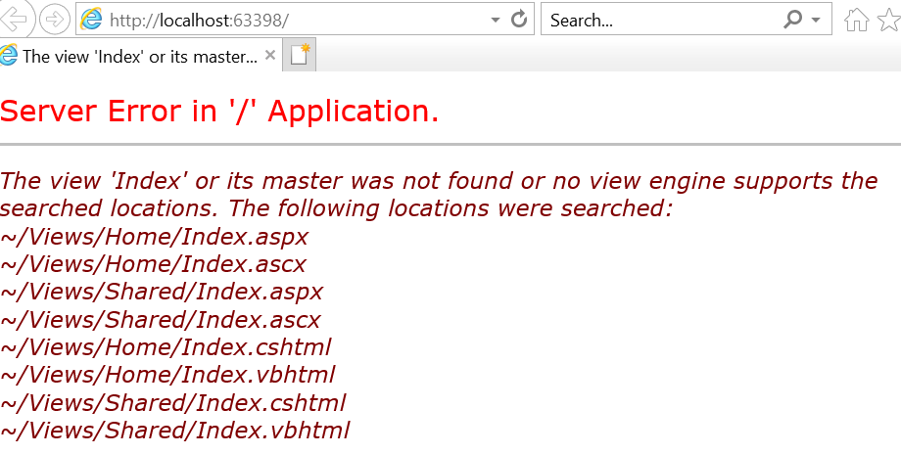

Because **Add New File** **(extension and update)**

press **Shift+F2**

**Views/Home/Index.cshtml**

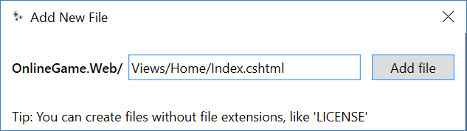

@model dynamic

@{

    ViewBag.Title = "title";

}

<h2>Name List</h2>

<ul>

    @*

        1.

        @foreach (string strNames1 in ViewBag.Names)

        {

            <li>@strNames1</li>

        }

    *@

    @*

        2.

        @foreach (string strNames2 in (List<string>)ViewData["Names"])

        {

            <li>@strNames2</li>

        }

    *@

    @*

        3.

        @foreach (string strNames1 in ViewBag.Names)

        {

            <li>@strNames1</li>

        }

        <br />

        <br />

        @foreach (string strNames2 in (List<string>)ViewData["Names"])

        {

            <li>@strNames2</li>

        }

    *@

    4.

    @foreach (string strNames1 in ViewBag.Names)

    {

        <li>@strNames1</li>

    }

    <br />

    <br />

    @foreach (string strNames2 in (List<string>)ViewData["Names2"])

    {

        <li>@strNames2</li>

    }

</ul>

<http://localhost:63398/Home/Index>

2. OnlineGame DB

In SQL server Management Studio (SSMS)

Database --> Right Click --> New Database -->

In General Tab -->

Name: **OnlineGame**

In options Tab --> Recovery model : **Simple**

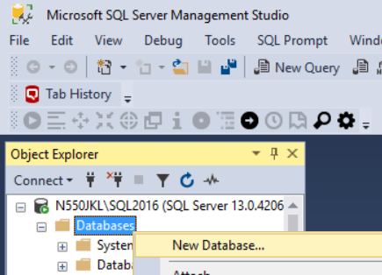

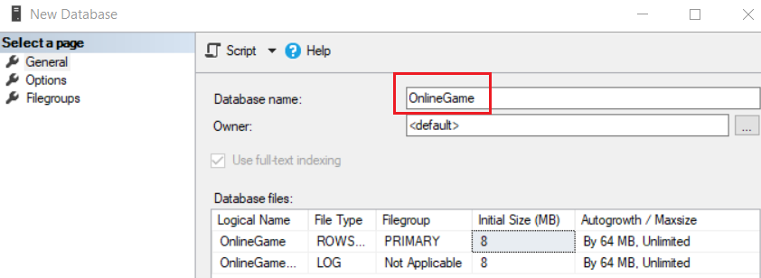

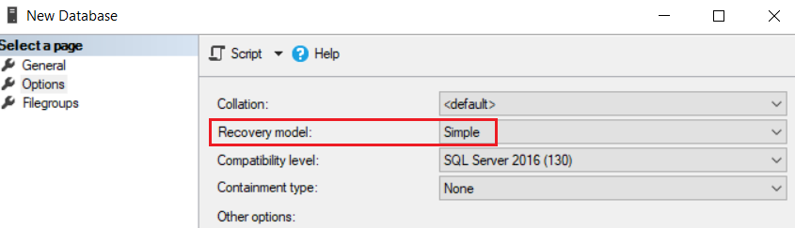

--1. Drop if it exists

--Drop Table if it exists.

IF ( EXISTS ( SELECT    *

              FROM      INFORMATION_SCHEMA.TABLES

              WHERE     TABLE_NAME = 'Gamer' ) )

    BEGIN

        TRUNCATE TABLE Gamer;

        DROP TABLE Gamer;

    END;

GO -- Run the previous command and begins new batch

IF ( EXISTS ( SELECT    *

              FROM      INFORMATION_SCHEMA.TABLES

              WHERE     TABLE_NAME = 'Team' ) )

    BEGIN

        TRUNCATE TABLE Team;

        DROP TABLE Team;

    END;

GO -- Run the previous command and begins new batch

--Drop Stored Procedure if it exists.

--IF OBJECT_ID('spSearchGamer') IS NOT NULL

IF ( EXISTS ( SELECT    *

              FROM      INFORMATION_SCHEMA.ROUTINES

              WHERE     ROUTINE_TYPE = 'PROCEDURE'

                        AND LEFT(ROUTINE_NAME, 3) NOT IN ( 'sp_', 'xp_', 'ms_' )

                        AND SPECIFIC_NAME = 'spGetGamers' ) )

    BEGIN

        DROP PROCEDURE spGetGamers;

    END;

GO -- Run the previous command and begins new batch

--IF OBJECT_ID('spSearchGamer') IS NOT NULL

IF ( EXISTS ( SELECT    *

              FROM      INFORMATION_SCHEMA.ROUTINES

              WHERE     ROUTINE_TYPE = 'PROCEDURE'

                        AND LEFT(ROUTINE_NAME, 3) NOT IN ( 'sp_', 'xp_', 'ms_' )

                        AND SPECIFIC_NAME = 'spAddGamer' ) )

    BEGIN

        DROP PROCEDURE spAddGamer;

    END;

GO -- Run the previous command and begins new batch

--2. Create Table

CREATE TABLE Team

    (

      Id INT PRIMARY KEY

             IDENTITY(1, 1)

             NOT NULL ,

      [Name] NVARCHAR(100) NULL

    );

GO -- Run the previous command and begins new batch

CREATE TABLE Gamer

    (

      Id INT PRIMARY KEY

             IDENTITY(1, 1)

             NOT NULL ,

      [Name] NVARCHAR(100) NULL ,

      Gender NVARCHAR(10) NULL ,

      City NVARCHAR(50) NULL ,

      DateOfBirth DATETIME NULL ,

      TeamId INT FOREIGN KEY REFERENCES Team ( Id )

    );

GO -- Run the previous command and begins new batch

--3. Insert Data

INSERT  Team

VALUES  ( N'Team1' );

INSERT  Team

VALUES  ( N'Team2' );

INSERT  Team

VALUES  ( N'Team3' );

INSERT  Gamer

VALUES  ( N'Name01 ABB', N'Male', N'City01', '1979/4/28', 1 );

INSERT  Gamer

VALUES  ( N'Name02 CDDE', N'Female', N'City03', '1981/7/24', 2 );

INSERT  Gamer

VALUES  ( N'Name03 FIJK', N'Female', N'City01', '1984/12/5', 3 );

INSERT  Gamer

VALUES  ( N'Name04 LMOPPQ', N'Male', N'City02', '1983/5/29', 1 );

INSERT  Gamer

VALUES  ( N'Name05 QRSTT', N'Male', N'City01', '1979/6/20', 3 );

INSERT  Gamer

VALUES  ( N'Name06 TUVVX', N'Female', N'City03', '1984/5/15', 3 );

INSERT  Gamer

VALUES  ( N'Name07 XYZZXX', N'Female', N'City01', '1986/4/29', 2 );

INSERT  Gamer

VALUES  ( N'Name08 ABBCDE', N'Male', N'City02', '1985/7/28', 1 );

INSERT  Gamer

VALUES  ( N'Name09 QRSTTUVXX', N'Male', N'City02', '1983/4/16', 1 );

GO -- Run the previous command and begins new batch

--4. SP

CREATE PROCEDURE spGetGamers

AS

    BEGIN

        SELECT  *

        FROM    Gamer;

    END;

GO -- Run the previous command and begins new batch

CREATE PROCEDURE spAddGamer

    (

      @Name NVARCHAR(50) ,

      @Gender NVARCHAR(10) ,

      @City NVARCHAR(50) ,

      @DateOfBirth DateTime ,

      @TeamId INT

    )

AS

    BEGIN

        INSERT  INTO Gamer

        VALUES  ( @Name, @Gender, @City, @DateOfBirth, @TeamId );

    END;

GO -- Run the previous command and begins new batch

--EXEC spGetGamers

--GO -- Run the previous command and begins new batch

3. Add Class Library - BusinessLayer, ADO.NET

In this BusinessLayer, we will use Ado.Net to connect database.

Solution Name --> Add --> New Project -->

Visual C# --> Windows Classic Desktop --> Class Library (.NET Framework)

-->

Name:

**BusinessLayer**

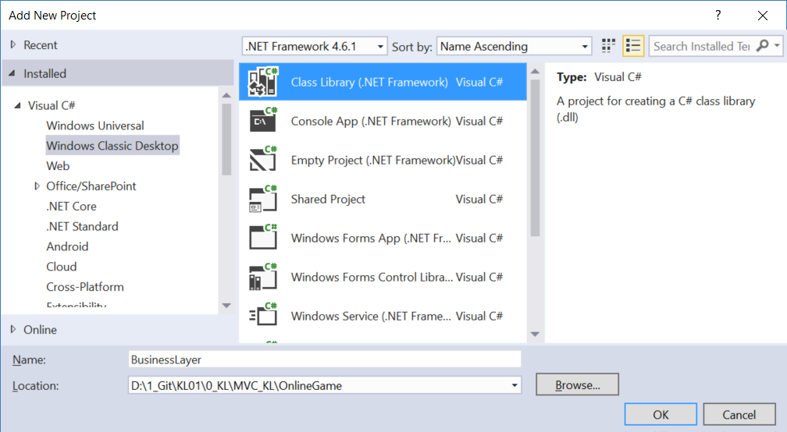

3.1. Add Reference

Add "EntityFramework"

3.2. BusinessLayer/Gamer.cs

Because **Add New File** **(extension and update)**

press **Shift+F2**

**BusinessLayer/Gamer.cs**

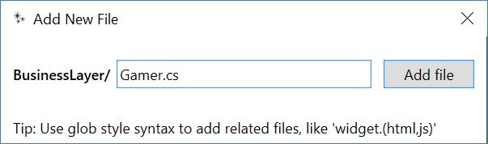

using System;

using System.ComponentModel.DataAnnotations;

namespace BusinessLayer

{

    public class Gamer

    {

        public int Id { get; set; }

        [Required]

        public string Name { get; set; }

        [Required]

        public string Gender { get; set; }

        [Required]

        public string City { get; set; }

        [Required]

        public DateTime DateOfBirth { get; set; }

        [Required]

        public int TeamId { get; set; }

    }

}

3.3. BusinessLayer/GamerBusinessLayer.cs  (ADO.NET)

Because **Add New File** **(extension and update)**

press **Shift+F2**

**BusinessLayer/GamerBusinessLayer.cs**

using System;

using System.Collections.Generic;

using System.Configuration;

using System.Data;

using System.Data.SqlClient;

namespace BusinessLayer

{

    public class GamerBusinessLayer

    {

        public IEnumerable<Gamer> Gamers

        {

            get

            {

                string connectionString =

                    ConfigurationManager.ConnectionStrings["OnlineGameContext"].ConnectionString;

                List<Gamer> gamers = new List<Gamer>();

                using (SqlConnection con = new SqlConnection(connectionString))

                {

                    SqlCommand cmd = new SqlCommand("spGetGamers", con);

[cmd.CommandType](http://cmd.commandtype/) = CommandType.StoredProcedure;

                    con.Open();

                    SqlDataReader rdr = cmd.ExecuteReader();

                    while (rdr.Read())

                    {

                        Gamer gamer = new Gamer();

                        gamer.Id = Convert.ToInt32(rdr["Id"]);

                        gamer.Name = rdr["Name"].ToString();

                        gamer.Gender = rdr["Gender"].ToString();

                        gamer.City = rdr["City"].ToString();

                        gamer.DateOfBirth = Convert.ToDateTime(rdr["DateOfBirth"]);

                        gamer.TeamId = Convert.ToInt32(rdr["TeamId"]);

                        gamers.Add(gamer);

                    }

                }

                return gamers;

            }

        }

        public void AddGamer(Gamer gamer)

        {

            string connectionString =

            ConfigurationManager.ConnectionStrings["OnlineGameContext"].ConnectionString;

            using (SqlConnection con = new SqlConnection(connectionString))

            {

                SqlCommand cmd = new SqlCommand("spAddGamer", con)

                {

                    CommandType = CommandType.StoredProcedure

                };

                SqlParameter sqlParamName = new SqlParameter

                {

                    ParameterName = "@Name",

                    Value = gamer.Name

                };

                cmd.Parameters.Add(sqlParamName);

                SqlParameter sqlParamGender = new SqlParameter

                {

                    ParameterName = "@Gender",

                    Value = gamer.Gender

                };

                cmd.Parameters.Add(sqlParamGender);

                SqlParameter sqlParamCity = new SqlParameter

                {

                    ParameterName = "@City",

                    Value = gamer.City

                };

                cmd.Parameters.Add(sqlParamCity);

                SqlParameter sqlParamDateOfBirth = new SqlParameter

                {

                    ParameterName = "@DateOfBirth",

                    Value = gamer.DateOfBirth

                };

                cmd.Parameters.Add(sqlParamDateOfBirth);

                SqlParameter sqlParamTeamId = new SqlParameter

                {

                    ParameterName = "@TeamId",

                    Value = gamer.TeamId

                };

                cmd.Parameters.Add(sqlParamTeamId);

                con.Open();

                cmd.ExecuteNonQuery();

            }

        }

    }

}

4. OnlineGame.Web/Controllers/GamerController.cs

4.1. Add Reference

Add Reference "**BusinessLayer**" into "**OnlineGame.Web**"

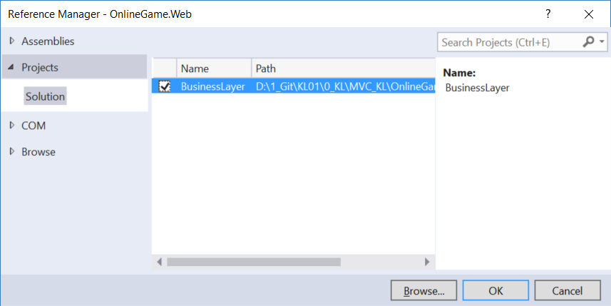

4.2. OnlineGame.Web/Controllers/GamerController.cs

using System;

using System.Collections.Generic;

using System.Linq;

using System.Web.Mvc;

using BusinessLayer;

using OnlineGame.Web.Data;

using Gamer = OnlineGame.Web.Models.Gamer;

namespace OnlineGame.Web.Controllers

{

    public class GamerController : Controller

    {

        // <http://localhost/OnlineGame.Web/Gamer/Details>

        //public ActionResult Details()

        //{

        //    var gamer = new Gamer

        //    {

        //        Id = 1,

        //        Name = "Name1",

        //        Gender = "Male",

        //        City = "City1"

        //    };

        //    return View(gamer);

        //}

        // <http://localhost/OnlineGame.Web/Gamer/Details>

        // <http://localhost/OnlineGame.Web/Gamer/Details/1>

        // <http://localhost/OnlineGame.Web/Gamer/Details/2>

        // <http://localhost/OnlineGame.Web/Gamer/Details/3>

        // <http://localhost/OnlineGame.Web/Gamer/Details/4>

        public ActionResult Details(int id = 0)

        {

            var onlineGameContext = new OnlineGameContext();

            Gamer gamer;

            if (id == 0)

            {

                gamer = new Gamer

                {

                    Id = 0,

                    Name = "Name0",

                    Gender = "NULL",

                    City = "NULL"

                };

                // or you may throw exception here.

            }

            else

            {

                gamer = onlineGameContext.Gamers.Single(p => p.Id == id);

                //Throws exception if can not find the single entity

            }

            return View(gamer);

        }

        public ActionResult Index(int teamId)

        {

            //Entity Framework

            OnlineGameContext context = new OnlineGameContext();

            List<Gamer> gamers = context.Gamers.Where(gamer => gamer.TeamId == teamId).ToList();

            return View(gamers);

        }

        public ActionResult Index2()

        {

            //[Ado.Net](http://ado.net/)

            GamerBusinessLayer gamerBusinessLayer = new GamerBusinessLayer();

            List<BusinessLayer.Gamer> gamers = gamerBusinessLayer.Gamers.ToList();

            return View(gamers);

        }

        //[HttpGet] attribute means it only respond to the "GET" request.

        [HttpGet]

        public ActionResult Create()

        {

            return View();

        }

        // 1. Retrieve form data using FormCollection

        [HttpPost]

        public ActionResult Create(FormCollection formCollection)

        {

            ////FormCollection implement C# indexer.

            ////See each key and value of formCollection.

            //foreach (string key in formCollection.AllKeys)

            //{

            //    Response.Write($"key=={key}, {formCollection[key]}, <br/>");

            //}

            int teamId;

            BusinessLayer.Gamer gamer = new BusinessLayer.Gamer

            {

                Name = formCollection["Name"],

                Gender = formCollection["Gender"],

                City = formCollection["City"],

                DateOfBirth = Convert.ToDateTime(formCollection["DateOfBirth"]),

                TeamId = int.TryParse(formCollection["TeamId"], out teamId) ? teamId : 0

            };

            GamerBusinessLayer gamerBusinessLayer =

                new GamerBusinessLayer();

            gamerBusinessLayer.AddGamer(gamer);

            return RedirectToAction("Index2");

        }

        // 2. Retrieve form data using name attribute of input tag from cshtml

        [HttpPost]

        public ActionResult Create2(string name, string gender, string city, DateTime dateOfBirth, int teamId)

        {

            BusinessLayer.Gamer gamer = new BusinessLayer.Gamer

            {

                Name = name,

                Gender = gender,

                City = city,

                DateOfBirth = dateOfBirth,

                TeamId = teamId

            };

            GamerBusinessLayer gamerBusinessLayer =

                new GamerBusinessLayer();

            gamerBusinessLayer.AddGamer(gamer);

            return RedirectToAction("Index2");

        }

        // 3. Retrieve form data using model binding

        [HttpPost]

        public ActionResult Create3(BusinessLayer.Gamer gamer)

        {

            //if any of input is not valid.

            if (!ModelState.IsValid)

            {

                return View("Create");

                //Go to Create.cshtml,

                //so users can correct their input value.

            }

            GamerBusinessLayer gamerBusinessLayer =

                new GamerBusinessLayer();

            gamerBusinessLayer.AddGamer(gamer);

            return RedirectToAction("Index2");

        }

        // 4. Retrieve form data using model binding by UpdateModel() or TryUpdateModel()

        [HttpPost]

        [ActionName("Create4")]

        public ActionResult Create_Post()

        {

            //if any of input is not valid.

            if (!ModelState.IsValid)

            {

                return View("Create");

                //Go to Create.cshtml,

                //so users can correct their input value.

            }

            GamerBusinessLayer gamerBusinessLayer =

                new GamerBusinessLayer();

            BusinessLayer.Gamer gamer = new BusinessLayer.Gamer();

            //UpdateModel<BusinessLayer.Gamer>(gamer);

            //UpdateModel(gamer);

            TryUpdateModel(gamer);

            //1.

            // UpdateModel() and TryUpdateModel() inspects all the HttpRequest inputs

            // such as posted Form data, QueryString,

            // Cookies and Server variables and populate the gamer object.

            gamerBusinessLayer.AddGamer(gamer);

            return RedirectToAction("Index2");

        }

    }

}

/*

1.

//var onlineGameContext = new OnlineGameContext();

//Gamer gamer = onlineGameContext.Gamers.Single(p => p.Id == id);

When user request, EntityFramework will request the data from the database

and sotre its data into a temp place called DBSet.

onlineGameContext.Gamers is a DBSet which is kind of temp place to store the Gamer Table Data.

We use LINQ to map the Gamer Table Column id to Gamer Model property, id.

Thus, we can get the gamer entity from Gamer Table by its id.

Then store gamer entity data into Gamer Model object.

Thus, each Gamer Model object is a temp place to store each Gamer Table entity from the database.

Then we pass the Gamer Model object as the ViewModel,

Thus, the Details.cshtml view can use the values from Gamer Model object

which is actually the temp place to store Gamer Table entity data.

-------------------------------

2.

//[HttpGet]

//public ActionResult Create()

The GET request will direct to Views/Gamer/Create.cshtml.

-------------------------------

3.

//[HttpPost]

-----------------

3.1.

//[HttpPost]

//public ActionResult Create(FormCollection formCollection)

Retrieve form data using FormCollection.

The key is the name attribute of input or select tag from cshtml.

-----------------

3.2.

//[HttpPost]

//public ActionResult Create2(string name, string gender, string city, DateTime dateOfBirth, int teamId)

Retrieve form data using name attribute of input tag from cshtml.

3.2.1.

string name is from

//<input class="form-control text-box single-line" id="Name" name="Name" type="text" value="">

3.2.2.

string gender is from

//<select id="Gender" name="Gender">...</select>

3.2.3.

string city is from

<input class="form-control text-box single-line" id="City" name="City" type="text" value="">

3.2.4.

DateTime dateOfBirth is from

//<input class="form-control text-box single-line" data-val="true" data-val-date="The field DateOfBirth must be a date." data-val-required="The DateOfBirth field is required." id="DateOfBirth" name="DateOfBirth" type="datetime" value="">

3.2.5.

int teamId is from

//<input class="form-control text-box single-line" data-val="true" data-val-number="The field TeamId must be a number." data-val-required="The TeamId field is required." id="TeamId" name="TeamId" type="number" value="">

-----------------

3.3.

//[HttpPost]

//public ActionResult Create3(BusinessLayer.Gamer gamer)

If the view has a lot of input,

then the previous two ways is not a good idea.

It is always better to retrieve form data using model binding.

The model of the cshtml is BusinessLayer.Gamer,

so we can pass the model object into HttpPost action.

The property value of model object will contain the value

from input or select tag from cshtml based on name attribute.

-----------------

3.4.

//[HttpPost]

//[ActionName("Create4")]

//public ActionResult Create_Post()

Retrieve form data using model binding by UpdateModel() or TryUpdateModel()

...

//BusinessLayer.Gamer gamer = new BusinessLayer.Gamer();

////UpdateModel<BusinessLayer.Gamer>(gamer);

////UpdateModel(gamer);

//TryUpdateModel(gamer);

3.4.1.

UpdateModel() and TryUpdateModel() inspects all the HttpRequest inputs

such as posted Form data, QueryString,

Cookies and Server variables and populate the gamer object.

3.4.2.

UpdateModel() throws an exception if validation fails.

TryUpdateModel() will never throw an exception and

return false if validation fails.

*/

4.3. OnlineGame.Web/Views/Gamer/Index2.cshtml

Delete OnlineGame.Web/Views/Gamer/Index.cshtml

before you continue this tutorial.

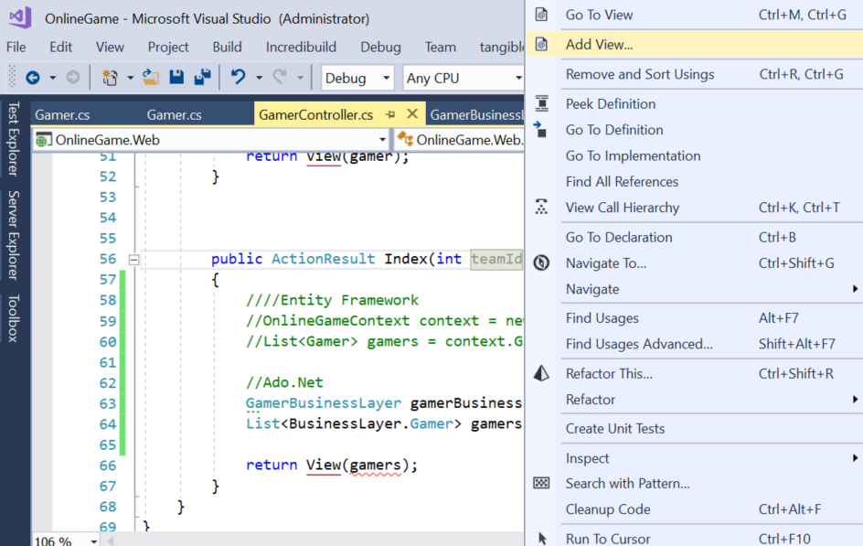

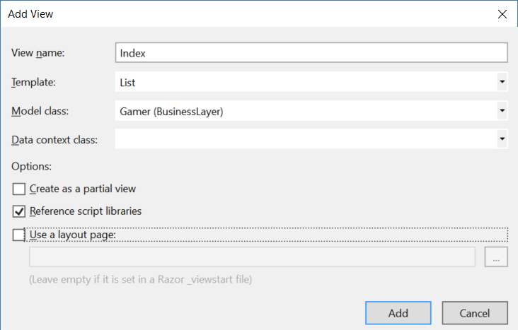

----------------------------------------------

I personally don't like the previous way to create views,

because it will include some unnecessary changes in the source control.

Here is the way I usually do.

Because **Add New File** **(extension and update)**

press **Shift+F2**

**Views/Gamer/Index2.cshtml**

@model IEnumerable<BusinessLayer.Gamer>

@{

    Layout = null;

}

<p>

    @Html.ActionLink("Create New", "Create")

</p>

<table class="table">

    <tr>

        <th>

            @Html.DisplayNameFor(model => model.Name)

        </th>

        <th>

            @Html.DisplayNameFor(model => model.Gender)

        </th>

        <th>

            @Html.DisplayNameFor(model => model.City)

        </th>

        <th>

            @Html.DisplayNameFor(model => model.DateOfBirth)

        </th>

        <th>

            @Html.DisplayNameFor(model => model.TeamId)

        </th>

        <th></th>

    </tr>

    @foreach (var item in Model)

    {

        <tr>

            <td>

                @Html.DisplayFor(modelItem => item.Name)

            </td>

            <td>

                @Html.DisplayFor(modelItem => item.Gender)

            </td>

            <td>

                @Html.DisplayFor(modelItem => item.City)

            </td>

            <td>

                @Html.DisplayFor(modelItem => item.DateOfBirth)

            </td>

            <td>

                @Html.DisplayFor(modelItem => item.TeamId)

            </td>

            <td>

                @Html.ActionLink("Edit", "Edit", new { id = item.Id }) |

                @Html.ActionLink("Details", "Details", new { id = item.Id }) |

                @Html.ActionLink("Delete", "Delete", new { id = item.Id })

            </td>

        </tr>

    }

</table>

--------------------------------------------------------------

<http://localhost:63398/Gamer/Index2>

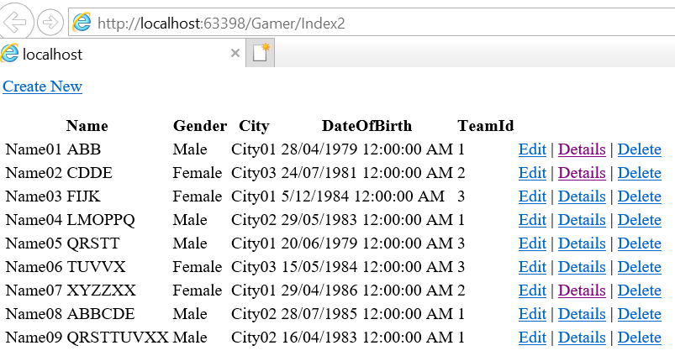

4.4. Create: OnlineGame.Web/Views/Gamer/Create.cshtml

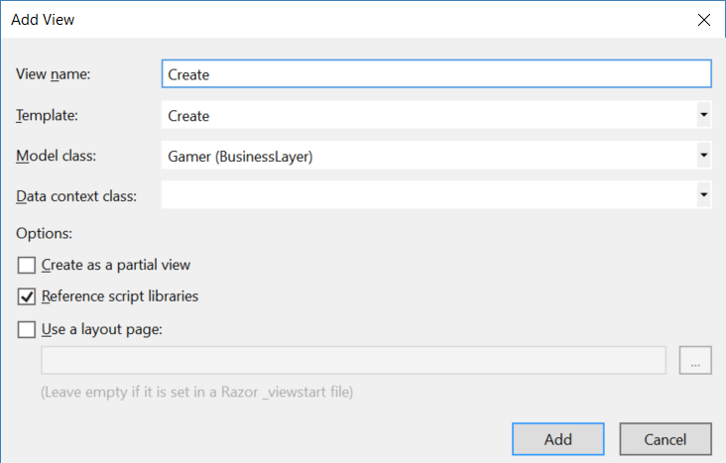

@model BusinessLayer.Gamer

@{

}

<script src="~/Scripts/jquery-1.10.2.min.js"></script>

<script src="~/Scripts/jquery.validate.min.js"></script>

<script src="~/Scripts/jquery.validate.unobtrusive.min.js"></script>

<div class="row">

    <h2>Create Gamer</h2>

    @*@using (Html.BeginForm())*@

    @*@using (Html.BeginForm("Create", "Gamer"))*@

    @*@using (Html.BeginForm("Create2", "Gamer"))*@

    @*@using (Html.BeginForm("Create4", "Gamer"))*@

    @using (Html.BeginForm("Create3", "Gamer"))

    {

        @Html.ValidationSummary(true, "", new { @class = "text-danger" })

        <div class="form-horizontal">

            <div class="form-group">

                @Html.LabelFor(model => model.Name, new { @class = "control-label col-md-2" })

                <div class="col-md-10">

                    @Html.EditorFor(model => model.Name, new { htmlAttributes = new { @class = "form-control" } })

                    @Html.ValidationMessageFor(model => model.Name, "", new { @class = "text-danger" })

                </div>

            </div>

            <div class="form-group">

                @Html.LabelFor(model => model.Gender, new { @class = "control-label col-md-2" })

                <div class="col-md-10">

                    @*@Html.EditorFor(model => model.Gender, new { htmlAttributes = new { @class = "form-control" } })*@

                    @*@Html.DropDownList("Gender",new List<SelectListItem>

                        {

                            new SelectListItem{Text = "Male", Value = "Male"},

                            new SelectListItem{Text = "Female", Value = "Female"}

                        })*@

                    @Html.DropDownList("Gender", new List<SelectListItem>

                    {

                        new SelectListItem{Text = "Male", Value = "Male"},

                        new SelectListItem{Text = "Female", Value = "Female"}

                    }, "Select Gender")

                    @Html.ValidationMessageFor(model => model.Gender, "", new { @class = "text-danger" })

                </div>

            </div>

            <div class="form-group">

                @Html.LabelFor(model => model.City, new { @class = "control-label col-md-2" })

                <div class="col-md-10">

                    @Html.EditorFor(model => model.City, new { htmlAttributes = new { @class = "form-control" } })

                    @Html.ValidationMessageFor(model => model.City, "", new { @class = "text-danger" })

                </div>

            </div>

            <div class="form-group">

                @Html.LabelFor(model => model.DateOfBirth, new { @class = "control-label col-md-2" })

                <div class="col-md-10">

                    @Html.EditorFor(model => model.DateOfBirth, new { htmlAttributes = new { @class = "form-control" } })

                    @Html.ValidationMessageFor(model => model.DateOfBirth, "", new { @class = "text-danger" })

                </div>

            </div>

            <div class="form-group">

                @Html.LabelFor(model => model.TeamId, new { @class = "control-label col-md-2" })

                <div class="col-md-10">

                    @Html.EditorFor(model => model.TeamId, new { htmlAttributes = new { @class = "form-control" } })

                    @*@Html.ValidationMessageFor(model => model.TeamId, "", new { @class = "text-danger" })*@

                </div>

            </div>

            <div class="form-group">

                <div class="col-md-offset-2 col-md-10">

                    <input type="submit" value="Create" class="btn btn-default" />

                </div>

            </div>

        </div>

    }

    <div>

        @Html.ActionLink("Back to List", "Index2")

    </div>

</div>

@*

1.

1.1.

Select <form>....</form>

We are using Web Essentials extension

Select part of HTML text, then press Shift + Alt + W

it will surround those pieces of text with <div>

1.2.

// <div class="row">

class="row" in bootstrap means this is the container for the bootstrap 12 columns grid system

1.3.

// <div class="col-md-6">

1.3.1.

.col-lg-XX means the screen size is >= 1200px, lg means large

.col-md-XX means the screen size is >= 992px, means 992px to 1199px, md means medium

.col-sm-XX means the screen size is >= 768px, means 768px to 991px, sm means small

.col-xs-XX means the screen size is < 768px, xs means extra small

1.3.2.

// <div class="col-md-6">

The md in   class="col-md-6"  means the screen size is 992px to 1199px

12 columns grid system divide this screen to 12 columns,

The 6 in   class="col-md-6" means this div occupy 6 columns out of 12 columns grid system.

Therefore,

// <div class="col-md-6">

//     ...

// </div>

// <div class="col-md-6">

//     <h2>The Map</h2>

// </div>

It will become left half and right half when it is full screen.

However, when reduce screen size less than 11 columns,

then it will become top and bottom.

1.3.3.

If we do this

// <div class="col-md-6 col-xs-8">

//     ...

// </div>

// <div class="col-md-6 col-xs-4">

//     <h2>The Map</h2>

// </div>

The  .col-xs-XX   will override  .col-md-XX

However, we actually only need big one, .col-md-XX

because for small screen device like phone,

we want it automatically align vertically.

so let's only use   .col-md-XX   and delete   .col-xs-XX

2.

// <div class="form-group">

//    <label>Date</label>

//    <input class="form-control"/>

// </div>

// ...

// <input type="submit" value="Add" class="btn btn-success"/>

2.1.

.form-group in bootstrap normally used for group label and input.

2.2.

.form-control in bootstrap will occupy the 100% width

2.3.

.btn-success in bootstrap will become green btn

2.4.

btn-danger in bootstrap will become red btn

2.5.

btn-warning in bootstrap will become orange btn

2.6.

btn-default in bootstrap will become gray btn

3.

3.1.

//<input type="submit" value="Create" class="btn btn-default" />

It is the submit button of the form.

3.2.

//@using (Html.BeginForm())

//@using (Html.BeginForm("Create", "Gamer"))

These two using will create

//<form action="/Gamer/Create3" method="post" novalidate="novalidate">

It will run the "Gamer" controller and "Create" HttpPost action.

//@using (Html.BeginForm())

It does not specify any controller or any action.

Thus, it will use the default controller and default HttpPost action.

It is Create.cshtml in Views/Gamer folder.

Thus, it will run "Gamer" controller and "Create" HttpPost action

3.3.

//@using (Html.BeginForm("Create2", "Gamer"))

It will create

//<form action="/Gamer/Create2" method="post" novalidate="novalidate">

It will run "Gamer" controller and "Create2" HttpPost action.

4.

4.1.

//@Html.LabelFor(model => model.Name, new { @class = "control-label col-md-2" })

It will create

//<label class="control-label col-md-2" for="Name">Name</label>

4.2.

//@Html.EditorFor(model => model.Name, new { htmlAttributes = new { @class = "form-control" } })

It will create

//<input class="form-control text-box single-line" id="Name" name="Name" type="text" value="">

4.3.

//@Html.ValidationMessageFor(model => model.Name, "", new { @class = "text-danger" })

It will create

//<span class="field-validation-valid text-danger" data-valmsg-for="Name" data-valmsg-replace="true"></span>

The cshtml also use the following JS

//<script src="~/Scripts/jquery-1.10.2.min.js"></script>

//<script src="~/Scripts/jquery.validate.min.js"></script>

//<script src="~/Scripts/jquery.validate.unobtrusive.min.js"></script>

Thus, the span will display the error message of Name input.

4.4.

//@Html.DropDownList("Gender",new List<SelectListItem>

//{

//    new SelectListItem{Text = "Male", Value = "Male"},

//    new SelectListItem{Text = "Female", Value = "Female"}

//})

It will create

//<select id="Gender" name="Gender">

//    <option value="Male">Male</option>

//    <option value="Female">Female</option>

//</select>

4.5.

//@Html.DropDownList("Gender", new List<SelectListItem>

//{

//    new SelectListItem{Text = "Male", Value = "Male"},

//    new SelectListItem{Text = "Female", Value = "Female"}

//}, "Select Gender")

It will create

//<select id="Gender" name="Gender">

//    <option value="">Select Gender</option>

//    <option value="Male">Male</option>

//    <option value="Female">Female</option>

//</select>

4.6.

//@Html.ActionLink("Back to List", "Index2")

It will create

//<a href="/Gamer/Index2">Back to List</a>

*@

<http://localhost:63398/Gamer/Create>

