(T9)討論EfDbFirst。討論ModelAttributes、DisplayTemplates、EditorTemplates。討論DateTime、JqueryUiDatepicker  
CourseGUID: 8503b39c-5887-4634-8291-facfb3117924  
=======================================================================  
(T9)討論EfDbFirst。討論ModelAttributes、DisplayTemplates、EditorTemplates。討論DateTime、JqueryUiDatepicker

(T9-1)討論EfDbFirst (1. to 5.3.)

(T9-2)討論ModelAttributes、DisplayTemplates、EditorTemplates (5.4. to 5.13)

(T9-3)討論DateTime、JqueryUiDatepicker (5.14 to 5.19)  
=======================================================================  
0. Summary

1. MVC conventions

-----------

2. OnlineGame DB

2.1. TSQL

2.2. Security login

-----------

3. New Project - OnlineGame

3.1. New Project - OnlineGame.Web

3.1.1. Global.asax.cs

3.1.1. Global.asax.cs

3.2. ADO.Net Entity Data Model - Entity Framework

-----------

4. OnlineGame.Web

4.1. Controllers/GamersController.cs

-----------

5. OnlineGame.Web

5.1. web.config

5.2. Controllers/GamersController.cs

5.3. Views/Gamer/Index.cshtml

5.4. Models/Gamer/Gamer.cs

5.5. Models/Gamer/GamerMetaData.cs

5.6. Models/Gamer/BoardGame.cs

5.7. Models/Gamer/GamerA.cs

5.8. Views/Gamer/Details.cshtml

5.9. Views/Gamer/DetailsTwo.cshtml (Display Complex Type Sample)

5.10. Views/Shared/DisplayTemplates/UrlToNewWindow.cshtml (UIHint Sample)

5.11. Views/Gamer/DetailsThree.cshtml ([HiddenInput(DisplayValue = false)], [ReadOnly(true)])

5.12. Views/Gamer/DetailsFour.cshtml (@Html.Display("GamerData") )

5.13. Views/Gamer/EditTwo.cshtml ([HiddenInput(DisplayValue = false)], [ReadOnly(true)])

5.14. Views/Gamer/EditThree.cshtml

5.15. Views/Shared/EditorTemplates/DateTime.cshtml

5.15. Views/Shared/EditorTemplates/DateTime.cshtml

5.17. Add Jquery UI

5.18. Views/Gamer/Create.cshtml

5.19. Views/Gamer/Delete.cshtml  
=======================================================================

0. Summary

In this tutorial, we will discuss

* MvcConventions

* AdoDotNetEntityDataModel

* EntityFramework

* AutoGenerate Delete, Update, Insert, Read

* DisplayName attribute

    * [DisplayName("Full Name")]

* DisplayAttribute attribute

    * [DisplayAttribute(Name="Full Name")]

* Display attribute

    * [Display(Name = "Full Name")]

* DisplayFormat attribute

    * [DisplayFormat(NullDisplayText = "Gender not specified")]

    * [DisplayFormat(DataFormatString = "{0:d}")]

        * Display only the date part. E.g. 29/04/1986

    * [DisplayFormat(DataFormatString = "{0:dd/MM/yyyy HH:mm:ss}")]

        * Display in 24 hour notation. E.g. 29/04/1986 13:00:00

    * [DisplayFormat(DataFormatString = "{0:dd/MM/yyyy hh:mm:ss tt}")]

        * Display in 12 hour notation. E.g. 29/04/1986 1:00:00 PM

* DisplayFormatAttribute attribute

    * [DisplayFormatAttribute(DataFormatString="{0:d}")]

        * Display only the date part. E.g. 29/04/1986

* DataType attribute

    * [DataType(DataType.Date)]

        * Display only date part

        * Please be aware, it actually covert DateTime to Date,

so Views/Shared/EditorTemplates/DateTime.cshtml will not Work.

    * [DataType(DataType.Time)]

        * Display only 12 hour notation Time part

    * [DataType(DataType.EmailAddress)]

        * Display mailto hyperlink

    * [DataType(DataType.Url)]

        * display a hyperlink.

    * [DataType(DataType.Currency)]

        * Display the currency symbol by globalization culture in web.config file.

        * In System.Web tag of web.config file,

<system.web> <globalization culture = "en-au" /> ...

Display au $ symbol.

* scaffoldcolumn attribute

    * [ScaffoldColumn(false)]

        * it will not display the column when using @Html.DisplayForModel() helper.

* HiddenInput attribute

    * [HiddenInput(DisplayValue = false)]

        * It will become a hidden input when using @Html.DisplayForModel() helper or @Html.EditorForModel()

* ReadOnly attribute

    * [ReadOnly(true)] or you may delete Setter.

        * It will make this property un-editable.

        * You may set a breakpoint to see the [HttpPost] action model for this property is null.

* DisplayColumn attribute

    * [DisplayColumn("Name")]

        * @Html.DisplayTextFor(model => model.GameHolder)

model.GameHolder will return a Gamer object.

        * The Gamer class has [DisplayColumn("Name")] attribute,

so it will display Gamer Name property value which is the full name of that gamer.

* UIHint attribute

    * [UIHint("UrlToNewWindow")]

        * UIHint specify the name of view DisplayTemplate

* 秒殺Entity Framework新增更新移除，征服Model Attributes，Display Templates，Editor Templates，Jquery Ui datepicker

* 秒殺Entity Framework新增更新移除。

* 完整攻略Model Attributes，Display Templates，Editor Templates。

* 初步使用Jquery Ui datepicker。

=========================================

1. MVC conventions

In MVC conventions,

1. Controllers must have the word "Controller" as the suffix and must extend "IController" interface.

2. A view must remain under "Views" folder.

3. If the view is for GamerController, then the view must remain under "Views/Gamer" folder.

4. In the "HomeController", when "Index" action "return View()", it will search the following files in order.

    4.1. ~/Views/Home/Index.aspx

    4.2. ~/Views/Home/Index.ascx

    4.3. ~/Views/Shared/Index.aspx

    4.4. ~/Views/Shared/Index.ascx

    4.5. ~/Views/Home/Index.cshtml

    4.6. ~/Views/Home/Index.vbhtml

    4.7. ~/Views/Shared/Index.cshtml

    4.8. ~/Views/Shared/Index.vbhtml

5. By MVC convention, MVC will look for the view in the following locations

    5.1. Views/ControllerName

    5.2. Views/Shared

6. The extension name of view can be cshtml, vbhtml, aspx, or ascx.

7. Models can be anywhere, even can be in another project.  However, it is better to put it in "Models" folder.

8. You may put Models in another project as business layer.

9. Shared folder stores shared views.

    E.g. Master for aspx and Layout pages for cshtml

----------------------------------------------

10. EditorTemplates and DisplayTemplates by MVC convention

-------------------------------

10.1.

DisplayTemplates

10.1.1.

Views\Shared\DisplayTemplates\UrlToNewWindow.cshtml

Views\Gamer\DisplayTemplates\UrlToNewWindow.cshtml

UrlToNewWindow.cshtml is the DisplayTemplate which must under "DisplayTemplates"  folder.

Views\Shared\DisplayTemplates\UrlToNewWindow.cshtml means

the template is available for all the views.

Views\Gamer\DisplayTemplates\UrlToNewWindow.cshtml means

the template is available for only the views of Gamer controller.

10.1.2.

Using DisplayTemplates

10.1.2.1.

In the Models/Gamer/GamerMetaData.cs

//[DataType(DataType.Url)]

//[UIHint("UrlToNewWindow")]

//public string ProfileUrl { get; set; }

[DataType(DataType.Url)] attribute will display a hyperlink.

[UIHint("UrlToNewWindow")] attribute specify the name of view DisplayTemplate

to display the property data.

In this case, it will look for "DisplayTemplates/UrlToNewWindow.cshtml"

under "Shared" folder or "Gamer" folder.

Use that view template to disply the data of this property.

10.1.2.2.

//<a href="@ViewData.Model" target="_blank">@ViewData.Model</a>

In the Shared/DisplayTemplates/UrlToNewWindow.cshtml,

@ViewData.Model will take the Model data from the parent view.

In this case, it will return a profile url.

-------------------------------

10.2.

EditorTemplates

10.2.1.

Views\Shared\EditorTemplates\DateTime.cshtml

Views\Gamer\EditorTemplates\DateTime.cshtml

DateTime.cshtml is the EditorTemplate which must under "EditorTemplates" folder.

Views\Shared\EditorTemplates\DateTime.cshtml means

the template is available for all the views.

Views\Gamer\EditorTemplates\DateTime.cshtml means

the template is available for only the views of Gamer controller.

10.2.2.

Using EditorTemplates

The EditorTemplate Name must match View Model property Type Name.

E.g. DateTime.ascx or DateTime.cshtml

10.2.2.1.

In the Models/Gamer/GamerMetaData.cs

////[DataType(DataType.Date)] //Views/Shared/EditorTemplates/DateTime.cshtml will not  Work.

////[DisplayFormat(DataFormatString = "{0:dd/MM/yyyy hh:mm:ss tt}")]

//[DisplayFormat(DataFormatString = "{0:d}")]

//public Nullable<System.DateTime> DateOfBirth { get; set; }

The type is DateTime, so it will look for the EditorTemplate from

Views\Shared\EditorTemplates\DateTime.cshtml or

Views\Gamer\EditorTemplates\DateTime.cshtml

In this case, Views\Shared\EditorTemplates\DateTime.cshtml will be the EditorTemplate.

The View Model Property in Edit mode will use the EditorTemplate to display.

In this case,

//@model DateTime?

//@Html.TextBox("", (Model.HasValue ? Model.Value.ToString("yyyy/MM/dd") :  string.Empty), new { @class = "date" })

So it will add the class="date" to the textbox input.

10.2.2.2.

In the Edit.cshtml

//<link href="~/Content/themes/base/jquery-ui.min.css" rel="stylesheet" />

//<link href="~/Content/bootstrap.css" rel="stylesheet" />

//<script src="~/Scripts/jquery-1.12.4.min.js"></script>

//<script src="~/Scripts/jquery-ui-1.12.1.min.js"></script>

//<script src="~/Scripts/bootstrap.min.js"></script>

    ...

//<script type="text/javascript">

//    $(function () {

//        $("input:text.date").datepicker(

//            {

//                dateFormat: "yy/mm/dd"

//            });

//    });

//</script>

----------------------------------------------

11.

There are 2 categories of built-in templated helpers.

-------------------------------

11.1.

Display Templates

-----------------

11.1.1.

//@Html.DisplayFor(model => model.Name)

The view must have strongly typed view Model.

It can work with the complex type Model property.

It is similar to @Html.DisplayTextFor(model => model.GameHolder)

//@Html.DisplayTextFor(model => model.GameHolder)

model.GameHolder will return a Gamer object.

The Gamer class has [DisplayColumn("Name")] attribute,

so it will display Gamer Name property value

which is the full name of that gamer.

-----------------

11.1.2.

//@Html.DisplayForModel()

The view must have strongly typed view Model.

It will display every property in view model

except the properties with [ScaffoldColumn(false)] attribute.

-----------------

11.1.3.

@Html.Display helper does not need strongly typed view Mode.

//ViewData["GamerData"] = gamer;

//return View();

In the controller, we put the gamer object into ViewData["GamerData"]

"GamerData" in this case is the key of ViewData.

ViewData["GamerData"] contains that gamer object data,

so we don't have to use a view model.

//@Html.Display("GamerData")

In the view, we use @Html.Display("GamerData")

to retrieve the Gamer data from ViewData["GamerData"].

It will display everything

except the properties with [ScaffoldColumn(false)] attribute.

-------------------------------

11.2.

Editor Templates

-----------------

11.2.1.

//@Html.EditorFor(model => model.Name)

The view must have strongly typed view Model.

It will create a textbox for the property value input.

-----------------

11.2.2.

//@Html.EditorForModel()

The view must have strongly typed view Model.

It will create textbox input for every property in view model

except the properties with [ScaffoldColumn(false)] attribute.

-----------------

11.2.3.

@Html.Editor helper does not need strongly typed view Mode.

//ViewData["GamerData"] = gamer;

//return View();

In the controller, we put the gamer object into ViewData["GamerData"]

"GamerData" in this case is the key of ViewData.

ViewData["GamerData"] contains that gamer object data,

so we don't have to use a view model.

//@Html.Editor("GamerData")

In the view, we use @Html.Editor("GamerData")

to retrieve the Gamer data from ViewData["GamerData"].

It will create textbox input for every properties in ViewData["GamerData"]

except the properties with [ScaffoldColumn(false)] attribute.

However, we pressed submit button and call the [HttpPost] action

//public async Task<ActionResult>

EditThree(int id, string name, string gender, string city, DateTime? dateOfBirth,  string emailAddress, int? score, string profileUrl, int? gameMoney, int? teamId)

OR

//public async Task<ActionResult>

EditThree(Gamer gamer)

Both ways can not retrieve the data because it is not strongly typed.

I don't suggest to use @Html.Editor helper

2. OnlineGame DB

2.1. TSQL

In SQL server Management Studio (SSMS)

Database --> Right Click --> New Database -->

In General Tab -->

Name: **OnlineGame**

In options Tab --> Recovery model : **Simple**

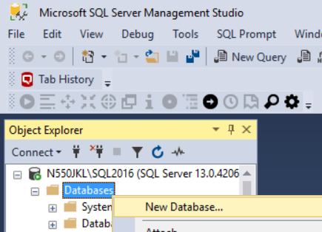

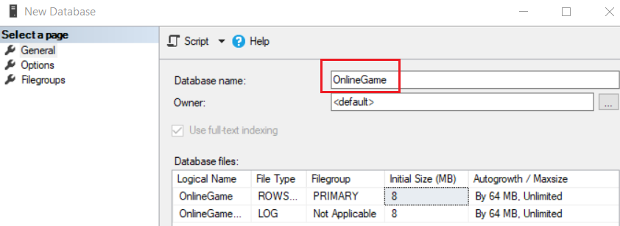

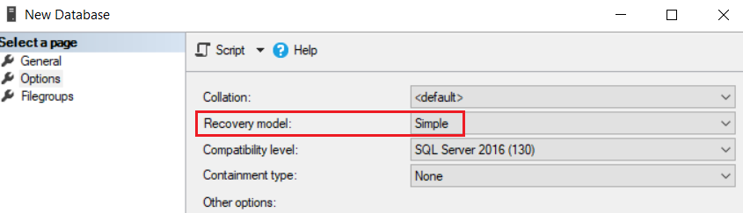

--1. Drop if it exists

--Drop Table if it exists.

IF ( EXISTS ( SELECT    *

              FROM      INFORMATION_SCHEMA.TABLES

              WHERE     TABLE_NAME = 'Gamer' ) )

    BEGIN

        TRUNCATE TABLE Gamer;

        DROP TABLE Gamer;

    END;

GO -- Run the previous command and begins new batch

IF ( EXISTS ( SELECT    *

              FROM      INFORMATION_SCHEMA.TABLES

              WHERE     TABLE_NAME = 'Team' ) )

    BEGIN

        TRUNCATE TABLE Team;

        DROP TABLE Team;

    END;

GO -- Run the previous command and begins new batch

--Drop Stored Procedure if it exists.

--IF OBJECT_ID('spSearchGamer') IS NOT NULL

IF ( EXISTS ( SELECT    *

              FROM      INFORMATION_SCHEMA.ROUTINES

              WHERE     ROUTINE_TYPE = 'PROCEDURE'

                        AND LEFT(ROUTINE_NAME, 3) NOT IN ( 'sp_', 'xp_', 'ms_' )

                        AND SPECIFIC_NAME = 'spGetGamers' ) )

    BEGIN

        DROP PROCEDURE spGetGamers;

    END;

GO -- Run the previous command and begins new batch

IF ( EXISTS ( SELECT    *

              FROM      INFORMATION_SCHEMA.ROUTINES

              WHERE     ROUTINE_TYPE = 'PROCEDURE'

                        AND LEFT(ROUTINE_NAME, 3) NOT IN ( 'sp_', 'xp_', 'ms_' )

                        AND SPECIFIC_NAME = 'spAddGamer' ) )

    BEGIN

        DROP PROCEDURE spAddGamer;

    END;

GO -- Run the previous command and begins new batch

IF ( EXISTS ( SELECT    *

              FROM      INFORMATION_SCHEMA.ROUTINES

              WHERE     ROUTINE_TYPE = 'PROCEDURE'

                        AND LEFT(ROUTINE_NAME, 3) NOT IN ( 'sp_', 'xp_', 'ms_' )

                        AND SPECIFIC_NAME = 'spSaveGamer' ) )

    BEGIN

        DROP PROCEDURE spSaveGamer;

    END;

GO -- Run the previous command and begins new batch

IF ( EXISTS ( SELECT    *

              FROM      INFORMATION_SCHEMA.ROUTINES

              WHERE     ROUTINE_TYPE = 'PROCEDURE'

                        AND LEFT(ROUTINE_NAME, 3) NOT IN ( 'sp_', 'xp_', 'ms_' )

                        AND SPECIFIC_NAME = 'spDeleteGamer' ) )

    BEGIN

        DROP PROCEDURE spDeleteGamer;

    END;

GO -- Run the previous command and begins new batch

--2. Create Table

CREATE TABLE Team

    (

      Id INT PRIMARY KEY

             IDENTITY(1, 1)

             NOT NULL ,

      [Name] NVARCHAR(100) NULL

    );

GO -- Run the previous command and begins new batch

CREATE TABLE Gamer

    (

      Id INT PRIMARY KEY

             IDENTITY(1, 1)

             NOT NULL ,

      [Name] NVARCHAR(100) NULL ,

      Gender NVARCHAR(10) NULL ,

      City NVARCHAR(50) NULL ,

      DateOfBirth DATETIME NULL ,

      EmailAddress NVARCHAR(100) ,

      Score INT ,

      ProfileUrl NVARCHAR(100) ,

      GameMoney INT,

      TeamId INT FOREIGN KEY REFERENCES Team ( Id )

    );

GO -- Run the previous command and begins new batch

--3. Insert Data

INSERT  Team

VALUES  ( N'Team1' );

INSERT  Team

VALUES  ( N'Team2' );

INSERT  Team

VALUES  ( N'Team3' );

GO -- Run the previous command and begins new batch

INSERT  Gamer

VALUES  ( N'Name01 ABB', N'Male', N'City01', '1979/4/28', '[1@AAA.com](mailto:1@AAA.com)', 3500,

          '<https://ithandyguytutorial.blogspot.com.au/>', 1000, 1 );

INSERT  Gamer

VALUES  ( N'Name02 CDDE', N'Female', N'City03', '1981/7/24', '[2@BBB.com](mailto:2@BBB.com)', 3500,

          '<https://ithandyguytutorial.blogspot.com.au/>', 1500, 2 );

INSERT  Gamer

VALUES  ( N'Name03 FIJK', N'Female', N'City01', '1984/12/5', '[3@CCCC.com](mailto:3@CCCC.com)', 3500,

          '<https://ithandyguytutorial.blogspot.com.au/>', 4000, 3 );

INSERT  Gamer

VALUES  ( N'Name04 LMOPPQ', N'Male', N'City02', '1983/5/29', '[4@DD.com](mailto:4@DD.com)', 3500,

          '<https://ithandyguytutorial.blogspot.com.au/>', 2500, 1 );

INSERT  Gamer

VALUES  ( N'Name05 QRSTT', N'Male', N'City01', '1979/6/20', '[5@EEE.com](mailto:5@EEE.com)', 3500,

          '<https://ithandyguytutorial.blogspot.com.au/>', 3500, 3 );

INSERT  Gamer

VALUES  ( N'Name06 TUVVX', N'Female', N'City03', '1984/5/15', '[6@FF.com](mailto:6@FF.com)',

          3500, '<https://ithandyguytutorial.blogspot.com.au/>', 2500, 3 );

INSERT  Gamer

VALUES  ( N'Name07 XYZZXX', N'Female', N'City01', '1986/4/29', '[7@GGGG.com](mailto:7@GGGG.com)',

          3500, '<https://ithandyguytutorial.blogspot.com.au/>', 4550, 2 );

INSERT  Gamer

VALUES  ( N'Name08 ABBCDE', N'Male', N'City02', '1985/7/28', '[8@HH.com](mailto:8@HH.com)', 3500,

          '<https://ithandyguytutorial.blogspot.com.au/>', 3550, 1 );

INSERT  Gamer

VALUES  ( N'Name09 QRSTTUVXX', N'Male', N'City02', '1983/4/16', '[9@IIII.com](mailto:9@IIII.com)',

          3500, '<https://ithandyguytutorial.blogspot.com.au/>', 2510, 1 );

GO -- Run the previous command and begins new batch

--4. SP

CREATE PROCEDURE spGetGamers

AS

    BEGIN

        SELECT  *

        FROM    Gamer;

    END;

GO -- Run the previous command and begins new batch

CREATE PROCEDURE spAddGamer

    (

      @Name NVARCHAR(50) ,

      @Gender NVARCHAR(10) ,

      @City NVARCHAR(50) ,

      @DateOfBirth DateTime ,

         @EmailAddress NVARCHAR(100) ,

      @Score INT ,

      @ProfileUrl NVARCHAR(100) ,

         @GameMoney INT,

      @TeamId INT

    )

AS

    BEGIN

        INSERT  INTO Gamer

        VALUES  ( @Name, @Gender, @City, @DateOfBirth, @EmailAddress, @Score, @ProfileUrl, @GameMoney, @TeamId );

    END;

GO -- Run the previous command and begins new batch

CREATE PROCEDURE spSaveGamer

    (

      @Id INT ,

      @Name NVARCHAR(50) ,

      @Gender NVARCHAR(10) ,

      @City NVARCHAR(50) ,

      @DateOfBirth DateTime ,

         @EmailAddress NVARCHAR(100) ,

      @Score INT ,

      @ProfileUrl NVARCHAR(100) ,

         @GameMoney INT,

      @TeamId INT

    )

AS

    BEGIN

        UPDATE  dbo.Gamer

        SET     Name = @Name ,

                Gender = @Gender ,

                City = @City ,

                DateOfBirth = @DateOfBirth ,

                             EmailAddress = @EmailAddress ,

                             Score = @Score ,

                             ProfileUrl = @ProfileUrl ,

                             GameMoney = @GameMoney ,

                TeamId = @TeamId

        WHERE   Id = @Id;

    END;

GO -- Run the previous command and begins new batch

CREATE PROCEDURE spDeleteGamer ( @Id int )

AS

    BEGIN

        DELETE  FROM Gamer

        WHERE   Id = @Id;

    END;

GO -- Run the previous command and begins new batch

--EXEC spGetGamers

--GO -- Run the previous command and begins new batch

2.2. Security login

In SQL server

Object Explorer --> Security --> Logins --> New Logins

-->

General Tab

Login Name :

**Tester**

Password:

**1234**

Default Database:

**OnlineGame**

-->

Server Roles Tab

Select

**sysadmin**

-->

User Mapping Tab

Select **OnlineGame**

Select every single role.

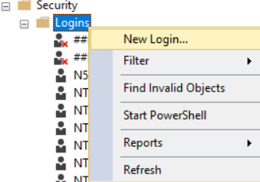

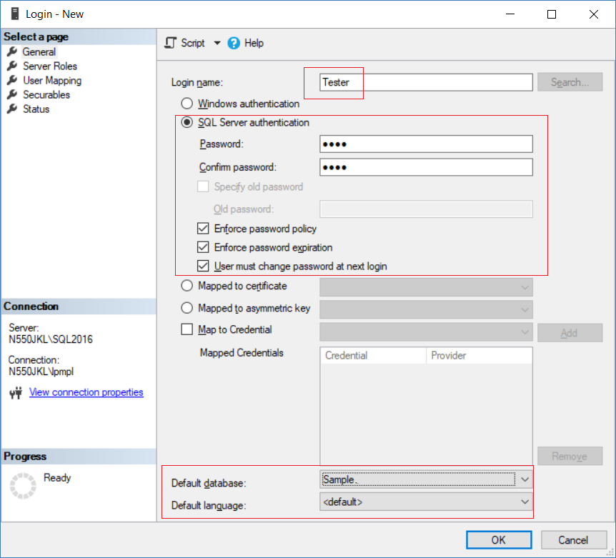

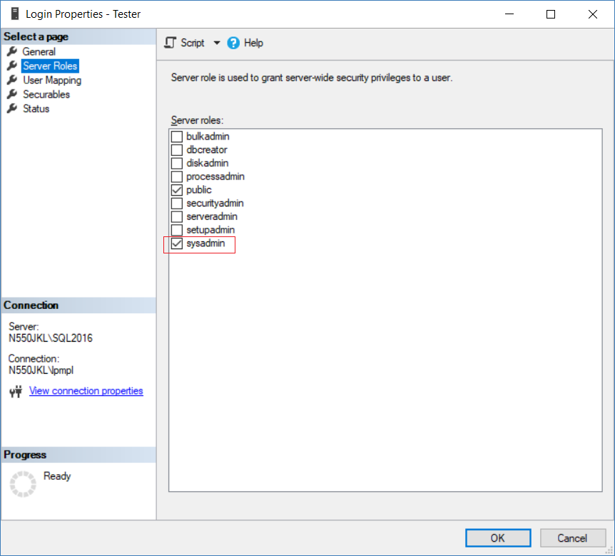

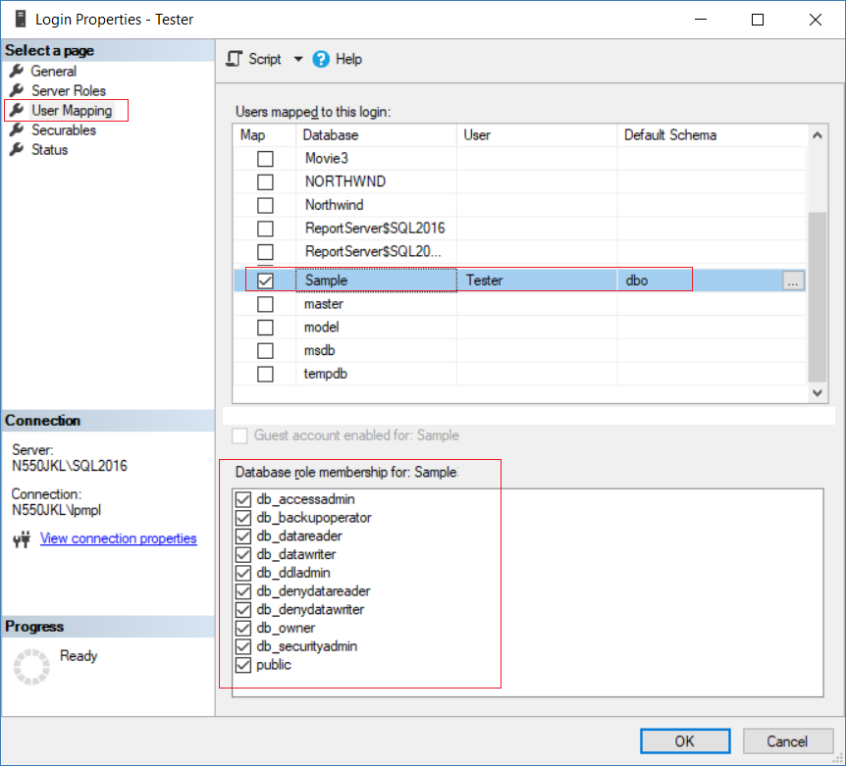

3. New Project - OnlineGame

File --> New --> Project... -->

Other Project Types --> Visual Studio Solutions -->  Blank Solution

-->

Name: **OnlineGame**

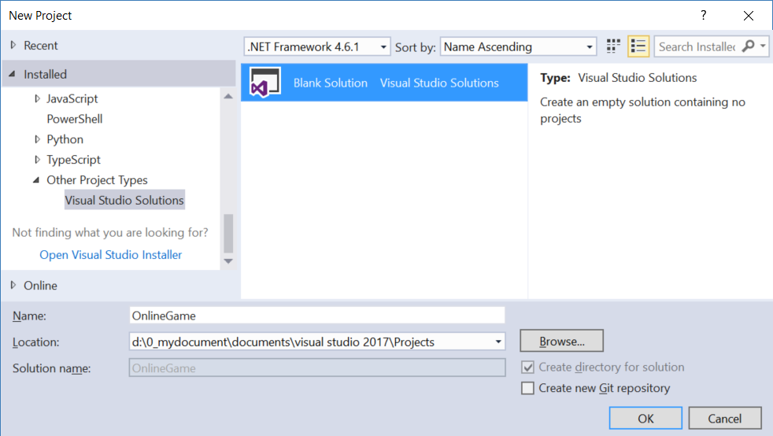

3.1. New Project - OnlineGame.Web

Solutions Name --> Add --> New Project -->

Visual C# --> Web --> [ASP.NET](http://asp.net/)Web Application (.Net Framework)

-->

Name: **OnlineGame.Web**

Empty --> Select "MVC" --> OK

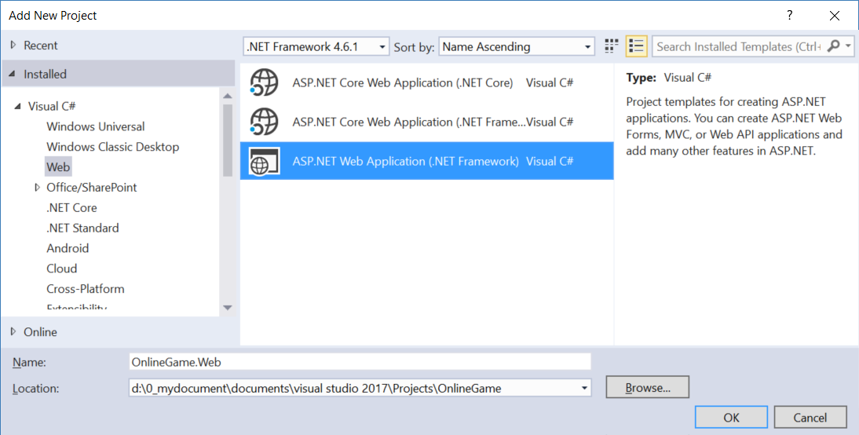

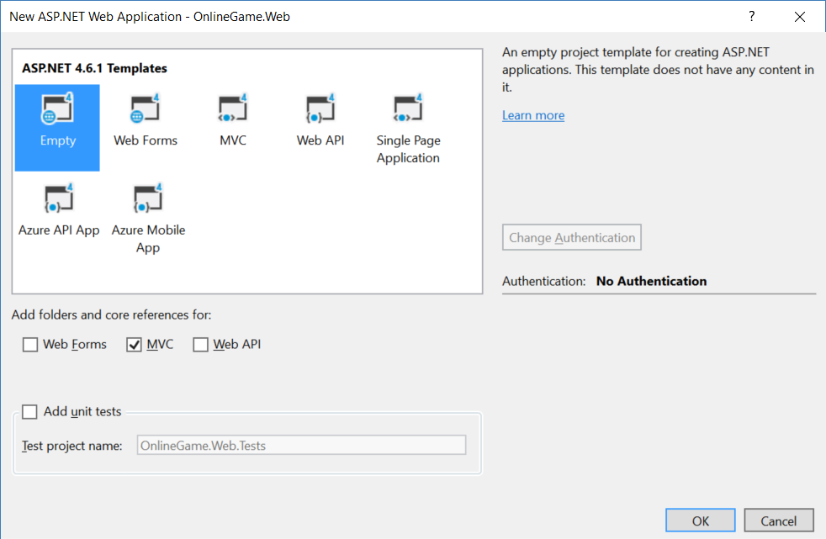

3.1.1. Global.asax.cs

using System.Web.Mvc;

using System.Web.Routing;

namespace OnlineGame.Web

{

    public class MvcApplication : System.Web.HttpApplication

    {

        //Application_Start() is the magic start point of this application

        protected void Application_Start()

        {

            AreaRegistration.RegisterAllAreas();

            //1.

            //Register Route Configure in RouteConfig.cs

            //If you want to see route configuration,

            //you may find it in RouteConfig.cs

            //2.

            //System.Web.Routing.RouteCollection Routes { get; }

            //Gets a collection of objects that derive from the System.Web.Routing.RouteBase class.

            RouteConfig.RegisterRoutes(RouteTable.Routes);

        }

    }

}

3.1.2. App_Start/RouteConfig.cs

using System.Web.Mvc;

using System.Web.Routing;

namespace OnlineGame.Web

{

    public class RouteConfig

    {

        public static void RegisterRoutes(RouteCollection routes)

        {

            //Handle the Route of the axd request file.

            //E.g. [ASP.Net](http://asp.net/) Tracing

            routes.IgnoreRoute("{resource}.axd/{*pathInfo}");

            //Handle the Route called "Default".

            //The mapping URL is "{controller}/{action}/{id}"

            //Set the default value of Controller, action, and id.

            routes.MapRoute(

                name: "Default",

                url: "{controller}/{action}/{id}",

                defaults: new { controller = "Gamer", action = "Index", id = UrlParameter.Optional }

            );

        }

    }

}

/*

1.

//routes.MapRoute(

//    name: "Default",

//    url: "{controller}/{action}/{id}",

//    defaults: new { controller = "Home", action = "Index", id = UrlParameter.Optional }

//);

1.1.

When a request comes in,

it's trying to do a pattern match based on

all the templates it sees in these mapped routes.

A route is some instructions for

how to take a URI coming into a request

and map it to some code,

normally a controller.

In this case,

look at defaults parameter,

when user request <http://localhost:PortNumber/>

IIS Express will run

HomeController Index action.

It will map to Controllers/HomeController.cs

and   map to Index Method

1.2.

By convention in MVC.

All controllers will have Controller suffix.

This suffix is not required in the URL.

So, if you want to invoke Home controller,

you specify /Home and not /HomeController.

-----------------------------------

2.

//routes.IgnoreRoute("{resource}.axd/{*pathInfo}");

2.1.

Reference:

<https://stackoverflow.com/questions/9016650/what-is-routes-ignorerouteresource-axd-pathinfo>

This line can handle the axd file request route,

E.g. trace.axd

.axd files don't exist physically.

[ASP.NET](http://asp.net/) uses URLs with .axd extensions

(ScriptResource.axd and WebResource.axd) internally,

and they are handled by an HttpHandler.

Therefore, you should keep this rule,

to prevent [ASP.NET](http://asp.net/) MVC from trying to handle the request

instead of letting the dedicated HttpHandler do it.

2.2.

trace.axd

Reference:

<https://msdn.microsoft.com/en-us/library/wwh16c6c.aspx>

trace.axd trace details for a specific request.

If you want to enable trace.axd,

then you have to go to Web.config

Add <trace enabled="true" pageOutput="false"/> under <system.web>

Then run the project, type the following URL

<http://localhost/OnlineGame.Web/trace.axd>

This will return [ASP.NET](http://asp.net/) trace, trace.axd.

If you do not have

// routes.IgnoreRoute("{resource}.axd/{*pathInfo}");

then you can not enable the trace.axd.

*/

3.2. ADO.Net Entity Data Model - Entity Framework

In Visual Studio 2017

**Models** folder --> Right Click --> Add --> New Item

--> Visual C# --> Data  -->  [ADO.Net](http://ado.net/) Entity Data Model

Name:

**OnlineGameDataModel**

-->

EF Designer from database

....

-->

Save Connection settings in Web.Config as:

**OnlineGameContext**

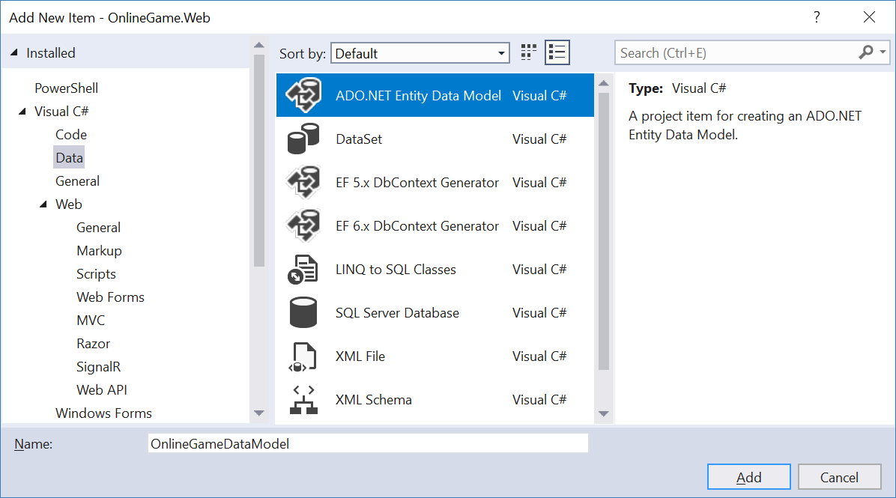

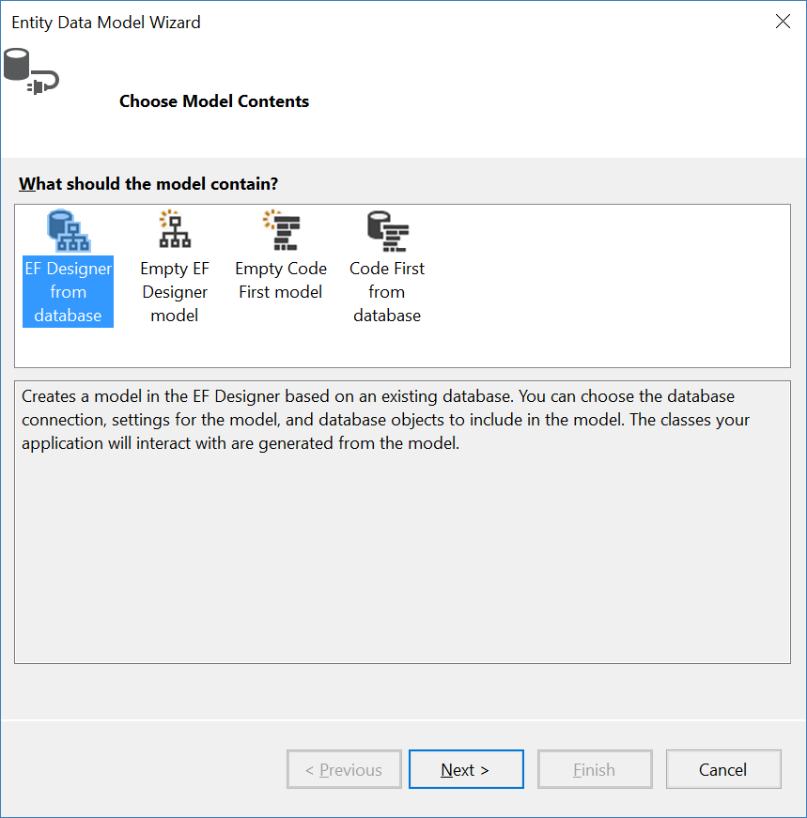

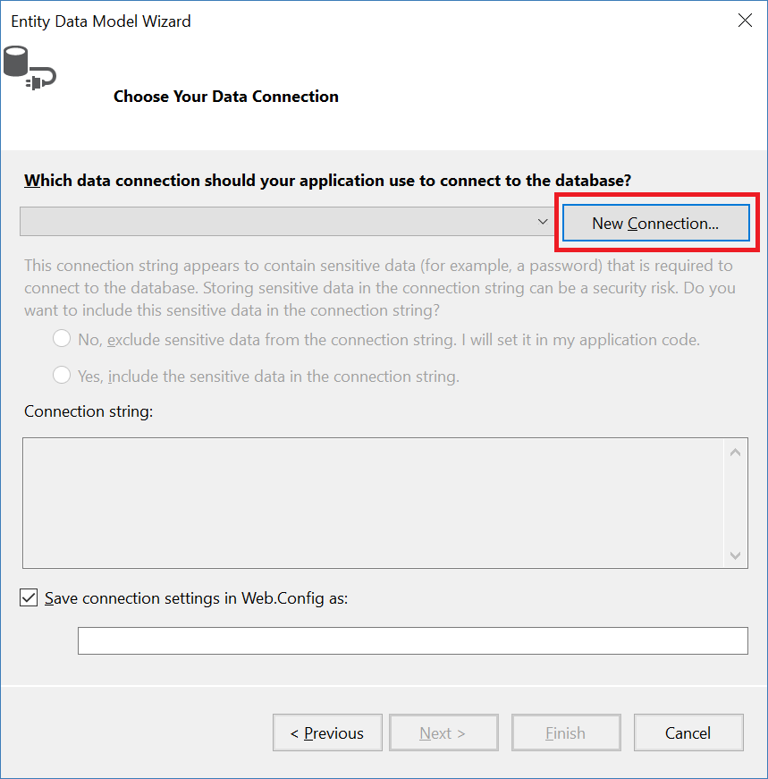

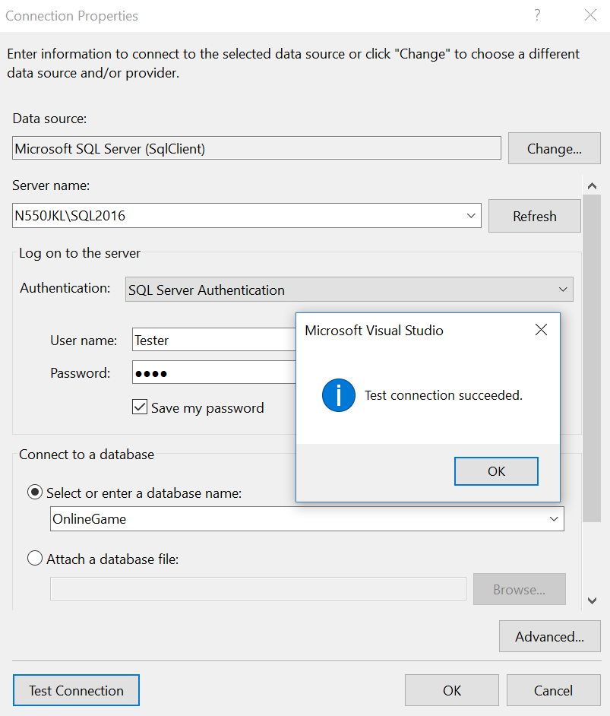

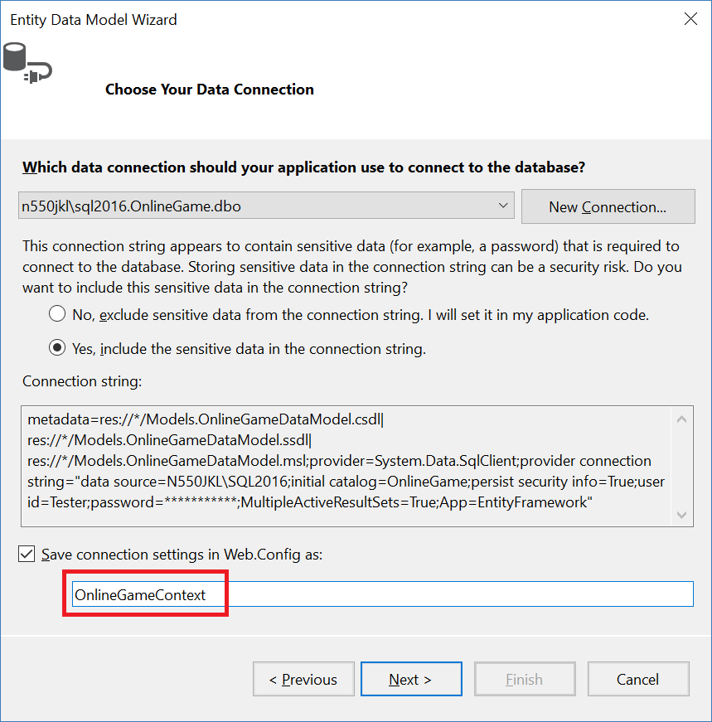

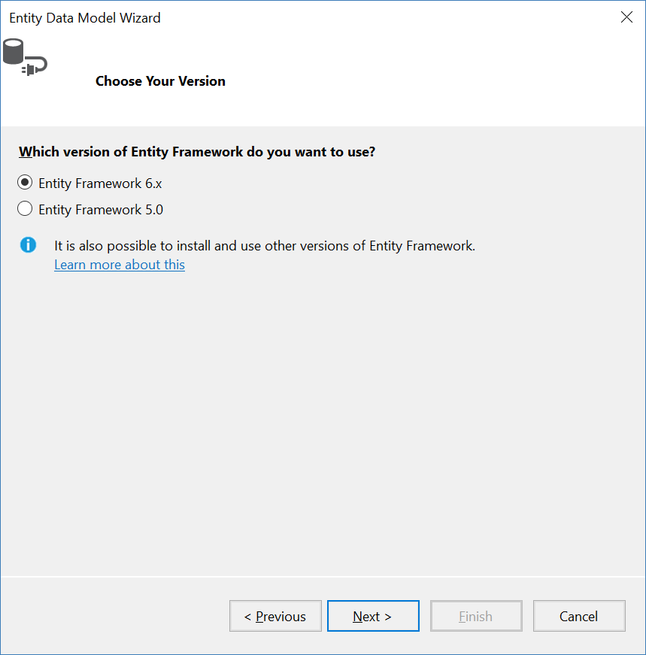

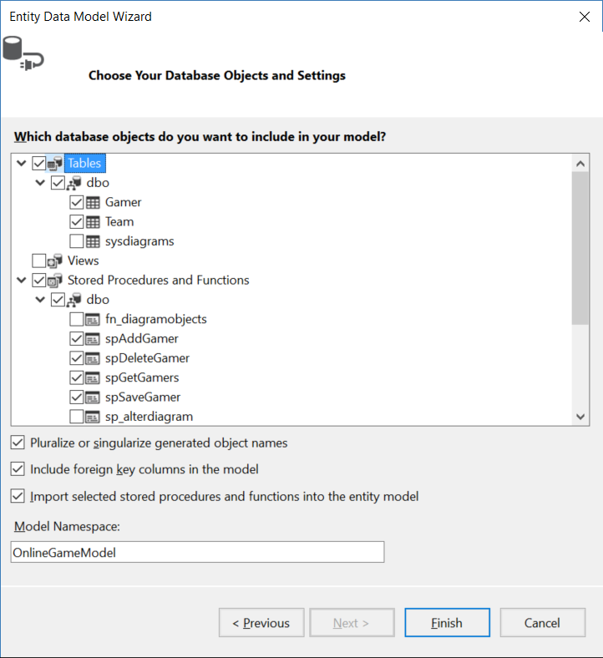

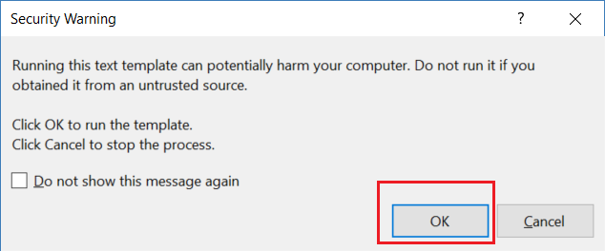

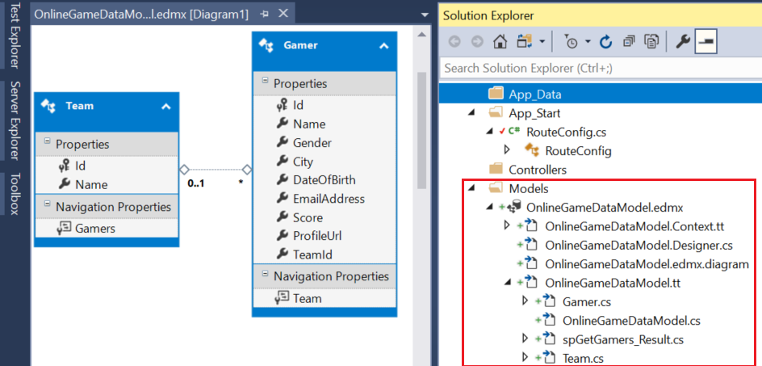

4. OnlineGame.Web

4.1. Controllers/GamersController.cs

Controllers --> Right click --> Add --> Controller

-->

**MVC 5 Controller with views, using Entity Framework**

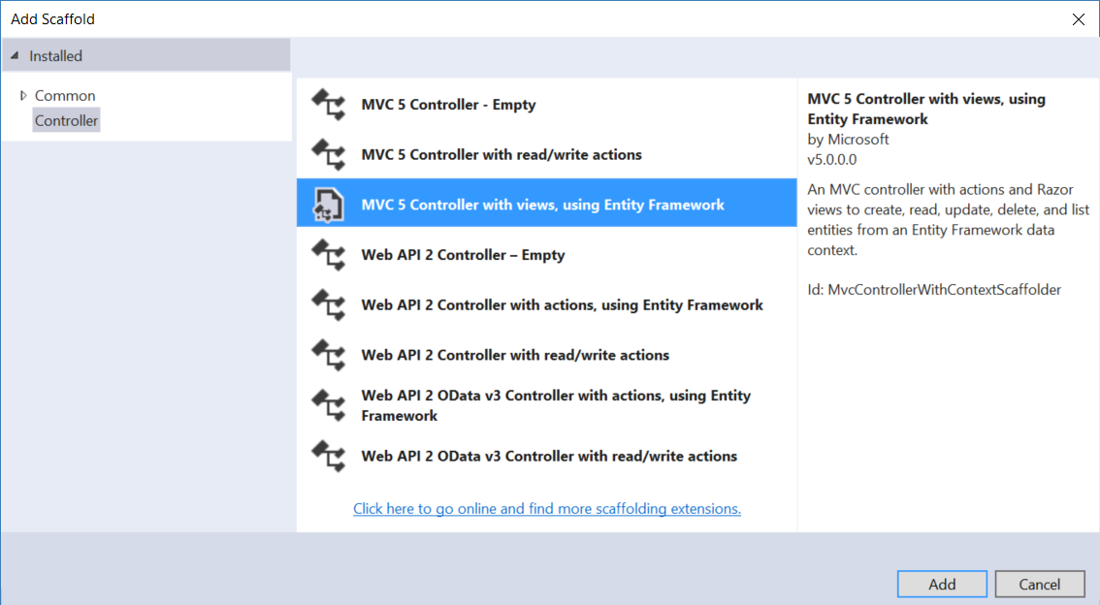

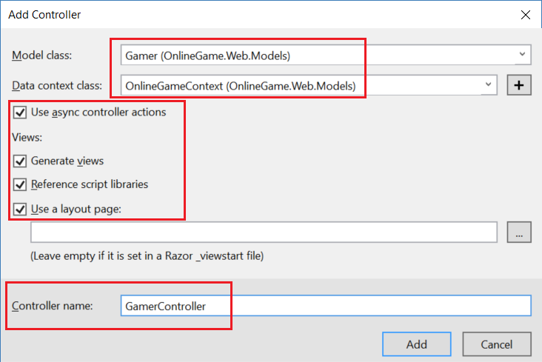

If you see the following error message, then you have to re-build solution before you create the controller.

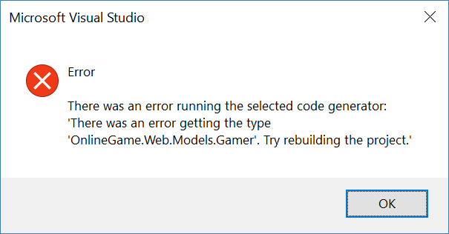

It will automatically generate the controller, views, and several javascript and css files.

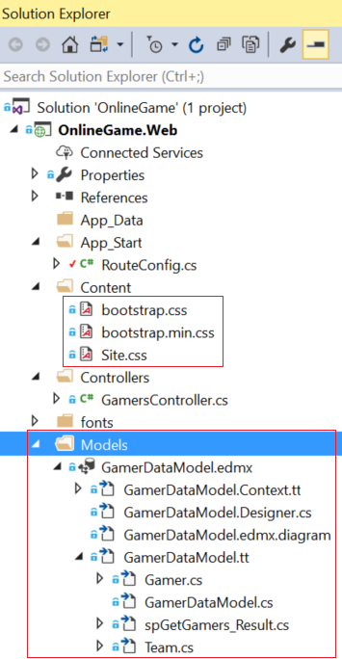

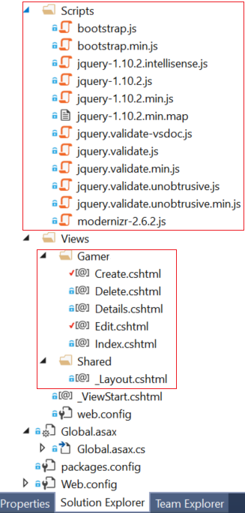

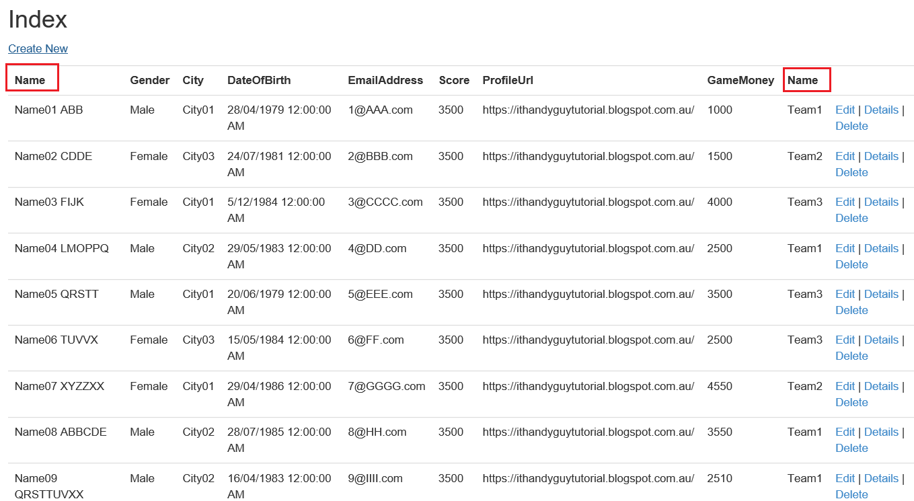

5. OnlineGame.Web

5.1. web.config

  <system.web>

    <globalization culture="en-au"/>

5.2. Controllers/GamersController.cs

using System;

using System.Data.Entity;

using System.Linq;

using System.Threading.Tasks;

using System.Net;

using System.Web.Mvc;

using OnlineGame.Web.Models;

namespace OnlineGame.Web.Controllers

{

    public class GamerController : Controller

    {

        private OnlineGameContext _db = new OnlineGameContext();

        // GET: Gamer

        [HttpGet]

        public async Task<ActionResult> Index()

        {

            IQueryable<Gamer> gamers = _db.Gamers.Include(g => g.Team);

            return View(await gamers.ToListAsync());

        }

        // GET: Gamer/Details/5

        [HttpGet]

        public async Task<ActionResult> Details(int? id)

        {

            if (id == null)

            {

                return new HttpStatusCodeResult(HttpStatusCode.BadRequest);

            }

            Gamer gamer = await _db.Gamers.FindAsync(id);

            if (gamer == null)

            {

                return HttpNotFound();

            }

            return View(gamer);

        }

        // GET: Gamer/DetailsTwo

        [HttpGet]

        public ActionResult DetailsTwo()

        {

            BoardGame boardGame = new BoardGame();

            return View(boardGame);

        }

        // GET: Gamer/DetailsThree/5

        [HttpGet]

        public async Task<ActionResult> DetailsThree(int? id)

        {

            if (id == null)

            {

                return new HttpStatusCodeResult(HttpStatusCode.BadRequest);

            }

            Gamer gamer = await _db.Gamers.FindAsync(id);

            if (gamer == null)

            {

                return HttpNotFound();

            }

            GamerA gamerA = GamerToGamerA(gamer);

            return View(gamerA);

        }

        [HttpGet]

        public async Task<ActionResult> DetailsFour(int? id)

        {

            if (id == null)

            {

                return new HttpStatusCodeResult(HttpStatusCode.BadRequest);

            }

            Gamer gamer = await _db.Gamers.FindAsync(id);

            if (gamer == null)

            {

                return HttpNotFound();

            }

            ViewData["GamerData"] = gamer;

            return View();

        }

        // GET: Gamer/Create

        [HttpGet]

        public ActionResult Create()

        {

            ViewBag.TeamId = new SelectList(_db.Teams, "Id", "Name");

            return View();

        }

        // POST: Gamer/Create

        // To protect from overposting attacks, please enable the specific properties you want to bind to, for

        // more details see <https://go.microsoft.com/fwlink/?LinkId=317598>.

        [HttpPost]

        [ValidateAntiForgeryToken]

        public async Task<ActionResult> Create([Bind(Include = "Id,Name,Gender,City,DateOfBirth,EmailAddress,Score,ProfileUrl,GameMoney,TeamId")] Gamer gamer)

        {

            if (ModelState.IsValid)

            {

                _db.Gamers.Add(gamer);

                await _db.SaveChangesAsync();

                return RedirectToAction("Index");

            }

            ViewBag.TeamId = new SelectList(_db.Teams, "Id", "Name", gamer.TeamId);

            return View(gamer);

        }

        // GET: Gamer/Edit/5

        [HttpGet]

        public async Task<ActionResult> Edit(int? id)

        {

            if (id == null)

            {

                return new HttpStatusCodeResult(HttpStatusCode.BadRequest);

            }

            Gamer gamer = await _db.Gamers.FindAsync(id);

            if (gamer == null)

            {

                return HttpNotFound();

            }

            ViewBag.TeamId = new SelectList(_db.Teams, "Id", "Name", gamer.TeamId);

            return View(gamer);

        }

        // GET: Gamer/Edit/5

        [HttpGet]

        public async Task<ActionResult> EditTwo(int? id)

        {

            if (id == null)

            {

                return new HttpStatusCodeResult(HttpStatusCode.BadRequest);

            }

            Gamer gamer = await _db.Gamers.FindAsync(id);

            if (gamer == null)

            {

                return HttpNotFound();

            }

            GamerA gamerA = GamerToGamerA(gamer);

            ViewBag.TeamId = new SelectList(_db.Teams, "Id", "Name", gamerA.TeamId);

            return View(gamerA);

        }

        // GET: Gamer/Edit/5

        [HttpGet]

        public async Task<ActionResult> EditThree(int? id)

        {

            if (id == null)

            {

                return new HttpStatusCodeResult(HttpStatusCode.BadRequest);

            }

            Gamer gamer = await _db.Gamers.FindAsync(id);

            if (gamer == null)

            {

                return HttpNotFound();

            }

            ViewData["GamerData"] = gamer;

            return View();

            //ViewBag.TeamId = new SelectList(_db.Teams, "Id", "Name", gamer.TeamId);

            //return View(gamer);

        }

        // POST: Gamer/Edit/5

        // To protect from overposting attacks, please enable the specific properties you want to bind to, for

        // more details see <https://go.microsoft.com/fwlink/?LinkId=317598>.

        [HttpPost]

        [ValidateAntiForgeryToken]

        public async Task<ActionResult> Edit([Bind(Include = "Id,Name,Gender,City,DateOfBirth,EmailAddress,Score,ProfileUrl,GameMoney,TeamId")] Gamer gamer)

        {

            if (ModelState.IsValid)

            {

                _db.Entry(gamer).State = EntityState.Modified;

                await _db.SaveChangesAsync();

                return RedirectToAction("Index");

            }

            ViewBag.TeamId = new SelectList(_db.Teams, "Id", "Name", gamer.TeamId);

            return View(gamer);

        }

        [HttpPost]

        public async Task<ActionResult> EditTwo(GamerA gamerA)

        {

            if (ModelState.IsValid)

            {

                Gamer gamer = GamerAToGamer(gamerA);

                //Retrieve data from DB

                Gamer gamerFromDb = await _db.Gamers.SingleAsync(g => g.Id == gamerA.Id);

                //Update all properties except Email and Score

                gamerFromDb.Name = gamer.Name;

                gamerFromDb.Gender = gamer.Gender;

                gamerFromDb.City = gamer.City;

                gamerFromDb.DateOfBirth = gamer.DateOfBirth;

                //gamerFromDb.EmailAddress = gamer.EmailAddress;

                //gamerFromDb.Score = gamer.Score;

                gamerFromDb.ProfileUrl = gamer.ProfileUrl;

                gamerFromDb.GameMoney = gamer.GameMoney;

                gamerFromDb.TeamId = gamer.TeamId;

                _db.Entry(gamerFromDb).State = EntityState.Modified;

                await _db.SaveChangesAsync();

                //return RedirectToAction("Index");

                return RedirectToAction("DetailsThree", new { id = gamerA.Id });

            }

            ViewBag.TeamId = new SelectList(_db.Teams, "Id", "Name", gamerA.TeamId);

            return View(gamerA);

        }

        [HttpPost]

        public async Task<ActionResult> EditThree(int id, string name, string gender, string city, DateTime? dateOfBirth, string emailAddress, int? score, string profileUrl, int? gameMoney, int? teamId)

        //public async Task<ActionResult> EditThree(Gamer gamer)

        {

            var gamerData = ViewData["GamerData"];

            return RedirectToAction("Index");

        }

        // GET: Gamer/Delete/5

        [HttpGet]

        public async Task<ActionResult> Delete(int? id)

        {

            if (id == null)

            {

                return new HttpStatusCodeResult(HttpStatusCode.BadRequest);

            }

            Gamer gamer = await _db.Gamers.FindAsync(id);

            if (gamer == null)

            {

                return HttpNotFound();

            }

            return View(gamer);

        }

        // POST: Gamer/Delete/5

        [HttpPost, ActionName("Delete")]

        [ValidateAntiForgeryToken]

        public async Task<ActionResult> DeleteConfirmed(int id)

        {

            Gamer gamer = await _db.Gamers.FindAsync(id);

            _db.Gamers.Remove(gamer);

            await _db.SaveChangesAsync();

            return RedirectToAction("Index");

        }

        private static GamerA GamerToGamerA(Gamer gamer)

        {

            GamerA gamerA = new GamerA

            {

                Id = gamer.Id,

                Name = gamer.Name,

                Gender = gamer.Gender,

                City = gamer.City,

                DateOfBirth = gamer.DateOfBirth,

                EmailAddress = gamer.EmailAddress,

                Score = gamer.Score,

                ProfileUrl = gamer.ProfileUrl,

                GameMoney = gamer.GameMoney,

                TeamId = gamer.TeamId

            };

            return gamerA;

        }

        private static Gamer GamerAToGamer(GamerA gamerA)

        {

            Gamer gamer = new Gamer

            {

                Id = gamerA.Id,

                Name = gamerA.Name,

                Gender = gamerA.Gender,

                City = gamerA.City,

                DateOfBirth = gamerA.DateOfBirth,

                EmailAddress = gamerA.EmailAddress,

                Score = gamerA.Score,

                ProfileUrl = gamerA.ProfileUrl,

                GameMoney = gamerA.GameMoney,

                TeamId = gamerA.TeamId

            };

            return gamer;

        }

        protected override void Dispose(bool disposing)

        {

            if (disposing)

            {

                _db.Dispose();

            }

            base.Dispose(disposing);

        }

    }

}

5.3. Views/Gamer/Index.cshtml

@model IEnumerable<OnlineGame.Web.Models.Gamer>

@{

    ViewBag.Title = "Index";

}

<h2>Index</h2>

<p>

    @Html.ActionLink("Create New", "Create")

</p>

<table class="table">

    <tr>

        <th>

            @Html.DisplayNameFor(model => model.Name)

        </th>

        <th>

            @Html.DisplayNameFor(model => model.Gender)

        </th>

        <th>

            @Html.DisplayNameFor(model => model.City)

        </th>

        <th>

            @Html.DisplayNameFor(model => model.DateOfBirth)

        </th>

        <th>

            @Html.DisplayNameFor(model => model.EmailAddress)

        </th>

        <th>

            @Html.DisplayNameFor(model => model.Score)

        </th>

        <th>

            @Html.DisplayNameFor(model => model.ProfileUrl)

        </th>

        <th>

            @Html.DisplayNameFor(model => model.GameMoney)

        </th>

        <th>

            @Html.DisplayNameFor(model => model.Team.Name)

        </th>

        <th></th>

    </tr>

    @foreach (var item in Model)

    {

        <tr>

            <td>

                @Html.DisplayFor(modelItem => item.Name)

            </td>

            <td>

                @Html.DisplayFor(modelItem => item.Gender)

            </td>

            <td>

                @Html.DisplayFor(modelItem => item.City)

            </td>

            <td>

                @Html.DisplayFor(modelItem => item.DateOfBirth)

            </td>

            <td>

                @Html.DisplayFor(modelItem => item.EmailAddress)

            </td>

            <td>

                @Html.DisplayFor(modelItem => item.Score)

            </td>

            <td>

                @Html.DisplayFor(modelItem => item.ProfileUrl)

            </td>

            <td>

                @Html.DisplayFor(modelItem => item.GameMoney)

            </td>

            <td>

                @Html.DisplayFor(modelItem => item.Team.Name)

            </td>

            <td>

                @Html.ActionLink("Edit", "Edit", new { id = item.Id }) |

                @Html.ActionLink("EditTwo", "EditTwo", new { id = item.Id }) |

                @Html.ActionLink("EditThree", "EditThree", new { id = item.Id }) |

                @Html.ActionLink("Details", "Details", new { id = item.Id }) |

                @Html.ActionLink("DetailsTwo", "DetailsTwo", new { id = item.Id }) |

                @Html.ActionLink("DetailsThree", "DetailsThree", new { id = item.Id }) |

                @Html.ActionLink("DetailsFour", "DetailsFour", new { id = item.Id }) |

                @Html.ActionLink("Delete", "Delete", new { id = item.Id })

            </td>

        </tr>

    }

</table>

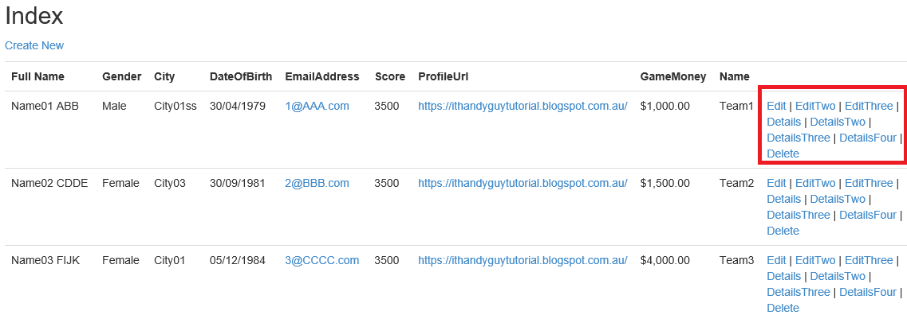

***********************************************************************

5.4. Models/Gamer/Gamer.cs

using System.ComponentModel.DataAnnotations;

namespace OnlineGame.Web.Models

{

    [MetadataType(typeof(GamerMetaData))]

    //[DisplayColumn("Id")]

    [DisplayColumn("Name")]

    public partial class Gamer

    {

    }

}

5.5. Models/Gamer/GamerMetaData.cs

using System;

using System.ComponentModel;

using System.ComponentModel.DataAnnotations;

namespace OnlineGame.Web.Models

{

    public class GamerMetaData

    {

        //[HiddenInput(DisplayValue = false)]

        public int Id { get; set; }

        //1.

        ////[DisplayAttribute(Name="Full Name")]

        ////[Display(Name = "Full Name")]

        ////[DisplayName("Full Name")]

        //Display Name as "Full Name"

        [DisplayName("Full Name")]

        public string Name { get; set; }

        //2.

        //If gender is NULL, then display "Gender not specified".

        [DisplayFormat(NullDisplayText = "Gender not specified")]

        public string Gender { get; set; }

        public string City { get; set; }

        //3.

        //DateTime

        //3.1.

        ////[DisplayFormat(DataFormatString = ".....")]

        //3.1.1.

        //////[DisplayFormat(DataFormatString = "{0:d}")]

        ////[DisplayFormatAttribute(DataFormatString="{0:d}")]

        ////public Nullable<System.DateTime> DateOfBirth { get; set; }

        //Display only the date part. E.g. 29/04/1986

        //3.1.2.

        ////[DisplayFormat(DataFormatString = "{0:dd/MM/yyyy HH:mm:ss}")]

        ////public Nullable<System.DateTime> DateOfBirth { get; set; }

        //Display in 24 hour notation. E.g. 29/04/1986 13:00:00

        //3.1.3.

        ////[DisplayFormat(DataFormatString = "{0:dd/MM/yyyy hh:mm:ss tt}")]

        ////public Nullable<System.DateTime> DateOfBirth { get; set; }

        //Display in 12 hour notation. E.g. 29/04/1986 1:00:00 PM

        //3.2.

        ////[DataType(DataType....)]

        //3.2.1.

        ////[DataType(DataType.Date)]

        ////public Nullable<System.DateTime> DateOfBirth { get; set; }

        //Display only date part

        //Please be aware, it actually covert DateTime to Date.

        //so Views/Shared/EditorTemplates/DateTime.cshtml will not Work.

        //3.2.2.

        ////[DataType(DataType.Time)]

        ////public Nullable<System.DateTime> DateOfBirth { get; set; }

        //Display only 12 hour notation Time part

        //Please be aware, it actually covert DateTime to Date.

        //so Views/Shared/EditorTemplates/DateTime.cshtml will not Work.

        //[DataType(DataType.Date)] //Views/Shared/EditorTemplates/DateTime.cshtml will not Work.

        //[DisplayFormat(DataFormatString = "{0:dd/MM/yyyy hh:mm:ss tt}")]

        [DisplayFormat(DataFormatString = "{0:dd/MM/yyyy}", ApplyFormatInEditMode = true)]

        public Nullable<System.DateTime> DateOfBirth { get; set; }

        //5.

        // Display mailto hyperlink

        [DataType(DataType.EmailAddress)]

        //[ReadOnly(true)]

        public string EmailAddress { get; set; }

        //4.

        ////[ScaffoldColumn(false)]

        //[ScaffoldColumn(false)] attribute means it will not display the column

        //when using @Html.DisplayForModel() helper.

        [ScaffoldColumn(false)]

        public Nullable<int> Score { get; set; }

        //8.

        //8.1.

        //In the Models/Gamer/GamerMetaData.cs

        ////[DataType(DataType.Url)]

        ////[UIHint("UrlToNewWindow")]

        ////public string ProfileUrl { get; set; }

        //[DataType(DataType.Url)] attribute will display a hyperlink.

        //[UIHint("UrlToNewWindow")] attribute specify the name of view DisplayTemplate

        //to display the property data.

        //In this case, it will look for "DisplayTemplates/UrlToNewWindow.cshtml"

        //under "Shared" folder or "Gamer" folder.

        //Use that view template to disply the data of this property.

        //8.2.

        ////<a href="@ViewData.Model" target="_blank">@ViewData.Model</a>

        //In the Shared/DisplayTemplates/UrlToNewWindow.cshtml,

        //@ViewData.Model will take the Model data from the parent view.

        //In this case, it will return a profile url.

        [DataType(DataType.Url)]

        [UIHint("UrlToNewWindow")]

        public string ProfileUrl { get; set; }

        //7.

        ////[DataType(DataType.Currency)]

        ////public Nullable<int> GameMoney { get; set; }

        //Display the currency symbol by globalization culture in web.config file.

        //7.1.

        //In System.Web tag of web.config file,

        //7.1.1.

        //<system.web> <globalization culture = "en-au" /> ...

        //Display au $ symbol.

        //7.1.2.

        //<system.web> <globalization culture = "en-uk" /> ...

        //Display UK pound symbol.

        [DataType(DataType.Currency)]

        public Nullable<int> GameMoney { get; set; }

        public Nullable<int> TeamId { get; set; }

    }

}

/*

------------------------------

1.

////[DisplayAttribute(Name="Full Name")]

////[Display(Name = "Full Name")]

//[DisplayName("Full Name")]

//public string Name { get; set; }

Display Name as "Full Name"

------------------------------

2.

//[DisplayFormat(NullDisplayText = "Gender not specified")]

//public string Gender { get; set; }

If gender is NULL, then display "Gender not specified".

------------------------------

3.

DateTime

--------------

3.1.

//[DisplayFormat(DataFormatString = ".....")]

3.1.1.

////[DisplayFormat(DataFormatString = "{0:d}")]

//[DisplayFormatAttribute(DataFormatString="{0:d}")]

//public Nullable<System.DateTime> DateOfBirth { get; set; }

Display only the date part. E.g. 29/04/1986

3.1.2.

//[DisplayFormat(DataFormatString = "{0:dd/MM/yyyy HH:mm:ss}")]

//public Nullable<System.DateTime> DateOfBirth { get; set; }

Display in 24 hour notation. E.g. 29/04/1986 13:00:00

3.1.3.

//[DisplayFormat(DataFormatString = "{0:dd/MM/yyyy hh:mm:ss tt}")]

//public Nullable<System.DateTime> DateOfBirth { get; set; }

Display in 12 hour notation. E.g. 29/04/1986 1:00:00 PM

--------------

3.2.

//[DataType(DataType....)]

3.2.1.

//[DataType(DataType.Date)]

//public Nullable<System.DateTime> DateOfBirth { get; set; }

Display only date part

Please be aware, it actually covert DateTime to Date.

So Views/Shared/EditorTemplates/DateTime.cshtml will not Work.

3.2.2.

//[DataType(DataType.Time)]

//public Nullable<System.DateTime> DateOfBirth { get; set; }

Display only 12 hour notation Time part

Please be aware, it actually covert DateTime to Date.

So Views/Shared/EditorTemplates/DateTime.cshtml will not Work.

------------------------------

4.

//[ScaffoldColumn(false)]

public Nullable<int> Score { get; set; }

[ScaffoldColumn(false)] attribute means it will not display the column

when using @Html.DisplayForModel() helper

------------------------------

5.

//[DataType(DataType.EmailAddress)]

//public string EmailAddress { get; set; }

Display mailto hyperlink

------------------------------

6.

//[DataType(DataType.Url)]

//public string ProfileUrl { get; set; }

Display hyperlink

------------------------------

7.

//[DataType(DataType.Currency)]

//public Nullable<int> GameMoney { get; set; }

Display the currency symbol by globalization culture in web.config file.

7.1.

In System.Web tag of web.config file,

7.1.1.

<system.web> <globalization culture="en-au"/> ...

Display au $ symbol.

7.1.2.

<system.web> <globalization culture="en-uk"/> ...

Display UK pound symbol.

------------------------------

8.

8.1.

In the Models/Gamer/GamerMetaData.cs

//[DataType(DataType.Url)]

//[UIHint("UrlToNewWindow")]

//public string ProfileUrl { get; set; }

[DataType(DataType.Url)] attribute will display a hyperlink.

[UIHint("UrlToNewWindow")] attribute specify the name of view DisplayTemplate

to display the property data.

In this case, it will look for "DisplayTemplates/UrlToNewWindow.cshtml"

under "Shared" folder or "Gamer" folder.

Use that view template to disply the data of this property.

8.2.

//<a href="@ViewData.Model" target="_blank">@ViewData.Model</a>

In the Shared/DisplayTemplates/UrlToNewWindow.cshtml,

@ViewData.Model will take the Model data from the parent view.

In this case, it will return a profile url.

------------------------------

9.

//[HiddenInput(DisplayValue = false)]

//public int Id { get; set; }

[HiddenInput(DisplayValue = false)] attribute

means it will become a hidden input

When using @Html.DisplayForModel() helper or @Html.EditorForModel()

------------------------------

10.

//[DataType(DataType.EmailAddress)]

//[ReadOnly(true)]

//public string EmailAddress { get; set; }

[DataType(DataType.EmailAddress)] attribute display mailto hyperlink.

[ReadOnly(true)] or you may delete Setter.

It will make this property un-editable.

You may set a breakpoint to see the [HttpPost] action model for this property is null.

*/

5.6. Models/Gamer/BoardGame.cs

using System.Data.Entity;

using System.Linq;

namespace OnlineGame.Web.Models

{

    public class BoardGame

    {

        public Gamer GameHolder

        {

            get

            {

                using (OnlineGameContext dbContext = new OnlineGameContext())

                {

                    return dbContext.Gamers.SingleAsync(x => x.Id == 1).Result;

                }

            }

        }

    }

}

5.7. Models/Gamer/GamerA.cs

using System;

using System.ComponentModel;

using System.ComponentModel.DataAnnotations;

using System.Web.Mvc;

namespace OnlineGame.Web.Models

{

    public class GamerA

    {

        //9.

        ////[HiddenInput(DisplayValue = false)]

        ////public int Id { get; set; }

        //[HiddenInput(DisplayValue = false)] attribute

        //means it will become a hidden input

        //When using @Html.DisplayForModel() helper or @Html.EditorForModel()

        [HiddenInput(DisplayValue = false)]

        public int Id { get; set; }

        //1.

        ////[DisplayAttribute(Name="Full Name")]

        ////[Display(Name = "Full Name")]

        ////[DisplayName("Full Name")]

        //Display Name as "Full Name"

        [DisplayName("Full Name")]

        public string Name { get; set; }

        //2.

        //If gender is NULL, then display "Gender not specified".

        [DisplayFormat(NullDisplayText = "Gender not specified")]

        public string Gender { get; set; }

        public string City { get; set; }

        //3.

        //DateTime

        //3.1.

        ////[DisplayFormat(DataFormatString = ".....")]

        //3.1.1.

        //////[DisplayFormat(DataFormatString = "{0:d}")]

        ////[DisplayFormatAttribute(DataFormatString="{0:d}")]

        ////public Nullable<System.DateTime> DateOfBirth { get; set; }

        //Display only the date part. E.g. 29/04/1986

        //3.1.2.

        ////[DisplayFormat(DataFormatString = "{0:dd/MM/yyyy HH:mm:ss}")]

        ////public Nullable<System.DateTime> DateOfBirth { get; set; }

        //Display in 24 hour notation. E.g. 29/04/1986 13:00:00

        //3.1.3.

        ////[DisplayFormat(DataFormatString = "{0:dd/MM/yyyy hh:mm:ss tt}")]

        ////public Nullable<System.DateTime> DateOfBirth { get; set; }

        //Display in 12 hour notation. E.g. 29/04/1986 1:00:00 PM

        //3.2.

        ////[DataType(DataType....)]

        //3.2.1.

        ////[DataType(DataType.Date)]

        ////public Nullable<System.DateTime> DateOfBirth { get; set; }

        //Display only date part

        //Please be aware, it actually covert DateTime to Date.

        //So Views/Shared/EditorTemplates/DateTime.cshtml will not Work.

        //3.2.2.

        ////[DataType(DataType.Time)]

        ////public Nullable<System.DateTime> DateOfBirth { get; set; }

        //Display only 12 hour notation Time part

        //Please be aware, it actually covert DateTime to Date.

        //So Views/Shared/EditorTemplates/DateTime.cshtml will not Work.

        //[DataType(DataType.Date)] //Views/Shared/EditorTemplates/DateTime.cshtml will not Work.

        //[DisplayFormat(DataFormatString = "{0:dd/MM/yyyy hh:mm:ss tt}")]

        [DisplayFormat(DataFormatString = "{0:d}")]

        public DateTime? DateOfBirth { get; set; }

        //10.

        ////[DataType(DataType.EmailAddress)]

        ////[ReadOnly(true)]

        ////public string EmailAddress { get; set; }

        //[DataType(DataType.EmailAddress)] attribute display mailto hyperlink.

        //[ReadOnly(true)] or you may delete Setter.

        //It will make this property un-editable.

        //You may set a breakpoint to see the [HttpPost] action model for this property is null.

        [DataType(DataType.EmailAddress)]

        [ReadOnly(true)]

        public string EmailAddress { get; set; }

        //4.

        ////[ScaffoldColumn(false)]

        //[ScaffoldColumn(false)] attribute means it will not display the column

        //when using @Html.DisplayForModel() helper.

        [ScaffoldColumn(false)]

        public int? Score { get; set; }

        //8.

        //8.1.

        //In the Models/Gamer/GamerMetaData.cs

        ////[DataType(DataType.Url)]

        ////[UIHint("UrlToNewWindow")]

        ////public string ProfileUrl { get; set; }

        //[DataType(DataType.Url)] attribute will display a hyperlink.

        //[UIHint("UrlToNewWindow")] attribute specify the name of view DisplayTemplate

        //to display the property data.

        //In this case, it will look for "DisplayTemplates/UrlToNewWindow.cshtml"

        //under "Shared" folder or "Gamer" folder.

        //Use that view template to disply the data of this property.

        //8.2.

        ////<a href="@ViewData.Model" target="_blank">@ViewData.Model</a>

        //In the Shared/DisplayTemplates/UrlToNewWindow.cshtml,

        //@ViewData.Model will take the Model data from the parent view.

        //In this case, it will return a profile url.

        [DataType(DataType.Url)]

        [UIHint("UrlToNewWindow")]

        public string ProfileUrl { get; set; }

        //7.

        ////[DataType(DataType.Currency)]

        ////public Nullable<int> GameMoney { get; set; }

        //Display the currency symbol by globalization culture in web.config file.

        //7.1.

        //In System.Web tag of web.config file,

        //7.1.1.

        //<system.web> <globalization culture = "en-au" /> ...

        //Display au $ symbol.

        //7.1.2.

        //<system.web> <globalization culture = "en-uk" /> ...

        //Display UK pound symbol.

        [DataType(DataType.Currency)]

        public int? GameMoney { get; set; }

        public int? TeamId { get; set; }

        public virtual Team Team { get; set; }

    }

}

/*

------------------------------

1.

////[DisplayAttribute(Name="Full Name")]

////[Display(Name = "Full Name")]

//[DisplayName("Full Name")]

//public string Name { get; set; }

Display Name as "Full Name"

------------------------------

2.

//[DisplayFormat(NullDisplayText = "Gender not specified")]

//public string Gender { get; set; }

If gender is NULL, then display "Gender not specified".

------------------------------

3.

DateTime

--------------

3.1.

//[DisplayFormat(DataFormatString = ".....")]

3.1.1.

////[DisplayFormat(DataFormatString = "{0:d}")]

//[DisplayFormatAttribute(DataFormatString="{0:d}")]

//public Nullable<System.DateTime> DateOfBirth { get; set; }

Display only the date part. E.g. 29/04/1986

3.1.2.

//[DisplayFormat(DataFormatString = "{0:dd/MM/yyyy HH:mm:ss}")]

//public Nullable<System.DateTime> DateOfBirth { get; set; }

Display in 24 hour notation. E.g. 29/04/1986 13:00:00

3.1.3.

//[DisplayFormat(DataFormatString = "{0:dd/MM/yyyy hh:mm:ss tt}")]

//public Nullable<System.DateTime> DateOfBirth { get; set; }

Display in 12 hour notation. E.g. 29/04/1986 1:00:00 PM

--------------

3.2.

//[DataType(DataType....)]

3.2.1.

//[DataType(DataType.Date)]

//public Nullable<System.DateTime> DateOfBirth { get; set; }

Display only date part

Please be aware, it actually covert DateTime to Date.

So Views/Shared/EditorTemplates/DateTime.cshtml will not Work.

3.2.2.

//[DataType(DataType.Time)]

//public Nullable<System.DateTime> DateOfBirth { get; set; }

Display only 12 hour notation Time part

Please be aware, it actually covert DateTime to Date.

So Views/Shared/EditorTemplates/DateTime.cshtml will not Work.

------------------------------

4.

//[ScaffoldColumn(false)]

public Nullable<int> Score { get; set; }

[ScaffoldColumn(false)] attribute means it will not display the column

when using @Html.DisplayForModel() helper

------------------------------

5.

//[DataType(DataType.EmailAddress)]

//public string EmailAddress { get; set; }

Display mailto hyperlink

------------------------------

6.

//[DataType(DataType.Url)]

//public string ProfileUrl { get; set; }

Display hyperlink

------------------------------

7.

//[DataType(DataType.Currency)]

//public Nullable<int> GameMoney { get; set; }

Display the currency symbol by globalization culture in web.config file.

7.1.

In System.Web tag of web.config file,

7.1.1.

<system.web> <globalization culture="en-au"/> ...

Display au $ symbol.

7.1.2.

<system.web> <globalization culture="en-uk"/> ...

Display UK pound symbol.

------------------------------

8.

8.1.

In the Models/Gamer/GamerMetaData.cs

//[DataType(DataType.Url)]

//[UIHint("UrlToNewWindow")]

//public string ProfileUrl { get; set; }

[DataType(DataType.Url)] attribute will display a hyperlink.

[UIHint("UrlToNewWindow")] attribute specify the name of view DisplayTemplate

to display the property data.

In this case, it will look for "DisplayTemplates/UrlToNewWindow.cshtml"

under "Shared" folder or "Gamer" folder.

Use that view template to disply the data of this property.

8.2.

//<a href="@ViewData.Model" target="_blank">@ViewData.Model</a>

In the Shared/DisplayTemplates/UrlToNewWindow.cshtml,

@ViewData.Model will take the Model data from the parent view.

In this case, it will return a profile url.

------------------------------

9.

//[HiddenInput(DisplayValue = false)]

//public int Id { get; set; }

[HiddenInput(DisplayValue = false)] attribute

means it will become a hidden input

When using @Html.DisplayForModel() helper or @Html.EditorForModel()

------------------------------

10.

//[DataType(DataType.EmailAddress)]

//[ReadOnly(true)]

//public string EmailAddress { get; set; }

[DataType(DataType.EmailAddress)] attribute display mailto hyperlink.

[ReadOnly(true)] or you may delete Setter.

It will make this property un-editable.

You may set a breakpoint to see the [HttpPost] action model for this property is null.

*/

5.8. Views/Gamer/Details.cshtml

@model OnlineGame.Web.Models.Gamer

@{

    ViewBag.Title = "Details";

}

<h2>Details (Model is Gamer)</h2>

<div>

    <h4>Gamer</h4>

    <hr />

    <dl class="dl-horizontal">

        <dt>

            @Html.DisplayNameFor(model => model.Name)

        </dt>

        <dd>

            @Html.DisplayFor(model => model.Name)

        </dd>

        <dt>

            @Html.DisplayNameFor(model => model.Gender)

        </dt>

        <dd>

            @Html.DisplayFor(model => model.Gender)

        </dd>

        <dt>

            @Html.DisplayNameFor(model => model.City)

        </dt>

        <dd>

            @Html.DisplayFor(model => model.City)

        </dd>

        <dt>

            @Html.DisplayNameFor(model => model.DateOfBirth)

        </dt>

        <dd>

            @Html.DisplayFor(model => model.DateOfBirth)

        </dd>

        <dt>

            @Html.DisplayNameFor(model => model.EmailAddress)

        </dt>

        <dd>

            @Html.DisplayFor(model => model.EmailAddress)

        </dd>

        <dt>

            @Html.DisplayNameFor(model => model.Score)

        </dt>

        <dd>

            @Html.DisplayFor(model => model.Score)

        </dd>

        <dt>

            @Html.DisplayNameFor(model => model.ProfileUrl)

        </dt>

        <dd>

            @Html.DisplayFor(model => model.ProfileUrl)

        </dd>

        <dt>

            @Html.DisplayNameFor(model => model.GameMoney)

        </dt>

        <dd>

            @Html.DisplayFor(model => model.GameMoney)

        </dd>

        <dt>

            @Html.DisplayNameFor(model => model.Team.Name)

        </dt>

        <dd>

            @Html.DisplayFor(model => model.Team.Name)

        </dd>

    </dl>

</div>

<p>

    @Html.ActionLink("Edit", "Edit", new { id = Model.Id }) |

    @Html.ActionLink("Back to List", "Index")

</p>

<hr />

<h2>Html.DisplayForModel()</h2>

@Html.DisplayForModel()

@*

1.

//@Html.DisplayNameFor(model => model.Name)

It will display "Full Name",

because Name property in Gamer has [DisplayName("Full Name")] attribute.

//@Html.DisplayFor(model => model.Name)

It will display "Name02 CDDE"

------------------------------------------------

2.

//@Html.DisplayForModel()

It will display everything

except the properties with [ScaffoldColumn(false)] attribute.

------------------------------------------------

3.

//@Html.ActionLink("Back to List", "Index")

It will create

//<a href="/Gamer/Index">Back to List</a>

------------------------------------------------

4.

There are 2 categories of built-in templated helpers.

-----------------------------

4.1.

Display Templates

-----------------

4.1.1.

//@Html.DisplayFor(model => model.Name)

The view must have strongly typed view Model.

It can work with the complex type Model property.

It is similar to @Html.DisplayTextFor(model => model.GameHolder)

//@Html.DisplayTextFor(model => model.GameHolder)

model.GameHolder will return a Gamer object.

The Gamer class has [DisplayColumn("Name")] attribute,

so it will display Gamer Name property value

which is the full name of that gamer.

-----------------

4.1.2.

//@Html.DisplayForModel()

The view must have strongly typed view Model.

It will display every property in view model

except the properties with [ScaffoldColumn(false)] attribute.

-----------------

4.1.3.

@Html.Display helper does not need strongly typed view Mode.

//ViewData["GamerData"] = gamer;

//return View();

In the controller, we put the gamer object into ViewData["GamerData"]

"GamerData" in this case is the key of ViewData.

ViewData["GamerData"] contains that gamer object data,

so we don't have to use a view model.

//@Html.Display("GamerData")

In the view, we use @Html.Display("GamerData")

to retrieve the Gamer data from ViewData["GamerData"].

It will display everything

except the properties with [ScaffoldColumn(false)] attribute.

-----------------------------

4.2.

Display Templates

-----------------

4.2.1.

//@Html.EditorFor(model => model.Name)

The view must have strongly typed view Model.

It will create a textbox for the property value input.

-----------------

4.2.2.

//@Html.EditorForModel()

The view must have strongly typed view Model.

It will create textbox input for every properties in view model

except the properties with [ScaffoldColumn(false)] attribute.

-----------------

4.2.3.

@Html.Editor helper does not need strongly typed view Mode.

//ViewData["GamerData"] = gamer;

//return View();

In the controller, we put the gamer object into ViewData["GamerData"]

"GamerData" in this case is the key of ViewData.

ViewData["GamerData"] contains that gamer object data,

so we don't have to use a view model.

//@Html.Editor("GamerData")

In the view, we use @Html.Editor("GamerData")

to retrieve the Gamer data from ViewData["GamerData"].

It will create textbox input for every properties in ViewData["GamerData"]

except the properties with [ScaffoldColumn(false)] attribute.

However, we pressed submit button and call the [HttpPost] action

//public async Task<ActionResult> EditThree(int id, string name, string gender, string city, DateTime? dateOfBirth, string emailAddress, int? score, string profileUrl, int? gameMoney, int? teamId)

OR

//public async Task<ActionResult> EditThree(Gamer gamer)

Both ways can not retrieve the data because it is not strongly typed.

I don't suggest to use @Html.Editor helper

*@

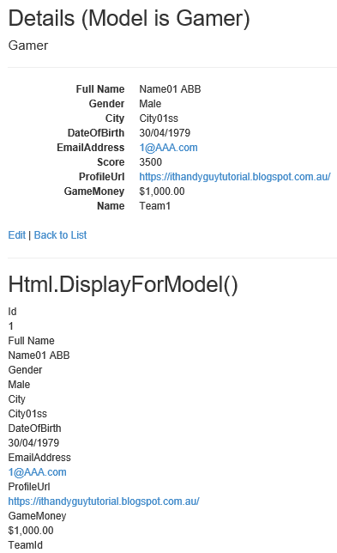

5.9. Views/Gamer/DetailsTwo.cshtml (Display Complex Type Sample)

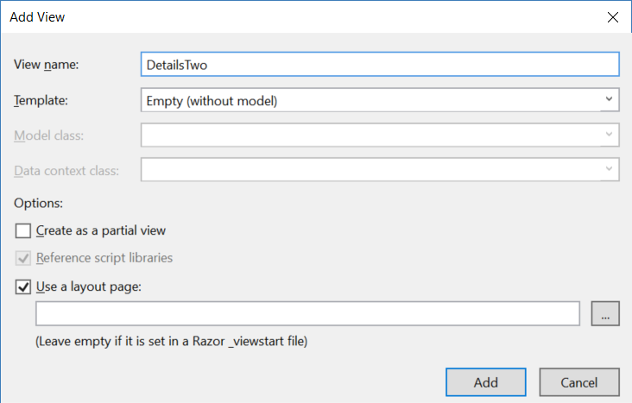

@using OnlineGame.Web.Models

@model BoardGame

@{

    ViewBag.Title = "DetailsTwo";

}

<h2>Display Complex Type Sample</h2>

@Html.DisplayTextFor(model => model.GameHolder)

@*

@Html.DisplayTextFor(model => model.GameHolder)

model.GameHolder will return a Gamer object.

The Gamer class has [DisplayColumn("Name")] attribute,

so it will display Gamer Name property value

which is the full name of that gamer.

*@

5.10. Views/Shared/DisplayTemplates/UrlToNewWindow.cshtml (UIHint Sample)

<a href="@ViewData.Model" target="_blank">@ViewData.Model</a>

@*

1.

//target="_blank"

measn open the link to new windows.

8.

8.1.

In the Models/Gamer/GamerMetaData.cs

//[DataType(DataType.Url)]

//[UIHint("UrlToNewWindow")]

//public string ProfileUrl { get; set; }

[DataType(DataType.Url)] attribute will display a hyperlink.

[UIHint("UrlToNewWindow")] attribute specify the name of view DisplayTemplate

to display the property data.

In this case, it will look for "DisplayTemplates/UrlToNewWindow.cshtml"

under "Shared" folder or "Gamer" folder.

Use that view template to disply the data of this property.

8.2.

//<a href="@ViewData.Model" target="_blank">@ViewData.Model</a>

In the Shared/DisplayTemplates/UrlToNewWindow.cshtml,

@ViewData.Model will take the Model data from the parent view.

In this case, it will return a profile url.

*@

5.11. Views/Gamer/DetailsThree.cshtml ([HiddenInput(DisplayValue = false)], [ReadOnly(true)])

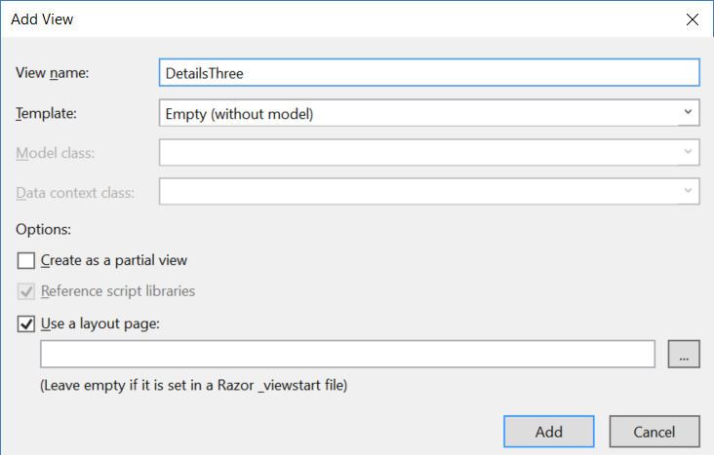

@model OnlineGame.Web.Models.GamerA

@{

    ViewBag.Title = "DetailsThree";

}

<h2>DetailsThree</h2>

<h2>Details (Model is GamerA)</h2>

<div>

    <h4>Gamer</h4>

    <hr />

    <dl class="dl-horizontal">

        <dt>

            @Html.DisplayNameFor(model => model.Name)

        </dt>

        <dd>

            @Html.DisplayFor(model => model.Name)

        </dd>

        <dt>

            @Html.DisplayNameFor(model => model.Gender)

        </dt>

        <dd>

            @Html.DisplayFor(model => model.Gender)

        </dd>

        <dt>

            @Html.DisplayNameFor(model => model.City)

        </dt>

        <dd>

            @Html.DisplayFor(model => model.City)

        </dd>

        <dt>

            @Html.DisplayNameFor(model => model.DateOfBirth)

        </dt>

        <dd>

            @Html.DisplayFor(model => model.DateOfBirth)

        </dd>

        <dt>

            @Html.DisplayNameFor(model => model.EmailAddress)

        </dt>

        <dd>

            @Html.DisplayFor(model => model.EmailAddress)

        </dd>

        <dt>

            @Html.DisplayNameFor(model => model.Score)

        </dt>

        <dd>

            @Html.DisplayFor(model => model.Score)

        </dd>

        <dt>

            @Html.DisplayNameFor(model => model.ProfileUrl)

        </dt>

        <dd>

            @Html.DisplayFor(model => model.ProfileUrl)

        </dd>

        <dt>

            @Html.DisplayNameFor(model => model.GameMoney)

        </dt>

        <dd>

            @Html.DisplayFor(model => model.GameMoney)

        </dd>

        <dt>

            @Html.DisplayNameFor(model => model.Team.Name)

        </dt>

        <dd>

            @Html.DisplayFor(model => model.Team.Name)

        </dd>

    </dl>

</div>

<p>

    @Html.ActionLink("Edit", "Edit", new { id = Model.Id }) |

    @Html.ActionLink("Back to List", "Index")

</p>

<hr />

<h2>Html.DisplayForModel()</h2>

@Html.DisplayForModel()

@*

4.

There are 2 categories of built-in templated helpers.

-----------------------------

4.1.

Display Templates

-----------------

4.1.1.

//@Html.DisplayFor(model => model.Name)

The view must have strongly typed view Model.

It can work with the complex type Model property.

It is similar to @Html.DisplayTextFor(model => model.GameHolder)

//@Html.DisplayTextFor(model => model.GameHolder)

model.GameHolder will return a Gamer object.

The Gamer class has [DisplayColumn("Name")] attribute,

so it will display Gamer Name property value

which is the full name of that gamer.

-----------------

4.1.2.

//@Html.DisplayForModel()

The view must have strongly typed view Model.

It will display every property in view model

except the properties with [ScaffoldColumn(false)] attribute.

-----------------

4.1.3.

@Html.Display helper does not need strongly typed view Mode.

//ViewData["GamerData"] = gamer;

//return View();

In the controller, we put the gamer object into ViewData["GamerData"]

"GamerData" in this case is the key of ViewData.

ViewData["GamerData"] contains that gamer object data,

so we don't have to use a view model.

//@Html.Display("GamerData")

In the view, we use @Html.Display("GamerData")

to retrieve the Gamer data from ViewData["GamerData"].

It will display everything

except the properties with [ScaffoldColumn(false)] attribute.

-----------------------------

4.2.

Display Templates

-----------------

4.2.1.

//@Html.EditorFor(model => model.Name)

The view must have strongly typed view Model.

It will create a textbox for the property value input.

-----------------

4.2.2.

//@Html.EditorForModel()

The view must have strongly typed view Model.

It will create textbox input for every properties in view model

except the properties with [ScaffoldColumn(false)] attribute.

-----------------

4.2.3.

@Html.Editor helper does not need strongly typed view Mode.

//ViewData["GamerData"] = gamer;

//return View();

In the controller, we put the gamer object into ViewData["GamerData"]

"GamerData" in this case is the key of ViewData.

ViewData["GamerData"] contains that gamer object data,

so we don't have to use a view model.

//@Html.Editor("GamerData")

In the view, we use @Html.Editor("GamerData")

to retrieve the Gamer data from ViewData["GamerData"].

It will create textbox input for every properties in ViewData["GamerData"]

except the properties with [ScaffoldColumn(false)] attribute.

However, we pressed submit button and call the [HttpPost] action

//public async Task<ActionResult> EditThree(int id, string name, string gender, string city, DateTime? dateOfBirth, string emailAddress, int? score, string profileUrl, int? gameMoney, int? teamId)

OR

//public async Task<ActionResult> EditThree(Gamer gamer)

Both ways can not retrieve the data because it is not strongly typed.

I don't suggest to use @Html.Editor helper

*@

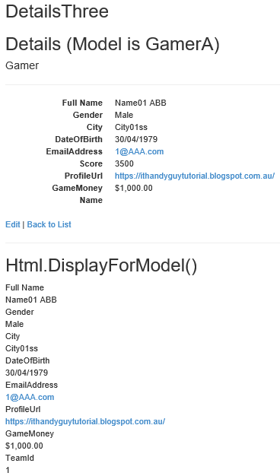

5.12. Views/Gamer/DetailsFour.cshtml (@Html.Display("GamerData") )

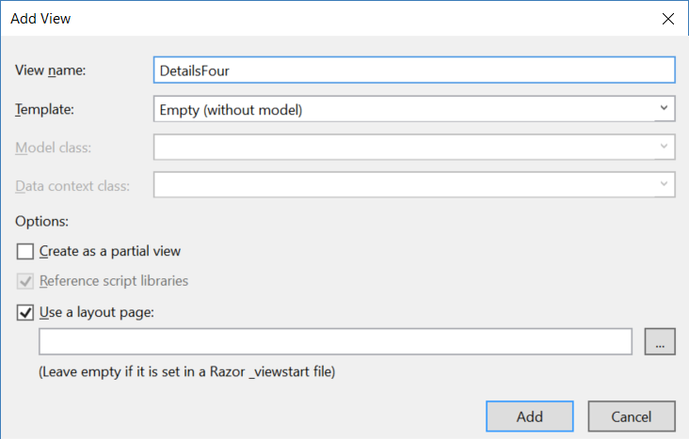

@{

    ViewBag.Title = "DetailsFour";

}

<h2>Html.Display("GamerData")</h2>

@Html.Display("GamerData")

@*

4.

There are 2 categories of built-in templated helpers.

-----------------------------

4.1.

Display Templates

-----------------

4.1.1.

//@Html.DisplayFor(model => model.Name)

The view must have strongly typed view Model.

It can work with the complex type Model property.

It is similar to @Html.DisplayTextFor(model => model.GameHolder)

//@Html.DisplayTextFor(model => model.GameHolder)

model.GameHolder will return a Gamer object.

The Gamer class has [DisplayColumn("Name")] attribute,

so it will display Gamer Name property value

which is the full name of that gamer.

-----------------

4.1.2.

//@Html.DisplayForModel()

The view must have strongly typed view Model.

It will display every property in view model

except the properties with [ScaffoldColumn(false)] attribute.

-----------------

4.1.3.

@Html.Display helper does not need strongly typed view Mode.

//ViewData["GamerData"] = gamer;

//return View();

In the controller, we put the gamer object into ViewData["GamerData"]

"GamerData" in this case is the key of ViewData.

ViewData["GamerData"] contains that gamer object data,

so we don't have to use a view model.

//@Html.Display("GamerData")

In the view, we use @Html.Display("GamerData")

to retrieve the Gamer data from ViewData["GamerData"].

It will display everything

except the properties with [ScaffoldColumn(false)] attribute.

-----------------------------

4.2.

Display Templates

-----------------

4.2.1.

//@Html.EditorFor(model => model.Name)

The view must have strongly typed view Model.

It will create a textbox for the property value input.

-----------------

4.2.2.

//@Html.EditorForModel()

The view must have strongly typed view Model.

It will create textbox input for every properties in view model

except the properties with [ScaffoldColumn(false)] attribute.

-----------------

4.2.3.

@Html.Editor helper does not need strongly typed view Mode.

//ViewData["GamerData"] = gamer;

//return View();

In the controller, we put the gamer object into ViewData["GamerData"]

"GamerData" in this case is the key of ViewData.

ViewData["GamerData"] contains that gamer object data,

so we don't have to use a view model.

//@Html.Editor("GamerData")

In the view, we use @Html.Editor("GamerData")

to retrieve the Gamer data from ViewData["GamerData"].

It will create textbox input for every properties in ViewData["GamerData"]

except the properties with [ScaffoldColumn(false)] attribute.

However, we pressed submit button and call the [HttpPost] action

//public async Task<ActionResult> EditThree(int id, string name, string gender, string city, DateTime? dateOfBirth, string emailAddress, int? score, string profileUrl, int? gameMoney, int? teamId)

OR

//public async Task<ActionResult> EditThree(Gamer gamer)

Both ways can not retrieve the data because it is not strongly typed.

I don't suggest to use @Html.Editor helper

*@

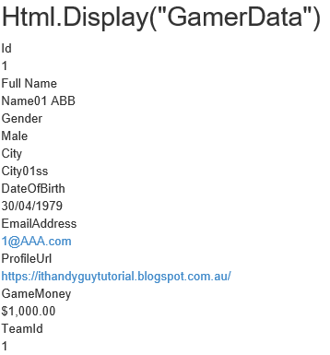

5.13. Views/Gamer/EditTwo.cshtml ([HiddenInput(DisplayValue = false)], [ReadOnly(true)])

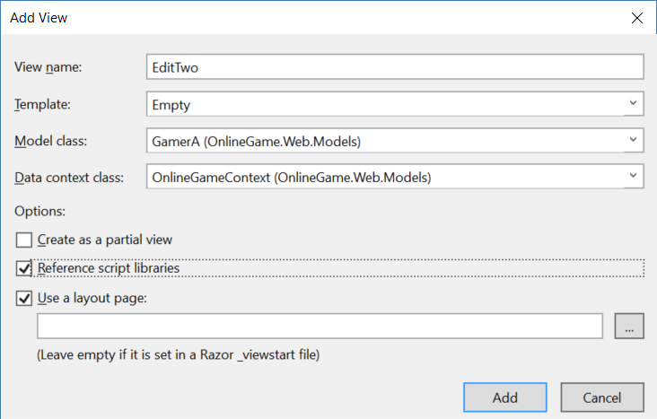

@model OnlineGame.Web.Models.GamerA

@{

    ViewBag.Title = "EditTwo";

}

<h2>EditTwo</h2>

@using (Html.BeginForm("EditTwo", "Gamer"))

{

    @Html.EditorForModel()

    <br />

    <br />

    <input type="submit" value="Save" />

}

@*

4.

There are 2 categories of built-in templated helpers.

-----------------------------

4.1.

Display Templates

-----------------

4.1.1.

//@Html.DisplayFor(model => model.Name)

The view must have strongly typed view Model.

It can work with the complex type Model property.

It is similar to @Html.DisplayTextFor(model => model.GameHolder)

//@Html.DisplayTextFor(model => model.GameHolder)

model.GameHolder will return a Gamer object.

The Gamer class has [DisplayColumn("Name")] attribute,

so it will display Gamer Name property value

which is the full name of that gamer.

-----------------

4.1.2.

//@Html.DisplayForModel()

The view must have strongly typed view Model.

It will display every property in view model

except the properties with [ScaffoldColumn(false)] attribute.

-----------------

4.1.3.

@Html.Display helper does not need strongly typed view Mode.

//ViewData["GamerData"] = gamer;

//return View();

In the controller, we put the gamer object into ViewData["GamerData"]

"GamerData" in this case is the key of ViewData.

ViewData["GamerData"] contains that gamer object data,

so we don't have to use a view model.

//@Html.Display("GamerData")

In the view, we use @Html.Display("GamerData")

to retrieve the Gamer data from ViewData["GamerData"].

It will display everything

except the properties with [ScaffoldColumn(false)] attribute.

-----------------------------

4.2.

Display Templates

-----------------

4.2.1.

//@Html.EditorFor(model => model.Name)

The view must have strongly typed view Model.

It will create a textbox for the property value input.

-----------------

4.2.2.

//@Html.EditorForModel()

The view must have strongly typed view Model.

It will create textbox input for every properties in view model

except the properties with [ScaffoldColumn(false)] attribute.

-----------------

4.2.3.

@Html.Editor helper does not need strongly typed view Mode.

//ViewData["GamerData"] = gamer;

//return View();

In the controller, we put the gamer object into ViewData["GamerData"]

"GamerData" in this case is the key of ViewData.

ViewData["GamerData"] contains that gamer object data,

so we don't have to use a view model.

//@Html.Editor("GamerData")

In the view, we use @Html.Editor("GamerData")

to retrieve the Gamer data from ViewData["GamerData"].

It will create textbox input for every properties in ViewData["GamerData"]

except the properties with [ScaffoldColumn(false)] attribute.

However, we pressed submit button and call the [HttpPost] action

//public async Task<ActionResult>

EditThree(int id, string name, string gender, string city, DateTime? dateOfBirth, string emailAddress, int? score, string profileUrl, int? gameMoney, int? teamId)

OR

//public async Task<ActionResult>

EditThree(Gamer gamer)

Both ways can not retrieve the data because it is not strongly typed.

I don't suggest to use @Html.Editor helper

*@

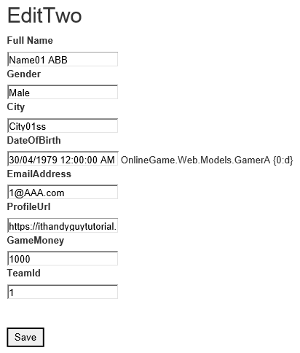

***********************************************************************************

5.14. Views/Gamer/EditThree.cshtml

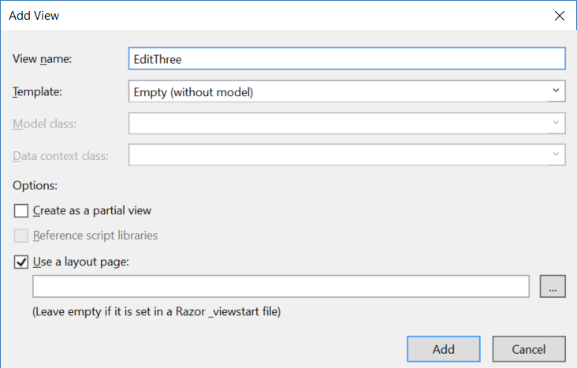

@{

    ViewBag.Title = "EditThree";

}

<h2>Html.Editor("GamerData")</h2>

@using (Html.BeginForm("EditThree", "Gamer"))

{

    @Html.Editor("GamerData")

    <br />

    <br />

    <input type="submit" value="Save" />

}

@*

4.

There are 2 categories of built-in templated helpers.

-----------------------------

4.1.

Display Templates

-----------------

4.1.1.

//@Html.DisplayFor(model => model.Name)

The view must have strongly typed view Model.

It can work with the complex type Model property.

It is similar to @Html.DisplayTextFor(model => model.GameHolder)

//@Html.DisplayTextFor(model => model.GameHolder)

model.GameHolder will return a Gamer object.

The Gamer class has [DisplayColumn("Name")] attribute,

so it will display Gamer Name property value

which is the full name of that gamer.

-----------------

4.1.2.

//@Html.DisplayForModel()

The view must have strongly typed view Model.

It will display every property in view model

except the properties with [ScaffoldColumn(false)] attribute.

-----------------

4.1.3.

@Html.Display helper does not need strongly typed view Mode.

//ViewData["GamerData"] = gamer;

//return View();

In the controller, we put the gamer object into ViewData["GamerData"]

"GamerData" in this case is the key of ViewData.

ViewData["GamerData"] contains that gamer object data,

so we don't have to use a view model.

//@Html.Display("GamerData")

In the view, we use @Html.Display("GamerData")

to retrieve the Gamer data from ViewData["GamerData"].

It will display everything

except the properties with [ScaffoldColumn(false)] attribute.

-----------------------------

4.2.

Display Templates

-----------------

4.2.1.

//@Html.EditorFor(model => model.Name)

The view must have strongly typed view Model.

It will create a textbox for the property value input.

-----------------

4.2.2.

//@Html.EditorForModel()

The view must have strongly typed view Model.

It will create textbox input for every properties in view model

except the properties with [ScaffoldColumn(false)] attribute.

-----------------

4.2.3.

@Html.Editor helper does not need strongly typed view Mode.

//ViewData["GamerData"] = gamer;

//return View();

In the controller, we put the gamer object into ViewData["GamerData"]

"GamerData" in this case is the key of ViewData.

ViewData["GamerData"] contains that gamer object data,

so we don't have to use a view model.

//@Html.Editor("GamerData")

In the view, we use @Html.Editor("GamerData")

to retrieve the Gamer data from ViewData["GamerData"].

It will create textbox input for every properties in ViewData["GamerData"]

except the properties with [ScaffoldColumn(false)] attribute.

However, we pressed submit button and call the [HttpPost] action

//public async Task<ActionResult>

EditThree(int id, string name, string gender, string city, DateTime? dateOfBirth, string emailAddress, int? score, string profileUrl, int? gameMoney, int? teamId)

OR

//public async Task<ActionResult>

EditThree(Gamer gamer)

Both ways can not retrieve the data because it is not strongly typed.

I don't suggest to use @Html.Editor helper

*@

5.15. Views/Shared/EditorTemplates/DateTime.cshtml

@model DateTime?

<link href="~/Content/themes/base/jquery-ui.min.css" rel="stylesheet" />

<link href="~/Content/bootstrap.css" rel="stylesheet" />

<script src="~/Scripts/jquery-1.12.4.min.js"></script>

<script src="~/Scripts/jquery-ui-1.12.1.min.js"></script>

<script src="~/Scripts/bootstrap.min.js"></script>

<script src="~/Scripts/jquery.validate.min.js"></script>

<script src="~/Scripts/jquery.validate.unobtrusive.min.js"></script>

@*@Html.TextBox("", (Model.HasValue ? Model.Value.ToString("yyyy/MM/dd") : string.Empty), new { @class = "date" })*@

@{

    object formattedModelValue = ViewData.TemplateInfo.FormattedModelValue;

    ViewBag.Title = "Edit";

}

@Html.TextBox("", (Model.HasValue ? @ViewData.TemplateInfo.FormattedModelValue : string.Empty), new { @class = "date" })

@ViewData.ModelMetadata.ContainerType.ToString()

@*OnlineGame.Web.Models.Gamer*@

@ViewData.ModelMetadata.DisplayFormatString

@*{0:dd/MM/yyyy}*@

<script type="text/javascript">

    $(function () {

        $("input:text.date").datepicker(

            {

                //dateFormat: "yy/mm/dd"

                dateFormat: "dd/mm/yy"

            });

    });

</script>

@*

10. EditorTemplates and DisplayTemplates by MVC convention

10.1.

DisplayTemplates

10.1.1.

Views\Shared\DisplayTemplates\UrlToNewWindow.cshtml

Views\Gamer\DisplayTemplates\UrlToNewWindow.cshtml

UrlToNewWindow.cshtml is the DisplayTemplate which must under "DisplayTemplates" folder.

Views\Shared\DisplayTemplates\UrlToNewWindow.cshtml means

the template is available for all the views.

Views\Gamer\DisplayTemplates\UrlToNewWindow.cshtml means

the template is available for only the views of Gamer controller.

10.1.2.

Using DisplayTemplates

10.1.2.1.

In the Models/Gamer/GamerMetaData.cs

//[DataType(DataType.Url)]

//[UIHint("UrlToNewWindow")]

//public string ProfileUrl { get; set; }

[DataType(DataType.Url)] attribute will display a hyperlink.

[UIHint("UrlToNewWindow")] attribute specify the name of view DisplayTemplate

to display the property data.

In this case, it will look for "DisplayTemplates/UrlToNewWindow.cshtml"

under "Shared" folder or "Gamer" folder.

Use that view template to disply the data of this property.

10.1.2.2.

//<a href="@ViewData.Model" target="_blank">@ViewData.Model</a>

In the Shared/DisplayTemplates/UrlToNewWindow.cshtml,

@ViewData.Model will take the Model data from the parent view.

In this case, it will return a profile url.

10.2.

EditorTemplates

10.2.1.

Views\Shared\EditorTemplates\DateTime.cshtml

Views\Gamer\EditorTemplates\DateTime.cshtml

DateTime.cshtml is the EditorTemplate which must under "EditorTemplates" folder.

Views\Shared\EditorTemplates\DateTime.cshtml means

the template is available for all the views.

Views\Gamer\EditorTemplates\DateTime.cshtml means

the template is available for only the views of Gamer controller.

10.2.2.

Using EditorTemplates

The EditorTemplate Name must match View Model property Type Name.

E.g. DateTime.ascx or DateTime.cshtml

10.2.2.1.

In the Models/Gamer/GamerMetaData.cs

////[DataType(DataType.Date)] //Views/Shared/EditorTemplates/DateTime.cshtml will not Work.

////[DisplayFormat(DataFormatString = "{0:dd/MM/yyyy hh:mm:ss tt}")]

//[DisplayFormat(DataFormatString = "{0:d}")]

//public Nullable<System.DateTime> DateOfBirth { get; set; }

The type is DateTime, so it will look for the EditorTemplate from

Views\Shared\EditorTemplates\DateTime.cshtml or

Views\Gamer\EditorTemplates\DateTime.cshtml

In this case, Views\Shared\EditorTemplates\DateTime.cshtml will be the EditorTemplate.

The View Model Property in Edit mode will use the EditorTemplate to display.

In this case,

//@model DateTime?

//@Html.TextBox("", (Model.HasValue ? Model.Value.ToString("yyyy/MM/dd") : string.Empty), new { @class = "date" })

So it will add the class="date" to the textbox input.

10.2.2.2.

In the Edit.cshtml

//<link href="~/Content/themes/base/jquery-ui.min.css" rel="stylesheet" />

//<link href="~/Content/bootstrap.css" rel="stylesheet" />

//<script src="~/Scripts/jquery-1.12.4.min.js"></script>

//<script src="~/Scripts/jquery-ui-1.12.1.min.js"></script>

//<script src="~/Scripts/bootstrap.min.js"></script>

    ...

//<script type="text/javascript">

//    $(function () {

//        $("input:text.date").datepicker(

//            {

//                dateFormat: "yy/mm/dd"

//            });

//    });

//</script>

*@

5.16. Views/Gamer/Edit.cshtml

@model OnlineGame.Web.Models.Gamer

@{

    ViewBag.Title = "Edit";

}

<link href="~/Content/themes/base/jquery-ui.min.css" rel="stylesheet" />

<link href="~/Content/bootstrap.css" rel="stylesheet" />

<script src="~/Scripts/jquery-1.12.4.min.js"></script>

<script src="~/Scripts/jquery-ui-1.12.1.min.js"></script>

<script src="~/Scripts/bootstrap.min.js"></script>

<script src="~/Scripts/jquery.validate.min.js"></script>

<script src="~/Scripts/jquery.validate.unobtrusive.min.js"></script>

<h2>Edit</h2>

@using (Html.BeginForm())

{

    @Html.AntiForgeryToken()

    <div class="form-horizontal">

        <h4>Gamer</h4>

        <hr />

        @Html.ValidationSummary(true, "", new { @class = "text-danger" })

        @Html.HiddenFor(model => model.Id)

        <div class="form-group">

            @Html.LabelFor(model => model.Name, htmlAttributes: new { @class = "control-label col-md-2" })

            <div class="col-md-10">

                @Html.EditorFor(model => model.Name, new { htmlAttributes = new { @class = "form-control" } })

                @Html.ValidationMessageFor(model => model.Name, "", new { @class = "text-danger" })

            </div>

        </div>

        <div class="form-group">

            @Html.LabelFor(model => model.Gender, htmlAttributes: new { @class = "control-label col-md-2" })

            <div class="col-md-10">

                @Html.EditorFor(model => model.Gender, new { htmlAttributes = new { @class = "form-control" } })

                @Html.ValidationMessageFor(model => model.Gender, "", new { @class = "text-danger" })

            </div>

        </div>

        <div class="form-group">

            @Html.LabelFor(model => model.City, htmlAttributes: new { @class = "control-label col-md-2" })

            <div class="col-md-10">

                @Html.EditorFor(model => model.City, new { htmlAttributes = new { @class = "form-control" } })

                @Html.ValidationMessageFor(model => model.City, "", new { @class = "text-danger" })

            </div>

        </div>

        <div class="form-group">

            @Html.LabelFor(model => model.DateOfBirth, htmlAttributes: new { @class = "control-label col-md-2" })

            <div class="col-md-10">

                @Html.EditorFor(model => model.DateOfBirth, new { htmlAttributes = new { @class = "form-control" } })

                @Html.ValidationMessageFor(model => model.DateOfBirth, "", new { @class = "text-danger" })

            </div>

        </div>

        <div class="form-group">

            @Html.LabelFor(model => model.EmailAddress, htmlAttributes: new { @class = "control-label col-md-2" })

            <div class="col-md-10">

                @Html.EditorFor(model => model.EmailAddress, new { htmlAttributes = new { @class = "form-control" } })

                @Html.ValidationMessageFor(model => model.EmailAddress, "", new { @class = "text-danger" })

            </div>

        </div>

        <div class="form-group">

            @Html.LabelFor(model => model.Score, htmlAttributes: new { @class = "control-label col-md-2" })

            <div class="col-md-10">

                @Html.EditorFor(model => model.Score, new { htmlAttributes = new { @class = "form-control" } })

                @Html.ValidationMessageFor(model => model.Score, "", new { @class = "text-danger" })

            </div>

        </div>

        <div class="form-group">

            @Html.LabelFor(model => model.ProfileUrl, htmlAttributes: new { @class = "control-label col-md-2" })

            <div class="col-md-10">

                @Html.EditorFor(model => model.ProfileUrl, new { htmlAttributes = new { @class = "form-control" } })

                @Html.ValidationMessageFor(model => model.ProfileUrl, "", new { @class = "text-danger" })

            </div>

        </div>

        <div class="form-group">

            @Html.LabelFor(model => model.GameMoney, htmlAttributes: new { @class = "control-label col-md-2" })

            <div class="col-md-10">

                @Html.EditorFor(model => model.GameMoney, new { htmlAttributes = new { @class = "form-control" } })

                @Html.ValidationMessageFor(model => model.GameMoney, "", new { @class = "text-danger" })

            </div>

        </div>

        <div class="form-group">

            @Html.LabelFor(model => model.TeamId, "TeamId", htmlAttributes: new { @class = "control-label col-md-2" })

            <div class="col-md-10">

                @Html.DropDownList("TeamId", null, htmlAttributes: new { @class = "form-control" })

                @Html.ValidationMessageFor(model => model.TeamId, "", new { @class = "text-danger" })

            </div>

        </div>

        <div class="form-group">

            <div class="col-md-offset-2 col-md-10">

                <input type="submit" value="Save" class="btn btn-default" />

            </div>

        </div>

    </div>

}

<div>

    @Html.ActionLink("Back to List", "Index")

</div>

@*

1.

1.1.

//@Html.HiddenFor(model => model.Name, new { htmlAttributes = new { @class = "form-control" } })

It will create the following.

//<input data-val="true" data-val-required="The Name field is required." htmlattributes="{ class = form-control }" id="Name" name="Name" type="hidden" value="Name01 ABB">

1.2.

//@Html.DisplayFor(model => model.Name, new { htmlAttributes = new { @class = "form-control" } })

It will create the following.

//Name01 ABB

1.3.

//@Html.EditorFor(model => model.Name, new {htmlAttributes = new {@class = "form-control"}})

It will create the following.

//<input class="form-control text-box single-line valid" id="Name" name="Name" type="text" value="Name01 ABB">

----------------------------------------------------

4.

There are 2 categories of built-in templated helpers.

-----------------------------

4.1.

Display Templates

-----------------

4.1.1.

//@Html.DisplayFor(model => model.Name)

The view must have strongly typed view Model.

It can work with the complex type Model property.

It is similar to @Html.DisplayTextFor(model => model.GameHolder)

//@Html.DisplayTextFor(model => model.GameHolder)

model.GameHolder will return a Gamer object.

The Gamer class has [DisplayColumn("Name")] attribute,

so it will display Gamer Name property value

which is the full name of that gamer.

-----------------

4.1.2.

//@Html.DisplayForModel()

The view must have strongly typed view Model.

It will display every property in view model

except the properties with [ScaffoldColumn(false)] attribute.

-----------------

4.1.3.

@Html.Display helper does not need strongly typed view Mode.

//ViewData["GamerData"] = gamer;

//return View();

In the controller, we put the gamer object into ViewData["GamerData"]

"GamerData" in this case is the key of ViewData.

ViewData["GamerData"] contains that gamer object data,

so we don't have to use a view model.

//@Html.Display("GamerData")

In the view, we use @Html.Display("GamerData")

to retrieve the Gamer data from ViewData["GamerData"].

It will display everything

except the properties with [ScaffoldColumn(false)] attribute.

-----------------------------

4.2.

Display Templates

-----------------

4.2.1.

//@Html.EditorFor(model => model.Name)

The view must have strongly typed view Model.

It will create a textbox for the property value input.

-----------------

4.2.2.

//@Html.EditorForModel()

The view must have strongly typed view Model.

It will create textbox input for every properties in view model

except the properties with [ScaffoldColumn(false)] attribute.

-----------------

4.2.3.

@Html.Editor helper does not need strongly typed view Mode.

//ViewData["GamerData"] = gamer;

//return View();

In the controller, we put the gamer object into ViewData["GamerData"]

"GamerData" in this case is the key of ViewData.

ViewData["GamerData"] contains that gamer object data,

so we don't have to use a view model.

//@Html.Editor("GamerData")

In the view, we use @Html.Editor("GamerData")

to retrieve the Gamer data from ViewData["GamerData"].

It will create textbox input for every properties in ViewData["GamerData"]

except the properties with [ScaffoldColumn(false)] attribute.

However, we pressed submit button and call the [HttpPost] action

//public async Task<ActionResult>

EditThree(int id, string name, string gender, string city, DateTime? dateOfBirth, string emailAddress, int? score, string profileUrl, int? gameMoney, int? teamId)

OR

//public async Task<ActionResult>

EditThree(Gamer gamer)

Both ways can not retrieve the data because it is not strongly typed.

I don't suggest to use @Html.Editor helper

*@

5.17. Add Jquery UI

Install Jquery UI from NuGet Package

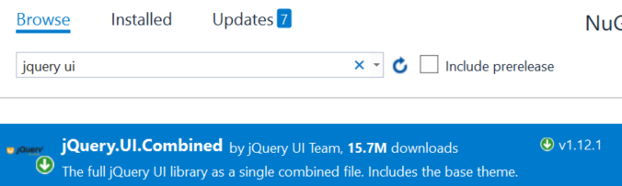

5.18. Views/Gamer/Create.cshtml

@model OnlineGame.Web.Models.Gamer

@{

    ViewBag.Title = "Create";

}

<h2>Create</h2>

@using (Html.BeginForm())

{

    @Html.AntiForgeryToken()

    <div class="form-horizontal">

        <h4>Gamer</h4>

        <hr />

        @Html.ValidationSummary(true, "", new { @class = "text-danger" })

        <div class="form-group">

            @Html.LabelFor(model => model.Name, htmlAttributes: new { @class = "control-label col-md-2" })

            <div class="col-md-10">

                @Html.EditorFor(model => model.Name, new { htmlAttributes = new { @class = "form-control" } })

                @Html.ValidationMessageFor(model => model.Name, "", new { @class = "text-danger" })

            </div>

        </div>

        <div class="form-group">

            @Html.LabelFor(model => model.Gender, htmlAttributes: new { @class = "control-label col-md-2" })

            <div class="col-md-10">

                @Html.EditorFor(model => model.Gender, new { htmlAttributes = new { @class = "form-control" } })

                @Html.ValidationMessageFor(model => model.Gender, "", new { @class = "text-danger" })

            </div>

        </div>

        <div class="form-group">

            @Html.LabelFor(model => model.City, htmlAttributes: new { @class = "control-label col-md-2" })

            <div class="col-md-10">

                @Html.EditorFor(model => model.City, new { htmlAttributes = new { @class = "form-control" } })

                @Html.ValidationMessageFor(model => model.City, "", new { @class = "text-danger" })

            </div>

        </div>

        <div class="form-group">

            @Html.LabelFor(model => model.DateOfBirth, htmlAttributes: new { @class = "control-label col-md-2" })

            <div class="col-md-10">

                @Html.EditorFor(model => model.DateOfBirth, new { htmlAttributes = new { @class = "form-control" } })

                @Html.ValidationMessageFor(model => model.DateOfBirth, "", new { @class = "text-danger" })

            </div>

        </div>

        <div class="form-group">

            @Html.LabelFor(model => model.EmailAddress, htmlAttributes: new { @class = "control-label col-md-2" })

            <div class="col-md-10">

                @Html.EditorFor(model => model.EmailAddress, new { htmlAttributes = new { @class = "form-control" } })

                @Html.ValidationMessageFor(model => model.EmailAddress, "", new { @class = "text-danger" })

            </div>

        </div>

        <div class="form-group">

            @Html.LabelFor(model => model.Score, htmlAttributes: new { @class = "control-label col-md-2" })

            <div class="col-md-10">

                @Html.EditorFor(model => model.Score, new { htmlAttributes = new { @class = "form-control" } })

                @Html.ValidationMessageFor(model => model.Score, "", new { @class = "text-danger" })

            </div>

        </div>

        <div class="form-group">

            @Html.LabelFor(model => model.ProfileUrl, htmlAttributes: new { @class = "control-label col-md-2" })

            <div class="col-md-10">

                @Html.EditorFor(model => model.ProfileUrl, new { htmlAttributes = new { @class = "form-control" } })

                @Html.ValidationMessageFor(model => model.ProfileUrl, "", new { @class = "text-danger" })

            </div>

        </div>

        <div class="form-group">

            @Html.LabelFor(model => model.GameMoney, htmlAttributes: new { @class = "control-label col-md-2" })

            <div class="col-md-10">

                @Html.EditorFor(model => model.GameMoney, new { htmlAttributes = new { @class = "form-control" } })

                @Html.ValidationMessageFor(model => model.GameMoney, "", new { @class = "text-danger" })

            </div>

        </div>

        <div class="form-group">

            @Html.LabelFor(model => model.TeamId, "TeamId", htmlAttributes: new { @class = "control-label col-md-2" })

            <div class="col-md-10">

                @Html.DropDownList("TeamId", null, htmlAttributes: new { @class = "form-control" })

                @Html.ValidationMessageFor(model => model.TeamId, "", new { @class = "text-danger" })

            </div>

        </div>

        <div class="form-group">

            <div class="col-md-offset-2 col-md-10">

                <input type="submit" value="Create" class="btn btn-default" />

            </div>

        </div>

    </div>

}

<div>

    @Html.ActionLink("Back to List", "Index")

</div>

<script src="~/Scripts/jquery-1.10.2.min.js"></script>

<script src="~/Scripts/jquery.validate.min.js"></script>

<script src="~/Scripts/jquery.validate.unobtrusive.min.js"></script>

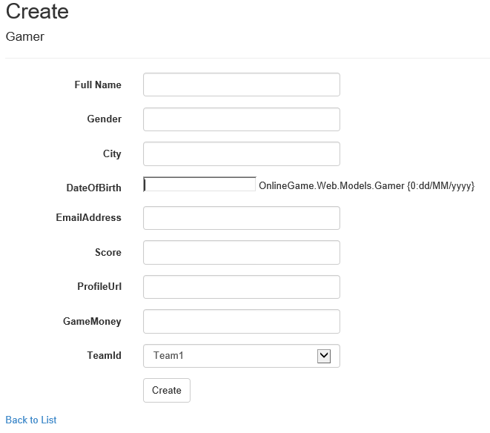

5.19. Views/Gamer/Delete.cshtml

@model OnlineGame.Web.Models.Gamer

@{

    ViewBag.Title = "Delete";

}

<h2>Delete</h2>

<h3>Are you sure you want to delete this?</h3>

<div>

    <h4>Gamer</h4>

    <hr />

    <dl class="dl-horizontal">

        <dt>

            @Html.DisplayNameFor(model => model.Name)

        </dt>

        <dd>

            @Html.DisplayFor(model => model.Name)

        </dd>

        <dt>

            @Html.DisplayNameFor(model => model.Gender)

        </dt>

        <dd>

            @Html.DisplayFor(model => model.Gender)

        </dd>

        <dt>

            @Html.DisplayNameFor(model => model.City)

        </dt>

        <dd>

            @Html.DisplayFor(model => model.City)

        </dd>

        <dt>

            @Html.DisplayNameFor(model => model.DateOfBirth)

        </dt>

        <dd>

            @Html.DisplayFor(model => model.DateOfBirth)

        </dd>

        <dt>

            @Html.DisplayNameFor(model => model.EmailAddress)

        </dt>

        <dd>

            @Html.DisplayFor(model => model.EmailAddress)

        </dd>

        <dt>

            @Html.DisplayNameFor(model => model.Score)

        </dt>

        <dd>

            @Html.DisplayFor(model => model.Score)

        </dd>

        <dt>

            @Html.DisplayNameFor(model => model.ProfileUrl)

        </dt>

        <dd>

            @Html.DisplayFor(model => model.ProfileUrl)

        </dd>

        <dt>

            @Html.DisplayNameFor(model => model.GameMoney)

        </dt>

        <dd>

            @Html.DisplayFor(model => model.GameMoney)

        </dd>

        <dt>

            @Html.DisplayNameFor(model => model.Team.Name)

        </dt>

        <dd>

            @Html.DisplayFor(model => model.Team.Name)

        </dd>

    </dl>

    @using (Html.BeginForm()) {

        @Html.AntiForgeryToken()

        <div class="form-actions no-color">

            <input type="submit" value="Delete" class="btn btn-default" /> |

            @Html.ActionLink("Back to List", "Index")

        </div>

    }

</div>

