Appendix C: IEEE 830 Template
Software Requirements Specification
for
Early dam overflow detection system system
Version Final
Prepared by Maciej Łęcki
27.04.2026
Table of Contents
Revision History
Name | Date | Reason for Changes | Version
Maciej Łęcki | 27.04.2026 | Initial version | V1
Maciej Łęcki | 08.05.2026 | Section 2 and 3 | V2
Maciej Łęcki | 15.05.2026 | Section 4 | V3
Maciej Łęcki | 22.05.2026 | Section 5 and 6 | Final
1. Introduction
1.1. Purpose
The purpose of this document is to specify the software requirements for Version 1.0 of the Early Dam Overflow Detection System (EDODS). This specification covers the complete conceptual system, including data ingestion from water level sensors and the logic for the alert software. While the full system is described here, only the core monitoring and alerting module will be realized during the final part of these laboratories.
1.2. Document Conventions
Document Conventions
This document follows the IEEE 830 standard for software requirements. The following typographical conventions are used:
- Requirement Tags: Functional requirements are labeled as REQ-[Number].
- Priorities: Unless otherwise stated, it is assumed that priorities for higher-level requirements are inherited by detailed requirements.
- Emphasis: Bold text is used for key system components and critical alerts.
1.3. Intended Audience and Reading Suggestions
Intended Audience and Reading Suggestions
This document is intended for several types of readers:
- Developers & Realizers: To guide the implementation of the sensor-alert module.
- Lab Instructors: For assessment of the system design and project progress.
- Testers: To verify that the software correctly triggers alerts based on sensor data.
Organization & Reading Sequence:
- Overview: Readers should start with Section 1.4 (Product Scope) and Section 2 (Overall Description) to understand the system’s goals.
- Implementation Focus: Developers should focus on Section 5 (System Features/Modules), which details the specific logic for the module being realized.
- Non-functional Constraints: Section 6 should be consulted for performance and security expectations.
1.4. Product Scope
Product Scope
The Early Dam Overflow Detection System is designed to provide real-time monitoring of dam water levels to mitigate the risk of catastrophic failure and flooding.
- Software Capabilities: The software will process incoming data from physical or simulated water level sensors, compare these levels against predefined safety thresholds, and trigger automated alerts (such as visual displays or notifications) when levels become critical.
- Benefits: The system automates the monitoring process, reducing the need for constant manual oversight and providing faster reaction times during environmental emergencies.
- Objectives: To deliver a reliable, real-time warning module that demonstrates the integration of hardware input with software logic
1.5. References
The following documents were used to establish these requirements:
- IEEE Std 830, IEEE Recommended Practice for Software Requirements Specifications.
- Laboratory Assignment Document: Provided for the course.
2. Overall Description
2.1. Product Perspective
The Early Dam Overflow Detection System is a new, self-contained software designed to replace or supplement manual dam monitoring. It acts as a critical intermediary between remote hardware and human operators, ensuring real-time environmental safety.
2.2. Product Features
- System processes incoming data from physical water level sensors.
- The software compares real-time water levels against predefined safety thresholds.
- The system triggers automated visual displays and notifications when water levels become critical.
2.3. User Classes and Characteristics
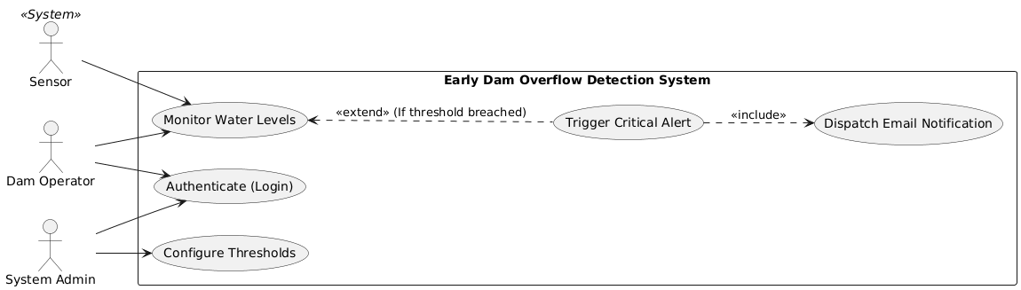
2.4. Operating Environment
The core monitoring and alerting module will operate on a central monitoring server located at the dam facility, interacting with distributed physical water level sensors deployed in the field.
2.5. Design and Implementation Constraints
- The software must read telemetry data from provided physical or simulated water level sensors without requiring hardware modifications.
- The system is constrained to using standard external APIs for dispatching SMS and email notifications.
- Developers must exclusively use the Argon2 algorithm for hashing administrator passwords.
2.6. User Documentation
- Operator Dashboard Guide: A concise manual detailing how to read sensor data and respond to visual alerts.
- Administrator Configuration Manual: Documentation covering sensor setup and threshold management.
2.7. Assumptions and Dependencies
- It is assumed that the physical or simulated water level sensors will continuously transmit data without prolonged hardware failure.
- The software relies on a stable network connection to receive data and dispatch external alerts.
3. System Features
3.1. Water Level Monitoring
This feature handles the continuous ingestion and evaluation of data from connected water level sensors.
3.2 Automated Alert Management
This feature controls the logic for triggering and dispatching visual or text-based notifications when safety thresholds are breached.
4. External Interface Requirements
4.1. User Interfaces Overview
The system shall provide a Graphical User Interface dashboard for Dam Operators. The dashboard will feature real-time data visualization and distinct visual indicators when alerts are triggered.
4.2. Hardware Interfaces
The software must establish a connection protocol to interface directly with physical water level sensors to receive continuous telemetry data.
4.3. Software Interfaces
The system will interface with standard external email and SMS APIs to dispatch automated notifications when critical thresholds are met.
5. System Features/Modules
5.1.1 Description and Priority
This is the core, high-priority module responsible for ensuring the dam does not overflow by tracking water levels and notifying personnel.
5.1.2 Stimulus/Response Sequences
Stimulus: A sensor transmits a new water level reading.
Response: The system logs the reading and updates the operator dashboard.
Stimulus: The incoming water level reading exceeds the predefined critical threshold.
Response: The system triggers an immediate visual alert and dispatches an automated notification.
5.1.3 Functional Requirements
REQ-1.1: The system shall ingest and log water level data from connected sensors every 1 minute.
REQ-1. The system shall display real-time water levels on the central operator dashboard.
REQ-1. The system shall trigger a critical visual display alert on the dashboard within 5 seconds of a sensor reading exceeding the maximum safety threshold.
REQ-1. The system shall send an automated notification via email to designated Dam Operators when a critical alert is triggered.
REQ-1. The system shall allow System Administrators to define and update the numerical values for warning and critical water level thresholds.
6. Nonfunctional Requirements
6.1. Performance
NF-1.1: The system shall process and respond to incoming sensor data queries in < 2 seconds.
NF-1.2 The system shall maintain 99.5% uptime to ensure continuous monitoring of the dam environment.
6.2. Security
NF-2.1: All administrator passwords used to access threshold configuration settings shall be hashed securely using Argon2.

