Appendix C: IEEE 830 Template
Software Requirements Specification
for
Early dam overflow detection system system
Version 2
Prepared by Maciej Łęcki
27.04.2026
Table of Contents
Revision History
Name | Date | Reason for Changes | Version
Maciej Łęcki | 27.04.2026 | Initial version | V1
Maciej Łęcki | 08.05.2026 | Section 2 and 3 | V2
1. Introduction
1.1. Purpose
The purpose of this document is to specify the software requirements of the Early Dam Overflow Detection System. This specification covers the complete system, including data ingestion from water level sensors and the logic for the alert software.
1.2. Document Conventions
This document follows the IEEE 830 standard for software requirements. The following typographical conventions are used:
- Requirement Tags: Functional requirements are labeled as REQ-[Number].
- Priorities: Unless otherwise stated, it is assumed that priorities for higher-level requirements are inherited by detailed requirements.
- Emphasis: Bold text is used for key system components and critical alerts.
1.3. Intended Audience and Reading Suggestions
This document is intended for several types of readers:
- Developers & Realizers: To guide the implementation of the sensor-alert module.
- Lab Instructors: For assessment of the system design and project progress.
- Testers: To verify that the software correctly triggers alerts based on sensor data.
Organization & Reading Sequence:
- Overview: Readers should start with Section 1.4 (Product Scope) and Section 2 (Overall Description) to understand the system’s goals.
- Implementation Focus: Developers should focus on Section 5 (System Features/Modules), which details the specific logic for the module being realized.
- Non-functional Constraints: Section 6 should be consulted for performance and security expectations.
1.4. Product Scope
The Early Dam Overflow Detection System is designed to provide real-time monitoring of dam water levels to mitigate the risk of catastrophic failure and flooding.
- Software Capabilities: The software will process incoming data from physical or simulated water level sensors, compare these levels against predefined safety thresholds, and trigger automated alerts (such as visual displays or notifications) when levels become critical.
- Benefits: The system automates the monitoring process, reducing the need for constant manual oversight and providing faster reaction times during environmental emergencies.
- Objectives: To deliver a reliable, real-time warning module that demonstrates the integration of hardware input with software logic
1.5. References
The following documents were used to establish these requirements:
- IEEE Std 830, IEEE Recommended Practice for Software Requirements Specifications.
- Laboratory Assignment Document: Provided for the course.
2. Overall Description
2.1. Product Perspective
The Early Dam Overflow Detection System is a new, self-contained software designed to replace or supplement manual dam monitoring. It acts as a critical intermediary between remote hardware and human operators, ensuring real-time environmental safety.
2.2. Product Features
- System processes incoming data from physical water level sensors.
- The software compares real-time water levels against predefined safety thresholds.
- The system triggers automated visual displays and notifications when water levels become critical.
2.3. User Classes and Characteristics
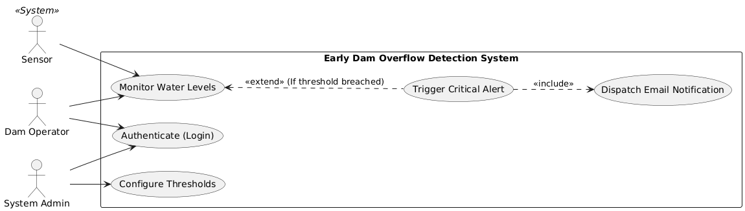
2.4. Operating Environment
The core monitoring and alerting module will operate on a central monitoring server located at the dam facility, interacting with distributed physical water level sensors deployed in the field.
2.5. Design and Implementation Constraints
- The software must read telemetry data from provided physical or simulated water level sensors without requiring hardware modifications.
- The system is constrained to using standard external APIs for dispatching SMS and email notifications.
- Developers must exclusively use the Argon2 algorithm for hashing administrator passwords.
2.6. User Documentation
- Operator Dashboard Guide: A concise manual detailing how to read sensor data and respond to visual alerts.
- Administrator Configuration Manual: Documentation covering sensor setup and threshold management.
2.7. Assumptions and Dependencies
- It is assumed that the physical or simulated water level sensors will continuously transmit data without prolonged hardware failure.
- The software relies on a stable network connection to receive data and dispatch external alerts.
3. System Features
3.1. Water Level Monitoring
This feature handles the continuous ingestion and evaluation of data from connected water level sensors.
3.2 Automated Alert Management
This feature controls the logic for triggering and dispatching visual or text-based notifications when safety thresholds are breached.
4. External Interface Requirements
4.1. User Interfaces Overview
«Describe the high level functionality of the system from the user’s perspective. Explain how the user should be able to use your system to complete all the expected features and the feedback information that will be displayed for the user (for each screen the user will see). For example, specify whether it is GUI or text based interface and how at high level it would work. Discuss at high level how user will interact with the game such as clicking buttons, typing in some selection character, etc.»
«Describe the minimum requirements for the interface. This may include some sample screen images whether for text or GUI approach, any GUI standards or product family style guides that are to be followed, screen layout constraints, for GUI standard buttons and functions (e.g., help) that must appear on every screen, keyboard shortcuts, error message display standards, and so on»
4.2. Hardware Interfaces
«Describe the logical and physical characteristics of each interface between the software product and the hardware components of the system. This may include the supported device types, the nature of the data and control interactions between the software and the hardware, and communication protocols to be used.»
4.3. Software Interfaces
«Describe the connections between this product and other specific software components (name and version), including databases, interpreters, operating systems, tools, libraries, and integrated commercial components. Identify the data items or messages coming into the system and going out and describe the purpose of each. Describe the services needed and the nature of communications. Identify data that will be shared across software components. If the data sharing mechanism must be implemented in a specific way (for example, use of a global data area in a multitasking operating system), specify this as an implementation constraint.»
5. System Features/Modules
«This template illustrates organizing the functional requirements for the product by system features, the major services provided by the product.»
5.1. «System Feature Name»
5.1.1 Description and Priority
«Provide a short description of the feature. Give its priority, too.»
5.1.2 Stimulus/Response Sequences
«”Stimulus” or “Condition”»: «Describe the stimulus or condition»
Response: «Describe the response»
«Additional Stimulus/Response pairs as needed»
5.1.3 Functional Requirements
«Itemize the detailed functional requirements associated with this feature. These are the software capabilities that must be present in order for the user to carry out the services provided by the feature. Include how the product should respond to anticipated error conditions or invalid inputs. Requirements should be concise, complete, unambiguous, verifiable, and necessary. Each requirement should be uniquely identified with a sequence number or a meaningful tag of some kind.»
REQ-1.1: «Some sentence goes here, in “shall” form, usually something like this: “Upon <some event or condition>, the <system, or the name of a module> shall <perform some action>.” Note that the entire requirement must be stated in the requirements area. Everything else is just a lead-up to this. There should be one such entry per S/R pair.»
REQ-1.«N»: «Additional S/R-related requirements as needed.»
REQ-1.«N»: «List any additional requirements needed in “Shall” form, but not necessarily in “Upon/Shall” form.»
REQ-1.«N»: «Additional requirements as needed.»
5.«N». «Additional feature blocks»
6. Nonfunctional Requirements
6.1. Performance
NF-1.1: «Any performance-related issue»
NF-1.«N»: «Any performance-related issue»
6.2. Security
NF-2.1: «Any security-related issue»
NF-2.«N»: «Any security-related issue»
6.«N». «Any additional “nonfunctional” blocks»

