Project 2

Title
“Yahtzee” v0.7.1
Dice Rolling Game

Course
CSC-17A

Section
45398

Due Date
July 31st, 2021

Author
Matthew Mickey

1. Introduction..................... | …......................................3
1a. Proposal................... | …......................................3
2. Game Wiki Link.............. | …......................................4
3. Game flow...................... | …......................................5
4. Development Approach.. | …......................................6
5. Development Summary.. | …......................................7
6. Checkoff List.................. | …......................................8
7. Program flow mechanics | …......................................9
8. Functions........................ | .......................................12
9. Classes........................... | …....................................13
10. Major Variables............. | …....................................14
11. Code............................. | …....................................15

- Introduction

Yahtzee. It's a game that most people have at least heard of and most likely,
have played. I chose this game because my previous game would not have made line count due to how little complexity there was in the game.

Regardless, I found trying to recreate Yahtzee as a CLI game...a bit more complicated than I'd like. More information is in the development summary section.

1a. Proposal

This game will attempt to incorporate all concepts listed on the check-off sheet and what has been covered so far in class. The goal is to utilize everything learned so far. This includes:
- Pointers
- Memory Allocation
- Character arrays & Strings
- Classes
- Static, Friends, and members
- Operator overloading
- Aggregation
- Inheritance
- Templates
- Binary files read/write

This program will be a command-line interface game that one person can play,
solo.

- Game Wiki Link

For a brief overview and history of the game, Wikipedia has a very verbose
article on the game.
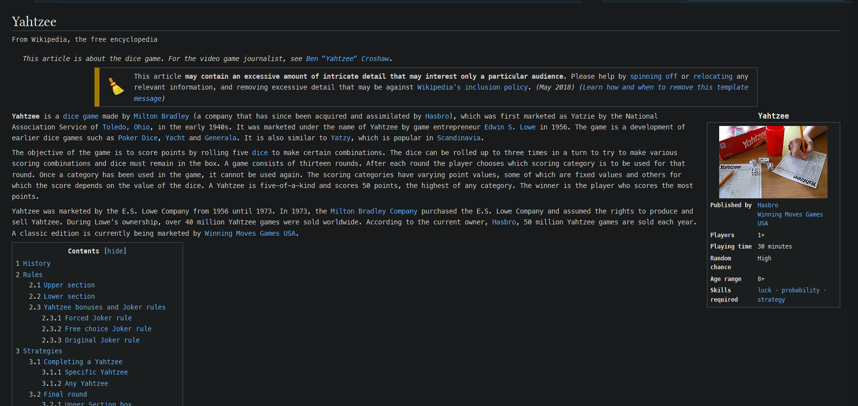

https://en.wikipedia.org/wiki/Yahtzee

- Game flow

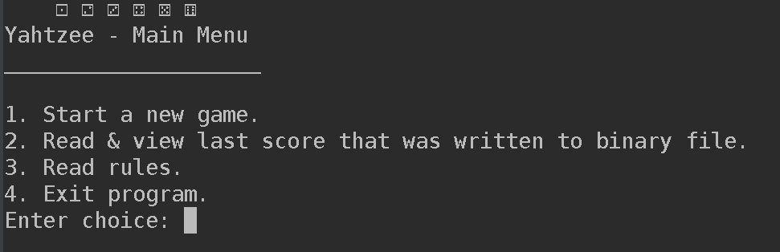

The game works as follows:

One rolls three times in a turn and is allowed to hold and release dice. After three
rolls, the player must select a scoring category. After thirteen turns, the game
is over, and the score is tallied, printed out, and written to a binary file.
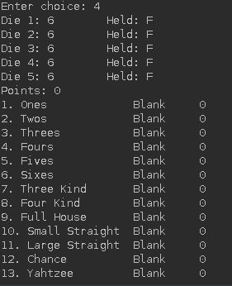
- Development Approach

Goal
The goal of this project was to get out of my comfort zone and apply new
concepts. I'm incredibly terrible at Object Orientated Programming, and I have lousy
programming practices in general. While functional programming will
always be something I prefer, I learned an extreme amount in a short amount of
time, fulfilling my goal.

Classes
Classes allow the ability to create objects that can hold multiple values and
data types of different kinds. With this in mind, it's possible to create more
complicated game logic. Though on the other hand, it's also possible to misuse
this functionality to one's detriment.

There will be seven classes:

1. Menu - Holds most menus.

- GameState - Controls the program & loops states.

- Entity - Barebone class for the player.

- Dice - A single die object. It needs to be an array of objects.

- Player - Built upon Entity class, hold some data & state.

- Scores - Scoring system.

- Check - Confirms & tallies points if category is valid.

Binary Files

In project 1, I only wrote to a binary file. This time, I decided to figure out how to properly read/write from the same binary file.

- At the end of every game, the player score is written to a binary file.

- To read that file, the user may view the score from the main menu.

- There is also fast testing, using debugger tools to quickly start & end games to verify this read/write functionality.

- Development Summary

Total lines: 1320
Lines of code: 848
Comment lines: 228 (~26.9%)
Blank lines: 122
Bracket lines: 25
Template lines: 97

Background on line count

I try to be as upfront as possible, so a proper breakdown is always done for these projects. With a 1000 LOC minimum and 20% afforded to comments, I have 1017 LOC. Bracket lines are lines where many people omit them and do not have them on their separate lines. I prefer doing that to keep my code neater and scope more apparent.

Setbacks
I had a lot of setbacks. For one, I restarted my project three times due to messing up what classes were connected and such. I think it shows how I frantically started passing pointers, a few references, and values to everything in my code. There is also some skeleton code leftover from where I had multiple sources of truth. Unfortunately, I still have my sources of truth split between classes.

Musings
I learned a lot, and I'm grateful for the opportunity I was given this summer. I think things to improve on are just general practice with C++ advanced class topics. Most importantly...better design and programming practices. I need to stop using (*p) and instead use p->.

Project time breakdown:
- 55 hours for actual programming
- 4 hours for flow charting & UML
- 2 hours for planning and designing scope
- 40+ hours for debugging
- 4 hours for writing documentation

Total: 105 hours
6. Checkoff List

Chapter | Section | Concept | Points | Location | Comments
13 | 1 to 3 | Instance of class | 4 | Line 57 - main.cpp | Spread throughout main
 | 4 | Private Data mem. | 4 | Line 21 – Menu.h | Two private mem
 | 5 | Spec vs. Implem. | 4 | All classes? Menu.h & Menu.cpp | All classes are setup this way, with header & cpp seperate
 | 6 | Inline | 4 | Line 36 – Menu.h | Char getPick();
 | 7, 8, 10 | Constructors | 4 | Line 30 – GameState.h | Gamestate overloaded constructor x2; 3 Construct. total
 | 9 | Destructors | 4 | Line 37 – Dice.cpp  Line 33 – Dice.h | Most have class have destructor
 | 12 | Array of Objects | 4 | Line 141 – main.cpp | Not proper static/dynamic, but it is array of object
 | 16 | UML | 4 | Located in documentation folder | I'm not sure if I did the “see/cant see” associations right...
14 | 1 | Static | 5 | Line 16–GameState.h  Line 20-Player.h | I hope I didn't break a rule.
 | 2 | Friends | 2 | Line 37 – Dice.h  Line 41 – Player.h | Almost every class has at least one friend tag.
 | 4 | Copy Constructors | 5 | Line 143 – main.cpp | Tried to make it like book example.
 | 5 | Operator Overload. | 8 | Line 48&49 – GameState.h  Line 48 – Scores.h | Used at:  Line 206&207 – main.cpp  Line 220 – main.cpp
 | 7 | Aggregation | 6 | Line 29 – Player.h | Initializing Entity from player
15 | 1 | Protected Member | 6 | Line 18– Gamestate.h | More in other classes
 | 2 to 5 | Base Class to Der. | 6 | Line 29 – Player.h | 15.2, 15.3, 15.5
 | 6 | Polymorphic Asso. | 6 | N/A | Bad planning structure of classes
 | 7 | Abstract Classes | 6 | N/A | Bad planning structure of classes
16 | 1 | Exceptions | 6 | Line 50 – Menu.cpp | Try catch, throw error at:  line 32 – Menu.cpp
 | 2 to 4 | Templates | 6 | Line 51 – Scores.h | Function template
 | 5 | STL | 6 | Line 35&39 – Scores.cpp | Vector & numeric libraries: accumulate, begin, end, push_back

7. Program Flow Mechanics

The game flow starts by setting a random seed.
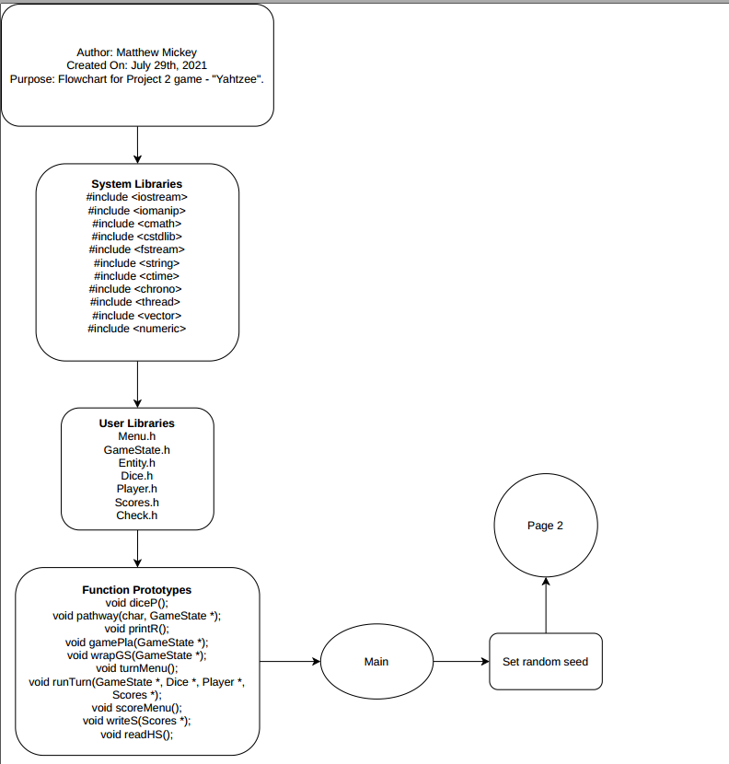

Next, class objects are created. The menu object member is set to true until the program ends. While in this do while loop, a gamestate object is created and some things are printed out, such as a menu. The user is prompted with 4 options. Extra precaution is taken with try/catch blocks spread out inside the menu class methods. If user wants to exit, they may do so and will immediately exit the program.

There is also the ability to read from a binary file. More information is given to the user how to quickly validate if read/write to the same file works. The user may also print the rules. Lastly, if the user wants to play, the gameState object is passed into another function that is basically a loop.
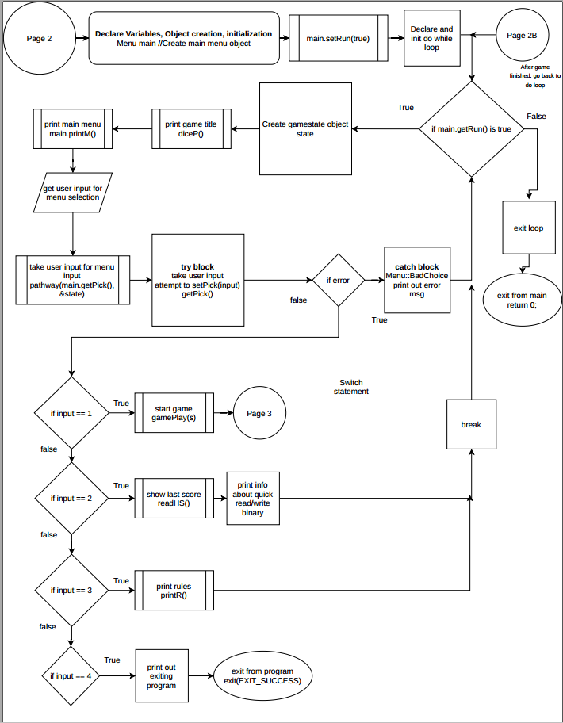

Now that the gameplay loop has started, an array of die is created and their values initialized. A wrapper function is run that sets gameStates to the needed values to start the game. Next, a player & scores object are created.
This loop works by exiting after 13 runTurn() functions have executed. Every time a runTurn() is called, the player is within another loop. This function will allow 3 rolls and a couple more options such as holding/releasing dice. After 3 rolls, the player is forced to choose a score category. After successful validation, the player's points are tallied up, turncount increases by one, then another runTurn() begins.

After 13 turns, the player will exit outside the gameplay loop. Though, before exiting, their score will be written to a binary file, stats will be printed out, then the dice array is cleaned up. (Deleted & set to nullptr).

After game has finished, the player is sent back to the main menu do while loop.

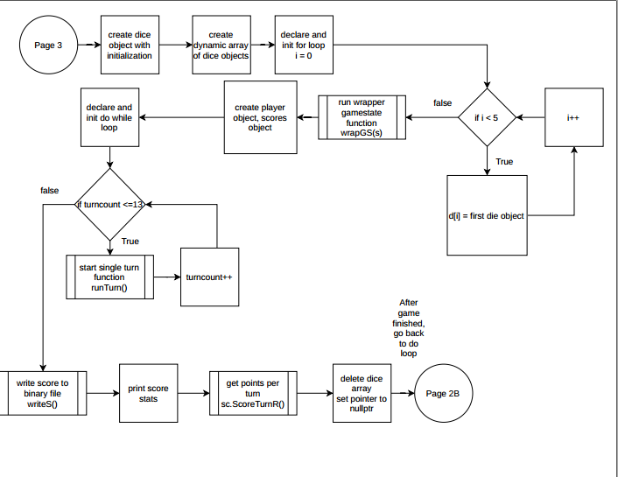

- Functions

- Void diceP()
  - Prints dice unicode art
- Void pathway(char, GameState *)
  - Acts as a wrapper function for initVal and initDie; creates gamestate structure.
- Void printR()
  - Prints rules for user
- Void gamePla(GameState *)
  - Main Gameplay loop
- Void wrapGS(GameState *)
  - Wrapper function for gamestate switches
- Void turnMenu()
  - Print out 4 options for each turn
- Void runTurn(GameState *, Dice *, Player *, Scores *)
  - One-turn gameplay loop
- Void scoreMenu()
  - Print out score options for player
- Void writeS(Scores *)
  - Write player's session score to binary file
- Void readHS()
  - Read from binary session score file

- Classes

Listed earlier, though here is a UML diagram showing the classes. Can be found in the documentation folder for better viewing.

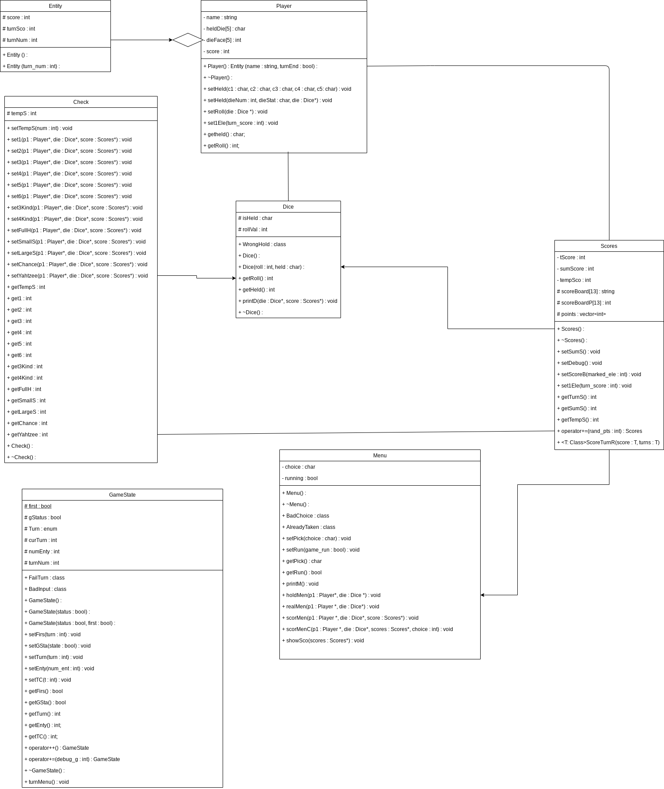

- Major Variables

- bool running – Main program loop exit condition
  - Menu.h
- char isHeld – Dice status of being held by player or not
  - Dice.h
- int rollVal – Dice roll value
  - Dice.h
- bool gStatus – Check if theres an active game
  - GameState.h
- int turnNum – Turn count; important for exit condition
  - GameState.h
- char heldDie[5] – Status for player
  - Player.h
- int dieFace[5] – Rolls for player
  - Player.h
- int sumScore – Total sum score
  - Scores.h
- string scoreBoard[13] – Status of score category printout
  - Scores.h
- int scoreBoardP[13] – Current points for each score category
  - Scores.h
- vector<int> points – Points for each round
  - Scores.h

- Code

11.a main.cpp
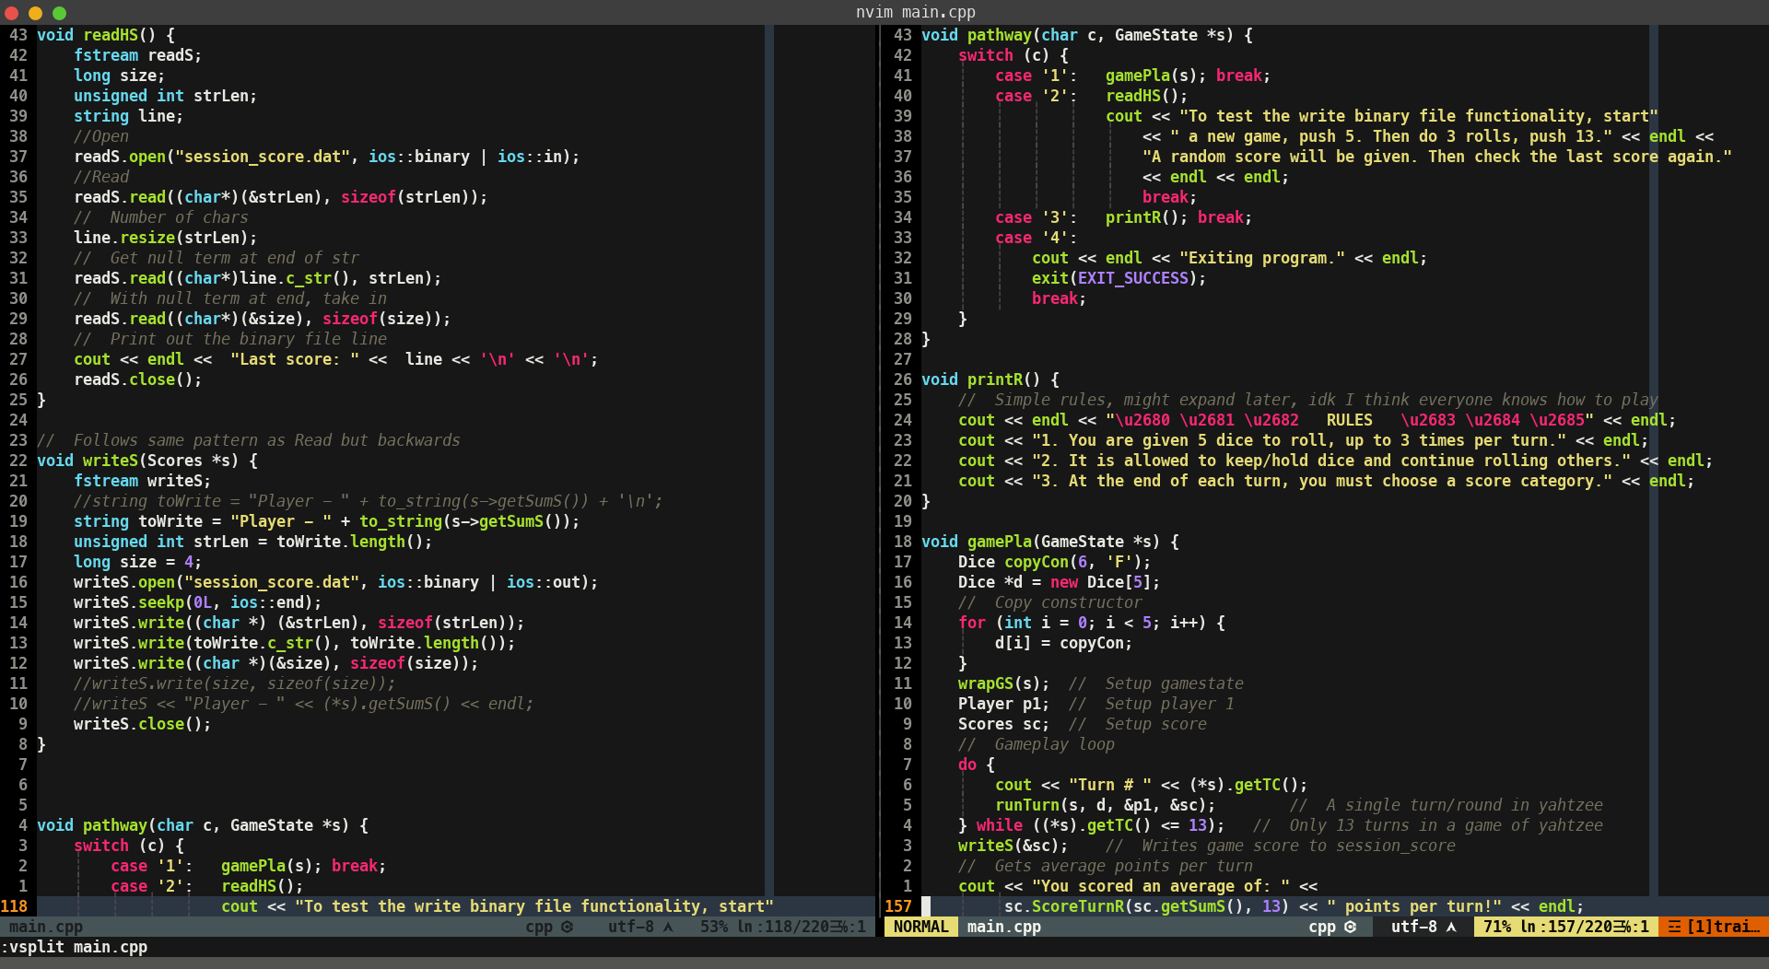
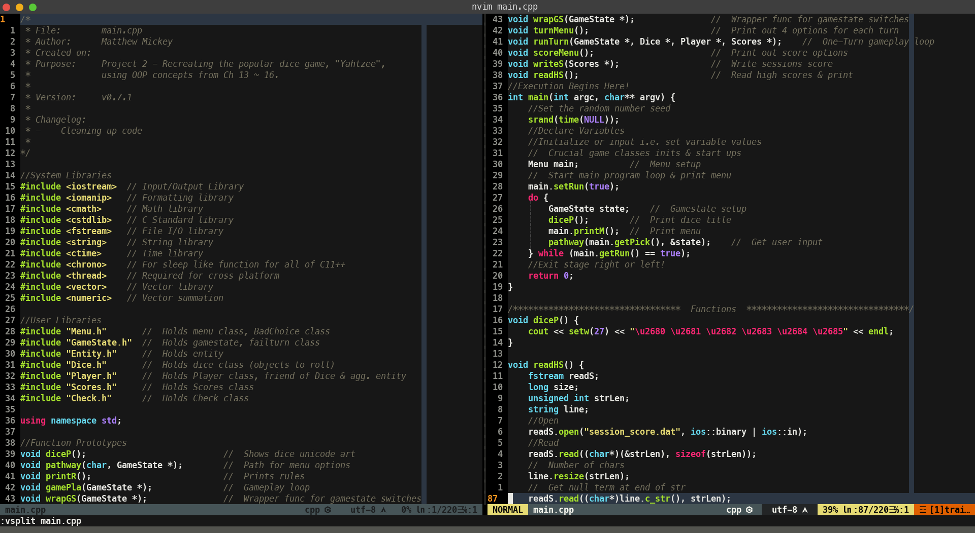
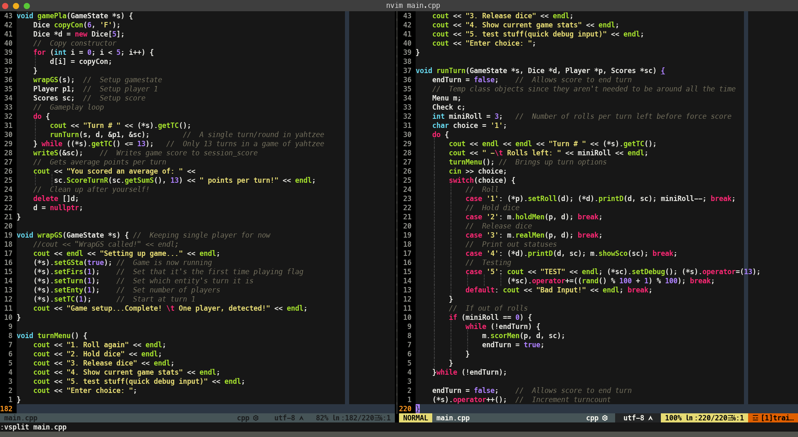
11.b menu
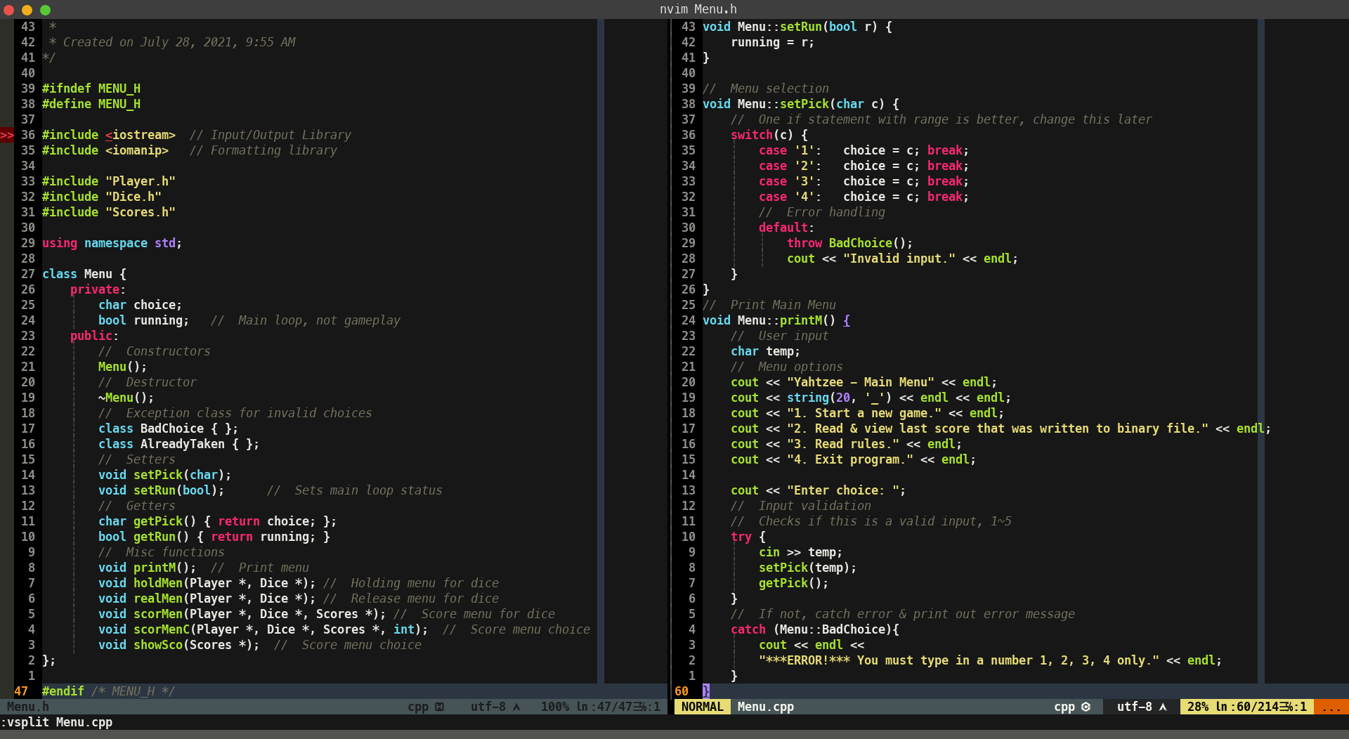
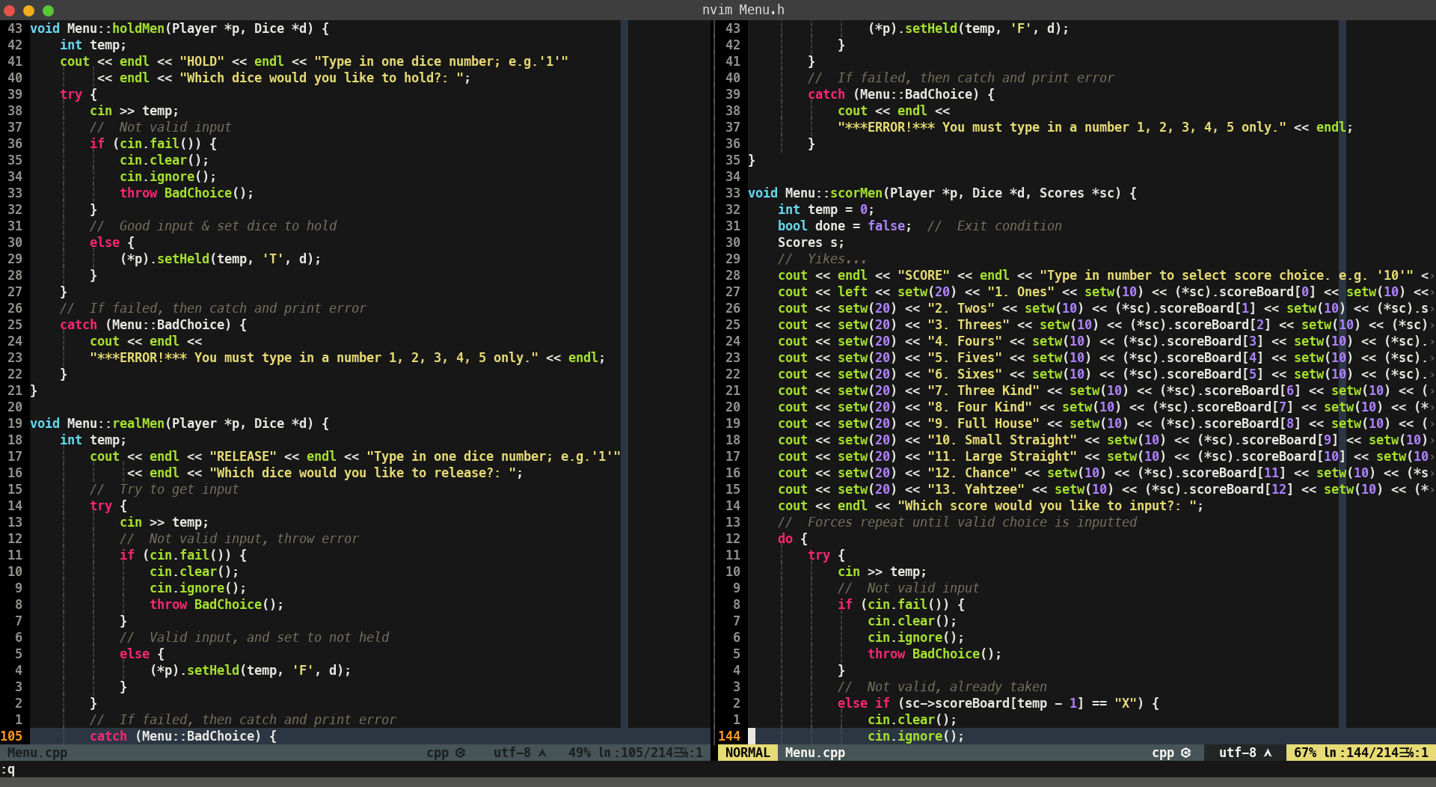

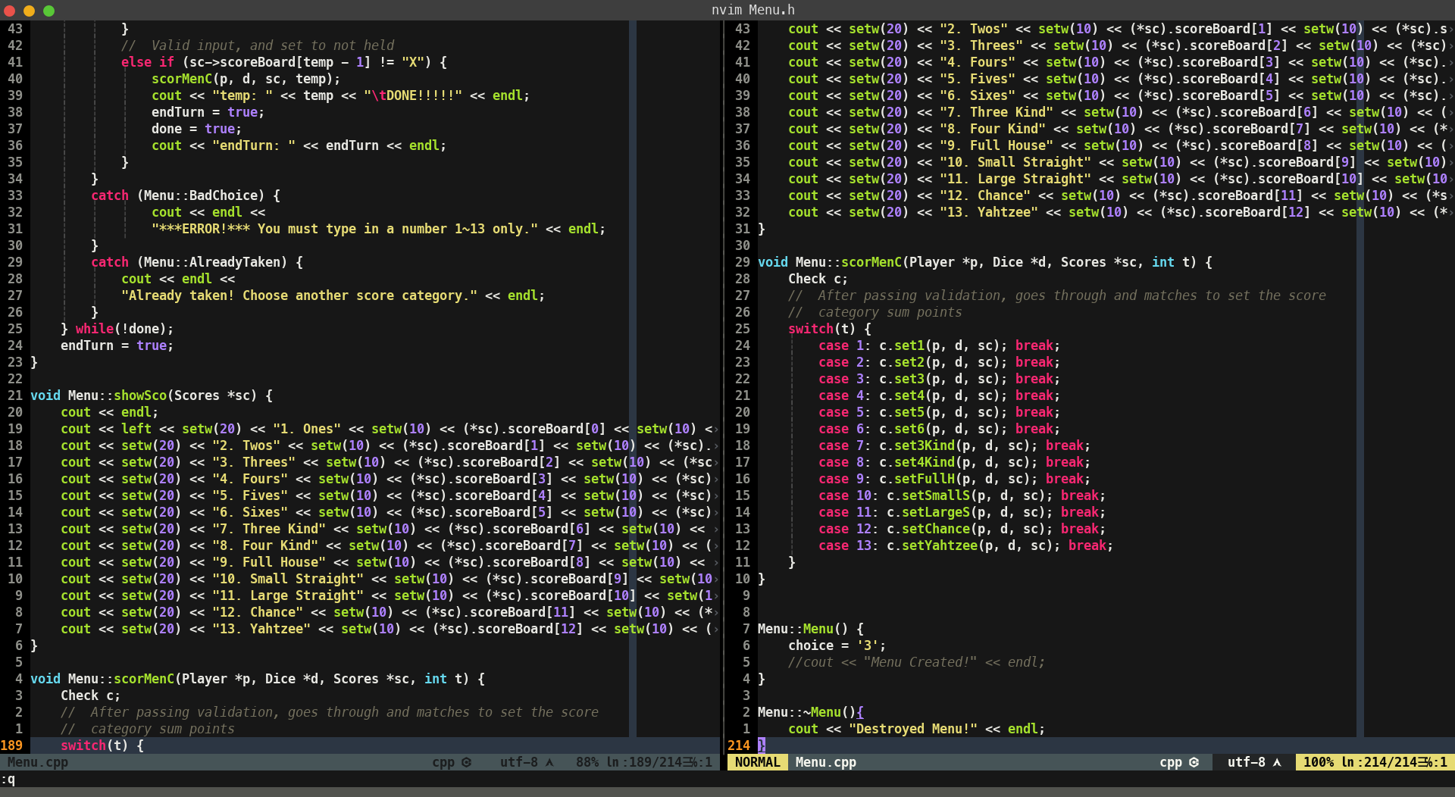
11.c entity
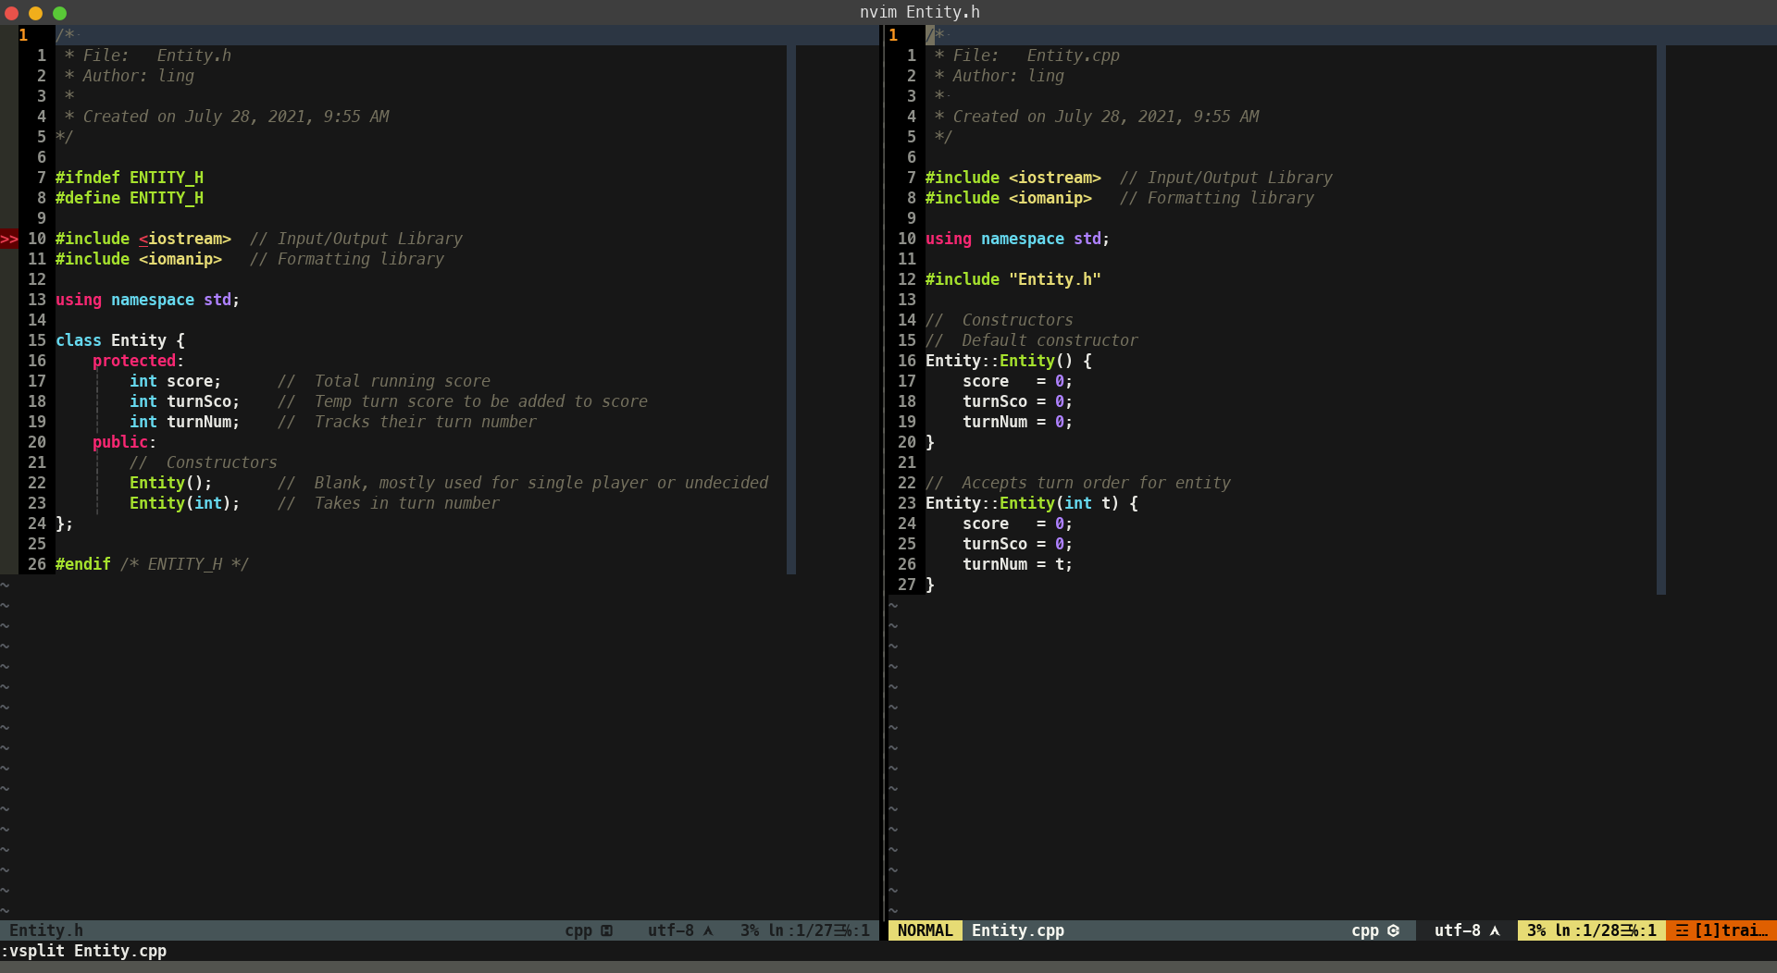
11.d dice
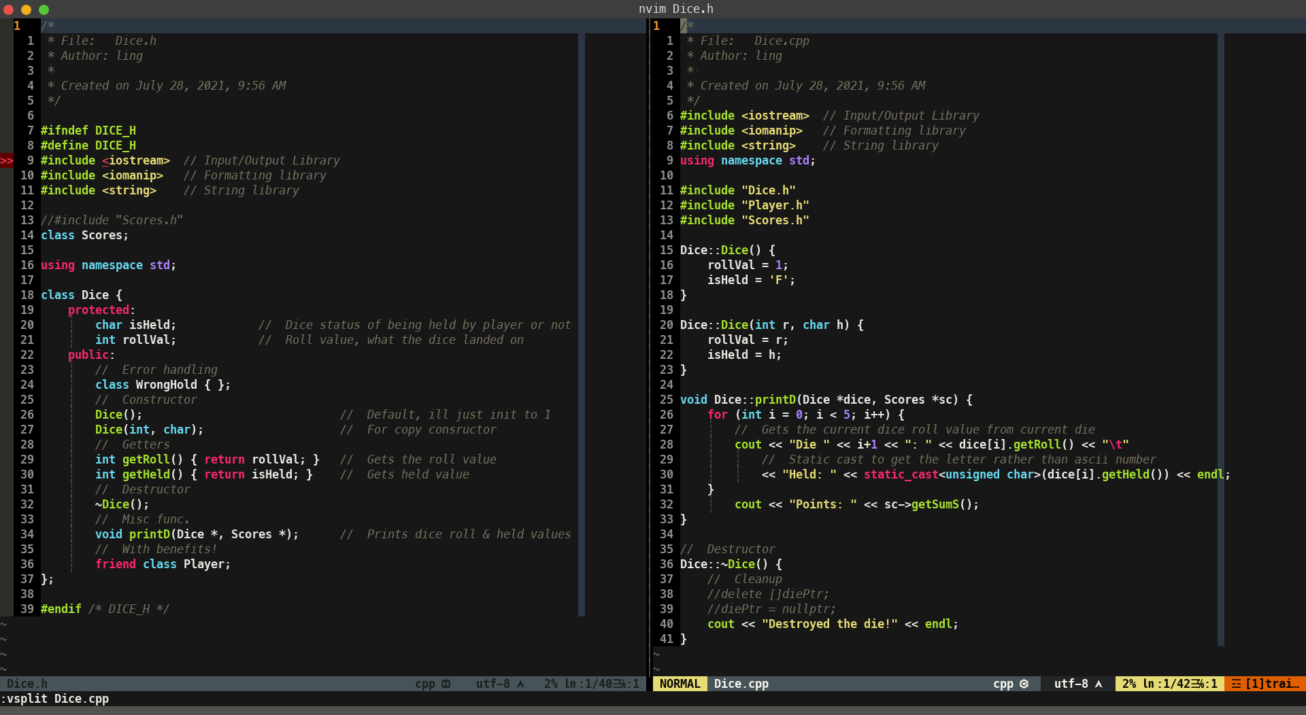
11.e player
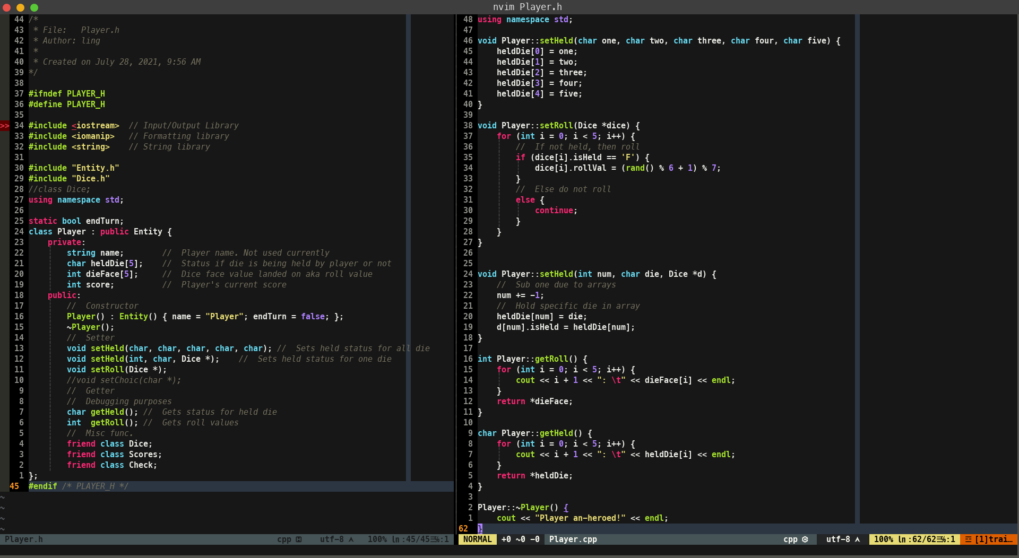
11.f gamestate
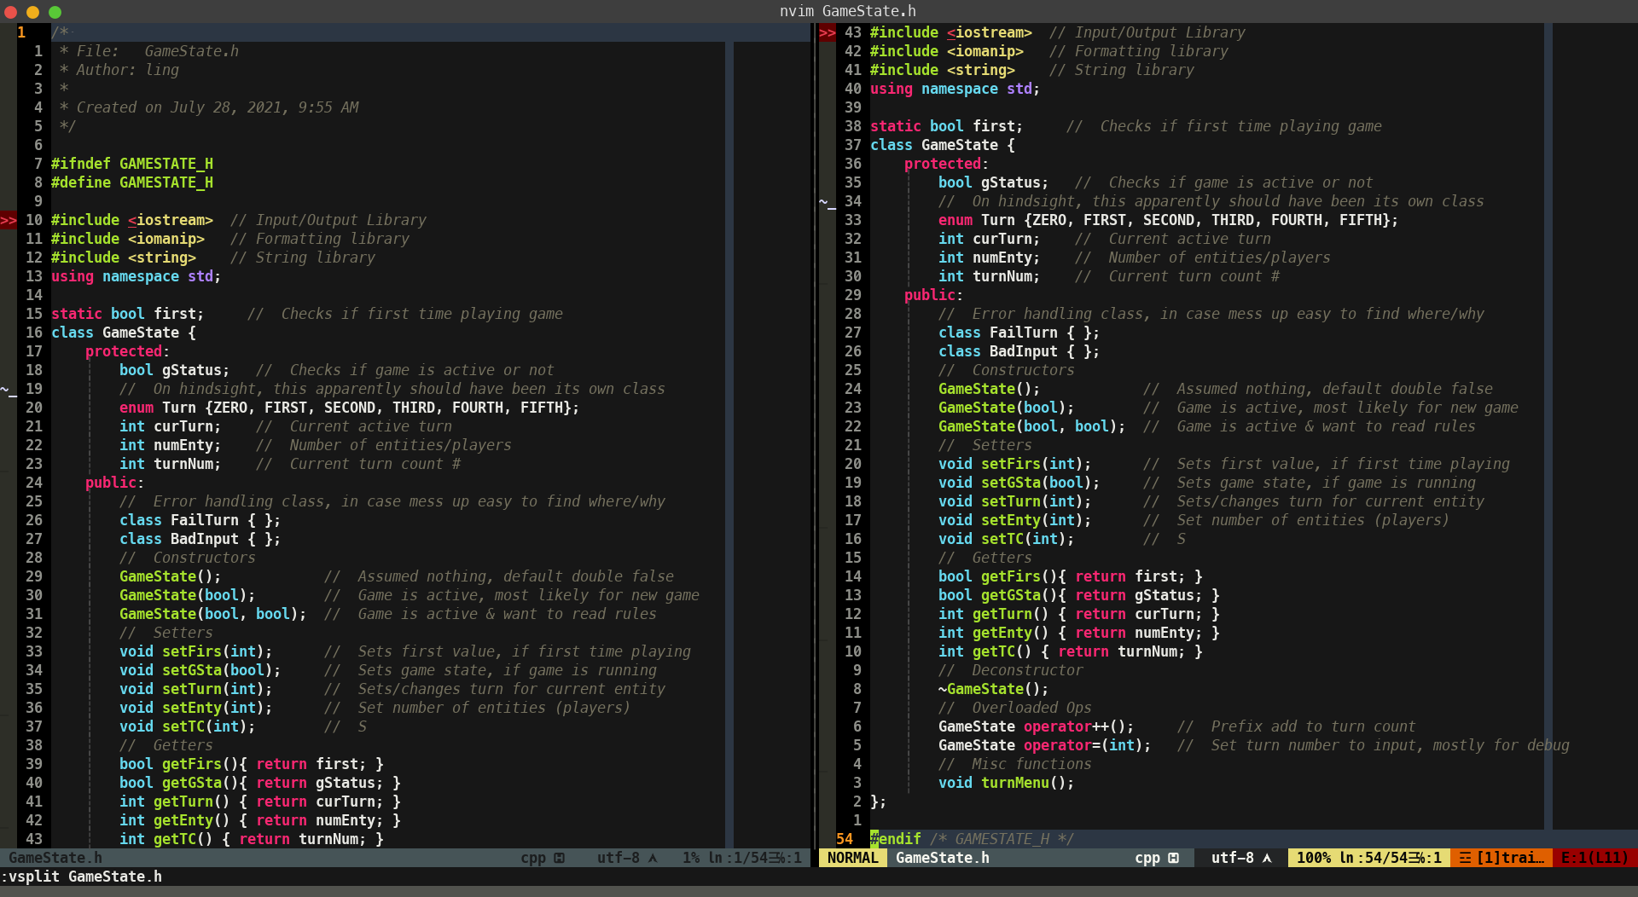
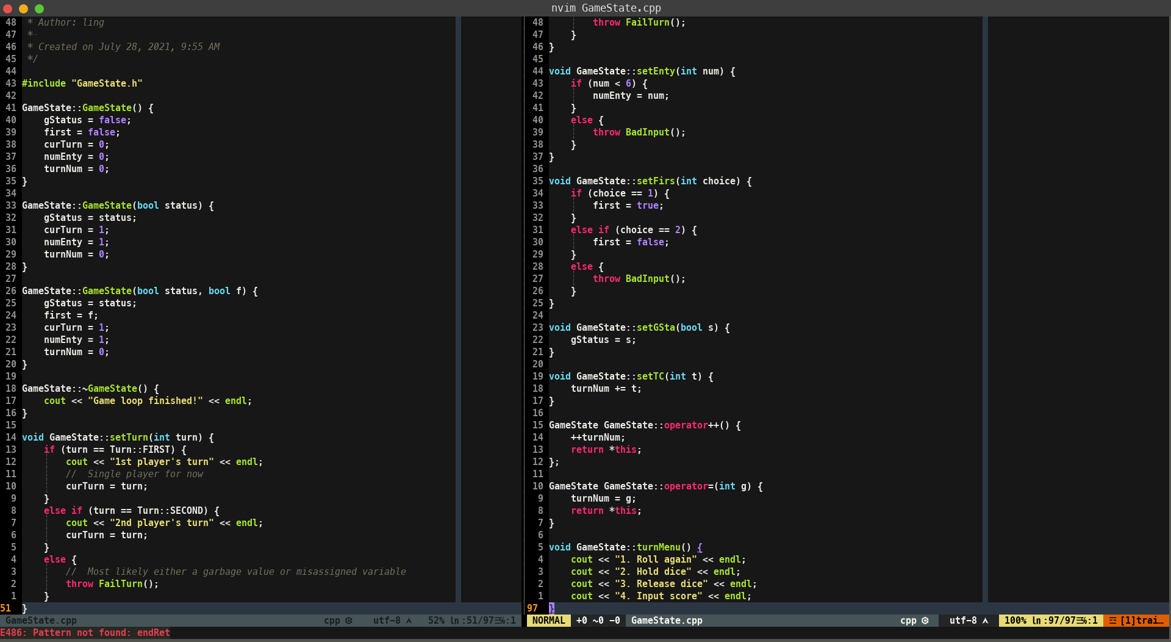

11.g scores
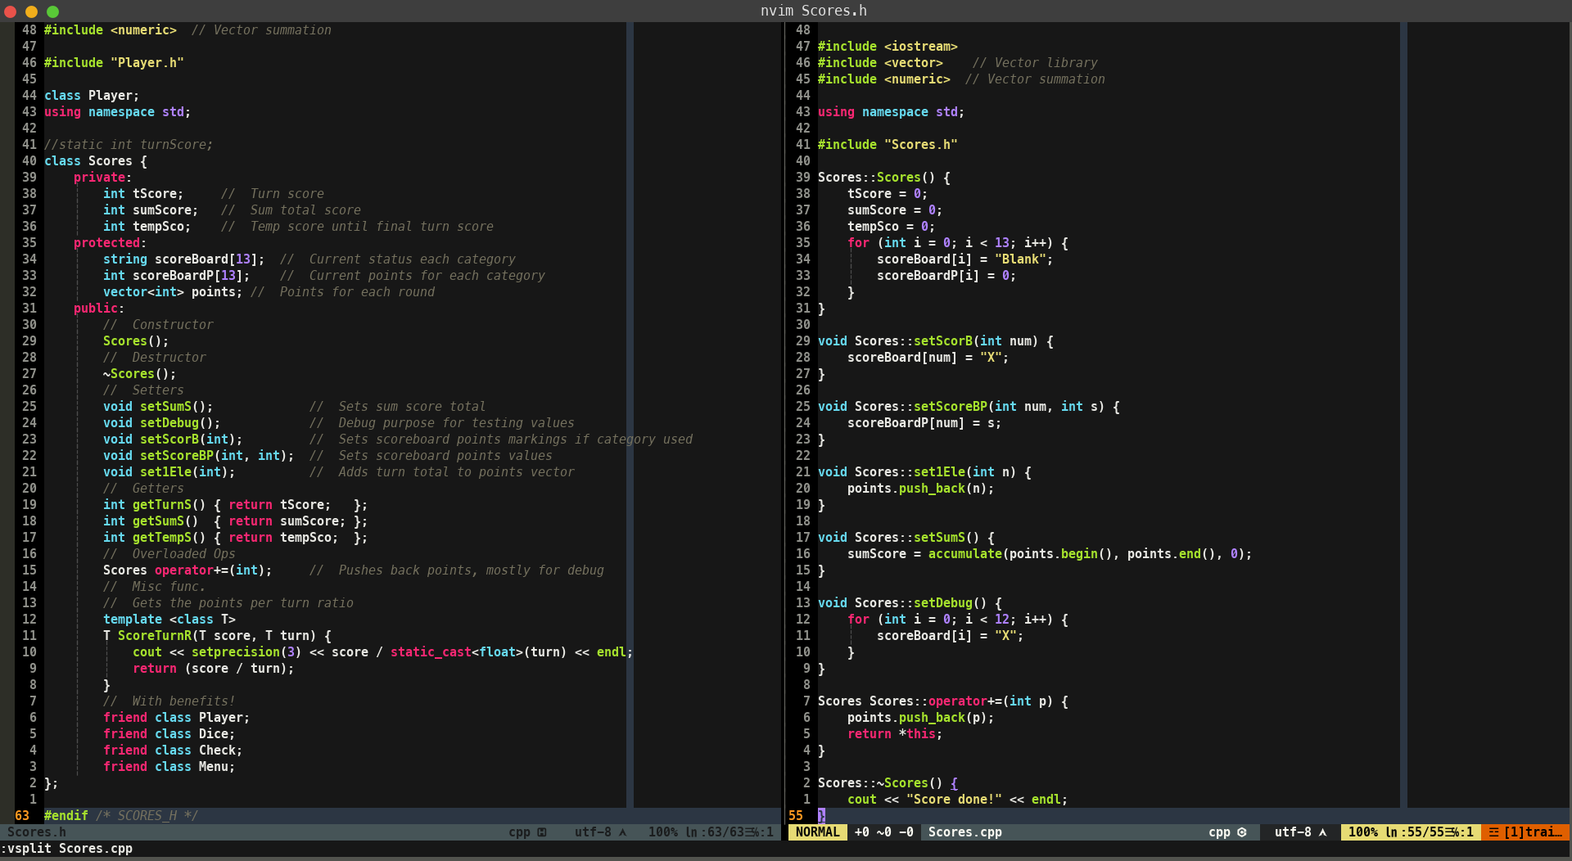

11.h check


