**Summer-2018 EECS 3421**

**Problem 1** (5 points)

**Customer**(cid, name, address)

**Magazine**(title, publisher, topic, frequency, url)

**Pricing**(title, publisher, period, offer, price)

FK (title, publisher) refs **Magazine**

**Subscribes**(cid, title, publisher, offer, from, period)

FK (cid) refs **Customer**

FK (title, publisher, period, offer) refs **Pricing**

In each relation, the underlined attributes indicate the primary key. FK stands for foreign key.

The attribute *period* in Pricing tells for how many years the subscription is. The attribute *frequency* in Magazine tells how often the magazine is published (weekly, monthly, etc.). The attribute *from* in Subscribes tells when the subscription for the customer commences.

Draw an E-R diagram from which this relational schema originated. Do not add any unnecessary elements. Do not make anything an entity that can be modeled appropriately as a relationship. Do not make anything a relationship (or an entity) that can be modeled appropriately as an attribute.



**Problem 2** (3 points)

Draw E/R diagram for the following scenario. Entity sets are Leagues, Teams, and Players. League names are unique. No league has two teams with the same name. No team has two players with the same number. However, there can be players with the same number on different teams, and there can be teams with the same name in different leagues.

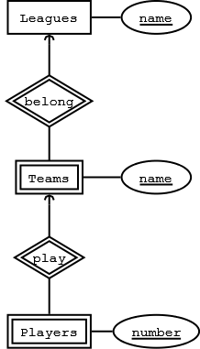

**Problem 3** (4 points) Consider the relation R with attributes A, B, C, D, E, and F, and with the functional dependencies:

AB → C, B → D, AC → B, BC → A, AD → E, E → F

Is R in 3NF?

No. Keys: AB, AC, BC. B → D violates 3NF

Is the decomposition of R into ABCD and ACEF a lossless join decomposition?

**yes**

**The remaining questions are multiple choice; only one answer is correct.**

1. Consider the following E/R model

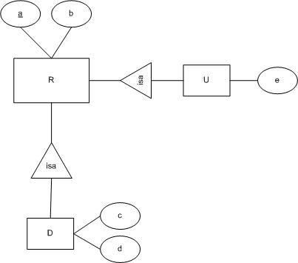

How many attributes are there in the relation that represents the entities of D, for the E/R approach?

    a) 2  
    b) 3  
    c) 4  
    d) 5

b

1. In the following expressions of relational algebra, the relations are R(a b) and S(b c).

Q1: πa,b(R ⋈ S)

Q2: R ∩ ( ρT(a) (πc (S)) × πb(S)

(a) Q1 and Q2 produce the same answer.

(b) The answer to Q1 is always contained in the answer to Q2.

(c) The answer to Q2 is always contained in the answer to Q1.

(d) Q1 and Q2 produce different answers.

C

The following three questions refer to a relation R(A B C D E) with functional dependencies A → B, BC → D, and E → C.

1. The number of keys of R is:
2. 1
3. 2
4. 8
5. 11

A

1. Which of the following functional dependencies does not necessarily hold in R?
2. AC → D
3. AE → C
4. BC → B
5. CE → D

B

1. If we project R onto S(B C D E) which of the following functional dependencies holds in S and also does not violate the BCNF condition for S?
2. BC → D
3. BE → D
4. B → E
5. E → C

D

Consider the following tables:





1. What is the resulting table of R ⋈ (S ⋈ T)?
2. I
3. II
4. III
5. IV
6. V

d

1. What is the resulting table of (S ⋈ R) ⋈ T)?
2. I
3. II
4. III
5. IV
6. V

D

1. What is the resulting table of πA,B (R ⋈ S) ⋈ πA,C (S ⋈ T)?
2. I
3. II
4. III
5. IV
6. V

B

1. What is the resulting table of πA(R) ⋈ πB (S) ⋈ πC (T)?
2. I
3. III
4. V
5. None of the tables shown here
6. This expression is illegal in RA

D