BLOCK CHAIN (ZONE 15)

ASSIGNMENT

**DEEPAK M**

NM ID: D4213FEF688E8DBB940443AC88988EF7

FINAL YEAR ECE

BHARATH NIKETAN ENGINEERING COLLEGE

TEAM Member

PROBLEM

create a program to return your string "ZONE NAME"

PROGRAM

// SPDX-License-Identifier: MIT

pragma solidity ^0.8.10;

contract zonecontract {

function zone(string memory zoneName) public pure returns(string memory){

return zoneName;

}

}

1. Go to the chrome and open remix platform

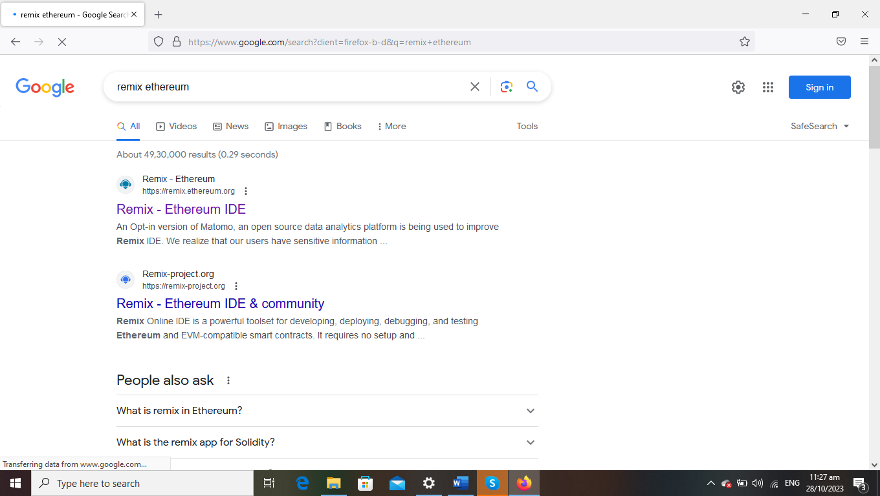

2.Open the remix page and create a new FILE

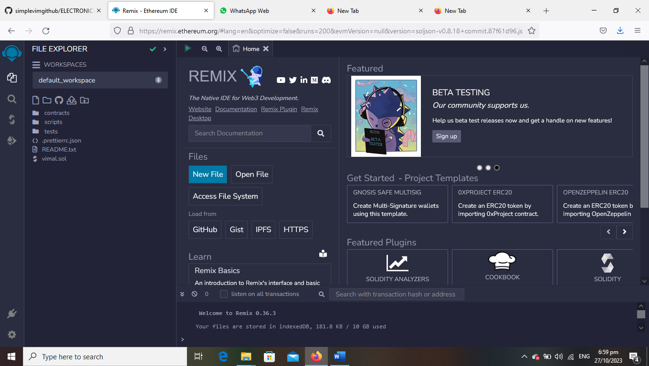

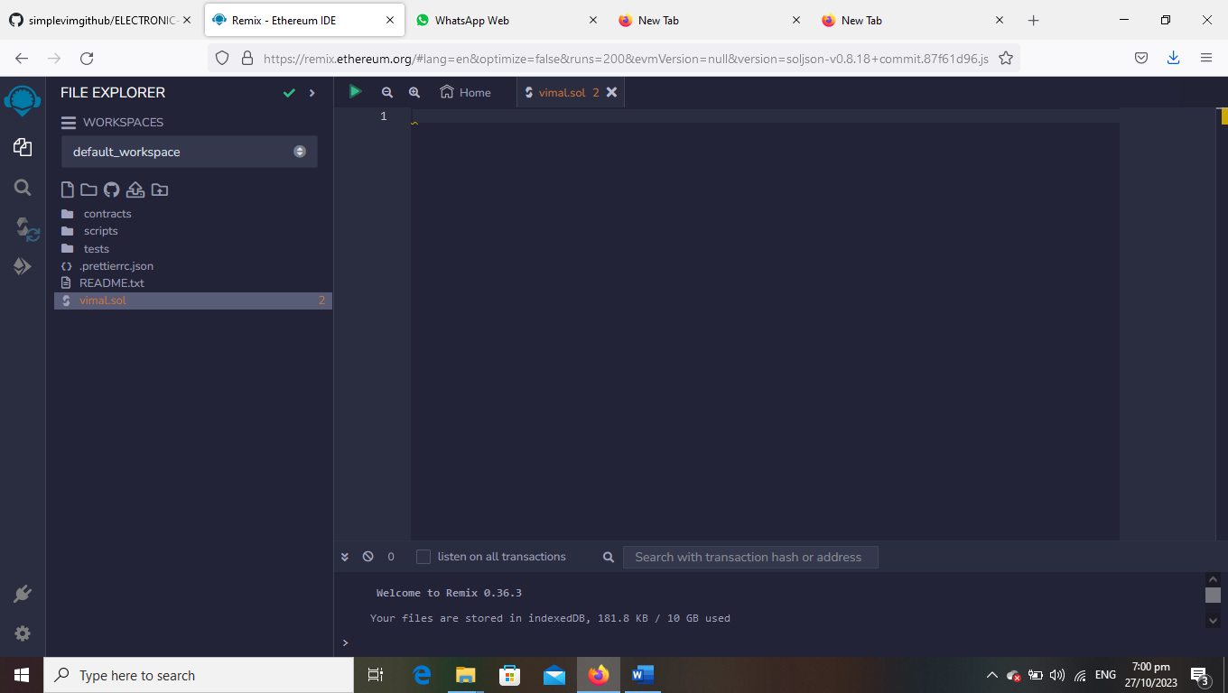

3.create a program to return your string ”ZONE NAME”

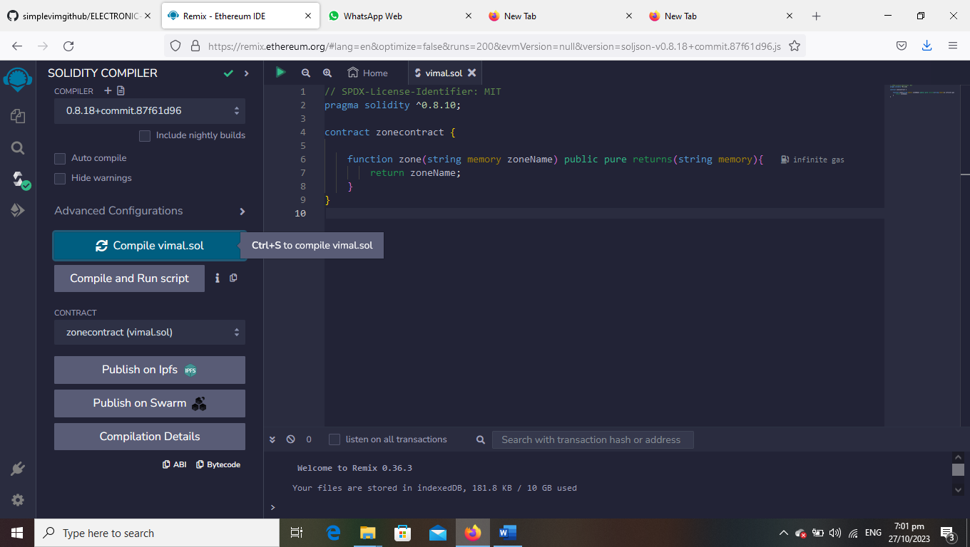

4.compile it det ABI code and BYTECODE

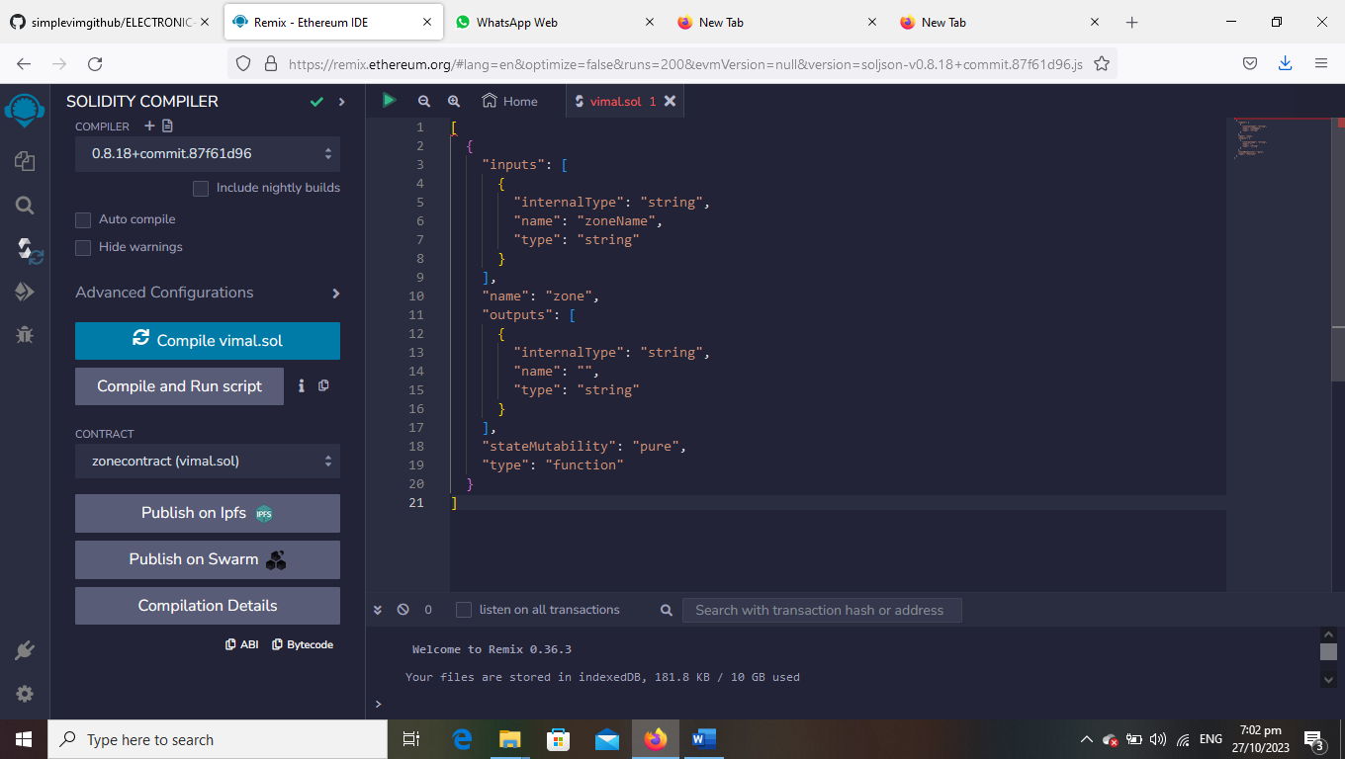

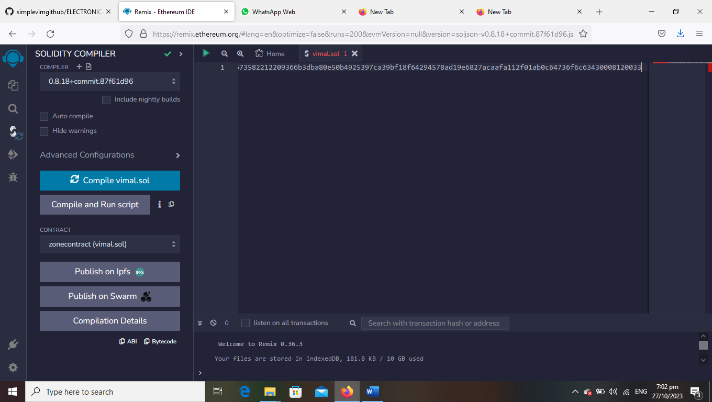

5.Deploy it to display the out put

