FPGA Audio Looping Station
Technical Design Document
Multi-Channel Audio Loop Station on an FPGA

Table of Contents
System Overview 2
Requirements 2
Component Summary 2
Hardware Overview 4
Core 1 — Audio Processor (PL) 4
Core 2 — Linux (PS) 4
System Architecture 5
Loop Control System 5
Audio Signal Path 5
Timer System 6
FSM Behavior 7
Track Behavior FSM 7
Track Timer FSM 8
Loop Length Arbiter FSM 8
Operating Modes 10
Mode 0 — Synchronized 10
Mode 1 — Independent 10
I2S Interface 11
Configuration 11
Timing Details 11
Output Specification 11
Core 1 Firmware 12
Core 2 Software 12
References 13

System Overview
This project implements a multi-channel audio looping station on a Zynq 7000 FPGA. The system records, stores, and plays back multiple audio loops simultaneously across 4 independent channels, functioning similarly to commercial loop station products such as the Boss RC-600 and RC-1. A key feature is a two-mode loop length arbitration system that enables both synchronized and independent loop lengths across tracks, giving the performer significant creative flexibility.

Requirements
- Record audio input and store it as a looping clip on any of 4 independent channels.
- Play back all active channels simultaneously with seamless, gapless looping.
- Support overdub: layer new audio on top of an already-playing loop.
- Accept audio from 2 independent input sources simultaneously.
- Provide per-channel volume control adjustable by the user in real time.
- All channel state changes (record / overdub / monitor) triggered via onboard footswitches.
- Audio sample rate of 48 kHz, 16-bit on all channels.
- Minimum 1 minute of loop storage per channel using onboard DDR3 RAM.
- Two operating modes: Synchronized (global loop length) and Independent (per-track loop length).

Component Summary
Component | Role
Core 1 — Audio Processor (PL) | Real-time audio capture, processing, DDR read/write, channel mixing, I2S interface, FSM control logic
Core 2 — Linux (PS) | High-level control, user interface, system configuration
DDR3 RAM | Loop storage — minimum 1 minute per channel at 48 kHz / 16-bit
I2S Interface | Audio input/output at 48 kHz, 24-bit (downsampled to 16-bit internally)
GPIO Debounce | Cleans mechanical switch signals for footswitches, reset button, and mode toggle
Track Behavior FSM | Per-track state machine: IDLE → RECORDING → OVERDUB ↔ MONITOR
Track Timer FSM | Per-track clock-tick counter measuring loop length during recording
Loop Length Arbiter FSM | Determines final loop_len per track based on operating mode

Hardware Overview
The system is built around a Zynq 7000 FPGA development board. The hardware architecture is split into two processing domains: a real-time audio processing core (Core 1, PL side) and a Linux application processor (Core 2, PS side). Audio enters and exits via an I2S codec, and loops are stored in onboard DDR3 RAM.

Core 1 — Audio Processor (PL)
Core 1 is the real-time heart of the system. It handles all time-critical audio operations including capture, processing, loop storage, and playback. The core runs deterministically without an OS to guarantee sample-accurate timing at 48 kHz. All FSMs, debounce logic, and audio path components live here.

Function | Description
Audio Capture | Captures live audio from two I2S RX interfaces at 24-bit, 48 kHz stereo
Stereo → Mono | Each I2S stream downmixed to mono before summing
Bit-Depth Conversion (In) | Downsizes 24-bit I2S audio to 16-bit for DDR storage
DDR3 Write / Read | Burst read/write via AXI DMA to loop buffers in DDR3
Loop State Management | Per-track FSM: IDLE → RECORDING → OVERDUB ↔ MONITOR
Loop Length Timing | Per-track timer counting clock ticks during recording; latched on stop
Loop Length Arbitration | Arbiter FSM applies Synchronized or Independent mode to set final loop_len
Channel Mixing | Per-track Gate + Volume multiplier, then 4-channel sum
Bit-Depth Conversion (Out) | Zero-pads 16-bit back to 24-bit for I2S output
Peripheral Input | GPIO debounce for 4 footswitches, reset button, and mode toggle

Core 2 — Linux (PS)
Core 2 runs a Linux environment on the Zynq 7000 ARM processor. It handles higher-level system management, user interface, and non-real-time control tasks. Communication with Core 1 occurs over shared memory or AXI interconnects.

⚠ TODO: Fill in Core 2 / Linux function details

System Architecture

Loop Control System
The loop control system handles all user input and coordinates the three FSMs that manage recording state, loop length measurement, and loop length arbitration. Footswitch presses are debounced and fed into the Track Behavior FSM, which drives timer_en and write/read enables. The Timer FSM counts clock ticks per track while recording is active. The Loop Length Arbiter determines the final loop_len for each track based on the current operating mode.

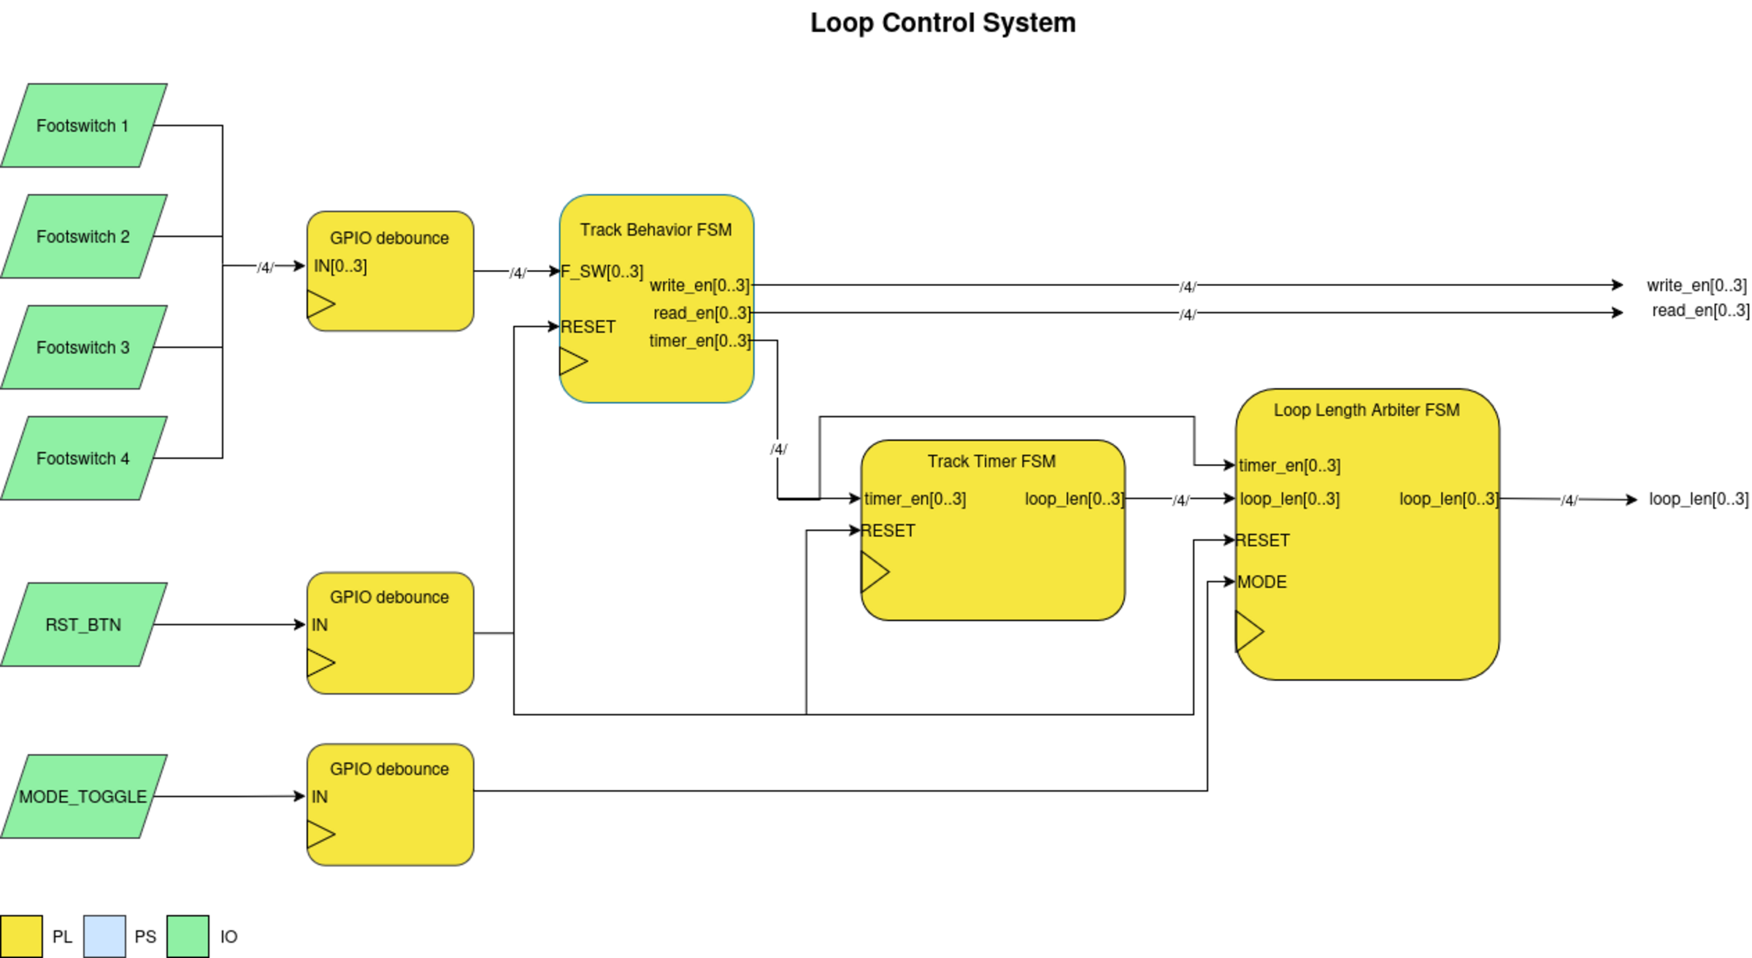
Figure 1 — Loop Control System Block Diagram

Audio Signal Path
Audio enters via two I2S RX interfaces at 24-bit stereo, 48 kHz. Each stream is downmixed to mono and the two are summed before being truncated to 16-bit and written to DDR memory via AXI DMA. The DDR block mixes existing loop audio with new input for overdubbing. On playback, each of the four tracks passes through a Gate (controlled by read_en) and a Volume multiplier before being summed and upconverted to 24-bit for I2S TX output. A bypass path allows live input monitoring regardless of loop state.

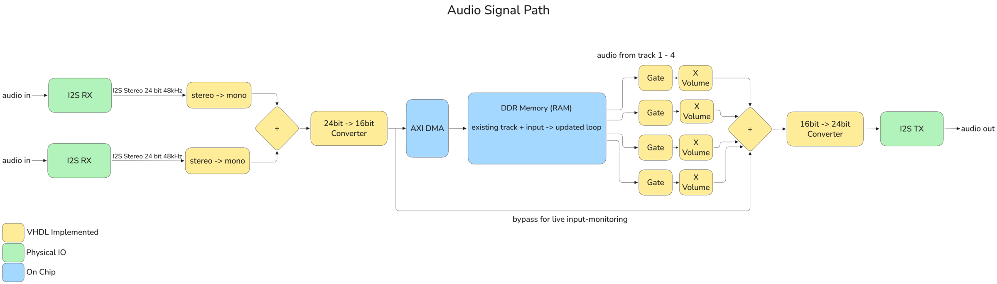
Figure 2 — Audio Signal Path

Timer System
The timer system is composed of the Track Timer FSM and the Loop Length Arbiter FSM. The Track Timer FSM runs one timer instance per track, counting clock ticks while timer_en is high (during recording). When timer_en falls, the timer latches its count and reports it to the Arbiter. The Arbiter then applies the active mode policy to determine the final loop_len output for all four tracks.

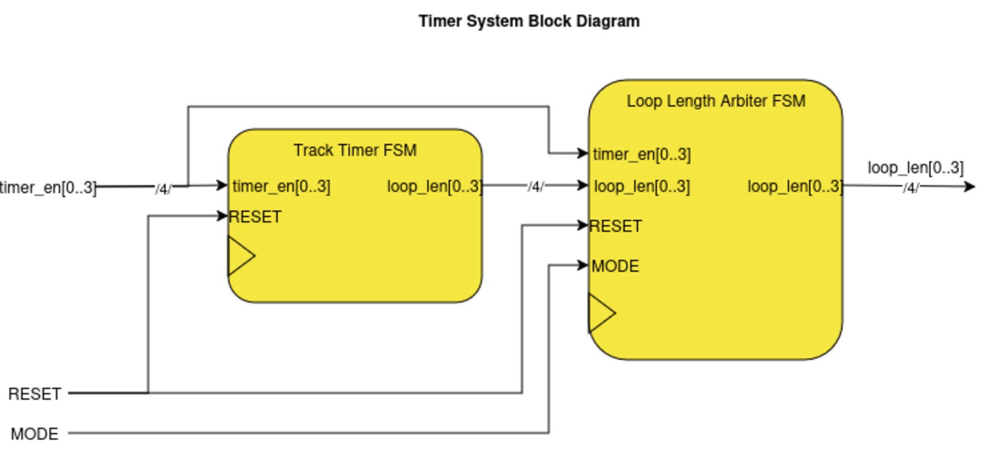
Figure 3 — Timer System Block Diagram

FSM Behavior

Track Behavior FSM
One instance is shared across all four tracks, with each footswitch independently cycling its corresponding track through states. The FSM drives write_en, read_en, and timer_en signals that control both the audio path and the timer system.

State | write | read | timer | Description
IDLE | 0 | 0 | 0 | Track inactive, no audio written or read
RECORDING | 1 | 0 | 1 | Audio written to DDR, timer counting loop length
OVERDUB | 1 | 1 | 0 | New audio layered onto existing loop, loop playing back
MONITOR | 0 | 1 | 0 | Loop plays back only, no new recording

State transitions are all triggered by F_SW[x] press. OVERDUB and MONITOR toggle back and forth on each press. RESET from any state returns all tracks to IDLE and clears loop data.

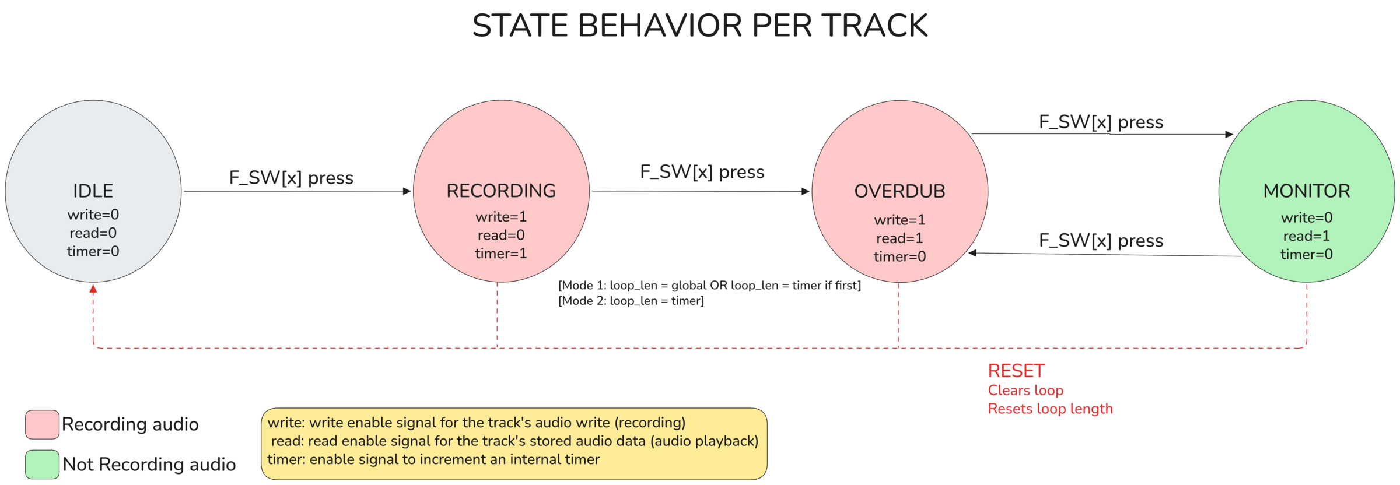
Figure 4 — Track Behavior State Diagram

Track Timer FSM
One timer FSM instance per track. The timer counts clock ticks (at the system clock rate) while timer_en is high. On the falling edge of timer_en, the count is frozen and reported as loop_len to the Loop Length Arbiter. RESET clears both the timer and loop_len registers.

State | timer | loop_len | Description
IDLE | 0 | 0 | Waiting for timer_en to go high
COUNTING | timer++ | 0 | Incrementing on every clock tick
LATCHED | frozen | timer | Count frozen and available to Arbiter

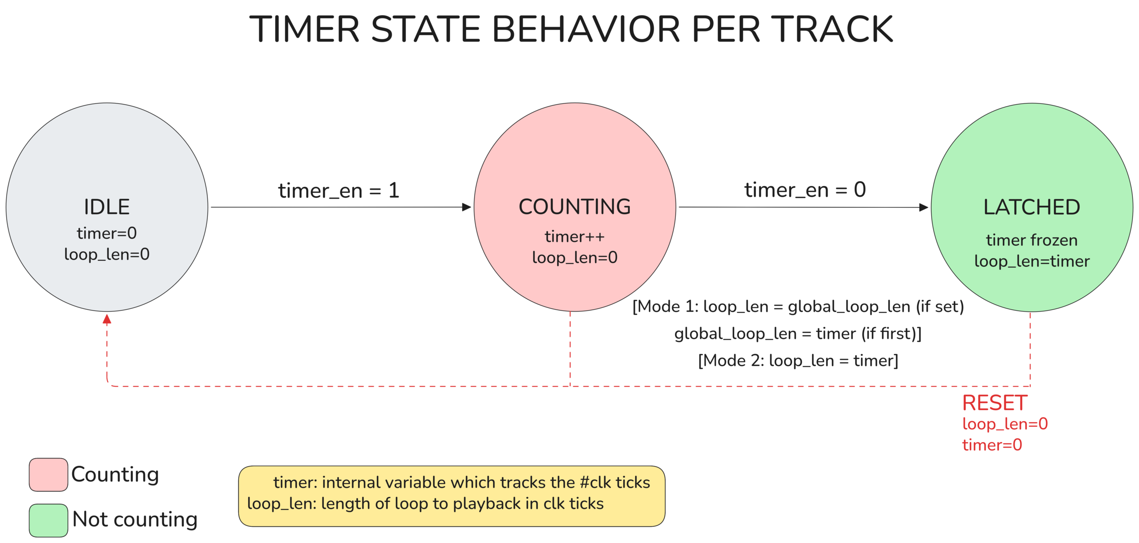
Figure 5 — Timer Behavior State Diagram

Loop Length Arbiter FSM
The Arbiter is the most architecturally significant component of the design. It takes the four timer values from the Track Timer FSMs and determines the final loop_len for each track based on the MODE input. This enables the two core operating modes of the device.

State | Description
IDLE | All loop_len and global values zeroed. Waiting for any track to begin recording.
INDEPENDENT | Mode=1. Each track sets its own loop_len from its own timer on latch.
GLOBAL_UNSET | Mode=0. Waiting for the first track to finish recording and set the global length.
GLOBAL_SET | Mode=0. Global length established. All subsequent tracks inherit this loop_len on latch.

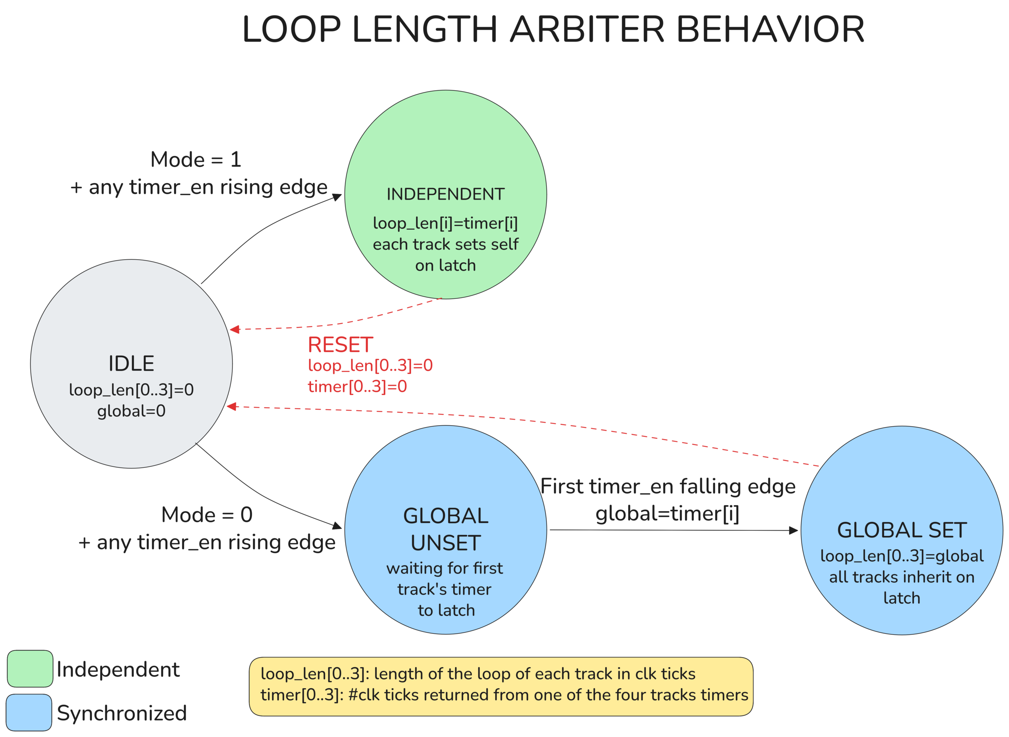
Figure 6 — Loop Length Arbiter Behavior State Diagram

Operating Modes
The mode toggle is a key design feature that distinguishes this looper from standard commercial units. A single MODE_TOGGLE input switches between two fundamentally different loop length behaviors.

Mode 0 — Synchronized
The first track recorded sets a global loop length. All subsequent tracks automatically inherit this length when they finish recording, regardless of when the footswitch is pressed. This locks all tracks to the same rhythmic grid, making it ideal for building up cohesive, layered loops in a live performance context — analogous to standard looper pedal behavior.

Mode 1 — Independent
Each track measures and keeps its own loop length independently. Tracks are not time-locked to one another, allowing different loop lengths to coexist simultaneously. This enables the performer to build a full song arrangement of distinct sections — a short repeating figure on one track, a longer chord progression on another — and trigger them as needed. This mode turns the device from a traditional looper into a live arrangement and composition tool.

I2S Interface

Configuration
Parameter | Value
Role | Slave — LRCK and SCK generated by host (Zynq 7000)
MCLK | 12.2880 MHz
LCLK (Sample Rate) | 48 kHz
Bit Depth | 24-bit per channel (input); 16-bit internal storage; 24-bit output

Timing Details
The I2S protocol requires data to be clocked on the FALLING edge of SCLK. The first bit of data is not clocked in until the first complete serial clock cycle has passed after LRCK changes state. This results in a one-cycle delay that must be accounted for in all shift register implementations — other samples will be offset by one bit if this is not handled correctly.

Output Specification
Parameter | Value
Resolution | 24-bit per channel
Sample Rate | 48 kHz
Channels | Stereo (L + R)

Core 1 Firmware
Module | Description
I2S Receive | Shift register capturing 24-bit serial audio; accounts for 1-cycle LRCK delay
24→16 Bit Truncation | Strips lower 8 bits prior to DDR write
Track Behavior FSM | Per-track FSM: IDLE → RECORDING → OVERDUB ↔ MONITOR
Track Timer FSM | Per-track clock-tick counter, latches on timer_en falling edge
Loop Length Arbiter FSM | Arbitrates loop_len across tracks based on operating mode
DDR3 Controller | Burst read/write interface to loop buffers via AXI DMA
4-Channel Mixer | Per-track Gate + Volume; accumulator sums 4 active channels; saturates on overflow
16→24 Bit Expansion | Zero-pads lower 8 bits before I2S transmit
I2S Transmit | Serializes 24-bit stereo output on SCLK falling edge
Button Debounce | Debounce logic for all footswitches, reset button, and mode toggle

Core 2 Software
⚠ TODO: Fill in Core 2 Linux software stack details

References
[1] Boss, "RC-600 Loop Station," https://www.boss.info/global/products/rc-600/
[2] Boss, "RC-1 Loop Station," https://www.boss.info/global/products/rc-1/
[3] Xilinx / AMD, "Zynq-7000 SoC Technical Reference Manual," https://www.xilinx.com/support/documentation/user_guides/ug585-Zynq-7000-TRM.pdf
[4] JEDEC, "Serial Peripheral Interface Standard I2S," https://www.sparkfun.com/datasheets/BreakoutBoards/I2SBUS.pdf

