Strategic Analysis: BigBasket Business Model Evolution (2025-26)

Market Research and Strategic Growth Recommendations
Analyst: Abhimanyu Patel

Date: December 29, 2025


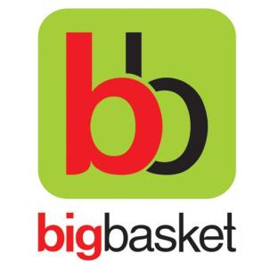
- Executive Summary
BigBasket, a pioneer in the Indian e-grocery space, has successfully transitioned into a quick-commerce (Q-commerce) powerhouse, with BB Now driving approximately 85% of its total business. By leveraging the Tata Neu ecosystem and its extensive dark store network, the company is positioned for an IPO by 2026. This report outlines a strategy to enhance market share through organic growth, premium offline expansion, and ESG-led operational efficiency.

2. Market Opportunity & Context
he Indian Q-commerce market has shifted from "impulse" shopping (snacks/drinks) to "planned-quick" shopping (fresh produce/staples). While competitors focus on 10-minute speed, BigBasket’s opportunity lies in the intersection of reliability, quality, and scale.

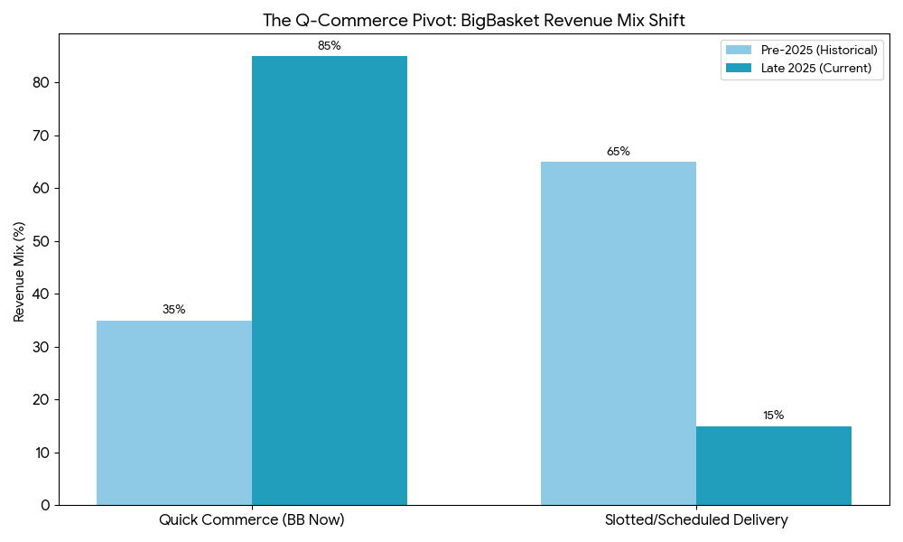
3. Strategic Recommendations

3.1 Premium Offline Presence & Organic Growth
To capture high-value urban segments, BigBasket should establish "Experience Centres" in high-posh areas.
- Tactical Focus: These stores will showcase the Organic and BB Royal private labels, which offer higher margins than third-party FMCG brands.
- Synergy: Physical stores act as micro-warehouses (dark stores) for BB Now, improving the "Express delivery" value proposition.

3.2 B2B Expansion: Corporate Ecosystems
- Strategy: Signing long-term MOUs with large corporations for pantry management and bulk employee gifting.
- Impact: This stabilizes revenue streams and reduces the reliance on individual "Product sales" fluctuations.

4. Operational Excellence & ESG Strategy

4.1 Green Logistics: The EV Transition
- Action: Switching the entire "Logistics fleet" to Electric Vehicles (EVs).
- Financial Impact: Reduces fuel and maintenance costs, which are significant parts of the "Cost structure".

4.2 Late-Night Efficiency
- Action: Optimizing "Order fulfilment operations" for 11 PM – 3 AM windows.
- Technology: Using the "Technology stack" to automate dark store sorting, ensuring consistent 10–30-minute delivery during nocturnal hours.
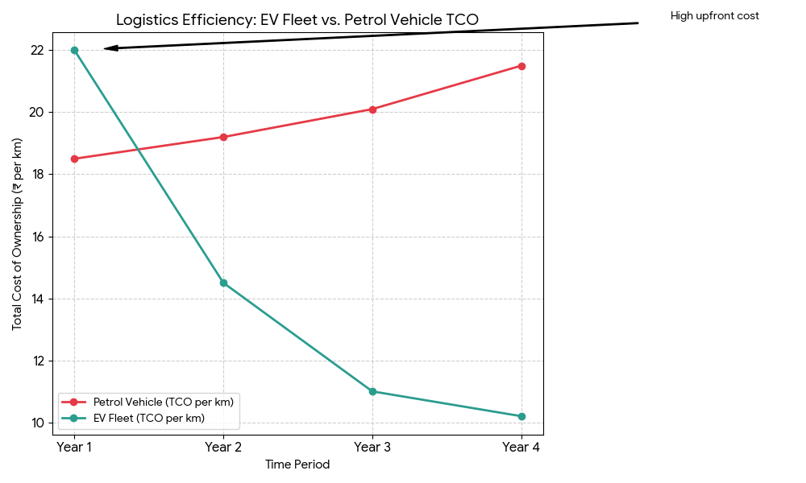

5. The "Care Moat": Human-Centric Logistics
For a "Strategy Analyst," human capital is as important as financial capital.
- The Problem: High attrition in delivery personnel leads to increased recruitment and training costs.
- The Solution: Implementing "Care Protocols"—data-driven route planning to avoid high-strain paths and providing scheduled breaks.
- Strategic Outcome: Improved "Customer Relationships" through better service consistency and higher delivery partner retention.

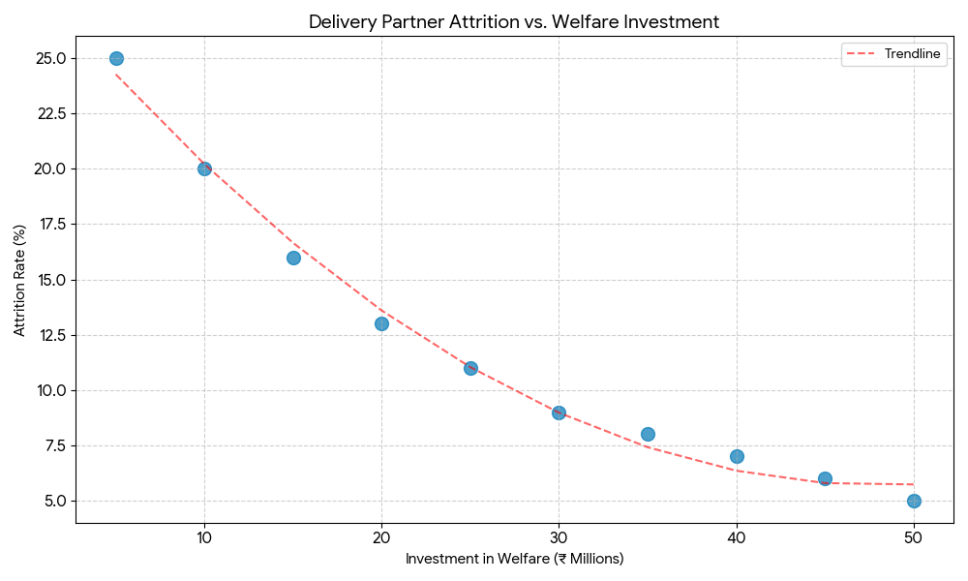

6. Conclusion
By integrating EV logistics, premium offline retail, and B2B corporate channels, BigBasket can evolve from a grocery aggregator into a sustainable "Quick Life-Essentials" platform. This multi-pronged approach ensures a robust valuation as the company approaches its 2026 IPO.

