**Assignment 3 Part 1:** Preload images and use a timer

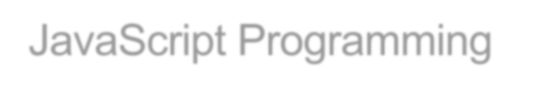

JavaScript Programming

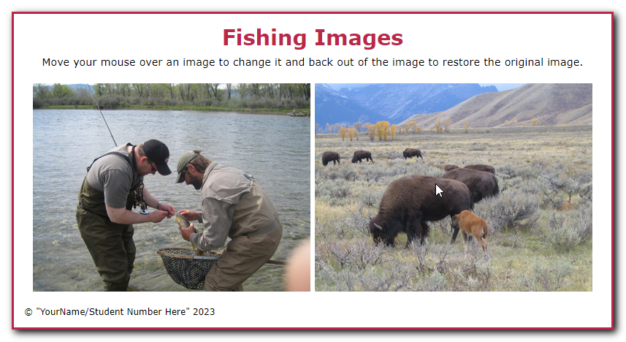In this assignment, you’ll modify an Image Rollover application so it preloads the images that are displayed when the original images are rolled over. In addition, you’ll create timers that cause the rollover images to be displayed when the page is first loaded.

1. Open the starter folder attached (zipped) to this Assignment folder:

# Evaluations\Assignments\Assignment 3\Assignment3-Files.zip -> rollover

1. Run the application and move the mouse pointer over each of the two images to see that the original image is replaced with another image when the mouse is in the image.
2. Add JavaScript code to preload the rollover images. These are the images that are specified by the id attributes of the img elements.
3. Add a timer that causes the rollover images to be displayed one second after the page is loaded.
4. Add another timer that causes the original images to be displayed again two seconds after the page is loaded.
5. In index.html, change the text in the <small> tag to your name and student number.

**Assignment 3 Part 2:** Add a stopwatch to the Clock application

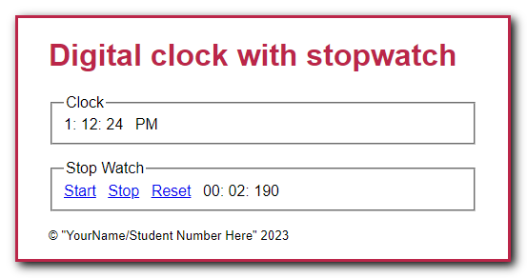In this assignment, you’ll add a stopwatch feature to the application you created in the previous assignment. The stopwatch will display elapsed minutes, seconds, and milliseconds. The enhanced application looks like this:

1. Open the starter folder attached (zipped) to this Assignment folder:  
   **Evaluations\Assignments\Assignment 3\Assignment3-Files.zip -> clock_stopwatch**
2. In the JavaScript file, note the $(), displayCurrentTime(), padSingleDigit(), and DOMContentLoaded event handler functions from the Clock application. In addition, note the global variables and starting code for the tickStopwatch(), startStopwatch(), stopStopwatch(), and resetStopwatch() functions.
3. In the tickStopwatch() function, add code that adds 10 milliseconds to the elapsedMilliseconds variable and then adjusts the elapsedMinutes and elapsedSeconds variables accordingly. Then, add code that displays the result in the appropriate span tags in the page.
4. In the startStopwatch() function, add code that starts the stopwatch. Be sure to cancel the default action of the link too.
5. In the stopStopwatch() and resetStopwatch() functions, add code that stops the stopwatch. Also, in the resetStopwatch() function, reset the elapsed time and the page display. Be sure to cancel the default action of the links too.
6. In the DOMContentLoaded event handler, attach the stopwatch event handlers to the appropriate links.
7. In index.html, change the text in the <small> tag to your name and student number.