**Assignment 5 Part 1:** Create a Progressbar widget that uses a timer



JavaScript Programming

In this assignment, you’ll modify an application that uses a timer to display the elapsed minutes and seconds in a text box so it displays the elapsed time in a Progressbar widget.

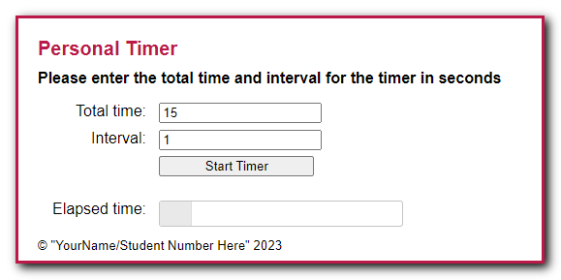

1. Open the starter folder attached (zipped) to this Assignment folder:  
   **Evaluations\Assignments\Assignment 5\Assignment5-Files.zip -> personal_timer**
2. Run this application and test it. When you enter a total time and interval and click the Start Timer button, note that the elapsed minutes and seconds are displayed in a text box and are updated each time the interval passes.
3. Go to the jQuery UI website at https://jqueryui.com, and display the documentation for the Progressbar widget. Review the code for one or more of the examples, then review the API documentation.
4. Modify the HTML for the application so it uses a Progressbar widget to display the elapsed time instead of a text box. Be sure to give the widget an id of “progressbar” so the CSS for the application works correctly.
5. Add a statement to the JavaScript file that activates the widget with a starting value of 0.
6. Modify the code that’s executed if the two entries are valid so it uses the widget. When you do that, you can delete the code that calculates and displays the elapsed minutes and seconds since it’s no longer needed. Then, you can add code that calculates and changes the value of the Progressbar widget.
7. In index.html, change the text in the <small> tag to your name and student number.

**Assignment 5 Part 2:** Replace a Tabs widget with an Accordion widget

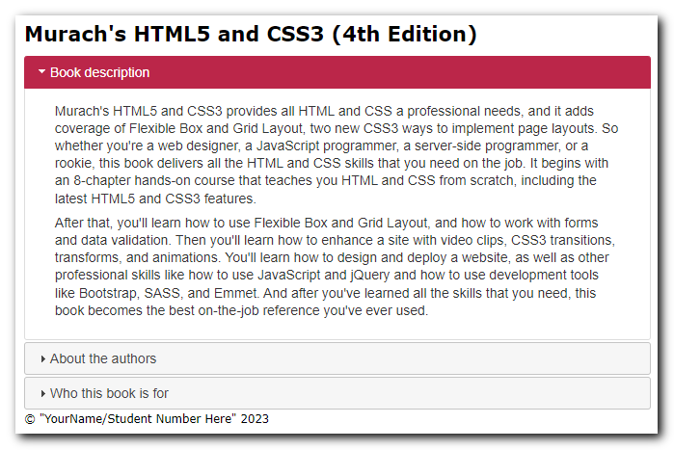In this assignment, you’ll modify an application that uses a Tabs widget to display the content of three panels to an application that uses an Accordion widget to display those panels.

1. Open the starter folder attached (zipped) to this Assignment folder:  
   **Evaluations\Assignments\Assignment 5\Assignment5-Files.zip -> accordion**Now, run this application to refresh your memory about how it works.
2. Modify the HTML so it can be used with the Accordion widget. To do that, you’ll need to omit the list of tabs and add an h3 element for each panel. Then, make any additional changes as appropriate.
3. In the HTML file, modify the jQuery code so it uses an Accordion widget. A panel should be opened when the user clicks on it. If the panel is already opened, it should be closed.
4. In index.html, change the text in the <small> tag to your name and student number.